

BA Leadership and Management
Module: Emergent Leadership Skills in the Workplace
Module code: BMSW 6101
Part 1 – Academic Report
Student name: Teodora Stoyanova
Student number: 2125443
Lecturer Name: Samuel Ofori

Table of Contents
Introduction 3
Providing a Brief Overview of Theories X, Y, and Z 4
Theory X 4
Theory Y 5
Theory Z 6
Explaining the Similarities and Distinctions 7
Examining the impact of factors such as culture, individuality, and more. 9
Understanding the Situational Strategy 11
Describing the Shifting Approaches to Leading 13
Demonstrating Practical Application of Situational Leadership: 14
Conclusion 16
References 17

Introduction
Within the contexts of management and business operation, the idea of leadership is extremely significant. Leaders play a crucial role in management by developing an atmosphere favorable to personal growth and professional achievement. A key component of the duties of managers is to demonstrate leadership skills, according to Carlos Pastor and Mayo (2008). To create and maintain a competitive advantage, leadership has to come up with and execute strategies. Among the many essential management functions are arranging, hiring, directing, and controlling. However, leadership is essentially a component of directing. To be an effective leader, one must not only listen, connect with others, and encourage teamwork, but also encourage, motivate, and impact those being managed.
The performance of an organization depends heavily on its leadership, and many theories provide information regarding the various manners in which leaders might achieve this success (Chima and Gutman, 2020). The leadership theories X, Y, and Z offer various perspectives on ways of leading and their effects. Cherylyak-Hai and Rabenu (2018) state that leaders can more effectively supervise organizations and teams if they have an in-depth knowledge of these concepts and what they imply. The ideas of X, Y, and Z will be discussed here, along with their consequences in various types of organizations. Furthermore, leadership theories provide light on various models of leadership, which enable leaders to reach sound choices that boost participation, motivation, and efficiency in the workplace. It will also address the need for situational or unforeseen leadership in dealing with the difficulties that UK companies are facing at this time. A leader's approach doesn't need to be the same in different situations. The approach to leadership may depend on the circumstances" is well-supported and valuable. Adaptability and modifying leadership approaches to fit particular situations are the foundational principles of the situational leadership model. Effective leaders can adapt their approach to leadership to meet the unique challenges of each scenario, and this perspective recognizes that different contexts require distinct actions.

Providing a Brief Overview of Theories X, Y, and Z
The various theories of leadership offer conceptual frameworks that can be applied to gain an awareness of how leaders can successfully influence their employees and boost productivity. There are numerous ideas on management and leadership, but two that stand out for their particular points of view are Theory Z by William Ouchi and Ideas X and Y by Douglas McGregor. This report's goal is to clarify these theories by comparing and contrasting them, discussing how they differ from one another, and finally, applying them to current leadership while keeping cultural and specific variations in mind.

Theory X
At its core, Theory X is based on an adverse assessment of what motivates and influences workers. This perspective holds that workers are naturally unmotivated; Xu and Farris (2024) note, and those they need constant excessive supervision. Here are some important assumptions of Theory X:
- A large percentage of workers are unwilling to perform their jobs if given the chance.
- Organizational goals can only be achieved through controlling, unsafe, and pressuring people as they dislike their work.
- Workers are dependent and afraid of taking initiative, and they prefer to be told what to do.
Theory X's benefits and drawbacks:
Some benefits are offered by Theory X as a style of leadership. Workers can accomplish their responsibilities with efficiency and by the organization's objectives because of the structure and guidance it offers. Theory X's emphasis on tight oversight and dominance over staff members might be useful when maintaining rules and regulations necessitates complete cooperation. Yet, there are certain drawbacks to Theory X as well (Chernyak-Hai and Rabenu, 2018). Poor morale and reduced efficiency could result in a toxic work environment. Theory X assumes that workers are fundamentally discouraged and inefficient, which in turn restricts their freedom of action and innovation, which restricts the possibilities they have as an organization.
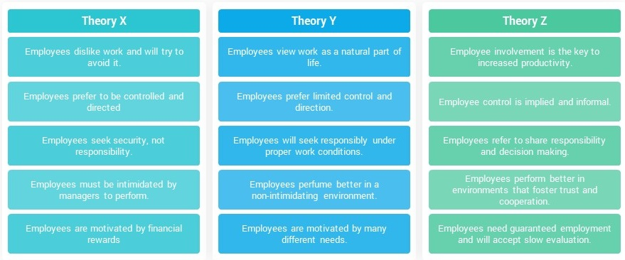
Figure 1: Theories of Leadership Style (Senarathne, 2020).

Theory Y
Workers are intrinsically motivated and develop when given responsibility, according to Theory Y, which paints a more favorable portrayal of behavior among employees. In Theory Y, some of the major assumptions consist of:
- The conditions must be suitable for work to feel as effortless as enjoyment.
- With an overwhelming feeling of purpose, workers can exercise initiative and self-control.
- A person's dedication to a goal depends on the benefits they intend to gain by seeing it succeed in completion.
- Employees show a strong desire for accountability and are capable of utilizing their imagination, imaginative thinking, and creativity to solve obstacles inside the business.
Benefits and drawbacks of Theory Y's:
The benefits of Theory Y are numerous. Theory Y promotes employee responsibility by understanding that workers are self-reliant, accountable, and motivated through internal reasons (Senarathne, 2020). This creates a supportive workplace that encourages employees to be satisfied with and motivated in their work. Because it encourages employees to develop personally and professionally and gives them the freedom to share their points of view, Theory Y helps managers get the majority out of their staff (Xu and Farris, 2024). Nevertheless, there are downsides to Theory Y as well. Certain workers, especially those who need more instructions, may not like it. Additionally, some company cultures may find it difficult to develop the confidence and transparent communication necessary for executing Theory Y.

Theory Z
William Ouchi's Theory Z combines Japanese and American managerial approaches with an emphasis on sharing decisions, individual accountability, and ongoing employment (Sethuraman and Suresh, 2014). The following are the foundational assumptions of Theory Z:
- Job consistency and predictability over the long term are emphasized in this approach to work to encourage dedication and dedication.
- Promotes collaboration in making choices and consensus-building for better outcomes.
- Even if decisions are made collectively, people are accountable for their actions and contributions. People are liable for how they contribute.
- Employers who express an integrated concern for their staff members are concerned with the physical and mental well-being of their staff members, covering their families and interactions with others.
Theory Z's benefits and drawbacks:
Theory Z offers a unique blend of Theory X and Theory Y, each contributing to the overall foundation. Based on Islam and Kalumuthu (2020), Theory Z helps foster an effective and constructive workplace by recognizing the significance of establishing strong connections and long-term employment. Collaboration, loyalty, and dedication among workers are enhanced, which in turn improves retention rates. Also, as Solinger, Jansen, and Cornelissen (2020), Theory Z acknowledges that workers have a greater tendency to be satisfied with their positions when their work and personal lives are well-integrated. The limits of Theory Z are, however, not inconsequential. Leroy et al. (2018) note that not all situations in organizations are suitable for the dedication and energy needed to develop reliable connections based on trust. As a consequence of its heavy focus on dedication and loyalty, Theory Z might also be less useful in companies that value rapid achievement beyond continuous development.

Explaining the Similarities and Distinctions
Some commonalities and some contrasts are present in the leadership conceptions of X, Y, and Z. The idea of a leader's approach and how it affects followers' actions and the results achieved by a company is fundamental to all these various theories. These similarities are discussed in more detail below:
- Concentrate on Strategy of Leadership: Leadership style and its effect on worker conduct and achievements are central to all the aforementioned theories. They appreciate that leaders can greatly affect the mindsets, determination, and output of those under them through the way they communicate with them.
- Relevance to the Context: Each of the three theories—X, Y, and Z—recognizes the significance of taking into account socioeconomic and organizational circumstances while implementing leadership strategies (Gichuhi, 2021). To be productive, leadership is contextually dependent, they acknowledge; it depends on the company's beliefs, conventions, and circumstances.
- Effect on Workers: All of these theories recognize that leadership can affect organizational results. Leaders with this mindset know that their approach to their position has a direct impact on morale, excitement, output, and efficiency in the workplace.
Also, the three theories take various routes to leadership: Theory X is more authoritarian, Theory Y supports a more participatory and motivating style and Theory Z highlights the importance of teamwork and personal growth for personnel. They are detailed below:
- Assumptions regarding employee nature: Worker dissatisfaction uninspired behavior, and the necessity for constant control are all components of Theory X. On the other hand, Theory Y is based on the assumption that workers are capable of independence, authentically driven, as well as accountable (Dulewicz and Higgs, 2005). The assumption underlying Theory Z is that workers place high importance on ongoing dedication, loyalty, and combining the elements of their private and professional lives continuously.
- Perspectives on Leadership: A more authoritarian and command-and-control style of management is suggested by Theory X (Fisher et al. 2021). The proponents of Theory Y's approach to leadership emphasize the need for managers to establish their faith in their staff and give them authority over important decisions. With an emphasis on a more complete and encouraging style of leadership, Theory Z promotes good relationships, teamwork, and growth for staff members (Sethuraman and Suresh, 2014).
- Motivating Factors for Employees: The motivation of employees is based on the use of external incentives and consequences, as defined by Theory X. As stated by Senarathne (2020), theory Y identifies intrinsic motivators like purpose, independence, and competence as the main culprits for worker productivity. Theory Z acknowledges that a combination of both inner and outward drive, in addition to a supportive workplace that encourages dedication and loyalty, is essential.
- Focus on the Broad Picture: Solinger, Jansen, and Cornelissen (2020) note that Theory Z differentiates by stressing the importance of long-term dedication, loyalty among staff members, and a harmonious combination of both private and professional lives. The importance of maintaining an atmosphere where workers are recognized and committed to the company is emphasized. Theory Y and Theory X are more concerned with what is currently happening and quick results, thus they don't place as much emphasis on the longer term.
So, leaders can develop a deeper understanding of the many leadership philosophies by comparing and contrasting each of them; then, they can adjust their strategies to fit the particular circumstances of their teams and companies.

Examining the impact of factors such as culture, individuality, and more.
To be productive, leaders must be able to adjust their style of leadership to different situations and people, and they must also be conscious of the influence that culture and individual diversity have on leadership. A considerable amount of time and attention is invested in developing an overview of the cultural origins, standards, and communication habits of the individuals on the team. The adoption and success of leadership theories such as X, Y, and Z are greatly affected by culture and personal variations between persons. An examination of their impact is presented here:
- Cultural aspects: The cultural norms, practices, and practices of the company or group are its core opinions, principles, and practices. The understanding and implementation of ideologies of leadership can be significantly influenced. As stated by Chima and Gutman (2020), different cultural backgrounds may have various preferences and norms when it comes to leadership styles. A participatory leadership style (like Theory Y) that emphasizes teamwork and unity may, for instance, be more highly regarded in communities with collectivism like those that exist in many Asian nations. Moreover, theory X and other approaches to leadership that emphasize personal initiative and success may find a broader market in individualistic countries. Leaders should take cultural considerations into account when adopting these ideas to make sure their strategy fits in with the standards and principles of the culture.
- Diversity in Personality: Within the working environment, every person brings their own set of traits, background, and desires. These individual variances may influence the way workers react to various leadership strategies. Because it gives clear guidelines and reduces the scope of interpretation, some people may find that Theory X's stricter style is more to their liking (Yang and Wei, 2018). Some people do well in contexts that stress the significance of independence, self-determination, and autonomy (Theory Y). On top of that, various people have varied communication styles, principles, and motives, which can impact how well their management styles work (Fisher et al. 2021). If leaders want their teams to be as productive and involved as possible, they need to take into consideration the individuals on their teams and adjust their manner of leadership correspondingly.
- Considerations of Context: Leadership theories are not only affected by cultural and individual characteristics, but also by industry, scale of organization, and the specifics of their position. For instance, companies that encourage employee growth and have ongoing staff members may find Theory Z, which stresses developing connections and ongoing dedication, more suitable (Islam and Kalumuthu, 2020). Contrarily, industries with rapid growth or high-pressure situations that demand speedy decisions and job completion may be better appropriate for Theory X or Y (Solinger, Jansen, and Cornelissen, 2020). It is the leader's responsibility to evaluate their work environment and select a framework of leadership that is compatible with the objectives of the business and the requirements of their employees.
Leadership theories offer a framework, but true leadership necessitates being able to shift settings and adapt to new situations. Good leaders are conscious of the impact of cultural norms and individual diversity, and they modify their approach to leadership appropriately. A friendly and diverse workplace that plays to everyone's talents is the consequence of their transparent communication, thoughtful listening, and customized approach. Leaders may inspire their teams to work together more effectively and achieve greater results if they follow this strategy.

Understanding the Situational Strategy
As stated by Yang and Wei (2018), Paul Hersey and Kenneth Blanchard's Situational Leadership Strategy is a paradigm of leadership that highlights the significance of adjusting leadership styles depending on the unique requirements and levels of competence of organizations or employees. Thus, this technique acknowledges that good leaders can't be inflexible in their approach and rather need to be able to change their strategy based on the circumstances.
Two critical factors form the basis of the Situational Leadership Approach: the degree to which tasks are structured and the level of preparation of employees. Employee willingness is defined as the extent to which individuals or groups are competent and dedicated to achieving the defined targets and objectives, whereas the task structure is the degree to which those objectives and goals are clear and specified (Blake and Mouton, 1985). Benmira and Agboola (2021) state that by the Situational Leadership Technique, good leaders need to determine how prepared their groups or staff members are for any position or circumstance. A person's level of competence can be affected by their amount of knowledge, expertise, experience, drive, and self-assurance (Tannenbaum and Schmidt 1971). The results of this evaluation will help leaders tailor their approach to each team's different capacities for preparedness and the specifics of each job at hand. Four different leadership styles have been identified by the approach:
- Directing (S1): This method works best when there is a lot of structure to the job and the employees aren't very well-prepared. As stated by Roe (2020), leaders who adopt this approach give detailed instructions, keep close monitoring of employees' work, and even make decisions for them. The objective is to offer personnel clear direction and encouragement so that they can enhance their abilities and gain self-confidence.
- Coaching (S2): This approach works well when workers' degrees of readiness are in the middle, and they still need some instructions on what to do. In the coaching model of leadership, the emphasis is on facilitating assistance and encouragement while simultaneously promoting two-way communication. Through constructive criticism and words of encouragement, they aid workers in perfecting their abilities, understanding what is expected of them, and strengthening their self-expression.
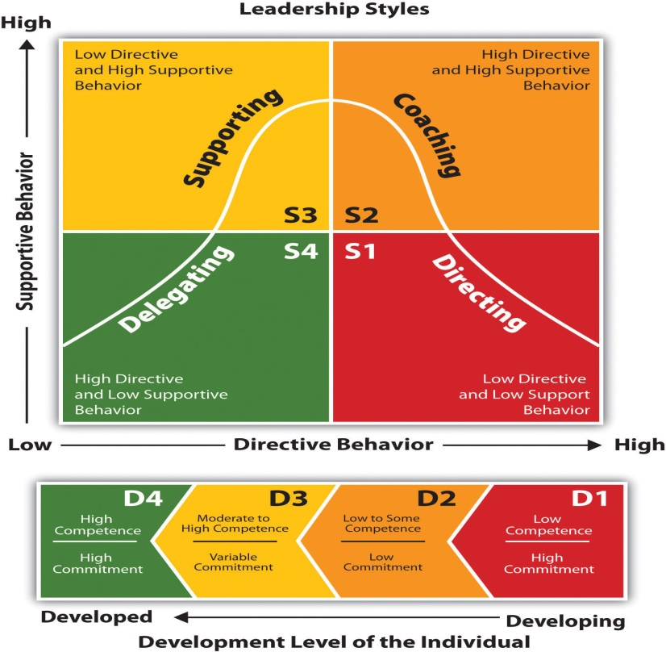
Figure 2: Strategy of Situational Leadership Style (Roe, 2020)
- Supporting (S3): Personnel with a moderate to substantial degree of preparedness but low levels of self-assurance or motivation might benefit from this approach. In a report by Benmira and Agboola (2021), leaders who adopt an empowering approach encourage and help their employees make decisions. They motivate and engage workers by allowing them greater independence to make decisions, including them in solving problems and recognizing them for their efforts.
- Delegating (S4): With specially trained workers and clearly defined roles and responsibilities, this technique succeeds. Delegating is a leadership style in which the leader gives subordinates the duty of completing tasks with little or no supervision. To a greater or lesser extent, they back workers up when they require it, but their main goal is to give workers freedom over their work and decision-making.

Describing the Shifting Approaches to Leading
To demonstrate the correctness of the statement, we must take into consideration an organizational instance: a business that develops software that is currently working on a project that is both time-sensitive and under severe pressure. Leaders may need to take an active role to make sure everyone knows their roles, responsibilities, and when they need to get things done (Chima and Gutman, 2020). The leader may take a Theory X strategy, that defines detailed procedures and keeps an open mind on development to ensure things stay under control. Due diligence and prompt completion are features of this type of undertaking (Roe, 2020). Another change in leadership style can be required when the task develops and team members gain expertise. As per Dulewicz and Higgs (2005), leaders can foster teamwork, innovation, and personal responsibility by adopting a more collaborative and supportive leadership style, as outlined in Theory Y. Leaders can enhance morale and productivity by giving their employees involvement in important decisions and showing recognition for their knowledge and experience.
In contrast, think of an additional situation in which the company is going through a time of great disruption, like a merger in its industry (Carlos Pastor and Mayo, 2008). The capacity to inspire perseverance and successfully overcome ambiguity are important qualities in such a leader. According to a study by McCauley and Palus (2021), a leadership style based on transformation, which is defined by vision, motivation, and adaptability, has the potential to be highly productive. Theory Z is an approach that encourages employees to accept change by developing relationships, offering support, and giving them the instruments they need to do so. An organization's leaders can encourage their teams to rise to the difficulties and grab every opportunity given by a dynamic environment by sharing their purpose and communicating it effectively (Sethuraman and Suresh, 2014).

Demonstrating Practical Application of Situational Leadership:
The relevance of situational leadership is further highlighted by real-world instances. One such example is Steve Jobs, who co-founded Apple Inc. Jobs' flexibility to change his style of leadership based on the situation is widely recognized. Jobs took on a more authoritarian role in the early days of Apple, while the firm was struggling financially and was up against intense rivalry. The company was able to make significant advancements as a result of his thorough consideration of detail and continuous desire for perfection (Leroy et al. 2018). Jobs shifted to a more powerful and visionary style as Apple recovered and began a new period of innovation and growth, emphasizing teamwork and creativity.
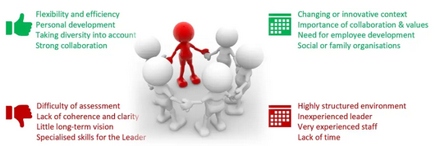
Figure 3: Situational Leadership (Gichuhi, 2021)
In addition, Jack Welch's position as CEO of General Electric is illustrative of situational leadership in action. Welch recognized that GE's divisions competed in separate markets and encountered different kinds of problems. A varied leadership approach was put in place by Welch to meet the needs of these variations. The head of every unit of the company was given the authority to make decisions according to their particular situations, and he supported decentralized decision-making (McCauley and Palus, 2021). This enabled GE to be more flexible and responsive, which in turn led to enhanced effectiveness and adaptability company-wide.
The chief executive officer of Microsoft, Satya Nadella, is a further illustration. When Nadella became CEO of Microsoft, the software giant had trouble trying to keep up with the rapidly changing technological industry. It was clear that change was necessary, so Nadella adopted the approach of transformational leadership (Gichuhi, 2021). An entrepreneurial attitude, employee empowerment, and an innovative culture were his primary targets. Microsoft's expansion and significance in the market were both renewed as a result of his leadership, which enabled the business to successfully transition its concentration from a Windows-centric technique to a strategy that was more comprehensive and online.
The above instances show how firms throughout industries have used situational leadership to find solutions to difficulties, engage employees, and succeed. These businesses accomplished great results and continued expansion by understanding the specific needs of each circumstance and adapting their leadership styles correspondingly.

Conclusion
The theories of X, Y, and Z offer exceptionally beneficial information into different types of leadership and the consequences that these styles have in the context of organizational settings. A hierarchical structure, with superiors making decisions and using their power on behalf of those they supervise, as suggested by Theory X. Employee motivation, job happiness, and imaginative contribution can all decrease under this management style, even though it works well in some situations that call for strict supervision and process adherence. Also, workers' sense of agency, innovation, and satisfaction in their work lives can all be enhanced by Leaders who Practice Theory Y. Employees are more invested and productive when they have a positive experience at work. In addition, the leadership principles of Theory Z center on making the workplace feel closer to a family, encouraging employees to feel like they belong, and giving them opportunities to grow professionally. Furthermore, an increase in organizational performance and stability can come from this strategy's ability to increase employee dedication and engagement. Although there are important consequences to each theory, it is crucial to understand that approaches to leadership ought not to be inflexibly limited to only one. The importance of customizing leadership approaches to each specific circumstance is highlighted by the situational perspective of leadership, which was previously covered. Moreover, adaptability and the ability to understand the specific requirements of one's team, assignment, and work environment are essential leadership qualities. True leaders know that there is no magic bullet that can ensure their company's success. They have an effective understanding of the significance of blending ideas from various philosophies into their leadership approaches. Therefore, leaders assess personnel preparation, job difficulty, organizational climate, and external forces.

References
Benmira, S. and Agboola, M., (2021). Evolution of leadership theory. BMJ leader, pp. leader-2020.
Blake, R. & Mouton, J. (1985). Managerial grid III: The Key to Leadership Excellence. Houston: Gulf Publishing Co.
Carlos Pastor, J. and Mayo, M., (2008). Transformational Leadership Among Spanish Upper Echelons: The Role of Managerial Values and Goal Orientation. Leadership & Organization Development Journal, 29(4), pp.340-358.
Chernyak-Hai, L. and Rabenu, E., (2018). The new era workplace relationships: is social exchange theory still relevant? Industrial and organizational psychology, 11(3), pp.456-481.
Chima, A. and Gutman, R. (2020). What it Takes to Lead Through an Era of Exponential Change. Harvard Business Review. Available at: www.hbr.org
Dulewicz, V. and Higgs, M. (2005), “Assessing Leadership Styles and Organisational Context”, Journal of Managerial Psychology, Vol. 20 No. 2, pp. 105-123,
Fisher, D.M., Good, S., Toich, M.J. and Schutt, E., (2021). Measuring moral disengagement with a situational judgment test: Advancing the assessment of an important workplace construct. International Journal of Selection and Assessment, 29(1), pp.114-133.
Gichuhi, J.M., (2021). Shared leadership and organizational resilience: a systematic literature review.
Islam, L.C.M.E. and Kalumuthu, K.R., (2020). Assumptions of theory Z: A tool for managing people at work. The Asian Journal of Professional & Business Studies, 1(1).
Leroy, H., Segers, J., Van Dierendonck, D. and Den Hartog, D., (2018). Managing people in organizations: Integrating the study of HRM and leadership. Human Resource Management Review, 28(3), pp.249-257.
McCauley, C.D. and Palus, C.J., (2021). Developing the theory and practice of leadership development: A relational view. The Leadership Quarterly, 32(5), p.101456.
Roe, K., (2020). Leadership: Practice and perspectives. Oxford University Press.
Senarathne, C.W., (2020). The optimal capital structure under the conditions of employment: An application of theory X and theory Y. Zagreb International Review of Economics & Business, 23(1), pp.51-69.
Sethuraman, K. and Suresh, J., (2014). Effective leadership styles. International Business Research, 7(9), p.165.
Solinger, O.N., Jansen, P.G. and Cornelissen, J.P., (2020). The emergence of moral leadership. Academy of Management Review, 45(3), pp.504-527.
Tannenbaum, R. and Schmidt, W.H., (1973). How to choose a leadership pattern. Harvard Business Review.
Xu, Y., & Farris, K. (2024). The Influence of Leadership Styles and Supervisor Communication on Employee Burnout. Journal of General Management, 03063070221122664.
Yang, Q.I. and Wei, H., (2018). The impact of ethical leadership on organizational citizenship behavior: The moderating role of workplace ostracism. Leadership & Organization Development Journal, 39(1), pp.100-113.

