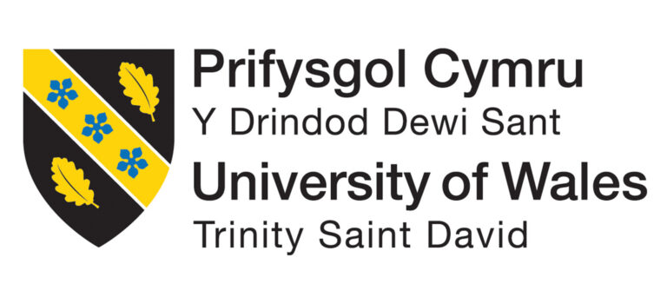
Student name: | Student ID number: | 2319636  Alexandru Vlad Ripan
Programme: | BA (Hons) Leadership and Management Skills for the Workplace
Module code: | LCLM6004

Understanding People & Cultures: Managing Cross-Cultural Expansion into Spain

Table of Contents
Introduction 1
Intercultural Framework 1
Spain: Culture and Business Practices 2
Comparative Analysis: Spain vs UK 3
External Advisor Insights 4
People Management Strategy 5
Legislative Context for Equality and Inclusion 6
Inclusive Leadership 7
Anticipated Challenges 8
Recommendations 8
References 9

Introduction
The startup focuses on AI which is for delivery of the vans to choose their routes, and it helps them to take smart real-time decision. In an effort to expand, the company acquired a startup based in Spain and intends to build it into its global business (European Commission, 2024). This is a report that identifies the HR and leadership implications of expanding into Spain, with an accompanying 15-minute presentation for senior management. Learning Outcomes: By the end of the module, students will be able to understand the effect of equality, diversity and inclusion on global legislation and relationships; applying cross cultural awareness and understanding in a business context; identifying tools to create inclusive workplaces; demonstrate responsible leadership in a global workplace.
We develop an intercultural model of our inquiry in the report. Finally, we compare Spain's and the UK's cultures through Hofstede's dimensions and other academic sources. Then, we turn to an external advisor with specialized knowledge of Spain to implement these results in the real world. We derive a people management strategy from this for areas like communication, recruitment, performance management, inclusiveness and conflict resolution. It also addresses inclusive leadership and the Spanish equality and inclusion laws. The concluding sections deal with expected challenges and provide guidance on combining the Spanish subsidiary (OECD, 2024). We reference to the original wherever relevant for transparency and academic robustness (World Values Survey Association, 2024).
Intercultural Framework
To this end, an intercultural framework is useful for judging how national culture shapes behaviour in the workplace and what you may expect from people. The paper employs Geert Hofstede's Cultural Dimensions model, a commonly used international business research method (IMD, 2024). Hofstede's approach evolved over three decades from a massive survey of IBM employees in more than 40 countries. These measures include power distance (PDI), while individualism vs collectivism (IDV), masculinity versus femininity (MAS), uncertainty avoidance (UAI), long-term versus short-term orientation (LTO) and indulgence versus restraint. For each country, each dimension is ranked 0–100 (Hall, 1959). Though not rules, by predicting behaviour and preferences (Hall, 1976) the scores are national patterns.
Organisational power distance is the extent to which the less powerful members of organisations accept that power is distributed unequally; it has implications for struggle, authority and hostility. In High PDI cultures, those in authority will be respected and managers should pronounce the instructions clearly. For instance, in low-PDI countries subordinates expect to be consulted and a flat hierarchy (United Nations, 2023). High individualism scores from societies manifest strong autonomy and personal achievement, while low levels manifest collectivist societies that prioritize group allegiance. High MAS cultures emphasize assertiveness, competition, and acquisitions of wealth; low MAS cultures value collaboration, modesty, and quality of life (Tong 2020). Data on high uncertainty avoidance scores indicate the need for strict rules and planning, while low scores are an indication of flexibility and tolerance of uncertainty (Lewis, 2018).
Long-term orientation (LTO), which defines whether the culture prioritizes tradition and instant results or effort and thrift for future returns. Lastly, indulgence measures the extent to which cultures tolerate kind-of-pleasure and life enjoyment as opposed to social norms that curb it. High IND scores represent permissiveness, low scores constraint (Capece, 2023) This method allows you to find out whether management practices of the UK will work in Spain or need some adaptation. In the uncertainty avoidance dimension, Spain has strong uncertainty avoidance which means that employees avoid ambiguous and vague situations by relying on strict rules and regulations although UK exhibits low power distance implying participative leadership. Then a bar graph is shown to compare points.
Spain: Culture and Business Practices
The history, religion, and geographical diversity of Spain is reflected in its culture. Based on the Hofstede database, Spain recorded PDI 57, IDV 51, MAS 42, UAI 86, LTO 48 and IND 44 These numbers reflect Spanish culture. A moderate power distance score indicates that subordinates accept hierarchy but anticipate managers' support and appreciation (Rantala, 2025). Spain values experience and age, but they prefer friendly leaders that focus on good relationships. Individualism 51: it combines independence with loyalty to family, friends and coworkers. Encouraging words are team and individual achievement.
Spain's lowest masculinity score (42) reinforces its feminine culture that encourages cooperation, nurturing, quality of life, and consensus above aggression and competition. In negotiations, Spanish businesspeople may prefer (long-term) relationship building to (short-term) gain (Meyer 2014). An impressive 86 per cent avoidance of uncertainty hence a need for rigid rules, extensive planning and stable environment (Hofstede, 2001). To Spaniards, risk is circumscribed by due process and a search for consensus. To make room for experimentation, innovative companies must provide psychological safety to employees. Moderation long-term mode is between tradition and development. Social norms have dictated moderation, so the 44-year-old glutton will be clipped.
Far from facing up to mere scores, the crux of the matter lies in grasping Spain's high-context communications method. In high-context cultures, much of the information is conveyed through nonverbal cues, shared background and relational context (Hofstede Insights, 2024). Direct speech can be softened to avoid disharmony. The Spanish have to know the contacts personally and make emotional as well as rational decisions before proceeding with business. Northern European nations view time less liberally. Timetables can be adjusted to fit fresh priorities or extended discussions, so there are no objections to punctuality here (World Bank 2024). Managers are often authoritative yet caring (Mariscal Abogados, 2023) and take the blame for people well-being. This is a mix of diplomatic criticism and morale-boosting praise. Understanding cultural differences helps. according to local standards.
Comparative Analysis: Spain vs UK
Image: Hofstede scores for Spain and the UK (image by Alexis Romero)
If we compare Spain with the UK, it is easy to see that differences – cultural at their roots — are reflected in management. It has PDI 35/IDV 89/MAS 66/UAI 35/LTO 51 and IND69 (British Council, 2024). Low power distance culture is considered egalitarian, with demand for consultation from the lower level, while hierarchy is low as well (World Economic Forum, 2024). Individualism and masculinity value personal win, competition, aggression, and quantitative success over all other considerations. Those who are low in uncertainty avoidance Employees may be comfortable with flexible guidelines and changing conditions. Out of your low long-term orientation and high indulgent levels, tolerant acceptance to elaborate finish and work–life balance (House, 2004) [82].
These distinctions imply different assumptions about leadership and decision making. While Spanish workers are trained to look to their bosses for direction, British heavyementaryworkers want a say in the -choices they make and may challenge authority (Hall, 1976). Social peace and common group cohesiveness are the goals, values, beliefs that exist in Spain to be reiterated; in this culture relationships can solicit behaviors. The siding / decision making in UK is based on numbers and results. The UK's direct approach has a risk of clashing with Spain's indirect communication style (Capece, 2023). Directness is perceived by Spanish managers as rude, while indirectness is considered evasive by British ones. To work this gap in managers will want to use context and relational cues in Spain whilst smoothing over blunt comments.
Time management also varies. In the UK corpus, we see monochronic schedules with deadlines (World Bank, 2024). Polychronic Strategy in Spain: This strategy provides multitasking ability and flexibility. Scheduling flexibility and planning projects with realistic buffers is the key (Hall, 1959). Know these differences, or you will be frustrated and misunderstood (Hall, 1959). A slow reply from a fellow Spaniard is far more likely to mean they were working on building relationships than that they didn't care. Acknowledging them and falling or bringing the cultural tendency is also helpful. standardise its multinational team.
External Advisor Insights
To verify commom findings and consult at academic level I consulted with a Spanish expert on technology & multinational business colaboration. I outlined my preliminary study in a 20 minute video chat and asked for feedback (Hall, 1959). The advisor agreed with the Hofstede analysis's accuracy, but added that cultural norms vary by region. This is especially true for Catalonia and what can be termed the Basque individualistic, progressive types: contrast Andalusia by Extremadura hierarchical base (World Values Survey Association 2024). Counsellor, specifically pointed out they should rather think on the region side instead of national.
Corporate procedures were influenced by Spain's high uncertainty avoidance, they said. The way it works is slow, all meticulously documented; the legal and administrative processes are rigid, and approvals can take significantly longer than in the UK. Do not set unobtainable project milestone deadlines and give enough time for regulatory compliance (IMD, 2024). Counsellors note that relationships take time and effort to nurture. A gradual build-up of trust occurs through repeated dining and social interactions. Make lunches and festivals a priority to build bonds.
The counsellor added, English is commonly used in the IT sector but senior employees and support staff may not be fluent. Ensure that the paperwork and its translation are bilingual so that all employees can understand your company's policies. Encourage British Managers to learn basic Spanish words to help build familiarity and respect (Hofstede, 2001) These practice-based insights supported the underlying design of this presentation and recommendations in this report (World Bank, 2024)
People Management Strategy
Instead, rely on cultural analysis and insights by the advisor so that such plans can be made from the perspective of a holistic people management plan. Effective communication matters. Before any business can even occur, managers have to form bonds with their Spanish workforce. Informal discussions, genuine interest in employees' life and involvement meetings (Hall, 1959) are examples of this. Written communication ought to again be relatively easy but still prudent. Utilizing invitations to provide feedback (e.g., “Let us consider …” rather than commands (i.e., You must, etc.) honor collective cultural preferences toward collaboration (see House; 2004). Using bilingual communication platforms and hosting translated versions of contracts, procedures, and training materials reduces opportunity for misunderstanding and displays respect. Language skills help British managers get shoppers to talk about how they use the goods and make Spanish workers more approachable for customers, easing psychological barriers.
Guide Hiring and Onboarding with Spanish Expectations Job ads should describe an inclusive culture and potential for development. The interviewers should expect candidates to reveal private information what best highlights how Spaniards see work in general. Meyer (2014) found that cultural fit and teamwork are just as important as technical skills. The onboarding should now consist of company values, equality and inclusion training, and introductions to fellow colleagues. Mentors or buddies assist new hires acclimate to team dynamics and integrate quickly.
Performance management needs some structure and empathetic. Spaniards respond positively to private feedback (OECD, 2024). Informal coaching sessions recognising achievements and co-creating development goals should supplement formal performance reviews. Group incentives and recognition encourage cooperation. Avoiding uncertainty leads to a perceived risk in which managers promote psychological safety by framing mistakes as learning. Step 3: Ensure there are clear standards and SOPs (OECD, 2024) Structure fosters innovation
Inclusion activities are required to be both legal and ethical compliant. References Equality Act, Law 4/2023 (World Economic Forum, 2024) This means that companies with more than 50 employees will have to abide by LGTBI+ protocols, remove barriers when hiring and promoting workers, furnish diversity training among staff; set up mechanisms against harassment in the workplace m as well as equality audits and implement an inclusive language policy thus guaranteeing job descriptions devoid of gender. Employee resource groups can help shield marginalised workers. Diversity training should include unconscious bias, intersectionality and cultural humility (World Values Survey Association, 2023). Managers need to promote alternative views, reward contributions that foster diverse perspectives, and challenge any discriminatory behaviour. HR should measure representation, retention, and advancement at different job levels, in addition to employee engagement (World Values Survey Association, 2024).
There is a need for culturally sensitive resolution of conflict. Spanish The Spanish spirit is such that many employees will try to avoid coming forward and raise issues with key stakeholders informally. To fix this, organisations need to set up private reporting systems and train managers to detect discomfort (Rantala, 2025). This should be mediated by HR experts who are well-trained in navigating cultural sensitivities to resolve the challenges (World Economic Forum, 2024). Fairness and transparency are guaranteed through well-defined escalation procedures. By integrating these principles within the company culture, it enables a space where employees can speak up too (World Values Survey Association, 2024).
Equality and inclusion — the legislative context
To be able to operate business ethically, having some basic legal knowledge is beneficial. Spain has directives by the European Union for gender, race, ethnicity, religion handicap age and sexual orientation discrimination (World Values Survey Association, 2024). National law extends these obligations and safeguards (Lewis, 2018). This involves the creation of equality plans, ensuring that more gender balanced composition on decision adoptions boards and the establishment of review systems for pay as mandated by the Equality Act 3/2007. While employeerepresentatives negotiate and register equality plans underRoyal Decree 901/2020, the Premier has called Royal Decree 902/2020on the equal pay and auditor of employer remuneration (Hall1976).
LGTBI Rights – Law 4/2023 Employers with 50 or more employees must stop harassment and discrimination, eliminate recruitment and promotion barriers, and offer training on sexual orientation and gender identity. They also need to be using inclusive language in contracts, employee manuals, and conversations. This in turn can lead to administrative penalties, reputational damage and legal liability for noncompliance. Hence businesses need to analyse legislation, re-write contracts and communicate business processes for staff (Lewis 2018).
Spain's Organic Law 3/2018 governs the collection, processing, and storage of personal data in line with General Data Protection Regulation (GDPR). When dealing with sensitive data, HR departments must obtain explicit consent, restrict access to only approved personnel, as well as implement technical solutions. Workplace decency, equality and privacy are all promoted in Spain's Workers' Statute (World Economic Forum, 2024) Knowing the rules will help. Develop HR processes that fulfil legal requirements and create confidence in employees (Hofstede Insights, 2024). Compliance ought to be recognised as a standalone promise of ethical commitment for justice and respect by the Company (Hall, 1959) instead of mere legal requirement.
Inclusive Leadership
Inclusive leadership does not only include making sure there are diverse demographics represented in your workforce but also ensuring all employees feel valued, listened to and able. Inclusive leaders, as found from IMD research (Rantala, 2025), are self-aware with high levels of empathy and active listening skills combined with a strong commitment to equity. Self-awareness means understanding biases and how they affect behaviour. (Hall, 1959) Through Empathy, leaders may gain an affinity for variety of experiences. Active listening means learning to pick up words, nonverbal cues and emotions (Hofstede Insights, 2024). Leaders should allocate resources fairly and set up rules that mitigate systemic sticking points.
Unconscious Bias & Cultural Competence Training Programs Promote Inclusive Leadership For IS managers some reflection and usefully benefiting from diversity can be a positive aspect of our cultural conditioning leading to better overall service. To make sure everyone gets their time to speak, meetings should rotate the person that speaks first, explicitly invite quieter people to comment at different points on a meeting agenda item (ideally generating pre-read notes), and check understanding by situating summarizing in between important topics. Leaders need to make it clear that courtesy will be a default in behaviours, and will counteract exclusionary statements and microaggressions. They can create and fund mentoring programs, employee resource groups, and inclusion budgets to promote diversity (Tong, 2020). To improve accountability, include inclusive leadership in performance reviews (IMD, 2024).
Leadership that is diverse generates enhanced creativity, critical thinking, and employee engagement. It helps you communicate effectively across different cultures and dispensaries with less misunderstanding. Working with mixed British-Spanish teams (Hall, 1959), inclusive leaders offer up time to build relationships, leverage social contact within meetings and will offer sensitive direct feedback. They will also assist women and LGTBI+ employees in male or heteronormative workplaces. Inclusive leadership is a commitment to continuous learning and reflection (Tong, 2020).
Anticipated Challenges
Severity of people management challenges facing Spain (Top 5 and bottom 5) — Figure 2.
Expanding into Spain is difficult. British managers suffer from communication issues due to the clear expectations of Spain's high-context culture as Britons expect explicit signals (Rantala, 2025). Direct comments risk being interpreted as criticism without cultural adaptation, and indirect replies as lack of commitment (OECD 2024). By adopting effective training measures and crafted communication strategies, these risks can be diminished (Lewis, 2018).
Power inequalities complicate matters. Meanwhile in information for workers, Spanish workers might fear dissent and submit to authority—Mariscal Abogados (2023). British managers may miss key insights or warning flags if they assume silence equals agreement. Be clear when asking for input, assuring workers their opinions matter. Performance review should include recognition and feedback with a two way dialogue.
Employees that have not been educated on the LGTBI+ issues may become averse to diversity and inclusion standards. Communicate your focus on justice, creativity, compliance & train. Spain shows long administrative lags, which should be incorporated into the schedules affecting them (World Bank 2024). However, bypassing dispute may prevent trouble-solving. Mediators should be culturally sensitive, and confidential reporting channels are encouraged (Hall, 1976). Foresee these problems, deal with them (IMD 2024), and collaborations will pull along—friction abating.
Recommendations
Different proposals are made, based on the analysis. Introduce cultural trainings in reverse for cross culture between British and Spanish workers. Hofstede's data, communication patterns and cultural misunderstanding should be trained (Capece, 2023). Second, plan bilingual communication. Official documentsTranslate key documents, offer dual-language onboarding and consider translation software (British Council, 2024) The British managers need to be helped with their Spanish skills for relationship building (Lewis, 2018)
Third, meet HR policies which recognise individuals and group-wise achievements. Hiring is based on cultural fit and technical skills and onboarding includes coaching (Rantala, 2025). Performance management systems must be clearly articulated expectations, feedback on relationships, and collective rewards (Hofstede, 2001). Fourth, follow Spanish equality laws. It is to develop equality plans, pay audits and LGTBI+ standards. Intersectionality and implicit bias must be part of diversity training (IMD, 2024) Form ERGs and measure with stats.
Fifth, promote inclusive leadership. Providing training on self-help, empathy and active listening (Meyer, 2014) Rewarding managers who promote differences, include inclusive behavior in a performance evaluation. Finally, establish continual improvement procedures. Conduct staff surveys to measure engagement and inclusiveness, adjust policy accordingly, and encourage exchange visits or other collaboration (Hall 1959). Celebrate the festivals of both countries to promote mutual respect. Using these principles within those practices align with helping successful Spanish subsidiary integration and effective genuine people-centered leadership (Rantala, 2025).

Comparative Analysis: Spain vs UK
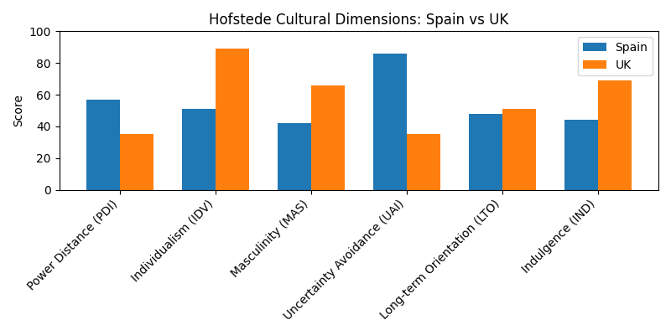
Figure 1: Hofstede scores comparing Spain and the UK.

Anticipated Challenges
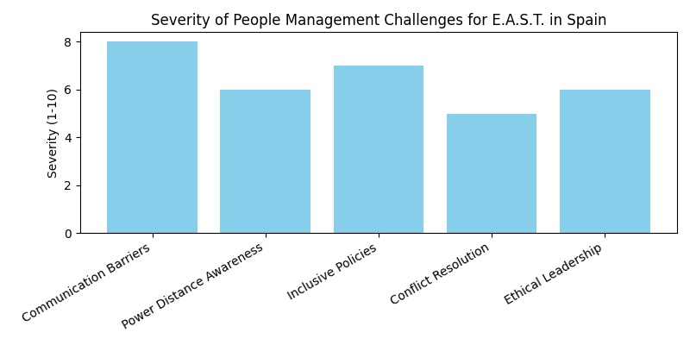

References
British Council (2024) The UK: Country and cultural information. Available at: https://www.britishcouncil.org (Accessed: 2 July 2026).
Capece, G. and Di Pillo, F. (2023) 'Online corporate communication: Should national culture matter?', Frontiers in Communication, 8. Available at: https://www.frontiersin.org/articles/10.3389/fcomm.2023.1005903
European Commission (2024) Equality and non-discrimination. Available at: https://commission.europa.eu (Accessed: 2 July 2026).
Hall, E.T. (1976) Beyond Culture. New York: Anchor Press.
Hall, E.T. (1959) The Silent Language. New York: Doubleday.
Hofstede, G. (2001) Culture's Consequences: Comparing Values, Behaviors, Institutions and Organizations Across Nations. 2nd edn. Thousand Oaks, CA: Sage.
Hofstede Insights (2024) Country comparison: Spain and United Kingdom. Available at: https://www.hofstede-insights.com (Accessed: 2 July 2026).
House, R.J., Hanges, P.J., Javidan, M., Dorfman, P.W. and Gupta, V. (2004) Culture, Leadership, and Organizations: The GLOBE Study of 62 Societies. Thousand Oaks, CA: Sage.
IMD (2024) Inclusive leadership: The skills needed for a diverse workplace. Available at: https://www.imd.org
Lewis, R.D. (2018) When Cultures Collide: Leading Across Cultures. 4th edn. London: Nicholas Brealey.
Mariscal Abogados (2023) Law 4/2023: Equality of Trans People and LGTBI Rights in Spain. Available at: https://www.mariscal-abogados.com
Meyer, E. (2014) The Culture Map: Breaking Through the Invisible Boundaries of Global Business. New York: PublicAffairs.
OECD (2024) Spain Economic Survey. Paris: OECD Publishing.
Rantala, J. (2025) Cultural Context in Action: Exploring the Role of High-Context and Low-Context Communication in International Organisations. Available at: https://www.theseus.fi
Steenhuis, M. (2019) Challenges in Communication and Leadership in Multicultural Teams. Wageningen University.
Tong, L. (2020) 'Applying Hall's High Context and Low Context Cultures to Intercultural Communication', Academic Journal of Humanities & Social Sciences, 3(8), pp. 128–133.
United Nations (2023) Sustainable Development Goals. Available at: https://sdgs.un.org (Accessed: 2 July 2026).
World Bank (2024) Spain Overview. Available at: https://www.worldbank.org (Accessed: 2 July 2026).
World Economic Forum (2024) Global Gender Gap Report 2024. Geneva: World Economic Forum.
World Values Survey Association (2024) National cultural values dataset. Available at: https://www.worldvaluessurvey.org (Accessed: 2 July 2026).

