Name | Student Number | Date | Lecturer’s Name | Your score
Asam Rashid | 2441027 | 30/06/2025 | Ellie Ristic | To be filled by the marker  ___/40
You will have 90 minutes to complete this assessment. It is divided into three sections: note-taking, paraphrasing and writing a paragraph.
---------------------------------------------------------------------------------------------------------------------
1. Take diagrammatic notes from the passage below using the space provided:

The university experience is not just about subject knowledge, but also about developing skills that will equip you for your future life. For starters, it's impossible to graduate without a range of people skills under your belt. You'll meet new people from different backgrounds. You'll also interact with lecturers, tutors and university staff almost daily. Another life lesson that university teaches you is taking responsibility for yourself, your own schedule and learning. A lot of university study is self-directed - it's up to you to plan and organise your work, juggle multiple projects and manage deadlines – you will need to develop self-motivation if you want to succeed. Let’s not forget learning how to overcome obstacles; whether academic, work-related or personal, you'll face your fair share of hurdles as a student, but you will develop resourcefulness and resilience in the process. If you were a bit unorganised before you went to university, you won't be by the time you leave. To successfully navigate student life you'll need to handle a variety of study, work, social and personal commitments and the only way to do this is with organisation and time management. Finally, university provides plenty of opportunities to work on and boost your confidence: you'll work in groups, deliver presentations, complete assessments and maybe even become a class representative.
Adapted from: https://www.prospects.ac.uk/applying-for-university/university-life/7-life-skills-youll-learn-at-university

Space for your notes (max 12 marks):
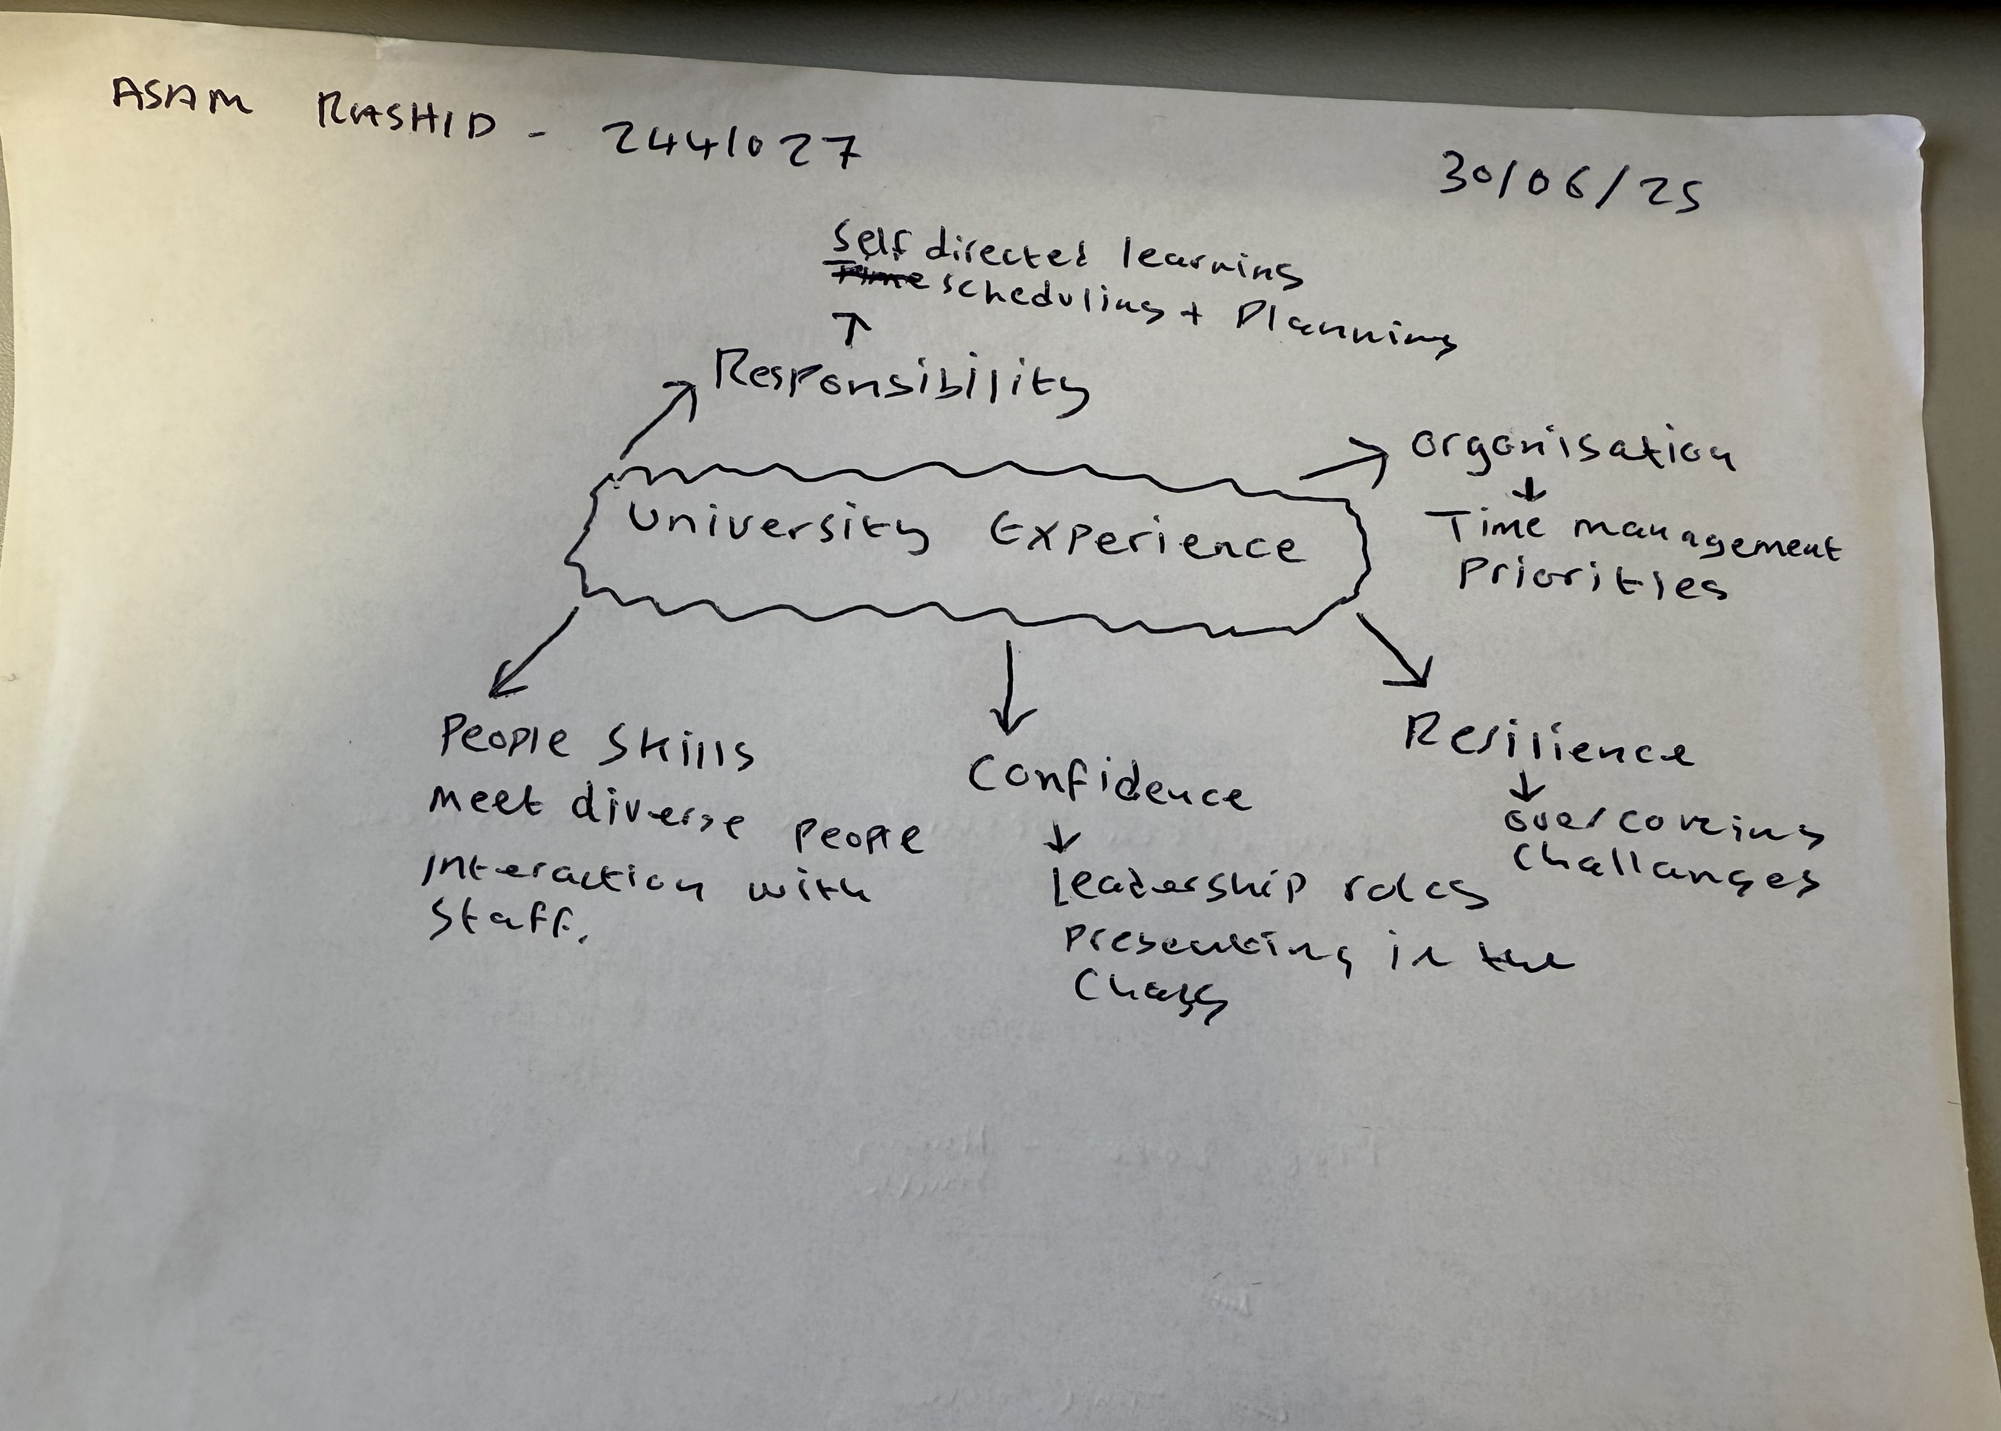

2. Paraphrase the following sentences (max 3 marks for each, max 12 marks in total):

- To successfully navigate student life you will need to handle a variety commitments.

Effectively navigating student life requires the ability to manage a diverse of obligations.

- You will need to develop self-motivation if you want to succeed at university.
Developing self motivation is essential for achieving success in a university environment.

- Many students find it challenging to manage stress during assessment periods.
Lots of students experience significant difficulty managing stress during examination and assessment periods

- Frequent reading can help you become a more effective communicator.

Involving in regular reading can enhance your ability to communicate with greater accuracy.

3. Write a well-structured paragraph (8 sentences) on the following topic:

Effective time management techniques for university students

Your paragraph must be written in full sentences (no bullet points) and in an academic style.

(max 16 marks in total)

Understanding time management is essential for university students juggling academic, personal and social duties.

University environment can be challenging for many students, to over come this, students must balance their personal and student lives effectively.

To effectively archive this, the student must learn time management, prioritise coursework and complete task on time.

Student mental health and wellbeing is important. Many students returned to the university environment after many years being away from the academic environment.

Many students are not tech savvy as such advances in technology are learning the basic to bring them self-back up to date with the new learning environment.

Downtime is important so student can focus on their personal hobbies such as going out and doing the things they enjoy in their own time.

Creating a to-do list can help prioritise work and personal life more effectively and help prevent burnout.

Overall, the moral of the story is life carry on, schedule for unexpected delays or changes and don’t beat yourself up if things don’t go perfectly.

