
University of Wales Trinity Saint David
Course: MBA

Module: Entrepreneurship

Module Code: SBMA7111D

Tutor: Dr. Alex Bell

Student: Maurice Cahill

ID: 1504125

Assessment 2 (a)

Contents
- Introduction
- Investments in enterprise opportunities
- Social change through philanthropy
- Conclusion
- References

1.0 Introduction
Dr Jonathon Milner is Deputy Chairman of Abcam, a life science company he founded in 1998. In the intervening years, he has grown Abcam into a £2b global business with over 1000 highly skilled employees (Abcam 2016). Abcam’s Initial Public Offering (IPO) in 2005 enabled Milner to invest in other enterprise opportunities and pursue philanthropic activities. In Milner’s own words his first IPO “Allowed me to unlock a small amount of money from Abcam, and this allowed me to follow two of my passions: investments in early stage life science companies and philanthropy”. (Hemme 2017).
It could be argued that his financial support and personal involvement in the companies he has invested in, has led to economic change while his philanthropic activities have enabled social change.
2.0 Investments in enterprise opportunities
Milner has been described as ‘a pioneer of the next generation of biotech entrepreneurs’ (Hemme 2017) and is ‘one of the UK’s most low-key but prolific Angel Investors’ Forbes (2014). The FT (2016) point out that ‘Angel investors provide more favourable terms compared to other lenders, since they usually invest in the entrepreneur starting the business rather than the viability of the business. Angel investors are focused on helping start-ups take their first steps, rather than the possible profit they may get from the business. Essentially, angel investors are the opposite of venture capitalist’, The FT also highlight that ‘Angel investors commonly band together in investor networks. Often these networks are based on regional, industry, or academic affiliation’. This observation can be applied to Milner: Forbes (2014) describe him as ‘a fervent member of the respected and exclusive ‘Cambridge Angels’ this is ‘a group of high-net worth investors who invest in and mentor high quality start-up’s in the Cambridge area and throughout the UK’ (Cambridge Angels 2016).
Whilst Abcam’s 2005 IPO provided Milner with the capital to become an angel investor his experience from a specific period in Abcam’s development prompted him to initially commence and then continue investing in enterprise opportunities, he has stated
“something happened to me which was quite unexpected, I really started to enjoy that problem-solving of, how do you get business’s to scale, I found it enormous fun’, that’s what I want to capture again and again in the angel investments I do”. (Brackley 2017)
Since 2005, he has invested over £11m in 31 different companies is actively involved in 10, and assisted three to IPO. He is currently Chairman of Cambridge Allergy Therapy, Axol Bioscience and PhoreMost. He is also a non-executive director of Frontier Developments, Horizon Discovery, GeoSpock Ltd and Syndicate Room. In addition he sits on the advisory boards of Desktop Genetics, Repositive, HealX and Definigen. These investments including Abcam, have contributed to economic development not just in the Cambridge area but beyond, by providing high technology employment opportunities which have attracted scientists from the UK and around the world.
2.1 Investment Approach
Milner has provided some insight into how he identifies enterprise opportunities, by commenting that ‘the team it is without a doubt the most important thing when deciding whether to invest’ and ‘a top performing team will figure out a way of making things work’. (Forbes 2014) .For example, Milner helped Horizon Discovery a biotech company to raise £67m via a successful IPO. He has pointed out that its co-founder, Chris Torrance, was key to his decision to invest in the company, because he was ‘very knowledgeable yet humble’. In contrast, Milner recognises that ‘life is too short to invest in people you don’t enjoy working with’, and that the times he lost money was when he “invested against [his] instincts about the team.” (Forbes 2014)
2.2 Impact of entrepreneurship on economic development.
The role entrepreneurs play in contributing to economic development is widely recognised. Schumpeter’s Theory of Economic Development (1934) emphasized the role of the entrepreneur as the prime cause of economic development. Carree and Thurik (2010) have argued entrepreneurship leads to ‘increased economic performance by firms and regions which will positively affect aggregated economic growth at the country level’, this supports Porter’s (1990) earlier contention that ‘entrepreneurship is at the heart of national competitive advantage’. This is also echoed by Naude (2013) when he highlights ‘it is widely believed that entrepreneurship is beneficial to the economic growth and development of a country’. Finally Toma et al (2014) conclude that ‘today entrepreneurship is widely recognized both by academics and practitioners as a fundamental factor of economic development throughout the world’. The Organisation for Economic Cooperation and Development (OECD 2011)) highlights that ‘Angel investors are playing an increasingly important role in the economy in countries around the world’, and importantly that ‘estimates indicate that companies backed by angel investments have been important contributors to economic and job growth.’ These findings are consistent with the outcomes of Milner’s entrepreneurial activity in setting up Abcam, and later investing in early stage life science companies as an angel investor. His activities are also congruent with Acs’s (1992) contention that high tech start-up firms are the source of considerable innovative activity, stimulating sector evolution, and creating an important share of new skilled jobs. The OECD (2011) has made a further critical observation: ‘angel investing can only flourish in a healthy entrepreneurial ecosystem in which a range of stakeholders play a role, including entrepreneurs, investors, large companies, universities, governments, and services providers’.

2.3 Entrepreneurial Ecosystem
Stam and Spigel (2016) define an entrepreneurial ecosystem as a ‘set of interdependent actors and factors coordinated in such a way that they enable productive entrepreneurship within a particular territory’. Roundy et al (2017) identify similar elements, namely: ‘communities of agents, social structures, institutions and cultural values that produce entrepreneurial activity’. Whilst Gutterman (2016) highlights the connection with an earlier construct by identifying that ‘it has become increasingly popular to refer to innovation clusters as ‘entrepreneurial ecosystems’. Isenberg (2011) echoes earlier research by identifying six domains within an entrepreneurial ecosystem as shown in Figure 1. It could be argued that Milner has influenced at least three of these, which have been circled in red to highlight.
Fig. 1. Isenberg’s (2011) Domains of an entrepreneurship ecosystem.
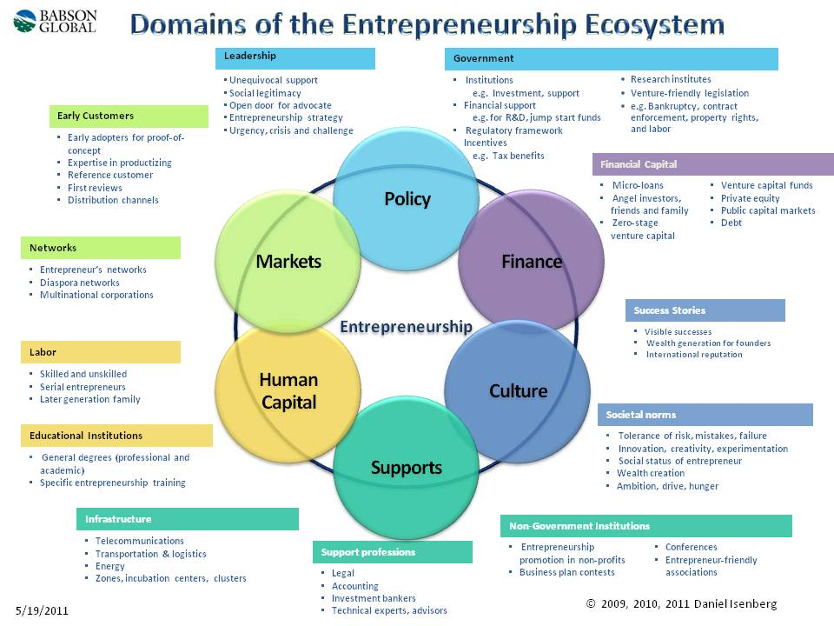
In addition to investing in early stage life science companies which form an essential part of the entrepreneurial ecosystem around the University of Cambridge, Milner is also embarking on building a new state of the art laboratory and office facility for Abcam on the Cambridge Biomedical Campus. In an echo of his earlier statement regarding investing in teams, he has stated that ‘collaboration is at the heart of what will be the largest life sciences research hub in Europe’. (Cambridge Independent 2017). In light of the above descriptions, definitions and activities, the Biomedical Campus can be described as an ‘entrepreneurial ecosystem’. The success of this system is evidenced by the comments of the former Prime Minister David Cameron, when, on visiting the Campus, said ‘the city lies at the heart of Britain’s economic recovery’ (Pagano 2014). Cambridge University Vice-Chancellor, Professor Sir Leszek Borysiewicz considers this is down to ‘the way local angels invested in local companies time and time again. Once the angels and entrepreneurs made some money, most of them reinvested back into other start-ups and so the eco-system flourishes’ (Pagano 2014). All of this evidence points to the positive economic impact Milner’s symbiotic activities have had within the entrepreneurial ecosystem based in the Cambridge area and in particular the success of early stage life science companies he has backed.
3.0 Social change through Philanthropy.
Although McAnany (2012) argues that ‘social entrepreneurship has not yet been adequately defined’, Gawlik (2015) provides a workable definition by describing social entrepreneurship as ‘an attempt at solving societal issues through entrepreneurial means’. By employing this description it could be argued that Milner has attempted to solve some local societal issues by ensuring Abcam regularly donates to a range of national and international causes through its Charity Committee. It recently announced its support for local good causes by donating an additional £45,000 to three local charities .The three charities: Red Balloon, a charity to support the recovery of bullied children; Winter Comfort, a social initiative to help the homeless; and Cambridge Community Foundation, a local charity working to connect a range of donors to local good causes. All of the charities have confirmed the benefits Abcam’s donations have made to the lives of the people they support. For example Winter Comfort has confirmed that the donation ‘will give those that that are homeless or vulnerably housed the skills to help them get back into employment and this money will help support current and future projects’. Newell (2014). Whilst it could be argued that Milner may not be acting directly as a ‘social entrepreneur’ his donations are supporting those that are.
Glover (2012) provides a further perspective on social entrepreneurship by highlighting that ‘social entrepreneurs seek to help organizations address and create opportunities to achieve their social purpose’. Through his support for educational programmes Milner’s philanthropic activities can be seen to address Glover’s observations. For example, evolution is something Milner is ‘really passionate about’, he believes that ‘evolutionary research can help us develop better health policies, advance medical treatments, and even improve public health messaging’ (University of Bath 2015). Acting on these beliefs, he has donated £5m to Bath University to establish the Milner Centre for Evolutionary Studies; its goal is to ‘to apply understanding of evolution to address real-world problems and promote the dissemination of evolutionary science and to engage the public so that everyone can learn and benefit from this knowledge’. (University of Bath 2016). To complement this, Milner founded the Evolution Education Trust in 2011 and helped set up and fund GEVOteach, an initiative whose goal is to improve the teaching of genetics and evolution in primary and secondary schools.
Milner has also ensured that Abcam is an active member of ‘Cambridge Enterprise’, which was established by the University of Cambridge to support staff and students commercialise their expertise and ideas for the benefit of the global community in both social and humanitarian contexts. (Jamison 2016)
He has also established The Milner Therapeutics Institute at the University of Cambridge. In recognition of its work which enables partnerships between academia, biotech, pharma, and service providers, to convert innovative science into treatments which can change the lives of patients around the world, it has been awarded the 2017 Medical Advancement Institute of the Year Award. (Milner Therapeutics Institute 2017) .
4.0 Conclusion
Milner’s identification of, and investment in, enterprise opportunities outside of Abcam, and the effect this has had on the Cambridge region in terms of employment and innovation is consistent with the findings of academic research on the impact entrepreneurship has on economic development. Furthermore the businesses’ he has invested in have enabled a sustainable symbiotic relationship within the Cambridge entrepreneurial ecosystem. This is also consistent with research on economic development derived from angel investing and entrepreneurial ecosystems.
Milner’s philanthropic generosity has clearly made a difference socially to the numerous charities that have benefited from his donations. However, not content with simply giving to charity, and conscious of Dr Martin Luther King’s concern that "Philanthropy is commendable, but it must not cause the philanthropist to overlook the economic injustice that makes philanthropy necessary." (Resource generation 2013) It could be argued that the outcomes from the Institutes and Programmes he has set up align with many of the descriptions and definitions associated with social entrepreneurship.
5.0 References
Abcam (2017) [on line] Available at http://www.abcam.com/content/about-us (Accessed 5 December 2017)
Acs, Z. J. 1992. Small business economics; a global perspective. Challenge, 35, November/December: 38–44. Available at UOWTSD on Line Library. (Accessed 2 December 2017)
Brackley. P (2017) Biotech star Jonathan Milner on Abcam’s new HQ and the breakthroughs he’s excited about. Cambridge Independent [online]. Available at http://www.cambridgeindependent.co.uk/business/business-news/biotech-star-jonathan-milner-on-abcam-s-new-hq-and-the-breakthroughs-he-s-excited-about-1-5057168 (Accessed on 9 December 2017)
Carree, M. A, and Thurik, R. A. The Impact of Entrepreneurship on Economic Growth. Handbook of Entrepreneurship Research, Available at https://personal.eur.nl/thurik/Research/Articles/The%20impact%20of%20entrepreneurship%20on%20economic%20growth%20-%20thurik%20chapter.pdf. (Accessed 8 December 2017)
Cambridge Angels 2017 .Available at http://www.cambridgeangels.net/ (Accessed 12 December 2016)
de Vasconcelos, G. (2014) How Do Business Angels Think About 'Team?' Unique Insights from Super Angel: Jonathan Milner. Forbes. Available at https://www.forbes.com/sites/goncalodevasconcelos/2014/07/07/exclusive-interview-with-super-angel-jonathan-milner-unique-insights-to-how-business-angels-think-about-team/#3116166547b1 (Accessed 20 December 2017)
Financial Times (2017) Available at http://lexicon.ft.com/Term?term=angel-investment (Accessed 16 December 2017)
Gawlik, R. (2015). Editorial: Social Entrepreneurship and Socio–Economic Development. Cracow University of Economics (Cracow, Poland). Available at https://mpra.ub.uni-muenchen.de/67328/8/MPRA_paper_67328.pdf (Accessed 15 December 2017)
Glover, Y. D. (2012) Organization Development and Social Entrepreneurship: Do Well By Doing Good Benedictine University. American Journal of Management vol. 12(2/3) 2012 117
Gutterman Dr A. S. (2016) Growth Orientated Entrepreneurship. Global Survey and Assessment. International Centre for Growth-Orientated Entrepreneurship. Available here http://alangutterman.typepad.com/files/gs_p5_16.pdf (Accessed 10 December 2017)
Hemme, P. (2017) Meet one of the Most Successful Biotech Entrepreneurs in the UK . Labiotech.eu [online] Available at https://labiotech.eu/jonathan-milner-abcam-interview/ (Accessed 11 December 2017)

Isenberg, D. (2011). The entrepreneurship ecosystem strategy as a new paradigm for economic policy: principles for cultivating entrepreneurship: The Babson entrepreneurship ecosystem project. Babson College, Massachusetts. Available at http://www.innovationamerica.us/images/stories/2011/The-entrepreneurship-ecosystem-strategy-for-economic-growth-policy-20110620183915.pdf (Accessed 8 December2017)
Jamieson, S (2016) Abcam taps into world-leading research expertise at our Industry Forum. Available at https://www.enterprise.cam.ac.uk/abcam-taps-into-world-leading-research-expertise-at-our-industry-forum/ (Accessed 12 December 2017)
McAnany (2012) Social Entrepreneurship and Communication for Development and Social Change Rethinking Innovation Nordicom Review 33 (2012) Special Issue, pp. 205-218
Milner Therapeutics Institute (2017) Available here https://www.milner.cam.ac.uk/medical-advancement-institute-year-2017/?lipi=urn%3Ali%3Apage%3Ad_flagship3_company%3BobQwYwqQR7G4%2Fi%2BdeZ5Evw%3D%3D [Accessed 10 December 2017)
Naude, W. (2013) Entrepreneurship and Economic Development: Theory, Evidence and Policy. University of Maastricht, IZA Discussion Paper No. 7507 July 2013. Available at http://ftp.iza.org/dp7507.pdf (Accessed 5 December 2017)
Newell, R (2014) Abcam donates an additional £45,000 to local charities .Cambridge Network 2014. [Online] Available at https://www.cambridgenetwork.co.uk/news/abcam-donates-additional-45000gbp-to-local-charities/ (Accessed on 17 December 2017)
Pagano, M. (2014) ‘Why Cambridge is at the heart of Britain's economic recovery’, The Independent’. 17 February 2014 [on line]. Available at http://www.independent.co.uk/news/business/analysis-and-features/why-cambridge-is-at-the-heart-of-britains-economic-recovery-9134717.html (Accessed 5 December 2017).
Porter, M. E (1990) The Competitive Advantage of Nations. Harvard Business Review. Available at https://hbr.org/1990/03/the-competitive-advantage-of-nations (Accessed 12 December 2017)
Resource Generation (2013) Social Change Philanthropy. Available at https://theedgefund.files.wordpress.com/2012/02/social_change_phil_info_sheet_2010-1.pdf (Accessed 19 December 2017)
Roundy, P. T. Brockman, B.K. and Bradshaw, M. (2017) ‘The resilience of entrepreneurial ecosystems’. Journal of Business Venturing Insights. Volume 8, November 2017, Pages 99-104
Schumpeter, P (1934).The Theory of Economic Development. An Inquiry into Profits, Capital, Credit, Interest, and the Business Cycle. Harvard Economic Studies. Available at UOWTSD on Line Library. (Accessed 2 December 2017)
Stam, E. and Spigel, B. (2016) Entrepreneurial Ecosystems. Utrecht University School of Economics and University of Edinburgh Business School. Koopmans Research Institute. Discussion Paper Series 16-13. Available at http://www.uu.nl/organisatie/utrecht-university-school-of-economics-use/onderzoek/publicaties/discussion-papers/2016 (Accessed 8 December 2017)
The Organisation for Economic Cooperation and Development (OECD). (2011), Financing High-Growth Firms: The Role of Angel Investors, OECD Publishing. Available at http://dx.doi.org/10.1787/9789264118782-en (Accessed 18 December 2017)
Toma, S.G. Ana-Maria Grigore, A.M and Marinescu P.(2014) ‘Economic Development and Entrepreneurship’ Procedia Economics and Finance Volume 8, 2014. Available here https://ac.els-cdn.com/S2212567114001117/1-s2.0-S2212567114001117-main.pdf?_tid=0fbb0786-df7f-11e7-b289-00000aacb35f&acdnat=1513112427_2d379d889cb27c83215436f45a1130b6 (Accessed 8 December 2017)
University of Bath (2016) Available at: http://www.bath.ac.uk/research/news/2015/06/04/centre-for-evolution-research/ (Accessed 9 December 2017).

