Contents
Report for Head of Information Governance 2
Assumptions 2
Introduction 2
Summary – Principles Affected to breach 2
Fairly, Lawful, and Transparently 2
Storage Limitation 3
Purpose Limitation 3
Security (Integrity and Confidentiality) 3
Accountability 3
Summary – Organisational Polices Affected 4
Summary – Actions to take to contain a Future Breach 4
Summary – Response Actions In regard to persons Affected 5
Appendices 5
Lawful Basis 5
Report for Executive Board 6
Summary 6
Implications 6
Fairly, Lawful, and Transparently Principle: 6
Storage Limitation Principle: 6
Purpose Limitation Principle 6
Security Principle 6
Authority Principle 6
Exposure Risk as A Result of Incident 6
Actions 8
Information Commissioners Office Evaluation 8
Meeting Discussion Note 10
Possible ways to prevent any future breaches occurring of the same nature 10
References 10

Report for Head of Information Governance

Assumptions
- Number of users affected is no more than fifty people, as it is relating to ‘members of their staff’ so would be one department.

Introduction
On the 20th October, a manager in the operational department Informed the Information Governance Team that they had:
“accidentally emailed the names and addresses of members of their staff to a member of the public. It is apparent that the manager had downloaded this list off an operational system in order to undertake a task ‘more efficiently’ and mistakenly attached the wrong document when sending a leaflet stored on his desktop”. Further investigation “established that scanned copies of staff sick notes and occupational health reports have accumulated on the managers desktop. “
These actions will have resulted in a breach of some principles of data protection. This report will outline; which principles have been breached, highlight the organisational polices which relate to the breach, comprise a list of actions which should be taken to mitigate any future breaches, lastly, actions to take regarding the individuals whose information has been leaked will be discussed.

Summary – Principles Affected By Breach
As a result of the actions outlined above, several data protection principles were violated, each of the principles which would have been infringed are discussed below:
Fairly, Lawful, and Transparently
Lawfully means that data is collected and processed in a way that does not break the law, breaching other principles usually results in this principle being broken. Also, before processing the data, a lawful basis must be clearly defined. The ‘fairly’ and ‘transparent’ aspect of this principle means that processing must not “mislead people about how you collect their data and how you use it.” [1] this information must be clear and concise for the individual to understand easily.
In this case data has not been processed lawfully, as the handling of data is outside of the clearly defined original purpose. Names and addresses of the workforce may have been held for a specific purpose, however there is not a lawful basis* for this action of processing. The ICO advise that the purpose “must be more than just useful” as well as that the “lawful basis will not apply if you can reasonably achieve the purpose by some other less intrusive means” [2]. As was advised by the operational manager, the data was held & processed locally on their machine, as it was ‘more efficient’.

*See appendices for detail on lawful basis.

Storage Limitation
The Storage Limitation principle states that data should not be held for longer that is required for the explicit purpose that was outlined at the beginning of data collection.
Regarding the actions undertaken by the operational manger, as they are colleagues of the business it is necessary to store this information. However, by storing the data on a local drive this would not have considered the retention policies in place. The defined purpose when collecting data would not include the task that the manager was undertaking, and therefore would not take into account the retention period for the data. For example, the data, including sick notes as well as exported data from the operational system, could be stored on the desktop for months or even years past when the data should have been erased.

Purpose Limitation - purpose was not to complete a task more efficiently, explicit purpose would not have mentioned the task that data was used for
“Purpose limitation is a requirement that personal data be collected for specified, explicit, and legitimate purposes, and not be processed further in a manner incompatible with those purposes” [3] The storage limitation principle states that the “reasons for processing are clear” from the outset, and also “any purpose that is additional to or different from the originally specified purpose is fair, lawful and transparent.” [4].
The explicit purpose for holding information such as an employee’s address or sick notes, might be in line with a requirement to send correspondence to staff to evidence periods of sickness in line with company policy and for future disciplinary procedures. However, the intended purpose was not to store this information locally on the managers desktop and to use unnecessarily to complete a task faster; employees were not informed of this purpose. For this reason, the principle has been breached.

Security (Integrity and Confidentiality)
Integrity and Confidentiality are often categorised under the umbrella of security, as this principle deals primarily with the measures which are put in place to protect against “the personal data a company holds being accidentally or deliberately compromised” [5]. This can include, technical aspects (such as encryption), risk assessments and physical aspects.
Security is instantly questioned, when the user copies the data from a secure ‘operational system’, to their unsecured network. It is likely that the operational system has measures in place such as network firewalls which enhance security for the data that is held within. By copying data to their local machine this exposes it to a lot more risks, that are easily mitigated when stored in a more secure location as access control measures are in place to control who has access. Risks have not been assessed before carrying out these actions, which infringes the security of the data.

Accountability – having robust policies in case, with tested procedures. as an Organisation we will be responsible for the data that was held
Accountability is about how an organisation must not only ensure data protection principles are complied with, but also that the business is able to demonstrate that the principles are adhered to. This is done by implementing robust polices which detail tested procedures for processing data.
The user has displayed a lack of respect for their accountability by not guaranteeing a good record is kept about how the data will be processed. In doing to if an external body was to audit to check if data was being used for its intended purpose then the user would not be able to document this, in the form of a compatibility assessment for example.

Summary – Organisational Polices Affected
The below points outline any organisation policies that have not been impacted by the breach reported.
- Access control Policy – The access control Policy Outlines that “Information in an electronic format should be stored on a dedicated network drive” and specifically mentions that “Users must not store Information on local drive” [6]. The user has clearly disregarded this policy and proceeded to store personal data of data subjects on their local drive.
- Standard Operating Procedure Personal Data Breach Reporting and Management – This policy will be affected as it outlines the steps to take once a breach has been recognised. This includes the mechanism for reporting a breach and how to contain the breach by acting proactively in some cases or reactively in the correct manner.
- Electronic Storage Procedure – date should be held in a secure manner, with encryption and firewall in place etc. On local machine encryption may be in place but not firewall.

Summary – Actions to take to contain a Future Breach
To prevent any issues occurring of the same nature in the future, it is important to understand measures that can be put in place to prevent another leak occurring of a similar nature:
- Data Protection Impact assessment should be occurring before data is handled in a certain manner. In this case the manager would have likely better recognised the risks involved in handling data how they did, and the principles that may be breached as a result.
- Following on form the impact assessment, staff training process could be investigated to understand if the staff member had sufficient information governance training before they performed data processing in the manner they did. If staff member was asked to do training but failed to complete either online or in a classroom-based training session, then they would be liable to the disciplinary process as their individual actions caused a data breach. One of the things covered in training would likely have been the impact assessment process, and a sound understanding of all the principles which can affect data processing.
- Signage around the office. More suitable posters to inform staff of their responsibility when dealing with data, posters could include information about the principles as well as reminding staff to ensure they are compliant with the latest training that is available to staff.
- Access control. Review which members of staff have access to which information, this could come down to a technical level where the access control list of a server can be exported using commands such as the PowerShell command “Get-ACL”, this would provide an extensive list of who has access to what. File management could also identify this information, along with active directory. Possibly better access control documentation could be created per department to ensure that the authority principle is applied successfully, and compliance is assured.

Summary – Response Actions In regard to persons Affected
To contain the breach as efficiently as possible, the actions below outline remediation actions which should be completed to minimise impact:

- Logging a service point call to revoke the email being sent. Could also use the built-in outlook function to try and recall email.
- Contact user who received incorrect information requesting that they evidence that data had been permanently deleted without being viewed.
- If data had already been viewed, investigation would take place to understand the impact. This would raise questions such as what data has been compromised? Does the recipient have a personal relationship with any of the data subjects?
- Data subjects would need to be informed of the breach.
- Logging the incident in Datix, the risk management solution.

Appendices

Lawful Basis
“The lawful bases for processing are set out in Article 6 of the GDPR. At least one of these must apply whenever you process personal data:
(a) Consent: the individual has given clear consent for you to process their personal data for a specific purpose.
(b) Contract: the processing is necessary for a contract you have with the individual, or because they have asked you to take specific steps before entering into a contract.
(c) Legal obligation: the processing is necessary for you to comply with the law (not including contractual obligations).
(d) Vital interests: the processing is necessary to protect someone’s life.
(e) Public task: the processing is necessary for you to perform a task in the public interest or for your official functions, and the task or function has a clear basis in law.
(f) Legitimate interests: the processing is necessary for your legitimate interests or the legitimate interests of a third party, unless there is a good reason to protect the individual’s personal data which overrides those legitimate interests. (This cannot apply if you are a public authority processing data to perform your official tasks.)” [7]

Report for Executive Board

Summary
Data was leaked in an accidental leak where names and addresses of employees were emailed in error to an individual. Further investigation found that on the user’s desktop copies of sick notes and occupational health reports, the latter would be in the special data category of data, whereas the former is viewed as personal data.

Implications
The breach occurred as multiple GDPR and data protection principles went infringed, they consist of.
Fairly, Lawful, and Transparently Principle: unlawful as other principles were breached, and data was not processed ‘fairly’, due to the fact it was used for an unnecessary purpose that was not previously stated.
Storage Limitation Principle: user held data on a local drive, failing to recognise the retention time tied to the data.
Purpose Limitation Principle: as previously mentioned, data was used for a different purpose that was not related to the explicitly defined purpose that was agreed before data collection.
Security Principle: user failed to recognise the need for security methods to protect the data.
Authority Principle: user failed to document the data processing sufficiently.

In brief the principles were breached as data was not used for the purpose specified before undertaking work, and was stored locally on the user’s computer system with little regard to the retention policy or security of the data being held.

Exposure Risk as A Result of Incident
The below diagram illustrated a risk matrix, this helps to ascertain a sensible risk rating, which will determine which actions will be taken in response to the data breach. One such action that may need to be taken is reporting the incident to the ICO.
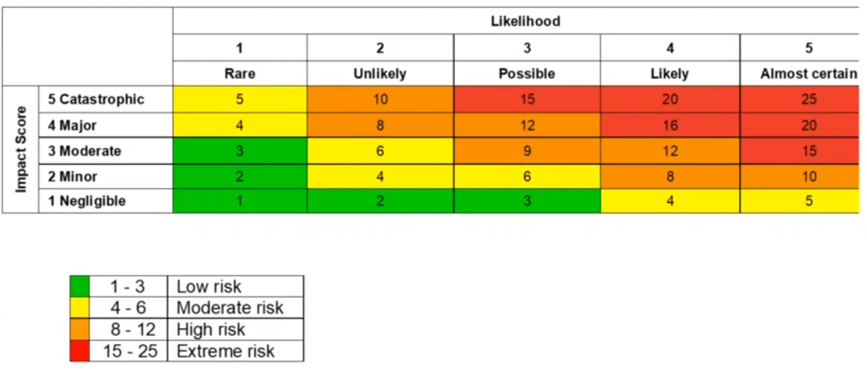
Figure 1 Risk Matrix [8]
The impact score table provided by Andrew Fletcher [8], is detailed below to assist in deciding on a suitable rating for impact.
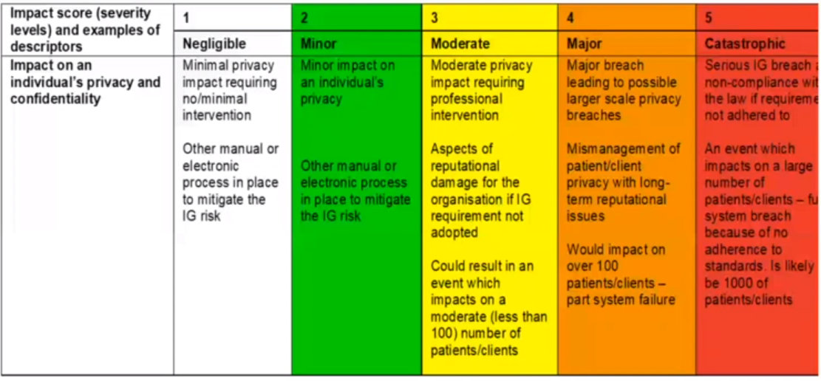
In the case of files being emailed incorrectly to a member of the public, this poses as a minimum a moderate risk since several data subjects are affected by the breach. Other reasons include the nature of data that was forwarded in error, the data was personal data but other data such as special category data was not forwarded to the recipient. Which would mean a moderate impact would be suitable. However data that was being stored on the desktop (against company policy), did contain special category data in the form of health records (sick notes) so therefore could result In the breach being major as not only must there be a lawful basis (article 6), there must also be a separate condition for processing under article 9. The breach also breached multiple principles so therefore could be of a more serious nature. The personal data that was breached could have been exploited if the recipient knew one of the data subjects included in the data, this could have serious repercussions if an ongoing court case was relating to a data subject and the recipient. Therefore, overall an impact rating of major was decided upon, due to the potential implications. However, mitigative action could supress the level of risk.
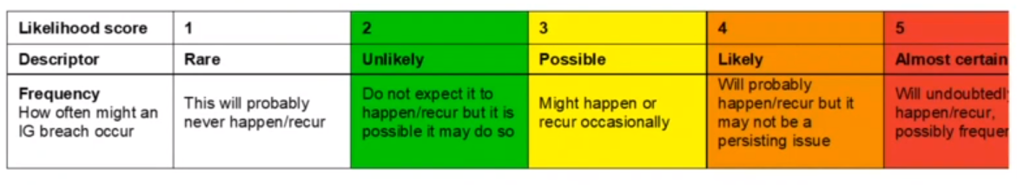
Figure 2 Likelihood Score [8]
The second factor to decide upon is the likelihood, in this case the likelihood would be possible. The risk would be possible as human error will mean that issues where data in forwarded in error or to the wrong recipient is likely to reoccur on the occasionally but not often enough to be likely to reoccur.
Overall, this would provide a risk rating of 9. This therefore resides in the lower half of a high risk. Further work should be done to mitigate risk, however as it is a high risk there is potential cause for the breach to be reported to the ICO.

Actions
- If the recipient has not yet opened the email, the built-in functionality of Outlook where emails can be recalled should be utilized to try and contain the breach before it becomes an issue. The is outlined in the standard operating procedure for Personal Data Breach Reporting and Management. Further support can be obtained from the email team if needed, if required a support call should be logged with the ServiceDesk along with a suitable priority. Email protocols included in the mail will allow the email team to advise if an email has been opened or not.
- If this is not possible the recipient of the data contained in the breach should be contacted immediately via telephone requesting that information is permanently deleted from the mailbox. If information has already been viewed by the user, it is important to understand if they know any of the affected data subjects
- Data subjects which are affected must be informed as soon as possible so that potential harm or impact can be reduced, and subsequent action taken as soon as possible.
- Immediately the incident should be reported within the risk management solution, Datix. This allows member of staff to access the risk, record the risk and forward to the Information Governance Team if further advice or guidance is required.
- Investigation must take place to understand which data subjects have been affected because of the data breech, with actions taken to remediate outlined clearly and documented.
- Impact assessment following a breach will need to take place, this will help to understand whether the breach should be reported further to the Information Commissioners Office (ICO).
- Potential disciplinary action towards the manager as they have failed in their role as a controller, by disregarding several data protection principles.
- Further investigation to understand if user responsible is compliant with the latest training to do with GDPR and Data protection. With the outcome deciding further actions to be taken.

Information Commissioners Office Evaluation
As discussed earlier a risk rating of 9 has been assigned to the breach, after reviewing the risk matrix. Therefore, there is a strong consideration that the breach should be reported to the ICO, for the following reasons:
- Data leaked is sensitive and does have potentially damaging implications.
- Special category data was located on local disk, as well as personal data stored locally and accidently sent to recipient.
- Multiple principles were infringed, as previously outlined.
However, GDPR does advise that breaches should be reported within 72 hours. For this reason, potentially a high priority internal investigation should take place to understand the impact and mitigate any risks. So, if the recipient, does not open or receive the email (as it is revoked beforehand) then the impact is greatly reduced and would not likely require any further investigation form the ICO. However, if the investigation could take longer than 72 hours or finds that the breach has had an impact then the ICO should be informed. As this breach is likely to “result in risk to rights and freedoms” [9] it would likely be reported to the ICO however.

Meeting Discussion Note

Possible ways to prevent any future breaches occurring of the same nature
- Signage in the workplace – A poster to educate staff about how their actions can affect GDPR principles
- Ensuring staff compliance with training which is available to educate them about principles and their responsibility. This could be done by a member of staff who deals with training, providing a report about how has completed training and who has not. Users who have not could then be targeted to complete training as soon as possible.
- Review access control. Did the manager require access to the information in the first place? If not, then data such as address and health issues should be handled by the Human Resources department. This would have avoided the issue as the staff member would not have had access to the data to be able to complete their task more efficiently.
- Ensuring that Risk assessments take place before work is carried out, rather than an impact assessment following a breach.
- Record management to be recirculated to ensure all staff have seen the latest revisions and are reminded of their responsibilities as controllers of data processing.

References

[1] | FreePrivacyPolicy, “The Six Privacy Principles of the GDPR,” 10 September 2020. [Online]. Available: https://www.freeprivacypolicy.com/blog/gdpr-6-privacy-principles/#Principle_1_Lawfulness_Fairness_And_Transparency.
[2] | ICO, “Lawful basis for processing,” ICO, 1 September 2020. [Online]. Available: https://ico.org.uk/for-organisations/guide-to-data-protection/guide-to-the-general-data-protection-regulation-gdpr/lawful-basis-for-processing/. [Accessed 10 September 2020].
[3] | Thomson Reuters Practical Law, “Purpose limitation,” Thomson Reuters Practical Law, 2020. [Online]. Available: https://uk.practicallaw.thomsonreuters.com/Glossary/UKPracticalLaw/I1a11102e5ea511e89bf199c0ee06c731?transitionType=Default&contextData=(sc.Default)&firstPage=true. [Accessed 10 September 2020].
[4] | L. F. d. l. Torre, “What does “purpose limitation” mean under EU Data Protection Law?,” 10 September 2020. [Online]. Available: https://medium.com/golden-data/what-is-purpose-limitation-under-eu-data-protection-law-fff4406ffe6.
[5] | Information Comissioners Office, “Security,” Information Comissioners Office, 2020. [Online]. Available: https://ico.org.uk/for-organisations/guide-to-data-protection/guide-to-the-general-data-protection-regulation-gdpr/security/. [Accessed 11 September 2020].
[6] | J. Ball, “Access Control Policy,” 20 May 2020. [Online]. Available: Redacted. [Accessed 11 September 2020].
[7] | ICO, “Lawful baiss for processing,” ICO, 21 October 2019. [Online]. Available: https://ico.org.uk/for-organisations/guide-to-data-protection/guide-to-the-general-data-protection-regulation-gdpr/lawful-basis-for-processing/. [Accessed 11 Septemeber 2020].
[8] | A. Fletcher, “L5 - Governance, Legislation and Ethics Work Based Project (ACCA5016) - DDA Modulde - 2nd Session (Tuesday 7th July 10am - 12pm),” 2 July 2020. [Online]. Available: https://moodle.uwtsd.ac.uk/course/view.php?id=2522. [Accessed 11 September 2020].
[9] | D. Lloyd, “GDPR Slides June 2018,” 19 June 2018. [Online]. Available: Redacted. [Accessed 11 Septemember 2020].
[10] | [Online].

