Module name- Developing Relationships and Workplace Achievement

Module Code- BMSW5102_BIRM
Title- International mergers and acquisitions (M&As) of China National Petroleum Corporation(China) and TotalEnergies SE (France)
Student name: George Giuliano Mihai
Student id:2027230

Executive Summary
A French global oil and gas organization with tasks in the north of 130 countries is TotalEnergies SE (beforehand All out SA). A huge opportunity for the two organizations to develop their tasks in space has as of late been introduced by the two organization’s declaration of a joint dare to foster a sizable gaseous petroleum field in China. The joint endeavor is expected to acquire from China's rising flammable gas interest, which is being powered by the country's drive to reduce its reliance on coal and to further develop its air quality. The coordinated effort will likewise assist China in accomplishing its level-headed goal of having a cleaner and more practical mix of fuel sources. Eventually, the joint endeavor between CNPC and TotalEnergies SE is a strategic decision that capitalizes on each organization's benefits to add esteem and work on their seriousness in the Chinese flammable gas market. The organization shows a commitment to dependable and feasible turn of events and is expected to deliver significant advantages for the two organizations and the bigger local area.

Table of contents
Introduction 4
a) Factors influencing the institutional and cultural differences in the merger and acquisition between countries China and France. Analyse institutional, cross-cultural management, and IHRM theories 4
Culture 4
Impact on organisational behaviour 4
Hofstede Analysis 5
Institutional approach to IHRM 6
PESTLE analysis of China and the France 6
Neo-institutional theory 9
Theory of isomorphism 9
Institutional and cultural differences in the merger and acquisition between countries China and France 10
Theoretical arguments on Institutional approach, Cross-Cultural Management, and IHRM 11
b) Discussing the role of IHRM in implementing effective mergers and acquisitions at the pre-merger and post-merger stages 12
Discussing the role of IHRM in implementing effective mergers and acquisitions at the pre-merger and post-merger stages 13
Planning and Recruitment strategies of IHRM in China 14
Planning and Recruitment strategies of IHRM in France 15
c) Conclusions and Recommendations 16
Reference 18

Company-China National Petroleum Corporation (China) and TotalEnergies SE (France)
Chosen country for merger and Acquisition- China and France
Component-1

Introduction
State-owned energy and gas company Beijing is home to China National Petroleum Company (CNPC). It was founded in 1988 and is now one of the largest coordinated energy groups in the world. Pipelines, oil and gas exploration, production, refining, and marketing are just a few of the activities that CNPC is engaged in. Additionally, it has businesses that provide design, development, and associated services. Paris serves as the home headquarters for the French global oil and gas company TotalEnergies SE, formerly known as All out S.A. It was established in 1924 and is one of the seven Supermajor oil companies in the world. Each stage of the oil and gas value chain, including exploration, extraction, processing, marketing, petrochemicals, and distribution, is handled by TotalEnergies. The study aims to focus on the cultural difference between France and China demonstrating key potential factors influencing their business strategies (Hughes et al., 2020). Two different companies’ Merger and acquisition strategy has been detailed with the use of different IHRM strategies and techniques.

a) Factors influencing the institutional and cultural differences in the merger and acquisition between countries China and France. Analyse institutional, cross-cultural management, and IHRM theories

Culture
Culture is the way, in which an individual can describe his tradition or religion, arts and beliefs and these cultural beliefs are spread from one generation to the next generation. Culture is also known as the lifeways of a whole society. Culture also includes manners, codes, rituals, beliefs and arts, language, dress up and many more. The term organisational culture is the beliefs of any company, attitudes and values of the company and the behaviour of the organisations towards their employees. Organisational culture also keeps an impact on organisational behaviour and a healthy organisational culture can create a positive work environment within the organisation.

Impact on organisational behaviour
Organisational culture is a common term in the context of business and the culture has kept both a negative and positive impact on organisational behaviour. Different background employees are working together within an organisation and that creates cultural diversity within the organisation (Tran, 2021). Positive work culture has created a healthy work environment and motivates employees to improve their work performance. On the other hand, negative work culture can create organisational conflicts and work politics that can negatively affect employee performance. A positive work environment is very necessary for organisational growth and employee motivation, therefore it can be said that to make the proper organisational behaviour, a positive work culture is very necessary.

Hofstede Analysis
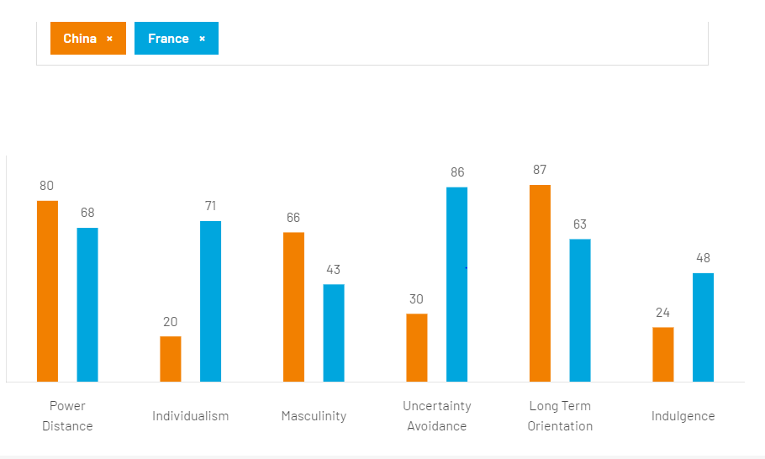
Figure 1: Hofstede Diagram
(Source: Hofstede-insights, 2021)‌
In this part of the study, the Hofstede diagram was provided in this part. The power distance is very high in both countries, China and France. The power distance is much higher in China than in France. Individualism is much higher in France than in China and masculinity is also much higher in China than in France (Hofstede-insights, 2021). From the above diagram, it can be said that the possibilities of uncertainty avoidance are much higher in France than in China and the long-term orientation of the Chinese organisations is also much higher in China than in France. The area of indulgence is higher in France than in China. Therefore it can be said that, from the Hofstede model, the organisational culture of both China and France can be understood by an individual easily.

Institutional approach to IHRM
International HRM is the common term for organisations and different types of institutional approaches are the strategic HRM approach, commodity and management approach, reactive and proactive approach, and systematic approach HRM (Ererdi et al., 2022). The strategic approaches provide competitive advantages to the organisations and it also focuses on the people management of any organisation. The proactive approaches help to save considerable money and time in the long and short run and the proactive approaches are very important for accelerating the organisation’s overall process. Reactive approaches are not very fruitful because organisations might lose their money and time if the organisations are trying to implement the reactive HRM approaches.

PESTLE analysis of China and the France

PESTLE | China National Petroleum Corporation (China) | TotalEnergies SE (France)
Political | - Since CNPC is a state-owned enterprise, Chinese government policies and laws have a significant influence over how the company conducts business.  - CNPC works in numerous nations with various political structures, which can present difficulties in terms of adhering to various regulations and political risks. | - Since TotalEnergies works in various countries with shifting political designs, the organization’s activities and benefits are affected by political flightiness and rules.  - As far as oil investigation and creation, the business is furthermore represented by various worldwide regulations, including exchange bans and ecological guidelines (Christofi et al., 2019).
Economical | - The profitability of CNPC is significantly impacted by the fluctuating global price of oil and gas, which is a major factor in the company’s operation.  - CNPC has operations in a number of developing nations, which can offer development prospects but also come with certain economic risks like unstable markets and currency fluctuations (Čirjevskis, 2019). | - Oil and gas cost vacillations affect TotalEnergies and can fundamentally influence the organization’s deals and benefits.  - The condition of the worldwide economy and cash trade rates affect the organization’s monetary achievement.
Socio-cultural | - CNPC works in a variety of cultural contexts, which can present difficulties in terms of social norms, values, and communication.  - CNPC has come under fire for its treatment of human rights and environmental issues, which could harm its standing and ability to conduct business. | - TotalEnergies is putting resources into environmentally friendly power to satisfy the need for cleaner energy decisions welcomed by the shift to environmentally friendly power sources like sun-based and wind.  - The business should be aware of and adjust to nearby traditions and accepted practices since it works in different social settings.
Technological | - CNPC has made technological investments to boost the effectiveness of its exploration and production processes, including the use of horizontal drilling and 3D seismic imaging (Haapanen et al., 2019).  - The use of renewable energy sources like wind and solar electricity has also been investigated by CNPC. | - To build efficiency and well-being in investigation and creation, TotalEnergies makes innovation ventures. These incorporate novel investigation strategies, similar to 3D seismic imaging, as well as the utilization of man-made reasoning and information examination.  - The business is additionally making interests in clean energy advancements like carbon catch and battery stockpiling.
Legal | - CNPC is governed by a number of national and foreign laws and regulations, including anti-corruption laws, labor laws, and environmental laws.  - Legal issues have been raised against CNPC because of claims of environmental pollution and bribes. | - In the countries where it conducts business, TotalEnergies is represented by various regulations and rules, including work regulations and ecological regulations (Haapanen et al., 2019).  - Also, the business faces legitimate troubles like claims and investigations into security and ecological issues.
Environmental | - The operations of CNPC may have a major negative effect on the environment, including air and water pollution and greenhouse gas emissions.  - Through investments in more environmentally friendly technologies and better environmental management techniques, CNPC has worked to lessen its effect on the environment. | - TotalEnergies is interested in clean creation strategies and sustainable power sources with the end goal to decrease its negative natural impact (Zborowski, 2019). Moreover, the business should maintain rules and particulars to reduce its impact on the climate, like bringing down emanations and limiting the impacts of oil slicks.
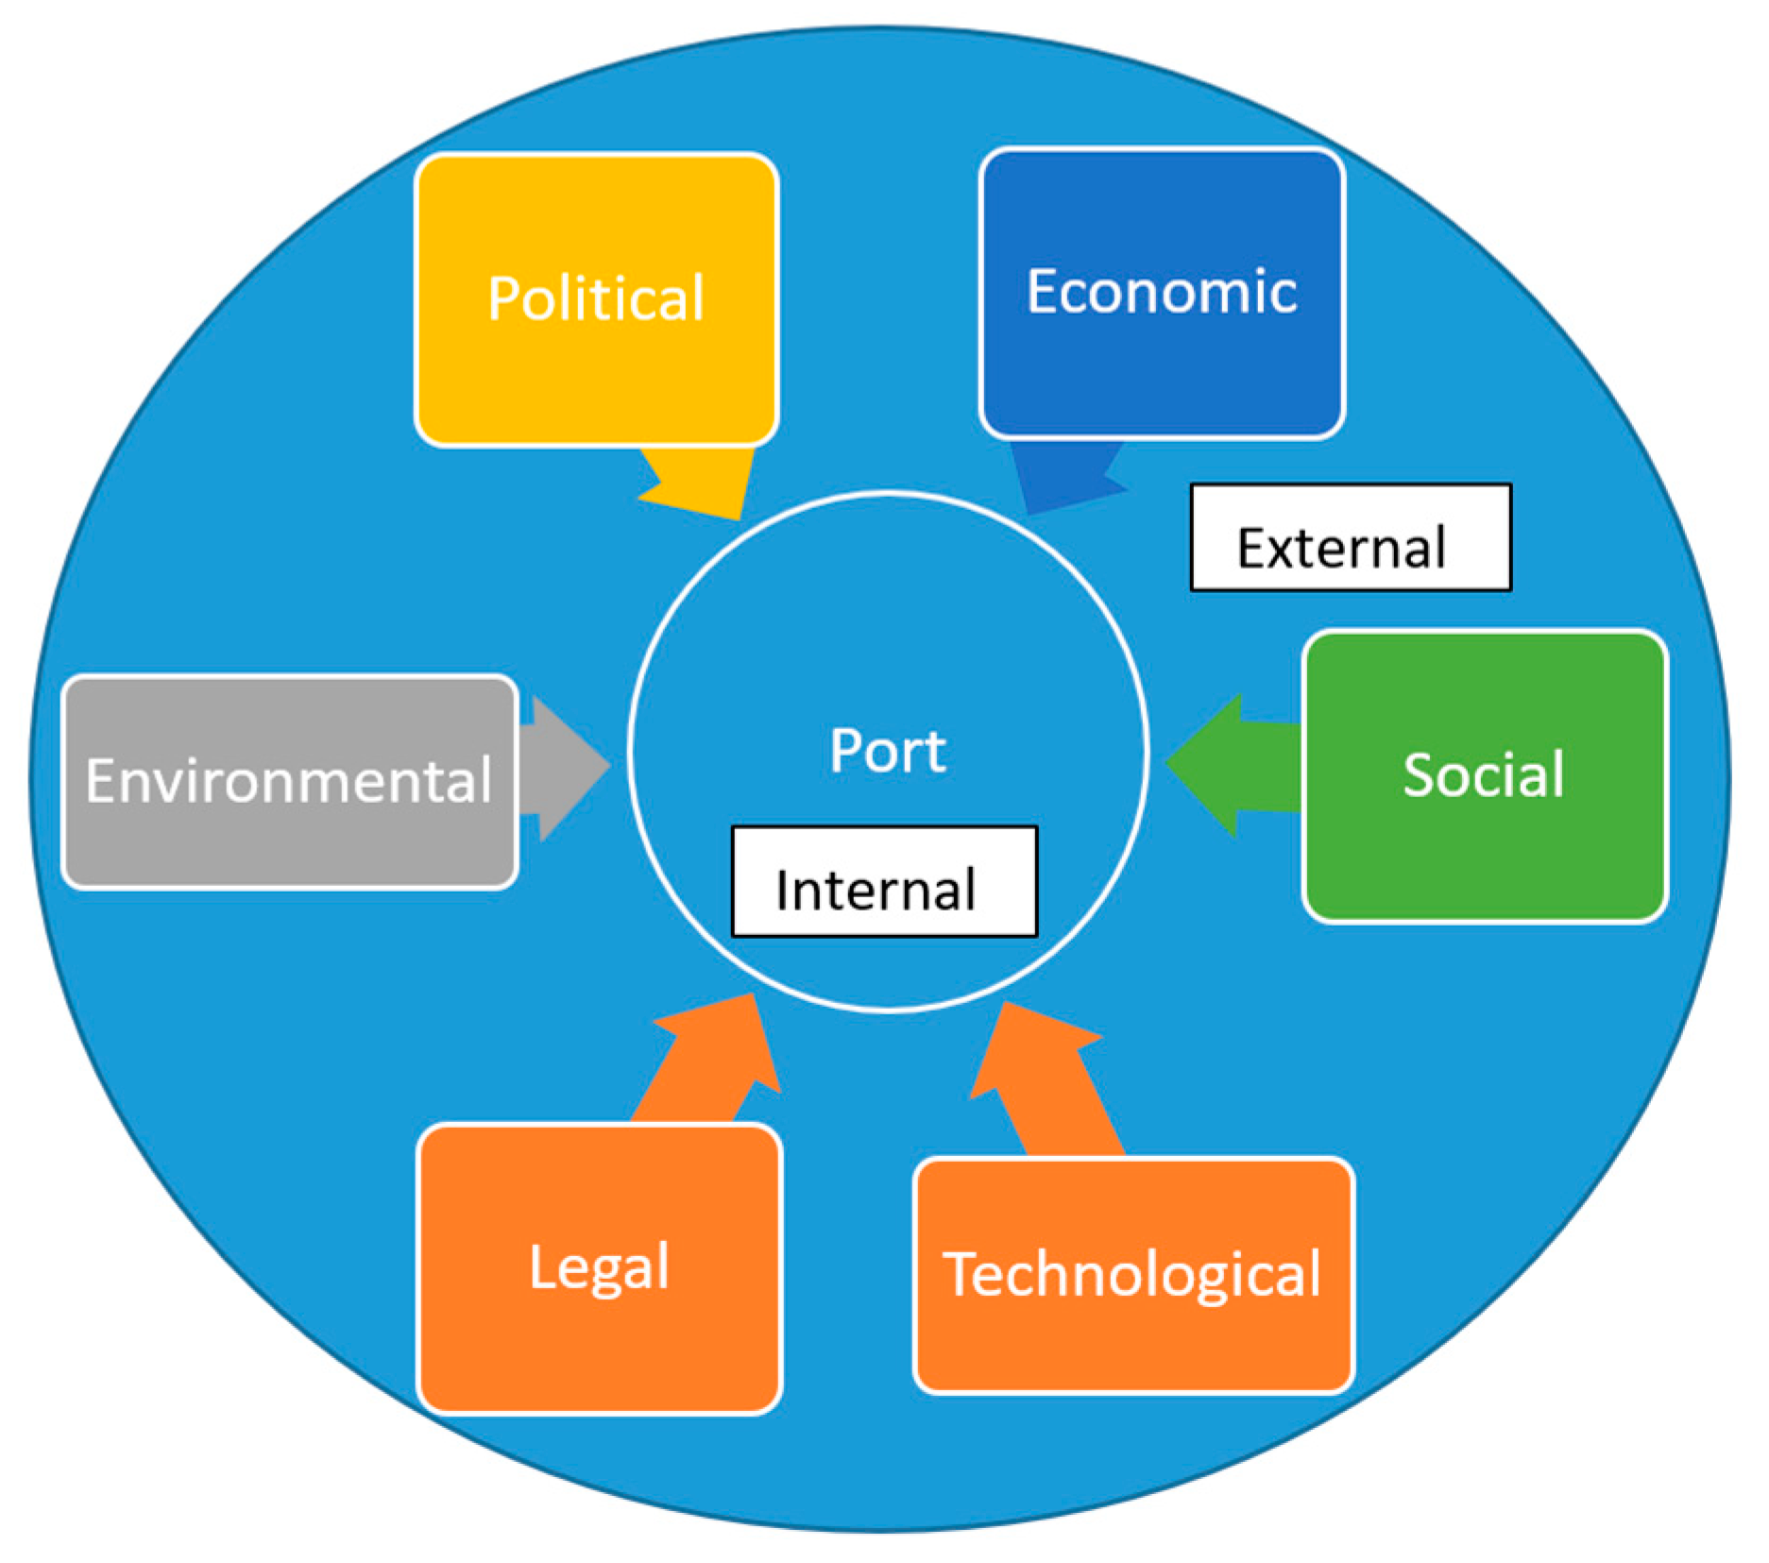
Figure 01: PESTLE analysis of China and the France
Source: (mdpi, 2023)

Neo-institutional theory
Scott's 1995 theory states that organisations must follow the rules and regulations regarding maintaining environmental stability to survive effectively in the global business market. In this reward, CNPC and TotalEnergies will be beneficial if they follow the theory as well as implement it in their business. Moreover, this theory will also help those organisations to identify both the social and environmental aspects as well as fulfilling them in all possible ways. Therefore, the companies will remain one of the most effective brands in China and France respectively.

Theory of isomorphism
DiMaggio and Powell developed a theory in 1991 on the concept of isomorphism to explain the homogeneous workforce of an organisation (Aksom and Tymchenko, 2020). This theory presented several mechanisms including mimetic, coercive as well as normative in which isomorphism occurs. Therefore, by implementing this framework, both the companies CNPC and TotalEnergies will run their internal operations as well as other necessary activities within their business. Moreover, both companies will also get several opportunities to implement homogeneity in their workplace. Therefore, every employee can perform all types of activities which are required for their business. It will also turn the companies to generate more productivity as well as provide better performance.

Institutional and cultural differences in the merger and acquisition between countries China and France
The consolidation and procurement (M&A) methodology between countries, including China and France, can be muddled by institutional and social contrasts. Coming up next are a few huge varieties that could influence M&A between these two countries:
Institutional Differences:
- General sets of laws: China has a communist overall set of laws, while France works under a common regulatory framework. Different M&A lawful structures might come from this, which might influence the arrangement’s prerequisites and interaction.
- Government Necessities: The strategy might be more troublesome and tedious in China because of the country’s stricter government rules and endorsement norms for unfamiliar speculations and M&A bargains (Kiessling, Vlačić, and Dabić, 2019).
- Possession: Because of the sizable state-claimed undertaking (SOE) market in China and the way that SOEs are more dependent upon particular administrative norms than private organizations, this component might affect the arrangement structure.

Cultural Differences:
- Correspondence Styles: French business culture is more direct and objective centered, though Chinese business culture will in general be more backhanded and relationship-centered. Subsequently, correspondence and perception issues might emerge during the dealing system.
- French organizations commonly have a more varied leveled administration structure, while Chinese organizations often have a more scattered structure. After the M&A exchange shuts, this could prompt contrasts in administration and dynamic strategies.
- Mentalities toward Hazard: Chinese organizations might be more ready to face challenges to accomplish improvement, though French organizations regularly have a more wary way to deal with risk-taking. Various ways to deal with the M&A system and post-consolidation methodology might result from this.
All in all, these institutional and cultural aberrations might present challenges for China and France’s M&A cycle (Degbey et al., 2021). It is essential for organizations to know about these distinctions and to team up to find points of arrangement and arrangements.

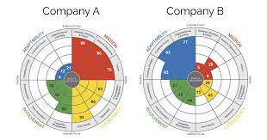
Figure 02: Institutional and cultural differences in the merger and acquisition between countries China and France
Source: (denisonconsulting, 2023)

Theoretical arguments on Institutional approach, Cross-Cultural Management, and IHRM

Institutional Approach:
As per the institutional strategy, associations are a piece of bigger institutional conditions that impact their way of behaving and strategies. This suggests that the institutional conditions in China and France, separately, affect the exercises and techniques of CNPC and TotalEnergies. Since CNPC is a state-possessed organization in China, it is represented by unmistakable regulations and guidelines than private organizations. Political and monetary parts of China, like guidelines on asset extraction and unfamiliar ventures, affect the organization's activities and procedures (González-Torres et al., 2020). The institutional climate in France, including the general set of laws, work regulations, and natural assurance rules, likewise affects TotalEnergies.
Cross-Cultural Management:
Dealing with the social distinctions among people and gatherings from different countries is the focal point of multifaceted administration. Since they work in different social settings, diverse administration is significant for CNPC and TotalEnergies. These organizations can make compelling diverse groups, close arrangements with progress, and deal with their tasks in different social settings by having an exhaustive comprehension of the social distinctions among China and France. For example, CNPC and TotalEnergies could have various approaches to imparting, approaches to arriving at choices, and perspectives toward facing challenges. Building solid associations with partners, like laborers, accomplices, and clients, can help these organizations (Vopilovskiy, 2022). This incorporates figuring out these social distinctions and adjusting their administration approaches properly.
International Human Resource Management (IHRM):
The administration of HR in worldwide enterprises is a focal point of IHRM. IHRM is vital for CNPC and TotalEnergies since they lead businesses in different countries and recruit individuals from different social foundations. Successful IHRM practices can help these organizations in finding, holding, and creating abilities abroad and in making a different and comprehensive labor force. For example, it may very well be important for CNPC and TotalEnergies to make different employing and determination methodologies, compensation and award plans, and preparing and improvement programs in different countries (Mineev, and Sæther, 2022). These organizations can foster a worldwide labor force that is in accordance with their organization's culture and values, which can give them an upper hand in different business sectors, with the guidance of powerful IHRM rehearses.
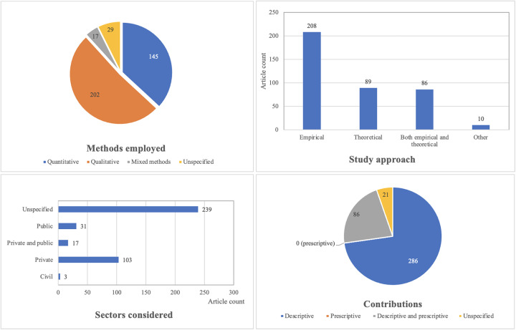
Figure 03: Theoretical arguments on Institutional approach, Cross-Cultural Management, and IHRM.
Source: (sciencedirect, 2023)

b) Discussing the role of IHRM in implementing effective mergers and acquisitions at the pre-merger and post-merger stages

Discussing the role of IHRM in implementing effective mergers and acquisitions at the pre-merger and post-merger stages
IHRM is crucial for the outcome of consolidations and acquisitions (M&A) on the grounds that it coordinates the HR of the two organizations with the essential targets of the joined organization. IHRM will be pivotal in empowering a consistent mix of the two organizations' societies, strategies, practices, and staff in the consolidation between China Public Oil Partnership (CNPC) and TotalEnergies SE (All out).
Pre-merger stages:
- IHRM can help with directing a social expected level of effort examination of the two organizations to figure out how their societies, values, and perspectives look into (Casanova, and Miroux, 2022). This information can be utilized to foster an incorporation methodology that praises the social assortment of the two organizations and produces a shared objective.

Post-merger stage:
- Mix of HR Strategies and Practices: IHRM can help with organizing the two organizations' HR strategies and methods to foster a brought-together methodology to faculty organization. This might include organizing pay and advantages, execution assessment, vocation development, and preparation and advancement.
- Multifaceted Preparation: IHRM can give laborers diverse preparation to assist them with grasping the varieties in the way of life, values, and convictions of the two organizations (Pichonnat, 2023). This can encourage social resistance and awareness while decreasing social conflicts.

IHRM, especially in dealing with the human resources of the two organizations, is fundamental for the progress of M&A. To guarantee a consistent convergence of the two organizations on account of the CNPC-Complete consolidation, IHRM can help with playing out a socially reasonable level of investment, labor force arranging, correspondence arranging, reconciliation of HR strategies and practices, culturally diverse preparation, and representative commitment and maintenance.

Figure 04: Pre-merger and Post-merger stages.
Source: (linkedin, 2023)

Planning and Recruitment strategies of IHRM in China
Because of the nation's social, political, and lawful scene, worldwide human assets, the executives (IHRM) in China stand up to specific challenges. IHRM should make fitting preparation and enlistment procedures that are in accordance with the organization's general business goals assuming it is to effectively oversee human resources in China. Coming up next are probably the best strategies IHRM can use in China:

- Arranging the labour force: In China, the productive human asset of the board is fundamental. The association's present and future necessities, as well as the vital ranges of abilities, skills, and experience of the labour force, should be dissected by IHRM. A guide for recruiting, preparing, and keeping laborers can be given by labour force arranging, which can likewise help with distinguishing any labour force holes.
- Worker Procurement: In China, one of the most urgent IHRM undertakings is enrolment. IHRM should formulate a careful work methodology that attracts, picks, and keeps the best competitors (Wanasinghe et al., 2020). IHRM ought to focus on fostering areas of strength for a brand, participating in friendly selection, and using computerized stages like virtual entertainment to attract the best ability.
- Representative suggestion plans: In China, worker reference plans are an effective technique for drawing ability. This strategy involves empowering current specialists to propose qualified candidates for open positions (Martins et al. 2020). Representative reference projects can help IHRM in China in distinguishing forthcoming applicants who are socially and etymologically viable with the organization by using the informal organizations that as of now exist among workers.

Planning and Recruitment strategies of IHRM in France
The cultural, political, and legitimate setting of France makes it especially hard for IHRM professionals to work there. IHRM should make proper preparation and enrolment procedures that are in accordance with the organization’s all-encompassing business targets assuming it is to effectively oversee human resources in France. Coming up next are the absolute best strategies IHRM can use in France:
- Arranging the labour force: In France, arranging the labour force is fundamental for productive human asset organization. The association's present and future necessities, as well as the vital ranges of abilities, skills, and experience of the labour force, should be broken down by IHRM (Kaviani et al. 2020). A guide for employing, preparing, and keeping laborers can be given by labour force arranging, which can likewise help with recognizing any labour force holes.
- Likely procurement: In France, one of the central liabilities of IHRM is enlistment. IHRM should come up with an exhaustive business methodology that attracts, picks, and keeps the best competitors (Gibson Smith et al., 2019). IHRM ought to focus on fostering serious areas of strength for a brand, using social enlisting, and connecting with expected candidates through proficient organizations to attract the best ability.
- Representative reference drives: In France, worker reference drives are fruitful at tricking top staff. This strategy involves empowering current specialists to recommend qualified candidates for open positions. Representative reference projects can help IHRM in France in distinguishing potential competitors who are socially and semantically viable with the organization by using the informal organizations previously settled by workers.

c) Conclusions and Recommendations
All in all, Global Human Asset executives (IHRM) is significant to the progress of consolidations and acquisitions (M&A) processes, particularly in the space of arranging, enrolment, and social combination (Wilton, 2019). Making a common vision and culture, moving information, abilities, and innovation among organizations, and guaranteeing a consistent labour force joining is completely made conceivable by a successful IHRM procedure.

In any case, given the various issues that should be settled, it is essential to deal with IHRM in M&A processes fundamentally. Social and etymological obstructions, varieties of parents in law and guidelines, and protection from change are a couple of these troubles (Storey, 2023). A basic procedure involves recognizing and resolving these issues as well as planning methodologies that are custom fitted to the specific necessities and setting of the M&A cycle included associations.

The study proposes the accompanying to successfully take on a basic way to deal with IHRM in M&A processes:
- Dissecting the distinctions in culture, regulation, and guideline between the associations that took part in the M&A cycle exhaustively. Through examination, conceivable struggle focuses can be found and systems to determine them can be all the more effortlessly evolved.
- Make a careful IHRM plan that is in accordance with the expansive business objectives of the associations partaking in the M&A cycle. This plan ought to have a particular arrangement for employing, preparing, and keeping laborers, as well as an arrangement for coordinating various societies.
- Make a viable correspondence intended to instruct staff individuals about the M&A interaction, including the inspirations driving the consolidation or buy, the expected advantages, and any likely changes to the hierarchical design or occupation obligations (Nankervis et al., 2022). To help staff in exploring the social distinctions between the associations participating in the M&A cycle, give diverse preparation and backing.
- Empower cooperation, data sharing, and development in a cooperative and comprehensive work climate that values variety.

In general, by working with the exchange of information, abilities, and innovation between associations, fostering a typical vision and culture, and guaranteeing consistent labor force coordination, a basic way to deal with IHRM in M&A cycles can assist with guaranteeing the interaction's prosperity.

Reference
Aksom, H. and Tymchenko, I., (2020). How institutional theories explain and fail to explain organizations. Journal of Organizational Change Management, 33(7), pp.1223-1252. Available at: https://www.researchgate.net/profile/Herman-Aksom/publication/342567484_How_institutional_theories_explain_and_fail_to_explain_organizations/links/61e46f668d338833e3735838/How-institutional-theories-explain-and-fail-to-explain-organizations.pdf
Casanova, L. and Miroux, A., (2022). EMERGING MARKET MULTINATIONALS CONTINUE TO MOVE AHEAD UNDER UNCERTAINTY1. Special Contributors, p.1.https://ecommons.cornell.edu/bitstream/handle/1813/112770/EMR%202022%20Master%20File%20final.pdf?sequence=2#page=25 [Accessed 13 March, 2023]
Casanova, L. and Miroux, A., (2022). US COMPANIES CONTINUE TO LEAD THE WAY GLOBALLY 3. Special Contributors, p.20.https://ecommons.cornell.edu/bitstream/handle/1813/112770/EMR%202022%20Master%20File%20final.pdf?sequence=2#page=44 [Accessed 13 March, 2023]
Christofi, M., Vrontis, D., Thrassou, A. and Shams, S.R., (2019). Triggering technological innovation through cross-border mergers and acquisitions: A micro-foundational perspective. Technological Forecasting and Social Change, 146, pp.148-166.https://www.sciencedirect.com/science/article/pii/S0040162519301970 [Accessed 13 March, 2023]
Čirjevskis, A., (2019). The role of dynamic capabilities as drivers of business model innovation in mergers and acquisitions of technology-advanced firms. Journal of Open Innovation: Technology, Market, and Complexity, 5(1), p.12.https://www.mdpi.com/421700 [Accessed 13 March, 2023]
Degbey, W.Y., Rodgers, P., Kromah, M.D. and Weber, Y., (2021). The impact of psychological ownership on employee retention in mergers and acquisitions. Human Resource Management Review, 31(3), p.100745.https://www.sciencedirect.com/science/article/pii/S1053482220300139 [Accessed 13 March, 2023]
Ererdi, C., Nurgabdeshov, A., Kozhakhmet, S., Rofcanin, Y. and Demirbag, M., 2022. International HRM in the context of uncertainty and crisis: A systematic review of literature (2000–2018). The International Journal of Human Resource Management, 33(12), pp.2503-2540. Available at: https://repository.essex.ac.uk/29323/1/IJHRM%20-%204th%20Revision-Final-Repository.pdf
Gibson Smith, K., Paudyal, V., Klein, S. and Stewart, D., (2019). Medical evacuations and absences from work in offshore personnel employed in the oil and gas industry. SelfCare, 10(4), pp.105-110.http://arro.anglia.ac.uk/id/eprint/704750/ [Accessed 13 March, 2023]
González-Torres, T., Rodríguez-Sánchez, J.L., Pelechano-Barahona, E. and García-Muiña, F.E., (2020). A systematic review of research on sustainability in mergers and acquisitions. Sustainability, 12(2), p.513.https://www.mdpi.com/613866 [Accessed 13 March, 2023]
Haapanen, L., Hurmelinna-Laukkanen, P., Nikkilä, S. and Paakkolanvaara, P., (2019). The function-specific microfoundations of dynamic capabilities in cross-border mergers and acquisitions. International Business Review, 28(4), pp.766-784.https://www.sciencedirect.com/science/article/pii/S0969593117307102 [Accessed 13 March, 2023]
Hofstede-insights., (2021). Country comparison tool. [online] Available at: https://www.hofstede-insights.com/country-comparison-tool?countries=china%2Cfrance.
Hughes, P., Hughes, M., Stokes, P., Lee, H., Rodgers, P. and Degbey, W.Y., (2020). Micro-foundations of organizational ambidexterity in the context of cross-border mergers and acquisitions. Technological Forecasting and Social Change, 153, p.119932.https://eprints.soton.ac.uk/442407/1/TFS_2019_1345_Revision_1_V0.pdf [Accessed 13 March, 2023]
Kaviani, M. A., Karbassi Yazdi, A., Ocampo, L., and Kusi-Sarpong, S. (2020). An integrated grey-based multi-criteria decision-making approach for supplier evaluation and selection in the oil and gas industry. Kybernetes, 49(2), 406-441.https://www.researchgate.net/profile/Mohamad-Kaviani/publication/331070803_An_integrated_grey-based_multi-criteria_decision-making_approach_for_supplier_evaluation_and_selection_in_the_oil_and_gas_industry/links/5d5149a292851cd046b51064/An-integrated-grey-based-multi-criteria-decision-making-approach-for-supplier-evaluation-and-selection-in-the-oil-and-gas-industry.pdf
Kiessling, T., Vlačić, B. and Dabić, M., (2019). Mapping the future of cross-border mergers and acquisitions: a review and research agenda. IEEE Transactions on Engineering Management, 68(1), pp.212-222.https://ieeexplore.ieee.org/abstract/document/8946901/ [Accessed 13 March, 2023]
Martins, I. D., Moraes, F. F., Távora, G., Soares, H. L. F., Infante, C. E., Arruda, E. F., ... and Lourenço, M. I. (2020). A review of the multicriteria decision analysis applied to oil and gas decommissioning problems. Ocean & Coastal Management, 184, 105000.https://www.researchgate.net/profile/Edilson-Arruda/publication/336248827_A_review_of_the_multicriteria_decision_analysis_applied_to_oil_and_gas_decommissioning_problems/links/5d96fb5d299bf1c363f5a89d/A-review-of-the-multicriteria-decision-analysis-applied-to-oil-and-gas-decommissioning-problems.pdf
Mineev, A. and Sæther, E.Z., (2022). Business Cooperation in the Arctic: Learning Points from the Russia-Based Oil and Gas Projects. In Global Development in the Arctic (pp. 98-114). Routledge.https://www.taylorfrancis.com/chapters/oa-edit/10.4324/9781003246015-8/business-cooperation-arctic-andrey-mineev-elena-zhurova-s%C3%A6ther [Accessed 13 March, 2023]
Nankervis, A., Baird, M., Coffey, J. and Shields, J., (2022). Human Resource Management 11e. Cengage AU.https://books.google.com/books?hl=en&lr=&id=JG6dEAAAQBAJ&oi=fnd&pg=PR9&dq=human+resource+management+UK&ots=V7HMYyp3BC&sig=Ui9kqgRC1HJ72psMgf8z2N8ycQI [Accessed 13 March, 2023]
Pichonnat, F., (2023). The capitalist dilemma in the energy sector. Profit and renewable energy investments of major oil companies: the case ofTotalEnergies SE (Doctoral dissertation, University of Geneva).https://archive-ouverte.unige.ch/unige:166374 [Accessed 13 March, 2023]
Storey, J., (2023). Human resource management. In Encyclopedia of Human Resource Management (pp. 182-184). Edward Elgar Publishing.https://www.elgaronline.com/abstract/book/9781800378841/H_19.xml [Accessed 13 March, 2023]
Tran, Q.H., (2021). Organisational culture, leadership behaviour and job satisfaction in the Vietnam context. International Journal of Organizational Analysis, 29(1), pp.136-154. Available at: https://www.researchgate.net/profile/Quan-Tran-21/publication/340234615_Organisational_culture_leadership_behaviour_and_job_satisfaction_in_the_Vietnam_context/links/5e83756d92851c2f5270c8ca/Organisational-culture-leadership-behaviour-and-job-satisfaction-in-the-Vietnam-context.pdf
Vopilovskiy, S.S., (2022). Foreign Economic Partners of Russia in the Arctic Zone. Arktika i Sever [Arctic and North], (46), pp.29-43.http://www.arcticandnorth.ru/upload/uf/3e9/46.pdf#page=29v [Accessed 13 March, 2023]
Wanasinghe, T.R., Wroblewski, L., Petersen, B.K., Gosine, R.G., James, L.A., De Silva, O., Mann, G.K. and Warrian, P.J., (2020). Digital twin for the oil and gas industry: Overview, research trends, opportunities, and challenges. IEEE access, 8, pp.104175-104197.https://ieeexplore.ieee.org/abstract/document/9104682/ [Accessed 13 March, 2023]
Wilton, N., (2019). An introduction to human resource management. An Introduction to Human Resource Management, pp.1-632.https://www.torrossa.com/gs/resourceProxy?an=5017769&publisher=FZ7200 [Accessed 13 March, 2023]
Zborowski, M. (2019). Industry Dives into UK’s New Oil and Gas Data Hub. Journal of Petroleum Technology, 71(07), 31-33.https://onepetro.org/JPT/article-abstract/71/07/31/207716

