

Tsvetana Galabova (2507216)

Table of Contents
Job Advertise 1 2
Job Advertise 2 3
Task 1 4
Comparison of Two Job Adverts and Identification of Key Skills 4
How I could use one of these key skills in my future role 5
Task 2 6
Self‑Assessment and SWOT Analysis 6
Strengths 6
Weaknesses 7
Opportunities 7
Threats 7
SWOT analysis table 8
Evidence of Readiness for Employability and Personal Advancement 9
Task 3 10
Employment Goals and Personal Development Plan 10
Conclusion 11

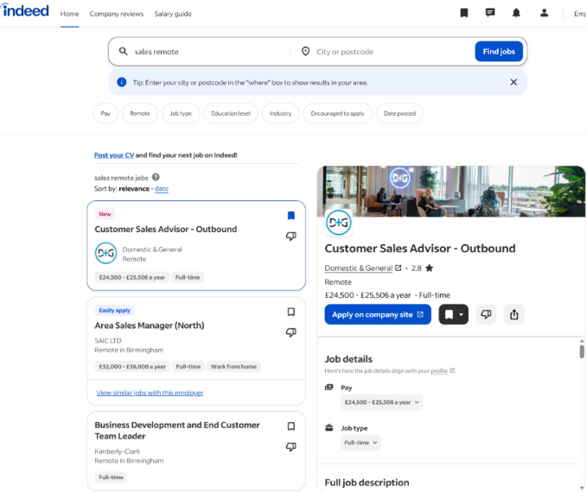
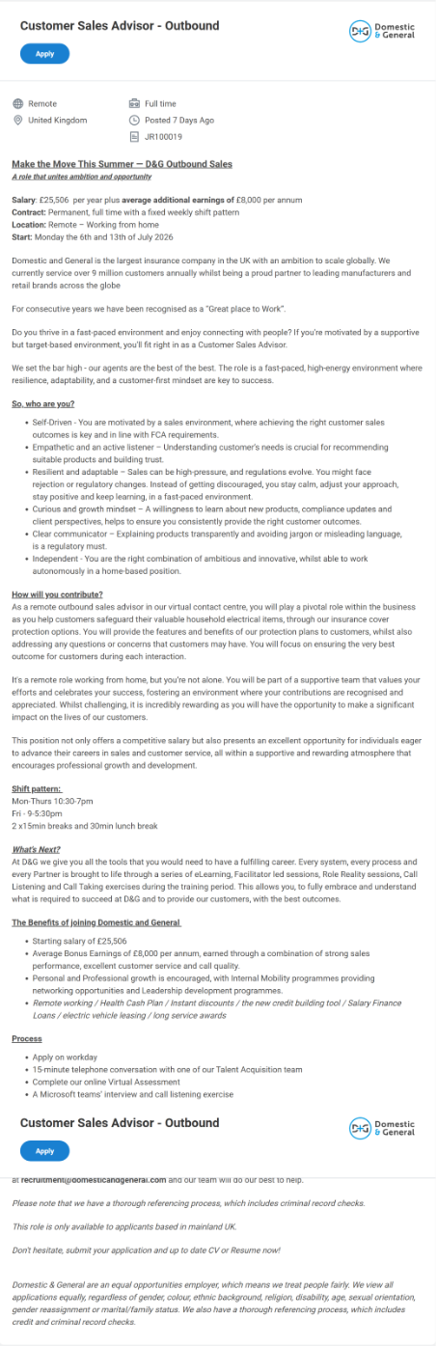
Job Advertise 1

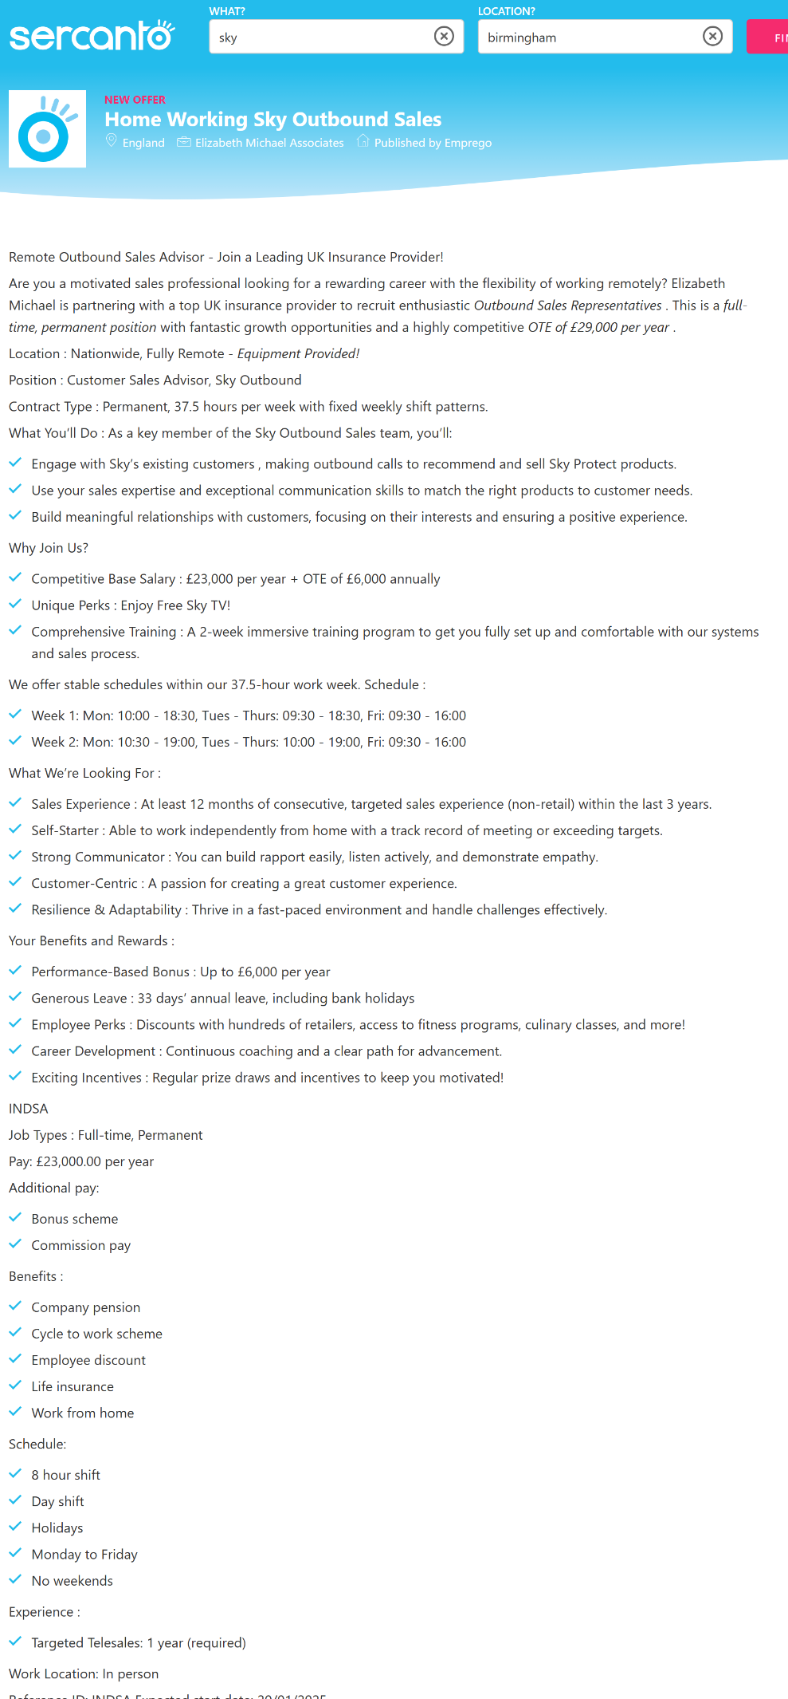
Job Advertise 2

Task 1

Comparison of Two Job Adverts and Identification of Key Skills
For this task, I am comparing two job adverts for the profession of Customer Sales Advisor – Outbound. The first advert is from Domestic & General (D&G), which I previously researched. The second advert is from Sky, who recruit remote outbound sales advisors nationwide. Both adverts outline the skills, behaviours, and knowledge required for success in outbound sales roles.
Across both adverts, several key skills appear consistently.
- The first shared skill is clear communication, which is essential for explaining products, building rapport, and ensuring customers understand what they are purchasing. Domestic & General emphasise transparent communication as a regulatory requirement under FCA rules, while Sky highlight the need to explain packages and offers clearly to customers. Both employers expect candidates to avoid jargon and communicate in a way that is professional, simple, and customer friendly.
- A second common skill is active listening. Domestic & General describe this as crucial for understanding customer needs and recommending suitable protection plans. Sky also emphasises listening as a core part of identifying customer preferences and matching them with the right products. Active listening supports trust, reduces misunderstandings, and leads to better customer outcomes.
- Another shared skill is resilience and adaptability. Outbound sales environments involve rejection, fast paced targets, and changing customer behaviours. Domestic & General highlight resilience as essential for staying positive and adjusting to regulatory changes, while Sky emphasise the ability to remain motivated and handle objections confidently. Adaptability is also important because sales scripts, compliance rules, and product information can change frequently.
- Both adverts also emphasise target driven performance. Domestic & General require meeting daily and weekly sales goals, maintaining call quality, and achieving customer satisfaction scores. Sky similarly expects advisors to achieve sales targets, maintain productivity, and deliver strong customer outcomes. This shows that self-motivation and consistency are essential in outbound sales roles.
- Finally, both adverts highlight compliance knowledge, especially FCA aligned communication. Domestic & General explicitly state that advisors must follow FCA requirements, including clear, fair, and not misleading communication. Sky also require compliance with internal policies and customer care standards, showing that regulated behaviour is a shared expectation.

How I could use one of these key skills in my future role
One key skill I will use in my future outbound sales role is active listening. This skill allows me to understand the customer’s situation, identify their needs, and recommend the most suitable protection plan. Active listening also helps reduce objections, improve customer trust, and increase the likelihood of a successful sale. In a remote outbound role, where tone and clarity are essential, active listening ensures that every conversation is personalised, compliant, and focused on delivering the best customer outcome.

Task 2

Self‑Assessment and SWOT Analysis
A self‑assessment is an essential part of understanding personal strengths, areas for development, and readiness for employment. Using the SWOT analysis framework (Strengths, Weaknesses, Opportunities, Threats), I have evaluated my current abilities, behaviours, and experiences in relation to my chosen profession: Customer Sales Advisor – Outbound.

Strengths
- One of my strongest qualities is my ability to communicate clearly and confidently with customers. Across my previous roles in customer service, online sales, and self‑employment, I developed strong communication skills, including active listening, transparent explanations, and the ability to build rapport quickly. These skills are essential in outbound sales, where understanding customer needs and presenting suitable solutions is key to achieving positive outcomes.
- Another strength is my resilience and adaptability. Working in fast‑paced environments such as production, customer service, and remote work has taught me how to remain calm under pressure, manage multiple tasks, and adjust quickly to changing expectations. This aligns well with outbound sales roles, which often involve rejection, evolving compliance rules, and performance targets.
- I also have strong organisational skills and attention to detail. My experience in Quality Control required accuracy, compliance, and following structured processes. These skills transfer directly to FCA‑aligned sales environments, where clear, fair, and compliant communication is essential.
- Finally, my multilingual ability (English, Bulgarian, and Polish) is a valuable strength. It allows me to communicate with a wider range of customers and demonstrates cultural awareness and flexibility.

Weaknesses
- One area for development is confidence in handling complex sales objections. Although I have experience resolving customer issues, outbound sales often involve more challenging objections related to cost, value, or product suitability. I need to strengthen my objection‑handling techniques to ensure I can respond confidently and maintain customer trust.
- Another weakness is limited experience with modern CRM systems used in large sales organisations. While I am confident using computers and online platforms, I have not yet worked extensively with advanced sales software. Improving my digital proficiency will help me work more efficiently in remote sales environments.
- A further weakness is time management during remote work. Although I am self‑driven, I sometimes struggle with balancing tasks when working independently. Strengthening my daily planning and productivity strategies will help me maintain consistent performance.

Opportunities
- There are several opportunities for personal and professional growth. The Domestic & General role offers structured training, including eLearning, facilitator‑led sessions, and call‑listening exercises. These opportunities will help me develop stronger sales techniques, improve objection handling, and gain confidence in FCA‑aligned communication.
- Another opportunity is career progression. Outbound sales roles often lead to senior advisor positions, team leadership, or specialist compliance roles. My resilience, adaptability, and communication skills position me well for future advancement.
- Additionally, remote work provides opportunities to develop independence, digital skills, and self‑management. Strengthening these areas will support my long‑term employability.

Threats
- One potential threat is the competitive nature of sales environments. Performance targets, call quality scores, and customer satisfaction metrics can create pressure. Without strong time management and objection‑handling skills, performance may be affected.
- Another threat is rapid changes in FCA regulations. Sales advisors must stay updated with compliance rules to ensure communication remains clear, fair, and suitable. Failing to keep up with regulatory changes could impact performance and customer outcomes.
- Finally, remote work can present challenges such as isolation, distractions, or reduced access to immediate support. Without strong self‑discipline, productivity may decrease.

SWOT analysis table

Evidence of Readiness for Employability and Personal Advancement
My academic achievements, work experience, and personal development activities demonstrate clear readiness for employment and future advancement. Throughout my education, I developed foundational skills in communication, organisation, and problem‑solving. My vocational studies included English and Maths, which support my ability to communicate professionally and manage numerical information relevant to sales performance.
My work experience provides strong evidence of employability. In customer service roles, I handled high volumes of calls and emails, resolved issues professionally, and met daily service targets. This experience shows my ability to work under pressure, communicate clearly, and deliver positive customer outcomes.
In Quality Control, I followed strict compliance procedures, maintained accuracy, and produced detailed reports. This demonstrates my ability to work within regulated environments, which is essential for FCA‑aligned sales roles. My self‑employment experience shows independence, responsibility, and the ability to manage my own workload. Remote work requires self‑motivation and discipline, both of which I have demonstrated consistently.
Extracurricular activities such as fitness, yoga, swimming, and outdoor activities show commitment to personal wellbeing, resilience, and balance. These qualities support long‑term employability and help maintain motivation in demanding roles. Feedback from previous supervisors highlighted my reliability, strong communication, and ability to adapt quickly. This reinforces my readiness for a professional outbound sales role and my potential for future advancement.

Task 3

Employment Goals and Personal Development Plan

Based on the weaknesses identified in my SWOT analysis, I have developed both short‑term and long‑term employment goals that support my career aspirations in outbound sales.
Short & Long-term Goals | What do I want to improve? | What and how will I do it? | What support and resources will I need? | How will I measure success? | How long will each step take?
1.Objection Handling | Improve my ability to respond confidently to customer objections during outbound sales calls. | 1.Complete an online objections-handling course  2. Practise sales scripts daily. | 1.Training videos  2. Example scripts  3. Coaching from manager  4. Feedback from practice calls | 1. More successful call outcomes  2. Fewer failed objections 3. Increased confidence | 2 weeks Training  3 weeks Practice  Review: week 4
2.CRM & Digital Skills | Improve my ability to use CRM systems and digital tools effectively. | 1.Complete CRM tutorials 2. Practise entering customer data  3.Learn digital shortcuts. | 1.CRM demo accounts  2.Online tutorials  3. Guidance from tutor  4.Practice exercises | 1.Faster data entry  2.Fewer mistakes  3.Confident navigation of CRM screens | Tutorials: week 1  Practice: weeks 2  Review: week 4
3.Remote Time Management | Improve my ability to manage time effectively while working remotely. | 1.Create a daily schedule  2.Use digital planners  3.Set reminders for tasks | 1.Calendar apps  2.Time-management templates  3.Productivity tools  4.Manager guidance | 1.Completing tasks on time  2.Reduced distractions  3.Consistent daily routine. | Planning: 1 week  Implementation:  3 weeks  Review: week 4
4.Confidence in Sales Structure | Build confidence in following structured sales scripts and processes. | 1.Practise using sales scripts  2.Role-play calls  3.Follow step-by-step sales frameworks | 1.Sales scripts  2.Role-play partners  3.Coaching sessions  4.Feedback sheets | 1.More fluent delivery  2.Fewer pauses  3.Improved flow during practice calls | Script learning: 1 week  Role-play: 2 weeks  Review: week 4
5.Regulated Industry Knowledge (FCA) | Increase my understanding of FCA regulations and compliance requirements. | 1.Study FCA guidelines  2.Complete compliance modules  3.Practise compliant communication | 1.FCA training materials  2.Online compliance modules  3.Manager guidance | 1.Correct use of compliant language  2.Improved accuracy  3.Confidence explaining regulated products | FCA study: 2 weeks  Modules: 2 weeks  Knowledge check: week 4
6.Career Progression into Senior Advisor/Team Leader | Advance into a senior sales advisor or team leader role | 1.Build leadership skills  2.Support colleagues  3.Complete internal development programmes  4.Gain experience in coaching others | 1.eadership training  2.Mentoring from managers  3.Access to development pathways  4.Feedback from supervisors | 1.Increased responsibility  2.Successful coaching sessions  3.Positive performance  reviews  4.Readiness for promotion | 1.Leadership training: 3–6 months  2.Coaching practice: ongoing  3.Promotion readiness by the and of the first year of starting work
7. Develop Specialist FCA Compliance Knowledge | Gain strong understanding of FCA regulations to work confidently in regulated environments and progress into compliance or quality-assurance roles. | 1.Study FCA guidelines  2.Complete compliance modules  3.Practise compliant communication  4.Apply knowledge in real scenarios | 1.FCA training materials  2.Compliance e-learning modules  3.Guidance from managers  4.Access to regulated product information | 1.Confident use of compliant language  2.Cmproved accuracy  3.Passing compliance assessments  4.Eligibility for compliance/QA roles | 1.FCA study: 2–3 months  2.Compliance modules: 1–2 months  3.Knowledge application: ongoing

Conclusion
Completing my SWOT analysis and Personal Development Plan has helped me clearly identify my strengths, development needs, and future career goals. I now understand what skills I need to improve and have created realistic steps to support my progress. My long-term goals, such as moving into a senior sales or compliance-focused role, show my commitment to professional growth and building a stable career in the sales sector.

