GLOBAL BUSINESS ENVIRONMENT (TESCO PLC)
LCBB4005

Adriana Marin 2133454
24.08.2022
Table of Contents
1 Introduction 3
2 Overview of the Company 3
3 Application of theories of the business environment 4
3.1 PESTLE Analysis 4
3.1.1 Political Factors 4
3.1.2 Economic Factors 4
3.1.3 Social Factors 4
3.1.4 Technological Factors 4
3.1.5 Environmental Factors 5
3.1.6 Legislative Factors 5
3.2 Porters Five forces 5
4 Opportunities and Challenges 5
4.1 Corporate governance 5
4.2 Business strategy 5
4.3 Cultural sensitivity 5
5 Barriers experienced by foreign businesses in Indonesia 5
6 Recommendation 5
7 Conclusion 5

Introduction
The purpose of this report is to identify the major forces that are driving the global business environment and to get knowledge of how the global business environment is evolving. For this purpose, Tesco Plc, which operates in Indonesia, has been chosen to use theoretical methods and business and corporate governance models within the framework of an international business environment. These models include PESTLE and the Porter Five Forces. In addition, the report will include a critical analysis of the opportunities and challenges that are currently available, as well as guidance on how to manage aspects of corporate governance, business strategy, and cultural sensitivity when conducting business in the chosen country. This analysis will be supported by relevant examples from previous literature. On the other side, the research will outline a variety of barriers that are faced by international companies operating in Indonesia. Lastly, the study will include recommendations that will increase the likelihood of success for the company in Indonesia.

Overview of the Company
Tesco PLC is a grocery store and general products retailer based in the United Kingdom. The corporate headquarters of Tesco PLC is centred in Welwyn, which is located in England. According to a survey that looked at retail companies' gross income in 2011, Tesco PLC was ranked as the third-largest retailer in the entire world (Tesco PLC, 2022). According to the study published by Euro-monitor (2010), Tesco is the ninth largest company on the planet in terms of revenue. Tesco began as a retailer of groceries, but it has since expanded its product line to include things like clothing, home theatre systems, electrical goods, utensils in the kitchen, and seasonal items like barbeques and patio furniture in the season. It currently sells around 4,000 different food items. According to Euro monitor (2010), Tesco PLC's annual profits in the year 2005 were announced as £2 billion, and the company announced in 2006 that it was planning to build overseas outlets very soon. Both of these events occurred in 2005. Tesco has a total of 3275 outlets throughout 13 countries, the majority of which are located in the United Kingdom (2115) but also some in Indonesia. As a result, this is its most important geographical market. It conducts business using a variety of shop formats, some of which are superstores, metros, express stores, hypermarkets, and extra stores. Tesco offers a variety of its items, ranging from the most affordable to the highest quality options, catering to customers with varying levels of disposable means.
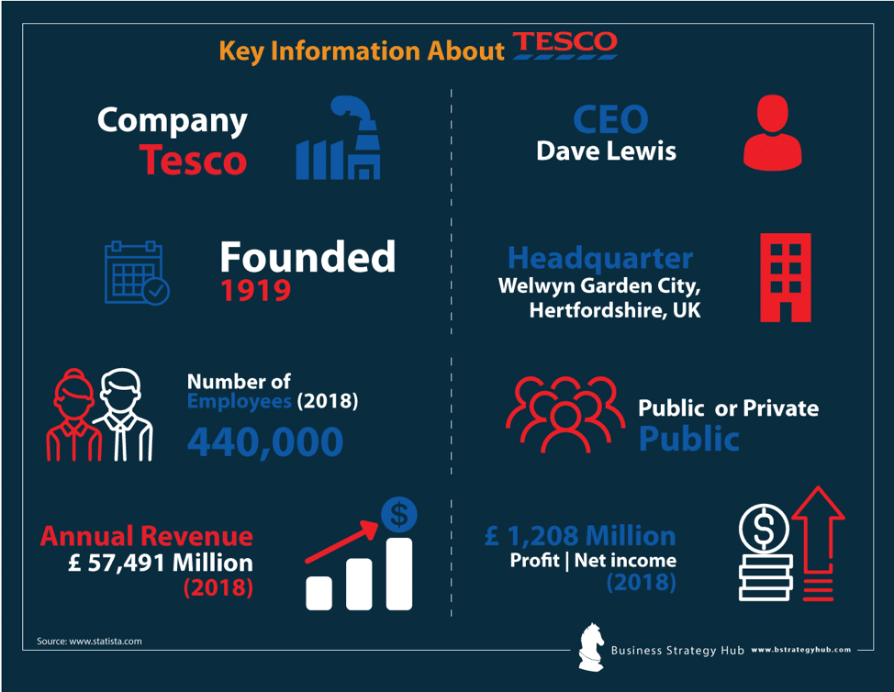
Figure 1: Key Information Tesco (Tesco PLC, 2022)

Application of theories of the business environment

PESTLE Analysis

Political Factors
Tesco PLC's operations in Indonesia are most susceptible to the influence of political issues from the outside world. This is because of the global political variables that come into play when doing business on a global scale. Within this framework, the tax rates, as well as the political environment, are strongly connected to the operations of Tesco PLC. Because of the country's precarious financial situation, this company may be forced to scale back its activities and investments in Indonesia (Apriliyant and Kristiansen, 2019). As a result, Tesco plays an important role in ensuring the job security of its employees and increasing the diversity of its staff.

Economic Factors
Tesco PLC's primary worry, due to price policies and leverage regulations in the country, is also the economic issues affecting the country. Within this framework, Tesco PLC is continually aware of any changes that may occur in the economic policies of Indonesia (Aribawa, 2016). If this does not happen, the changes in financial rules and the currency could result in significant losses for Tesco PLC because the company focuses primarily on the UK market.

Social Factors
According to current trends, customers in the Indonesian region are gravitating toward bulk buying and shopping at a single location for all of their needs. This may be the result of a variety of socioeconomic developments that have occurred in Indonesia over the past few decades (Rokhman and Ahamed, 2015). As a direct consequence of this development, Tesco PLC has increased the number of non-food products that can be purchased at their various retail locations. The perspectives and dispositions of consumers, which are in turn impacted by the social conditioning they have received, are the key variables that are responsible for determining the kinds of goods and services that they have an interest in acquiring. Tesco is adapting its business model to account for these changes in customer behaviour by satisfying the rising market for organic goods (Purwati et al., 2021). The reason for this is that consumers are becoming increasingly aware of the importance of maintaining a healthy lifestyle, which is leading to a shift in the way that they continuously think about it and approach food.

Technological Factors
The rapid innovation and technological advancement, Tesco PLC has developed its operation and supply chain management system. This has increased the opportunities in Indonesia for the employees. Two of the most important ones were the creation and execution of shopping online in Indonesia, replete with possibilities for home delivery. Online shopping was also one of the first things to be offered in Indonesia. This was the second of two significant ones that occurred. Second, the implementation of self-service checkouts has resulted in a decrease in the price of labour by making things more simple and less unclear for clientele, which has led to a decrease in the overall cost of labour (Tesco PLC, 2021). In addition, Tesco PLC has capitalised a sizeable amount of money on initiatives that improve energy to realise its short and long-term goal of reducing the company's overall environmental impact. It is done to achieve the goal of lowering the firm's carbon intensity (Tesco PLC, 2021).

Environmental Factors
Despite the increasing amount of pressure which is being placed on business owners to address environmental issues and enforce business practices that are positive for society, Tesco PLC has clarified that it aims to trim its carbon footprint by 50 per cent by the year 2020. This goal will be achieved regardless of whether or not other businesses follow Tesco's lead (Tesco PLC, 2021). In addition to this, Tesco is working to elevate the level of collective consciousness among its clientele to cut down on the quantity of waste that is produced within its stores (Tesco PLC, 2021).

Legislative Factors
The laws and guidelines which are imposed by the government are other factors that have a direct influence on Tesco PLC's level of performance. For instance, the Foreign Agricultural Service of the United States Department of Agriculture in Indonesia suggested in 2017 that a Code of Conduct ought to be put into action. This Code of Practice would make it illegal to engage in a large number of the practises that are currently accepted, such as changing pricing without providing adequate notice or pressing for payments from vendors (Meylinah and Slette, 2014). Tesco PLC provides its customers with price cuts on the energy they purchase, based on the amount invested in their grocery shops, intending to make these programs more accessible and simple for their customers. In addition, there are a variety of special discounts and promotions that reduce prices (Tesco PLC, 2022).

SWOT Analysis
Strength | Weaknesses
- Tesco is the best retailer and grocery store in the UK. It has high revenue and sales to globally expand its business such as in Indonesia (Tesco PLC, 2022).  - The presence in other 14 countries is evident in the successful expansion (Wood, Wrigley and Coe, 2017).  - Tesco PLC covers a diversified market and product range which can benefit them to engage with the customers of Indonesia (Rosnizam et al., 2020).  - The option of online shopping is also an advantage to put their step in Indonesia (Rosnizam et al., 2020). | - The operational failure in US and Japan can be a weakness in expansion to Indonesia (Wood, Wrigley and Coe, 2017).  - The 8% decrease in market share and profit in recent years can cause fear of more investment in Indonesian markets  - The low-cost strategy can be a weakness in Asian markets (Wood, Wrigley and Coe, 2017).  - The public negativity due to selling expired products can cause them to decrease in maintaining trust among consumers (Wood, Wrigley and Coe, 2017).
Opportunity | Threat
- The strategic partnership with other stores in Indonesia can be a huge opportunity for Tesco PLC  - The emerging markets in Indonesia can benefit Tesco PLC operations in future.  - The delivery services can be an advantage for Tesco PLC. | - The competition in Indonesian markets for Tesco PLC can be a threat.  - The recent economic crisis and pandemic can disrupt the expansion in Indonesia.  - The supply chain issues in Asian markets can be challenging for Tesco PLC.
Table (1): SWOT Analysis

Opportunities and Challenges

Corporate governance
From an Indonesian point of view, there are problems with corporate governance that revolve around the operation of businesses in terms of rules. On the other hand, certain nations, like Malaysia, already have developed economies, which make it easier for businesses to grow in those nations. At the same time, Indonesia is considered a developed country even though its regulations have not been improved in a way that is more favourable to businesses (Muda et al., 2018). In the case of Tesco PLC, the company law obligates the company's commercial activities to respect the social and environmental measures that are in place. In the same vein, the GR 47 of Article 5 requires businesses like Tesco PLC to adhere to moral and ethical standards when conducting their operations. In Indonesia, businesses are required to adhere to the regulations for the creation of financial plans and budgets (Government, 2022). On the other hand, the investment law in Indonesia obligates businesses to engage in corporate social responsibility, which presents opportunities for those businesses. The increase in sustainability is advantageous to the markets in Indonesia, and it may be to Tesco PLC's advantage to rapidly expand in the country (Bunawan, 2017).

Business strategy
When it comes to putting a company strategy into action, there are many obstacles to overcome, including complicated bureaucracy, a lack of transparency, problems with the supply chain, and the development of infrastructure (Agustia et al., 2017). According to the report of Dick and Mulholland, (2016), corruption is a serious issue that needs to be addressed in the business strategy of Indonesia. It deprived developing economies of the investment opportunity as well as the chances for economic expansion. In the case of Tesco PLC, the operation of the supply chain may present the company with significant challenges. The high cost of logistics and the pervasive culture of bribery continue to be important obstacles to doing business and investing in Indonesia. In addition to this, European enterprises also have the potential to benefit from doing business in Indonesia (Gantino, Ruswanti and Rachman, 2017).

Cultural sensitivity
Tesco PLC may find it difficult to sell products and cater to the preferences of customers in Indonesia due to the country's unique culture. This is because the culture of Indonesia has a significant emphasis on impersonal ties and large commercial networks (Claramita et al., 2020). Concurrently, it is challenging to interpret an Indonesian language and responds straightforwardly. However, they also convey indications that cannot be understood verbally, such as through their body language and eye contact. While this is true, people in Indonesia tend to avoid saying exactly what they are thinking and put up significant effort to avoid offending others (Sutan and Berkat, 2014). Prejudices held by employees of a company like Tesco PLC can also be a problem for the company as a whole and cause bottlenecks in the processing of various business operations. The unique methodologies employed by multinational corporations are sometimes misinterpreted and rejected by local businesses due to cultural differences. On the other side, sensitivity to culture can also create opportunities for businesses to obtain rapid growth and development by comprehending and embracing alternative methods of doing business. In the instance of Tesco PLC, the company needs to be able to distinguish between the components of contact that are brought about by cultural sensitivity and those that are brought about by differences in cultural viewpoint.

Barriers experienced by foreign businesses in Indonesia
The nation of Indonesia is home to a plethora of natural resources, and it is the world's fourth-largest consumer market overall. As a result, the biggest archipelago in the world has massive untapped potential for expansion, particularly among international companies with their eyes on the local market (Tambunan, 2019). As a direct result of this expansion, Indonesia is now home to some start-up companies with the potential to become unicorns. A corporate culture, a complex market, the continuation of corruption, an elaborate tax structure, governmental inefficiency, and a population that solely uses mobile phones are among the key obstacles that must be overcome when conducting business. As per the findings of the Business Confidence Index for 2019, around sixty per cent of respondents indicated that they still had a favourable outlook on conducting business in Indonesia over the following twelve months. Despite this, investors continue to be concerned about some things that are beyond our control. As outlined by Rosyadi et al., (2021), Indonesia is an archipelago that consists of more than 17,000 islands and has a population that speaks 500 different languages. It is without a doubt a challenging environment in which to conduct business. It is confirmed by research that was conducted by TMF (2020), which shows that Indonesia was placed first as being the market that is the most difficult to conduct business in. This highlighted a challenge for internationally-based companies like Tesco PLC operating in Indonesia. In addition, bribery and corruption are still prevalent aspects of everyday business life, which presents considerable challenges for international companies like Tesco PLC operating in Indonesia. According to the findings of the Business Confidence Index for 2019, 51 per cent of international investors are concerned about the possibility of corruption, which is an increase from 43 per cent in 2018 and 49 per cent in 2017As outlined in this study, another obstacle is that Indonesia has a complicated bureaucracy and a lot of red tapes. To successfully conduct business in Indonesia, investors will need to communicate with a great number of distinct organisations and ministries.

Recommendation
It is recommended to Tesco PLC should keep an eye out for the loosening of regulations governing labour to reduce the amount of paperwork required, lowering of barriers to investment, and strengthen institutions and regulations to combat corruption. This points to opportunities for Tesco PLC to grow its operations in Indonesia, which is encouraging news for the company. Similarly, the government should have made efforts to simplify the procedure, such as through the implementation of the Online Single Submission system (2018). However, businesses still require a few weeks of preparation time before their organisation is ready to debut. When conducting business in Indonesia, Tesco PLC must comply with a significant number of tax orders. This is true for individual business owners as well as corporations like Tesco PLC. The Indonesian government has indicated that it intends to prioritise some structural reforms in the year 2021. It is recommended that businesses aiming for a "fast win" look elsewhere; yet, the potential benefits of conducting business in Indonesia can be quite substantial. It may take some time to build the essential relationships before any financial rewards materialise, and businesses should be aware of this fact and account for it when planning their strategy for entering new markets.

Conclusion
In conclusion, the report has highlighted the primary challenges in doing business including business culture, complex market, the persistence of corruption, an elaborate tax system, bureaucratic inefficiency and a mobile-only population. It is concluded that the presence of complex markets in Indonesia demonstrated a barrier for foreign businesses like Tesco PLC in Indonesia. Furthermore, corruption and bribery remain regular characteristics of business life and significant barriers for foreign businesses like Tesco PLC in Indonesia.
References
Agustia, D., Muhammad, N.P.A. and Permatasari, Y., 2020. Earnings management, business strategy, and bankruptcy risk: evidence from Indonesia. Heliyon, 6(2), p.e03317.
Apriliyanti, I.D. and Kristiansen, S.O., 2019. The logic of political business in state-owned enterprises: the case of Indonesia. International Journal of Emerging Markets.
Aribawa, D., 2016. E-commerce strategic business environment analysis in Indonesia. International Journal of Economics and Financial Issues, 6(6), pp.130-134.
Bunawan, P., 2017. Foreign investment in Indonesia the legal aspects under the new indonesian investment law. Dialogia Iuridica, 8(2), pp.01-14.
Claramita, M., Arininta, N., Fathonah, Y., Kartika, S., Prabandari, Y.S. and Pramantara, I.D.P., 2020. A partnership-oriented and culturally-sensitive communication style of doctors can impact the health outcomes of patients with chronic illnesses in Indonesia. Patient Education and Counseling, 103(2), pp.292-300.
Dick, H. and Mulholland, J., 2016. The politics of corruption in Indonesia. Geo. J. Int'l Aff., 17, p.43.
Euro Monitor Indonesia (2010). Available at: https://www.euromonitor.com/indonesia (Accessed: 12 August 2022).
Gantino, R., Ruswanti, E. and Rachman, T., 2017. Performance model: Environmental uncertainty, decentralization of authority and business strategy on managerial performance (property and real estate and food and beverage sectors listed on Indonesia stock exchange). International Journal of Economic Research, 14(12), p.2017.
Meylinah, S. and Slette, J., 2014. Indonesia Sugar Annual Report 2010. USDA Foreign Agricultural Service. Global Agricultural Information Network(GAIN) Report.
Muda, I., Maulana, W., Sakti Siregar, H. and Indra, N., 2018. The analysis of effects of good corporate governance on earnings management in Indonesia with panel data approach. Iranian Economic Review, 22(2), pp.599-625.
Purwati, A., Budiyanto, B., Suhermin, S. and Hamzah, M., 2021. The effect of innovation capability on business performance: The role of social capital and entrepreneurial leadership on SMEs in Indonesia. Accounting, 7(2), pp.323-330.
Rokhman, W. and Ahamed, F., 2015. The role of social and psychological factors on entrepreneurial intention among Islamic college students in Indonesia. Entrepreneurial Business and Economics Review, 3(1), p.30.
Rosnizam, M.R.A.B., Kee, D.M.H., Akhir, M.E.H.B.M., Shahqira, M., Yusoff, M.A.H.B.M., Budiman, R.S. and Alajmi, A.M., 2020. Market opportunities and challenges: A case study of Tesco. Journal of the Community Development in Asia (JCDA), 3(2), pp.18-27.
Rosyadi, S., Kusuma, A.S., Fitrah, E., Zayzda, N.A. and Pimoljinda, T., 2021. Barriers of public policy faced by SMEs of creative economy in Indonesia. International Journal of Law and Management.
Sutan, R. and Berkat, S., 2014. Does cultural practice affects neonatal survival-a case control study among low birth weight babies in Aceh Province, Indonesia. BMC pregnancy and childbirth, 14(1), pp.1-13.
Tambunan, T., 2019. Recent evidence of the development of micro, small and medium enterprises in Indonesia. Journal of Global Entrepreneurship Research, 9(1), pp.1-15.
Tesco PLC (2022). Annual Report. Available from https://www.tesco.com/ [Accessed 12 August 2022].
Wood, S., Wrigley, N. and Coe, N.M., 2017. Capital discipline and financial market relations in retail globalization: insights from the case of Tesco plc. Journal of Economic Geography, 17(1), pp.31-57.

