University of Wales Trinity Saint. David
Name: Mohammed Amir Rashid
Student Number: 1714326
Supervisor: Prof. Dennis Pepple
Exploring the role of equal opportunity in employee engagement in the telecommunications industry.

DECLARATION
I declare that this dissertation has been written solely by myself and that it has not been submitted, in whole or in part, in any previous application for a degree in this university or any other institutions. In addition, I have acknowledged all main source/s-author/s appropriately in parts of this dissertation where I have quoted work from others.

Abstract
The purpose of this research is to broaden various factors as well as the importance of exploring the role of equal opportunity in employee engagement in the telecommunications industry where there has been an identified gap that can impact the role of equal opportunity in certain areas of the telecommunications.
Research was conducted using different strategies, methods and theories by previous researchers who also identified problems which need to be implemented within the current time. Human Resource management has a huge part to play when it comes to the problem-solving and decision-making processes which is required to increase employee engagement, equal opportunity, and productivity within the telecommunications industry towards the potential employees.
Within the literature review chapter there has been articles which have been supported with relevant research which relate to the topic of equal opportunities in employee engagement within the telecoms industry within the UK. This chapter also explains and addresses the impact of equal opportunities within the telecoms industry as well as the impact of employee engagement.
Furthermore, the literature review is also backed by a relevant theory which is the Maslow’s employee engagement model which is a theory of motivation fulfilling the five basic human needs involving physiological needs, safety, love and belonging, esteem and self-actualisation which led to higher engagement. This chapter also covers the impact of workplace culture on employee’s performance, the decision-making process for HRM and the qualitative data research which will be conducted using annual reports, conceptual framework, and content analysis.
The methodology chapter will be focused on creating an understanding for the research which can give an accurate assessment of causes and the effectiveness of relationships between independent and dependent variables. This is where the secondary data research will be conducted with the interpretivism philosophy which will be used with qualitative and quantitative sourced data to create clarity between the researcher and research subject.
In the findings chapter this will outline the role of equal opportunities in employee engagement in the telecoms industry and both positive and negative results impacting employee engagement and equal opportunities which have an impact on the telecoms industry.
Furthermore, in the conclusion and recommendations chapter the usefulness of the research will be conducted, and further recommendations will be detailed on how equal opportunities in employee engagement can create a positive working environment and how employees can be motivated to keep the telecommunications industry a positive environment to create equal opportunities.

Table of Contents

CHAPTER 1: - introduction
- Background and problem review
1.1 Research aims.
1.2 Research objectives
1.3 Research questions
1.4 Relevance of study
1.5 Research methodology
1.6 Project structure

CHAPTER 2: Literature Review
- Introduction
Research areas: -
2.1 What is equal opportunity and why is it important?
The origin of equal opportunity debates
The factors which influence equal opportunity.
2.2 The impact of equal opportunity within the telecoms industry
2.3 What is employee engagement and why is it important?
Factors which influence employee engagement.
2.4 Why focusing on equal opportunity is important.
The impact of employee engagement within the telecoms industry
The importance of employee engagement
2.5 Impact of workplace culture on employee’s performance
2.6 Current gap within the telecommunications industry
2.7 Maslow’s employee engagement model supporting the role of equal opportunity on employee engagement.
The decision-making process of HRM
2.8 Qualitative data research using annual reports and the conceptual framework.
Content analysis
Summary of the gap
2.9 Chapter summary
CHAPTER 3: Research Methodology
- Introduction
3.1 Research design
3.2 Research philosophy
3.3 Research approach
3.4 Methods for data collection
3.5 PRISMA model
3.6 Ethical considerations
3.7 Chapter summary

Chapter 4: Results and Analysis of findings
- Overview of findings
4.1 Table summary of articles
4.2 Analysis of results
4.3 Discussion of results
Chapter 5: conclusion and recommendations
- Summary of findings
5.1 Conclusion
5.2 Recommendations
References

CHAPTER 1: introduction - Background and problem review
It has become transparent that the role of equal opportunity within the telecommunications industry should be limitless. Equal opportunities should not have a limit on any individual on who is to have such an opportunity within the industry. The purpose of this is to help to bring and unite all cultures together which includes employees and all internal stakeholders towards the common goal of telecommunications.
This helps the industry as well the employees to show their experience and expertise within their given field which can increase productivity and employee engagement according to (Reed, 1996). The role of equal opportunity and employee engagement have different variables related to Gender, Age, problem-solving and decision-making techniques, communication (both verbal and literal) and motivation.
1.1 Research aims.
To investigate how equal opportunities and work inclusivity influence employee engagement through secondary data analysis using systematic review.
1.2 Research objectives
To explore how organisations are creating equal job opportunities and fairness for employees as well as job applicants.
To explore how organisations are creating inclusivity where people’s differences are valued and used to enable individuals to thrive at work.
To explore how organisations actions in 1 and 2 above influence employee engagement.
1.3 Research questions
How are organisations creating equal job opportunities and fairness for employees as well as job applicants?
How are organisations creating inclusivity where people’s differences are valued and used to enable individuals to thrive at work?
How organisations actions in 1 and 2 above influence employee engagement?
1.4 Relevance of study
The relevance of the study is to indicate factors of the equal opportunity in employee engagement within the telecommunications industry which affects the various fields of the industry including the selection process of recruiting potential employees for specific areas of the industry such as the gender gap in recruiting a repair technician within the repairs field of the industry.
A research was conducted which explored the gender culture at a telecommunications company where it was gathered that female internal stakeholders met with a lack of understanding of what is required from them as an individual to meet the needs to satisfy potential customers as well as company growth which is why equal opportunities has become biased within the telecommunications industry in the upcoming years and has potentially worsened according to (Nagy, B. and Vicsek, L., (2014).

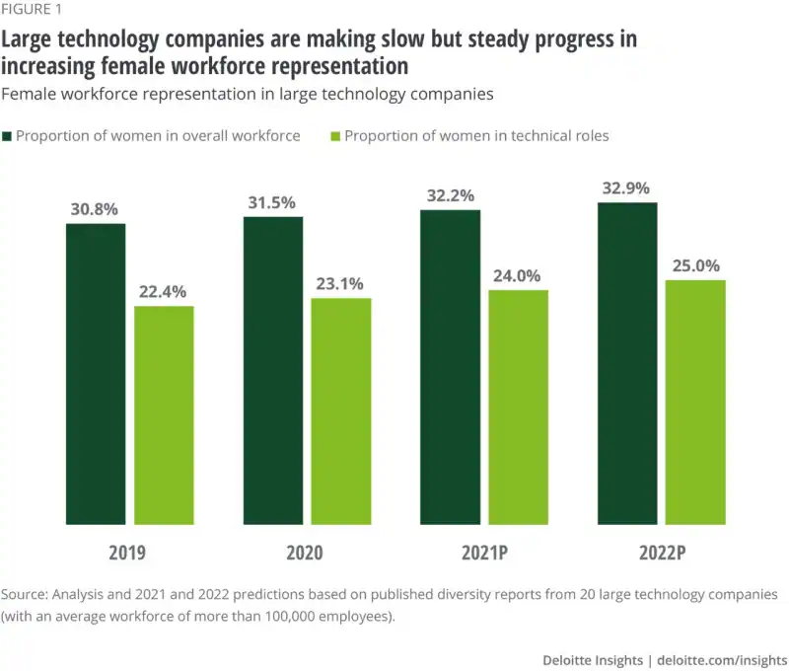

Above is a diagram which shows the analysis that has been conducted by previous researchers which were predictions predicted in between the year 2019 and 2022. This shows the percentage of women in the overall industry being at 30.8% in 2019 and had then risen to 32.9% 3 years later which is only a small increase of 2.1% which is still 17.1% away from where we should be today in 2023 to execute the 50% equal opportunity rights for the female workforce according to (Hupfer, et al.,2021).
1.5 Research methodology
This research will be conducted using a secondary data research to be able to obtain appropriate data which is effective and has been analysed by other potential researchers which makes the appropriate data authentic and saving time consumption by having to source this data manually as an individual which can take a huge amount of time and effort.
This as a result will save Significant amount of money on essentials and tools to collect data when data is available from researcher’s who have conducted their research in the same field. As a result, utilizing existing data for research is becoming more prevalent, and therefore secondary data analysis. While secondary analysis is flexible and can be utilized in several ways, it is also an empirical exercise and a systematic method with procedural and evaluative steps according to (Johnston, M.P., (2014).
1.6 Project structure
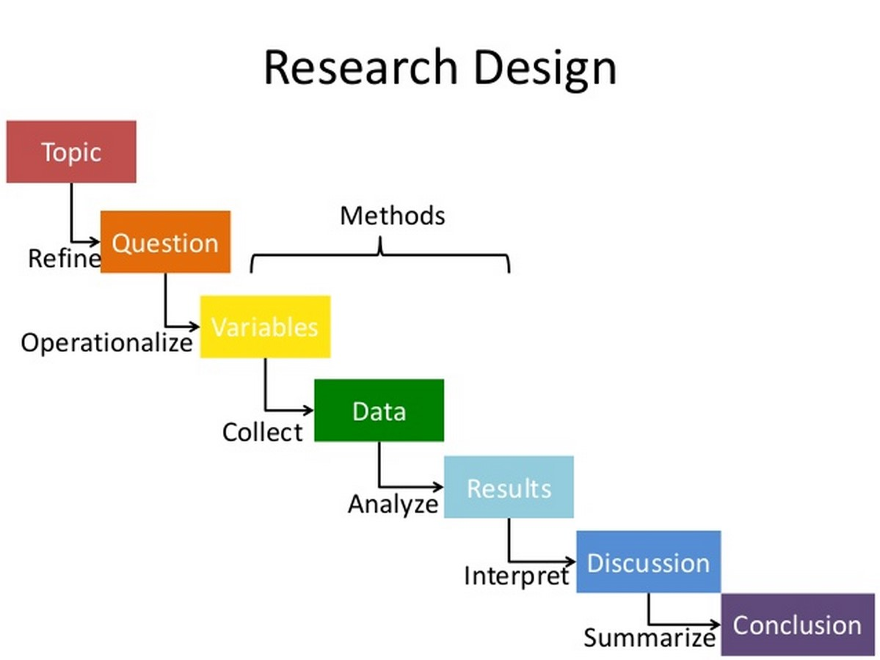
CHAPTER 2: Literature Review
Introduction
This research has identified potential factors affecting the gender gap within the telecommunications industry which has an affect on equal opportunities as well as employee engagement. This then becomes the duty of HRM to who ensure to policy creations, strategic planning, recruitment, training and development, employee and labour relations and risk management all of which are duties which should be conducted by a HRM professional and such duties in place can decrease the problems with employee engagement as well as the affect that there is in this current time with equal opportunities with the gender gap within the telecommunications industry according to (Greenwood, M.R., (2002).
Within this research of literature, it will help to better understand and recognise the importance and impact of the conducted research as well as the outcome. It is a well-known fact that industries who offer equal opportunities to every employee helps to build a more positive and diverse workforce and without following the equality act may mean indirectly discriminating against workers which is a high risk with certain protected characteristics according to (Kraal, K., Wrench, J., Roosblad, J. and Simon, P., (2009).
2.1 What is equal opportunity and why is it important?
Equal opportunity is to ensure that everybody has an equal opportunity and that is whether they have a disability, their beliefs and religion is different as well as their background, lifestyle, and gender. This creates a diverse workforce for industries such as the telecoms business because it shows appreciation to colleagues and employees around the business that their values, beliefs, cultures, and lifestyles are being respected and appreciated which can lead to an increase of motivation, employee retention, employee engagement, performance management and comfortability to work as part of a team. The purpose of equal opportunity within a working environment is to protect the right of equal opportunities for every employee and the main aim is to prevent sexual harassment, promoting gender equality and discrimination within the workplace.
The importance of equal opportunity is to create value opportunities and fairness because across demographic groups when there are employees who feel that have been given an equal opportunity they are aware of the advancement of the industry and believe the workplace system is fair with everyone, they feel much happier with their career progression, they have long term plans to stay with the company longer and are also likely to recommend and leave great feedback as an experience for them for more potential growth adding value to increase the number of potential employees who are also willing to join the business to help it grow with their skills and experience.
The origin of equal opportunity debates
Equal concept of opportunity comes from an examination which was conducted by a philosopher known as Peter Westen. Weston had showed that opportunity is conducted in a three-way relationship which is between a person, obstacles, and the desired goal however an individual would only have an opportunity if he/she has a chance of achieving the specific goal.
Equal opportunity is debated in certain fields which involve political philosophy, psychology, and sociology. This is applied to help increase wider areas beyond employment and this includes housing, admissions, rights, and lending. Many factors and debates which are faced today in the world of work involve racial equality, gender equality, LGBTQ equality, equal employment access, income equality and religious equality most of which are found within the telecoms industry.
Laws and regulations have been set out in the UK to avoid such situations from happening in workplaces within the UK. The laws introduced by the UK government are to protect potential employees as well as job applicants against employment discrimination and factors which are covered by these laws involve unfair treatment which can be due to colour, religion, culture, race, sex, gender identity, sexual orientation, disability, genetic information, and national origin. All workforces are to follow these rules and regulations set out by the UK government but at the same time some speculate and debate over whether enough is being done to ensure it will be prevented.
Many workplaces question whether humans are born to with equal opportunity which makes it a must for all workplaces to follow as they believe they can reserve the right to refuse and innate legal and political freedoms which has created a huge speculation for many businesses and hence why rules and regulations in workplaces such as telecoms begin to have issues related to equal opportunities amongst their potential employees which justifies the high percentage of unsatisfied employees who have reported discrimination of gender equality and the skills gap amongst women leaders within the industry.
The factors which influence equal opportunity
A study has suggested that a thicker conception of equality of opportunity isn’t really classified appropriately as being formal as there are still factors which affect businesses today which include nepotism and direct discrimination which are based on factors including gender equality, race, religion, beliefs, skills, culture, and sexual orientation which all undermine the equality of opportunity.
The biggest factor affecting the telecoms industry is the gender gap where women are discriminated of their gender which is why many lack the skills gap in managing the telecoms sector. This has a huge influence on their performance as there is lack of training for women to increase their skills set to increase performance and productivity within the industry which is caused by biasness as it is believed that men have the correct and adaptative skills to execute the job sufficiently according to (Sally, 2023).
Other factors which are influenced by equal opportunities involve diversity and inclusion. Diversity is a factor which recognises differences between a group of disparate people. It acknowledges benefits which have a range of perspectives when it comes to making decisions within the workplace as well as the workplace representing the organisations customers. Every individual in a diverse workplace set of perspectives, life experiences, religious and cultural differences, and work so, advantages can only be taken once these differences are recognised which is why its important for workplaces to promote value to one another and respecting each other.
When it comes to inclusion this is where people’s differences are valued and then used to ensure everyone thrives at work. An inclusive workplace shows everyone feel they belong there without having to conform that their contribution matters which they can then perform to their fullest potential regardless of their identity, gender, circumstances, background, culture, religion, and beliefs. Inclusive workplaces practice the fair policies act to enable a diverse workforce so that everybody can perform effectively.
2.2 The impact of equal opportunity within the telecoms industry
Research has been carried out to define equal opportunity within the telecoms industry where it is apparent that it can increase the diversity of an organisation and its potential employees if the labour market has included groups which have been previously discriminated against. However, increased diversity is typically professed to bring three different types of benefits which include better service to diverse customer groups, increased and greater innovation and customer approval according to (Riley, Metcalf and John, (2021).
The telecommunications network equality has a vital role when it comes to bridging the global divide in between developing countries and countries which are already developed and this is by providing equal access to telecommunication services where countries can progress and accelerate their economic development as well as participate effectively in the global digital economy and reduce their inequalities according to (Sally, 2023).
The impact of equal opportunity within the telecommunications industry is focused on breaking down barriers especially of the digital divide and this is said because achieving telecoms network equality is a crucial factor for having a fair and inclusive society according to (Gruber, et all., 2011).
So, the telecoms industry has focused on expanding the coverage supplied to customers including employees and have been working on improving infrastructure which they believe increases accessibility so that this is a technique to open doors as well as unlock opportunities for individuals, communities, and economies worldwide to work together to create equal opportunities for everybody according to (Iversen, T, et all, 1998).
Moreover, the impact that equal opportunity has within the telecommunications industry is that it is reducing employee turnover as well as recruitment costs however, if there isn’t any discrimination, prejudice or biasness employees feel much safer at work and are able to be themselves, increase productivity, give them the ability to perform to their fullest potential and feel satisfied which means they are more likely to stay with the business in the long term which the industry can then benefit from reduced employee turnover and recruitment costs according to (Minett, (2022).
According to a recent study research was conducted into the gender diversity within the telecommunications industry where it had been gathered that the women who are leaders within majority of the telecoms industries showed a percentage of 25% within the UK and 45% in North America which is a substantial 20% difference. The reason given for the substantial difference related to an explanation given from senior leaders who stated there is a huge skills gap around science, technology, engineering, and maths better known as (STEM).
This has a significant impact on equal opportunities on gender equality especially within the UK telecommunications industry although the percentage had increased by a fair 18% taking the current percentage to 38% this is still a problem which impacts gender equality within the UK telecoms industry leaving women with a 12% difference less than men to be able to obtain a role within the senior sector of a telecoms business which as a result gives men 12% more advantage and likelihood of being employed by a telecoms business than men according to (Molina, Lin and Wood, 2015).
2.3 What is employee engagement and why is it important?
Employee engagement is one of the biggest and most important factors in gauging work satisfaction. This is said because employees want to be involved in their work, be enthusiastic towards the organisation they are working for which for the employee creates a sense of belonging and be given flexibility around schedule and their current workplace location. Employee engagement is a function of relationships between employees and an organisation which is about making necessary improvements for the workplace as well as the culture so that employees feel connected and dedicated towards the business goals and the values of the business.
The importance of employee engagement is to direct engagement with employers to work with them and to create/adjust job roles which are best suitable for their employees based on their skills set and performance which can prove to be highly effective where employees are needed around the business.
Employee engagement has always been a well-known factor for businesses but as of today and future planning for businesses it has become a fast-paced and constant changing business landscape for businesses as it has become more important than ever because engaged employees are more productive, loyal and are most likely to stay with the business in the long run.
Factors which influence employee engagement
Factors which influence employee engagement involve increasing productivity and this is said because engaged employees are innovative which means they always have an idea about what they can do better and the quality of being collaborative and enthusiastic towards the world of work allows them to complete their workplace goals effectively and this is believed to be a lead to increased workplace productivity.
Factors which affect employee engagement and workplace productivity include feeling supported by one’s supervisor, common goals, vision, communication, trust, social cohesion, and information sharing, and this is said because employees want to be able to feel valued and respected within the workplace so they would want to know that their work is meaningful as well as their ideas being heard and taken on board.
Managers also influence employee engagement, and this is said because managers are the critical link between the business and the employees so, they do this by establishing a clear and straight forward objective for their teams which would ensure people understand their roles and what is required of them in a better way which managers believe this helps to set the tone of the business.
Tracking and providing feedback on employee performance can also influence employee engagement even though feedback is all a part of making employees know where they stand but can have an impact on their performance if in some instances feedback is too harsh for an individual to handle may lead to decreased performance output which can influence other factors of the business negatively involving low productivity, employee retention, behaviour, customer satisfaction, customer service and profitability.
2.4 Why focusing on equal opportunity is important.
The importance of focusing on equal opportunity is based on equality and diversity practises which ensures that services which are being provided are accessible and fair to everybody. This ensures that people are treated fairly and equally, and that people get the dignity and respect that they deserve which leads to their differences being valued which is what makes this very important for businesses to consider.
It is also important for businesses such as the telecoms industry to ensure employees have an equal chance of succeeding regardless of the gender, culture, background, personal circumstances, and religion. Focusing on equal opportunities is now a huge important factor for businesses who promote diversity and inclusion which means different perspectives and ideas are represented and valued and this can lead to accurate decision-making and problem-solving outcomes.
When people work along side each other as a team especially from different backgrounds creates a better and more positive workplace culture within the business as this can bring new and unique perspectives to the table which can lead to more creative and effective solutions. Furthermore, a diverse workforce can lead to creating positive and better relationships with suppliers and customers because as a business they would understand and cater to the needs of different groups of people.
Additionally, these factors can lead to building trust between employees and management as well because everybody knows they would be treated fairly and opportunities and promotions will be based on merit but not on the factors which involve age, gender, culture, religion, sex, race, personal circumstances etc.
The impact of employee engagement within the telecoms industry
When it comes to employee engagement it plays a critical role in creating a sustainable competitive advantage especially in the highly competitive and rapid growing telecoms industry. A recent study has suggested that employees who are actively engaged are less likely to be open to sourcing a new job opportunity and the employees who are less likely to be engaged typically endure turnover rates which are 18% to 43% higher than other engaged employees which can negatively impact engaged teams as a whole which can prevent highly engaged teams which can disband and create other potential problems for HRM to deal with internally and negatively impact the industry as a whole according to (Sharma, J. et all, (2018).
Employee engagement can lead to motivation, this is said because employees who have good quality jobs are known to be well managed therefore will be very happy, healthy, and more fulfilled. Employees like this are most likely to drive productivity, provide better products and services and innovation which is an essential not only to the telecoms industry but other industries and businesses as well. The factor that impacts employee engagement the most is job satisfaction where employees don’t tend to feel satisfied with their job and makes it very difficult for them to be and feel engaged within the world of work. This factor can affect their daily duties as well as the company itself according to (Patro, C.S., 2013).
Employee engagement can also lead to an affect of the overall telecommunication industry success which can cause a huge impact on revenue. If employee engagement is affected there isn’t a strong connection between the employee and what is required of them which as a result reduces productivity, affects their performance level, and decreases profitability for the industry. According to a meta-analysis by the Harvard Business Review, companies with highly engaged employees experienced an average 21% increase in profitability according to (Karthikeyan, 2023).
When it comes to retaining employee’s employee engagement can have a significant impact on the telecoms industry and this is said because when employees are engaged, they can develop a strong connection with their work and this creates motivation where they feel valued and appreciated and this fulfilment and purpose can increase the overall job satisfaction which makes an employee more than likely to continue their future with the industry.
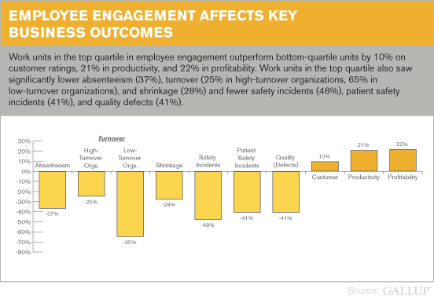
When it comes to business outcomes these are also be affected by employee engagement and this is because high employee engagement equates to less absenteeism as well as less turnover, less defects, and less theft but the more safety there is this can increase better quality, profitability and most importantly number of happy customers increases. This is why telecom companies who have better levels of employee engagement quickly outperform their competitors in every area.
The most important factors which are affecting business outcomes within the telecommunications industry are customer loyalty/engagement, profitability, productivity, turnover (for high-turnover and low-turnover organisations), safety incidents, shrinkage (theft) and absenteeism all of which affect organisational outcomes by employee engagement within the telecoms industry.
The importance of employee engagement
The importance of having employee engagement within the world of work in the telecommunications industry is so that effective strategies are in place which helps to create a positive workplace culture and this leads to a reduction of staff turnover which also can increase productivity to build better work and customer relationships which have a positive impact on company profits according to (Markos, S. and Sridevi, M.S., 2010). Employee engagement is an extent to which the employees of the industry feel more passionate about their job role and are hence committed to the organisation and put discretionary effort into their work for the business.
The purpose of using employee engagement as a strategy within the telecoms industry is to make this a business objective because engaged employees tend to lead to long-term employee retention, and this increases their overall performance within the industry and improves the quality of work produced by the employees which can in return be rewarding with recognition for their hard work. Rewarding employees for their hard work because of ability to engage effectively is also an important factor within the telecoms industry because when they have done a good job this helps them to feel appreciated and important. Employees are more than likely to show their reactions in a positive and productive way when management shows them how appreciative they are for their hard work and efforts.
HRM have fostered a stimulated working environment for employees by introducing, implementing, and organising engagement activities. This then gives HR the ability to see the value of the contributions made by effective employees and to be able to then recognise productive collaboration which also can help to measure the HR department who play a vital role in gatekeeping for employee engagement. Industries such as the telecommunications who have high employee engagement reduce both their turnover and their hiring costs and as for disengaged employees, they are a major factor who contribute to the high employee turnover.
When it comes to Human Resources (HR) they use the concept of employee engagement which to them describes the level of enthusiasm as well as dedication employees feel about their current job responsibilities so that they know engaged employees care about their work as well as their performance of the company which makes them feel valued and understand that their efforts, achievements, and achieved goals impacted the industry positively and made a difference. HR tend to use the achievement and progression technique which to them are the five important C’s when it comes to employee engagement which are care, connect, coach, contribute and congratulate when monitoring employee engagement and employee performance.
HR managers then promote recognition as a strategy to keep potential employees engaged where they promote peer-to-peer recognition platforms which let their employees thank the colleagues they work in a team and even give props after the job that’s handled and performed well which is known to be an indicator of the best low-cost and high reward initiative in engagement that HR departments can implement within the telecoms industry according to (Romera, 2022).
2.5 Impact of workplace culture on employee’s performance
The impact of having a strong company culture gives employees the opportunity to grow, and this is by keeping them motivated with incentives by offering career development programs, extra training and offering promotions which in return improves the business performance when individuals are motivated to work as part of a strong bonded team who are also motivated which as a result will put forward extra effort to achieve organisational goals. Organisational culture also affects the performance of an individual because a good culture has employees which potentially respect and trust their employer which makes them proud to work within the business and feel that their personal goals are respected in return.
The impact of the culture within the telecoms industry on employee’s performance is quite significant as the business culture tends to attract individuals who are willing to work and be productive and even do business with the company. This can inspire individuals to then be more productive as well as be positive whilst at work to reduce turnover.
This can then potentially act as the best recruiting technique to attract qualified candidates who are willing to work and progress with the business. This is where businesses such as telecommunications use Edgar Schein’s model of organisational culture using the three layers of organisational cultures which are artifacts, espoused values, and underlying assumptions and these are different levels of important cultures which are used to shape the culture of an organisation.
The Edgar Schein’s model of organisational culture shows visible signs of the organisational culture within the telecommunications industry which is the shallowest indicator of what the actual industry culture is like. These artifacts include employee dress-codes, job titles, style, workplace design and posters. When it comes to the espoused values these are things within the telecoms industry which the industry states its ways of working and about its culture. These things are known to be team contracts, vision and mission statements, promotions, newsletters and even employee charters which give an insight to the telecoms industry culture with some level of change which are small changes.
As for underlying beliefs this is a deeper indicator of the industry culture which investigates detail the way the business really works on the inside. This includes beliefs which are held by employees which are assumptions about how they should work alongside each other and beliefs which indicate towards behaviour which can lead to workplace success of failure for example business nowadays believe that remote working has a huge positive impact for both employees and businesses but employees may believe that they feel the need to be better performing physically when they are present at work in order to create recognition for their performance according to (Egli, V.L., 2011).
When there is a weak organisational culture employees feel like they are not valued and do not enjoy their job and feel like they have no control over their jobs and this leads to employees feeling powerless even if its from working from the comfort of their home, choosing their own project or even trying a new role that has been offered to them because they don’t feel valued. This leads to employees making the decisions of performing at a low-level and even leaving their jobs which can create disbanding teams leaving the organisation with potential negative problems to deal with.
Organisational culture can really affect employee performance and the indicators this refers to are the shared values, beliefs and practices which shape the attitude and behaviour of an employee within the organisation. This is why it is hugely important for the telecoms industry to keep a strong and well-maintained organisation culture which can have a significant positive impact on the employee’s behaviour which would then lead to increased motivation, productivity, and job satisfaction according to Praveena, A. & Fonceca, Clayton. (2023).
2.6 Current gap within the telecommunications industry
The gender diversity gap within the telecoms industry has created a significant gap with equal opportunities within the telecoms industry. Having said this, women are still under-represented within different industries in the UK with the telecoms industry facing a steeper gender disparity were looking at some of the leading telecom’s industries such as Carphone Warehouse, Vodafone, and Everything Everywhere (EE), and Three (3), in only one of these industries 40% of the directors were a female gender whilst the rest of the industries had none.
This has then caused gender diversity amongst some of the leading telecom’s industries which have then created biasness within their businesses claiming women leaders not having the right levels of skills sets to execute the job role sufficiently causing a negative impact on the industry.
In telecommunications the role of IT is to constantly change pricing systems and complex systems which require sophisticated IT systems for rating, billing, and mediation so the real time processes such as prepaid accounts billing would require a fully IT-automated process chain. There have been reports within the current year 2023 which have been conducted to gather the important information on the current gap within the telecommunications industry.
This gap is believed to be 36% of employers within the industry have expected to increase the number of staff employed within the second quarter of this year. It has also been gathered that 42% of these businesses report a gap within specialist digital/IT skills gap especially within the external labour market. It is reported by many of the employees working within the industry who have reported and identified the same alarming IT skills gap within their current job roles according to (Stokes, 2023).
With 5G being launched in the year 2018 with vast majority of upgrades taking place to increase better connectivity for consumers making it a better experience for everybody there are certain skills sets which are required to achieve the huge project launched by the telecoms industry.
The impact of 5G technology within the telecoms industry is very significant as it is expected to rise the capacity and the efficiency of the mobile networks especially and enable massive technology-type communications which can give a better user experience to all consumers but without the right IT skills by 36% of employees can really negatively impact the industry which means more expenses, longer time scales to reach customer expectations and even more time consuming for potential business goals which can impact several other aspects of the business including profitability, performance, behaviour and even revenue.
The current gap with IT skills within the telecoms industry also affects the growing network for potential providers who supply 3rd party services to consumers which are provided by the telecoms industry. These begin to affect telecom trends especially the 5G interface which can potentially affect the innovation network (UKTIN).
The industry is committee to building and growing a network which can identify future skills and attractions as well as talented people but if employees do not have the correct skills to achieve this then it can be affected significantly as the industry would be lacking on finding such people with potential and people who can really drive the industry forward with their key attributes.
When it comes to a skilled workforce availability there have been as many as 86% of company executives who have named skilled workers to be the initial primary challenge which the telecoms industry is facing. The executives have also identified the second largest challenge faced within the industry is network quality and reliability which 40% of executives have stated according to (Campbell, 2023).
These results have demonstrated how important skilled training programs are for the telecoms industry as well as the safety compliance within the industry which has a demand for labour whilst the availability of the trained workers is declining. This is a huge factor which explains why there is a shortage of employees because multiple generations of younger people choose to progress with a traditional four-year college over trades as well as apprenticeships programs. Also, there is a rapid growth of advancement in telecom technology which broadens the spectrum of the required technical skills. This is why the profile of connected networks and necessary build-out requires a technical workforce where essential training programmes are needed to build a better and technical workforce.
In the year 2020 it was announced by the telecoms industry that workers can have a increase of an annual salary above the £70,000 threshold that was in place at the time without a four-year degree for skilled workers. However, in the same year 2020 the global Covid-19 pandemic had accelerated digitalization to proceed moving forward as there have been millions of workers transitioned to work remotely overnight and this led to workforces to access their work networks and tools from anyplace at any time.
So, telecom companies were given the ability to increase the delivery of reliable systems which were a must to support the new flexibility and this is how the network quality and reliability were identified as the largest challenges faced by the telecom industry by almost half of the firms involved in telecoms and this interrupted the expectations of customers, uninterrupted services due to relying on cloud, mobility services, operations, competition and the internet according to (Campbell, 2023).
2.7 Maslow’s employee engagement model supporting the role of equal opportunity on employee engagement.
When using Abraham Maslow’s theory for employee engagement this starts with fundamental means of survival which involve safety, shelter, food, and clothing. It then makes progression towards more sophisticated necessities including intangible necessities which help to achieve internal growth within an organisation. Using these necessities for internal growth involve having a sense of belonging, self-actualisation, and self-esteem.
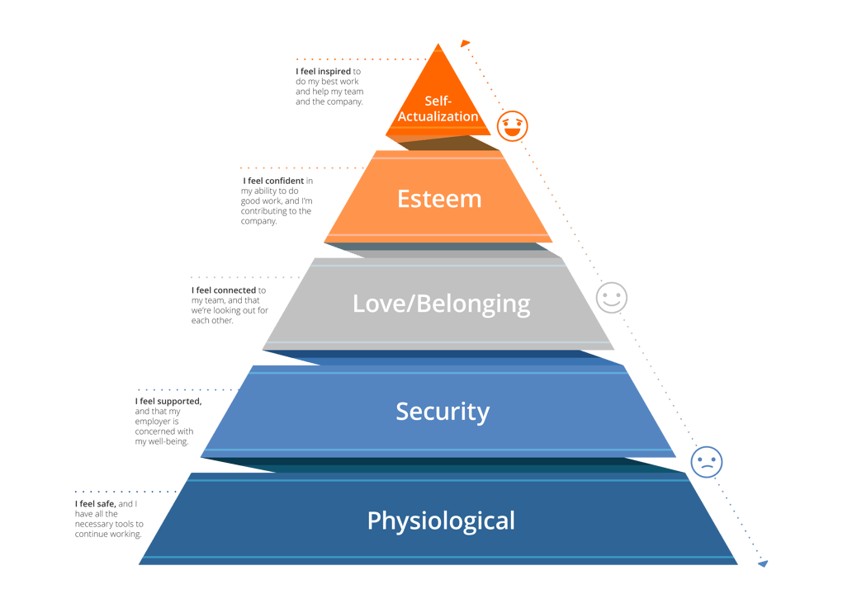
Maslow’s theory is mainly focused on motivation based on human needs and interaction which dictate an individual’s behaviour. An example of using this theory in everyday life is that of a child’s experience making this hierarchy clear that when there is no access to a reliable carer a child would then be unlikely to be safe and would lack shelter, clothing and food which is needed on a daily basis so, once people feel safe they would then move up the pyramid to focus on the next goal which would be love and belonging.
Relating this to an industry such as telecoms if employees do not feel safe due to the lack of motivation and systems in place which they do not have the correct skills set for than they are highly likely not to perform, there would be a change of behaviour and performance and may even leave the business all together which would impact the industry with less employees, less profitability, revenue streams, low performance rates, innovation, daily performance, lack of sales, lack of communication and much more.
The way that Maslow’s Hierarchy of needs influences employee engagement especially within telecoms is building a thriving network as well as a productive employee environment which would increase the industry potential of meeting basic requirements which in telecoms can only be possible using money.
This is said because substantial income and compensation is crucial to the industry where survival is not as concerning for them but moving to their next goal which is security and retaining potential employees is where the focus needs to be for them. The way that the theory takes affect is when employees who have the lowest-level needs that have not been met are the ones who will make decisions which will be based on safety, stability, and compensation and this is why it becomes a vital role for HRM professionals who must ensure these needs are being met before others who are further up the pyramid.
The decision-making process of HRM
When it comes to Human Resource Management this is a vital part of an organisation who oversee making the important business decisions. The purpose of an equal opportunities policy is to ensure that there is transparency and accountability towards the entire industry which constitutes fair treatment as well as what is fair treatment, abuse, harassment, and discrimination which such policy should address both direct and indirect discrimination according to (Lisa, 2022).
The equality act looks like a practice which the industry is committed to which involves gender, race, age, disability, marital status and religion and beliefs which is the duty of HRM to conduct and ensure all guidelines are followed to treat employees fairly. Within the UK alone there have been reports of over 8.2 million workers who have said they have been discriminated against due to their gender and 70% of ethnic minorities over the last 5 years which HRM needs to investigate to prevent this within the telecoms industry according to (Lisa, (2022).
2.8 Qualitative data research using annual reports and the conceptual framework.
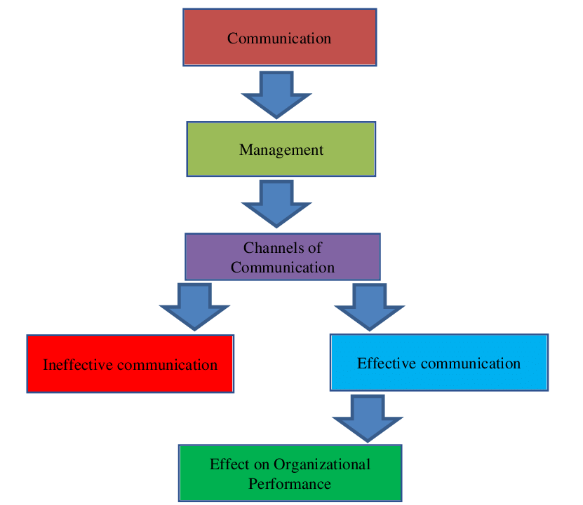
The conceptual framework is a representation of a relationship which is seen between variables, characteristics, or even properties. This is a visual representation of independent variables and dependent variables which create a systematic literature review for specific topics which involve research. The conceptual framework also helps with identifying important relationships between independent and dependent variables which are also identified using relevant research according to (Alomyan, H., (2017).
The independent variable within this research is focused on the affects of equal opportunities within the telecommunications industry within the UK. When it comes to Human Resource Management making decisions and solving potential problems this is also within the independent variable which is influenced by change which directly can influence the dependent variables (Alomyan, H., (2017).
When it comes to the dependent variable this is a change towards the outcome of the independent variable which in this instance is the importance of employee engagement and its role within the telecommunications industry.
Content analysis
The content analysis is a concept used within qualitative data where research will be able to be quantified and analysed within the presence, meanings, and relationships. The categories which the content analysis will cover will be looking into the impact of employee engagement, equal opportunity, workplace culture, performance management and the decision-making techniques used by HRM within the telecommunications industry within the UK.
Summary of the gap
Based on all necessary secondary data which has been collected it is quite clear that there is a gender gap as well as a skills requirement for women who are leaders within the telecoms industry who do not have the correct skills set to drive the telecommunications industry towards succession of creating equal opportunities.
This is said because 8.2 million workers within the UK alone have reported discrimination against them by senior leaders due to their gender and there have been reports from 86% of senior leaders within the telecoms sector who have reported skilled workers to be the primary challenge for creating equal opportunity as women are not trained enough to perform as well as men in this type of industry which has a huge effect on employee engagement as workers don’t feel encouraged and comfortable to ask for relevant training and support due to the high percentage of discrimination towards them such as their gender being the problem in order to drive and perform the industry according to (Ben, 2022).
2.9 Chapter summary
The chapter above based on literature involves an insight into the equal opportunities in the telecoms industry as well as employee engagement . Information and knowledge gathered gives a deeper insight on the issues faced within the telecoms industry which have a significant affect on the industry itself. This chapter also gives a deeper insight into what equal opportunity is and how it was originated to become a major factor for businesses to follow in the modern-day era.
This chapter concludes the impacts of equal opportunity on employee engagement followed by the impact on workplace culture due to equal opportunities being a problem within the telecoms sector which affects employee engagement, employee performance and motivation.
This involves management of employees within the workplace and how equal opportunity affects the business aspects of the telecoms industry creating a gap on the gender equality and skills set for women leaders which has created biasness within the sector which impacts laws, employees themselves, employee retention, employee motivation, performance and even the decision-making processes Human Resource Management who are the most vital part of the industry.
Chapter 3: Research methodology
Introduction
The research methodology gives a clear view and findings which are permissible towards the research currently being conducted. This also explains the reasons behind the approach of this research which is supported by data collection methods such as secondary data analysis and the conceptual framework to plan and outline the intentions of this research. The focus of the research methodology here is to describe and explore the understanding of Exploring the role of equal opportunity in employee engagement in the UK telecommunications industry to familiarise the purpose of exploring this topic.
The purpose of the research methodology is to create and set specific procedures and techniques which will be helpful to identify, process, select, and analyse the information used from secondary data resources to source suitable and reliable data for the role of equal opportunity in employee engagement within the telecoms industry which will also critically evaluate the study’s overall validity.
3.1 Research design
The purpose of doing a research design for methodology is because it provides a plan of study which can give an accurate assessment of causes and the effectiveness of relationships between independent and dependent variables according to (Jang, (1980). The researcher will then go on to choosing what is called descriptive research which is a method that describes the characteristics of the phenomenon as the process of design progression. The purpose and advantage of using descriptive research methodology is to focus more on the “What” rather than the “Why” of the research subject which will give a better insight and understanding of the research being carried out.
The purpose of using descriptive research is to systematically obtain valuable information which is a type of research design to effectively describe a situation which is happening within the telecoms industry as well as using the phenomenon and population to source such important data related to this research. This approach also helps to identify and answer the what, when, where and how questions in relation to this research problem rather than just looking into the why scenario according to (Lans, W & van der Voordt, DJM 2002).
When it comes to sourcing data collection using a secondary data analysis to gather information on the telecoms industry this would be data that has already been previously collected as well as readily available from numerous sources. The benefits of using such data have many positives such as not only being cost effective but also being quickly available and this is why desk-based research has been used a method to collect secondary data. Once the sourced data relevant to this topic has been obtained and used it helps to give the researcher the validity and reliability of the collected data which will be highly valid hence why it would be academically referenced when such data is used in this research according to (Starc, 2023).
3.2 Research philosophy
As for secondary data research this is popular with the interpretivism philosophy which typically emerges meanings towards the end of the research process. The most noteworthy variations of interpretivism include the following: Hermeneutics refers to the philosophy of interpretation and understanding according to (Collins, H. (2010).
This is where the transactional/subjectivist epistemology will be used as an approach because people cannot be separated from their knowledge therefore it shows signs of being clear between the researcher and the research subject. A crucial factor on the interpretivism philosophy is that it can create an understanding of someone’s reality through experiences which may be different from another person’s due to the historical perspective.
This is where the qualitative method will be used to investigate the phenomena where instead of searching for the truth the interpretivism approach will generate a detailed understanding as well as the most relevant position of the current situation within the telecoms sector which is based on equal opportunity on employee engagement which is where the gender and skills gap have been identified to become a potential problem for the industry.
When using the interpretivist approach for communication within the telecoms sector this approach encompasses perspectives which embrace the view of reality when being socially constructed or even made meaningful through actions and the understanding of events which take place on a daily basis within the sector which can help an organisation with effective communication and hence why scholars have been focusing on the complexity as enacted when it comes to language and social interactions according to (Syed, G.A., (2015).
The interpretivist approach falls into the inductive reasoning category, and this is said because the deductive reasoning for such an approach would mainly focus with the scientific or positivist approach which makes this research more logical to follow the inductive reasoning instead. This is the reason qualitative research has also been selected to create a basic interpretive study which shows interest towards the main factors of the study which involve how people within the telecoms industry interpret their experiences, how they construct, and the meaning towards attributing to their experiences according to (Pretorius, D.A., (2019).
3.3 Research approach
The research approaches that will be used will be focused on qualitative and quantitative sourced data. The qualitative data research will be exploring deeper insights into the problems in the real world which helps to create a hypothesis and further investigate into the problem. As for the quantitative research this will be looking more into the numerical data and intervene or even introduce treatments which is great for recommendations for resolving a problem. This is where the content analysis will be used as a study of documentation and communication artifacts which can be as various formats such as images, audio and video which is helpful to examine patterns in communication in a manner that is replicable and even systematic.
The importance of using hypothesis within the research approach is to express the relationship between variables to determine whether the relationship is significant which gives a deeper insight into the negatives and positives between relationships within a workplace such as the telecoms sector in this instance.
The hypothesis is specific and gives a prediction on results based on the research question itself and this is what leads to developing the hypothesis initially and this is why exploring the role of equal opportunities in employee engagement within the telecommunications sector is used in this research as its specific and clear to determine accurate results of the question according to (Pandey, P. and Pandey, M.M., (2021).
Using qualitative and quantitative sourced data as a research approach is defined as secondary data which is categorised into internal and that from an organisation perspective that is under observation as well as data that is routinely given by management which is external outside of the organisation and these will be obtained from various sources such as journals, books, directories, non-governmental statistical data, internet, and census data.
The use of secondary data is intended to provide information to analyse and make decisions as well as identify the research problem and develop a strategy to conclude a solution for the research problem. To construct a sampling plan, formulate a suitable research design, gather answers for certain research questions, test some of the hypothesis, interpret primary data, validate the outcomes from qualitative research, identify potential problems, and to be able to obtain the required background information which can improve credibility of the study being conducted.
3.4 Methods for data collection
The methods for data collection will be legitimate and authentic which will avoid any kind of delay within the research period and process. The information that is going to be gathered for the purpose of this research will be conducted from legitimate sources such as Government websites, Journal articles, Google Scholar which will avoid the uncertainty of the outcome of this research. This is also where the systematic review will also be conducted which is a type of literature review which requires equivalent standards that have a clear and logical rationale used to report to the reader of the review and this is used in such research and policymaking that informs evidence-based decisions to improve workplace practices.
Using journal articles and Google Scholar allows to locate such articles and books relevant to the study and research being conducted. These articles are highly accurate and authenticated sources and pieces of vital information used as a strategy in secondary data which saves money, time, and effort to gather such vital information from the beginning.
Unlike primary data research Google scholar and the journal articles searches beyond just data that is available to or near it will also include resources which are not available to a person hence which makes it quite a systematic review for literature to be discussed with data that’s highly important for such research.
Furthermore, the academic journals being used within this research study are a source of academic information which are highly valuable towards such research which are known to usually offer a current view which also have credibility due to the process of peer review. This is why journal articles are submitted by researchers that are evaluated by experts within the field before they are published.
The most important steps for using the systematic review as a method for data collection is to choose the correct type of review which in this instance is to focus on the equal opportunities in employee engagement in the telecoms industry within the UK. Next is to formulate the questions of the research which have been conducted in chapter 2 in the literature review for equal opportunities and employee engagement.
Then investigate establishing a team within the workplace of the telecoms industry and develop a protocol which helps to conducting the research. Finally, after conducting the research the next step of the systematic review would be to select relevant studies to be able to extract the necessary data which would then synthesize the results of the study according to (Pollock, A. and Berge, E., (2018).
3.5 PRISMA model
Using the PRISMA model for this research is to have an evidence-based minimum set of items which report within the systematic review as well as the meta-analysis. The main focus for using the PRISMA model is to report views and a evaluation of randomised trials and use the model as a basis for reporting systematic reviews of different types of research particularly interventions. Below is a PRISMA model conducted based on the current research.
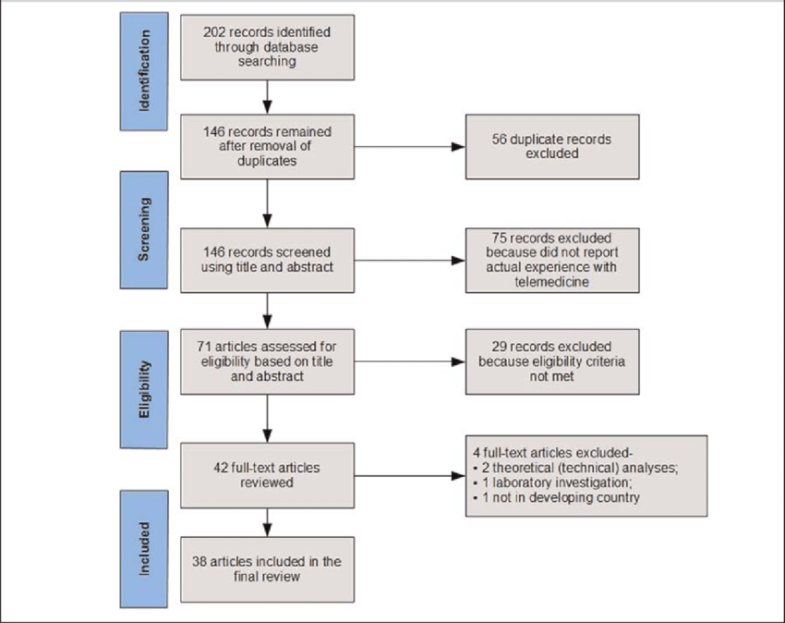
3.6 Ethical considerations
The ethical considerations within the conducted research have a set of principles which can guide the research design and practices and these principles include, informed crescent, anonymity, confidentiality, potential for harm, and results communication. The very top of the ethical consideration list is fabrication where data is made up and used for results and falsifying the data and altering data as a result will be avoided from this research.
All data used within this research will be authenticated from valuable and reliable sources such as Google Scholar, Government websites, company websites, annual reports online, and journal articles. This is to increase the value and effectiveness of this research and the UK data protection act (DPA) 2018 will be followed for being responsible for using personal data fairly, lawfully, and transparently (Service, (2015).
Ethical considerations are known to be a series of guidelines that when it comes to research these should be followed when conducting research into behaviour. This is significantly important in this research as it ensures the quality of the research is well maintained as a result prevents people from being harmed with it as well as their lawful rights being taken away during and after the conducted research.
This is where the GDPR and data Protection Act 2018 come into the equation because this means the research and collected data that is personal should be anonymised as soon as practical (when anonymisation is needed) which can be archived to be used for scientific research as long as the reuse is that to be compatible with the original purpose for which the collected data was collected for according to (Bristol, 2018).
The ethical considerations within this research are a set of principles which are used as a guide for research designs as well as practices and these principles also involve, confidentiality, informed consent, participation, anonymity, and results communication. When it comes to informed consent the results will be collected online where the publication of such data has been published for view where the consent of the owner would not be needed as they would upload this for anybody to access via online resources including authenticated websites which give such specific data to such topic.
When it comes to confidentiality this would refer to ensuring that all participants including personal details which have been disclosed will be kept anonymous and private throughout this entire research and even after the research has been completed. Confidentiality is very important especially when investigating sensitive subjects and the point of confidentiality is to make sure that readers are not able to identify such participants involved as this may affect the conducted research and even influence discrimination which is why everything involved within this research will remain anonymous according to (Ridges, 2023).
3.7 Chapter summary
The methodology used for the purpose of this research shows a clear path to enable researchers to have a better understanding and a clear outcome of the conducted research. All the relevant data that will be conducted within this research will be always protected avoiding any information to be obtained and gathered by anybody else, the information will also be stored, protected, and remain confidential to avoid any information being out in the open. All processes followed from start to finish of this research will be effective which means it will create more value when evaluated.
Chapter 4: Results and Analysis of findings
4.1 Overview of findings
Conducting the overview of findings, it has been gathered that potential factors are affecting the gender gap within the telecommunications industry including employee engagement. This research has conducted that the identified gender gap has a significant impact on equal opportunities within the industry where women have believed to have stepped down from potential managerial roles since they have been informed by the industries that they do not have the correct skills set to carry out such effective roles which potentially decreased the percentage of women leaders within the industry giving men more opportunities to be successful within the managerial aspects of the industries.
Furthermore, women within these industries have stated they felt discriminated against their gender, skills, and ability to perform such tasks within the business which as a result leaves the industries lacking to provide training, increase the potential of quality workers and further develop the business by providing the necessary training where employees need it the most.
The purpose of creating a diverse workforce is to create fairness and equal opportunity where employees are aware of a fair workplace system to avoid discrimination and who feel confident as well as motivated to continue working at their best for the industry. A diverse working environment then becomes an important asset where there is acknowledgement of employee strengths to what they bring to the business. So, valuing the differences of every individual fairly is ultimately what brings together a diverse workforce and the ability to be successful within a thriving workplace with a fair culture according to (Sadri, G. and Tran, H. (2022).
It has also come apparent that laws and regulations are in place when it comes equal opportunity within any working environment following the equality act 2010. The equality act 2010 is a legal protection for people from discrimination within a working environment as well as within the wider society. This was replaced from previous anti-discrimination laws with a single act which had made the law much easier to understand for people and strengthen protection within some situations.
This sets out different ways in which it is lawful to treat someone according to (Gov.co.uk, (2013). This is where it is believed that reports which were conducted by individuals within the telecommunications sector showed that an increased percentage of employees had stated that they felt discriminated against within the working environment due to their lack of skills, ability to perform for personal reasons, gender, and background.
The biggest factor affecting the telecoms industry is known to be the gender gap and this has mainly been towards women, and this is why women believe that they are lacking with the skills gap when managing such businesses as there is also lack of training being provided by individual companies within the sector.
This is believed to have created a significant impact on women’s ability to perform and increase their skills set which can increase productivity within the industry and this has led women to believe that these are the reasons behind biasness behind closed doors within the telecoms sector which is why men have the correct adaptative skills to execute the job better than women.
Factors which have been influenced by equal opportunity also include diversity and inclusion. diversity currently has an affect within the telecoms sector when it comes to making business decisions as well as representing the business customers. Factors such as religious and cultural differences then become affected which can influence diversity and inclusion within a working environment and which in this case in the telecoms sector this is also the case and findings which have a negative affect within the sector.
It has been conducted that gender diversity within the telecoms industry was a factor which influenced a lot of telecoms businesses within the UK not to have as many women leaders within their businesses, this was because research had shown a decrease of 20% of women leaders compared to North America who was at a percentage of 45% showing a significant difference of 20%.
This refers to the explanation that was conducted by senior leaders based within the individual telecoms industries all of which concluded the same problem stating women didn’t have the right skills set around technology, science, engineering and maths better known as (STEM) which had created the total opposite of having a diverse working environment within the telecoms industry potentially creating a significant impact on equal opportunities within the sector according to (Molina, Lin and Wood, (2015). This also became a problem for the laws and regulations which have been set out in the UK for the equality act 2010 which seemed to potential employees were not followed and believed biasness and discrimination had become normality for individuals.
It has also been conducted that managers within the telecoms industry also have had an influence on employee engagement. This is because the link is crucial between employees and managers so the main objectives for managers is to set a clear objectives and form a great team of individuals to execute the targets but within the telecoms industry this wasn’t clear since women leaders were not treated fairly and felt biasness which they believed had a huge impact on their ability to perform so this has an affect on employee engagement amongst managers as women then didn’t feel the comfortability to approach senior managers and ask questions, seek help for their current situation, and didn’t feel comfortable to ask for relevant training where it was needed.
Women employees felt the need of receiving accurate feedback about how they are performing in order to do better and use feedback as motivating factor to know their strengths and weaknesses also but this was found to be another problem amongst the employees where they felt appropriate feedback was judgemental and not feedback and the feedback given was too harsh majority of the time which was a demotivator for female employees which again negatively impacted the percentage of why the number of women leaders has decreased over the last 10 years within the telecommunications industry.
4.2 Table summary of articles
Theme | Article | Author | Year | Findings
Exploring the role of equal opportunity in employee engagement in the telecommunications industry. | “The ideal of equal opportunities and the practice of unequal chances. Equal Opportunities and Ethnic Inequality in European Labour Markets, p.9.” | “(Kraal, K., Wrench, J., Roosblad, J. and Simon, P.,” | 2009 | Industries who offer equal opportunities to every employee helps to build a more positive and diverse workforce and without following the equality act may mean indirectly discriminating against workers which is a high risk with certain protected characteristics. This has been gathered using the Meta-analysis method.
 | “Equality act 2010: Guidance.” | “Gov.co.uk” | 2013 | Using the content analysis for qualitative data research it has been identified that. All workforces are to follow these rules and regulations set out by the UK government but at the same time some speculate and debate over whether enough is being done to ensure it will be prevented.
Functionality of HRM which help the functionality of the telecoms industry to reach appropriate decisions and use effective techniques to avoid the equality act 2010 which is a UK law being misused in any way. | “What Is an Equal Opportunities Policy?” | “Lisa, H.” | 2022 | This article is to define the importance of business decisions within the telecoms industry which help to prevent the misuse of the equality act 2010 and helps with measures put in place to treat every individual equally to avoid biasness and an increased diverse workforce.
 | “Employee engagement: Its impact on financial performance and long-term strategy, Employee Engagement: Its Impact on Financial Performance” | Karthikeyan. | 2021 | A validity test was used in this article to gather the impact of employee engagement within the telecoms industry.
Impact of workplace culture on employee’s performance. | “Organizational Culture and Its Influence on Employee Behaviour. 14. 2945-2949”. | “Praveena, A. & Fonceca, Clayton” | 2023 | This article was used to gather the impact of the culture within the telecoms industry on employee’s performance.
Impact of workplace culture on employee’s performance. | “The moderating effects of organizational culture on the relationships between leadership behaviour and organizational commitment and between organizational commitment and job satisfaction and performance. Leadership & Organization Development Journal, 30(1), pp.53-86.” | “Huey Yiing, L. and Zaman Bin Ahmad, K.” | 2009 | This article was used as an indicator, to investigate beliefs and attitudes of an employee which has an impact on their performance aspect within the telecoms industry.

4.3 Analysis of results
The telecommunications industry has had a huge focus on creating a diverse workforce for potential employees, considering similarities and differences amongst their employees in terms of their age, cultural background, disabilities, race, gender, sexual orientation, religion, and physical abilities. The telecoms industry has been focusing on creating an inclusive environment that can provide equal rights which create opportunities for all workers.
The industry has also had its focus on employee engagement which describes the enthusiasm and dedication of how an employee feels about their job. The reason for this is because employee engagement is critical towards business succession and given the success that it has increases employee retention, satisfaction, and employee morale. The telecoms industry believe that engaged employees are most likely to be more productive and have a higher performance rate.
The telecoms industry is obliged by the UK law to follow and comply with an equal opportunities policy which is a formal document which outlines the industry commitments to fair treatment of all potential employees regardless of gender, age, race, sex, beliefs, and religion. This means that employers within the telecoms industry cannot make decisions because of making judgements towards a person’s race, gender, age, sex, beliefs, and religion. It also a known fact that the employer cannot discriminate against workers who are 40 years of age and older based on their age.
According to the results conducted within the telecoms industry it has become apparent that in fact there is biasness in gender within the industry when it comes to women leaders. It has also been stated that one of the biggest barriers for women who are seeking leadership within a working environment and has also become persistent bias which exists in many organisations with telecoms being one of them. Research has conducted that men are most likely seen as more competent as well as being capable of a leadership role than women and that being even when they have appropriate, similar, or same qualifications as men do according to (Rodriguez, 2022).
It has also been gathered that less than 20% of women within the telecoms industry are/have been involved in technical roles within the industry. Results had shown that women have faced social and cultural barriers which discourage individuals from pursuing their careers within technology as well as telecommunications. This is where there is lack of mentorship and representation which affects the progression of women within this field according to (Abraham, 2023).
The telecommunications industry has been focusing on advancing the digital inclusion strategies which would put the gender divide to a close so, this is where it has been critical for them to implement strategies which have addressed the barriers which can empower women in the telecoms industry. It was conducted that less than 20% of women within the telecoms sector had been involved in the technical aspects of the industry and only a percentage of 24% of the workforce in the sector is female and that being a 5% mere holding at senior management positions.
Results had shown women have been facing social and cultural barriers which have been discouraging them from pursuing a career further within the sector especially in telecoms and broad technology. There has also been lack of mentorship as well as representation affecting the progression of women within the field. This has led to the impact of equal opportunity in employee engagement within the industry.
Having discussed this, the impact of employee engagement within the sector has been affected by a huge margin as results gathered that women do not feel comfortable in obtaining critical feedback as they feel the sector is biased by being informed from higher management teams, they do not have the required skills set to execute specific tasks which is impacting the telecoms performance levels. This has caused individuals to believe that they are discriminated due to their gender, skills set and ability to complete tasks when there has been no mentorship and training provided where it is relevant and needed.
Results have also shown that there have been 42% of businesses who have had their employees report a gender gap within the sector especially within the digital/IT sector where employees have been informed by senior management teams they are lacking in their skills and there is a skills gap which is affecting the overall performance of the business. It has also been conducted without the correct level of IT skills within the sector has significantly impacted the telecoms market by a huge margin and employers and management including HR within business in this sector have reported that they believe this is due to the lack of skills from individuals and the lack of performance due to not having the correct skills set.
Lastly, 86% of business executives within the telecoms sector have also reported that skilled workers are the primary challenge which the telecoms sector is currently facing as of which they have also identified is the second largest challenge that has been faced within the industry when it comes to employees working around the network quality especially when the sector has had the release of the new 5G roll out it is important for them to provide the best services possible to consumers. It has also become apparent that 40% of the executives still believe that this is a current problem which still needs enhancing which as a result they believe that skilled training programmes need to be more common within the sector where more training is a must to provide to some aspects of the industry where it is needed most.
4.4 Discussion of results
It has been gathered that women employees have been facing major issues within the industry of telecoms. Women managing telecom companies have stated that they have felt discriminated against by above leaders such as HR for instance where women have said they have been judged by their performance, their gender, skills, and abilities without having the necessary training where it was needed to enhance their skills and abilities whereas men were found to be more adaptable and knowledgeable than women in their workforce which women had found discriminative and judged by their skills and abilities.
8.2 million workers within the UK alone have reported discrimination against them by senior leaders due to their gender and there have been reports from 86% of senior leaders within the telecoms sector who have reported skilled workers to be the primary challenge for creating equal opportunity as women are not trained enough to perform as well as men in this type of industry which has a huge effect on employee engagement.
Women don’t feel comfortable in engaging in a workforce where there is discrimination, especially towards gender, skills, and abilities to perform just as well as anybody else male/female. This has been one of the reasons why there has been an increase of women leaders stepping down from managerial levels due to the levels of discouragement, discrimination from higher leaders, and feeling demotivated when feedback is given to them according to (Abrams, K., (1989).
This is where a diverse workforce should play a vital role in the world of work in telecoms where everybody is treated fairly no matter what their gender, age, sexual orientation. skills, abilities, disabilities are. Within an inclusive environment like telecoms, teamwork and cooperation can thrive and drive a more productive workforce as well as finding that ethnically a diverse workforce is known to be more successful and having said this companies who have a even gender balance are 25% more than likely to outperform those workforces who don’t according to (Hudson Jr, S.W., (2014).
The decision-making process of HR plays a vital role in every business where they oversee making the most important business decisions. This is where employees tend to see the impact of equal opportunities especially within a lot of telecom companies. There should be transparency and accountability within the entire industry which as a result would lead to fair treatment amongst everyone, but this is not the case when there have been 8.2 million workers in the UK alone who have reported discrimination and a huge chunk of that coming from women workers in the telecom companies which showed a percentage of 70% just in telecoms.
In the year 2020 the global pandemic Covid-19 had accelerated telecom companies to focus on digitalization to continue moving forward where there had been millions of employees working remotely in the day and night giving workforces within telecoms to access working network data and tools from the comfort of their home which led to employees feeling more comfortable, safe, flexible, and happy used as a form of motivation. However, this didn’t resolve the factor of gender equality where a lot of jobs were advertised in the sector from managerial roles to roles of customer service advisory where the selection process also wasn’t conducted very well.
Having said this the selection process was found to be poor as the balance of employment between male and female it was found more men had been selected for managerial roles for their experiences and knowledge and women were given more customer service advisor roles than men which showed that telecoms were lacking in providing necessary training and useful help to women who are leaders or want to become leaders. This is said because women who were found to have worked within the sector had the accurate qualifications but were lacking on some experience to execute specific tasks.
This means the industry should potentially have employed women as they have the required experience and could have been given mandatory training before actually executing such roles and targets so that they were familiar with what is required of them just as the industry has been doing with male leaders, women are not any different and are still human which means they are highly capable of achieving and succeeding as well as men, which led to the understanding of how women were feeling discriminated against according to (Farren, C., (2022).
In the year 2018 the telecoms providers had launched out 5G with a vast majority upgrade creating better connectivity for its users and consumers. The telecoms industry had launched a project the same year mainly focusing on how end to end users would greatly benefit from the new roll-out of the 5G interface however the industry also had its focus on employees as well to create the best interaction experience for them in the world of work communicating with fellow colleagues, managers, and team leaders etc…
The significant change to telecoms here was that there was a huge increase in communication within the workforce which created a better atmosphere for colleagues as well as the managerial aspects of the business, and created an opportunity for telecoms to increase their effective communication with a significant percentage of 36% which is a huge increase to positively impact the employee engagement aspect of the business and overturn a potential problem resulting to more goals being achieved, retention of employees, increase in profitability, more productivity, and a better working environment.
The role of IT plays a significant factor in telecoms where it involves pricing systems and complex systems that require sophisticated IT systems for billing, mediation, and rating for prepaid accounts mainly where its necessary to have a trained employee/employees to manage manually and make sure everything is correct and accurate and most importantly up to date.
In the year 2023 it was gathered that there was a gap in the telecoms industry where IT management systems were not managed properly. It was also found that 36% of employers within the sector had to increase the number of staff and follow the selection process for new recruits. It was also found that 42% of telecoms businesses had been reporting the gap within specialist digital skills which had been impacting the external labour market.
This was also identified by many employees also who had brought this to the businesses attention which they felt was alarming for the businesses out of which most reports had been coming from customer service agents within the industry which as a result showed that women had conducted far more reports of the same matter which then goes to show that they are highly capable of managing and sustaining such an industry if they were able to carry out and gather the same results which were conducted by the managerial aspect of the industry.
Chapter 5: conclusion and recommendations
- Summary of findings
The telecoms industry has many downfalls when it comes to the equality act being followed, this involves mainly gender biasness, judgement based on skills and judgement based on abilities to perform especially when it comes to women working within the industry.
Within this research it has become apparent that 70% of women have been discouraged to work within the telecoms sector out of which 36% have either stepped down from a managerial role or were given the opportunity for a managerial role which had been turned down due to the discrimination of their gender and their ability to carry out such tasks native to a managerial role that would potentially impact the business in higher managements eyes.
This has led to believe that the equality act 2010 created to avoid such biasness and discrimination in workplaces which potentially may have been avoided by the telecoms industry to have followed which is a law and regulation which every business within the UK must follow (Gov.co.uk, (2013).
This has created a barrier for equal opportunities within the industry which has also led to an impact on employee engagement within the industry as women do not feel comfortable communicating with managers and higher seniors when there is a problem whether it is a personal problem or an internal problem within the business as this leads to them being discouraged to perform to their fullest ability as they are told they are lacking on skills which affects their ability to carry such tasks within the business according to (Sharma, J. and Nargotra, M., (2018).
This has been identified as a potential barrier where the industry has a lack of training programmes and training facilities for employees to enhance their skills and know how this affects the business which necessary training becomes a mandatory programme in which it will not only help the employee and encourage them but will also have a positive impact on the businesses as it will reduce the current level of impact there is as well as creating a diverse workforce where everybody’s feedback is heard and necessary requirements are then put in place to support potential employees which would potentially increase employee engagement, employee satisfaction and motivation.
It has also become apparent that most business decisions and the selection process is relied on the HR side of the industry which potentially means where the biasness ness comes from as the year 2020 where the global pandemic impacted a lot of businesses showed that far more male employees where employed than female employees both in the managerial aspect and customer service aspect of the business which led employees to feel that their employers do not believe that women are capable of performing a highly recognised job within the industry according to (Rukumba, S., (2021).
It is a well-known fact that keeping a balanced gender within the working environment of any business creates a diverse workforce which increases motivation, employee satisfaction, it creates a stronger workforce, it leads to the equality act being followed, this avoids biasness with the gender aspect and most importantly increases employee engagement.
5.1 Conclusion
Women have been affected by discrimination within the telecoms industry for a long time and it has become apparent in the most recent years where women have decided to speak up by suggesting polls and review sites where they were able to leave anonymous feedback based on their employers within the industry of telecoms which broadens how this has affected them.
Gender diversity within any working environment is crucial for all businesses and this helps to sustain a business, increase productivity and workflow, meet necessary targets, increase performance, increase employee satisfaction, employee engagement, increase motivation and create a better environment for everybody.
This is critical for the telecoms businesses to follow especially when there is an equality act to follow which are laws and regulations in place to avoid such scenarios in any working environment. Since this is a huge negative impact within the telecoms sector this needs to be actioned so that women are given the equal opportunity just as men are given the equivalent opportunity for sustaining a business, using their key skills, adapting to new skills, and even given an opportunity for a career progression for managerial roles.
This is where it becomes a necessity for the telecoms industry to not only use the selection process where needed but to also give women leaders or women who wish to become leaders the opportunity to enhance their skills using appropriate training where needed and giving women a chance to show their capabilities just as any other individual within the industry, potentially women leaders are known to be more determined then men and wish to perform daily task and targets to their fullest potential so there shouldn’t be any judgement which can potentially disband groups, affect employee engagement, create biasness within the industry and create an environment where judgement is more important than potential.
  - Recommendations
The telecoms industry should begin by creating equality within their working environments such as enhancing their hiring processes considering that gender shouldn’t be a problem when selecting an ideal candidate who is suitable for the advertised job role. The industry should also focus on creating a safe working environment for everybody and persistently help employees to educate themselves by creating an opportunity for employees to also enhance their skills and boost their abilities by offering regular training programmes and monitoring systems which would also give the business an insight into how this is impacting the business and whether things need to be changed and done differently according to (Farren, C., (2022).
The industry should also focus on business promoting that they stand for equality and have made necessary changes and take feedback on board as to how the working environment can best be strategized to ensure everyone feels encouraged to work creating increased motivation and realising which aspects of the business need to be monitored so that employees feel that their feedback is taken seriously and that there will not be any biasness and neither any form of discrimination within the working environment and to acknowledge better and brighter leaders who also do not favour such problematic issues within any aspect of the industry.
Clear communication is key for businesses such as telecoms as well as transparency which contribute to effective employee engagement which lead to opportunities for growth and development which helps to create a positive working environment and this also leads to recognition, rewards as well as showing a strong sense of purpose and alignment with the organisations mission which is key for the telecoms industry to increase employee engagement and show determination towards caring for their employees according to (Freeman, R.L., (2005).
Enhancing the most important factors of the industry which here is the communication barrier amongst women who don’t feel comfortable in bringing up problems which may occur internally or externally which they require support for as they fear discrimination towards them so enhancing such important factors and monitoring these within the working environment would potentially resolve the communication barrier within telecoms and potentially create a diverse workforce.
Retention of potential employees such as women in this instance within the telecoms industry should be shown recognition for who they are and the importance of them being apart of the team and the business itself which should be considered like a working family of employees working and adapting with one another. Employers should support their employees with their well-being showing their kindness and consideration of care towards all employees as well as seeking feedback, providing on-going training, building a community, and rewarding the employees which are all tested factors for the telecoms industry for improving employee retention rates which would also discourage discrimination, biasness, and the potential gender discrimination there is within the industry according to (Ratna, R. and Chawla, S., (2012).

References
Abraham, J.B. (2023) Telecommunication Towers and bridging the Digital Gender Divide, Utilities One. Available at: https://utilitiesone.com/telecommunication-towers-and-bridging-the-digital-gender-divide (Accessed: 27 December 2023).
Abrams, K., (1989). Gender discrimination and the transformation of workplace norms. Vand. L. Rev., 42, p.1183.
Aloy man, H., (2017). A Conceptual Framework for Web-Based Learning Design. International Association for Development of the Information Society.
Ben, P. (2022) What is an equal opportunities policy? Personio. Available at: https://www.personio.com/hr-lexicon/equal-opportunities-policy/ (Accessed: 26 November 2023).
Bristol, U. of (2018) Informed model consent form - university of Bristol, GDPR and Data Protection Act 2018: Implications for Research. Available at: https://www.bristol.ac.uk/media-library/sites/sps/documents/research-ethics/ukda-model-consent-form-template.pdf (Accessed: 22 November 2023).
Campbell, J. (2023) The top 2 telecom challenges: Skilled workforce availability and network quality and reliability, Veri force. Available at: https://veriforce.com/blog/the-top-2-telecom-challenges-skilled-workforce-availability-and-network-quality-and-reliability (Accessed: 04 November 2023).
Collins, H. (2010) “Creative Research: The Theory and Practice of Research for the Creative Industries” AVA Publications
Egli, V.L., (2011). The impact of organizational culture on information sharing. Monograph. Fort Leavenworth, KS: School of Advanced Military Studies, United States Army Command and General Staff College.
Equality act 2010: Guidance (2013) GOV.UK. Available at: https://www.gov.uk/guidance/equality-act-2010-guidance (Accessed: 14 December 2023).
Equality act 2010: Guidance (2013) GOV.UK. Available at: https://www.gov.uk/guidance/equality-act-2010-guidance (Accessed: 10 January 2024).
Farren, C., (2022). A Study Identifying the Progression of Women in the Telecommunications Industry and how HR Departments can Improve Gender Diversity through Initiatives and Programs (Doctoral dissertation, Dublin, National College of Ireland).
Farren, C., 2022. A Study Identifying the Progression of Women in the Telecommunications Industry and how HR Departments can Improve Gender Diversity through Initiatives and Programs (Doctoral dissertation, Dublin, National College of Ireland).
Freeman, R.L., 2005. Fundamentals of telecommunications. John Wiley & Sons.
Greenwood, M.R., (2002). Ethics and HRM: A review and conceptual analysis. Journal of Business Ethics, 36, pp.261-278
Gruber, H. and Koutroumpis, P., (2011). Mobile telecommunications and the impact on economic development. Economic Policy, 26(67), pp.387-426.
Hudson Jr, S.W., 2014. Diversity in the Workforce. Journal of Education and Human Development, 3(4), pp.73-82.
Huey Ying, L. and Zaman Bin Ahmad, K., (2009). The moderating effects of organizational culture on the relationships between leadership behaviour and organizational commitment and between organizational commitment and job satisfaction and performance. Leadership & Organization Development Journal, 30(1), pp.53-86.
Hupfer, S., Mazumder, S., Bucaille, A. and Crossan, G. (2021) Women in the tech industry: Gaining ground but facing new headwinds. Available at: https://www2.deloitte.com/uk/en/insights/industry/technology/technology-media-and-telecom-predictions/2022/statistics-show-women-in-technology-are-facing-new-headwinds.html (Accessed: Oct 11, 2023).
Iversen, T. and Wren, A., (1998). Equality, employment, and budgetary restraint: the trilemma of the service economy. World politics, 50(4), pp.507-546.
Jang, R. (1980) 'General purpose of research designs', American Journal of Hospital Pharmacy, 37(3), pp. 398-403.
Johnston, M.P., (2014). Secondary data analysis: A method of which the time has come. Qualitative and quantitative methods in libraries, 3(3), pp.619-626.
Karthikeyan, H. (2023) Employee engagement: Its impact on financial performance and long-term strategy, Employee Engagement: Its Impact on Financial Performance and. Available at: https://www.linkedin.com/pulse/employee-engagement-its-impact-financial-performance-karthikeyan#:~:text=The%20Financial%20Impact%20of%20Employee%20Engagement&amp;text=According%20to%20a%20meta%2Danalysis,average%2021%25%20increase%20in%20profitability. (Accessed: 03 November 2023).
Kraal, K., Wrench, J., Roosblad, J. and Simon, P., (2009). The ideal of equal opportunities and the practice of unequal chances. Equal Opportunities and Ethnic Inequality in European Labour Markets, p.9.
Lans, W & van der Voordt, DJM (2002), Descriptive research. in TM de Jong & DJM van der Voordt (eds), Ways to study and research urban, architectural, and technical design. DUP Science, Delft, pp. 53-60.
Lisa, H. (2022) What Is an Equal Opportunities Policy? Available at: https://www.personio.com/hr-lexicon/equal-opportunities-policy/ (Accessed: Oct 15, 2023).
Markos, S. and Sridevi, M.S., (2010). Employee engagement: The key to improving performance. International journal of business and management, 5(12), p.89.
Minett, A. (2022) 'The Benefits of Equality and Diversity in the Workplace', CHAS, -04-26T10:48:34+00:00. Available at: https://www.chas.co.uk/blog/workplace-equal-opportunity-importance/ (Accessed: Oct 15, 2023).
Molina, M., Lin, S. and Wood, C. (2015) 'Connected Women 2015', Accelerating the digital economy: Gender diversity in the telecommunications sector, 15, pp. 1-15 Available at: https://www.gsma.com/mobilefordevelopment/wp-content/uploads/2015/11/Accelerating-the-digital-economy-Gender-diversity-in-the-telecommunications-sector.pdf.
Molina, M., Lin, S. and Wood, C. (2015) 'Connected Women 2015', Accelerating the digital economy: Gender diversity in the telecommunications sector, 15, pp. 1-15 Available at: https://www.gsma.com/mobilefordevelopment/wp-content/uploads/2015/11/Accelerating-the-digital-economy-Gender-diversity-in-the-telecommunications-sector.pdf.
Nagy, B. and Vicsek, L., (2014). Exploring gender culture at a telecommunications company. Gender in Management: An International Journal, 29(6), pp.318-333.
Pandey, P. and Pandey, M.M., (2021). Research methodology tools and techniques. Bridge Centre.
Patro, C.S., (2013), December. The impact of employee engagement on organization’s productivity. In 2nd International Conference on Managing Human Resources at the Workplace (Vol. 1, pp. 1-9).
Pollock, A. and Berge, E., (2018). How to do a systematic review. International Journal of Stroke, 13(2), pp.138-156.
Praveena, A. & Fonceca, Clayton. (2023). Organizational Culture and Its Influence on Employee Behaviour. 14. 2945-2949. 10.24327/ijrsr.2024.1404.0605.
Pretorius, D.A., (2019). Factors that affect digital transformation in the telecommunication industry (Doctoral dissertation, Cape Peninsula University of Technology).
Ratna, R. and Chawla, S., 2012. KEY FACTORS OF RETENTION AND RETENTION STRATEGIES IN TELECOM SECTOR. Global Management Review, 6(3).
Reed, H. (1996).'Providing Opportunity for All Through the Telecommunications evolution - Reed Hundt, 1996', 80(582) Available at: https://doi.org/https://doi.org/10.1177/0192636596080582 03.
Ridges, J. (2023) Ethical considerations in Research, Study Smarter UK. Available at: https://www.studysmarter.co.uk/explanations/psychology/cognition/ethical-considerations-in-research/ (Accessed: 22 November 2023).
Riley, R., Metcalf, H. and John, F. (2021) 'The Business Case for Equal Opportunities', The Business Case for Equal Opportunities, 335, pp. 1-35 Available at: https://www.niesr.ac.uk/wp-content/uploads/2021/10/dp335.pdf.
Rodriguez, P. (2022) Women in technology: Statistics on bridging the gender gap in fibre, Talent [Revolution].
Romera, J. (2022) 8 Ways your HR team can help boost employee engagement. Available at: https://workleap.com/blog/employee-engagement-hr/ (Accessed: Nov 4, 2023).
Rukumba, S., 2021. Human Resource Management Practices and Performance of Telecommunication Industry in Kenya (Doctoral dissertation, JKUAT-COHRED).
Sadri, G. and Tran, H., (2002). Managing your diverse workforce through improved communication. Journal of Management Development, 21(3), pp.227-237.
Sally, M. (2023) Transforming Access Unlocking Opportunities through Telecommunications Network Equality. Available at: https://utilitiesone.com/transforming-access-unlocking-opportunities-through-telecommunications-network-equality (Accessed: Nov 1, 2023).
Sally, S. (2023) 'Equality of Opportunity (Stanford Encyclopaedia of Philosophy)', 14(1), pp. 1-20 Available at: https://plato.stanford.edu/entries/equal-opportunity/.
Service, G.D. (2015) Data protection, GOV.UK. Available at: https://www.gov.uk/data-protection (Accessed: 19 October 2023).
Sharma, J. and Nargotra, M., (2018). Exploring the employee engagement in telecom sector. Journal of Strategic Human Resource Management, 7(2), pp.16-23.
Sharma, J. and Nargotra, M., 2018. Exploring the employee engagement in telecom sector. Journal of Strategic Human Resource Management, 7(2), pp.16-23.
Starc, M. (2023) Quantitative data analysis, stats work. Available at: https://www.statswork.com/services/quantitative-data-analysis/ (Accessed: 19 November 2023).
Stokes, B. (2023) Skills shortages put the communications industry’s future on the line, manpower.co.uk. Available at: https://www.manpower.co.uk/article/skills-shortages-put-the-communications-industry-s-future-on-the-line/#:~:text=Even%20though%2036%25%20of%20employers,skills%20deficit%20within%20their%20current (Accessed: 04 November 2023).
Syed, G.A., (2015). An interpretive framework for complexity in IT projects (Doctoral dissertation).
Appendix 

