

UNIVERSITY OF WALES TRINITY SAINT DAVID
Y DRINDOD DEWI SAINT
SWANSEA BUSINESS SCHOOL
YSGOL FUSNES ABERTAWE

EXPLORING UNIVERSITY STUDENT’S PERCEPTIONS OF SWANSEA HIGH STREET AND RECCOMENDATIONS TO RECTIFY SOCIAL ISSUES ACCOCIATED WITH IT.

BA (HONOURS) LAW AND CRIMINOLOGY

Name: Cerys Rebecca Row
Student ID: 1802701

2020-21

COVID IMPACT STATEMENT
The University of Wales Trinity Saint David recognises that the COVID-19 pandemic, and consequent closures of campus and national lockdowns has directly or indirectly impacted the work of many undergraduate researchers. However, supervision meetings continued, through documents being shared electronically and meetings arranged online via Microsoft teams. All research data collection was designed to utilise digital data collection.
The inclusion of this statement is to facilitate the readers awareness, both now and in the future that the pandemic may have influenced the scope, direction and presentation of the research.
This study originally adopted a mixed methods design, which would be carried out by face-to-face structured interviews and a questionnaire. However, due to covid-19, changes were made, whereby the research was carried out using online platforms. This study used an online questionnaire which was approved by the dissertation supervisor and coordinator.
The academic standards and quality threshold for the award remains unchanged. I wish to reassure readers that this statement is not evidencing a lack of original research or quality.

DECLARATION

This work has not previously been accepted in substance for any degree and is not being concurrently submitted in candidature for any degree.


Signed
Date 3.5.21

STATEMENT 1

This dissertation is being submitted in partial fulfilment of the requirements for the degree of BA.


Signed
Date 3.5.21

STATEMENT 2

This dissertation is the result of my own independent work/investigation, except where otherwise stated.

Other sources are acknowledged by footnotes giving explicit references. A bibliography is appended.

Signed
Date 3.5.21

STATEMENT 3

I hereby give consent for my dissertation, if accepted, to be available for photocopying and for interlibrary loan, and for the title and summary to be made available to outside organisations.

Signed
Date 3.5.21

STATEMENT 4

I hereby give consent for my dissertation, if accepted, to be available on the university’s IT system to those who have consent to use the system.

Signed
Date 3.5.21

ACKNOWLEDGEMENTS

I would like to thank those who have played a role in this academic achievement.

Firstly, both DR Caroline Jawad and my supervisor Mike Durke for their continued support and guidance during this process.
Secondly to my father for his many words of wisdom. Thank you for installing passion and confidence in me to work hard and to pursue my dreams without boundaries.
Thirdly, to my mother for her continued emotional support and belief in my capabilities.
Finally, to my partner Joe, for his love, support and patience.

Abstract

Throughout the media and academic research, UK High Streets are said to be in crisis. Although this has been widely accepted by the government and regulatory bodies by provisions being installed or created to tackle this problem, the social issues that are generated are often overlooked. Research into this area has highlighted a common theme of issues that inner cities adopt due to the decline of the High Street. These social issues have become so prevalent that cities focus on mitigating these issues than attending to the issues of the decline in the area. This may suggest that if the main problem of the decline of the High Street is not managed, the issues that it creates will not be rectified. Research from consumers support this point and states that the High Street’s decline is the main setback. Public opinions have been analysed while investigating this issue ,and found that their perception of the High Street illustrates the social issues it creates and strongly supports the action taken to tackle these problems. This study aims to explore university student’s perception of Swansea High Street. This study also investigated whether age, gender and the year of study impacted their views. Previous research suggested that the general public are the most affected by these social issues, so this study wants to explore whether university students share the same opinion. An online questionnaire was created and distributed on social media networks to an opportunity sample of 72 participants, 40 were female and 32 were male. Over half of the sample were aged 21, and currently in their second year of university. These figures were analysed by a chi- square test to examine if there was a significant difference in the data. Results supported previous research; participants identified key social issues that have been common in several city High Streets. It was also found that females were most likely to support action to mitigate these social issues, suggesting that they are affected by these problems more than males. It was also found that older students who are more dominant users of the High Street identified more sustainable recommendations to rectify both the social issues caused by the decline and the decline itself. Following this study’s research, recommendations were made by the researcher to acknowledge those affected by the decline of Swansea High Street which can be generalised to other areas of the UK. Further research should focus on adaption of the consumer market on UK’s High Streets.

Table of Contents

ACKNOWLEDGEMENTS 4
Abstract 5
Figures List 7
Chapter 1-Introduction 8
Aim and Objectives 8
Conclusion 9
Chapter 2- Literature Review 10
Decline of UK’s Inner city High Streets 10
Impact of the decline 11
Government intervention 12
Decline in Swansea 13
Regeneration for Swansea 14
Conclusion 16
Chapter 3- Methodology 17
Introduction 17
Philosophy and Approach 18
Strategy 18
Resources and Planning (Time horizon) 19
Research choice 19
Data collection and sampling 19
Validity and Reliability 20
Ethical Considerations 20
Covid-19 21
Conclusion 21
Chapter 4- Data Analysis 22
Introduction 22
Data analysis 22
Hypothesis 22
Methods 22
Sample 23
Gender 23
Demographic 24
Year of Study 25
CHI SQUARE ANALYSIS 27
Quantitative data 28
Qualitative Data 30
Conclusion 34
Chapter 5- Findings, Recommendations and Limitations 35
Introduction 35
Main Findings 35
Recommendations 35
Achievement of Objectives 36
Conclusion 37
Reference List 38
Appendix 42

Figures List

Figure 1- Research Onion (Saunders et al,2007) 17
Figure 2-Gender classification 22
Figure 3-Correlation graph showing a significant difference between age and the responses to 'Do you use or have used Swansea high street?' 24
Figure 4-Frequency of year of study 25
Figure 5-Graph of respondents of Question 6 and year of study 25
Figure 6-Cross Tabulation between Question 6 and year of study 26
Figure 7-Pie chart of question 8 responses 27
Figure 8-Cross tabulation table of Question 8 and year of study 28
Figure 9-Graph of Year of study and question 8 responses 29
Figure 10-Word cloud representing Question 12 30
Figure 11- Graph of question 12 responses and year of study 30
Figure 12-Graph showing frequency of responses in question 13 31
Figure 13-Graph of responses from question 13 and gender 32
Figure 14- Graph of responses from question 13 and age 32

Chapter 1-Introduction

This chapter will provide a background and rationale for the study and will explain its aims and objectives.
This research aims to explore university student’s perception of Swansea High Street. Previous research states that Uk High Streets are in a terminal decline, which has forced government to intervene with suggestions to rectify this problem. In 2011 it was illustrated that nearly ¼ of UK High Streets were said to be falling and that unoccupied shops set a downward spiral for the area. The change in cultural values and the rise of e-commerce makes the High Street unattractive and fails to meet demands of a more sophisticated clientele (Crossleyhealth,2019). It was reported that the 2008 recession had a significant impact on High Street shops with increased business rates and commercial rents. In addition, due to the spiral of decline there is less investment in the environment. This spiral of decline has introduced more issues within the city centre (Department of business, innovation, and skills,2011). Although customers have been flooding into retail enterprise parks, the High Street’s environment has been desirable for certain behaviours, welcoming crime, and social implications to the area. The limited presence of customers along with empty shops has attracted criminal behaviour. Research suggested that several areas across the UK suffer with the same type of issues of anti-social behaviour and crime. (Shaw,2020). Research into these social issues found that the public are being affected by these problems, more specifically students, as they subsist in close proximity to the city centre. Therefore, this study will explore students’ perceptions of Swansea High Street, to understand whether previous research reflects their opinions.
The researcher has a personal interest in this study as she has a passion for criminology, which involves the understanding and explanation for social reactions. As a social science, it requires the ability to accept a rage of perspectives, similar to this study.

Aim and Objectives

Aim
To explore university student’s perceptions of Swansea High Street

Objectives
- To analyse academic literature on the social issues associated with UK High Streets and the provisions put in place to rectify them.

- To select and undertake primary research to explore students views on societal issues that are linked with Swansea High Street.

- To analyse the collected data and investigate whether there are differences in students’ perceptions compared to their age, gender and year of study.

- To generate recommendations to the local authority to amend the implications highlighted in this research.

Conclusion

This chapter has outlined the aim and objectives of this study by discussing the background and rationale, which enables further enquiry to delve deeper into this subject which underpins this study.

Chapter 2- Literature Review
This chapter will focus on the first objective of the study.
To analyse academic literature on the social issues associated with UK High Streets and the provisions put in place to rectify them.
This chapter will carry out a review of academic literature concerning the decline of UK High Streets and the social issues that have been generated. To achieve the objective, this chapter will use a variety of academic sources such as journals, textbooks, government publications, government websites and relevant newspaper articles. This will aid the researcher in designing the study’s methodology in chapter 3.

Decline of UK’s Inner city High Streets
The United Kingdom is dominated by High Streets, the street of business and retail which shapes the city centre (Grimsey,2012, pg25). It has been calculated that in 2020 the UK possesses 5,300 high streets. The fundamental function of a High Street refers to the marketplace where items are sold and bought, but not only has the term High Street been popular to refer to shopping, but as a community space for the public as a city High Street adopts the hospitality sector which introduces cafes, pubs and restaurants (Office of National Statistics,2020). Wixcey (2013) highlighted that 39% of UK consumers explained that their High Street was located in their city centre and because of this, proximity is the fundamental reason why consumers visit regularly. Evidence shows that the High Street was a key destination for those within the community. Although popular in Victorian Britain and certainly in the 21st century the prosperity of city’s High Streets has dramatically declined, forcing many properties to close. This has been investigated and it is due to the changing nature of retail (Turner and Gardner,2014). As town centres evolve to keep abreast with consumer demand, the High Streets have become abandoned. The combination of increasing e-commerce and out of town convenience has increased the number of empty shops on the High Street, making it an unwelcoming place (Shaw,2020). Only 18.1% of retail purchases are made online in the UK and thus, it is not the key factor of the decline of UK cities High Streets (ONS,2020). This is supported by the institute of place management (2016) which was set up to transform town centres, which states that city centres adopted a pure function of retail and therefore, gradually the High Street lost its individuality and was limited to a number of less significant and unpowerful chains. As High Streets across the UK became to mirror each other, they also lost their appeal.

Impact of the decline
There is a significant decline in the vitality of UK High Streets, but the initial footfall also contributes to the overall reputation of the town it resides in. In recent years, the decline of High Streets has brought social issues to the heart of the cities. Crime rate in city centres across England and Wales has risen in the last two years, along with the amount of homelessness and the issue of prostitution and red- light districts (UkCrimeStats,2020). Monaham and Gemmell (2015) states that a specific built environment plays a role in crime. The layout of city centres with the use of alley ways are crime hot spots with excess of graffiti and the opportunity for sexual activity or drug crime. With most alleyways not covered by CCTV and the decline of High Street frequent use, it is now rife with crime. In addition, homelessness, which is defined by the government (2020) as a situation in which an individual is without appropriate housing or the prospect of acquiring it, is an issue for the majority of UK towns and cities, but with closed, boarded up shops and unoccupied properties, the increase of individuals sleeping rough is prevalent in city centres (Hubbard,2017). This adds to the unwelcoming presence for consumers. It is estimated that 280,000 individuals are recorded as homeless in England alone, with 75% of them residing in city centres and High Streets (bigissue,2020). Highlighting, that not only has the decline in the retail sector of High Streets has had a detrimental effect in the city itself but the social problems that it has brought.
Furthermore, the evolving industry of sex work is also deteriorating in inner cities with curb crawling on its main city streets. The term ‘sex work’ is used to describe the range of sexual activities which corresponds with the sex industry. Sex work can be divided into different categories with different terminology. Commonly, the word ‘prostitution’ is a stigmatising term which ignores individuals who sell sex due to very difficult circumstances but rather perceives it as a conscious decision (Sugar, Jones and symons,2015). This literature review will refer to this subject area as sex work. In recent years, with the acceptance, sex work is a profession which is commonly adopted in the UK. Not all towns and cities have such a problem with physical presence of sex work on the streets but is a social issue which can relate to most of the UK. Not only is the profession itself a separate issue but the high presence in city centres is adding to the reputation and the fall of cities High Streets. Through much research, sex work has been linked to homelessness and drug addiction, whether it is an implication from the sex work or a contributing factor of the catalyst of entering the profession, it attracts criminal activity to the area (Flowers,1998).
Individuals within the proximity of city centres are impacted on the decline of inner cities High Streets, customers will need to venture out of the inner city to shop which many stated as an inconvenience (Wixcey,2013) Students, however, are said to be the most effected by the decline of city’s High Streets. Students rely on the high street for their part time employment, generally in retail while carrying out their studies. Most city universities are found within the proximity of its city centre, to enable students to have access to essentials with limited cost. With High Streets all around the UK facing the same issues, students are at a detriment. Students can no longer have the safety net of part time employment in close proximity to their university campus or living accommodation and therefore will have to travel further to balance the cost of living (Foster,2020).

Government intervention
The UK High Streets and city centres need an intervention, to save and restore which was once the beating heart of a city. The High Street Report set out solutions to the current issues tackling UK’s High Streets and making it a place where people want to be. It stated that to regenerate, it is fundamental that the issues that are faced must be understood. No town is completely alike and therefore solutions should be unique to that specific setting (Ministry of housing, communities and local government,2018). However, such towns and cities with High Streets do possess the same characteristics and therefore would share the same solutions proposed. High street task force is a recommendation which combines local authorities, community leaders and businesses to meet aims of regeneration in their cities while assessing their performance. Funding is mentioned as a crucial factor in re-visualising a city’s High Street. Across the UK it is evident that local authorities do not have the funding or resources to comprehend a constructive renovation plan (BBC,2020). In 2018 the chancellor announced £675 million for a future High Street fund to help towns to update their city centres (HM Treasury,2018). In relation to crime, a report on proposed solutions to crimes situated in the city centre was published. It is vital that surveillance is needed more Widely in places such as High Streets and alley ways. which would somewhat act as a deterrent to crime. In addition, the accessibility to unused places, empty shops and buildings should be focused on and restricted. Service areas are reported to be the most problematic as they are out of sight and tucked away, potentially being the ideal place to loiter and commit crimes. The solution proposed is removing or restricting such places, with the use of locks, chains, bars and controlled access (Monahan and Gremmell,2015).
In relation to homelessness in city centres, Cardiff council introduced its rough sleeper strategy in 2017 which set out a list of commitments to ensure individuals who are homeless in the city get the support they need. Breaking the cycle is a plan of action to reduce the number of rough sleepers in the city centre. Cardiff City council have recognised that a majority of rough sleepers have complex needs due to bad life experiences or lifestyle choice which end in a harmful cycle of hospitalisation, prison, crime and exclusions from support services. The breaking the cycle approach will support those and address their issues to stop the cycle. Cardiff council has also invested £256 million to tackle homelessness as the local authority will build an extra 2,230 new homes for individuals (Cardiff. Department of Housingl,2020).
Although the sex industry, especially on street sex work, carries a social stigma, it is highly recognised within local authorities. In response to soliciting on the streets, Leeds city council have legalised its red- light district in order to allow street workers to operate without conviction and to reduce crimes in the hope to aid their safety. Although not a permanent solution to its city’s social issue it has seen improvements (BBC,2020). A city which shares similar characteristics in relation to crime rate, drugs and prostitution, its focus to target the social problems itself, rather than regenerating its city centre, which as discussed above and through literature is the fundamental cause of such issues in the heart of the city’s town (Lawrence.2007).

Decline in Swansea
Swansea has the population of 242,383 people and is a coastal city (SwanseaCouncil,2020). Like many, regeneration for town centres like Swansea have been previously carried out with investments in the 1990’s and the early 2000’s in infrastructure and new buildings to transform the town (Littlewood,2015). But like trends in these environments, the downfall has become significant. This is supported by Kollowe (2012) who suggests that four out of 10 shops or businesses will close in the next five years due to the increasing number of consumers abandoning the traditional ways of shopping. With Swansea adopting three retail outlets in Parc Tawe, Morfa and Fforestfach, the high street has struggled to re- establish itself due to high competition. Swansea High Street can visibly be seen as an unwelcoming and intimidating place to be which will and have deterred customers to shop there. BBC Wales (2019) have supported this with recent photographs of the street which include closed and boarded up shops and premises and broken windows in empty offices. As explained by Hubbard (2017) empty shops and abandoned sites do not only create eye sores for the city but also can potentially attract crime to the area. This assumption is encouraged by South Wales Police (2019) when they reported that 1,164 incidents were reported in relation to Swansea’s High Street, compared to 691 incidents reported in 2017.Which highlights the add on effects of the downfall of a city’s High Street. In addition, Swansea High Street can also mirror its social problems of sex work and high crime. Sex work in Swansea has been to be rife with residents and the public describing it as a common nuisance which attract more crime as there is a lack of CCTV and is not used by the community (BBC Wales,2019). Sex work in Swansea is an increasing problem so much so that South Wales police launched operation Jaeger to tackle the issue (South Wales Police,2019). Literature on the decline of High Streets have highlighted that inner cities share characteristics and trends and could say that with the ever-growing retail online and out of city shopping, it could be inevitable that High Streets in city centres will have a downfall.

Regeneration for Swansea
Swansea High Street is in need of an upgrade, not only to its physical buildings but its appeal. Swansea council (2016) have stated that the solution to the issue of the High Street downfall and the social issues it attracts is to regenerate Swansea’s town centre, in the aim to make it a more attractive area for people to live, work and visit. Swansea Council have set out a regeneration agenda which will focus on creating a living and working area, developing the retail leisure, and creating a green artery. Which argues to be the best way to re-establish the city based on sustainability, economic prosperity, design and accessibility.
Swansea Railway station is located at the heart of the High Street and remains a main route for workers and visitors to arrive in the city. Improvements in the area have been stimulated by the urban village scheme frontage to High Street, a new infill development of derelict sites (Swansea Council,2016). It has arguably redefined the character of the area, to a new and inviting city centre. In addition, to facilitate the number of students that are welcomed to the city each year, the major development opportunity of High street is the mariner street surface car park opposite the railway station, which has the ability to accommodate a new building development in the form of a tall block of flats to be occupied by students (Swansea Council ,2020). Swansea High Street adopts multiple ownerships which possess a challenge in generating a unified development plan. The council’s building enhancement programme (2019) stated that there could not be a new change in the area due to the low rate of intervention for independent traders. Temporary solutions have involved pop up shops, cultural and art activities to enhance perceptions of the High Street and renew interest in the area.
Swansea Council (2019) have introduced a safer Swansea partnership to achieve safe communities for people to work and live in by reducing the levels of crime. This initiative adopts the social issues associated with the city centre and High Street and have created solutions to combat such issues. The increase of CCTV in city areas which have a lack or no CCTV has been installed. 24-hour surveillance on specific areas where crime is prevalent will help protect individuals and their property, deter crime and has the potential to solve any crime that is committed. In addition, Public space protection orders have also increased to tackle anti -social behaviour in the city.
South Wales victims focus is an initiative which supports individuals who have experienced and have been affected by crime. It is independently run by a victim support charity and therefore offers services for individuals who have experienced crime whether or not they have reported it to the police (Swansea.gov,2019). This can be linked to street life, which is a project based in Swansea and Cardiff which protects women who are exploited through sex work. Safer wales (2016) stated that it encourages those who participate in sex work to report cases of violence and abuse while highlighting the risks sex workers are exposed to when they work. South Wales police (2019) has supported this initiative to not only protect individuals who participate in sex work but also to deter and prevent any other criminal activity in rife areas. It is reported that 766 cases of anti-social behaviour and 531 cases of violence and sexual assault was recorded on High Street in November 2020 alone, thus, increasing police presence in the area (Police.uk,2020).
Inner cities with town centres which possess a High Street have experienced or will experience a decline due the advances of e-commerce and the accessibility to retail outlets and are also sharing a battle of social issues which has been seen through literature, inhabit in the area. The solutions however take different approaches in each region of the UK but has the potential to be sustainable in regenerating city centres, but it is only clear whether these initiatives proposed will help, only in the foreseeable future.

Conclusion
This chapter has successfully carried out a review of academic literature. It has been clearly demonstrated that there is a substantial amount of research concerning the issues of High Street decline in the UK and the issues it creates. However, there is a lack of research on the affect these issues have on students, which highlights the need and importance of this study.

Chapter 3- Methodology

Introduction

This chapter of the dissertation will focus on the aim and objectives of the study. The fundamental aim of this study is to;
-Understand student’s perception of Swansea High street.
In particular, this section will focus on the second objective which will help achieve this aim. The second objective of this study is:
-To select and undertake primary research to explore students views on societal issues that are linked with Swansea High street.

When defining research, Saunders et al (2009) stated that it is ‘something that people undertake in order to find out things in a systematic way’. Therefore, to identify the perceptions of students on the social issues associated with Swansea High Street, the research design methods that are used should be selected to produce research that is done in a strategic manor. The research for this document will coincide with the Research onion to select strategic approaches and strategies. The Research Onion is one of the most popular models in academia and represents multiple stages which lead a researcher to conduct a successful methodology. It has six layers which should be processed from the outmost layer of research philosophy first (Josephine,2019). This research will now discuss the selection of research stages. Figure 1 illustrates the Research Onion.
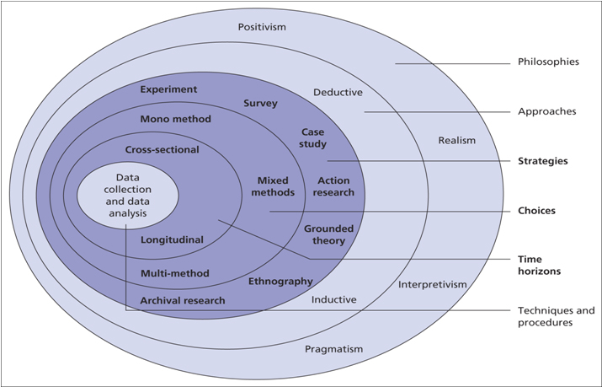
Figure 1; Research Onion (Saunders et al,2007)

Philosophy and Approach
Saunders’ first outer layer refers to research philosophy. This research will adopt a Positivism philosophy outlook. Positivism refers to generalisations from natural science and research to get an overview on societal behaviours. (Eriksson&Kovalainen,2008). This research will also adopt an interpretivism philosophy approach. An interpretivist approach integrates theories about how researchers gain knowledge of the world, which relies upon interpretation and understanding the meanings of human actions (Blaikie,2009). In addition, this study will also select a deductive style approach. A deductive approach is a process of reasoning, from statements to reach a logical conclusion (Lancaster,2005). This study will analyse the abundance of information on social issues and the rolling effects it carries, but to achieve the overall aim of this research, to gain understanding on the topic area and to identify its perceptions within the student community, a more focused approach is needed.

Strategy
The third layer of the research onion refers to strategies. Strategies in philosophy underpin the methods of research that is to be carried out. In this study the strategy that is selected is surveys which is a quantitative research method which will enable the researcher to collect public views and opinions in order to subject it to comparison. Surveys can be used to create possible reasons for particular relationships between variables and will give the researcher more control over the research process, such as the creation of response formats. (Saunders, lewis,Thornhill,2009).

Resources and Planning (Time horizon)
Gordon (2007) explains that in any research, planning is crucial, and that the successfulness of any research is determined by the quality of planning. In order to achieve the aim and objectives set out, various resources must be used. To ensure all deadlines are met for this dissertation a Gantt chart will be produced (see appendix) to plan and organise work. The use of primary and secondary data creates an understanding to societal issues in surrounding areas for the researcher, which can be seen in the literature review. Secondary data will include, academic books, journals, articles which will be accessed through the university library, which possess reliable and up to date resources. Primary data will be conducted online, with surveys in the form of a questionnaire being distributed on social media websites.

Research choice
In relation to research choice, the researcher will use a mono-method choice. As outlined by Creswell (2014) a mono method design involves a structured approach with one framework based on decisions on previous stages of the research. This research will use questionnaires to generate quantitative and qualitative data in identifying the perceptions of university students on social issues associated with Swansea High Street. Using this research design will allow the researcher to understand and compare the responses between participants along with providing the participants a voice to the study which ensures that results are based on participants experiences (Clark et al,2016).

Data collection and sampling
The timescale for data collection in this study will be cross sectional, as described by Saunders et al (2009) this involves conducting research within a particular time frame. As this study is part of an academic course this choice is suitable as there is a time limit on the study. As stated by Jamison (2006, pg33) volunteer sampling refers to a technique in which participants self -select themselves to participate in the study. A volunteer sampling tool will be used for university students to take part in a questionnaire. This choice is the most practical as the decision to take part will be at the participants discretion as the variable, university students, is unique to certain individuals. However, due to the sampling method of volunteering it may indicate a limitation as the sample may not be fully representative. In addition, the average age of a student will be estimated to create a representative sample group. However, this is not always the case and therefore the definition of a ‘student’ in this research will be addressed and the age of the participant will be required.

Validity and Reliability
Validity and reliability refer to “… how social scientists can determine the extent to which a particular empirical indicator represents a given theological concept” (Carmines&Zeller,1979). Validity concerns whether the results of the research will be representative to real life scenarios. Whereas reliability concerns the extent on whether research can be successfully repeated (Payne&Payne,2004). This concept must be considered in this study and therefore to limit the threat to validity and reliability the research must ensure that the correct design methods and strategic methodology coincides with its aims and objectives.

Ethical Considerations
When conducting any research using human participants there are several risks that need to be considered. In the UK, The Ethics Committee is one of a series of safeguarding human participants in research. These Safeguards were formed and have been set out in the Declaration of Helsinki which has been named as the most important document in the history of ethical research and is adopted by all countries (Health Research Authority,2020). This study will consider and adopt ethical guidelines when carrying out its research. The sample group which has been chosen does not allow any bias as participants are not specifically selected due to their gender, age, race or sexuality. Participants have the right to consent to participate in any research and therefore, the researcher will provide a consent form, enclosed with the aims, objectives and purpose of the study. This study topic may be deemed as sensitive and therefore all information, including personal that is retrieved from participants will be confidential, as stated by Saunders et al (2009) Everyone has the right to privacy. This study will complete an Ethics form to present the ethical considerations that have been made before research is carried out.

Covid-19
Due to the covid-19 pandemic, in line with ethical considerations, the risk of health and safety in relation to coronavirus will also need to be considered. This will be with guidance from the Welsh Government. Therefore, the questionnaire will be distributed online.

Conclusion
As stated above, the aim of this research is to understand student’s perception of Swansea High Street, this research can gain an insight into the implications and real-life experiences of those who use Swansea High Street and are affected by the social issues surrounding it. Do university students feel intimidated when attending the university? Do they feel that they have selected the wrong university to study at? Is Swansea city council letting down the community? These experiences may have the potential to produce significant recommendations to help and support those who are affected by this issue.

Chapter 4- Data Analysis

Introduction
The previous chapter discussed the methods and methodology of this study which focused on the second objective of this dissertation:
-To select and undertake primary research to explore students views on societal issues that are linked with Swansea High street.
The chapter that follows will focus on data analysis and findings of the methodology which will satisfy the third objective of this study:
To analyse the collected data and investigate whether there are differences in students’ perceptions compared to their age, gender and year of study.

Data analysis
Analysing data is vital in research as it is used to process data for it to be clearly interpretated. It will allow the researcher to examine and identify relationships between the variables and make comparisons (saunders,2007). Fundamentally, data analysis presents data in a more simplistic way.

Hypothesis
To achieve the fundamental aim in this study and the objectives outlined above the hypothesis for this data set is as follows:
H0- There will be no difference between university students’ perceptions of Swansea High Street and their age, gender and period of study.
H1- There will be a difference between university students’ perceptions of Swansea High Street and their age, gender, and period of study.

Methods
The data in this study consists of both quantitative and qualitative data. A mono method approach was selected where data has been collected by an online questionnaire which has been distributed on social media platforms and a copy can be found in the appendix. Therefore, the methods used for data analysis will be selected carefully, ensuring it is appropriate for the specific data set. A data matrix was used to display the data collected on Microsoft Windows Excel; this will allow quantitative data to be systematically analysed through a numerical data system. Statistical package for the social sciences (SPSS) software was also used in analysing data. Qualitative data collected from the questionnaire however will be analysed by NVIVO, a system which creates clear analysis of descriptive data. To determine whether comparisons or significant relationships can be formed, several statistical tests will be used, this will involve a chi square test of independence. The data analysis needs to be purposeful and appropriate to represent the findings from this study.

Sample
As discussed in chapter 3 the sample that was used in this study was university students studying in Swansea, which was obtained by a volunteer sampling method. As the population of students currently studying in Swansea is an ambitious sample to use in this study this was the most appropriate sampling method to use. 72 responses were received from the questionnaire and have been used in this data analysis.

Gender
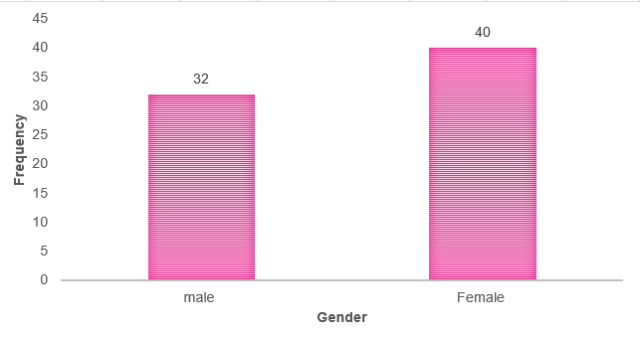

Figure 2-Gender classification

When analysing the sample from the data collection, 55% of the participants identified as female and 44% of participants identified as male. It is clear that statistics show that more females than males took part in this study. As stated, gender will be a focus for the researcher when testing the hypothesis.

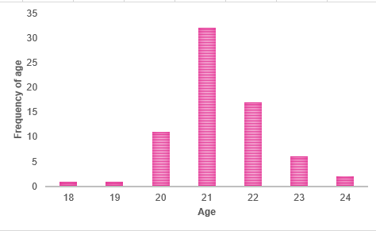
Demographic
Figure 3- Frequency of Age

Question two asked the participants to specify their age. All participants were required to be at least 18 years old to complete the questionnaire. This question was not limited to age brackets as a specific answer would be easy to input and analyse in a numerical system. In addition, as suggested in chapter 3, although we assume the age bracket of a ‘typical’ university student is 18-22 there is no specific age requirement for a student studying at university, and therefore an open tool response was the most appropriate. As the figures show the most common frequency of age was 21 with 44% responses, as opposed to only 1% of participants who fall under the 18- and 19-year-old bracket.
To visibly see if there is a possible relationship between the age of participants and their responses, question 6 was used to compare responses to determine any significant difference. This was completed with a correlation test and submitted into a graph.
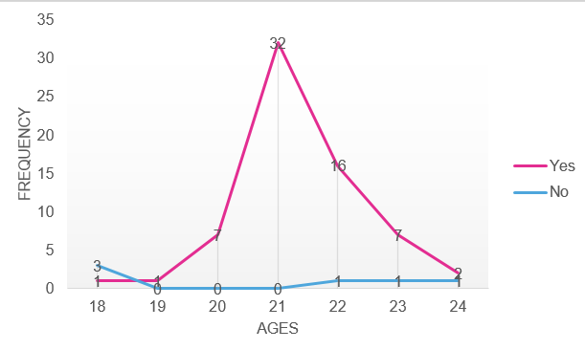
Figure 4 Correlation graph showing a significant difference between age and the responses to 'Do you use or have used Swansea high street?’

Question 6 asked the students if they use Swansea High Street. As the graph illustrates, there is a clear significant difference between the ages of the participants and whether they use Swansea High Street. 44% of 21-year-olds responded with yes to question 6, compared to the lowest percentages of a yes response of 1% in the category of 18 and 19. In contrast there is a significant drop in those who answered no to question 6 but also differs in age category, as the highest percentage at just 3% sits in the 18 age category. Summarising that the majority of students who took part in this questionnaire are not only 21 years old but also use Swansea High Street the most.

Year of Study
To achieve the main objective in this chapter, question 4 in the questionnaire relates to the participants year of study. It was vital that this was analysed as it is needed in order to determine if there are differences or relationships that can be established, hence accepting or rejecting the dissertation hypotheses.
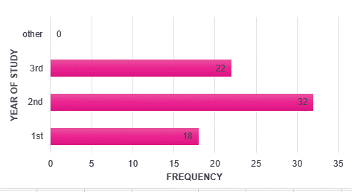
Figure 5-Frequency of year of study

As the figures show there is a higher frequency of students that stated that they are currently studying in their 2nd year of university. Compared with only 18 students who stated that they are currently in their 1st year of study and 22 in their 3rd year.

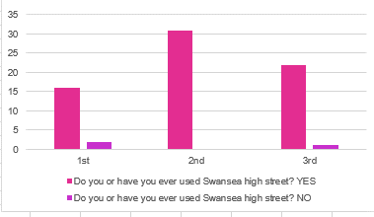
Figure 6-Graph of respondents of Question 6 and year of study
The results indicate that 100% of all 2nd year respondents of the questionnaire stated that they do use or have used Swansea High Street. This is intriguing as compared with third year students who have been studying in the same city for longer, 3% stated that they do not use or have used the High Street at all.

CHI SQUARE ANALYSIS

A Chi Square test of independence has been selected for this study and will be used to test the accuracy of the above figures. This will determine whether there is an association between two categorical variables. A Chi Square test was carried out to determine whether there is a significant difference between the year of study at university and the responses as to whether students use or have used Swansea High Street. A chi square test is calculated by focusing on how the observed value of a data set is significantly different from the expected value. In this case, a null hypothesis, as stated above states that two variables are equal or that the difference between them are zero. To calculate whether this is true the researcher must calculate the p-value, 0.5% or less would reject the null hypothesis as it would mean that there is a statistically significant difference between the variables, whereas if the value was 0.5% or more, there is no significant difference between the variables and the null hypothesis can be accepted (Kozak,2015).

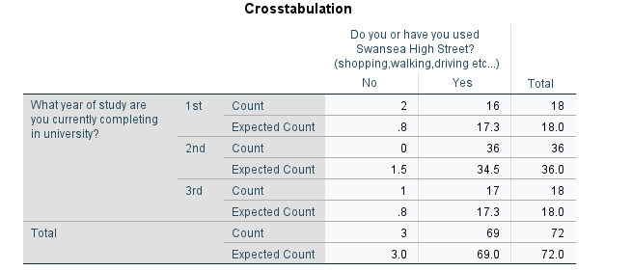
Figure 7-Cross Tabulation between Question 6 and year of study
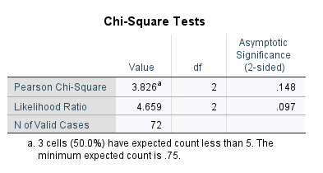

The figures show from the cross tabulation and from the graph that the expected value and the observed value differ, but to state whether the difference is a statistical certain one, a chi square test has been carried out and the results show that 0.148 is the value that needs to be compared with the p-value. It can be concluded that the null hypothesis can be rejected and that there is a statistical significant difference between the year of study at university and whether the students use Swansea High Street.

Quantitative data
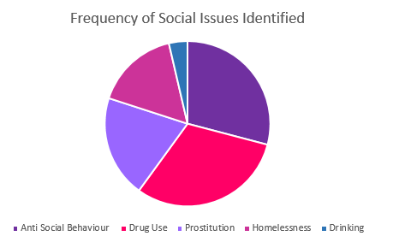

Figure 8-Pie chart of question 8 responses
Question 8 asked for the respondents who answered yes to question 7: Have you seen any social issues when using Swansea High Street? to state the social issues they have witnessed. The responses show that the participants responded with identifying 5 key issues. The highest frequency of the social issues identified was drug use with 31% of participants identifying this issue. The second most common social issue identified was anti-social behaviour with a frequency of 29%. In comparison, the social issues with the least frequency were drinking (alcohol consumption).
To achieve the objective of this chapter, to determine whether there is a difference between student’s perceptions of Swansea High Street and their year of study, this pie chart will be analysed along with the respondent’s current year of study.

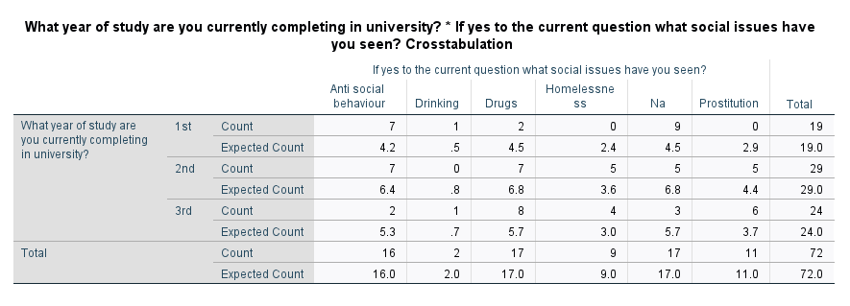
Figure 9-Cross tabulation table of Question 8 and year of study
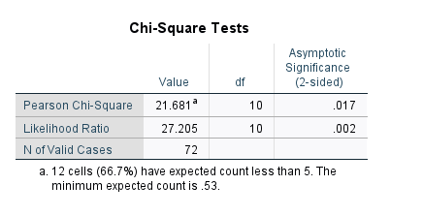

When looking at these figures and with the p value of being 0.5%, the statement that can be made is that 0.17 is less that then the p- value and therefore significantly different. The researcher can accept the experimental hypothesis of this study. It is a true reflection that there is a difference between student’s perception of Swansea High Street and their year of study. The reasoning of this will be discussed in the findings.

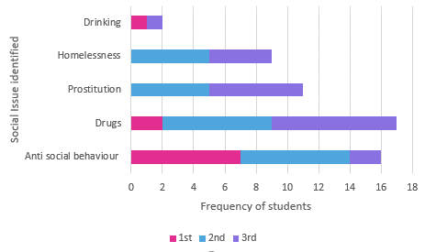
Figure 10-Graph of Year of study and question 8 responses

Qualitative Data

As mentioned above, NVIVO software was used to analyse qualitative data collected from the online questionnaire. It allows data from open ended questions to be analysed and categorised. Question 12 asked the students to describe Swansea High Street. Again, for this to achieve the objective of this chapter this will be compared to the student’s year of study to determine if there are any differences or relationships between these variables. A word cloud was created for question 10 which gathers the most frequent responses. The bigger the font the most frequent the word was in the responses.


Figure 11-Word cloud representing Question 12
The most frequent response was 21% who described Swansea High street as ‘Run Down’, followed by 17% of students using the word abandoned to describe the High Street. Through the data collected it was confirmed that all who responded to question 10 used negative and concerning comments when describing the city’s High Street.
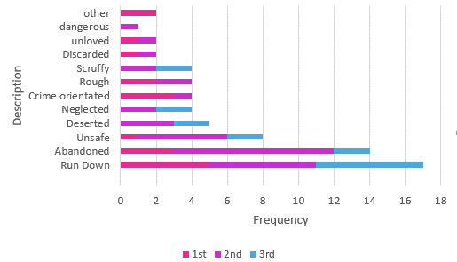

Figure 12- Graph of question 12 responses and year of study
The figures above illustrate the frequency of the adjectives the respondents used. The statistics clearly show that the most frequently used word to describe Swansea High Street was ‘Run-down’ with respondence rate of 21%. The second highest frequency was 17% with the description of ‘Abandoned’. The lowest frequency consisted of 1% of the sample group which described Swansea High Street as ‘Dangerous’. These figures also show the year of study the students are currently completing, it is evident that 1st and 2nd year students describe the High Street in more variation, as 3rd year students only used the range of 6 categories out of the possible 12. As previous charts have shown that the highest frequency of students currently completing their 2nd year of university, hence, expecting to be a distribution between all categories, however, the majority of students from this year of study described the High Street as abandoned.
The final question in this questionnaire asked the respondents to propose any recommendations to rectify these social problems. As all participants who answered question 12 described the High Street in negative or derogatory terms the analysis of this question was intriguing.

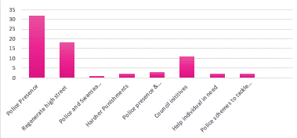
Figure 13-Graph showing frequency of responses in question 13

These figures show that the most common suggested answer was police presence of the street and the second most common answer suggesting that there should be a regeneration in the area. After looking at this analysis the researcher wanted to find out if gender had an impact on the recommendations given by the respondents. Is there a significant difference between gender and the type of recommendations suggested to help or mitigate the social issues identified on Swansea High street?
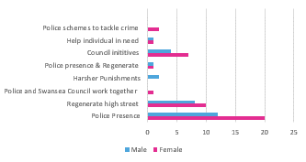
Figure 14-Graph of responses from question 13 and gender

These statistics show that there is a possible difference between gender and the responses given by the participants. It is clear that female students mostly suggested more police presence on the High Street in order to mitigate the social issues discussed above. This can be interpreted in many ways and will be discussed in the findings. In addition, females have the highest frequency for regenerate high street and council initiatives. Males however, had the highest frequency in suggesting that more harsher punishments should be given to individuals who cause these issues.
This question was also analysed in relation to age, and whether there was a difference in the responses. The graph below shows the variation of ages and the responses. It can be seen that the majority of those aged 21 favoured police presence as a recommendation compared to the others identified. These figures also show that the older students, aged 22-24 identified recommendations that cover a wide range of solutions, other than the social issues highlighted in this study.

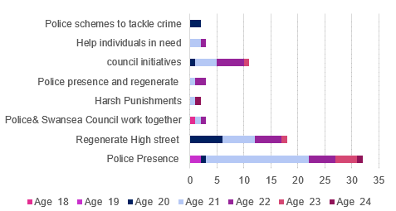

Figure 15- Graph of responses from question 13 and age

Conclusion
This chapter has achieved the aim and objective. This chapter analysed and explored students’ perceptions of Swansea High Street and has investigated whether there are differences in student’s perceptions compared to their age, gender and year of study. There are several main findings found in this analysis and will be discussed in the next chapter.

Chapter 5- Findings, Recommendations and Limitations

Introduction
This chapter will discuss the 5th and final objective of this study:
To discuss the findings of this research to generate recommendations to the local authority to amend the implications that have been highlighted.

Main Findings
The main findings included the general perceptions of Swansea High Street by students currently living and studying in Swansea. More specifically, age, gender and year of study was incorporated in distinguishing differences in responses. The study found 4 main findings. Firstly, 2nd year students are more likely to be the dominant users of the High Street, this may be because 2nd year students are labelled as more comfortable students in regard to their course, relationships and environment, thus the most affected by the decline of Swansea High Street and the issues that have been identified with it. Secondly, there is a statistical difference between student’s responses of the questionnaire and their year of study. This suggests that due to the 2nd year students are more dominant users their responses are more likely to be more advanced as it can be assumed that they are affected by these social issues more than others in a different year of study. Thirdly, all participants who answered used negative and derogatory terms when describing the High Street. This highlights the need for recognition of the problems caused by the city’s High Street decline and how it has affected not only the area but they residents of the city. Finally, females are more likely than males to favour police presence in the area compared to any other recommendation. This can be linked to the literature review as female’s may be more vulnerable within the city centre and would feel unsafe, hence, feeling that police presence would reassure them and solve their issues with safety.

Recommendations
Following this study, a number of recommendations can be made.
Firstly, the study in this dissertation illustrated that there is a major issue with social issues inhabiting Swansea High Street after its decline and therefore is important to stress the impact this has on students and potential other individuals in the community.
Secondly, to introduce measures to ensure students, specifically female students are kept safe when using Swansea High Street. South Wales Police must act on the issues highlighted in this study.
Thirdly, Swansea city council should accept the findings found in this study and make changes where appropriate. A regeneration plan for Swansea city centre should include the High Street.

Achievement of Objectives
This study completed its objectives:

- To analyse academic literature on the social issues associated with UK High streets and the provisions put in place to rectify them.

This was completed with a in depth literature review which focused on previous research and information relating to the decline of Uk High Streets and the issues Swansea currently faces. It involved exploring specific social issues that were associated with the decline of High Streets and the measures government bodies are doing on the issues.

- To select and undertake primary research to explore students views on societal issues that are linked with Swansea High street.

This was achieved by completing the research onion (Saunders et al,2016). This study adopted a mono-method approach and created a questionnaire to explore student’s perceptions of Swansea High Street. This was distributed with opportunity sampling.

- To analyse the collected data and investigate whether there are differences in students’ perceptions compared to their age, gender and year of study.

This was completed using SPSS software programme. Quantitative data was displayed in cross tabulations and using NVIVO. Further analysis in investigating whether there were relationships between the responses and their age, gender or year of student, chi-square tests of independence were conducted. Main findings highlighted the specific issues students faced when using Swansea High Street and their prevalence.

- To generate recommendations to the local authority to amend the implications highlighted in this research.

This was completed by considering the results in this study. Based on the responses in the questionnaire, recommendations have been proposed to the local police force and city council to mitigate the issues found in this study.

Conclusion

This study should be used as a voice for the students living and working in proximity to the High Street and who have been affected by the social issues identified. Local authority and provisions should be made to make them feel safe and should create an environment where their university experience is an efficient one.

Reference List

BBC NEWS (2020) High streets across England secure cash boost for regeneration [online] published December 2020 (Accessed:19.01.21) Available at: High streets across England secure cash boost for regeneration - BBC News
BBC NEWS (2020) Holbeck legal red-light zone not a permanent solution [online] published November 2020 (Accessed:20.1.12) Available: High streets across England secure cash boost for regeneration - BBC News
Big Issue (2020) How many people are homeless and what can you do about it. Published November 2020 [online] (Accessed:19.01.21) Available at: How many people are homeless in the UK? And what can you do about it? (bigissue.com)
Blaikie (2009) Designing social research: The logic of anticipation, polity press: Cambridge.
Cardiff. Department of Housing (2020) Breaking the cycle. Published November 2020, county hall. Cardiff. (Accessed:20.1.21)
Crossley Health (2019) The Death of the High Street? Available at: Geography-321-Death-of-the-high-street.pdf (crossleyheath.org.uk) (Accessed:4.3.21)
Department for Business, innovation and skills (2011) Understanding high street performance, Available at: https://assets.publishing.service.gov.uk/government/uploads/system/uploads/attachment_data/file/31823/11-1402-understanding-high-street-performance.pdf (Accessed:3.3.21)
E. Carmines and Zeller (1979) Reliability and Validity Assessment, London: sage publications
Erriksson.P, Kovaline. A (2008) Qualitative Methods in Business Research, London: Sage Publications
Flowers (1998) The prostitution of women and girls. 1ED, Mcfarland and company inc publishers: London (Accessed:19.01.21)
Foster.L (2019) The relationship between students and the High Street, Available at: The relationship between students and the high street - FLAVOURMAG (Accessed:3.2.21)
G. Creswell (2014) Research Design: Qualitative, quantitative and mixed methods approach (4th edition) sage: California
G. Lancaster (2005) Research Methods in management, Elsevier Butterworth-Heinemann: Oxford
Grimsey. B (2012) sold out: Retail veteran lifts lid on who killed the high street and it’s not who you think, Filament publishing: Surrey.
Health Research Authority (2020) Research Ethics Service, Available at: Research Ethics Service - Health Research Authority (hra.nhs.uk) (Accessed:10.2.21)
HM Treasury (2018) our plan for the high street. published December 2018, Home Office publications, Westminster, London (Accessed:19.01.21)
Hubbard. P (2017) The battle for the high street retail gentrification, class, disgust, Palgrave Macillian UK: London (Accessed:18.01.21)
Institute place management (2016) England’s high streets to be revitalised with help of new government task force [online] (accessed:17.01.21) available at High Streets Task Force Announced | Institute of Place Management
J. Creswell, L. Vicki and P. Clark (2015) Mixed Methods Research: A guide to the field, Sage
J. Gordon (2007) Planning Research: A concise guide for the environment and natural recourses science, Yale University
J. Jamison (2006) Research Methods in Psychology for high school students, New York: iuniverse inc
Kollowe. J (2012) up to 40% of high street shops could close in the next five years [online] Published March 2012,The Guardian (Accessed:20.1.21) Available: Up to 40% of high street shops 'could close over next five years' | Retail industry | The Guardian
Kozak.K (2014) Statistics using technology, 2nd ed, USA: Lulu.
Lawrence.K (2007) Prostitution strategy. Published January 2007, Safer Leeds Partnership. Civic Hall, Leeds (Accessed:21.1.21)
Littlewood. J (2015) The sustainable regeneration of the Swansea high street- a cohesive community, Sustainability in energy and buildings research Advances, ISSN, Vol 6, no1 pp35-43(Accessed 21.1.21)
M Saunders, P Lewis and A Thornhill (2016) Research Methods for Business Students (7th Edition) Harlow: Pearson education limited.
M. Williams (2016) Key concepts in the Philosophy of social research, London: Sage
Martin and Bridgeman (2003) Quantitative and Statistical Research methods from hypothesis to results, San Francisco: Josey Bass
Ministry of Housing , communities and local government (2018) The High Street Report Available at: The High Street Report (publishing.service.gov.uk) (Accessed: 12.1.21)

Monham and Gemmell (2015) Reducing crime hotspots in city centres. published July 2015 BRE Briefing paper (Accessed:18.01.21)
Office Of National Statistics (2020) High streets of Great Britain (Accessed:15.01.21) Available at: High streets in Great Britain - Office for National Statistics (ons.gov.uk)
Office of National Statistics (2020) Internet sales as a percentage of total retail. Retail sales: Great Britain: December 2020(Accessed: 16.01.21)
Payne. G and Payne. J (2004) Key concepts in social Research, London: Sage Publications
Police.UK (2020) Crime Map [online] (Accessed:22.1.21) Available at: Castle | Police.uk (www.police.uk)
Safer Wales (2016) Safer wales to protect sex workers in Swansea. Available at: Safer Wales to protect Sex Workers in Swansea — Safer Wales (Accessed:12.2.21)
Sagar, Jones and Symons (2015) Sex work, drug and alcohol use: Bringing the voices of sex workers into the policy and service development framework in Wales, published 2015, Swansea University, Welsh Government, Cardiff (Accessed:18.01.21)
Saunders, Lewis and Thornhill (2009) Research Methods for business students, (5th Edition) Pearson: New York
Shaw. A (2020) How to save the UK’s crisis hit high streets [online] (posted:12.01.20) (Accessed:15.01.21) Available at: How to save the UK's crisis-hit High Streets - BBC News
South Wales Police (2019) Operation jaeger: Tackling sex working in Swansea city Centre, Published January 2019. (Accessed:21.1.21) Available at: Home | South Wales Police (south-wales.police.uk)
Swansea Council (2016) Swansea Central Area: Regeneration framework. Published February 2016. Civic centre, Swansea. Wales (Accessed:21.1.21)
Swansea Council (2019) Safer Swansea partnership. Published August 2019, Partnership working, Civic centre, Swansea (Accessed:21.1.21)
Swansea Council (2020) Council’s building enhancement programme, published January 2020, civic Centre, Swansea (Accessed:21.1.21)
Swansea Council (2020) Population. Published November 2020, Civic Centre, Swansea (Accessed:20.01.21)
Turner. J and Gardner. T (2014) Critical reflections on the decline of the UK high street: exploratory conceptual research into the role of the service encounter. Handbook of Research on Retail-consumer Relationship Development, 127-151 (Accessed: 17.01.21)
UK Crime Stats (2020) England and Wales crime breakdown [online] (accessed:17.01.21) available at: UKCrimeStats.com - The Leading Independent Crime Data Platform
UK Government (2018) Homelessness data and definitions. Published April 2018, Ministry of housing, communities and local government, Westminster, London UK (Accessed:17.01.21)
Wixcey (2013) The Deloitte consumer Review: Reinventing the role of the high street. A deloitte Report. The creative studio: London (Accessed:15.01.21)

Appendix

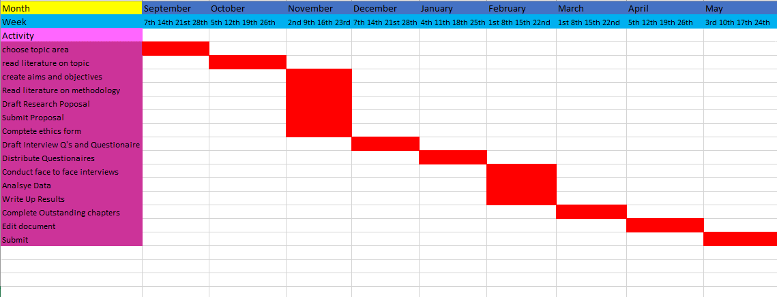
Gantt Chat

Online Questionnaire
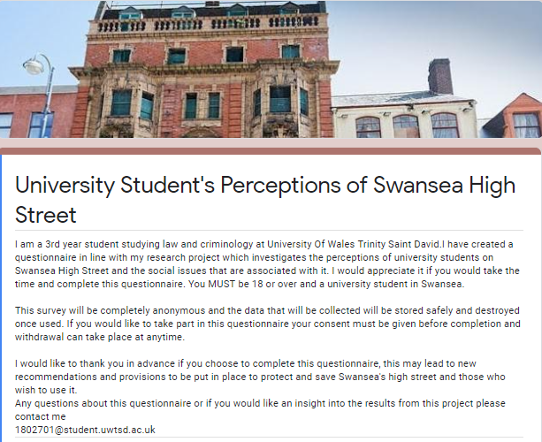

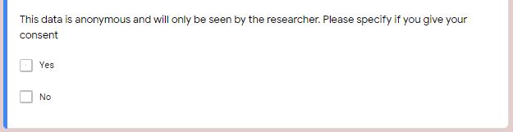
Q1


Q2


Q3

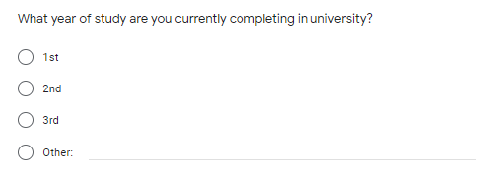
Q4


Q5

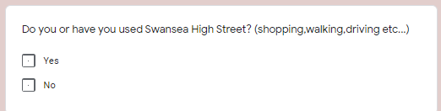
Q6

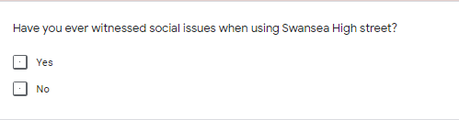

Q7

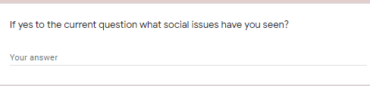
Q8

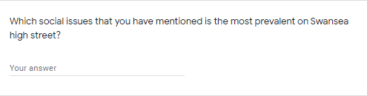
Q9

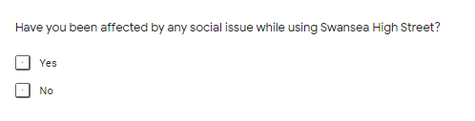
Q10


Q11


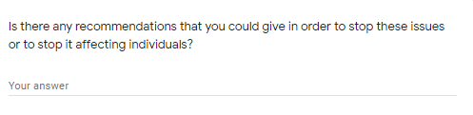
Q12

