 |  | Lab Report – Flame test
 |  |  | Arun Sherlock  2318644    20/02/2024  —  Dr Ewa Kazimierska  —  ACDB4011 – Chemistry | 

Contents
Introduction 3
Purpose 3
Hypotheses 3
Variables 4
Independent 4
Dependent 4
Control 4
Equations 4
Materials & Methods 5
Materials & Equipment 5
PPE 5
Procedure 5
Results 6
Experimental data 6
Explanation 6
Discussion 7
Analysis 7
Electromagnetic radiation 7
Barium 7
Strontium 7
Relevance & use cases 7
Limitations of the experiment 8
Conclusions 8
Findings 8
Improvements 9
References 9

Introduction

Purpose

The purpose of the flame test is to determine the presence of specific metal ions within chemical compositions. This could be used in several fields, including OME, to determine which metals are present in pyrotechnic compounds, as well as in field tests to confirm the presence of metals for evidential reasons.

Hypotheses

Based upon the information included on the experimentation sheet we would expect to see the following colours if these metals are present.

Element | Colour produced
Lithium | Red
Sodium | Strong, persistent orange
Potassium | Lilac (pink)
Rubidium | Red (Red-Violet)
Caesium | Blue/Violet
Calcium | Orange/Red
Strontium | Red
Barium | Pale Green
Copper | Blue/Green
Lead | Gray/White
Figure 1 – Flame colour produced from each metal [2]

This is due to the electrons in the atoms in the sample (specifically the metal atoms) being excited as they are heated. These electrons exist in a “ground state”, and when energy is applied to them, they are excited. The electrons cannot stay excited, and when they return to the ground state, they give off the energy in the form of photons. Though this may always be happening, the majority is not within the visible light spectrum. Some will be within the visible spectrum when they are excited and depending upon the metal content, they will give off specific colours due to the wavelength of the energy in the photons.

Variables

Independent
The sample which is burned during the flame test.

Dependent
The colour produced during the flame test.

Control
The chemicals used in the washing process.
The Bunsen burner flame used.
The sample holder.
The person determining the colour of the flame.

Equations

The light given off is related to the frequency of the emitted photons of light, this is detailed by the equation below.

ΔE = h x F

ΔE is the energy difference.
H is a Planck Constant (h = 6.63 x10^-34).
F is the frequency of the light in Hz.

c = f x λ

c is the speed of light (3.0x10^8 ms^-1)

Materials & Methods

Materials & Equipment

- 8 samples of material 1 M, unidentified.
- 1M Hydrochloric Acid (5%)
- DI Water (De-ionised)
- Bunsen Burner
- Heat proof mat
- Metal rod sample loop
- 2x Beakers
- 8 Sample tubes
- Blue cobalt glass
- Matches

PPE

- Gloves
- Safety Goggles
- Lab coat
- Hair ties (Where necessary)

Procedure

Setup
Setup Bunsen burner on the heatproof mat, connect the gas pipe to the tap. Turn the tap on & light the Bunsen burner, use the air vent to control the flame. Always use a safety flame when not in use, and a blue flame while testing samples.

Cleaning
Dip the metal rod’s sample loop into the hydrochloric acid, tap it off to allow the HCl to evaporate, and then place into the hot flame to burn off any remaining sample. Repeat until flame no longer shows colour. Once no colour shows, dip the loop into the DI Water, and then place into the hot flame to remove any remaining HCl. These steps must be completed between testing each sample.

Testing
Allow the loop to cool down, then dip it into a sample. Place the loop into a hot flame, watch the flame to see what colour is produced. Note this in results book next to sample number. If unsure, look through the cobalt glass to gain a clearer view. Note the results in the booklet and repeat for all samples.

Results

Experimental data

Sample | Flame colour | Metal present | Wavelength (nm)
A | Red | Strontium | 625 - 750
B | Red / Pink | Lithium | 700 ~
C | Orange | Calcium | 590 - 620
D | Lilac | Potassium | 400 - 450
E | Green/Yellow | Barium | 500 - 600
F | Red/Orange/Pink | Sodium | 600 ~
G | Bluey Green | Copper | 480 ~
H | Yellow, hint of purple? | Sodium / Potassium mix | 570 – 590 & 400 - 450
Figure 2 – Table of results

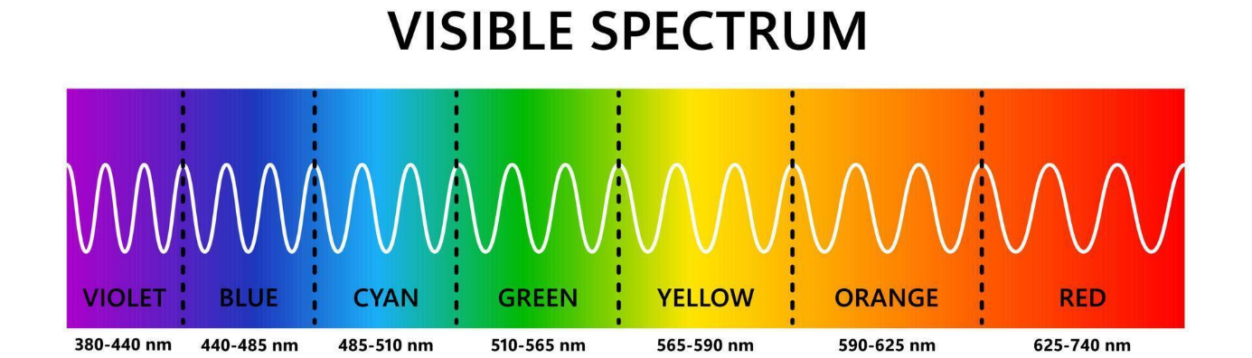
Figure 3 – Visible light spectrum [1]

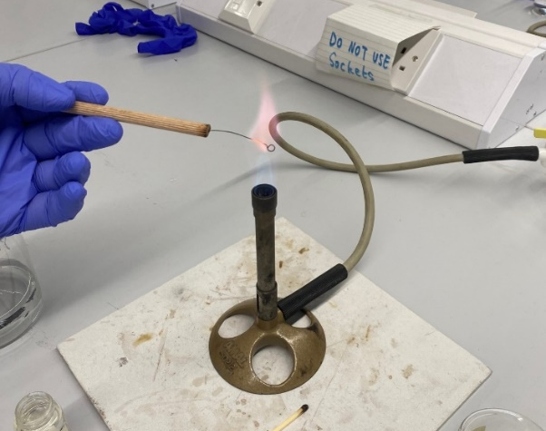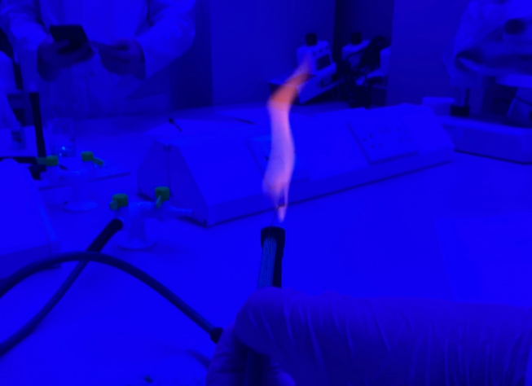
Figure 4 – Flame test in progress Figure 5 – Flame test seen through boron glass

Explanation

The table above contains the results. Certain metals produced different colours when heated, suggesting which sample contained which metal. The wavelengths are approximated based upon the wavelengths of visible light. Multiple tests of some samples were performed, as the colour was very hard to distinguish. There were issues with contamination of the sample holder, which may have biased the results.

Discussion

Analysis

These results were not as accurate as expected, it was harder than expected to distinguish between colours in the flames. However, that aside this is an effective qualitative method for determining which metals are present in a sample. This could be an effective field test, as very little equipment is required to carry it out and although not particularly accurate, it can give a good idea.

They did however prove that when metal ions are heated, the electrons become excited and give off ions of visible light

Electromagnetic radiation

Barium
When heated, the electrons within the Barium become excited and release this energy in photons. This produces a green flame, which has a wavelength of around 500 – 600 nm. Barium is described as 6S^2, meaning it is a 6th period element, with 2 valence electrons. These are the electrons which will move outwards into empty shells when excited, and then produce photons as they return to their ground state. Considering the equations above, we can see that the light produced is equivalent to releasing between 3.9729e-19 & 3.3108e-19 joules of energy. This relates to the maximum amount of energy that the atom can hold within an excited state.

Strontium
Strontium produces a strong red when heated, which can be estimated between 625 – 750 nm, which equates to an energy release of between 3.1783E-19 & 2.6486E-19, per photon released. This photon produces a strong red light which is distinctive when compared with the colours produced by other metals in this test.

Relevance & use cases

This experiment is relevant to OME due to the use of these metals within pyrotechnic compositions, used in products such as flares, tracers and smoke compositions. Some real-world testing within the OME world involves burning materials to validate them for use & confirm their composition without expensive laboratory equipment. It also relates to processes within energetic material hazard testing (EMTAP), as some tests- such as the train test- involve burning the energetics, watching how they react & any by-products produced, and then analysing this.
Tracers use pyrotechnic compositions containing elements such as strontium and barium (depending on the necessary colour), and these are tested through a more complex version of this simple experiment. During pyrotechnic testing, a small sample is ignited. This is watched by a person, but also monitored by a spectrometer, providing quantative data, confirming that the specification desired is reached. An example of a tracer composition contains barium peroxide (86%), magnesium powder (12%) & acaroid resin (2%) [3]. Within this composition, two metals are used, magnesium which produces a bright white light, and barium which produces a green colour. The magnesium will also burn hot, aiding with the combustion of the barium.

Aircraft flares use metals such as magnesium and aluminium [4] to produce a bright source of infrared light, to distract / disorient heat seeking infrared missiles. These compositions are designed to give off the maximal amount of radiative energy possible to increase their effectiveness.

Limitations of the experiment

This experiment does have some limitations, the largest being the human aspect. As it relies on vision to determine the results, there is a large area for interpretation, which means one person could view the results differently from another. People with colour blindness may not be able to determine the results at all, as they will not be able to perceive the colour given off in the flame.

Another limitation is around the wavelength result, as we have no way of accurately measuring this. They are solely based around the rough wavelengths of the colours seen, rather than an accurate reading which would give us more accurate results.

Finally, there were issues of contamination in our test. Even after cleaning the sample holder several times, we were still seeing evidence of colours from previous tests, which may have changed the results of samples after them. This could be a significant issue if more samples were tested.

Conclusions

Findings

The experiment used was able to determine the presence of metals within the samples, and generally give the user a clear idea of which metal was present. There are issues with the test, such as contamination, the human element and vision.

The results seemed conclusive when compared with other groups work, which reinforces the accuracy. The metals made a significant change to the colour of the flame, which reinforces the theory that photons are given off when the electrons are excited, and they do change colour depending on the metal- confirming the different behaviours of different materials & atomic structures.

Improvements

To remove the qualitative element of the test, and provide quantative data, the use of spectrometry to provide an accurate measurement of light given off by the metals. This would allow more accurate measurement of the metals present within the samples. In a laboratory, this would be done with a spectrometer, which will provide highly accurate results, however this is not feasible for a field test. In the field, photographs may be taken with a DSLR, which when uploaded to a computer can be analysed to provide a vague idea of the spectrums of light produced within the flame through software analysis and could also be peer reviewed by multiple eyes- improving accuracy. This would combat both the human element and the limitations around the wavelength results.

To combat the issues with contamination, there are a couple of options which could be explored. The first is to use a stronger acid to clean the sample holder, as this would be more likely to remove any trace of the samples. Alternatively, disposable sample holders may be used, such as wooden splints, if a splint is used any remnants will be burnt away with the sample, and a separate splint may be used for each test. The only issue with this is that the splint may influence the colour of the flame, so testing would need to be carried out to confirm whether this influenced the results before use.

References

[1] E. Pimukova, Visible spectrum of light. 2024. Accessed: Feb. 21, 2024. [Digital Image]. Available: https://static.vecteezy.com/system/resources/previews/007/695/528/non_2x/visible-light-spectrum-optical-light-wavelength-electromagnetic-visible-color-spectrum-for-human-eye-gradient-diagram-with-wavelength-and-colors-educational-illustration-on-white-background-vector.jpg

[2] J. Clark, “Flame Tests,” Chemistry LibreTexts, Aug. 15, 2020. https://chem.libretexts.org/Bookshelves/Inorganic_Chemistry/Supplemental_Modules_and_Websites_(Inorganic_Chemistry)/Descriptive_Chemistry/Elements_Organized_by_Block/1_s-Block_Elements/Group__1%3A_The_Alkali_Metals/2Reactions_of_the_Group_1_Elements/Flame_Tests (accessed Feb. 21, 2024).

[3] B. Fitchett, “Tracer Bullets - Chemical Analysis Of Firearms,” Bev Fitchett’s Guns, Jan. 08, 2023. https://www.bevfitchett.us/chemical-analysis-of-firearms/tracer-bullets.html (accessed Feb. 22, 2024).

[4] J. Pike, “Flares - Infrared Countermeasures,” www.globalsecurity.org. https://www.globalsecurity.org/military/systems/aircraft/systems/flares.htm (accessed Feb. 22, 2024).

