Assignment Mark
1st Marker’s Provisional mark
2nd Marker’s/Moderator’s provisional mark
External Examiner’s mark (if relevant)
Final Mark

NB. All marks are provisional until confirmed by the Final Examination Board.

For completion by Marker 1 :
Comments:

Marker’s signature: |  | Date:
For completion by Marker 2/Moderator:

Comments:

Marker’s Signature: | Date:
External Examiner’s comments (if relevant)

External Examiner’s Signature: | Date:

Essay based on a Sky Journal

‘Be clearly aware of the stars and infinity on high. Then life seems almost enchanted after all.’ Discuss this statement from Vincent Van Gogh as it relates to your sky journal observations. Gogh, Vincent van, and Ronald de Leeuw. The Letters of Vincent Van Gogh. London: Penguin Books, 1997, p.392.

Word count: 2078
This essay reviews and analyses a Sky Journal kept from October to November 2023. I use my experience of observing the sky to consider what it means to connect with the night sky even in areas of high light pollution. In starting the project, I was interested in how much of a connection with the night sky was possible given the high levels of urban light pollution. Only a handful of stars are visible even on clear nights and consequently the beginning of the Van Gogh quote – “be clearly aware” – struck me as just as relevant as the second part “then life seems almost enchanted after all”. I was sceptical about whether a genuine feeling of enchantment could be felt when I was so aware of how much I was not seeing when looking at the night sky from my home in London. My awareness of celestial phenomena being visible or hidden became a key part of the process, along with the observation of the changing cycles of the moon and the connections I made with my existing symbolic understanding of celestial phenomena. These will form the main themes of this essay, along with the impact my observations had on my sense of an enchanted connection with the night sky.

Methodology

I live in London and with high levels of light pollution, many of the stars and planets are not reliably visible. I therefore chose to observe the Moon each day for at least a month, noting where possible the time of its rising and timing my observations according to the lunar cycle in order to have the best chance of seeing the moon. I kept the journal from 3 October 2023 to 10 November 2023, noting each day whether the moon was visible, how much cloud cover there was and my feelings on observing the moon and the rest of the sky. Due to the cycle of the moon, as many of my observations took place early in the morning as in the evening or at night. I was generally observing from my home, sometimes from the front or back gardens but often from the roof, which allowed access to a clearer perspective above the height of most of the surrounding buildings.

‘Be clearly aware’: visibility and the act of looking

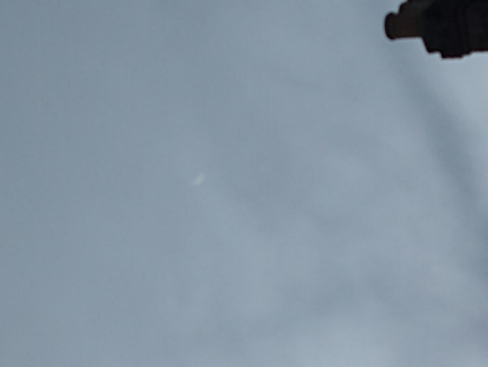
The very first entry in the Sky Journal on 3 October expressed my concern with the lack of visibility of celestial phenomena; “Tonight the moon is hidden… all I see is an opaque blanket of cloud”. The importance of dark skies has been documented by Dill, who notes that “the transformative power of dark night skies…can be understood by assessing the important intellectual, cultural and restorative roles they play for subjects who perceive and are affected by them”. This is borne out by Blair in her research on dark skies on the island of Sark, who found “many examples of enhanced wellbeing” among her research subjects. Throughout the process of keeping the journal, I was aware of this possibility of being positively affected by the night skies and concerned it would not be forthcoming, since I was often barely able to see the moon or seeing it through thick cloud, as in Figure 1 below. On 30th October, I wrote “I gaze at the skies with a hunger for magic. I’m grateful for a clear night, for the bright moon. But I long for more stars, for enough stars to be able to learn the constellations, to follow their seasonal movements. How much wilder would the sky feel then?”

Figure 1 Waning moon barely visible through clouds, taken from the roof. 10 November 2023, 7:14am Photo: Lisa Stockley
However, as the journal progressed, the act of truly looking and observing the night sky opened up my perception. On 21st October I wrote “the moon is hiding from me” but also that I felt “excited and connected” by the faint stars I was able to locate. On October 25th, I acknowledged “recognition and gratitude that the sky is clear tonight; it makes me smile to see it”. Whilst it may seem obvious, observing the moon on a daily basis brought a deeper connection with the changing phases of the moon and with the moon as a physical phenomenon. For example, on 7th October I wrote “This morning the light of the sun, following behind the rising of the moon, makes the moon pure white, at once ethereal and solid. A sense of the physical body up there, the cratered rock orbiting us”. I began to see the moon in “in spectacular, naturalistic clarity” as Boyle has noted in the context of changing artistic and imaginative representations of the moon. In her exploration of historical images of the moon, Boyle notes that “due to our increasingly mediated lives, the moon is glimpsed between city buildings, caught accidentally in a family snapshot; it is rarely seen”. In contrast to this, I felt that I was genuinely seeing the moon, not just in looking but in writing and taking photographs of it, as in Figure 2 below.

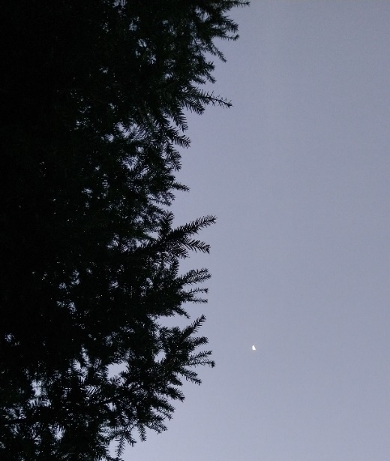
Figure 2 Waning moon and yew tree, taken from my back garden. 7 October 2023 6:57am
I was able to tune in more deeply with a lived experience of the lunar cycle as the Journal progressed, noting for example on 15th October “Although I haven’t seen the moon following yesterday’s dark moon, I’m very aware of its cycle. Of where it’ll be rising, with the sun at around the time I got up this morning”. Likewise on 7th November, I wrote “The waning crescent high up and to the south. And the sun rising, just over the tops of the trees. I can see the lunar cycle right there above me, the moon past the last quarter and moving towards the balsamic phase” (Figure 3).
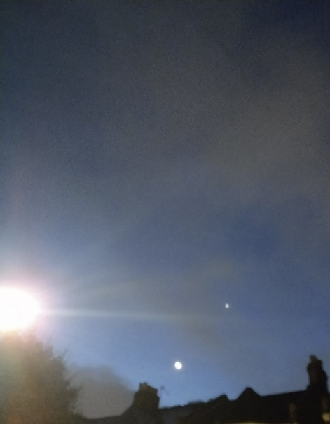
Figure 3; View of moon and Venus with rising sun, taken from the street in front of my house. 10 November 6:15 am Photo: Lisa Stockley

In engaging with more conscious attention, I began to take a more phenomenological approach, observing what was actually there rather than dwelling on what I knew was invisible to me. I experienced, or recognised, “an attunement or synchronization between my own rhythms and the rhythms of the things themselves, their own tones and textures” as Abram has observed. To summarise, regular observation of the physical phenomena of the moon led me to see the moon itself and also its cycles more clearly. The act of observation brought changes to my perception of what I was looking at and perhaps also how I was looking at it.

Observational and symbolic approaches

The act of regularly observing the moon had an impact on my relationship with lunar symbolism. Throughout my adult life, I have followed a pagan spiritual path, practiced astrology and read tarot cards, all of which have had an impact on my connection with the moon as a symbolic and mythological phenomenon. On 29th October I wrote in the journal;

“I felt a lack of connection to the moon for years, turned off by my discomfort with ideas of the triple goddess, Robert Graves and his endless influence. It’s only in the
last year or so I’ve begun to feel a deeper connection with the moon, born of noticing, watching, observing it each night. My mind defaults to meaning-making, nonetheless. I sense something of the sacred, of the soul, when I gaze upwards”.

For example, I have never been comfortable with ideas of the moon as strongly linked to the triple goddess in the work of Robert Graves. This concept of the triple goddess is still ubiquitous in modern pagan practice, despite being questioned by many practitioners, as for example River Enodian who expresses some of my own frustration. The more I observed the moon, the less my perception of it was clouded by awareness of this symbolism and the more I was able to find a more authentic sense of the moon, and the night sky, as meaningful. I felt that I was actually sensing something of the sacred rather than experiencing an intellectual overlay from my awareness of the symbolism. For example, on 31st October I noted that “the moon is becoming a symbol of peace at the beginnings and endings of my days”. My inner experience of the moon was changed by my regular observation, allowing me to let go of outdated symbolic concepts and form a more authentic connection.

‘Then life seems almost enchanted after all’: beyond everyday reality

This opening up of perception showed me that despite my concerns, observing the sky on a daily basis even in an area of light pollution and buildings made “life seem almost enchanted after all”. In exploring the concept of enchantment, Bennet notes that “To be enchanted is to be struck and shaken by the extraordinary that lives among the everyday” and this was very much my experience. On October 30th I wrote

“I gaze out, at the motorbikes passing, the neighbours walking home from the tube station. The moon is beyond all that, gazing out towards space takes me out of the mundane. A clear night, a clear moon takes me out past myself, whilst possibly also bringing my back to myself”.

As well as confirming enchantment as part of my experience, keeping the Sky Journal allowed me to situate that experience in the context of debates around disenchantment and re-enchantment. I had begun my journey at least partly expecting a Weberian experience of disenchantment, modern urban growth meaning that I was unable to see the full extent of the enchanted sky. As Lyons has explored, Weber’s 1918 comments on the disenchantment of everyday life are “often invoked as shorthand for a particular narrative of Western secularization”. I began to consider that I had perhaps been more caught up in this narrative than I had realised. As Bennett has considered, perhaps “the very characterization of the world as disenchanted ignores and then discourages affective attachment to that world”. I was indeed discouraged by my own expectation of disenchantment whereas in fact, I experienced enchantment despite my perceived barriers to that enchantment.

Conclusion

This essay has analysed the Sky Journal kept in October and November 2023, noting links between observation, experience and enchantment. I was able to see the moon as a celestial phenomenon more clearly, for example by observing the cycles of the moon as it changed. These observations also had an inner effect, changing my perceptions of the symbolism I had previously associated with the moon. Despite initial scepticism, experiences of enchantment and connection were recorded, being “both caught up and carried away”, as I experienced on 19th October: “Today I just gazed up into the depths, really seeing depths instead of a two-dimensional backdrop to land…an awareness of the cosmos, the distance, of being part of it”. My overall experience was one of enchantment, an enchantment formed by being “clearly aware” of the night sky, just as Van Gogh noted.

References

Abram, David, The Spell of the Sensuous, (New York: Vintage Books, 1996)

Bennett, Jane. “The Wonder of Minor Experiences.” The Enchantment of Modern Life: Attachments, Crossings, and Ethics, (Princeton: Princeton University Press, 2001) JSTOR, http://www.jstor.org/stable/j.ctt1ggjkxq.4. Accessed 16/11/2023.

Blair, Ada. (2018). An Exploration of the Role that the Night Sky Plays in the Lives of the Dark Sky Island Community of Sark. Journal of Skyscape Archaeology, 3(2), p. 235-252 https://doi.org/10.1558/jsa.34689 Accessed 12/11/2023.

Boyle, Colleen, “You Saw the Whole of the Moon: The Role of Imagination in the Perceptual Construction of the Moon.” Leonardo, vol. 46, no. 3, 2013, pp. 246–52. JSTOR, http://www.jstor.org/stable/23468271. Accessed 16/11/2023.

Dill, Kimberly M. (2022) In Defense of Wild Night, Ethics, Policy & Environment, 25:2, p. 153, DOI: 10.1080/21550085.2021.1904496 Accessed 16/11/2023.

Enodian, River, Why I Absolutely Loathe And Despise The “Maiden-Mother-Crone” Model, Tea Addicted Witch blog, https://www.patheos.com/blogs/teaaddictedwitch/2018/07/maiden-mother-crone-model/ Accessed 28/11/2023.

Graves, Robert, The White Goddess, (London: Faber and Faber, 1948)

Lyons, Sara. “The disenchantment/re-enchantment of the world: Aesthetics, Secularization, and the gods of Greece from Friedrich Schiller to Walter Pater.” The Modern Language Review, vol. 109, no. 4, 2014, pp. 873–95. JSTOR, https://doi.org/10.5699/modelangrevi.109.4.0873. Accessed 16/11/2023.

Kimberly M. Dill, (2022) In Defense of Wild Night, Ethics, Policy & Environment, 25:2, p. 153, DOI: 10.1080/21550085.2021.1904496 Accessed 16/11/2023.
Ada Blair, (2018). An Exploration of the Role that the Night Sky Plays in the Lives of the Dark Sky Island Community of Sark. Journal of Skyscape Archaeology, 3(2), p. 246 https://doi.org/10.1558/jsa.34689 Accessed 12/11/2023.
Colleen Boyle, “You Saw the Whole of the Moon: The Role of Imagination in the Perceptual Construction of the Moon.” Leonardo, vol. 46, no. 3, 2013, pp. 246–52. JSTOR, http://www.jstor.org/stable/23468271. Accessed 16 Nov. 2023.
Colleen Boyle, “You Saw the Whole of the Moon”, p 251.
David Abram, The Spell of the Sensuous, (New York: Vintage Books, 1996), p.54
Robert Graves, The White Goddess, (London: Faber and Faber, 1948), p.377
River Enodian, Why I Absolutely Loathe And Despise The “Maiden-Mother-Crone” Model, Tea Addicted Witch blog, https://www.patheos.com/blogs/teaaddictedwitch/2018/07/maiden-mother-crone-model/ Accessed 28/11/2023.
Bennett, Jane. “The Wonder of Minor Experiences.” The Enchantment of Modern Life: Attachments, Crossings, and Ethics, Princeton University Press, 2001, pp. 4. JSTOR, http://www.jstor.org/stable/j.ctt1ggjkxq.4. Accessed 16 Nov. 2023.
Lyons, Sara. “The disenchantment/re-enchantment of the world: Aesthetics, Secularization, and the gods of Greece from Friedrich Schiller to Walter Pater.” The Modern Language Review, vol. 109, no. 4, 2014, pp. 873–95. JSTOR, https://doi.org/10.5699/modelangrevi.109.4.0873. Accessed 16 Nov. 2023.
Bennett, Jane. “The Wonder of Minor Experiences.” The Enchantment of Modern Life: Attachments, Crossings, and Ethics, Princeton University Press, 2001, p. 3. JSTOR, http://www.jstor.org/stable/j.ctt1ggjkxq.4. Accessed 16 Nov. 2023.
Bennett, Jane. “The Wonder of Minor Experiences.”, p. 5.

