Transition Handbook
(Caerphilly Early Years, 2023)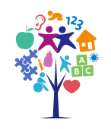

A handbook for key workers in early years’ settings to promote their understanding of the importance of effective communication for young children’s learning and development during transitions.
Contents

3……… Introduction

4……… Transitions

5……… Needs of the Child

8……… Role of the Adult

9……… Partnerships

10…….. Interventions and Strategies

12…….. Proposed Outcomes

13…….. References

Introduction
A transition is often defined as ‘a change’. ‘If a child struggles with a transition it can have a negative impact on their wellbeing and academic achievement.’ (mentallyhealthyschools.org.uk, n.d.). This booklet is aimed at practitioners and parents/guardians of children either with Additional Learning Needs (ALN) or undergoing the process of diagnosis to acknowledge and support the child to manage the feelings that both large and small changes can invoke. It will define the reasoning behind striving for effective transitions and highlight steps that can be taken in support, so that the child is comfortable and resilient in change.
Transitions are often triggers for difficult behaviour due to the uncertainty a child can feel with regard to change in routine or even from one task to another, for example. “For successful life outcomes for our young people, the first thing we need to address when presented with challenging behaviour are the feelings.” (Links, F., 2021). Many children and young people with emerging needs struggle to understand their own or others’ feelings and can ‘act out’ until these feelings are addressed, and the needs met. Managing effective transitions can support the child to feel calm and ready for change, no matter how big or small.
This guide can support professional practice and the relationship with caregivers by detailing how they can partner with both each other and other involved agencies to ensure the child’s needs are met. This can allow families to not only have a say in their child’s education but to understand the developing roles and relationships that they all play in the child’s life. A parent/guardian will know the child best and professionals should always listen to the voice of the caregiver which will often enrapture the voice of the child to ensure their voice is also heard in line with Article 12 of the United Nations Convention on the Rights of the Child. (UNICEF, 2023).
As stated in Mentally Healthy Schools (accessed 23/11/2023), vulnerable children such as those with ALN, have a more difficult time navigating transitions. The reasons for this can vary between children, however, they can include but are not limited to social communication difficulties, limited family support, care experienced children and anxieties. There are signs of a child struggling with transitions which includes increased absences, loneliness, challenging behaviour and lower than expected attainment, among others. This guide aims to provide information to the professional and the parent/guardian to support the child in their transitions.
Transitions
Children go through many transitions in their early lives, from weaning, toilet training, changing social connections (playgroup to nursery to school) and possibly childcare providers to everyday transitions with activities and routines. All of these can be a challenge to children and those with ALN who thrive on consistent routine often struggle more. Kagan and Neuman, 1998 stated that transitions are not linear and can be seen as vertical such as moving up the school system and horizontal which incorporates everyday changes. Fabian and Dunlop, 2007 argue that it’s the horizontal changes which have the most impact on the child’s wellbeing and life path.
Vertical transitions allow for attainment, moving up with each age and stage of development and as argued by Volger, Crivello and Woodhead in 2008, can be seen as ‘Rights of Passage’. While horizontal transitions help children to navigate their everyday lives where they learn skills such as social communication through role-play, for example and resilience. Transitions can mean changes in environment, relationships, expectations, roles, routine and behaviour. All of these can invoke different feelings dependent on the child and their ability to navigate and regulate their emotions. With the Curriculum for Wales focusing on child centred learning, settings understand the importance and value of supporting each child through their everyday changes. For a child with ALN, a variance from routine, for example, may affect them more and thus additional support should be provided to help with the adjustment.
Managing and navigating successful transitions allows children to accept and process inevitable changes which in turn reduces their anxiety levels and allows for them to focus on the task at hand, whether that be learning, socialisation or familiarity with routine, thus supporting the child’s ongoing wellbeing and resilience. For the families, a successful transition will build a good working relationship with the setting and reduce the possible anxiety of the parent not being there to support their child through everyday changes. With a parent’s anxiety reduced and replaced with excitement, a child will also feel more confident in exploring their new surroundings.

Needs of the Child
(Project Maslow, 2023)
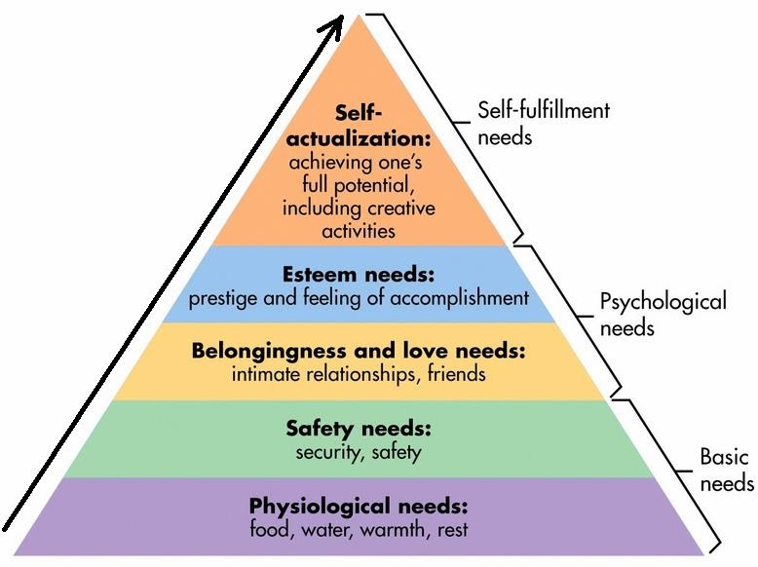
Maslow’s Hierarchy of Needs provides a foundation for the transitional needs of children. For the first few years of a child’s life, it is the caregiver that provides for their basic needs. It can be argued that love needs should be within basic needs as discussed by Oved, O. (2017).

John Bowlby developed attachment theory which states that a child must develop a good attachment with a caregiver to be able to thrive. This attachment is based on the caregiver providing for the basic needs (including love) of the child as referenced in Maslow’s diagram. Wales’ National Minimum Standards for Regulated Childcare suggests that settings must support the idea that ‘babies and very young children are able to develop an attachment to a consistent carer or small number of regular carers’ in order for them to support their emotional wellbeing. This in turn can support positive transitions where the child feels capable of managing change and developing their resilience.
The term ‘Key Person’ was coined by Goldschmeid and Jackson in People Under Three - Young children in daycare (1994) and further developed in the 2nd addition (2004) in which they state ‘Good care’…’needs to be informed by understanding of the experiences and emotional states of young children, especially when they are separated from their parents.’ They argued that children cope with the transition from home to setting better when they have a consistent person who provides care. This can also support the UNCRC’s article 12 to ensure the child is heard by the key person developing a good relationship with not only the child but also the family which in turn alleviates their anxieties in being separated from their child.
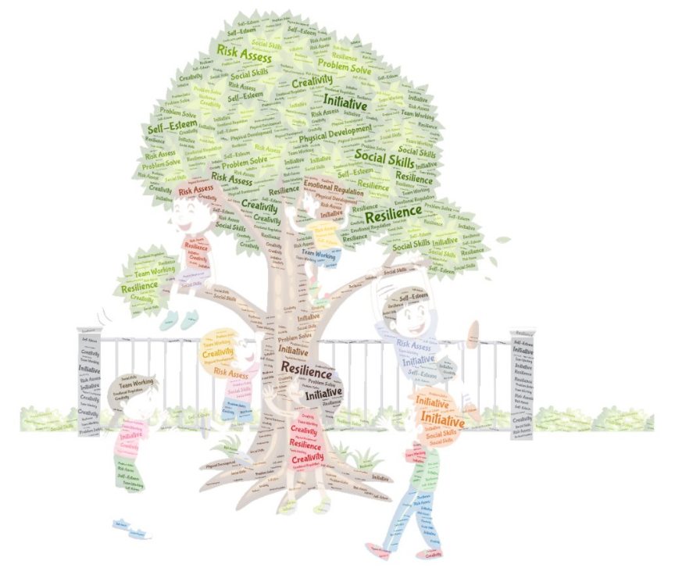
Newman and Blackburn (2002) argue that ‘the most important resilience-promoting factors are supportive families, positive peer relationships, external networks, and the opportunity to develop self-esteem and efficacy through valued social roles.’ These opportunities can be offered to children through their environments and opportunities for play. There are many types of play that can build self-esteem and efficacy which include but are not limited to role-play, risky play and loose parts play, among many others. These all allow children to explore their environment and their roles in it, in a safe way. The UNCRC’s Article 31 states that children have the Right to Play. Play supports a child’s development with practitioners being the facilitators of play. Play Wales (2023) notes the contribution that ‘self-organised play, can make to children’s long-term and immediate wellbeing, physical health, mental health and resilience.’
(Hyde, 2023) The Benefits of Risky Play.
Professional Association for Childcare and Early Years 2016)
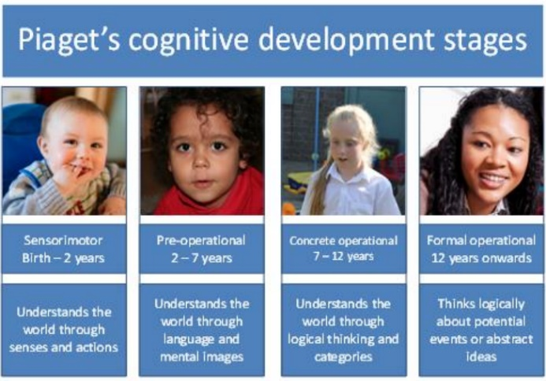
Piaget’s Cognitive Development (Constructivist) theory states that there are 4 stages of development which children go through as they age, taking in and experiencing the world around them. As children grow, their thinking develops and changes in behaviour can be noted based on what they previously knew compared to the combined with added new information. (Malik and Marwaha, 2023).
Skinner developed Behaviourist Theory which is also known as Operant Conditioning where he identified 3 groups of consequences or operant; Positive Reinforcers that rewards behaviour with something that the child likes. Negative Reinforcers where their game is stopped due to the child be hurt or scared. The final operant is Punishment where there is an unpleasant consequence of behaviour such a technology being banned. Skinner found that positive reinforcement was the way that a child learns best, and it therefore follows that if a transition is positive, then the child will be more ready to learn.

(www.linkedin.com, 2023)
Bandura developed the Social Learning theory when he conducted the Bobo Doll experiment which saw children who were exposed to aggressive behaviour towards the doll, take it further when they realise there are no consequences, and displayed violent behaviour toward the doll.

There are many theories that feed into Early Years settings, and all have their basis on how a child learns best. A nurturing environment with welcoming staff who are able to take care of the child’s needs will have a positive influence, however we must remember that all children are unique and the development of relationships with those who know the child best is essential to be able to build a strong attachment with the child to be able to hold their emotions in the absence of their parent/carers.
(Stock Image, 2023)
Role of the Adult
Staff have a responsibility to create a safe and nurturing environment for children to attend setting. This will help parents and children alike feel more comfortable and making the transition from home to setting easier. There are exceptions to this especially for children with ALN who are in a fixed routine. Following the covid pandemic, professionals have seen an increase in separation anxiety as the children were not used to being taken care of by others and therefore hadn’t developed their resilience in transition. Clear and effective communication between home and setting is vital in supporting smooth transitions. This ensures that there is consistency in the care of the child ensuring staff and parents develop a plan to work together for effective outcome. It is the ‘responsibility of all early years practitioners to ensure that children feel welcomed, gain a sense of belonging and are helped to settle happily’. (Birth To 5 Matters, 2023.)
The staff are facilitators of play which supports development. Planning and setting up areas to ensure that the development needs of each child are being met is completed alongside observations and continual reflection to ensure their practice is effective for each child’s social, emotional and physical development. This is done alongside appropriate continual professional development to ensure practice is up to date with current guidelines and legislation.

The parent/carer can partner with the setting to ensure the child knows what is coming. Using the resources from settings and visiting for transition or settling in days is essential for the child to understand that the parent/carer is coming back for them. A parent is the trusted adult who the child will often share they hopes or fears. Them partnering with settings ensures that these worries or anxieties are addressed and the child’s mind eased.

(Caerphilly Early Years, 2023)
Partnerships
The phrase ‘it takes a village to raise a child’ is often said but not looked at in more detail. A child is born to a family who often need additional support to be able to fully support the child. This is more so for a child with ALN, who may have wider family and caregivers supporting while their parents work but may also have additional support from teams such as Speech and Language, Family Support, Behaviour Support and Social Communication Support, among others. All of these teams will have an impact on the child’s ability to manage everyday life transitions. Birth to 5 matters states ‘High quality transitions recognise the importance of feeling “known”’. With children often feeling ‘un-known’ in a new place, it is important for all care givers and other agencies to partner to ensure that the child feels known.
‘Multidisciplinary collaboration and culturally sensitive interventions can result in better participation of both parents and children in crucial early childhood transitions.’ Vogler, Pia; Crivello, Gina and Woodhead, Martin (2008). Multidisciplinary teams are made up of professionals from many different specialisms such as health, education, and social care, for example. By partnering with each other and the family, they can ensure that the child gets the correct support, at the correct time in order for them to thrive. This can be achieved by developing information sharing protocols to ensure that everyone is on the same page and has the same information to be able to accurately offer the correct support without the family or their designated advocate relaying their story multiple times. Correctly set up, the family will have a point of access to be able to share updates or concerns with the whole team via fluid working documents and whole team meetings.
As stated in Article 12, children have the right to have a say in what affects them as stated in the UNCRC. Children are also able to have advocates to ensure this is the case. With the new ALN Act in Wales, embracing this with promises such as ‘Children, their parents/carers and young people will be supported to understand and participate in the decisions which are taken that affect them’. (Additional Learning Needs and Education Tribunal (Wales) Act Factsheet 5, 2016) Families can feel reassured in the knowledge that legislation is on their side.

Interventions/Strategies
Preparation is often key for children with ALN in being able to process change and this booklet can provide the background to and importance of managing transitions as well as practical guidance on how to support the individual child. Below are some strategies and ideas that have been proven to help support effective transitions. However, there is no ‘one size fits all’ and the individual child as well as their individual needs should always be considered.
(Mcilroy, 2022)

Drawing and talking is a person centred, attachment based therapeutic intervention that supports the development of a trusted relationship and allows the participant to process their internal emotions in an emotionally safe environment. This allows for a trusted attachment to be formed where the child feels secure that they have someone they can turn to should they need support or reassurance. (Drawing & Talking, 2023.) (Sitefinity_63, n.d.)
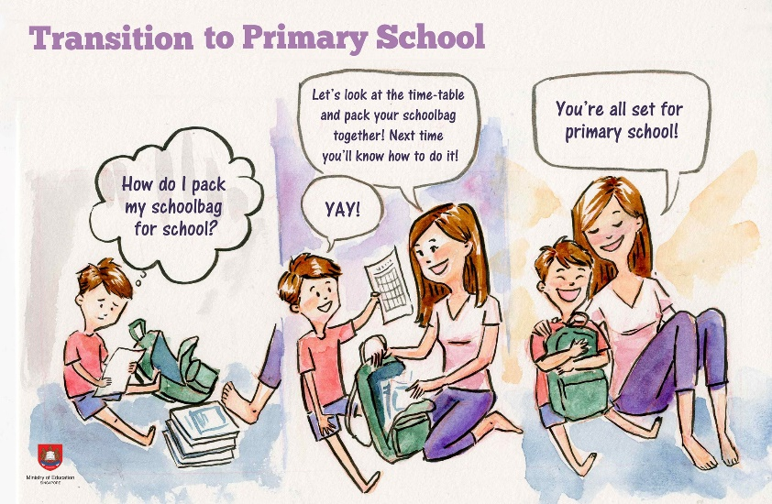
Preparation and consistency are key for children to feel comfortable with change. A ‘look book’ with the classroom, yard, entrance, and teacher’s pictures is a good way for the family to partner with the setting and prepare the child for a new environment, routine or even a return from a break. Developing these books with the child in mind can address their individual anxieties and support inclusivity as well as be consistent with the new curriculum in Wales which states that a child’s learnings should be individualised.
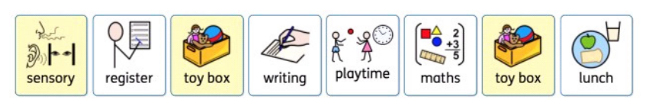
Children often struggle with the concept of time and visual timetables can help a child feel secure in the knowledge of how their day is going to be and what activities they will be accessing supporting their independence and planning skills. Visual timetables scaffold the child to support their memory and recall skills as well as promote independence and resilience particularly with the introduction of a change card to know when the transiions take place. (McCann, 2020)
Phased entry or return to setting can support the child to get used to the new routine in a way that is not over stimulating or too long for them to manage. The times they arrive in setting, can be different from other students to allow a less stressful and chaotic entry to setting and the same can be done for when the day is over. Lunch times can also be over-stimulating, particularly for children with sensory sensitivities and being able to eat their lunch in a quieter area may be beneficial to them to avoid sensory overload. It could also be beneficial to allow a friend to sit with them to support their social communication development. These strategies can encourage and support the child to feel more comfortable and confident with their environment.

(Twinkl, 2023)
Now and Next charts support children to move from one task or transition to the next, giving them reassurance of what is happening and when and taking away uncertainty and hopefully fear of the unknown.
Circle of security is an attachment-based parenting programme designed to explore the parent/child relationship. The course gives the parent the tools and strategies to support the child to confidently explore their world knowing that they have a secure relationship with their parent/carer to come back should they need reassurance. (Caerphilly Early Years, 2023)
Proposed Outcomes
(Williams, 2019)
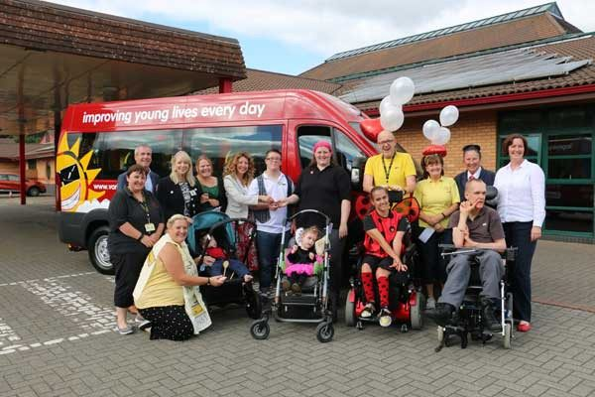
A long-term effective transition can be witnessed with happy children who are able to thrive by meeting milestones, hitting targets and continual attendance. However, in the short term, an effective transition can be the child not having a ‘meltdown’ or being able to concentrate following the change. No matter how big or small the change, they can have a profound effect on a child’s wellbeing if not managed correctly. It can take time but with consistent preparation, understanding and care, each child can learn a life skill, resilience. ‘There is something that children need if they are going to truly succeed in life, and that’s resilience.’ (MD, 2017).

References
Additional Learning Needs and Education Tribunal (Wales) Act Factsheet 5. (2018). Available at: https://www.gov.wales/sites/default/files/publications/2018-06/aln-factsheet-how-will-the-act-affect-children-young-people-and-parents-carers.pdf.
Birth To 5 Matters (2022). Attachment and the role of the key person – Birth To 5 Matters. [online] Birthto5matters.org.uk. Available at: https://birthto5matters.org.uk/attachment-and-the-role-of-the-key-person/#:~:text=A%20key%20person%20approach%20is. [Accessed November 2023]
Birth To 5 Matters. Transitions – Birth To 5 Matters. [online] Birth to 5 Matters. Available at: https://birthto5matters.org.uk/transitions/ [Accessed 27 Nov. 2023].
Caerphilly Early Years. (2023). Circle of Security Parenting (COSP). [online] Available at: https://www.caerphillyearlyyears.co.uk/family-support/parental-support/parenting-programmes-and-courses/cosp/ [Accessed 1 Dec. 2023].
Drawing & Talking. Home. [online] Available at: https://drawingandtalking.com/. [Accessed 22Nov. 2023].
Fabian, H. and Dunlop, A.-W. (2007) ‘Outcomes of good practice in transition processes for children entering primary school’. Working Papers in Early Childhood Development, No 42, The Hague: Bernard van Leer Foundation.
Froebel Trust. (2019). The voices and experiences of children with autism, and their…. [online] Available at: https://www.froebel.org.uk/research-library/the-voices-and-experiences-of-children-with-autism-and-their-families-in-their-transition-from-nursery-to-primary-school. [Accessed November 2023].
Goldschmied, E. and Jackson, S. (2004). People under three: young people in day care. New York: Routledge.
King, E. (2018). Supporting families under pressure with multidisciplinary teams - Supporting Families Programme. [online] supportingfamilies.blog.gov.uk. Available at: https://supportingfamilies.blog.gov.uk/2018/11/28/helping-people-have-a-life-not-a-service-the-role-of-multidisciplinary-teams-in-supporting-families-under-pressure/. [Accessed Nov. 2023]
Links, F. (2021). Feelings Drive Behaviours. [online] Family Links. Available at: https://www.familylinks.org.uk/post/feelings-drive-behaviours [Accessed 27 Nov. 2023].
Malik F, Marwaha R. Cognitive Development. [Updated 2023 Apr 23]. In: StatPearls [Internet]. Treasure Island (FL): StatPearls Publishing; 2023 Jan-. Available from: https://www.ncbi.nlm.nih.gov/books/NBK537095/
Maslow’s Hierarchy of Needs – Project Maslow. [online] Available at: https://www.projectmaslow.org/maslows-hierarchy-of-needs/. [Accessed 27/11/2023].
Mayo Clinic (2020). How to build resiliency. [online] Mayo Clinic. Available at: https://www.mayoclinic.org/tests-procedures/resilience-training/in-depth/resilience/art-20046311.
McCann, L. (2020). The right way to use Visual Timetables. [online] Reachout ASC. Available at: https://reachoutasc.com/the-right-way-to-use-visual-timetables/#:~:text=A%20visual%20 [Accessed 1 Dec. 2023].
Mcilroy, T. (2022). The Stages of Drawing Development in Children: 0-6 Years. [online] Empowered Parents. Available at: https://empoweredparents.co/child-development-drawing-stages/.
MD, C.M. (2017). Resilience: A skill your child really needs to learn (and what you can do to help). [online] Harvard Health. Available at: https://www.health.harvard.edu/blog/resilience-a-skill-your-child-really-needs-to-learn-and-what-you-can-do-to-help-2017061311899 [Accessed 27 Nov. 2023].
Nesta. (2023). Parents Helping Parents: It takes a village to raise a child. [online] Available at: https://www.nesta.org.uk/report/parents-helping-parents-it-takes-village-raise-child/. [Accessed Nov. 2023]
Newman, T. and Blackburn, S. (2002). Transitions in the Lives of Children and Young People: Resilience Factors. Interchange 78.
Oved, O. (2017). Rethinking the Place of Love Needs in Maslow’s Hierarchy of Needs. Society, [online] 54(6), pp.537–538. doi:https://doi.org/10.1007/s12115-017-0186-x. Accessed November 2023.
play.wales. (2023). Play and health - Play Wales. [online] Available at: https://play.wales/working-with-children/childcare/. [Accessed November 2023].
Positive relationships: Key people -part 1 - Handle with care. (n.d.). Available at: https://www.happykids-childcare.co.uk/content/uploads/2014/12/Key-Person.pdf. [Accessed November 2023]
Professional Association for Childcare and Early Years (2016). Supporting Members to Provide the Highest Standards of Care and Learning for Children. [online] p.7. Available at: https://www.pacey.org.uk/Pacey/media/Website-files/PACEY%20member%20practice%20guides%20(PDFs)/PG28-Theories-of-child-development.pdf.
Sitefinity_63. (n.d.). Story. [online] Available at: https://www.schoolbag.edu.sg/story/transition-to-primary-school [Accessed 27 Nov. 2023].
UNICEF (2023). UN Convention on the Rights of the Child (UNCRC). [online] Unicef. Available at: https://www.unicef.org.uk/what-we-do/un-convention-child-rights/.
Vogler, Pia; Crivello, Gina and Woodhead, Martin (2008). Early childhood transitions research: A review of concepts, theory, and practice’ Working Paper 48. Bernard van Leer Foundation
What is a visual timetable? (2023). Available at: Visual Timetables Resource.I CAN.FINAL_.pdf (councilfordisabledchildren.org.uk). [Accessed November 2023].
Williams, R. (2019). Glowing report for Trinity Fields school. [online] Caerphilly Observer. Available at: https://caerphilly.observer/news/979319/glowing-report-for-trinity-fields-school/ [Accessed 27 Nov. 2023].
www.linkedin.com. (2023). The Power of Imitation: Using Bandura’s Bobo Doll Experiment to Drive Climate Consciousness and Action. [online] Available at: https://www.linkedin.com/pulse/power-imitation-using-banduras-bobo-doll-experiment-drive-ragavoodoo.

