Environmental analysis in automobile industry

Name;

Title;

Date;

Table of Contents
Environmental analysis in automobile industry 1
Table of Contents 2
Introduction 3
Internal analysis of Toyota using SWOT analysis 3
Internal analysis using Toyota’s Value chain analysis 4
Toyota External analysis using PESTLE 6
Toyota’s Competitive analysis using Porter’s five forces 8
Competitive advantages in line with their core values on sustainability 9
Conclusion 11
References 12

Introduction
The automotive industry can be traced way back in 1880s when Karl Benz made the first modern automobile. Since then, there have been great innovations and improvements in the industry leading to varieties of automobiles. Toyota Motor Company as one of the automotive industry organisations was founded in 1933 and produced its first automotive in 1936, by 2008 it was rated the largest automobile manufacturer in the world. The company have tremendously grown and embraced technology to come up with different varieties to match the customer’s demand. However, the company also experiences challenges both internally and externally. This work shall evaluate the challenges of the internal and external business environments using several methods that include SWOT analysis, PESTLE analysis, value chain and porters five forces. The paper shall also address their competitive advantage concerning their core value and sustainability.

Internal analysis of Toyota using SWOT analysis
The SWOT analysis clearly identify the company’s strengths that makes it prevail and some weaknesses that needs to be worked on in order to remain in business. The opportunities are pinpointed in which the company can venture in to in order to become more competitive and the threats are also identified to help the company be aware what the competitors are best at.
Strength
One of the Toyota company’s strengths is the ability to strongly focus on research and development leading to production of the most innovative vehicles in the world (Soe, 2020). This have helped the organisation to produce environmentally friendly vehicles and incorporate safety and information technology. The company also has a strength in its strong brand image that help to retain the clients and also its global supply chain that help to reach a vast number of customers.
Weaknesses
The organisation has a global hierarchical organisational structure that prevents maximum flexibility of regional operations. The company also has a secrecy culture that reduce response times in addressing an emerging issue. These weaknesses can be addressed by adjusting the organisational structure and culture.
Opportunities
The company have several opportunities at its exposure which includes, growing markets in developing countries which present an opportunity to penetrate new markets and increase its revenue. Rising demand for fuel-efficient automobiles and growing interest in advanced electronics in vehicles is an opportunity for the company to focus its innovations in that direction. Weak Japanese Yen vs U.S dollars leads to higher competitiveness of products exported from Japan
Threats
The organisation also experiences some threats that includes growing market presence of low-cost competitors from Korea and China and also rapid innovations of competitors like General Motors and Honda.

Internal analysis using Toyota’s Value chain analysis
Value chain is a set of activities that a business performs to maximise profit. It highlights the bases where business can create value for their customers and identify the sources of competitive advantage (Masiero, 2018). Toyota Motors activities can generally be classified as primary activities and support activities.
The primary activities
Toyota’s primary activities are comprised of the activities that contribute to value creation directly. They include;
Logistics
Toyota have a great supply chain. It has thousands of suppliers around the globe and have worldwide distribution network centres and warehouses. These enable quick and efficient parts distributions to different locations and regions across the globe
Operations
The operations are distributed worldwide with its headquarters in Japan. The brand serves its customers globally through a large distribution network. The brand has various part distribution centres at different location. The operations incorporate a lot of technology enabling the smooth operations
Sales and marketing
For Toyota to retain its market share and clients base, it heavily invests on marketing and promotions. The company utilises a mix of traditional and modern methods of advertising and promotion of products. It greatly uses the website and social media.

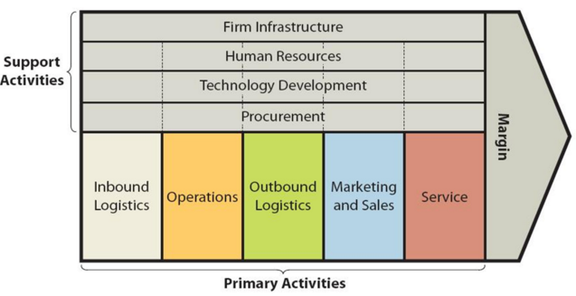
Figure 1 Value chain analysis
The support activities
The support activities are those which assist the primary activities. They include, firm infrastructure, human resource, technology and procurement.
Firm infrastructure
Toyota have managed to establish great infrastructure around the globe. It has maintained an extensive presence in Japan north and South America, Asia and Europe.
Technology
Toyota is greatly advanced in engineering and technological innovations to ensure growth and developments of the brand. The company has its own research centre and have partnered with some technological institute to ensure up to date development.
Human resource
The brand is highly concerned with human resource issues and uses a human centric approach to value creation and focuses on human resources welfare. the smart and abled human capital have a major source of competitive advantages.
Toyota Motors focuses on ensuring smooth operation and quality from purchasing of raw materials to the sale of the end product. It utilises technology to produce up to date vehicles that can meet the customers need, increase customer’s satisfaction and increase its revenue. Below is a diagram indicating the operation in assembling plant flow.

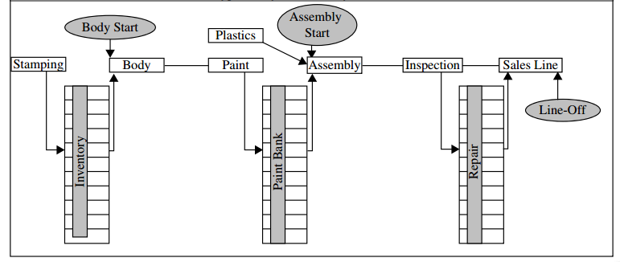
Figure 2 Typical Toyota assembly plant flow

Toyota External analysis using PESTLE
This is a model that evaluate how different factors affect the business operations.
Political factors
For a business to run smoothly it is dependent on the political stability of a market and government policies among other issues. For example, the Toyota Company in Britain threatened to make significant cutbacks if the country vote to leave the European Union citing reduction of competitiveness of its company and an uncertain future (Nkomo, 2019). Another example on the impact of political factors is the poor relationship between Japan and China following a dispute over an island possession. This have left the two in a position that they cannot do business together nor support each other (Morgan, 2017). The Toyota Motor Corporation being a Japanese company therefore cannot sail in China no matter how good the products may be.
Economic factors
Currency exchange fluctuation is one of the major macro-economic factors that affect Toyota reported revenues, for example Toyota Motors Corporation income for the year 2014 benefited in billions after the Japanese yen weakened against both the U.S dollars and the Euro (li, 2018). Following the pandemic, the company’s annual revenue declined by 23% by the end of 2020 following loss of jobs, financial insecurity and uncertainty thus reducing the purchasing power of the people (Manaka, 2020). Following the increasing oil prices many customers have turned to fuel efficient cars thus Toyota had to adjust by manufacturing such to remain in the market.
Social factors
Increasing awareness about environmental implication of driving is very crucial and should be addressed by automotive companies to ensure customers are well catered for. Toyota has been working towards achieving this. When the Toyota Company recalled vehicles with faulty fuel pump, though it was a good thing to do but many questioned their credibility and some trust in the brand was lost (Yun, 2017). Others lost their trust when some Toyota vehicles lost safety control due to faulty acceleration pedal system. The ‘Innova’ Toyota model that was in market in India was termed as a perfect car due to its low price and good quality serving the market well
Technological factors
To ensure that it comes with up-to-date vehicles, Toyota have been allocating a lot of money on research and development in order to come up with something that is competitive and that is eco-friendly (Morgan, 2020). Accepting the latest technology have helped Toyota to stay at the top of the global market ensuring continuous improvement. This have increased the company’s revenue because many customers like to engage with technologically innovative brands.
Legal factors
Toyota have been keen on settling legal issues even if it costed the company a lot. Example in the incident when the company recalled some vehicles it had to spend a lot of money but its integrity was clear.
Environmental factors
Toyota have proved its concerns about the environment by manufacturing electric, hybrid and gasoline vehicles to address the environmental issues. In 2015 the company laid down the future environmental plan for 2050, including steps like zero carbon emission, optimising the usage of water, and recycling based sustainable society.

Toyota’s Competitive analysis using Porter’s five forces
Porters five forces model is used to determine the factors that affect the profitability and advantages of a business. Following is a summary of porter’s five forces components on how they impact the Toyota motors company
Rivalry among existing competitors
Toyota Motors operates in a highly competitive industry with well-established organisations, highly aggressive firms, and low number of large firms; thus, the company must work hard to remain at the top of global market. Toyota Motors have tackled the rivalry of the existing competitors by building a sustainable differentiation, building scales so it can compete better and collaborating with the competitors to increase the market size
The Bargaining power of suppliers
Toyota Motors buys its supply from numerous suppliers around the world. This reduces the chances of supplier manipulation thus increasing the productivity. The organisation tackles this by building efficient supply chain with multiple suppliers, by using different materials such that if price hikes on one material the other can be used and by developing dedicated suppliers whose business depend upon the firm.
The bargaining power of buyers
Customers always want to get the best at the minimum cost possible. This factor directly affects the profitability of the company. Toyota Motors have handled this by building a large base of customers thus reducing the buyers bargaining power and provide an opportunity to the firm to streamline the company’s process. Quickly innovating new products reduces the chances of bargaining or defecting to competitors’ products.
The threat of substitute products and services
The threat of a substitute is high and the reasons to substitute are many.in automobiles there are numerous substitutes of a product due to low switching costs, high quality information and moderate substitute available. Toyota Motors has tackled this by being service oriented rather than just product oriented, by increasing the switching cost for customers and by understanding the actual need of the customers.
The threat of new entrants
New entrants usually apply innovations and strategies that the competitors do not have or have not properly utilised, they may include lower pricing strategy, reducing cost and adding value proposition. Toyota Motors has managed these by innovating new products thus bringing in new customers and attracting the old ones too, by building capacities and investing on research and development thus defining the standards regularly.

Competitive advantages in line with their core values on sustainability
Toyota Motors uses both differentiation and low cost strategy to gain competitive advantage against the competitors and stand out in the automotive industry.it remain among the top companies globally because of its superior quality and design, continued innovation and intensive growth strategies. It is always ready to accommodate any technological developments and utilise different innovation in order to come up with the most suitable products. This have enabled the organisation to remain more competitive than other companies as every time there are new products and different varieties and different prices. The company have been able to serve a global market because it has numerous varieties thus increasing its profitability

Conclusion
Toyota motors brand have been able to make a good brand image, capture a global market and incorporate technological innovations to produce the most suitable vehicles for their customers. However, the organisation still faces challenges in both internal and external business environments that need to be addressed to maximise its profitability. The company need to address its weaknesses and threats posed by the competitors and ensure that its popularity continues with people of all status. Toyota Motors should maximise on its competitive advantages in order to increase its viability in the market.

References
Abdallah Ali, A. (2021). How can lean manufacturing lead the manufacturing sector during health pandemics such as COVID 19: A multi response optimization framework. Computers, Materials, & Continua, pp.1397-1410.
Bhise, V.D. (2019). Ergonomics in the automotive design process. CRC Press.
Cohen, T., Stilgoe, J. and Cavoli, C. (2018). Reframing the governance of automotive automation: insights from UK stakeholder workshops. Journal of Responsible Innovation, 5(3), pp.257-279.
Haria, H.J. (2021). Organizational Change and Development during the COVID-19 Pandemic in Automotive Industry. Available at SSRN 3814901.
Janoskova, K. and Kliestikova, J. (2018). Analysis of the impact of selected determinants on brand value. Journal of International Studies, 11(1).
Li, Z. (2018). Business Network Positioning Analysis of Toyota. American Journal of Industrial and Business Management, 8(07), p.1693.
Manaka, T. (2020). Toyota Financial confirms measures to help customers impacted by COVID-19. SABI Magazine-Tydskrif, 12(4), pp.28-28.
Masiero, G., Ogasavara, M.H., Jussani, A.C. and Risso, M.L. (2017). The global value chain of electric vehicles: A review of the Japanese, South Korean and Brazilian cases. Renewable and Sustainable Energy Reviews, 80, pp.290-296.
Monden, Y. and Talbot, B. (2019). The Toyota management system: linking the seven key functional areas. Routledge.
Morgan, J.M. and Liker, J.K. (2020). The Toyota product development system: integrating people, process, and technology. Productivity press
Nishizawa, T., Kawakami, A., Taguchi, T. and Osugi, Y. (2021). Transient global amnesia with bilateral hippocampal lesions during the COVID‐19 global outbreak. Journal of General and Family Medicine, 22(3), pp.154-155.
Nkomo, T. (2019). Analysis of Toyota Motor Corporation.
SOE, Z. (2020). An Analysis of Strategic Marketing Management on Organizational Performance (Doctoral dissertation, SCHOOL OF BUSINESS, SIAM UNIVERSITY, BANGKOK, THAILAND).
Xing, P., Yang, M., Tsuge, B., Flynn, T., Lawrence, J. and Siegmund, G.P.(2018). The accuracy of Toyota vehicle control history data during autonomous emergency braking (No. 2018-01-1441). SAE Technical Paper.
Yun, J.J. and Yigitcanlar, T. (2017). Open innovation in value chain for sustainability of firms. Sustainability, 9(5), p.811.

