Module: Individuals and Families: Living in the Contemporary World
Module Number: SJSI6022
Student Number: 1502479

Choose 3 images of ONE group at risk of exclusion and critically reflect upon these representations and how they might be interpreted by society.

Interpretation of families differs in society today Murdock (1949) defines a traditional family as ‘adults of both sexes, at least two of whom maintain a socially approved sexual relationship, and one or more children, own or adopted, of the sexually cohabiting couple’ (Murdock, 1949, P.1). However, according to AHEA (cited in Newman & Grauerholz, 2002) they believe families are seen as anyone living under the same roof sharing the same aspersions and attitudes. Similarly, Gaviel-Fried et al (2011) suggest this is because of adaptions in society. However today, the nation of family is diminishing as the number for looked after children (LAC) is increasing leaving many children holding the view that they do not belong to a family unit, resulting in adverse negative experiences for these children (Guishard-Pine et al, 2007).
Vygotsky (1962 cited in Slee 2002) argues that family is at crucial importance within a child’s life as he believes that everything a child learns is through involvement with their parents. Despite this in 2017 it was found that 72,670 children were looked after by local authorities, an increase from previous years (Department for Education, 2017). Reasons for this could be due to; family illness, threatened welfare, abuse or family breakdown, as a result these experiences can lead to children expressing challenging behaviours (Golding et al, 2006). Supporting this is Meltzer et al, (2003) who suggest that the probability of LAC experiencing poor mental health is over double to that of children who are in contact with their parents, subsequently affecting their educational outcomes and risk of delinquency.

Image 1: LAC achieve lower than others
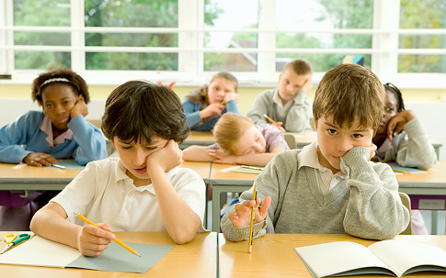

- Describe image and reference and link to theory
- How these fit into a ‘traditional’ view of a family
- How the situation affects the individual in the society (statistics)
- Theorists

Durkheim’s theory (1956) that education is at vital importance for a child’s healthy development as it efficiently socialises individuals into society.
According to …. LAC are already at a disadvantage before even starting school.
….. believes that primary education is of vital importance for LAC social, physical,
LAC are five times more likely to be excluded on a short term basis than other children.
Less likely to miss school/ more likely to be NEET
More likely to require special educational need and have not meet their basic needs by the time they leave primary school. However, the support for LAC in education is most differently not what it should be.
Research shows that LAC achieve lower than other children from a ‘traditional’ family, 67.8 per cent of LAC

Image 2: LAC have poor mental health.

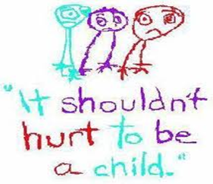

- Describe image and reference and link to theory
- How these fit into a ‘traditional’ view of a family
- How the situation affects the individual in the society (statistics)
- Theorists

Although the theory of mental health we often found difficult to define, The World Health Organisation (WHO) describe it as….
‘A state of well-being in which every individual realizes his or her own potential, can cope with the normal stresses of life, can work productively and fruitfully, and is able to make a contribution to her or his community’ (WHO, 2014).
However, it has be found that ten per cent of children under the age of sixteen have poor mental health despite many individuals not recognising that children can experience these issues (Children Society, 2008). Youngminds (2017) purpose that the mental health and well-being of individuals is affect by the exposure of risks they may face within their lives for example; abuse and negative attachments, and this is most commonly seen within LAC.

Image 3: LAC are more than likely to commit a crime.
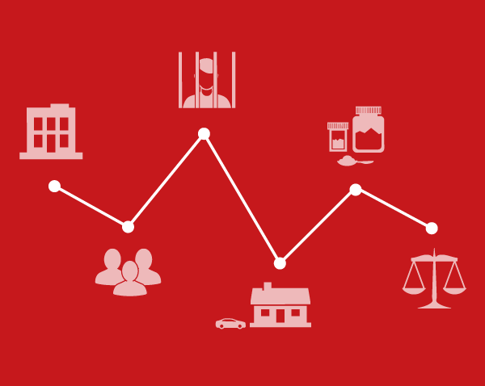

- Describe image and reference and link to theory
- How these fit into a ‘traditional’ view of a family
- How the situation affects the individual in the society (statistics)
- Theorists
The labelling Theory of Crime socially constructed, stereotypical self-filling prophecy
micro-level
Howard Becker (1963)

Conclusion
- Summary of three
- How they differ from traditional families
- How they differ from other modern families

References
Guishard-Pine, J., Hamilton, L. and McCall, S. (2007). Understanding Looked After Children: An Introduction to Psychology for Foster Care. London: Jessica Kingsley Publishers.
Murdock, GP (1949) Social Structure, New York: Macmillan. OUP (2011) Concise Oxford Dictionary, Oxford: OUP.
Newman. D. (2008): Families: A Sociological Perspective, McGraw-Hill Higher Education, Boston Mass.
Gavriel-Fried, B., Shilo, G. and Cohen, O. (2012). How Do Social Workers Define the Concept of Family? British Journal of Social Work 44:992–1010.
Slee, P., Campbell, M. and Spears, B. (2012). Child, adolescent and family development. Cambridge: Cambridge University Press.
Department for Education (2017) children looked after in England (including adoption),year ending 31 march 2017. [Online] Available at: https://assets.publishing.service.gov.uk/government/uploads/system/uploads/attachment_data/file/664995/SFR50_2017-Children_looked_after_in_England.pdf [Accessed 10 May 2018].
Golding, K. (2006). Thinking psychologically about children who are looked after and adopted. Chichester: John Wiley.
Meltzer, H. Gatward, R. Corbin, T. Goodman, R. and Ford, T. (2003) The mental health of young people looked after by local authorities in England .London: The Stationery Office (TSO).
Durkheim, E. (1956). Education and sociology. Glencoe, Ill.: Free Press.
The World Health Organisation (2014) Mental health: a state of well-being. [Online] Available at: http://www.who.int/features/factfiles/mental_health/en/ [Accessed 10 May 2018].
Children Society (2008) the good childhood inquiry: health research evidence. London: Children’s Society
Youngmind (2017) risk and resilience [Online] Available at: http://www.youngmind.org.co.uk/training_services/training_andconsultancy/for_school/wellbeing/risk_and_resilience [Accessed 10 May 2018].

