PROJECT PORTFOLIO – CLM5003

Student name: Ioan Lup
Student number :2228580
Program of Study: Business Management with Foundation Year

Total word count 3500 words includuing the poster

Table of content
Part A Poster ………………………………………………………………………………………….3
Part B Revision of Feedback …………………………………………………………………….4
Part C Project management plan……………………………………………………………...5
Conclusion ………………………………………………………………………………………….10
References ………………………………………………………………………………………….10

Recovery Transport Corridor in Worcester: Reconstruction of Flood Damaged Transport Corridor.

Part A: Project Proposal (Picture)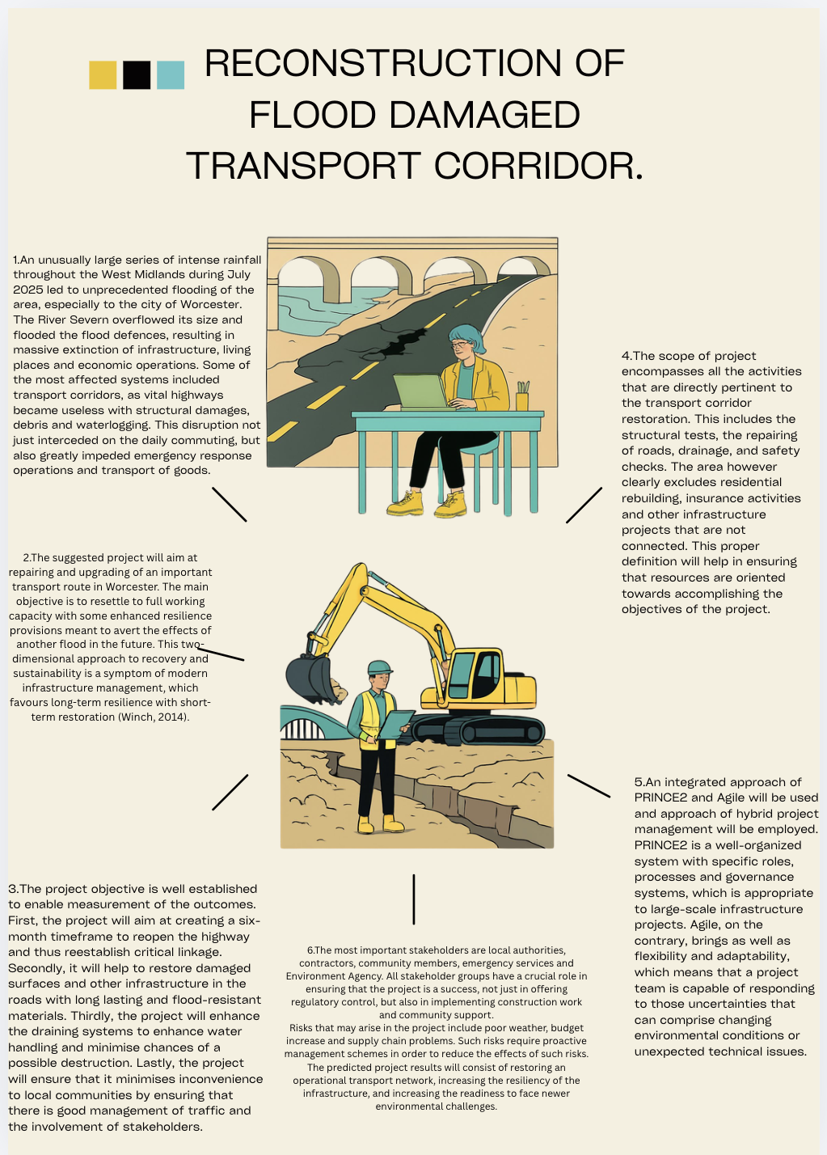

Part B: Revision of Feedback

Feedback that I received as a student both by the tutor and peers gave me insight on what was working and what was not in the first project proposal. This feedback was a very important method of reflection and improvement as one could develop a more developed and professionally well-structured project management plan.

The clarity of the project aim and its relevance was one of the main strengths determined in the original proposal. The interest in rebuilding an important transport route in Worcester was deemed very suitable to the situation of the flooding scenario. The correspondence of the project goals with needs of the impacted community was an indicative of the comprehension of project requirements in the real world. Moreover, the proposal successfully outlived the major stakeholders, such as local authorities and the Environment Agency that emphasized on the collaborative attribute of infrastructural projects.

Although these are the strengths, the following areas were pointed at as an area of improvement. The lack of sufficient justification of the choice of project management methodologies was one of the most important issues. Although the proposal referred to PRINCE2 and Agile, it failed to expound how the two methodologies were suitable to the project. Subsequently, on the basis of this feedback, the final project management plan will contain a more critical assessment of these methodologies, its benefits, drawbacks, and appropriateness to the priority of infrastructure reconstruction projects. This improvement also makes the work more scholarly and illustrates a better mastery of the concepts of project management.

The second practice that was found to be improved was the fact that the risk analysis was not deeply analyzed. The first proposal simply enumerated the overall risks and not how they would impact or mitigated them. This made the proposal not as applicable in practice. To overcome this problem, the final project plan will include a section on risk analysis including an extensive risk register with the estimation of the likelihood, impact, and mitigation measures. This inclusion enhances the division of project plan to a considerable degree.

Another area indicated in the feedback was the lack of critical project management tools, e.g. the Work Breakdown Structure (WBS) and Gantt chart. The tools play a crucial role in visualisation of project tasks, timelines and dependencies. Being included in the end game plan of the project will add clarity and show how theoretical concepts are in practice.

Moreover, colleagues recommended that the proposal might be better suited to paying more attention to sustainability and resilience. In reaction, the last plan incorporates sustainable building practice and the need to make infrastructure architectural designs that could survive and compete such environmental issues in future. This is in line with the current trends in infrastructure management and promotes the overall quality of the project.

To recap it all, the feedback that was received helped to improve the project proposal. It also showed critical spheres of development and offered a clear vision where improvements are to be made. These advances are reflected in the final project management plan in the form of a more detailed, structured and professionally developed approach towards infrastructure reconstruction.

PART C: Project management plan.
Worcester Flood Repair Transport Corridor.

Introduction
The frequency and severity of extreme weather, experienced in the United Kingdom, have exerted a lot of pressure on the national infrastructures of the United Kingdom, especially the transport networks. in July 2025, due to heavy flooding in the West Midlands, such as Worcester, there were widespread disruptions to roads, bridges and vital transport corridors. The River Severn topped the critical flood levels, and caused the structural failures, road closures and limited accessibility of the emergency services. This disruption had extensive economic and social consequences including effects on the commuting, trade, and emergency response operations.

The process of infrastructure recovery under these circumstances needs to be a well-organised and systematic project management process. Project management methodologies like PRINCE2 offer governance frameworks, role descriptions and stage-wise control systems, which are critical in overseeing the complex public infrastructure projects. Contrary to this, Agile approaches create flexibility and agile decision-making, which are especially helpful in dynamic settings with constantly shifting conditions at any point of implementation. A combination of the two methods offers the ideal equilibrium hybrid framework that may be applied in disaster recovery infrastructure projects.

This project management plan is thus a holistic plan to re-establish of a transport route damaged by flooding in Worcester that will not only see the re-established infrastructure working, but also endures environmental hazards in the future.

Project Description
The project aims at the rehabilitation of one of the major transport corridors in Worcester that were devastated in a massive flooding during the 2025 emergency. This is an important route that helps in serving the local and regional connectivity and to help in the transportation of commuters, emergency services and freights. Its disruption has culminated to huge economic losses and less accessibility to other surrounding communities.

The project will entail a systematic flow of activities that will start with site assessment in detail to determine structural damages and environmental conditions. This is followed with engineering design activity to create reconstruction schemes, that incorporate new resiliency features like enhanced drainage system and hardened road structures. Construction phase entails construction of the road per se, having the dug road, re-laid, and the drainage provisions. The last stage involves testing and inspection and passing formal handover to the local authorities.

The project will be done within a period of six months with severe cost and quality limitations. It has the intention as well to incorporate the principles of sustainability in order to foster the resilience of the environment and structure in the long term.

Project Objectives
The main goal of the project is to achieve operational capacity of the affected transport corridor in full within six months whilst promoting better resiliency to the future occurrence of floods. Besides this, the project will also be involved in rebuilding destroyed infrastructure with long lasting and sustainable materials that meet the current engineering guidelines. Reduction of disturbance of local businesses and local communities during the period of construction is another important aim, which can be achieved by the use of effective traffic management strategies and effective communication strategies. The project would also aim to enhance drainage to minimize chances of damages done by floods in the future and long term stability of infrastructure. Lastly, the project will focus on making certain of total adherence to environmental laws and safety levels, especially the ones that exist in the UK.

Project Scope
The project scope is well outlined to make the projects focused and exclude scope creep. It encompasses all the works involving reconstructions of the transport corridors such as road resurfacing, installation of drainage systems, structural repair of bridges and culverts and installation of traffic control systems throughout the construction. The scope also entails environmental protection policies giving way to the conformance of the sustainability requirements.
But the project specifically excludes residential reconstruction, processing of insurance claims and infrastructure not directly connected with the transport corridor. This will allow project resources to be focused on the basic deliverables and the borders of the project will be well defined throughout the lifecycle.

Best Methodology and Project Governance.
The project has a hybrid project management approach that incorporates PRINCE2 and Agile concepts. The formalized governance system of PRINCE2 guarantees the project is run in well-defined phases, formality in documentation, responsibility frameworks and decision making mechanisms. This is especially during publicly funded infrastructure projects whereby transparency and accountability are critical.
Agile principles can be added to this structure in order to bring flexibilities and adaptability in the execution stage of the project. Agile is applicable to provide the flexibility of changing construction plans in response to changes in the field at the same time, as conditions evolve during post-flood rebuilding since construction's nature is unpredictable. This combined methodology makes project be both managed and adapting.
The organizational hierarchy consists of: a Project Board which oversees the strategic work, a Project Manager who deals with the daily activities and a Senior User representative who is in charge of ensuring that the community needs are included when making decisions about the project. This will be used to make sure that there is a balance during making of decisions and effective representation of the stakeholders throughout the project life cycle.

Work Breakdown Structure (WBS).
The project has been divided into five major phases, which form the major stages in the project lifecycle. The initial stage is initiation and planning that includes the feasibility studies, site surveys and the risk assessment to develop the basis of project. The second is design, where engineering solutions are created such as structural design and planning of the drainage system. The third stage is the procurement stage through which contractors are identified, materials are billed and contracts are concluded based on the competitive tendering processes.
The fourth stage is the construction, which is the most resource-consuming part of the project. It involves the destruction of damaged infrastructure, earthworks, road construction and drainage systems installation. The last stage is testing and hand over that entails quality checks, safety checks and handing over of the completed infrastructure to the local authorities.
Such a well-organised dissection guarantees the transparency of the distribution of tasks and makes it possible to monitor the progress of the project successfully.

Project Schedule (Gantt Overview).

The project calendar will be developed in such a manner as to have a logical order of sequence and time utilization. Planning and mobilisation activities will be done within the first two weeks, with three weeks of design phase, which will be the finalisation of engineering plans. The next three weeks are spent in procurement and mobilisation of contractors to be ready with materials and resources prior to the start of construction.
Activity power The construction period of the project lasts around twelve weeks and is the main implementation period of the project. This is followed by three week long testing and quality assurance period to test adherence to engineering and safety standards. The last two weeks will be used to undertake handover and formal closure to the project.

This organized time schedule is capable of smoothly carrying one phase into the next as well as having flexible time longevity against unexpected delays.

Stakeholder Management
Stakeholder involvement is an element that is very important in success of projects in infrastructure. Major sources of influence are those at the local level where the local authorities would be meant to provide funding and approvals, the contractors who would be involved in the construction business, local inhabitants as well as local businesses who would be impacted by the disruption and the emergency service who would demand to have the viability of transport routes up and running and the Environment Agency that would have to handle the environmental regulation and the flood risks management.

Communication strategies are also employed so as to make sure that there is stakeholder alignment during the project. These are periodic progress reports, open consultation and formal meetings with major players. A power-interest framework is also used to classify stakeholders according to the levels of engagement to be adopted and frequency of communication with them.

Resource Allocation
Resource management is critical towards efficiency and success of projects. These human resources consist of project managers, civil engineers, construction workers, safety officers as well as environmental specialists. Material materials comprise of asphalt, concrete, and drainage systems, and heavy construction equipment. The budget will use financial resources allocated in a budget of 5million pound with a contingency budget to allow covering of unforeseen expenses. Technological resources refer to scheduling and monitoring project tools like Microsoft project which facilitate planning, monitoring and reporting of activities.

Procurement Strategy
The procurement strategy is anchored on design and build model where both design and construction are incorporated in a single contractor. Such a method minimizes the concern of coordination, it decreases project schedules, and enhances accountability. Tendering is done competitively to provide transparency and value and framework agreements with a number of suppliers decrease supply chain risks and guarantee material availability.

Quality Management
Quality assurance and quality control procedures are also established in all the project lifecycle to help in ensuring construction is in accordance to standards required. Such processes are in line with ISO 9001 quality management principles and the UK infrastructure regulations. Quality assurance is made in every construction phase such as material tests, structural tests and quality tests. This would help in preventing defects that have to be corrected at a tender age thereby lowering the cost of maintaining the infrastructure and enhancing the reliability of the infrastructure.

Communication Management
An organized communication strategy will guarantee proper communication among stakeholders. Monthly reports are provided to the stakeholders and weekly internal meetings are made to review the progress. Communities are kept informed of local updates which are announced through the local authority. There are also communication escalation guidelines which are put in place to ensure that issues are quickly and efficiently fixed.

Risk Management
A codes based PRINCE2 aligned risk management is carried out. Some of the major risks include poor weather conditions, overruns, supply chain delays, accidents and delayed approval of regulations. All the risks have to be evaluated according to their probability and the effect they are bound to have, and the mitigation measures drawn up. It has a contingency budget and time buffers to cater to unplanned risks. The sustained risk monitoring enables that any emerging risks should be identified and countermeasures taken to mitigate such risks in the project lifecycle.

Advanced Risk Considerations
Besides the main risks, other less significant risks included are archaeological finds, stakeholder opposition and the possibility of a change in environmental regulations. The risks are addressed by adopting a flexible planning, ensuring early stakeholders involvement and working together with the regulatory agencies. This will make the project very flexible to the dynamic conditions.

Monitoring and Evaluation
Key Performance Indicators such as the cost performance, schedule performance, quality compliance, and the satisfaction of stakeholders are used to monitor project performance. Planned and actual performance are compared using the Earned Value Management and thus deviations are easily seen at an early stage. Review meetings happen regularly and corrective measures taken in the situation when needed.

Sustainability and Environment.
One of the priorities in the project design and implementation is sustainability. When possible, recycled asphalt and low-carbon concrete (environmentally friendly materials) are used. Better drainage mechanisms are also featured to minimize the risk of flooding in future. There are environmental impact assessments done in partnership with the Environment Agency to ascertain that they adhere to the set regulations. Such measures will guarantee that the project has effects that enhance long term resilience in the environment.

Ethical Considerations
Ethical issues are implemented in the project life cycle. The procurement procedures are done openly so as to eliminate corruption and give fairness. Community involvement helps to make sure that affected populations are implemented and listened to in the decision-making. Health and safety laws are well adhered to protect the workers and others. Ethical governance boosts trust and accountability of all the stakeholders involved in the project.
Stage gate controls and Project Lifecycle Management.
Lifecycle management is critical in the successful implementation of the large infrastructure projects like the Worcester transport corridor reconstruction. The project lifecycle here will take a process of a stage-gate projecting model in line with the PRINCE2 principles that the transitioning between phases will be controlled with a formal review point. This guarantees that every phase is completed, justified and approved before proceeding in order to minimise the chances of incurring a costly rework or uncontrolled variances.

The lifecycle takes off with initiation where viability of the project is determined and business case is prepared. This phase will make the project a priority in relation to strategic infrastructure needs and will prove that the project is worth investment. The next planning step is aimed at the scope, scheduling, budgeting and identification of risk. This is then succeeded by design and procurement where technical specification is finalised and the choice of contractors carried out using the structured procurement methods.

Execution phase entails the actual implementation of infrastructure projects such as demolition, reconstruction and system upgrades. This step is the most resource-demanding stage that has to be attended closely by constant monitoring because it is vulnerable to environmental, financial and operational risks. Its last stage, project closure, includes testing, validation, and delivering it to the responsible authorities.
The stage gate control makes sure that no phase is undertaken without a formal consent which is more accountable and disciplines governance. This highly organized lifecycle method is especially essential where infrastructure projects are funded by the state and transparency and regulatory adherence is essential.

Conclusion
The larger discussion of the Worcester transport corridor reconstruction project shows that a contemporary infrastructure project management is complex and multi-dimensional. In addition to the fundamental reconstruction, the project integrates governance frameworks, hybrid approaches, risk management models, sustainability frameworks, and digital transformation strategies.
PRINCE2 will mean high governance and accountability, and Agile will improve the responsiveness in the highly unpredictable environmental circumstances. Combined, they offer a powerful framework that can deal with both the structured planning and dynamic execution challenges.
Focus on resilience and sustainability and lifecycle cost optimisation control make sure that the project brings long term value as opposed to short term repair. The project complies with the modern trends in civil engineering and project management by incorporating climate change adaptation initiatives, digital technologies, and involving stakeholders. Overall, this project represents a comprehensive response to infrastructure failure caused by extreme weather events. It not only restores critical transport functionality but also strengthens long-term resilience, reduces future risk exposure, and contributes to regional economic and social recovery.

📚 References (Harvard Style)
Burke, R. (2013) Project Management: Planning and Control Techniques. Wiley.
Freeman, R.E. (2010) Strategic Management: A Stakeholder Approach. Cambridge University Press.
Hillson, D. (2017) Practical Project Risk Management.
Kerzner, H. (2022) Project Management. Wiley.
Lock, D. (2020) Project Management. Routledge.
Maylor, H. (2010) Project Management. Pearson.
OGC (2009) PRINCE2 Manual.
PMI (2021) PMBOK Guide.
Too, E.G. and Weaver, P. (2014) International Journal of Project Management.
Winch, G. (2014) Managing Construction Projects. Wiley.

