Questionnaire Analysis
I am writing a questionnaire analysis on my findings of My CBD Questionnaire.
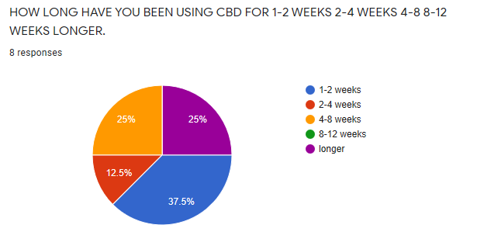
Out of 100% of Customer who did the survey 37.5% these customers had only been using CBD products for 1-2 weeks making them new customers to CBD products. The second highest amount of these customers were joint using CBD products for longer than 12weeks which was 25% of these customers, shared jointly with customer who had also 25% of them being customers who been using CBD products for 4-8 weeks. Then the smallest number of customers being 2-4 weeks which was 12.5% had only been using the CBD products for 2-4 period. This proves that highest number of customers are new to CBD products and secondly 50% of customers who had done the survey are customers who have been using CBD for 2 months or for a period longer than 12weeks. Although customer with the smallest amount with 12.5% was 2-4 weeks what this identified to us was a gap where our customer had, no one using CBD products for a period of 8-12 weeks are there reasons why? There could be many reasons for this? We need to find out why?

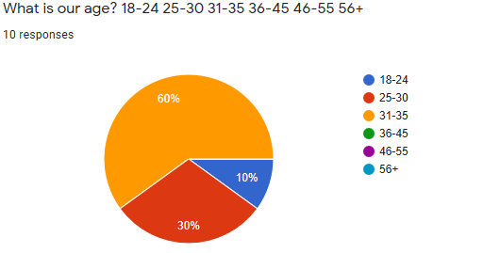
This second pie charts shows us that 60% of these customers who had taken the CBD survey was within the age gap of 31-35 which is more than half our cutomers are within this age group which is a very high percentage for one age group. Secondly highest was slightly younger with 30% was the age group 25-30 these both age groups 25-30 and 31-35 was a masive 90% of our customers who had taken the survey overall, this meaning that the last 10% was made up of customers who had taken the survey was 18-24 year old customers, resulting with no customers ages between 36-45, 46-55 and 56+ years old, No customers who had taken this survey was older than 36 years old. This was three out of the six groups had no customers who had taken the CBD surveys was within these ages.
Overall Summary –
My finding of both questions are that 100% of the customers who had taken the survey are over the age of 18 but still under the age of 36 years old. Also surjests that three quarters of these customers have been using CBD for less than 8-12 weeks as none had been using for 8-12weeks and reamining 25% had been using CBD products for longer than 12weeks.

Website Analysis.
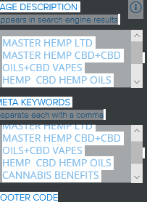
STUDENT NUMBER 1817418@STUDENT.UWTSD.AC.UK PASSWORD Warren15Daz


