May 9, 2024
Emma Moseley (2317703)
BEng Embedded Electronics Systems Engineering
Resonance
Electrical & Electronic Principles

Abstract
This report presents a laboratory study on parallel RLC circuits, focusing on Q factors and resonance frequencies. The research combines simulation and practical experimentation to improve understanding of these circuits. The experiment involved designing both simulated and practical parallel RLC circuits. The simulated circuit was made using Proteus software, while the practical circuit was produced by attaching components to a breadboard. Resonant frequencies and Q factors were measured and compared in both simulation and practical experiments. The results are consistent with theoretical expectations for resonant frequencies, yet there are significant variances in Q factor values. These variations highlight how real-world conditions affect circuit performance. Overall, the experiment emphasises the importance of using real-world experiments to validate theoretical models and emphasises the significance of reliable circuit designs that have been modified for practical use.

Contents
1 Introduction 6
1.1 Background 6
1.2 Key Concepts 7
1.2.1 AC Theory 7
1.2.2 Resonance 7
1.2.3 Reactance 7
1.2.4 Attenuation 7
1.2.5 Q Factor 8
1.3 Practical Application 8
1.4 Report Structure 8
2 Experiment Setups 9
2.1 Simulated Experiment 9
2.1.1 Circuit Design 9
2.1.2 Resonant Frequency Calculation 9
2.2 Practical Experiment 10
2.2.1 Circuit Design 11
2.2.2 Connection Setup and Measurement 12
2.2.3 Data Collection 14
3 Results 15
3.1 Graphical Representation 16
3.2 Calculating Q Factor 17
4 Discussion 20
4.1 Resonance Frequency Comparison 20
4.2 Q Factor Analysis 20
4.3 Factors Influencing Simulation 21
4.4 Simulation Adjustments and Challenges 21
5 Conclusion 22
6 References 22

Table of Figures
Figure 1: Parallel RLC circuit schematic for the simulation experiment. 9
Figure 2: Signal generator settings in the simulation experiment. 10
Figure 3: Breadboard circuit design for the practical experiment. 11
Figure 4: Connecting the breadboard circuit to the equipment. 12
Figure 5: Oscilloscope probe connections. 13
Figure 6: Signal generator settings. 13
Figure 7: Sine wave from the practical experiment on the oscilloscope. 14
Figure 8: Graph of attenuation for simulated and practical experiments. 17
Figure 9: Q factor/attenuation graph for simulated results. 18
Figure 10: Q factor/attenuation graph for practical results. 18
Figure 11: Q Factor calculation for simulated results. 19
Figure 12: Q Factor calculation for practical results. 19

Table of Tables
Table 1: Simulation experiment readings and attenuation calculations. 15
Table 2: Practical experiment readings and attenuation calculations. 16

Table of Equations
Equation 1: Resonant frequency equation. 10
Equation 2: Attenuation equation. 14
Equation 3: Q Factor equation. 17
Equation 4: Q Factor equation using graph data. 19

Introduction
This report presents a laboratory experiment that focuses on the behaviour of parallel RLC circuits and is intended to enhance practical measurement and data analysis skills. The study uses a combination of simulation and practical experiments to gain insight into the resonance theory of RLC circuits at different frequencies. Additionally, the examination of the Q factor provides a better understanding of how parallel RLC circuits work.

Background
Parallel RLC circuits are essential components of electrical engineering, used in a wide range of electronic devices. These circuits, which include resistors, inductors, and capacitors, are important for understanding how alternating current (AC) systems behave.
Resonance in electronic circuits is produced by connecting a capacitor and an inductor in parallel, enabling energy to be stored and transferred at a specific frequency [1]. This resonance creates a largely resistive circuit because the inductor and capacitor cancel each other out [2]. As a result, resonance has low current and high impedance characteristics, where impedance is the resistance to AC in a circuit [3][4]. Understanding resonance theory is important for designing and analysing electronic devices and systems.
A tank circuit is a specific configuration of components (the inductor and capacitor are in parallel) that stores and oscillates electrical energy at a resonant frequency [5]. These circuits are important for radio tuning and communication systems [6]. However, real-world tank circuits oscillate at decreasing amplitudes due to losses such as dielectric, magnetic, and conductor resistances [5]. A better understanding of the peak response at resonant frequency can result in more efficient electronic systems.

Key Concepts

AC Theory
AC theory explains how resistors, inductors, and capacitors react to AC and provide insights into how different circuit components function in various situations. AC theory predicts electrical circuit behaviour under specific conditions, such as changes in frequency or voltage of the AC signal [7].

Resonance
Resonance occurs when the inductive and capacitive components in a circuit balance each other, producing a peak response at the resonant frequency [8]. The circuit amplifies signals at its resonant frequency and attenuates those away from it. This underlines the importance of understanding how peak responses at appropriate frequencies are generated by the balanced interaction of inductive and capacitive components [7].

Reactance
Reactance is the resistance that AC encounters in a circuit as a result of inductors or capacitors, which influence the circuit's total impedance [9]. The reactance of capacitors and inductors varies with frequency, affecting the circuit's response characteristics [7].

Attenuation
Attenuation is the reduction in signal strength as it passes through a circuit, which is important in signal transmission and filtering applications. Attenuation measurements can be used to analyse the circuit's ability to amplify or attenuate signals at various frequency ranges, providing insights on the circuit's performance characteristics across various frequencies [8]. This method involves calculating the ratio of the peak-to-peak voltage measured across the inductor to the peak-to-peak input voltage set on the signal generator. Attenuation is measured in decibels (dBs), which plays an important role when designing efficient communication networks and signal processing circuits [10].

Q Factor
An electrical circuit's Quality Factor (Q) represents how well it tunes and reacts to a particular frequency [11]. It regulates the circuit's efficiency in storing and releasing energy during each operating cycle. A higher Q Factor shows that the circuit is more efficient in storing and releasing energy during each operational cycle [7]. Additionally, it shows how effective and selective the circuit's resonance is [11].

Practical Application
Theoretical concepts such as AC theory provide a framework for understanding the behaviour of parallel RLC circuits with varying input signal frequencies. This understanding is used to examine the characteristics of impedance for a range of frequencies [7].
Experimenting with these theories enhances understanding of circuit operations and their practical applications. Additionally, comparing experimental results to simulations is a way to assess the accuracy of predictions in real-world circumstances, which leads to a better knowledge of electrical engineering concepts [7].

Report Structure
The report is organised into sections for simulation and experimental setups, results, discussion, and conclusion. It begins with a description of the simulated RLC circuit in Proteus, followed by the practical experiment setup, which includes component specifications and measurement methods. Following that, the Results section contains measured data, calculations, and graphical representations of the circuit's frequency response. The Discussion section evaluates and interprets the data, comparing simulated and practical results and highlighting noteworthy findings. The Conclusion section summarises the experiment's findings while also emphasising the main points.

Experiment Setups

Simulated Experiment

Circuit Design
The parallel RLC circuit schematic in Figure 1 was created with Proteus software. The circuit included a 1kΩ resistor, 1uF capacitor, and 1mH inductor. The resistor was connected in series to the power supply, and the capacitor and inductor were connected in parallel. This setup allowed for the formation of a tank circuit. The circuit was then linked to an oscilloscope and a signal generator in the simulation environment.
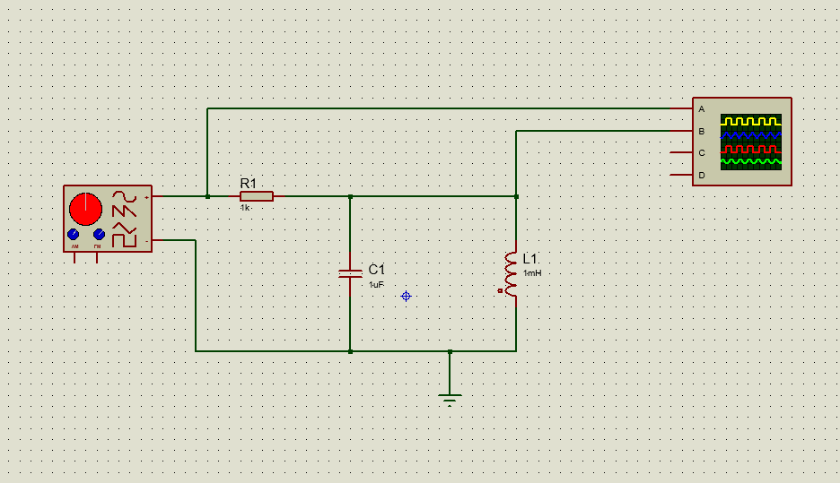
Figure 1: Parallel RLC circuit schematic for the simulation experiment.

Resonant Frequency Calculation
After designing the schematic, Equation 1 was used to calculate the resonant frequency, where 𝐶 is for capacitance and 𝐿 for inductance. The resonance frequency was adjusted to include the real component values, a 1mH inductor and a 1uF capacitor.
Equation 1: Resonant frequency equation.
$$f= \frac{1}{2πLC}$$
$$f= \frac{1}{2π\sqrt{1mH*1uF}}$$
$$f= \frac{1}{2π\sqrt{(1*{10}^{-3})*(1*{10}^{-6})}}$$
The resonance frequency obtained from the above calculation is 5032.92Hz.
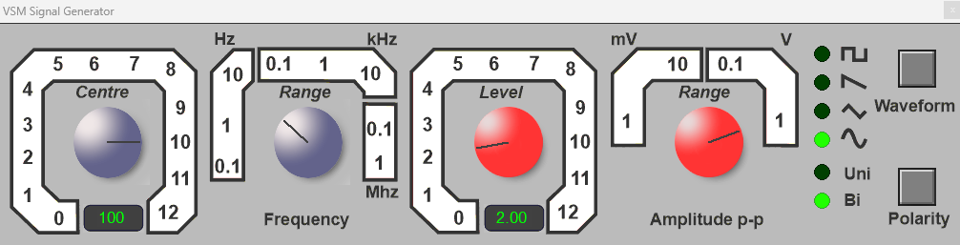
Figure 2: Signal generator settings in the simulation experiment.
The resonance frequency became the primary focus of the simulation. Proteus' signal generator was set to generate a sine wave with a frequency of 100 Hz and a constant peak-to-peak voltage of 2 Vpk-pk (see Figure 2). To maintain consistency, the voltage value was kept constant throughout the simulation. The circuit's responsiveness was evaluated over a range of frequencies, from 100Hz to 20kHz. Measurements were taken at specific points around the estimated resonant frequency to accurately evaluate the circuit's response qualities, including half-amplitude and peak values. The simulation findings provide vital information about the resonance behaviour and functionality of the circuit.

Practical Experiment
In the practical experiment, the circuit was constructed on a breadboard.
Components:
- Capacitor: 1uF
- Inductor: 1K63 with a tolerance of ±10%
- Resistor: 1kΩ with a tolerance of ±5%
- Red wire: Connected to the input signal
- Black wire: Outputs the signal

Circuit Design
The tank circuit was built by connecting the inductor and capacitor in parallel. Next, the resistor and tank circuits were connected in series. Input and output wires were placed on either side of the components to complete the circuit. Figure 3 shows how the components were placed in the breadboard.
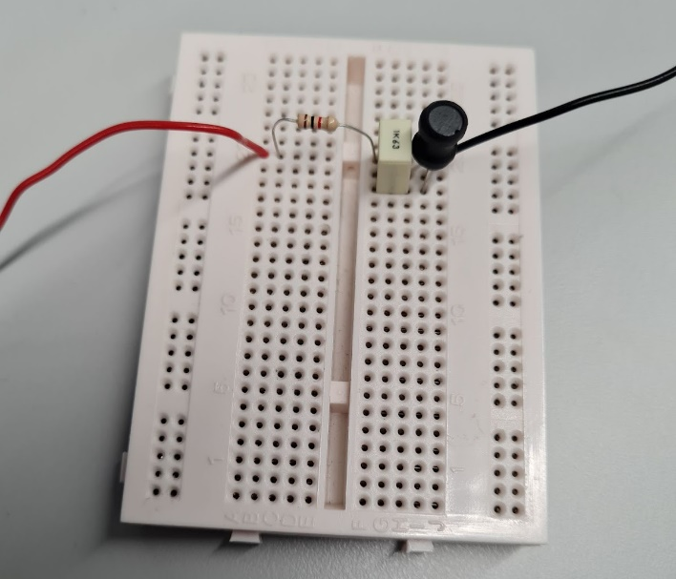
Figure 3: Breadboard circuit design for the practical experiment.

Connection Setup and Measurement
To enable measurement, the oscilloscope probes and wires from the signal generator were connected to the circuit. The black wire on the circuit, which served as the signal generator's output, was connected to both the oscilloscope probes' black cables and the signal generator itself (see Figure 4). This ensured that the output signal from the signal generator reached the circuit for the oscilloscope probes to measure.
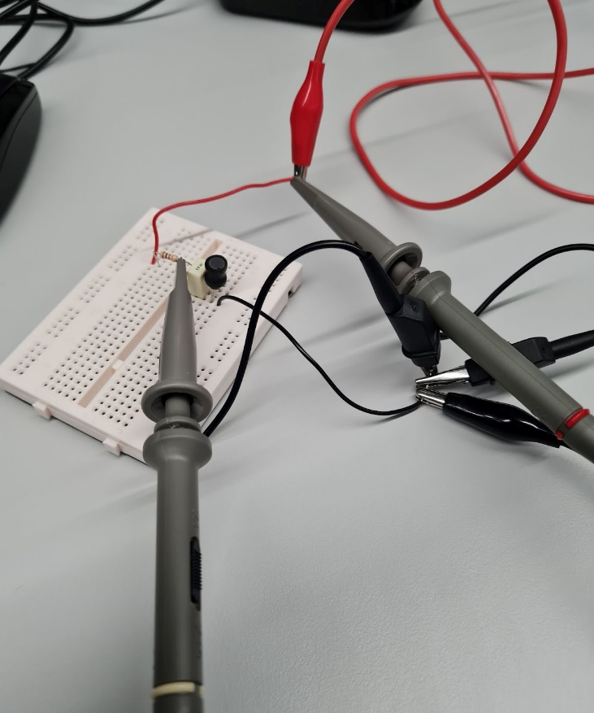
Figure 4: Connecting the breadboard circuit to the equipment.
A wire from the signal generator was linked to the red wire on the circuit to connect the input signal. This linkage ensured that the signal generator's input signal was transmitted to the circuit via the red wire. The probe tip from channel 1 of the oscilloscope was connected to the circuit's red wire to measure the signal (see Figure 5). Channel 2's probe tip was attached to the resistor (see Figure 5), to monitor the reaction within the circuit.
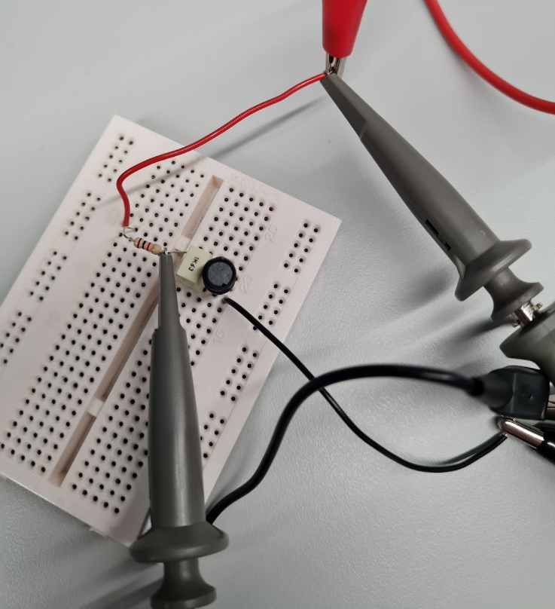
Figure 5: Oscilloscope probe connections.
The experiment began by setting the signal generator to generate a sine wave with a peak-to-peak voltage of 2 Vpk-pk and a frequency of 100Hz (see Figure 6), which matched the simulation. Using the same settings ensured the simulated and practical findings were comparable. A frequency range of 100Hz to 20kHz was used to match the simulated experiment to enable a direct comparison of results.
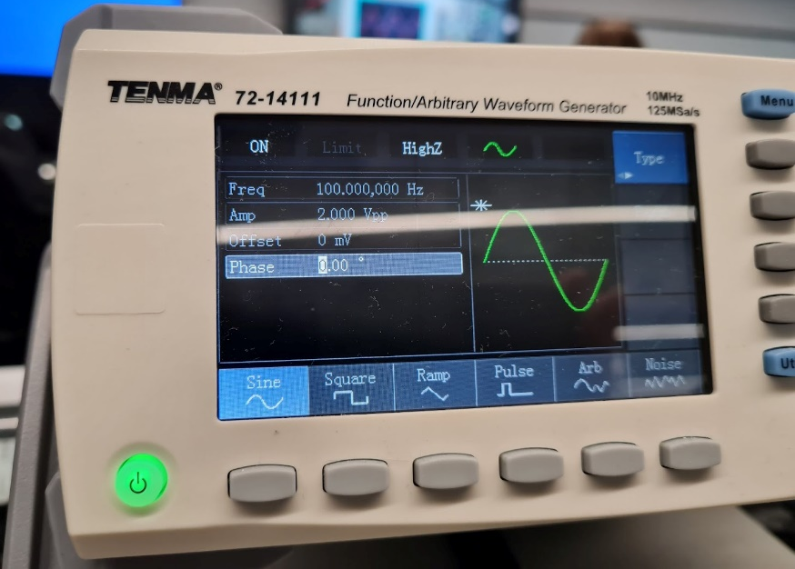
Figure 6: Signal generator settings.
Input and output connections were carefully considered to enable reliable data capture. With this setup, as well as the use of two oscilloscope probes to identify and record output waveforms (see Figure 7), it was possible to analyse the circuit’s response to different frequencies and provide precise experimental data.
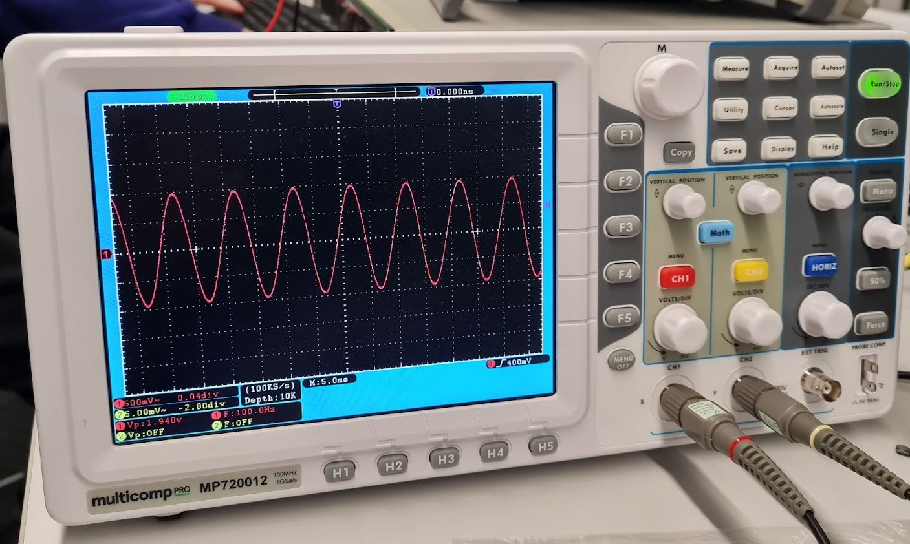
Figure 7: Sine wave from the practical experiment on the oscilloscope.

Data Collection
The voltage outputs across the circuit at different frequency settings were recorded in Excel. These measurements were important for calculating the circuit's attenuation. The attenuation was calculated using Equation 2. Where 𝑉𝐿 is the peak-to-peak voltage across the circuit, 𝑉𝐼𝑛 is the peak-to-peak input voltage set on the signal generator, and 𝐴 is the attenuation in decibels.
Equation 2: Attenuation equation.
$$A=20* \frac{V_{L}}{V_{In}}$$

Results
In this section, data from the simulation, shown in Table 1, and practical experiments, shown in Table 2, were collected to evaluate the circuit's behaviour at various frequencies.

Table 1: Simulation experiment readings and attenuation calculations.
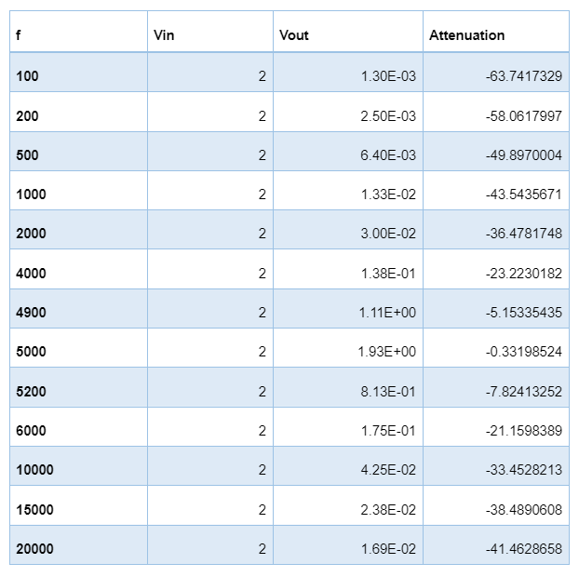

Table 3: Practical experiment readings and attenuation calculations.
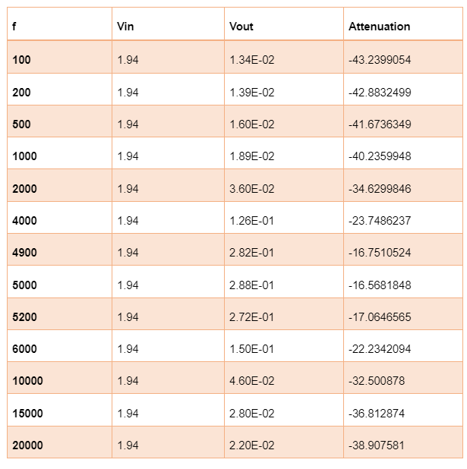

Graphical Representation
The data was used to create a graph of attenuation (see Figure 8). This graph presents the simulation and practical results side by side for direct comparison, giving an overview of each circuit's response to different frequencies.
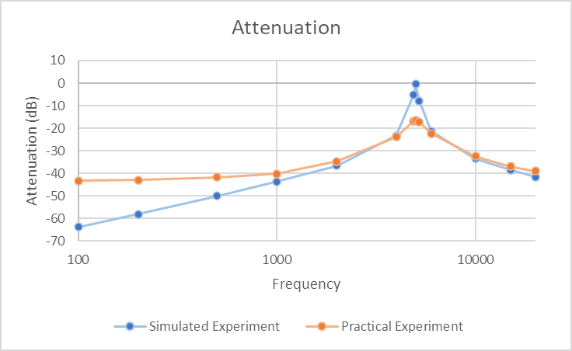
Figure 8: Graph of attenuation for simulated and practical experiments.

Calculating Q Factor
The Q factor was determined using two approaches. First, the Q factor was calculated using Equation 3, where $R$ is the resistance, $C$ is the capacitance, and $L$ is the inductance. A Q factor of around 31.62 was achieved by entering the actual values from the circuit components into the equation.
Equation 3: Q Factor equation.
$$Q=R\sqrt{\frac{C}{L}}$$
$$Q=1*{10}^{3}\sqrt{\frac{1*{10}^{-6}}{1*{10}^{-3}}}$$
The second method used an Excel spreadsheet created to calculate the Q Factor. Component values, and information from the results table were entered into the spreadsheet to construct an attenuation graph. The range shown on the x-axis (frequency) and the y-axis (attenuation in dB) was changed to increase the visibility of the resonance peak. The horizontal line on the graph represents the bandwidth, which was plotted -3dB from peak. The lower and upper frequency bands are marked by vertical lines that were placed at the connecting point of the frequency line and bandwidth (see Figure 8 for simulated results and Figure 9 for practical results).
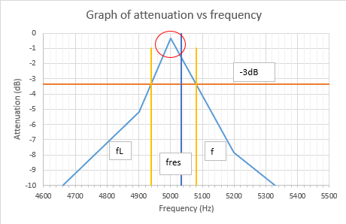
Figure 9: Q factor/attenuation graph for simulated results.

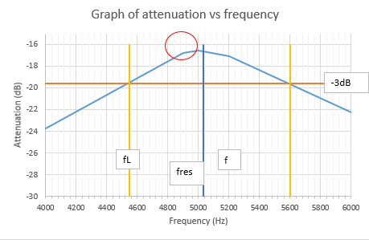
Figure 10: Q factor/attenuation graph for practical results.
The Q factor of the circuit was then calculated using Equation 4, where $fr$ is the resonance frequency, $f2$ is the upper frequency band, and $f1$ is the lower frequency band (see Figure 10 for simulated and Figure 11 for practical Q Factor calculations).
Equation 4: Q Factor equation using graph data.
$$Q= \frac{fr}{f2-f1}$$
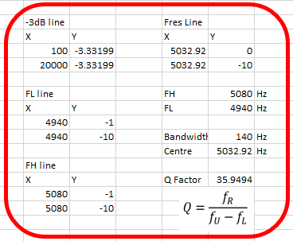
Figure 11: Q Factor calculation for simulated results.

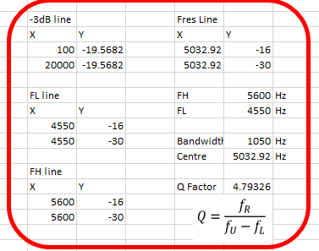
Figure 12: Q Factor calculation for practical results.

Discussion

Resonance Frequency Comparison
The resonant frequencies obtained from the experiments closely match the theoretical prediction. Resonance peaks in both cases contain unique features, but the general form and amplitude are similar. There are some variations which may be related to parasitic elements and component tolerances [13]. A variety of factors can influence a circuit's resonance frequency, including parasitic elements and component qualities. Understanding component behaviour helps predict resonance frequency properly. In order to achieve the best results in high-frequency circuits, Mancini stresses the importance of selecting capacitors based on their self-resonant frequencies and dielectric materials [12].
Awareness of frequency response improves circuit design, reduces interference, and enhances performance. Combining theoretical estimations with experimental data is important for improving circuit performance and understanding resonance. Combining theoretical understandings with empirical data can help to improve the reliability of circuit designs for real-world applications [11].

Q Factor Analysis
The Q Factor varies significantly between the simulation and the practical experiment. The simulation shows a higher Q factor of 35.9494, indicating efficient resonance with minimal loss or distortion [11]. However, the practical experiment gives a lower Q factor of 4.7933. Circuit performance is impacted by parasitic effects and component tolerances, as seen by variations in Q factor. Q factor can be increased by selecting components that correspond with their specifications and by minimising stray capacitance and inductance [12].
Interestingly, the Q factor from the simulation (35.9494) closely matches the theoretical Q factor (31.62), showing a small variation of approximately 4. The similarity confirms the mathematical theory's ability to predict circuit behaviour with ideal components.

Factors Influencing Simulation
Differences between the simulation and experiment results could be due to a variety of reasons. One reason could be due to the tolerance values of the components used in the practical experiment. Tolerance refers to the allowable variance from the specified values of components such as resistors and inductors. A resistor with a tolerance of ±5% allows for maximum variance of 5% from the specified value [13]. Additionally, tolerances can be found in inductors, such as ±10% tolerance depending on the component [14]. These variations impact circuit behaviour, including signal amplitude and frequency responsiveness. Component tolerances must be carefully evaluated during the circuit design process to provide the desired performance and dependability.
Real-world variables that can cause noticeable changes can be reproduced in the simulation by including stray capacitance and inductance [12]. Additionally, accuracy can be improved by including environmental variables like temperature, humidity, and interference in the simulation model and by representing real-world circumstances [11]. For better comparison between simulation and practical results, simulation parameters need to be as similar as possible to the practical experimental setup.

Simulation Adjustments and Challenges
Multiple simulations were run, with minor adjustments made to improve the simulation circuit's behaviour to match that of the practical circuit. An extra resistor was added to the circuit to evaluate the effect. Adding the resistor in series to either the inductor or capacitor resulted in an increase in total resonance, which was not the anticipated outcome because the goal was to lower the Q factor to match the practical experiment results.
The resistor was then placed in parallel with the tank circuit, resulting in a significant increase in the Q factor, which reached around 100. However, this went against the goal of lowering the Q factor to match the practical experiment's value.
Although there were adjustments, the simulation results did not match the practical experiment outcomes. In addition, Proteus exhibited errors and occasionally failed to provide reliable simulations. This unforeseen issue possibly contributed to the failure of a number of the adjustment tests.

Conclusion
This experiment provides important insights on parallel RLC circuit behaviour. While resonant frequencies matched theoretical predictions, there were significant differences in Q factor values between the practical and simulation experiments. These differences showed the impact of real-world variables on circuit performance. The simulation circuit can be improved to better replicate real-world behaviour by running several simulations and making small modifications throughout. Taking all of these variables into consideration reduces the difference between simulation and practical findings, resulting in more accurate and reliable circuit design for practical applications. Overall, this experiment enhanced understanding of parallel RLC circuits and highlighted the value of combining theoretical insights with practical experience when designing circuit designs for real-world applications.

References
[1] A. Ahmad, “Understanding resonance in parallel RLC circuits - technical articles,” EEPower, 06-Jul-2023. [Online]. Available: https://eepower.com/technical-articles/understanding-resonance-in-parallel-rlc-circuits/. [Accessed: 24-Apr-2024]
[2] M. Mulko, “Parallel RLC circuits: What are they and how do they work?” Interesting Engineering, 2021. [Online]. Available: https://interestingengineering.com/science/parallel-rlc-circuits-what-are-they-and-how-do-they-work. [Accessed: 24-Apr-2024]
[3] “What is the impedance of an RLC circuit?” Cadence. [Online]. Available: https://resources.pcb.cadence.com/blog/2022-advanced-pcb-design-blog-what-is-the-impedance-of-an-rlc-circuit. [Accessed: 24-Apr-2024]
[4] Electrical4U, “Parallel RLC circuit: What is it? (circuit analysis),” Electrical4U, 01-May-2024. [Online]. Available: https://www.electrical4u.com/rlc-parallel-circuit/. [Accessed: 24-Apr-2024]
[5] T. R. Kuphaldt, “Basic Alternating Circuit (AC) Theory,” in Antennas and Resonant Circuits (Tank Circuits), Control Automation, 2008, pp. 485–488 [Online]. Available: https://control.com/uploads/Control-Automation-Textbook.pdf
[6] “Tank Circuit (LC circuit): Diagram, working and applications.,” Testbook. [Online]. Available: https://testbook.com/electrical-engineering/tank-circuit. [Accessed: 24-Apr-2024]
[7] D. W. Knight, Devon, 2015 [Online]. Available: https://g3ynh.info/zdocs/AC_theory/AC_theory.pdf
[8] S. Mugo, “Resonance explained - technical articles,” EEPower, 29-Sep-2022. [Online]. Available: https://eepower.com/technical-articles/resonance-explained/. [Accessed: 25-Apr-2024]
[9] A. Ahmad, “Determining Series RLC Circuit resonance frequency,” EEPower, 02-May-2022. [Online]. Available: https://eepower.com/technical-articles/determining-series-rlc-circuit-resonance-frequency/. [Accessed: 25-Apr-2024]
[10] What is attenuation in an electrical system? [Online]. Available: https://www.elandcables.com/the-cable-lab/faqs/faq-what-is-attenuation-in-an-electrical-system. [Accessed: 25-Apr-2024]
[11] J. G. Paulson and M. W. Ray, “Exploration of the Q factor for a parallel RLC Circuit,” American Journal of Physics, vol. 90, no. 12, pp. 903–907, Dec. 2022.
[12] R. Mancini, Texas Instruments, 1999 [Online]. Available: https://www.ti.com.cn/cn/lit/an/sloa027/sloa027.pdf [Accessed: 30-Apr-2024]
[13] Allied Components International, “What are the relations of tolerance with resistors?” What Are the Relations of Tolerance with Resistors? 17-Nov-2022. [Online]. Available: https://www.alliedcomponents.com/blog/what-are-the-relations-of-tolerance-with-resistors. [Accessed: 30-Apr-2024]
[14] “How to read inductance values,” Spiceman, 24-Jul-2022. [Online]. Available: https://spiceman.net/inductor-value/. [Accessed: 30-Apr-2024]

