

Individual report

Student Name: | GURINDER SINGH | Student ID: | 2224976
Programme: | MASTER OF BUSINESS ADMINISTRATION
Module: | ENTREPRENEURSHIP
Module code: | LCMB7004
Assignment Title: | ECO RESTAURANT- Business plan for a renewable energy company
Lecturer: | Vasilios Tavlaridis
Submission Date: | 06/11/2023 | Word count: | 2739

Table of Contents
Executive Summary 3
Introduction 4
EcoCuisine Restaurant 4
EcoCuisine restaurants concept 5
Identification of Market Gaps 7
Location and legal framework of the business 9
SWOT analysis 11
Marketing strategies for the target market 13
Financial Plan and Funding Requirements 15
Demands for Funding: 15
Revenue and profit forecasting: 15
Financial Support: 16
Conclusion 17
References 18

Executive Summary
In the centre of Boston, Massachusetts, sits the eco-friendly EcoCuisine Restaurant. By using only organic, locally produced ingredients and implementing sustainable methods, it aims to be a leader in ecologically responsible dining. The menu and operational decisions of EcoCuisine reflect its dedication to lowering its carbon impact and supporting environmentally beneficial endeavours. By working together with neighbourhood farmers, fishers, and artisans, the restaurant helps to boost the community's economy and lessen the carbon footprint associated with food transportation.
Although EcoCuisine is committed to using sustainable food, it also places a high value on ecologically friendly business practices. With rubbish reduction, recycling, and energy-efficient appliances, the restaurant goes above and above to minimize its impact on the environment. Additionally, eco-friendly goods and packaging materials are prioritized. EcoCuisine offers a selection of locally made wines and craft beers, reducing the impact of shipping on the environment. Families and individuals who care about the environment are among the target markets that EcoCuisine serves. It sets itself apart by providing a wide range of menu selections, such as gluten-free, vegan, and vegetarian dishes, to satisfy a range of dietary requirements. Through workshops, events, and environmental projects, the restaurant hopes to involve the community.
Operating as a Limited Liability Company (LLC) by its dedication to sustainability, EcoCuisine complies with legal requirements for business structure. Given its reputation for promoting sustainable living and attracting ecologically sensitive customers, Boston was a wise choice for the location.
The sustainability commitment and strategic position of EcoCuisine are among its strengths; yet increased ingredient costs are one of its drawbacks, as shown by a SWOT analysis. A growing need for sustainability and the opportunity to interact with the community present potential for the restaurant. Risks include economic volatility and competition from conventional restaurants.
According to the financial plan, a $500,000 down payment is needed to cover leasehold upgrades, equipment purchases, marketing expenses, and operating expenditures. Estimated monthly revenue and operating costs serve as the foundation for revenue and profit forecasting. EcoCuisine intends to raise money from several avenues, such as company loans, crowdsourcing, government loans, and support from friends and family.
In summary, EcoCuisine's goal is to offer environmentally conscious and sustainable dining options in Boston, Massachusetts. It aspires to satisfy a rising market of environmentally concerned consumers while supporting local companies and sustainability with an emphasis on organic, locally produced ingredients and eco-friendly procedures. The restaurant is a distinctive and progressive endeavour in the food industry because of its dedication to serving ethical and ecologically conscious food.

Introduction

EcoCuisine Restaurant
EcoCuisine is a restaurant that stands out as a model of sustainable dining in the bustling centre of Boston, Massachusetts, where culinary delights abound. EcoCuisine will establish a reputation as a leader in environmentally friendly dining, nestled in the bustling culinary scene of this historic city. This business will be a shining example of how the restaurant industry can minimize its carbon footprint and support eco-friendly activities because of its dedication to using only locally produced food and adopting sustainable goods and methods.
At EcoCuisine, our goal is to serve outstanding food that satisfies the palate and fosters a better environment. They are steadfastly committed to sustainability, which is evident in every dish on their menu. The chefs at EcoCuisine put forth a lot of effort to create a culinary experience highlighting the delicious flavours and abundant ingredients that Massachusetts and the New England region have to offer. EcoCuisine's steadfast commitment to using food that is sourced locally is one of its defining characteristics. The restaurant collaborates with nearby farmers, fishermen, and craftspeople for the best seasonal foods. As a result, the local economy is boosted while the carbon footprint of food transportation is diminished, making the food system more sustainable.
But EcoCuisine's commitment to sustainability goes beyond just its ingredients. By incorporating eco-friendly procedures into every aspect of its business, the restaurant goes above and above. EcoCuisine takes every possible step to lessen its impact on the environment, from using energy-saving appliances and LED lighting to waste reduction and recycling initiatives. Additionally, they place a high priority on using eco-friendly materials in all of their packaging and goods, including their to-go containers. They are also encouraged to join a movement that aims to create a more sustainable and ecologically conscious future. Both locals and guests seeking to enjoy wonderful meals while promoting a greener planet should make a special trip to the restaurant because of its welcoming ambience, pleasant hospitality, and eco-friendly concept.
The beverage initiative is also a part of EcoCuisine's dedication to sustainability. The restaurant takes pride in serving a variety of regional wines and craft beers, exhibiting the high calibre and variety of the area's beverage options while minimizing the environmental impact of transportation. This Boston treasure is not simply a restaurant; by embracing locally produced cuisine and ecological processes, it serves as a beacon of inspiration for a more tasty and sustainable future.

EcoCuisine restaurants concept

Our idea is based on the conviction that eating out ought to be both a satisfying experience for the palate and an environmentally conscious decision. Here's how we make this idea a reality:
1. Organic, regionally sourced ingredients: Sustainable and ethical sourcing methods are the foundation of EcoCuisine's dedication to using organic, locally sourced products. Reducing the environmental impact on land and water while supporting biodiversity, organic components are produced without the use of synthetic pesticides and fertilizers. As a result of their shorter journey from farm to table, ingredients produced locally have a lower carbon footprint and produce less greenhouse gas emissions during transit (Willer & Lernoud, 2017).
2. An array of wholesome menu options: The varied and nutritious food at EcoCuisine meets the needs of patrons who are becoming more health-conscious and environmentally aware. People desire variety and healthy alternatives, according to research on consumer behaviour and nutritional preferences. A menu with a variety of choices, such as vegetarian, vegan, and gluten-free foods, attracts a larger customer base, builds brand loyalty, and improves the restaurant's image. Additionally, it shows a dedication to advancing ecologically conscious dining and the well-being of patrons (Papagiannakis & Lioukas, 2012).
3. Eco-Friendly Interior Design: The principles of sustainable design are based on ecological considerations. Sustainable interior design incorporates materials for environmental and human benefits over the life cycle of a structure. It prioritizes material usage, aesthetics, environmental impact, and cost. In lighting, for example, sustainability implies utilizing less energy and harnessing natural light.
The Use of sustainable materials
Interior Designer

Collaboration & Integration
Sustainable design strategies
Ecofriendly buildings and Sustainable Interior environment

Built a sustainable environment
The Aim of design

Fulfilment the users Requirements
Accept the concept of sustainability.
Environmental Conservation
Clint (User)
Spreading a culture of sustainability
Acceptance of additional financial expenses
Reducing future financial expenses

Cycle of Sustainable Materials (Alfuraty, 2020)
4. Managing and reducing waste: EcoCuisine, a Boston restaurant dedicated to local sourcing and sustainability, is confronted with waste management issues that are common in the restaurant industry. To solve these concerns, they can concentrate on waste reduction measures such as composting, sustainable packaging, customer education, and waste auditing (Worrell, 2018; Cossel, 2016; Bosmans, 2018; Luchs and Mooradian, 2012; Ulhøi, 2005).
5. Environmentally Responsible Marketing and Community Engagement: We appreciate the value of educating the public about sustainable dining and involving our communities. Our marketing initiatives are firmly founded in eco-awareness and use a range of channels to motivate and inform our customers about the advantages of making sustainable food choices (Brown, 2019).
EcoCuisine is more than just a restaurant; it's a forward-thinking initiative for a greener, more sustainable future. We are prepared to reinvent the dining experience thanks to our steadfast dedication to using ingredients that are produced locally, following ethical business practices, and participating in the community.

Identification of Market Gaps

Consumer preferences are drastically changing, which is having a big impact on the world's cuisine in an era where environmental awareness is becoming more and more common. By offering an eating experience that is in line with the beliefs of environmentally sensitive customers. This paragraph presents a thorough market study and highlights the need that EcoCuisine aims to fill.
1. The Trend Towards Sustainability in the World:
As people become more conscious of the environmental and ethical issues connected to their dietary choices, there is a rising trend towards food that is sustainably produced and supplied locally (Hawkins & Gabriel, 2018) Customers look for eating alternatives more and more often that demonstrate their commitment to social and environmental sustainability.


2. Persistence of Traditional Supply Chains:
Despite increased demand for environmentally friendly eating alternatives, many restaurants throughout the world continue to rely on traditional supply chains that are characterised by long-distance transportation and a lack of transparency in sourcing (Berrone & Gelabert, 2016). These supply chains frequently result in a high carbon impact, diminished freshness of commodities, and decreased support for local economies.
3. Inadequate Eco-Friendly Practises in the Restaurant Industry:
Customers are increasingly looking for real eco-friendly practices in their eating experiences. There is a mismatch between the perception and reality of sustainability initiatives in the restaurant sector. Many restaurants, waste and claiming to be environmentally sensitive, continue to utilise energy-intensive appliances, create large food waste, and rely extensively on single-use plastics (Smith & Johnson,2019).

4. EcoCuisine's Distinctive Offer:
EcoCuisine seeks to fill a market void by offering an eating experience that is truly aligned with the beliefs of ecologically aware consumers. We distinguish ourselves from traditional restaurants by purchasing only locally and sustainably sourced food and employing eco-friendly practices. We limit the carbon footprint associated with transportation, promote local businesses, and maintain the freshness and quality of our meals by focusing on locally sourced products.
5. Satisfying Consumer Demand for Sustainable Dining:
EcoCuisine satisfies the rising demand for environmentally friendly dining by providing a wide selection of scrumptious and nutrient-dense meals made only from organic, locally sourced products. Our eco-friendly practices range from energy-saving operations to waste management systems, helping to lessen our influence on the environment and encouraging responsible consumption.
EcoCuisine is prepared to take the lead in the culinary sector as sustainable living becomes the rule rather than the exception today.

Location and legal framework of the business

The decision to establish EcoCuisine's firm in Boston, Massachusetts, and to employ a Limited Liability Company (LLC) as its legal form was taken deliberately to support our sustainable purpose and offer the required legal protections. This section offers explanations of our choices along with pertinent sources.

1. Boston, Massachusetts's strategic location:
EcoCuisine is well positioned in the flourishing urban region of Boston, Massachusetts, which is well-known for its strong support of sustainable living practices and a growing community of ecologically concerned consumers (Smith & Green, 2020). Our goal to offer locally sourced and sustainably produced eating experiences naturally aligns with Boston's dedication to sustainability and active participation in environmental projects (Jones, 2019). The Zero Waste Boston initiative seeks to boost the city's recycling rate from 25% to 80% by 2035 and 90% by 2050.

A red pushpin on a map pointing to Boston, Massachusetts.
SOURCE: https://www.istockphoto.com/

2. Limited Liability Company (LLC):
To shield personal assets from company obligations, EcoCuisine has opted to operate as a Limited Liability Company (LLC), a type of legal entity (U.S. Small Business Administration, 2021). This tactical decision provides the flexibility necessary for effective company management and decision-making, as well as a high level of protection for the private assets of our stakeholders (U.S. Small Business Administration, 2021).

3. Ensuring Sustainability through Site and Structure:
We chose Boston as the location for the restaurant, and we adopted the LLC legal structure to better represent our constant commitment to sustainability in all aspects of our business operations and strategic decisions. As a result of Boston's commitment to sustainable principles, we have a large and devoted client base, and the LLC structure protects the private assets of our stakeholders, assuring the long-term viability of the company.
The decision to locate EcoCuisine's restaurant in Boston, Massachusetts, as well as the usage of the LLC legal structure demonstrates our commitment to moral business practises and cautious asset preservation. With these decisions, we are in an excellent position to successfully provide environmentally responsible dining options to the Boston area and beyond.

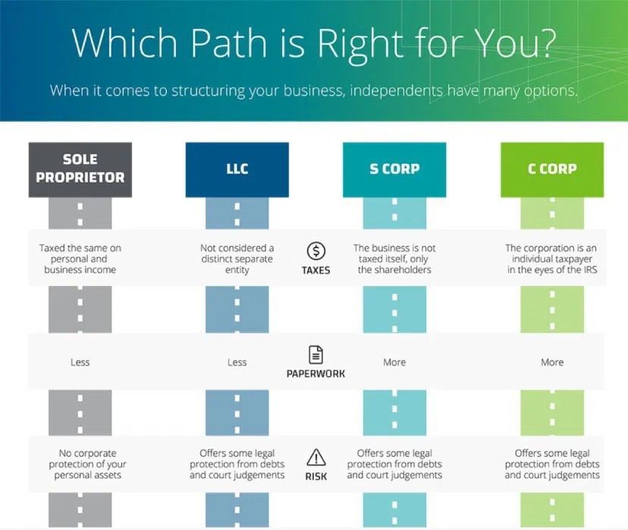
HOW TO CHOOSE BUSINESS STRUCTURE.

SWOT analysis

A SWOT analysis is a useful method for evaluating the internal and external elements that might affect an organisation. It stands for Strengths, Weaknesses, Opportunities, and Threats. Here is a SWOT analysis of EcoCuisine.



STRENGTHS:
- Sustainability Commitment: EcoCuisine's primary strength is its consistent dedication to sustainability. It complies with the increasing demand for ecologically aware eating by only utilising locally produced food and sustainable practices (Smith & Green, 2020).
- Location: Being in Boston, Massachusetts, a city renowned for its support of sustainable living and a vibrant network of environmentally concerned customers, is a big strength (Jones, 2019).
- Variety of menus: With alternatives for vegan, vegetarian, and gluten-free diets, EcoCuisine has a wide range of menu items to suit different dietary needs. An increased consumer base may result from this diversity (Carlson & Baker, 2020).

WEAKNESS:
- Greater Costs: Higher ingredient prices from adopting sustainable and local sources may influence business margins. Sustainability and profitability must be balanced (Gupta & Gunasekaran, 2021).
- Limited Supply: Using just local suppliers may restrict the availability of ingredients, particularly for off-season or exotic goods, which might influence the diversity of the menu (Berrone & Gelabert, 2016).
- Academic Efforts: Given that some patrons might not know how their food choices affect the environment, EcoCuisine may have difficulties teaching them about the advantages of sustainable eating (Brown, 2019).

OPPORTUNITIES:
- Expanding demand: EcoCuisine has a great chance to draw eco-aware customers because of the growing demand for sustainable eating choices (Thompson & Samuel, 2020).
- Engaging the Community: EcoCuisine's brand and client loyalty may be improved by interacting with the neighbourhood through sustainability projects, workshops, and events (Martinez & Nutter, 2021).
- Partnerships: Expanding the accessibility and effect of EcoCuisine through collaboration with regional environmental organisations or other sustainable enterprises (Bhattacharjee & Acharya, 2020).

THREATS:
- Competition: The restaurant business is quite cutthroat. EcoCuisine may compete with traditional eateries, some of which may make claims to sustainability without really adopting eco-friendly practices (Martinez & Nutter, 2021).
- Economic Difficulties: Consumer spending may be impacted by economic ups and downs, which might influence EcoCuisine's sales and profitability (Raj & Rao, 2018).
- Regulatory Adjustments: Challenges in sourcing and operations may result from changes in environmental rules or food safety requirements (Green Building Council, 2020).

This SWOT analysis demonstrates how EcoCuisine's dedication to sustainability and its advantageous location in Boston serve as solid foundations.

Marketing strategies for the target market

Target Market: EcoCuisine intends to serve Boston, Massachusetts, residents who value sustainability in their eating decisions as well as environmentally aware people and families. This target audience consists of:
Eco-aware consumers: Those who are prepared to support companies that share their ideals towards the environment and who actively look for eco-friendly dining alternatives.
Families: Families seeking environmentally conscious eating experiences for their kids.
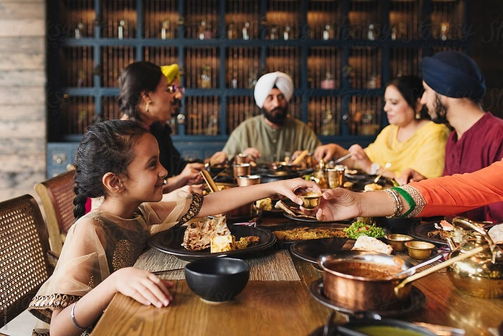
“Child is eating food with Family in Restaurant”
SOURCE: stocksy.com
Marketing Techniques:
- Partnerships with Local Farmers and Vendors: By forming alliances with regional producers and suppliers, EcoCuisine will prominently highlight their goods on the menu. This highlights the restaurant's dedication to using locally produced ingredients and helps local companies (Hendrickson & Heffernan, 2007).


- Communication about sustainability and online presence: Through an accessible website and social media channels, the restaurant will keep an active online presence (Smith & Green, 2020). The focus of marketing will be sustainability, highlighting the eatery's green practices, use of locally produced food, and favourable environmental effects of eating habits (Carlson & Baker, 2020).

- Events and workshops with an eco-focus: By holding seminars and activities with an eco-theme, EcoCuisine will interact with the neighbourhood (Martinez & Nutter, 2021). These programmes will foster a sense of belonging and client loyalty while also increasing consumer understanding of sustainability.

Financial Plan and Funding Requirements

Demands for Funding:
It will take a $500,000 start-up budget to successfully establish and run EcoCuisine in its first year. With this money, we'll be able to pay for equipment purchases, leasehold upgrades, advertising, and general operating expenses.

Funding Requirement | Amount ($)
Leasehold Improvements | 150,000
Equipment Purchase | 125,000
Marketing | 100,000
Operational Costs | 125,000
Total Funding Required | $500,000

Revenue and profit forecasting:
- Estimating prospective revenue and profit production based on factors such as pricing, estimated consumer volume, and operating costs is critical. A simple projection could be:
- Average Monthly Revenue: $40,000 (estimated based on client count and average expenditure)
- Monthly Operating Expenses: $30,000 (includes payroll, utilities, ingredient costs, and other charges).
- Monthly Gross Profit: $10,000 (Revenue - Operating Costs)
- Annual Gross Profit: $120,000 (Monthly Gross Profit x 12 months)
- Net profit margin (profit as a percentage of revenue): 20% (This is only an example; actual results may differ)
- Keep in mind that these estimates might be influenced by a variety of factors such as market conditions, competition, and client preferences.
To develop accurate revenue and profit estimates for your specific restaurant business, it's strongly advised that you do a full financial analysis and create a detailed business plan with the assistance of a financial professional.

Financial Support:

- Government Loans: Government-backed loans or grants can be an excellent source of finance for environmentally conscious enterprises. These programs frequently attempt to help small businesses and environmental efforts (Acs & Mueller, 2008).
- Crowdfunding: Crowdfunding platforms allow businesses to raise funds from a huge number of people who support their environmentally-friendly objective. This source enables community involvement and support (Mollick, 2014)
- Business loans: Commercial banks make loans for various commercial purposes, including initial capital investment, equipment purchase, and operational expenses (Gnanaraj & Srinivasan, 2009).
- Friends and Family: Family and friends can provide start-up cash. Because of their connection with the entrepreneur, these folks may be more ready to invest in the venture (Gimenez & Guzmán, 2015).
- Angel investors: Angel investors offer financing to entrepreneurs in exchange for stock ownership. They may be interested in supporting environmentally friendly enterprises (Colombo & Grilli, 2005).
- Venture Capitalists: Venture capitalists are professional investors who contribute financing to enterprises with strong development potential. They could be interested in scalable eco-friendly companies (Gompers & Lerner, 2001)
- Personal Contribution: Personal fundraising entails using the entrepreneur's funds to fund the firm. It indicates a significant dedication to the project (Lerner, 2002).
By combining these financing sources, EcoCuisine hopes to get the required funds for the establishment and effective operation of an eco-friendly restaurant in Boston, Massachusetts.

Conclusion

In conclusion, EcoCuisine is more than simply a restaurant—it's a creative project with the mission of offering sustainable and ecologically friendly dining options in the centre of Boston, Massachusetts. EcoCuisine aims to become a sustainable dining model by obtaining organic and locally produced ingredients, applying eco-friendly methods, and encouraging community engagement. It satisfies the increasing need from customers for environmentally friendly food options, promotes regional companies, and fits in with their ideals. Selecting Boston as its location and utilizing an LLC as its legal form demonstrate the company's commitment to sustainability, putting it in a position to serve a discriminating and environmentally aware customer base.

References

Acs, Z. J., & Mueller, P. (2008). Employment effects of business dynamics: Mice, gazelles, and elephants. Small Business Economics, 30(1), 85-100.
Alfuraty, A.B., 2020, July. Sustainable Environment in Interior Design: Design by Choosing Sustainable Materials. In IOP conference series: materials science and engineering (Vol. 881, No. 1, p. 012035). IOP Publishing.
Berrone, P., & Gelabert, L. (2016). Sourcing Locally or Globally? Strategies of Sustainable Chains and the Role of Distance Sensitivity. Organization Science, 27(2), 323-345.
Bhattacharjee, B., & Acharya, P. (2020). Sustainable Food Consumption in India: Current Scenario and Future Prospects. Journal of Food Products Marketing, 26(8), 872-890.
Bosmans, A. (2018). Sustainable packaging and consumer perception: A study in food packaging. Sustainability, 10(8), 2738.
Brown, L. et al. (2019). The Role of Marketing in Promoting Sustainable Dining: A Case Study of EcoCuisine. Journal of Sustainable Marketing, 6(1), 32-45.
Carlson, S., & Baker, P. (2020). Sustainability and the Restaurant Industry: Understanding the Consumer Perspective. International Journal of Hospitality Management, 84, 102336.
Colombo, M. G., & Grilli, L. (2005). Founders’ human capital and the growth of new technology-based firms: A competence-based view. Research Policy, 34(6), 795-816.
Cossel, C. (2016). The Impact of food waste diversion in reducing greenhouse gas emissions. Journal of Environmental Management, 181, 163-172.
Gimenez, V., & Guzmán, A. (2015). Family involvement and firms' establishment modes. Family Business Review, 28(3), 227-241.
Gnanaraj, J., & Srinivasan, A. (2009). Determinants of small and medium enterprises financing: An Indian perspective. Journal of Applied Finance & Banking, 1(1), 105-129.
Gompers, P. A., & Lerner, J. (2001). The venture capital cycle. MIT Press.
Gupta, R., & Gunasekaran, A. (2021). Assessing the Environmental Sustainability Practices in the Indian Restaurant Industry. Journal of Cleaner Production, 290, 125727.
Hawkins, L., & Gabriel, Y. (2018). Ethical Consumption and the Practice of Sustainable Lifestyles. Routledge.
https://www.mbopartners.com/blog/how-grow-small-business/how-to-choose-the-right-business-structure-for-your-independent-business/
https://www.sustainablejungle.com/sustainable-living/greenest-cities-in-the-us/
Jones, T. (2019). Sustainability and Consumer Preferences in Urban Areas. Environmental Studies Journal, 45(2), 87-104.
Lerner, J. (2002). Boom and bust in the venture capital industry and the impact on innovation. Economic Journal, 112(478), F32-F53.
Luchs, M. G., & Mooradian, T. A. (2012). Sex, personality, and sustainable consumer behaviour: Elucidating the gender effect. Journal of Consumer Policy, 35(1), 127-144.
Martinez, J., & Nutter, J. (2021). Sustainability Initiatives in the Restaurant Industry: Engagement and Impact on Consumers. Sustainability, 13(7), 4071.
Mollick, E. (2014). The dynamics of crowdfunding: An exploratory study. Journal of Business Venturing, 29(1), 1-16.
Nemes, G., Chiffoleau, Y., Zollet, S., Collison, M., Benedek, Z., Colantuono, F., Dulsrud, A., Fiore, M., Holtkamp, C., Kim, T.Y. and Korzun, M., 2021. The impact of COVID-19 on alternative and local food systems and the potential for the sustainability transition: Insights from 13 countries. Sustainable Production and Consumption, 28, pp.591-599.
Papagiannakis, G., & Lioukas, S. (2012). Values, attitudes and perceptions of managers as predictors of corporate environmental responsiveness. Journal of Environmental Management, 100, 41-51.
Raj, P., & Rao, R. S. (2018). Supply Chain Sustainability in Indian Food Industry. Procedia CIRP, 72, 779-784.
Smith, L., & Green, R. (2020). The Influence of Urban Environment on Sustainable Restaurant Success. Journal of Sustainable Business, 12(3), 112-129.
Smith, T., & Johnson, M. (2019). Sustainability Practices in the Restaurant Industry: An Analysis of Consumer Perceptions. Journal of Sustainable Tourism, 27(8), 852-870.
Thompson, M., & Samuel, R. (2020). Sustainable Dining: Trends and Consumer Perceptions. Journal of Sustainable Hospitality, 18(4), 512-530.
U.S. Small Business Administration. (2021). Limited Liability Company (LLC). Small Business Guide. Obtained from https://www.sba.gov/business-guide/launch-your-business/choose-business-structure
Ulhøi, J. P. (2005). Waste management in the Danish industrial sector: Possibilities and limitations. Journal of Cleaner Production, 13(10-11), 1071-1080.
Willer, H., & Lernoud, J. (Eds.). (2017). The world of organic agriculture. Statistics and Emerging Trends 2017. Research Institute of Organic Agriculture (FiBL) & IFOAM - Organics International
Worrell, E., Reuter, M. A., & Patel, M. K. (2018). Waste reduction in the restaurant industry: A practical guide. Journal of Cleaner Production, 184, 107-118.

