Chapter 4 Data analysis and findings
4.1 Introduction
The previous chapter of this dissertation explained the methodology of the research project by achieving objective two which is to; identify the research approach which appropriately relates to the research of the public’s perception of institutional racism and its effect on crime reporting based on ethnicity. This chapter will analyse the findings of the data obtained and the correlation to the research question. This chapter will also aim to achieve objective three of the dissertation which is; To analyse the data to highlight key themes and whether they support or oppose the research question.

The survey was published via social media where 38 anonymous people participated from a variety of ethnicities. Due to being limited by the word count, only three themes can be analysed from the survey.

4.2 Data analysis
According to Nehme and Crabtree (2025), data analysis is a method of inspecting and transforming data to gain useful findings and draw conclusions. In simple terms, it is a method of organising obtained data to see clear patterns or trends to further support or argue against the research question. The analysis throughout this chapter will aim to relate to the research question as well as relating the data to existing research found within chapter 2.

4.3 Method for analysis
The data obtained is quantitative where it is imperative to select the most appropriate method of analysing this data to identify patterns to support or argue the research question. The data was obtained through an online survey, and the results were imported to Microsoft Excel so that graphs could be created for ease when looking at the data. Due to the low numbers of participants from black and mixed-race ethnicity, they will be grouped together within the data to help with drawing comparisons.

4.4 Background Results
Out of the 38 participants within this research, the majority of them were aged between 26-35 were almost half of them were female (48.4%). 70% of the participants had reported an incident to the police or had some sort of police interaction where 25 participants had reported to the police between 0-3 times. Due to the survey being posted onto social media where the general demographic of my family and friendship group is Caucasian, 76% of participants were of white ethnic origin and 21% were of black or mixed-race ethnicity. The participants were asked if they had previously reported crime where the majority (14 participants) resulted in no further action and 6 participants were dealt with a lower level of disposal. 68% of participants did not feel like they were treated differently due to their ethnicity which would also not affect the likelihood of them reporting again and would not feel hesitant to report again. Over half (55%) of the participants stated they do not deem the police to be institutionally racist where the main reasons for this is the media, racially biased officers, social media and key events in history. The full results of the general findings can be found in appendix B.

4.5 Theme one: Crime reports by ethnic groups
Figure 4.5.1 Chart of crime reported by ethnicity and the outcome

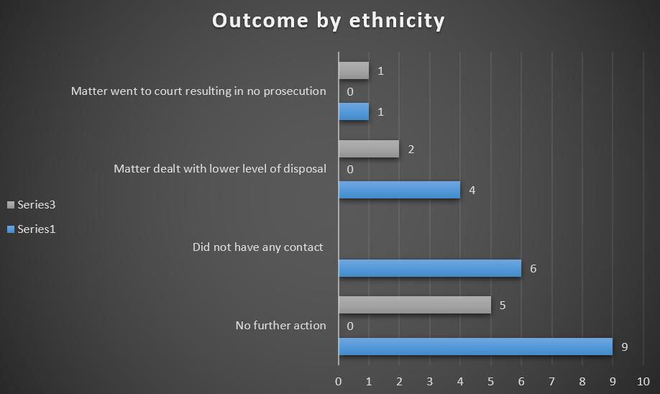
White
Black and mixed race
As seen above in figure 4.5.1, out of the 31 white participants of which 20 had ever made a report to the police, the majority of the reports resulted in no further action (9). Of these participants, 6 did not have any contact from the police and 4 were dealt with a lower level of disposal and 1 went to court resulting in no prosecution. Compared to 8 participants of black or mixed-race origin, all of which had made reports to police, 5 of them resulted in no further action where 2 of their reports resulted in a lower level of disposal. These findings support research conducted by Ariel and Tankebe (2016) who explored the differences in stop and search outcomes by ethnicity, concluding that utilising these powers is the most contentious problem to date. The key findings of the study found that white British people are more likely to receive formal warnings instead of arrest opposed to black people which creates an argument against Donald blacks’ stratification model (Greenberg 1983) which predicted that BAME groups are arrested more during stop and searches than whites. This in turn, negatively impacts BAME communities’ perception of institutional racism within policing and their likelihood of reporting crime. Furthermore, another contributing factor to the differences in crime reporting, supported by Rollock’s (2009) findings that under reporting of ‘racial incidents’ from officers had occurred due to it being seen as minor to certain officers as they did not understand the definition as well as realising more work would be involved if the incident was categorised as ‘racial’.
Figure 4.5.2 Reports made by police by ethnicity - white

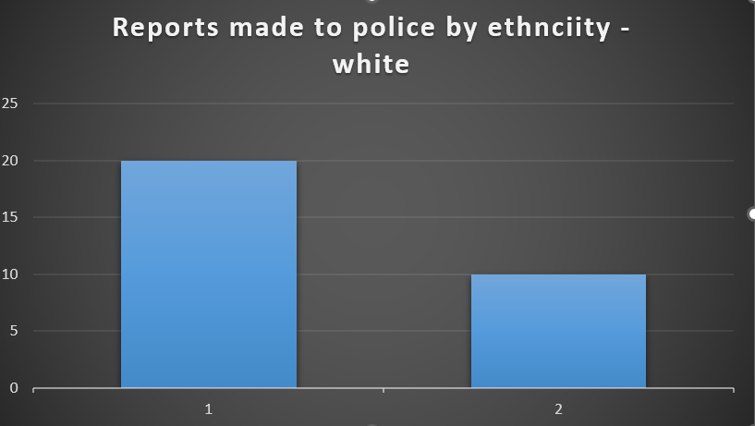

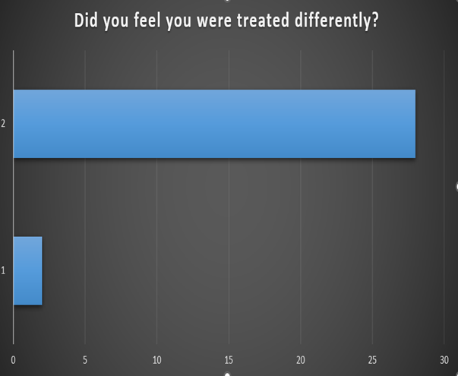

No
Yes
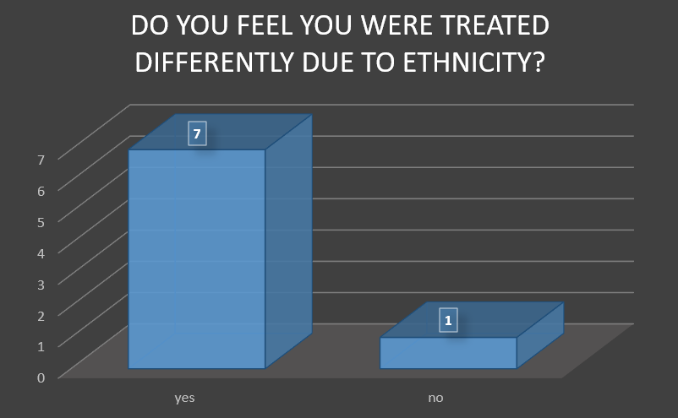
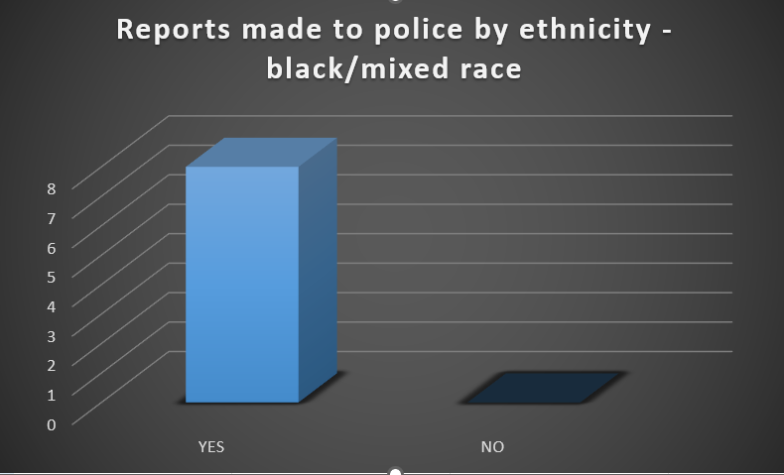
As shown in figure 4.5.2, out of 30 participants of white ethnic origin, 20 had made a report to police whereas 10 had never reported or had any police interaction. Of these 30 participants, 28 did not feel as if they were treated differently due to their ethnicity whereas 2 did. As shown in figure 4.5.3, out of 8 participants of black/ mixed race ethnicity, 8 of them had previously made reports to police where 7 of them felt as if they were treated differently due to their ethnicity. This supports Bezemer et al (2023) study, finding that suspects scoring high social desirability also shows a low likelihood to self-report crime when they are part of an ethnic minority community. Furthermore, Tarling and Morris (2010) compared findings of the 2007/2008 British Crime Survey (BCS) with the 1999 survey and found that during 1999, there is no consistent evidence of reported crimes broken down into ethnic minority groups where ethnicity of the perpetrator was not captured within any data. Also, in incidents where the victim and perpetrator come into contact, protected characteristics including ethnicity, have minimal impact on the decision to report. Overall, this supports the argument of the police being institutionally racist which negatively impacts crime reporting.
Figure 4.5.3 Reports made by police by ethnicity – black/mixed race

4.6 Theme two: Crime reports by ethnic group and willingness to report again based on treatment
Figure 4.6.1 Graph of how hesitant participants would be due to their ethnicity
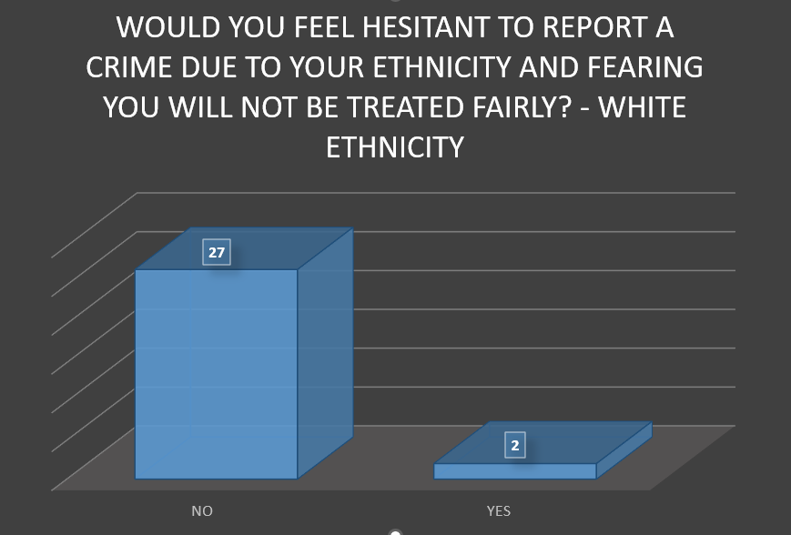
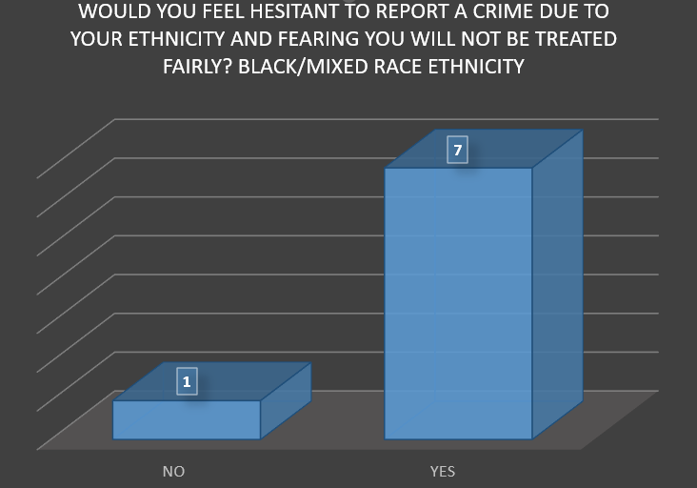

Interestingly, as shown above in figures 4.5.2 and 4.5.3, participants of white ethnicity did not feel like they were treated differently due to their ethnicity whereas participants of black/mixed race ethnicity did. However, figure 4.6.1 shows that participants of black/ mixed race ethnicity would feel hesitant to report crime due to their ethnicity and fear they would not be treated fairly (7) whereas participants of white ethnicity would not feel hesitant. This supports existing research conducted buy Rollock (2009), who analysed the literature of the Stephen Lawrence inquiry, a decade after the inquiry took place. A key finding within this review was from one of the key recommendations which was to build trust between the police and ethnic minorities. However, the literature review concluded that there is still a continuing confidence gap amongst black communities which was underplayed in the report.
Furthermore, this also supports findings by Bowling and Phillips (2003), who found that BAME communities are more likely to be stop and searched by police compared to white people which has been the most damaging factor of the relationship with police due to the humiliation of being stopped and searched continuously which in turn, creates hostility and decreases confidence in the Police.
Bowling and Phillips (2003) concluded that black people are considerably less satisfied with the service they have received and felt to be treated less fairly compared to other groups, resulting in them being less willing to contact the Police.

4.6 Theme three: Perception of institutional racism and ethnicity
4.6.1 Graph of participants perception of whether the police is institutionally racist and the biggest influence
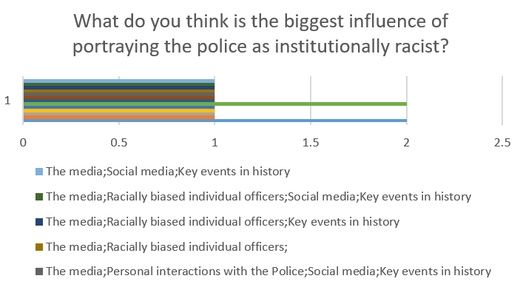
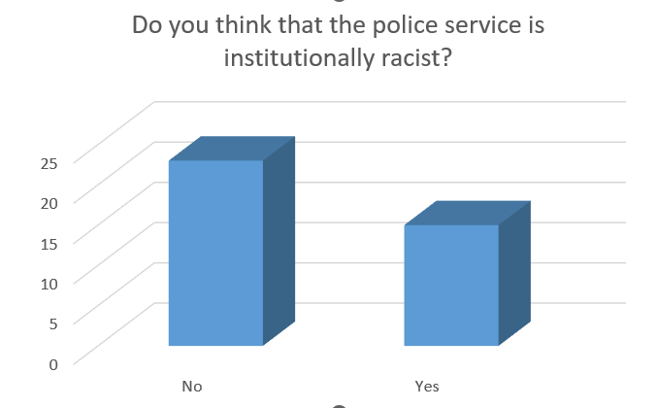

As shown in figure 4.6.1, out of the 38 participants, 15 answered ‘yes’ to the police being institutionally racist whereas 23 answered ‘no’. This argues against research conducted by Innes (1999) who criticized the Machperson report, concluding that the consequences of missed opportunities of improving the quality of service provided whilst investigating murder supports the hypothesis that the Macpherson report negatively affected ethnic minority communities’ perception of the police and in turn, negatively effecting crime reporting. As seen above, the most common influence of the portrayal of the police being institutionally racist is the media, racially biased individual officers and key events in history.

4.6.2 Graph of participants perception of whether the police is institutionally racist and the biggest influence
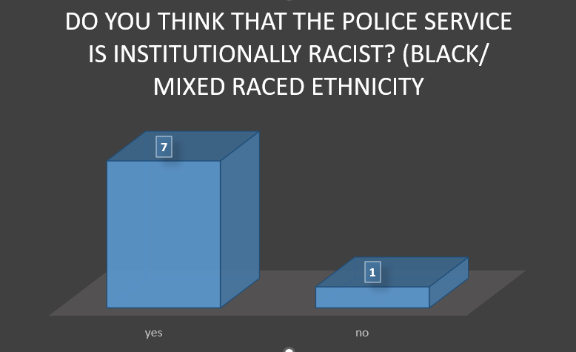
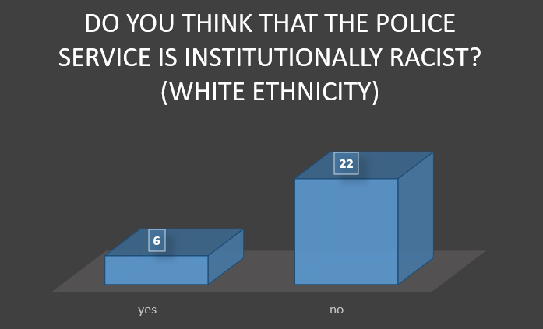

As seen in figure 4.6.2, 20% of white participants thought that the police are institutionally racist whereas 78% think they are not. In contrast to participants of black or mixed-race ethnicity, 87.5% deem the police to be institutionally racist whereas 12.5% do not. However, a clear limitation of making any comparisons between white and black ethnicities is the disproportionate number of participants for each individual ethnicity.

4.7 Results of findings
As a result of analysing the quantitative survey data, key themes have emerged supporting the argument that institutional racism within policing negatively impacts crime reporting.
4.7.1 Theme one: Crime reports by ethnic groups
Theme one, found that the research supported academics argument that people from BAME communities are less likely to report crime due to them being more likely to be arrested than dealt with a lower level of disposal. Of 31 white participants, 20 of them had made a report to police or had some sort of interaction where 9 of them resulted in no further action. Whereas participants of black or mixed-race ethnicity, 8 participants all made reports to police where 5 of them resulted in no further action. The limitation of this theme is that there is a large difference in participants between ethnicities. As highlighted in figure 4.5.2/4.5.3, there is a vast difference in ethnicities feeling they were treated differently due to their ethnicity where the majority of black/ mixed race ethnicity felt as If they were treated differently.

4.7.2 Theme two: Crime reports by ethnic group and willingness to report again based on treatment
Theme two, highlighted crime reports made by ethnic groups and their willingness to report again based on treatment. This found that there is a large difference in whether they would report again where 27 of participants of white ethnicity said they wouldn’t opposed to black/mixed race ethnicity would. This supports academics argument that BAME communities are more likely to be stopped and searched which damages the relationship with the police and creates a confidence gap, thus effecting willingness to report crime.

4.7.3 Theme three: Perception of institutional racism and ethnicity
Theme three, highlighted the participants perception of institutional racism within policing and the biggest influences. Overall, participants did not perceive the police to be institutionally racist which opposes the research question where they perceive the media and racially biased individual officers to be the biggest influence. As shown in figure 4.6.2, the majority of white participants do not believe the police to be institutionally racist whereas the majority of black/mixed race ethnicities do believe the police to be institutionally racist. This support the research question of the public’s perception of institutional racism and its effect on crime reporting.

4.8 Conclusion
This chapter has presented the findings of the research question obtained by collecting primary quantitative data via an online survey. This chapter has also achieved objective three of the dissertation which is to analyse the data to highlight key themes and whether they support or oppose the research question.
The next chapter of the dissertation will conclude the research project, discussing the implications and to provide recommendations around institutional racism as well as answering the research question: Public’s perception of institutional racism in policing: does crime reporting differ based on ethnicity?

Bibliography
What is Data Analysis? An Expert Guide With Examples | DataCamp

