Data Handling & Business Intelligence

University name
University of Wales Trinity Saint David

Lecturer's name
Amitave Banik

Student name
Stanislav Momchev Danailov

Student ID
2112418

Assessment 2- LCBB5000

The goal of this report is to use Excel and SPSS to analyse a dataset and find the required information from the dataset. The Excel file is provided where PivotTable and Lookup function. Once done, the SPSS is used for the student data file provided where analysis will take place on the SPSS to find required results.
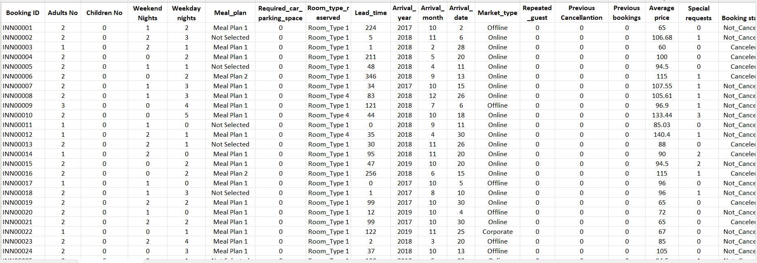
This is the excel file that is provided which consists of different data regarding the bookings that were made. The data consists of several significant values regarding the people that have booked a room in the hotel, such as the number of adults and children, whether weekday or weekend, pricing, year of booking, etc. All these data can be useful for different analysis, but the goal of this report is to find out the changes that have happened regarding the average price of booking, and identify the increase or decline trend of it over the years.
To analyse the data and find specific results that is required, pivot table feature of Microsoft Excel can be used which will help to obtain the result easily. The pivot table is one of the major features of Microsoft Excel where the data can be easily analysed regardless the size of the dataset and there are different fields available where the necessary columns required for the analysis can be included (Rumsey, 2016). It makes the analysis and data filter process efficient for the analysis, and the first part of the report will consist of the Pivot table analysis.
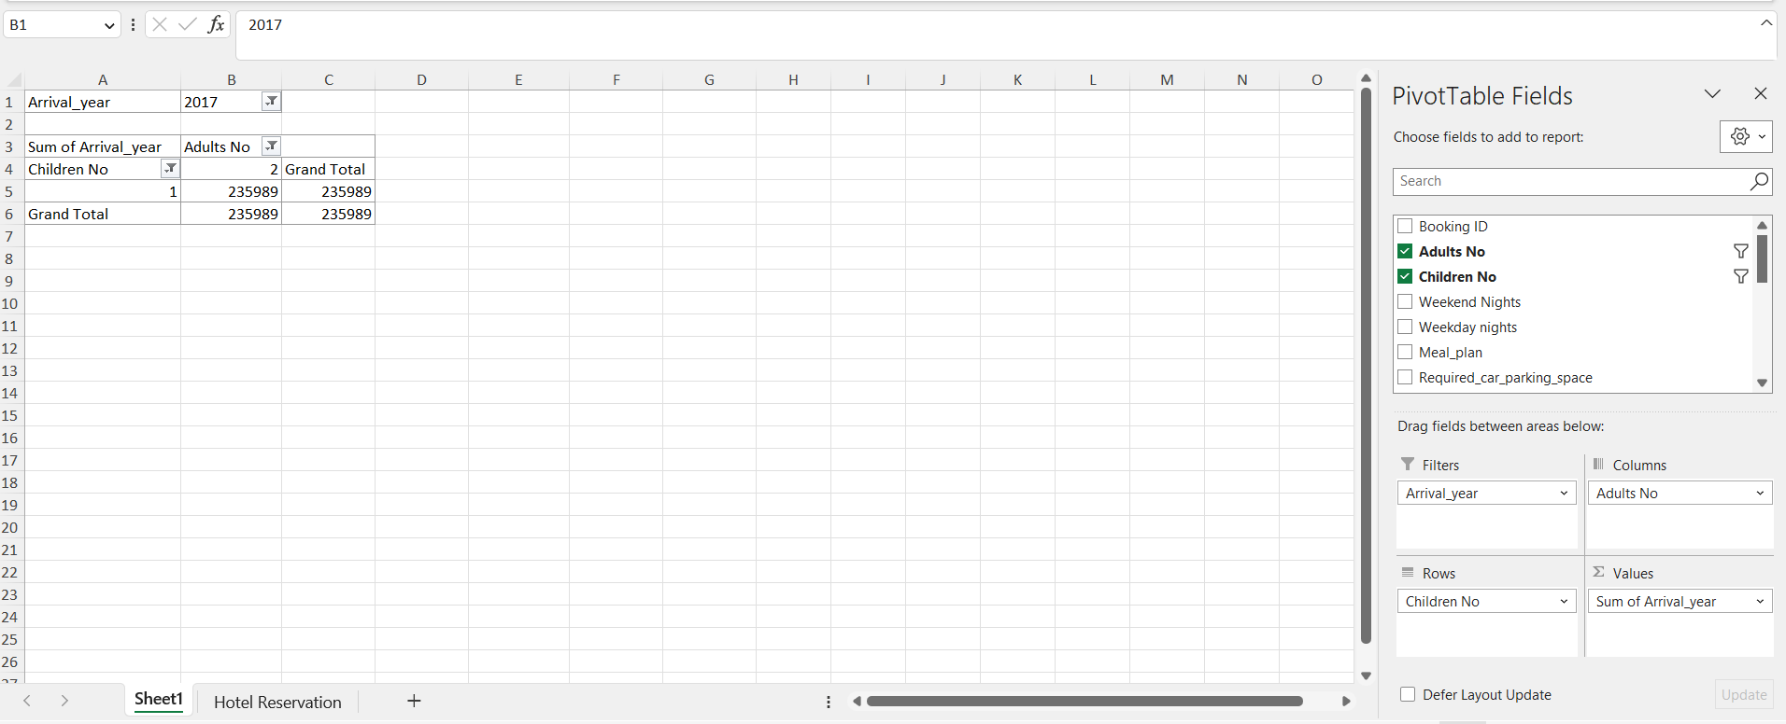
The above picture shows the pivot table that is already made in the file which will be used to get the required result for this analysis. The fields that are selected here will not be useful for this analysis, so these fields will be changed as required. Additionally, the name of the sheet needs to be changed so that the report can easily understood and the file can be easily managed.
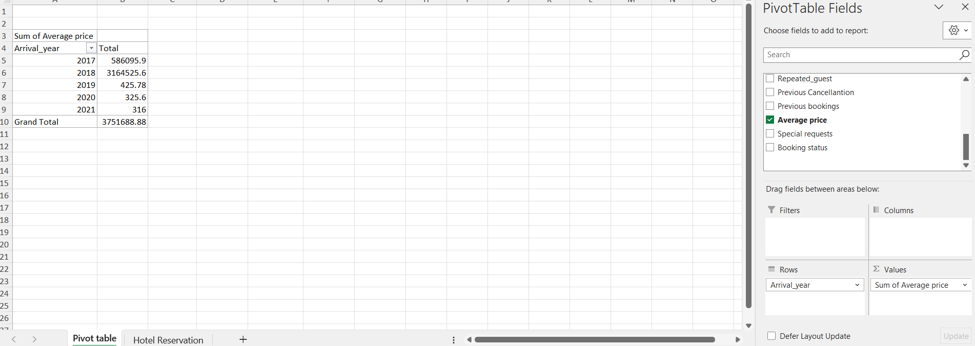
In the above picture, required changes have been made in the fields as well as the name of the sheet has been updated as required. In the fields box, Arrival_Year has been added as Rows to be used in the pivot table, and the average price is another column that needs to be added to the pivot table (Rumsey, 2016). However, the sum of average price is added to the pivot table by default which will not be useful for this analysis, so it needs to be changed.
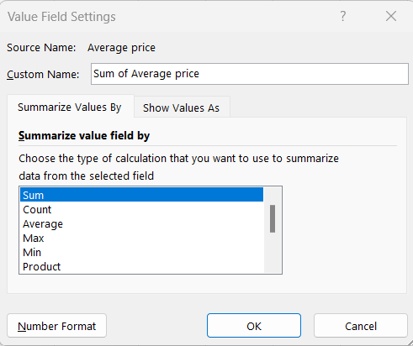
By clicking on the “Sum of Average Price”, an option is available called “Value Field Settings” which is being utilized to set the required options. The value field settings is shown in the above picture where the Average option is available. This is the option that needs to be utilized for this analysis, so the Average option is chosen and the pivot table field has been updated accordingly (Dalgleish, 2006).
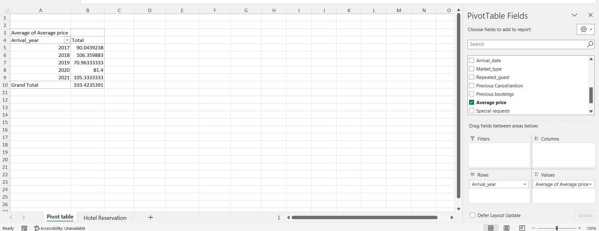
These are the fields that will be useful for this field and the required analysis has already been done by Microsoft Excel to provide the required results as shown in the above picture. However, the data of 2022 arrival year is provided in the dataset which is not included in the pivot table, so it can be assumed that the data shown in the pivot table is incorrect.
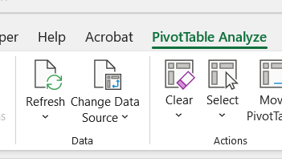
On top, PivotTable Analyze is available, and by clicking that, a new set of options have come up. Among them, Refresh is an option that can be utilized to refresh the data that is being considered by the pivot table, and the results will also be rechecked by Microsoft Excel (Dalgleish, 2006).
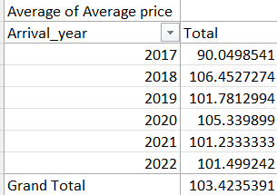
After refreshing, the data has been updated and as shown in the above picture, the required results has been achieved.

By utilizing the pivot chart, the above chart has been created where the increase of decrease of the average price from year to year is shown. During 2017, the average price was comparatively very low which is only 90.04, but the price went up on the very next year and has not went down as much as 2017 in any other years (Guerrero et al., 2019). Even the jump was so big that the highest price among these six years happened on the very next day on 2018, so the jump was from 90.04 to 106.45 (Guerrero et al., 2019). The price of the other years did not exceed the lowest or the highest price, instead the price remained in between these two price limits throughout the years. Another important fact that is found through the analysis is that, if the price increases on a specific year, the price drops on the very next year, and this has been the case throughout the study period. During 2021, the average price was 101.23, and on the year 2022, the price was very close to that which was 101.499, yet the trend of rising and dropping still exists in these years (Guerrero et al., 2019). Based on these findings, forecasting can be made of the upcoming years, and it can be expected that the price will drop during 2023.
Another method is the Lookup Function that is available in the Excel and can help to analyze a large set of data with relative ease. The Lookup function basically looks based on a specific data in a column of the dataset, and provides a related data from a different column. The Lookup function provides a benefit as it can look on both sides from the column that it is using to look for the value, due to it, the function is being used in this task (Bluttman, 2013).
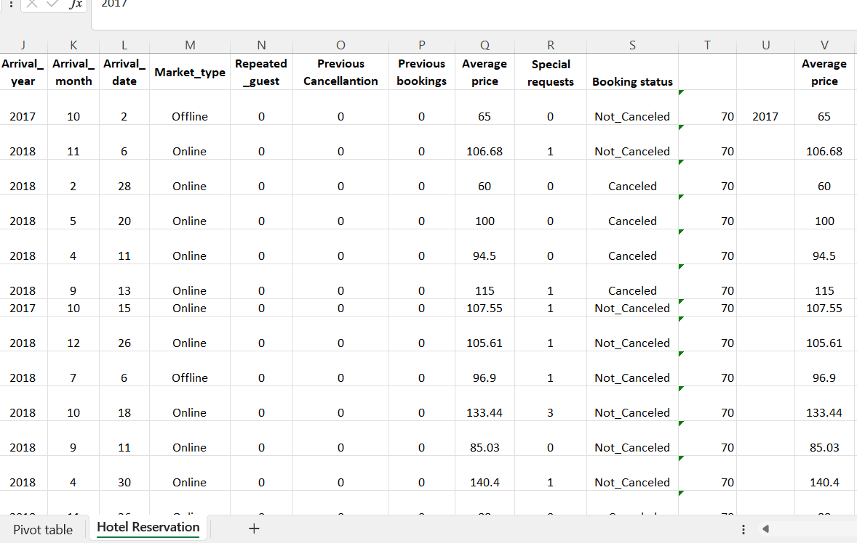
The Arrival Year is the J column in this spreadsheet, and the Average Price column has been copied on the V column which is being used for this report. Using these two columns, the goal is to apply the Lookup function so that the average price value can be separated based on the arrival year.
=IFERROR(LOOKUP(2017,J2:J2,V2:V2), "No Match")
This is the formula that has been used to separate the average price data based on the year 2017. The Lookup function requires three different input, the first one is the data, the second one is the cell where the data will be searched, and the third value is the one which will be provided as output (Bluttman, 2013). The benefit of using this formula is if the J column or relevant cell does not consist of 2017, then an issue will arise as there are no value less than 2017. To avoid this error, IFERROR function is added, and due to it, if the cell output is not error then the output will be provided, but if the output is error, then No Match will be provided as output (Goldmeier, 2014).
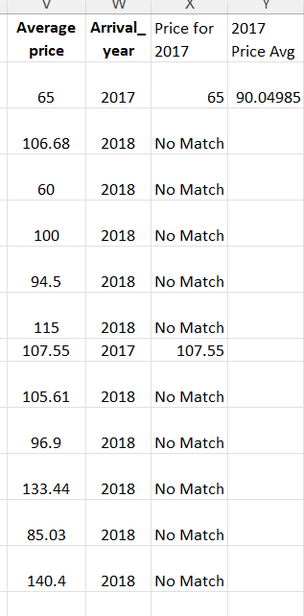
As shown here, the data which are relevant to 2017 have provided output of average price on the X column, the rest of the cells are written as No Match. Now, the task is to find the average value, and to get that,
=AVERAGE(X2:X36276)
This is the formula has been used, which basically finds the average of the cells in X column which have numeric inputs, thus the average was found (Bluttman, 2013).
In 2018 data, the same formula could not have been used, as the Lookup function has a characteristic of providing the close shorter data if the exact data is not found. For example, if the same formula was used, then the 2018 and 2017 data, both will be shown as output which will produce error in the analysis.
=IF(J2=2018, LOOKUP(2018,J2:J2,V2:V2),"No Match")
So, this is the formula that were used where IF function is added to provide the accurate result. Here, the IF function ensures that if the cell of J column consists of 2018, then it will get into the Lookup function, otherwise, No Match will be printed as output (Goldmeier, 2014). By doing so, the data output was achieved which is similar to the data found in the previous method.
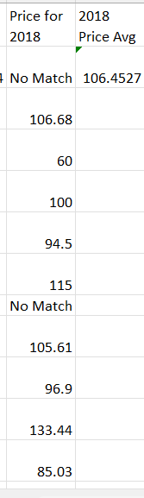
As the data was found as shown in the column, the average formula has also been used to find the average of average price related to 2018.
Arrival Year | Average Price
2017 | 90.0498541
2018 | 106.4527274
2019 | 101.7812994
2020 | 105.339899
2021 | 101.2333333
2022 | 101.499242

This is the trend that is found within this dataset, and using it, the chart has been produced. This is the same chart which was produced using the PivotTable method, so relevant explanation is provided before as well.
The SPSS is a great tool which makes analysis easier and time efficient, so the popularity of SPSS is increasing in the current days. The way tasks need to be done using SPSS is different from that of Microsoft Excel, though same results can be achieved using both the software. The advantage of using SPSS is that each tasks does not need to be performed through extensive steps manually, instead the software does all the calculation automatically with only a couple of clicks (Hinton et al., 2014). However, the data needs to be set correctly for the analysis to take place, and for that the Variable View sheet is provided in the SPSS where assigning the variable types will take place.
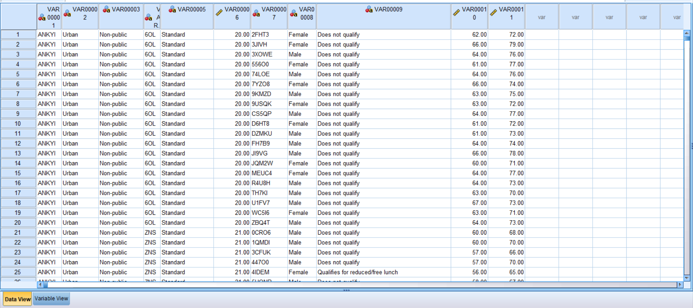
First of all, the Microsoft Excel file consisting of all the required data were copied and pasted in the SPSS file so that the required analysis can take place in Microsoft Excel. On the bottom of the screen, two sheets can be observed and among them the Data View sheet is currently on where all the data is recorded (Hinton et al., 2014). The second tab called Variable View is the one where the type of variable will be assigned, and based on the changes made on that sheet will influence the variables in the Data View Sheet (Hinton et al., 2014).
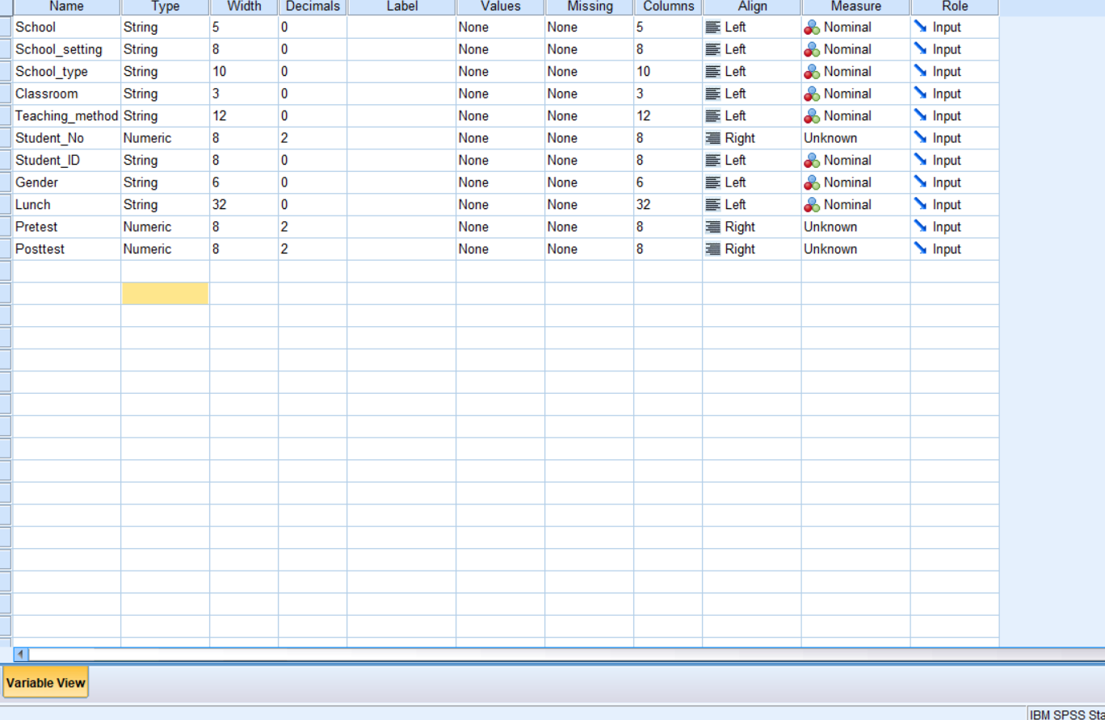
In the above picture, the Variable tab is shown where the name of the variables has been set so that the tab can be easily understood.
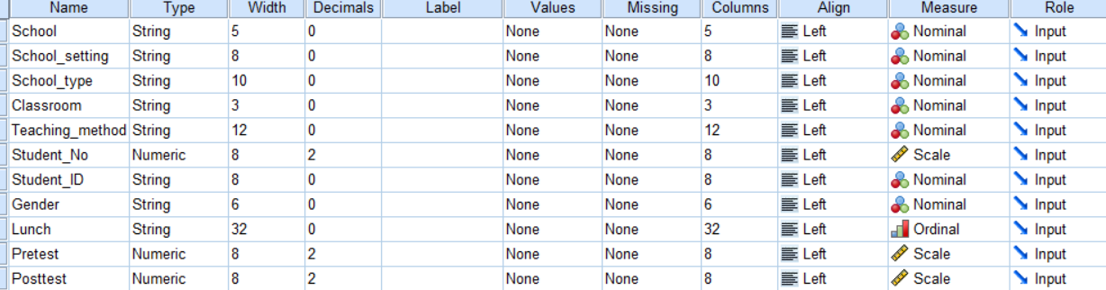
As shown above, the variable view sheet has been updated with the required changes, so that the analysis can be run on the sheet. The measure column needed some changed where the numeric values were set as Scale, and another major change was the Lunch variable which has been set as Ordinal in the variable view sheet (Cronk, 2017).
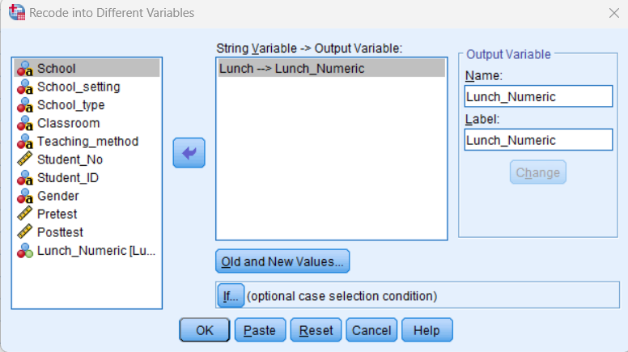
The Lunch is still set as String which will create complexity as string data cannot be analysed by SPSS properly, so the lunch variable need some changes. In the SPSS, under Transform, Recode into Different variables option is available which can be useful to transform the string into numeric entry (Cronk, 2017). Over there, the Lunch has been selected to be set as an output variable and the name of new output variable has been set as Lunch_Numeric to indicate that the values under this variable will represent the lunch variable but in a numeric form (Cronk, 2017).
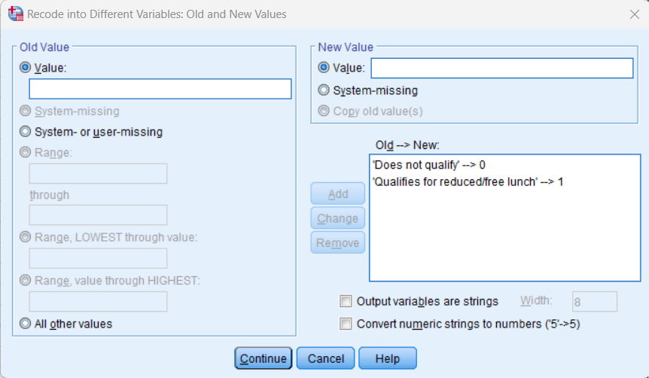
By clicking Old and New values, on the previous tab, this new tab was found where the values can be assigned as needed to transform the qualitative values into quantitative values. The first option that is “Does not qualify” was assigned to 0, so that the values on the Data view shit gets updated. The later one was assigned with a numeric value 1, and with these numeric values a new column will be created on the Data View sheet (Cronk, 2017).
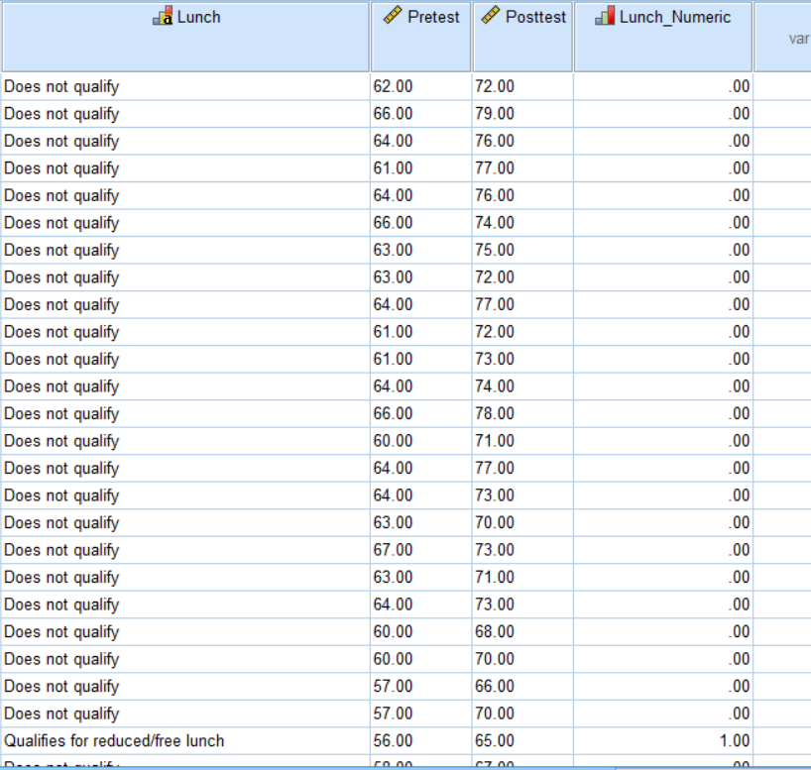
As shown in the above picture, a new column was created which represents the lunch variable in a numeric form, and to provide evidence, it is shown in the picture all the rows of the Lunch_Numeric column contains 0 because their respective entry in the Lunch column says “Does not qualify”. On the last row shown in the above picture, the Lunch_Numeric column shows 1 and the respective entry on the Lunch column is shown as “Qualifies for reduced/free lunch” (Cronk, 2017). So, it can be stated that the conversion was correct, and the dataset is now ready for the required analysis, and the final step is to set Lunch_Numeric variable as an Ordinal.
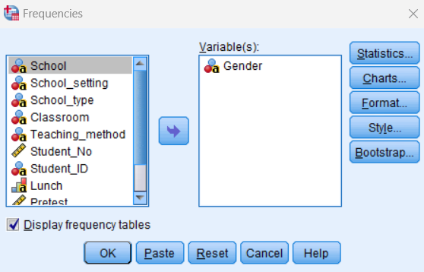
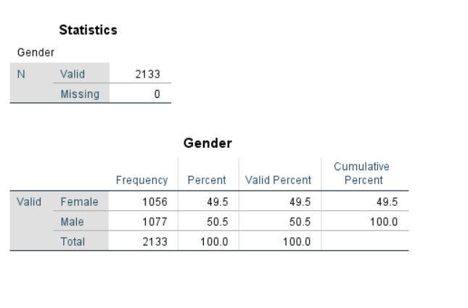
As the first task is to find the number of male and female students, so the analysis was done through the Analysis tab on SPSS where Descriptive Statistics tab was used to find the number of Male and Female (Morgan et al., 2004). The numbers are 1056 and 1077 for female and male respectively which in total shows the number of students in the class which is equal to 2133.
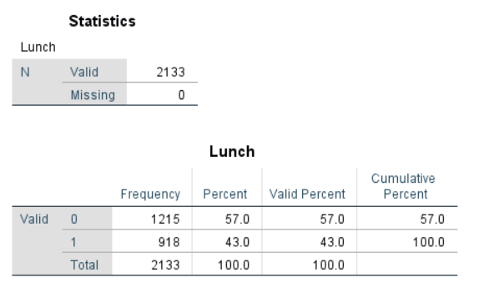
The frequencies regarding lunch was found using the same steps, and the total number of students regarding lunch also shows 2133 students. However, the values are shown as 0 and 1 due to the values set for the qualitative values to turn them into numeric values (Morgan et al., 2004). The frequency for people who does not qualify are greater than the other, and the value is 1215 students. The others who enjoy the reduced lunch are 918, and it total they form the total students in the class.
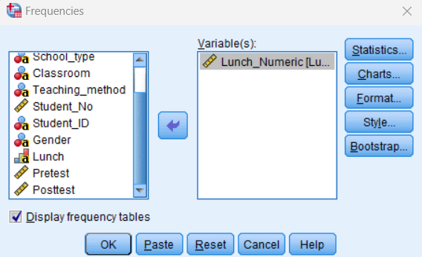
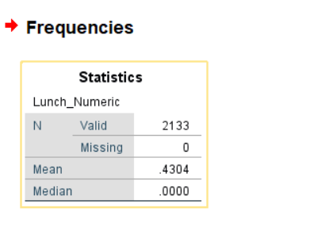
At this stage, the mean and median values need to be found, so the additional column that was created called Lunch_Numeric will come into play (Allen et al., 2014). Using that column, the mean value was calculated and found to be .4304, and the median was shown on the same tab where the value is .0000 (Allen et al., 2014).
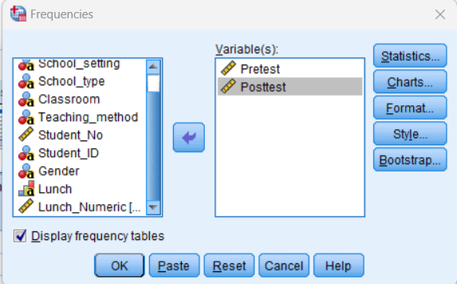
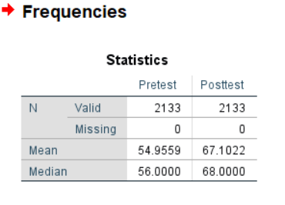
To find the mean and median using the scores, both the score variables were selected for analysis on the right side of the tab. As the mean and median values are available, so the difference can easily be found through simple subtraction.
Mean difference = 67.1022-54.9559 = 12.1463
Median difference = 68.0000-56.0000 = 12.0000
For K means cluster, the option is available in SPSS so that the analysis parts can be done automatically. For that, the analyze tab provides an option called K means cluster which provides the tab shown (Ibm.com, 2021).
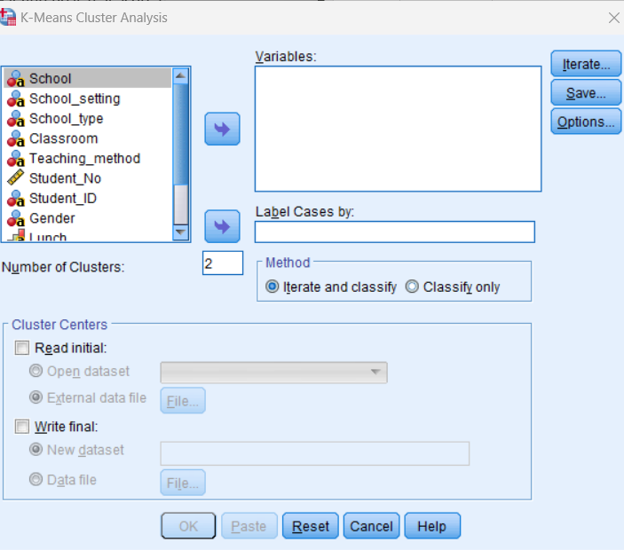
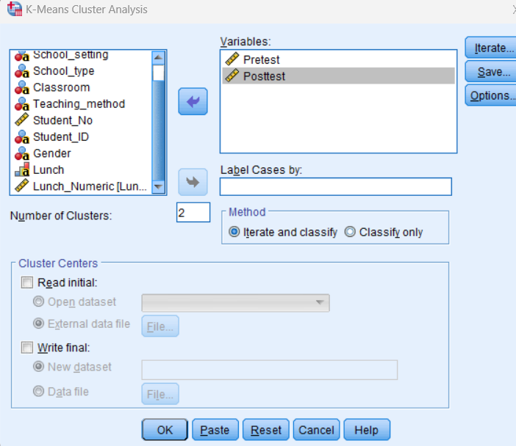

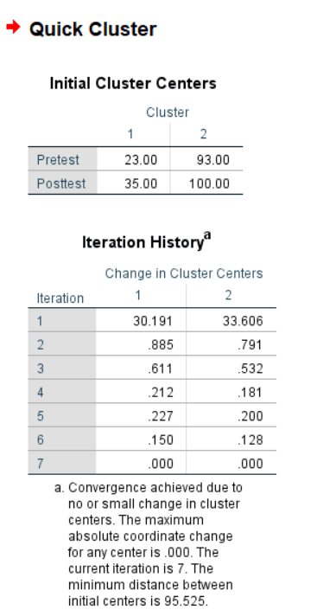
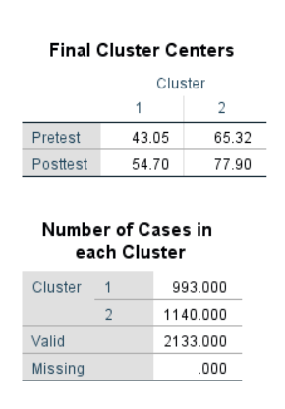
By utilizing the options available in the SPSS, the K cluster was performed which provided with the results. Based on the inputs provided in the SPSS, the software was able to run the required analysis, and provided the required results.
Data mining is a technique that is used in the field to provide important information regarding data collected by companies. The clustering is a data mining method which basically creates group among the data so that the data can be used for various purposes (‌Aggarwal, 2015). For example, the retail stores avoid sending bulk of ads to their customers as it will be fruitless. Instead of that, retail stores uses cluster data mining to create groups among the customers based on their product purchase or similar data, and tailored ads are created and distributed based on these groups. Classification is a method where features of a specific set of data are identified and labelled based on the features (‌Aggarwal, 2015). Email of a person or company is shared publicly which can be taken advantage of to spam their inbox. Classification helps to identify spamming these emails, so that the inboxes can remain clean. Regression analysis is a method where a relationship between a independent variable and a dependent variable which provides several benefits to the people. The sales includes several types of data, and to identify important relationship with the data regression is a useful method (‌Aggarwal, 2015). With regression, the planned advertising spend for upcoming days and the profit that can be achieved with these spending can be forecasted. The association rule mining is a method that helps to identify patterns that shows co occurrence in the data, and the market basket analysis can take advantage of it. In grocery stores, when a customer buys bread, he may prefer to buy butter and milk, because these are related food that is often consumed with bread. As a result, this method suggests these products when a customer buys a bread. The anomaly detection helps to identify data points that are significantly different from the norm which has significant implication in the job field. The anomaly detection is used in financial institutions which helps them to identify the unusual occurences that occur in their institution.
Text mining methods are useful as it helps to detect texts which has various implecations in the job field. The text classification is a method where the text documents are classified, and these classes helps to separate different classifications (Jo, 2019). Business uses this method to determine what people are saying through their comments regarding their products which reflects customer opinion to help them improve their profitability. Named Entity Recognition (NER) is a method where different important information are identified so that information can be used for other tasks (Jo, 2019). For example, the name of politicians, location of an incident, etc. can easily be identified through this method. Text clustering is a method where groups are made based on the type of content, and research institutions often use this method to cluster different research papers based on their content which helps them to navigate through them easily. Topic modelling is a method which helps to identify the topics from a huge document or a collection of these types of document (Jo, 2019). Using this method, releavent articles are being suggested in the social media to retain the customers on the site. Text summarization is a method that helps to create a summary of a text document which saves time and increases the understanding of the topic. Legal firms uses text summarization to summarize the legal documents so that the layers can easily identify the relevant topics of the documents.
By running the required analysis, the results was successfully obtained, and the use of Excel and SPSS was ensured throughout this report. By using these software, further analysis is possible, and including several other factors provided in the dataset, more information can be extracted.

References
‌Aggarwal, C.C., 2015. Data mining: the textbook (Vol. 1). New York: springer.
Allen, P., Bennett, K. and Heritage, B., 2014. SPSS statistics version 22: A practical guide. Cengage Learning Australia.
Bluttman, K., 2013. Excel formulas and functions for dummies. John Wiley & Sons.
Cronk, B.C., 2017. How to use SPSS®: A step-by-step guide to analysis and interpretation. Routledge.
Dalgleish, D., 2006. Excel pivot tables recipe book: a problem-solution approach. Apress.
Goldmeier, J., 2014. Advanced Excel Essentials. Apress.
Guerrero, H., Guerrero, R. and Rauscher, 2019. Excel data analysis. Springer International Publishing.
Hinton, P.R., McMurray, I. and Brownlow, C., 2014. SPSS explained. Routledge.
Ibm.com. (2021). IBM Documentation. [online] Available at: https://www.ibm.com/docs/en/spss-statistics/beta?topic=features-k-means-cluster-analysis [Accessed 20 Aug. 2023].
Jo, T., 2019. Text mining (Vol. 45). Cham, Switzerland: Springer International Publishing.
Morgan, G.A., Leech, N.L., Gloeckner, G.W. and Barrett, K.C., 2004. SPSS for introductory statistics: Use and interpretation. Psychology Press.
Rumsey, D.J., 2016. Statistics for dummies. John Wiley & Sons.

