Faculty of Humanities and Performing Arts
University of Wales Trinity Saint David

Chinese and Philosophy Studies
Single and Joint Honours

Yangsheng and Daoist Body Philosophy

Module Outline
Module Code: HPPH 5015

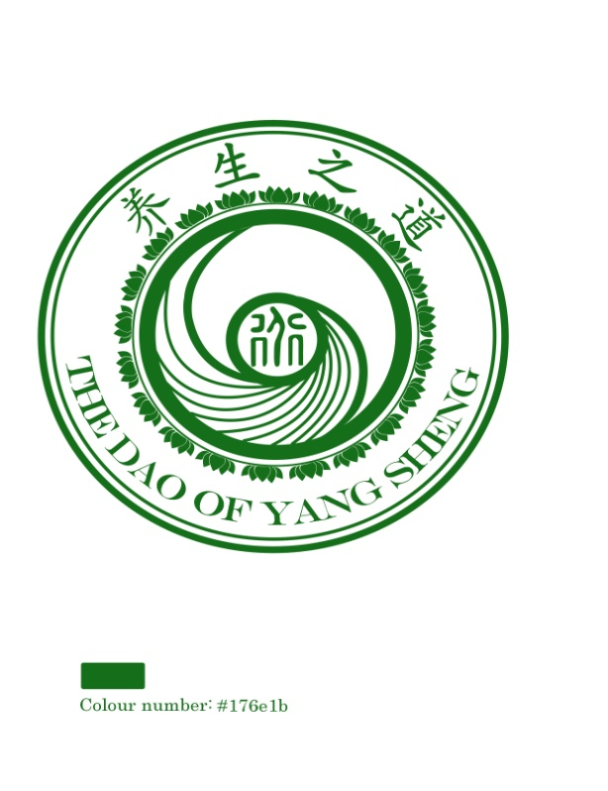
Number of Credits: 20
Module Tutor: Prof Yanxia Zhao
Email: y.zhao@uwtsd.ac.uk
Tel.: (01570) 424 860

AIM(S)

- To engage the central concepts and themes of Daoist Body Philosophy and Daoist way of thinking on life and how to nourish life; understand the main characteristics of Daoism as a philosophical and religious tradition;

- To examine critically the Daoist theories and exercises on self-health care and nourishing life.

LEARNING OUTCOMES

Upon the successful completion of this module, the student should be able to:

- Obtained a skill of critical examining the primary and secondary resources relating to Daoist Body Philosophy:

- Gained a coherent and detailed knowledge of Daoist Tradition of Nourishing Life from ancient to contemporary China;
- Demonstrate an understanding of the similarities and differences between Daoist philosophical ideas of nourishing life and Daoist religious and cultural practice of Self- health-care exercises.

Module will be taught in Block 6 (8th March– 30th April) 2021 though online teaching (every Monday and Thursday from 11am to 2pm)and in class teaching at arts 5 from 10am to 13pm every Tuesday and Friday:

Course Outline

Week 1 (8th -9th April)

Session 1 (8th April 2021 online through teams conference from 11am to 2pm): Daoism, Yangsheng, and Daoist Body Philosophy
- Daoism as Tradition of Philosophy as well as a tradition of Religion
- Life and Nourishing Life in Chinese tradition
- Daoist understanding of life and nourishing life

Session 2 (9th April 2021 online through teams conference from 10am to 1pm): The Origin of Yangsheng
- Definition of Yangsheng
- The meaning of Yangsheng in Ancient Chinese Classics
- The Origin of Chinese Yangsheng, from Historical Perspective

Week 2 (12th -16th^{th} April 2021):

Session 3 (Monday 12th April 2021 online from 11am to 2pm): Structure of Daoist Body philosophy
- Brief introduction to Daoist Body Philosophy: Terminologies, principles and exercises
- Internal logic of Daoist Yangsheng Terminology system: Natural centred philosophy
- Cosmic energy and human life energy
- Same nature of Human body with the state and natural environment

Session 4: (Tuesday 13th April 2021 at classroom Arts 5 from 10am to 1pm): Special terminology of Daoist Body Philosophy (1)
- Dao and De
- Wu and You
- Wuji and Taiji

Session 5 (Thursday 15th April 2021 Online from 11am to 2pm): Special terminology of Daoist Body philosophy (2)
- Qi, breath and life force energy
- Yin-Yang and harmony
- Wuxing (Five Phases)

Session 6 (Friday 16th April 2021 at Arts 5 from 10am to 1pm): Special terminologies of Daoist Body Philosophy (3)
- Jing, Qi, and Shen
- Xing and Ming
Eight Trigrams
Week 3 (19th -23rd April):

Session 7 (19th April 2021 Online from 11am to 2pm): Presentation of Assignment 2

Assessment Component 2
(Tick one
☐ | Written exam | ☐ | Coursework | ☒ | Practical

Mode of assessment | Volume | Weighting
presentation | 15 minutes + writing material | e.g. 50%

Topics for Assignment 2 can be designed by individual according their own interested, but should be agreed by the module tutor
Topics for Assignment 2 can be designed by individual according their own interested, but should be agreed by the module tutor

19th April 2021: Submission of the writings and PPT of assignment 2, and the material of oral presentation

Session 8 (20th April 2021 at Arts 5 from 10am to 1pm) Principles of Nourishing of Life
- Daoist principle of following the nature
- Yangsheng principle of returning to the Embryo
- Yangsheng principle of dual cultivation of Xing and Ming
- Principe of water
- Principe of none action as an action

Session 9 (22ndApril 2021 Online from 11am to 2pm)
: Daoist Energetic Body
- Meridians
- Eight extra meridians
- Acupoints
- Solid Organ system
- Hollow Organ system

Session 10 (23rd April at Arts 5 from 10am to 1pm): Daoist understanding of health
- Dao and human life, longevity and immortality
- Yin-Yang balance and health
- Morality and health

Week 4 (26th -30th April 2021):

Session 11 (26th April 2021 online from 11am to 2pm): Daoist yangsheng exercises
- Food Medicine, Daoist Dietary (Bigu (avoiding grains)
- Happy longevity exercises (Taiji, Daoyin, Qigong, Massage)

Session 12 (27th April 2021 at Arts 5 from 10am to 1pm): Daoist Internal alchemy cultivation

Session 13-14 (29-30thApril): Writing up assignment 1

30th April 2021:
Submission of Assignment 1, the 2500 words Essay

ASSESSMENTS

Assessment Component 1
(Tick one)
☐ | Written exam | ☒ | Coursework | ☐ | Practical

Mode of assessment | Volume | Weighting
essay | 2500 words | e.g. 50%

Assessment Component 2
(Tick one
☐ | Written exam | ☐ | Coursework | ☒ | Practical

Mode of assessment | Volume | Weighting
presentation | 15 minutes + writing material | e.g. 50%

Submission Deadlines:

19th April 2021: Oral presentation (15 minutes) and writing material of presentation
30th^{th} April 2021: 2500 words Essay submission

READING LIST

Module Code | HPPH5015
Module Title | Yangsheng and Daoist Body Philosophy
Classification | Reading List entry | Electronic*
 | Coutinho, Steve (2013): An Introduction to Daoist Philosophies, Columbia University Press | ☒
Essential | Liu Xiaogan (2015): Dao Companion to Daoist Philosophy, Springer | ☒
Essential | Kohn, Livia (2008): Introducing Daoism, Routledge | ☐
 | Acton, Michael (2009): Eternal Spring: Taijiquan, Qi Gong, and the Cultivation of Health, Happiness and Longevity, Singing Dragon | ☒
Further | Kohn, Livia (1990): Daoist Mystical Philosophy: The Scripture of Western Ascension, Lulu Press | ☒
 |  | ☒
  Kohn，Livia , Harold David Roth (eds. 2002): Daoist Identity: Cosmology, Lineage, and Ritual, University of Hawaii Press
 | Kohn, Livia (ed. 2011): Living Authentically: Daoist Contributions to Modern Psychology, Lulu Press | ☒
 | Cao Feng (2017): Daoism in Early China: Huang-Lao Thought in Light of Excavated Texts, Palgrave Macmillan US
 | Chen, Ellen M. (2011): In Praise of Nothing: An Exploration of Daoist Fundamental Ontology, Xlibris Corporation | ☒
 | Clarke, J. J. (2000): The Tao of the West: Western Tranformations of Taoist Thought, Routledge | ☒
 | Coutinho, Steve (2016): Zhuangzi and Early Chinese Philosophy: Vagueness, Transformation and Paradox, Routledge
 | Cooper, David Edward (2012): Convergence with Nature: A Daoist Perspective, Green
 | Cristaudo，Wayne ; Kaplan, Gregory (eds, 2012): Love in the Religions of the World, Cambridge Scholar Publishing | ☒
 | Froese, Katrin (2006): Nietzsche, Heidegger, and Daoist Thought: Crossing Paths In-Between, State University of New York Press | ☒
 | Guo Xuezhi (2002): The Ideal Chinese Political Leader: A Historical and Cultural Perspective, Greenwood Publishing Group | ☒
 | Hansen, Chad (1992): A Daoist Theory of Chinese Thought: A Philosophical Interpretation, Oxford University Press | ☒
 | Hartz, Paula (2009, Third Edition): Daoism, Infobase Publication
 | Shan, Chun (2012): Major Aspects of Chinese Religion and Philosophy: Dao of Inner Saint and outer King, Springer | ☒
 | Lay, Karyn (2016): Learning from Chinese Philosophies: Ethics of Interdependent and Contextualized Self, Routledge | ☒
Further | Liu Zheng-cai，Ka Hua (1999), A Study of Daoist Acupuncture & Moxibustion, Blue Poppy Press | ☐
 | Littlejohn，Ronnie ; Dippmann, Jeffrey (eds. 2011), Riding the Wind with Liezi: New Perspectives on the Daoist Classic, Suny Press | ☒
 | Long, Rob (2016): Feeling the Way: Touch, Qi Gong healing, and the Daoist tradition, Singing Dragon | ☒
 | Michael, Thomas (2005): Pristine Dao, The: Metaphysics in Early Daoist Discourse, State University of New York Press | ☒
Further | Moeller, Hans-Georg (2006): Daoism Explained: From the Dream of the Butterfly to the Fishnet Allegory, Open Court | ☐
Further | Moeller, Hans-Georg (2012): The Philosophy of the Daodejing, Columbia University Press | ☒
Further | Mitchell, Damo (2011): Daoist Nei Gong: The Philosophical Art of Change, Singing Dragon | ☒
 | Miller, James (2017): China's Green Religion: Daoism and the Quest for a Sustainable Future, Columbia University Press | ☒
 | Møllgaard, Eske (2007): An Introduction to Daoist Thought: Action, Language, and Ethics in Zhuangzi, Routledge | ☒
Wu Jyh Cherng | Wu Jyh Cherng (trans. 2015), Daoist Meditation: The Purification of the heart method of meditation and discourse on sitting and forgetting (zuo wang lun) by si ma cheng zhen, Singing Dragon | ☒
 | Wu, Zhongxian (2014): XinYi WuDao: Heart-Mind - The Dao of Martial Arts, Singing Dragon | ☒
Further | Reiter, Florian C. (ed. 2007): Purposes, Means and Convictions in Daoism: A Berlin Symposium, Harrassowitz Verlag publishing house | ☐
Further | Towler , Solala (2010): Cha Dao: The Way of Tea, Tea as a Way of Life, Singing Dragon | ☒
Further | Zhou Zuyan (2013): Daoist Philosophy and Literati Writings in Late Imperial China: A Case Study of 'The Story of the Stone', Chinese University Press | ☐

