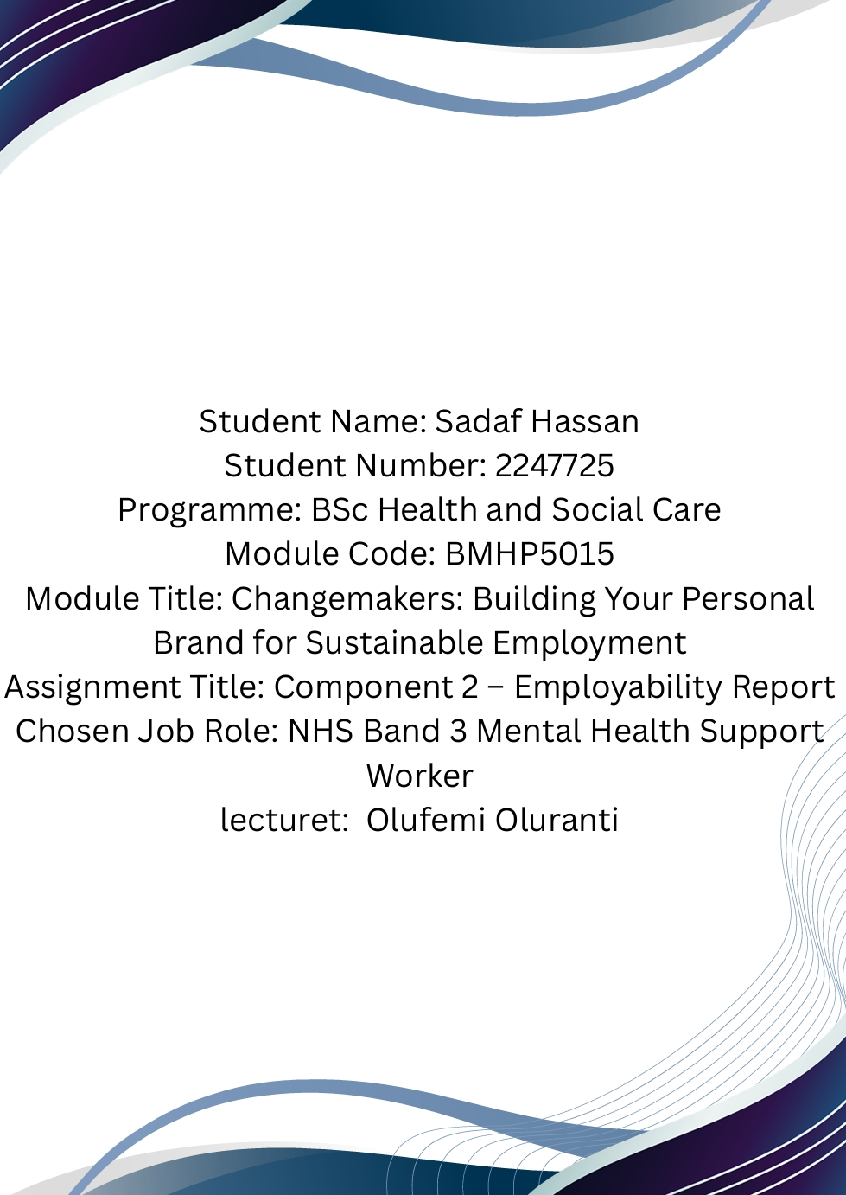
1. Introduction 2
2. Analysis of the NHS Band 3 Mental Health Support Worker Role 3
2.1 Introduction to the Role 3
2.2 Critical Analysis of the Job Description 4
2.3 Analysis of the Person Specification 5
2.4 Employability Skills Required 6
Communication 6
Compassion 6
Teamwork 6
Resilience 6
Professionalism 6
2.5 Critical Evaluation 7
Critical Evaluation of My Employability Skills Against the NHS Person Specification 7
3.1 Introduction 8
3.2 Communication Skills 8
3.3 Teamwork and Professional Relationships 9
3.4 Person-Centred Care and Compassion 9
3.5 Professionalism and Responsibility 10
3.6 Areas for Development 10
3.7 Critical Reflection 11
Building My Personal Brand and Professional Identity 12
4.1 Introduction 12
4.2 Developing My Professional Identity 12
4.3 Personal Brand within Healthcare 13
4.4 Continuous Professional Development (CPD) 13
4.5 Professional Use of Digital Platforms 14
4.6 Critical Evaluation 15
Professional Networking 15
5.1 Introduction 16
5.2 Building My Professional Network 16
5.3 Networking Through Professional Organisations 17
5.4 Networking Through Work Experience 17
5.5 Critical Evaluation 18
6. SMART Action Plan 18
6.1 Critical Evaluation of the Action Plan 19
Conclusion 20
Appendix A – Current NHS Job Advertisement 21
Appendix B – Summary of the Person Specification 23
Essential Requirements 24
Desirable Requirements 24
Appendix C – Curriculum Vitae 24
Appendix D – Personal Development Timeline 25
References 26

1. Introduction
Employability is an essential part of professional development within health and social care because employers require individuals who possess not only appropriate qualifications but also the knowledge, skills and professional values needed to provide safe, compassionate and person-centred care. As demand for mental health services continues to increase across the United Kingdom, Mental Health Support Workers have become an important part of multidisciplinary teams by supporting service users with recovery, promoting independence and contributing to high-quality care. Current NHS recruitment continues to emphasise recovery-focused practice, teamwork, effective communication and compassionate care as key requirements for Band 3 Mental Health Support Workers.
This report is based on a current NHS Band 3 Mental Health Support Worker vacancy and critically evaluates the employability skills required for this role. The selected vacancy requires staff to assist qualified professionals, support individuals with severe and complex mental health needs, contribute to assessment and care planning, maintain accurate records and work collaboratively within multidisciplinary teams while promoting recovery and person-centred care.
The report also evaluates my own knowledge, skills and previous experience against the requirements outlined within the NHS person specification. I currently have approximately two years of experience working as a Care Worker in residential care homes in Birmingham and Wolverhampton, where I developed transferable skills including communication, teamwork, safeguarding awareness, person-centred care and professional responsibility. However, reflective practice demonstrates that although these skills provide a strong foundation, further development is required to meet the specialist knowledge and competencies expected within NHS mental health services.
Rather than simply describing the role, this report critically analyses why employability skills such as communication, resilience, professionalism, emotional intelligence and reflective practice are essential for delivering safe and effective mental health care. It also evaluates the importance of developing a professional identity, building a positive personal brand and establishing professional networks to improve future employment opportunities. Finally, the report presents a SMART action plan that identifies realistic development goals to support my progression towards becoming an NHS Band 3 Mental Health Support Worker.
Overall, this report demonstrates that employability is a continuous process of reflection, learning and professional development. Developing both practical skills and professional behaviours will improve my ability to provide evidence-based, person-centred care while supporting my long-term career within the NHS.

2. Analysis of the NHS Band 3 Mental Health Support Worker Role

2.1 Introduction to the Role
The Mental Health Support Worker is an important member of the multidisciplinary team who provides practical and emotional support to individuals experiencing severe and complex mental health conditions. The current NHS Band 3 vacancy selected for this report is a Community Mental Health Support Worker with Bradford District Care NHS Foundation Trust. The role involves assisting qualified health and social care professionals, supporting service users to achieve recovery goals, monitoring changes in mental wellbeing and contributing to assessment and care planning.
Unlike many physical healthcare roles, mental health support work depends heavily on therapeutic relationships. Service users may experience conditions such as schizophrenia, bipolar disorder, severe depression or anxiety, meaning staff must combine practical care with emotional support while respecting each person's independence and dignity. This makes interpersonal skills just as important as clinical knowledge.

2.2 Critical Analysis of the Job Description
The NHS job description demonstrates that Mental Health Support Workers have responsibilities that extend beyond providing basic care. One of the main duties is supporting qualified professionals during the assessment, delivery and evaluation of care. Although the support worker does not make independent clinical decisions, they spend significant time with service users and are often the first to notice changes in behaviour, mood or mental state. Early recognition of deterioration allows timely intervention and may reduce the risk of mental health crises.
The role also requires workers to encourage recovery rather than creating dependence. Recovery-focused practice supports individuals to develop confidence, independence and control over their lives instead of concentrating solely on reducing symptoms. This reflects modern mental health policy, which promotes partnership between professionals and service users instead of a purely medical model.
Another important responsibility involves working within a multidisciplinary team. Mental health services rely on effective collaboration between psychiatrists, mental health nurses, psychologists, occupational therapists, social workers and support workers. Poor communication between professionals can result in delays to treatment, inconsistent care and increased clinical risk. Therefore, teamwork is not simply desirable but is essential for maintaining patient safety and continuity of care.
The vacancy also highlights record keeping as a core responsibility. Accurate documentation enables healthcare professionals to monitor patient progress, evaluate treatment effectiveness and share information safely across the multidisciplinary team. Inaccurate or incomplete records could affect decision-making and compromise patient safety.

2.3 Analysis of the Person Specification
The person specification identifies communication as one of the most important employability skills. The vacancy requires excellent listening skills together with the ability to communicate effectively with people experiencing complex mental health problems.
Communication within mental health care is different from communication in many other healthcare settings. Service users may experience hallucinations, paranoia, severe anxiety or emotional distress, making conversations more challenging. Healthcare professionals must therefore use active listening, empathy, patience and appropriate non-verbal communication to build trust. Research consistently demonstrates that therapeutic communication improves patient engagement, treatment adherence and recovery outcomes.
The vacancy also requires applicants to use their own initiative when responding to unfamiliar situations. This reflects the unpredictable nature of mental health care. Service users' mental health can change rapidly, meaning support workers must recognise concerns, remain calm under pressure and report information promptly to qualified staff. Consequently, critical thinking is becoming an increasingly important employability skill alongside compassion.
Knowledge of mental illness is another desirable requirement identified within the person specification. The employer expects applicants to understand severe mental illness, prescribed medication, the Mental Health Act and wider support services available to service users. Although these areas are desirable rather than essential, possessing this knowledge would strengthen an applicant's employability because it demonstrates readiness to contribute effectively from the beginning of employment.

2.4 Employability Skills Required
Analysis of the vacancy suggests that successful Mental Health Support Workers require a combination of technical knowledge, professional values and transferable skills.

Communication
Effective communication underpins every aspect of mental health care. Workers must communicate sensitively with service users, relatives and professionals while maintaining confidentiality. Poor communication may damage therapeutic relationships, reduce patient engagement and increase clinical risk.

Compassion
Compassion enables professionals to recognise emotional distress and provide care that respects individual dignity. However, compassion alone is insufficient. Staff must combine empathy with professional judgement, evidence-based practice and appropriate boundaries to maintain safe care.

Teamwork
The vacancy clearly demonstrates that Mental Health Support Workers operate within multidisciplinary teams rather than independently. Effective teamwork improves decision-making, reduces communication errors and supports holistic care.

Resilience
Mental health services can be emotionally demanding because staff regularly encounter challenging behaviour, self-harm, relapse and crisis situations. Emotional resilience helps professionals maintain compassionate care while protecting their own wellbeing and reducing the risk of burnout.

Professionalism
Professional behaviour includes punctuality, confidentiality, accountability, respect and adherence to NHS values. Employers increasingly assess these behaviours during recruitment because they influence patient safety and organisational culture as much as technical ability.

2.5 Critical Evaluation
The selected NHS vacancy clearly shows that Mental Health Support Workers require much more than practical care experience. While personal care and observation remain important responsibilities, the role increasingly demands communication, emotional intelligence, reflective practice and collaborative working.
One strength of the NHS approach is its emphasis on recovery-focused care. Encouraging individuals to participate in decisions about their treatment promotes independence and respects patient autonomy. However, implementing recovery-focused practice can be challenging when services experience increasing demand, workforce shortages and limited resources. These pressures may reduce the amount of time available for meaningful therapeutic interactions despite their recognised importance.
Furthermore, the vacancy demonstrates that employability extends beyond academic qualifications. Employers seek applicants who can demonstrate compassion, resilience, adaptability and commitment to lifelong learning alongside technical competence. Therefore, professional development should be viewed as an ongoing process rather than something completed before employment.
Overall, the analysis demonstrates that the Band 3 Mental Health Support Worker role requires a balanced combination of knowledge, professional values and interpersonal skills. Individuals who continuously develop these qualities are more likely to provide safe, effective and person-centred care while progressing successfully within NHS mental health services.

Critical Evaluation of My Employability Skills Against the NHS Person Specification

3.1 Introduction
Self-evaluation is an important part of employability because it allows individuals to compare their current knowledge, skills and experience with the expectations of employers. Reflection helps identify strengths while recognising areas that require further development. For healthcare professionals, reflective practice is particularly important because it supports continuous learning and improves the quality of care provided to service users (Schön, 1983).
After reviewing the NHS Band 3 Mental Health Support Worker person specification, I believe that I already possess many of the transferable skills required for the role. My previous employment as a Care Worker has enabled me to develop communication, teamwork, compassion and person-centred care skills. However, I also recognise that working in specialist mental health services requires additional knowledge and competencies. This section critically evaluates my strengths and weaknesses by comparing my experience with the requirements of the NHS vacancy.

3.2 Communication Skills
Communication is one of my strongest employability skills. During my two years working in residential care homes in Birmingham and Wolverhampton, I communicated daily with residents, colleagues, nurses, managers and family members. Effective communication was essential for ensuring continuity of care, reporting changes in residents' health and responding to individual needs.
This experience has improved my confidence in speaking with vulnerable adults and working within multidisciplinary teams. I have learned the importance of listening carefully, treating individuals with respect and adapting my communication according to each person's needs. These skills are directly relevant to the Mental Health Support Worker role because therapeutic communication is fundamental to building trust and supporting recovery.
However, reflecting on my experience, I recognise that communication in mental health settings can be more complex than in residential care. Service users may experience hallucinations, severe anxiety, depression or psychosis, requiring specialist communication techniques such as de-escalation, validation and active therapeutic listening. Although I have a strong communication foundation, I need further training and practical experience to communicate confidently in these situations.
Therefore, my communication skills represent a strength, but they also require continuous development to meet NHS expectations fully.

3.3 Teamwork and Professional Relationships
Another significant strength is my ability to work effectively within a team. Throughout my previous employment, I worked closely with senior carers, nurses and managers to ensure residents received safe, consistent and person-centred care. Teamwork involved sharing information, supporting colleagues during busy periods and following agreed care plans.
The NHS vacancy highlights multidisciplinary working as an essential requirement because mental health care depends upon collaboration between different healthcare professionals. My previous experience has helped me understand that good teamwork improves communication, reduces errors and contributes to better patient outcomes.
Nevertheless, multidisciplinary teams within mental health services often include psychiatrists, psychologists, occupational therapists and social workers. I have limited experience working alongside these professionals. Therefore, although I understand the principles of teamwork, I would benefit from gaining experience within NHS mental health settings to develop greater confidence working in larger multidisciplinary teams.

3.4 Person-Centred Care and Compassion
Providing person-centred care has been one of the most important aspects of my previous role. Every resident had different physical, emotional and cultural needs, meaning I learned to respect individual preferences while promoting dignity, independence and choice. These experiences reflect the NHS commitment to person-centred care and the principles of the NHS Constitution.
Compassion is another quality that I believe I demonstrate consistently. Supporting older adults with personal care, emotional wellbeing and daily activities taught me that kindness, patience and empathy are essential for developing trusting relationships. These qualities are equally important within mental health services because many service users experience stigma, isolation and emotional distress.
However, reflective practice has also helped me understand that compassion alone is not enough. Healthcare professionals must combine empathy with professional judgement, accountability and appropriate boundaries. Becoming emotionally involved in every situation may affect professional decision-making and increase the risk of compassion fatigue. Therefore, maintaining resilience while continuing to provide compassionate care will remain an important aspect of my professional development.

3.5 Professionalism and Responsibility
Professionalism is another area where I believe I meet many of the NHS requirements. During my previous employment, I consistently followed workplace policies, maintained confidentiality, respected safeguarding procedures and understood the importance of accountability. I also recognised the importance of punctuality, appropriate behaviour and maintaining professional standards when caring for vulnerable adults.
The NHS places significant emphasis on professionalism because support workers represent both their profession and the organisation they work for. Patients and families expect staff to behave respectfully, honestly and ethically at all times. I believe my previous experience has prepared me well in these areas.
Despite these strengths, I recognise that NHS mental health services involve additional responsibilities, including understanding legal frameworks such as the Mental Health Act 1983 (as amended 2007), the Mental Capacity Act 2005 and safeguarding legislation. Developing greater knowledge of these legal responsibilities will improve my confidence and professional competence.

3.6 Areas for Development
Although my previous experience provides many transferable skills, comparing myself with the NHS person specification highlights several areas that require improvement.
The most significant gap is my lack of direct experience within specialist mental health services. While I have cared for vulnerable adults, I have not yet worked in inpatient mental health wards or community mental health teams. As a result, I have limited practical experience supporting individuals experiencing severe depression, schizophrenia, bipolar disorder or personality disorders.
Another development need is understanding recovery-focused mental health practice. Mental health care encourages service users to become active participants in their own recovery rather than depending entirely on healthcare professionals. Developing a deeper understanding of recovery models will help me provide more effective, person-centred support.
I also need to increase my knowledge of risk assessment, suicide prevention, trauma-informed care and de-escalation techniques. These competencies are increasingly important because Mental Health Support Workers regularly support individuals experiencing emotional crises or behaviours that challenge services. Completing NHS training and continuing professional development will strengthen these areas.

3.7 Critical Reflection
Overall, comparing my own skills with the NHS person specification demonstrates that I possess many of the personal qualities required for a Mental Health Support Worker. My experience in residential care has enabled me to develop communication, teamwork, compassion, professionalism and person-centred care, all of which are highly valued by NHS employers.
However, this evaluation also demonstrates that employability is not determined solely by previous experience. Continuous professional development is essential because healthcare practice continues to evolve through new research, legislation and service improvements. Recognising my development needs allows me to create realistic learning goals rather than assuming my current knowledge is sufficient.
Therefore, I believe I have a strong foundation for working within NHS mental health services. By gaining specialist mental health experience, improving my knowledge of recovery-focused care and participating in ongoing professional development, I will become a more confident, competent and effective Mental Health Support Worker.

Building My Personal Brand and Professional Identity

4.1 Introduction
Developing a professional identity is an important part of becoming an effective healthcare practitioner. Employers within the NHS recruit individuals not only because of their qualifications and experience but also because they demonstrate professional values, ethical behaviour and a commitment to continuous learning. A strong professional identity helps healthcare workers build trust with service users, colleagues and employers while supporting career progression.
Closely linked to professional identity is personal branding. In healthcare, personal branding is not about promoting oneself for personal gain. Instead, it involves demonstrating reliability, professionalism, compassion and competence through everyday behaviour. A positive professional reputation can improve employability because employers increasingly value applicants who consistently demonstrate NHS values alongside appropriate knowledge and skills.

4.2 Developing My Professional Identity
As a Health and Social Care student with approximately two years' experience as a Care Worker, I have already started developing my professional identity. My previous role required me to provide person-centred care, respect confidentiality, communicate effectively and work collaboratively with colleagues. These experiences helped me understand that professionalism is demonstrated through behaviour rather than simply holding a qualification.
Working in care homes also taught me the importance of accountability. I understood that my actions could directly affect the safety, dignity and wellbeing of vulnerable adults. This experience strengthened my awareness of professional responsibility and reinforced the importance of following organisational policies, safeguarding procedures and ethical standards.
However, developing a professional identity is a continuous process rather than something achieved once employment begins. As I progress towards working within NHS mental health services, I will need to strengthen my understanding of mental health legislation, evidence-based practice and recovery-focused care. Continuous learning will enable me to adapt to changing healthcare policies and improve the quality of care I provide.

4.3 Personal Brand within Healthcare
Healthcare professionals create their personal brand through the way they behave, communicate and interact with others. Unlike commercial industries, success in healthcare depends on building trust and maintaining professional credibility. A positive personal brand is therefore based on honesty, compassion, reliability and respect rather than self-promotion.
Reflecting on my own experience, I believe my strengths include being caring, patient and willing to learn. Throughout my previous employment, I consistently treated residents with dignity and respected their individual preferences. These behaviours reflect the NHS values of compassion, respect and commitment to high-quality care.
Nevertheless, building a professional brand also requires recognising personal weaknesses. Although I have practical care experience, I have limited direct experience in specialist mental health services. Acknowledging this limitation demonstrates professional honesty and motivates me to seek additional training and development rather than becoming overconfident. Employers generally value applicants who show self-awareness and a willingness to improve because these qualities support safe and reflective practice.

4.4 Continuous Professional Development (CPD)
Continuous Professional Development (CPD) is essential for maintaining professional competence throughout a healthcare career. Health and social care practice changes regularly because of new research, legislation and service improvements. Consequently, professionals who fail to update their knowledge may struggle to provide evidence-based care.
For me, CPD will involve participating in university learning, NHS training programmes, workshops and online learning opportunities. I also intend to complete additional courses in areas such as mental health awareness, suicide prevention, safeguarding, conflict resolution and trauma-informed care. These activities will improve both my knowledge and confidence while demonstrating commitment to lifelong learning.
Reflective practice is another important aspect of CPD. By regularly evaluating my own performance, identifying strengths and recognising development needs, I can continuously improve my professional competence. Reflection also encourages critical thinking, enabling healthcare professionals to learn from experience rather than repeating mistakes.

4.5 Professional Use of Digital Platforms
Digital technology has become increasingly important within professional healthcare practice. Platforms such as LinkedIn allow healthcare professionals to present their qualifications, work experience and professional achievements while connecting with employers and other professionals.
I already have a LinkedIn profile, which provides an opportunity to develop my professional presence online. I plan to update my profile regularly by including my education, work experience, skills, training certificates and continuing professional development activities. Following NHS Trusts, mental health organisations and healthcare professionals will also help me remain informed about current developments within mental health services and identify future employment opportunities.
However, using digital platforms professionally also requires maintaining confidentiality and following professional standards. Healthcare professionals must ensure that social media activity does not compromise patient privacy or damage public confidence in the profession. Therefore, maintaining appropriate online behaviour is an important aspect of professional identity.

4.6 Critical Evaluation
Developing a professional identity is essential because healthcare employers increasingly assess professional behaviours alongside academic qualifications and work experience. While qualifications demonstrate knowledge, professional identity demonstrates how individuals apply that knowledge safely, ethically and compassionately in practice.
My previous employment has already enabled me to develop many of the behaviours expected by NHS employers, including responsibility, teamwork, communication and respect for service users. However, comparing my current experience with NHS expectations demonstrates that my professional identity will continue to develop as I gain specialist mental health experience and participate in continuing professional development.
Building a positive personal brand will also strengthen my employability by demonstrating commitment, professionalism and lifelong learning. Rather than focusing only on obtaining employment, I aim to establish a reputation as a compassionate, reliable and reflective healthcare professional who consistently delivers person-centred care.
Overall, professional identity should be viewed as an ongoing process of personal and professional growth. Through continuous learning, reflective practice and adherence to NHS values, I will continue developing the knowledge, skills and behaviours required to become an effective Mental Health Support Worker.

Professional Networking

5.1 Introduction
Professional networking plays an important role in career development because it enables individuals to build relationships, share knowledge and identify employment opportunities. In health and social care, networking is more than simply making professional contacts; it supports learning, encourages collaboration and contributes to the delivery of high-quality patient care. Employers increasingly value applicants who actively engage with professional communities because this demonstrates motivation, commitment to learning and awareness of current healthcare practice.
For someone wishing to become an NHS Band 3 Mental Health Support Worker, professional networking can provide opportunities to learn from experienced practitioners, gain career advice and access vacancies that may not be widely advertised. Therefore, networking should be viewed as an important employability skill rather than an optional activity.

5.2 Building My Professional Network
As I prepare for a career within NHS mental health services, developing a strong professional network will support both my personal and professional development. One way I have already started this process is by creating a LinkedIn profile. LinkedIn allows me to present my qualifications, work experience and skills professionally while connecting with healthcare professionals and NHS organisations.
However, simply creating an online profile is not enough to improve employability. I intend to update my LinkedIn profile regularly by adding my university achievements, training certificates, CPD activities and relevant work experience. This will demonstrate my commitment to continuous learning and allow potential employers to see evidence of my professional development.
University also provides valuable networking opportunities. Lecturers, tutors and fellow students have professional experience and may provide career guidance, placement advice and references for future employment. Building positive relationships with academic staff will therefore support my transition from university into professional practice.

5.3 Networking Through Professional Organisations
Professional organisations play an important role in supporting healthcare workers throughout their careers. Organisations such as NHS England, Skills for Care, the Royal College of Nursing (RCN) and Mind provide learning resources, guidance, conferences and professional updates that help healthcare professionals remain informed about current practice.
Although Mental Health Support Workers are not registered with a professional regulator in the same way as registered nurses, engaging with professional organisations still demonstrates commitment to professional development. Following guidance published by recognised organisations will improve my knowledge of mental health practice and ensure that I remain informed about current policies and evidence-based approaches.
Voluntary organisations also provide valuable networking opportunities. Mental health charities frequently work alongside NHS services to support individuals experiencing mental illness. Volunteering with organisations such as Mind or Rethink Mental Illness would enable me to develop practical experience while building relationships with professionals working within mental health services.

5.4 Networking Through Work Experience
My previous employment in residential care homes has already introduced me to multidisciplinary working. I have worked alongside senior carers, nurses and managers while supporting vulnerable adults. These professional relationships helped me understand the importance of communication, mutual respect and teamwork in providing safe and effective care.
As I move towards employment within mental health services, I hope to expand my professional network by working alongside mental health nurses, psychologists, occupational therapists, psychiatrists and social workers. Learning from experienced professionals will improve both my confidence and clinical knowledge.
Networking also creates opportunities for constructive feedback. Receiving feedback from experienced colleagues allows healthcare professionals to identify weaknesses, improve performance and develop reflective practice. Therefore, networking contributes not only to employment opportunities but also to professional competence.

5.5 Critical Evaluation
Professional networking should not be viewed simply as a strategy for finding employment. Instead, it contributes to lifelong learning, reflective practice and professional development. Strong professional relationships encourage the sharing of knowledge, improve collaborative working and ultimately contribute to better patient outcomes.
Reflecting on my own development, I recognise that my professional network is currently limited because I have not yet worked within NHS mental health services. Although my previous care experience has allowed me to develop valuable relationships within residential care, expanding my network into specialist mental health services will strengthen my employability and improve my understanding of mental health practice.
I also recognise that networking requires professionalism and active participation. Simply attending events or creating online profiles will not automatically improve career opportunities. Building meaningful professional relationships requires honesty, respect, effective communication and willingness to learn from others.
Overall, developing a professional network will support my transition into NHS employment by improving my knowledge, increasing my confidence and creating opportunities for future career progression.

6. SMART Action Plan
Following the evaluation of my employability skills, I have developed a SMART action plan to support my career goal of becoming an NHS Band 3 Mental Health Support Worker.
SMART goals are Specific, Measurable, Achievable, Relevant and Time-bound, making them more effective than general career ambitions because they provide clear direction and allow progress to be monitored.
Development Need | Action | Timescale | Success Measure
Mental health knowledge | Complete NHS e-learning and independent study | 3 months | Improved knowledge
Communication skills | Attend therapeutic communication training | 4 months | Increased confidence
Challenging behaviour | Complete conflict resolution training | 5 months | Training certificate
NHS experience | Apply for Band 3 Healthcare Assistant roles | 6 months | Attend interviews
Professional development | Update LinkedIn and complete CPD | Ongoing | Strong professional profile

6.1 Critical Evaluation of the Action Plan
The action plan demonstrates that improving employability requires continuous professional development rather than relying solely on previous experience. While my care home experience has provided valuable transferable skills, the evaluation identified specialist mental health knowledge as my greatest development need. Completing relevant training and gaining practical experience will therefore improve both my confidence and competence.
The action plan also reflects the importance of lifelong learning within healthcare. Healthcare policies, legislation and clinical practice continue to evolve, meaning professionals must regularly update their knowledge to provide evidence-based care. Consequently, achieving employment within the NHS should be viewed as the beginning of professional development rather than its final goal.
Finally, setting realistic timescales will help maintain motivation while allowing progress to be reviewed regularly. Reflective practice will enable me to evaluate each objective and adjust where necessary, ensuring that my professional development continues throughout my healthcare career.

Conclusion
This report has critically analysed the employability skills required for the role of an NHS Band 3 Mental Health Support Worker using a current NHS job advertisement as the basis for evaluation. The analysis has demonstrated that employers require more than technical knowledge and previous care experience. Successful applicants must also demonstrate compassion, effective communication, resilience, professionalism, teamwork and a commitment to person-centred, recovery-focused care.
Comparing my own knowledge, skills and experience with the NHS person specification has shown that I already possess many transferable skills developed through my two years of employment as a Care Worker in residential care homes. My experience has strengthened my communication skills, teamwork, professionalism and understanding of person-centred care. These qualities provide a strong foundation for working within NHS mental health services.
However, this report has also identified important areas for development. My limited direct experience in specialist mental health settings means that I need to expand my knowledge of mental health conditions, recovery-focused practice, risk assessment, therapeutic communication and current mental health legislation. Recognising these development needs is important because reflective practice enables healthcare professionals to improve their competence and deliver safer, higher-quality care.
The report has further demonstrated that employability is an ongoing process rather than a single achievement. Developing a professional identity, building a positive personal brand and engaging in professional networking will strengthen my future employment opportunities while supporting lifelong learning and continuous professional development.
The SMART action plan provides realistic and achievable objectives that will help bridge the gap between my current abilities and the expectations of NHS employers. By completing additional training, gaining specialist experience and continuing to reflect on my professional practice, I will be better prepared to meet the standards expected of an NHS Band 3 Mental Health Support Worker.
In conclusion, my previous experience has provided a valuable starting point for a career in mental health services. However, achieving long-term success within the NHS will depend on my willingness to continue learning, develop specialist knowledge and consistently demonstrate the professional values expected within modern health and social care practice.

Appendix A – Current NHS Job Advertisement
Job Title: Mental Health Support Worker (Band 3)
Employer: Bradford District Care NHS Foundation Trust
Source: NHS Jobs
Evidence to include in your report:
- Screenshot of the NHS Jobs vacancy.
- Job description.
- Person specification.

screenshot job advertisement
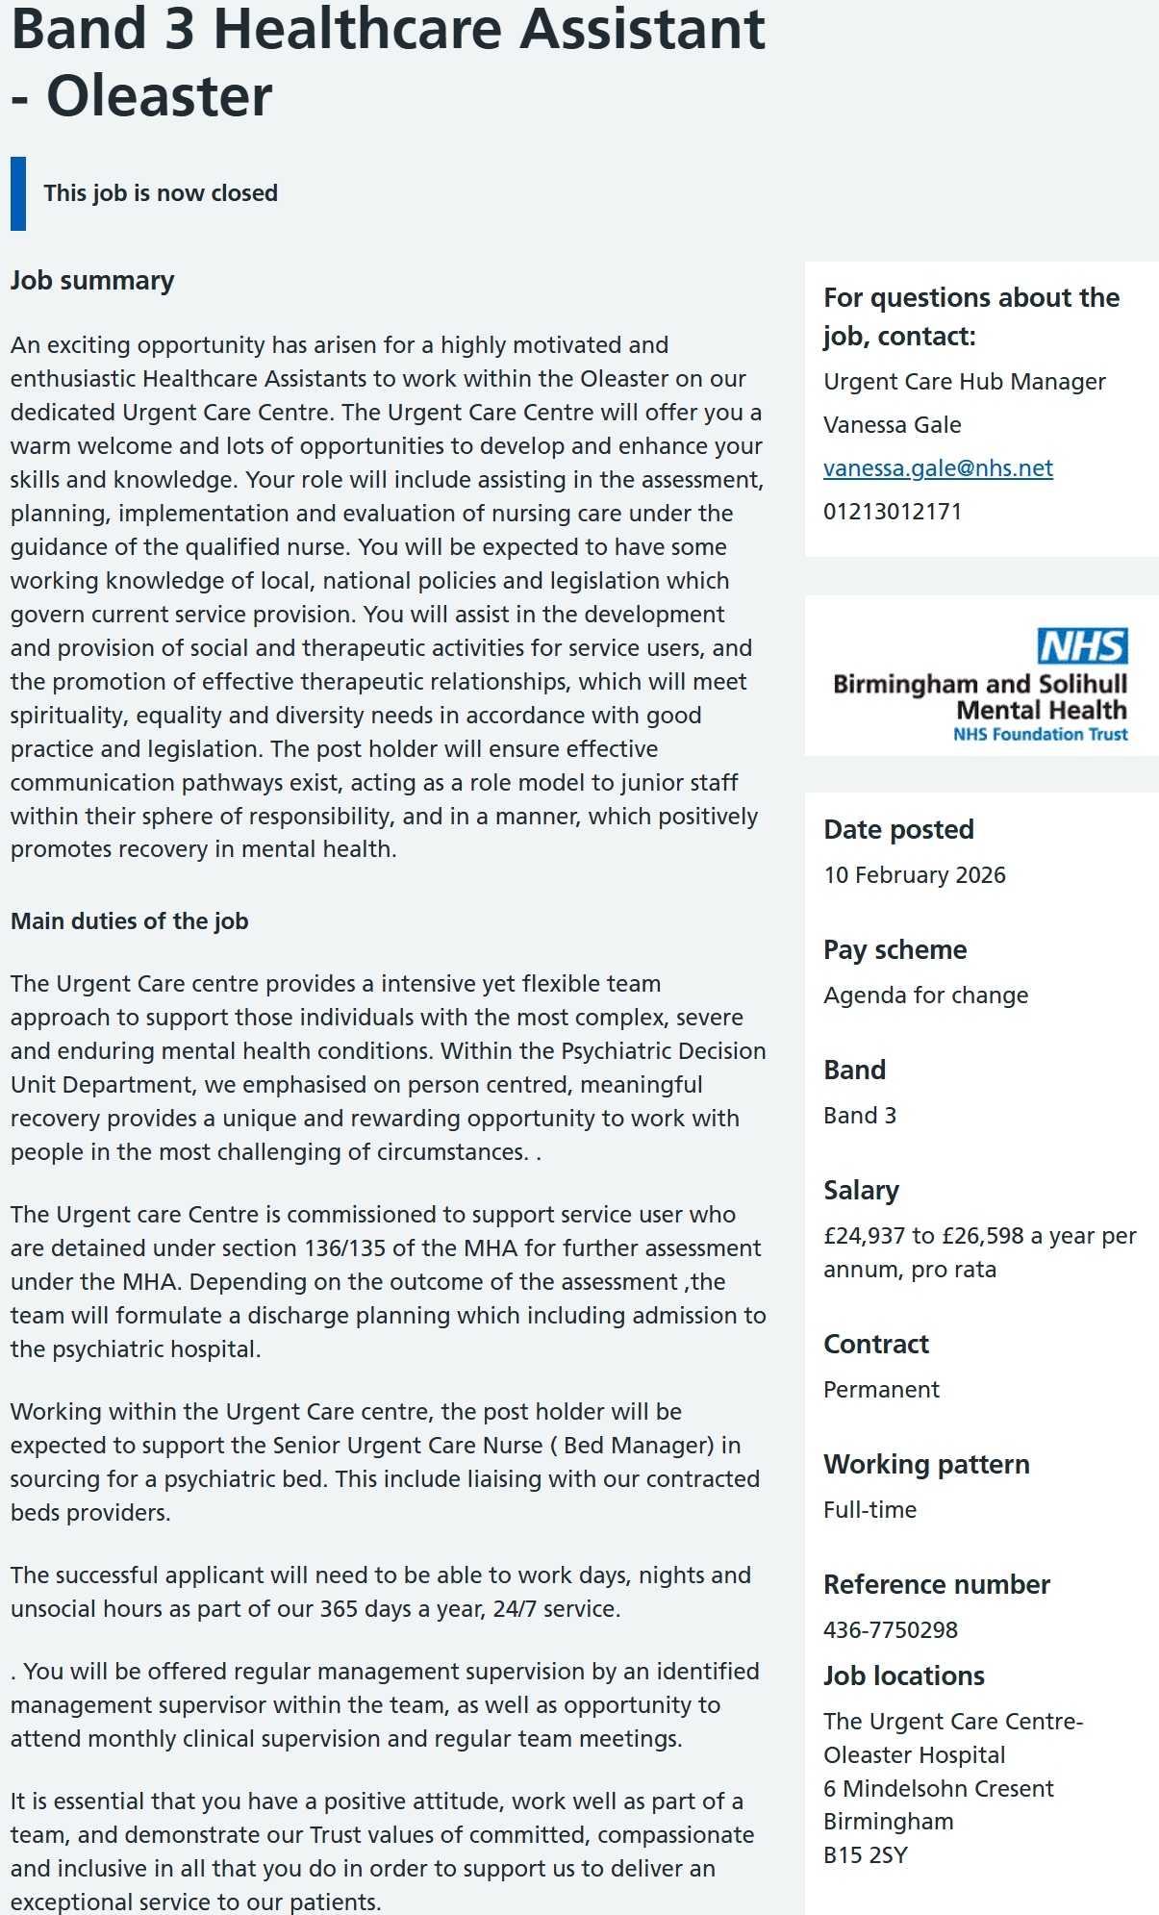

Appendix B – Summary of the Person Specification

Essential Requirements
- Good verbal and written communication.
- Compassion and empathy.
- Ability to work within a multidisciplinary team.
- Good organisational skills.
- Understanding of confidentiality.
- Flexible approach to work.
- Commitment to person-centred care.
- Basic IT skills.
- Professional attitude.
- Willingness to participate in training and CPD.

Desirable Requirements
- Previous care experience.
- Knowledge of mental health conditions.
- Understanding of recovery-focused care.
- Awareness of safeguarding.
- Experience supporting vulnerable adults.

Appendix C – Curriculum Vitae
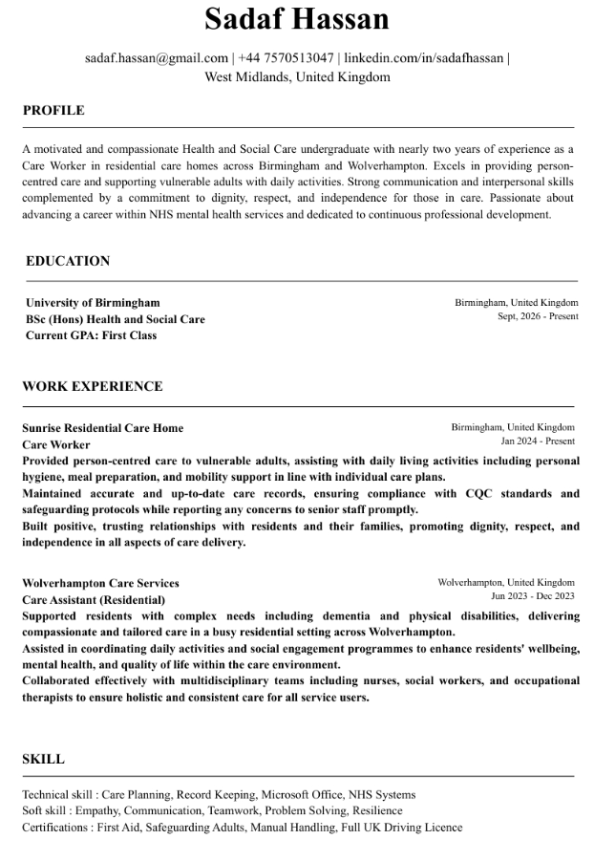

Appendix D – Personal Development Timeline

Time | Development Activity | Expected Outcome
Month 1–3 | Complete NHS mental health e-learning | Improve knowledge of common mental health conditions
Month 3–4 | Attend therapeutic communication training | Improve confidence communicating with service users
Month 4–5 | Complete conflict resolution training | Improve management of challenging situations
Month 5–6 | Apply for NHS Band 3 Mental Health Support Worker vacancies | Secure interviews and employment opportunities
Ongoing | Record CPD, maintain LinkedIn profile and reflective journal | Continue professional growth and lifelong learning

References
Arnold, E.C. and Boggs, K.U. (2020) Interpersonal Relationships: Professional Communication Skills for Nurses. 8th edn. St Louis, MO: Elsevier.
Barker, P. (2009) Psychiatric and Mental Health Nursing: The Craft of Caring. 2nd edn. London: Hodder Arnold.
Cottrell, S. (2021) Skills for Success: Personal Development and Employability. 5th edn. London: Red Globe Press.
Department of Health and Social Care (2021) The NHS Constitution for England. London: Department of Health and Social Care. Available at: GOV.UK – The NHS Constitution for England (Accessed: 15 July 2026).
Doran, G.T. (1981) ‘There’s a S.M.A.R.T. way to write management’s goals and objectives’, Management Review, 70(11), pp. 35–36.
Gibbs, G. (1988) Learning by Doing: A Guide to Teaching and Learning Methods. Oxford: Oxford Polytechnic.
Health and Safety at Work etc. Act 1974. London: The Stationery Office.
Mental Capacity Act 2005. London: The Stationery Office.
Mental Health Act 1983 (as amended 2007). London: The Stationery Office.
National Institute for Health and Care Excellence (2020) Rehabilitation for Adults with Complex Psychosis (NG181). Available at: NICE Guideline NG181 (Accessed: 15 July 2026).
National Institute for Health and Care Excellence (2021) Shared Decision Making (NG197). Available at: https://www.nice.org.uk/guidance/ng197 (Accessed: 15 July 2026).
NHS England (2019) The Community Mental Health Framework for Adults and Older Adults. London: NHS England.
Nursing and Midwifery Council (2018) The Code: Professional Standards of Practice and Behaviour for Nurses, Midwives and Nursing Associates. London: NMC.
Schön, D.A. (1983) The Reflective Practitioner: How Professionals Think in Action. New York: Basic Books.
Skills for Care (2023) The Care Certificate Standards. Leeds: Skills for Care.
Taylor, C., Lynn, P. and Bartlett, J. (2019) Fundamentals of Nursing: The Art and Science of Person-Centred Care. 9th edn. Philadelphia: Wolters Kluwer.
World Health Organization (2022) World Mental Health Report: Transforming Mental Health for All. Geneva: World Health Organization.
Birmingham and Solihull Mental Health NHS Foundation Trust (2026) Band 3 Healthcare Assistant – Oleaster: NHS Job Advertisement. NHS Jobs. (Accessed: July 2026).

