
FLORICA BOCEA 2530200
DOREEN DAI | LCML4006 COMPONENT 1
Enterprise and Entrepreneurship
Alina’s Nails Studio
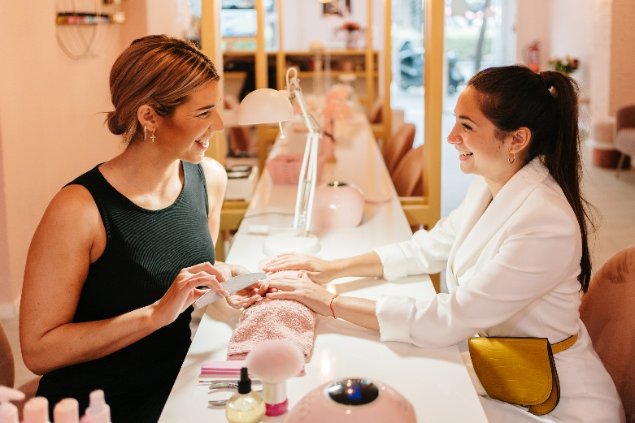

EXECUTIVE SUMMARY

My business is a professional nail salon. It is a small business and it is called Alina’s Nail Studio. It will be based in Solihull and will be offering services such as BIAB, gel nails, acrylic extensions, and nail art.
My goal for the business is to provide the best high-quality treatments at excellent prices in a friendly and welcoming positive vibe environment.
My business will provide customers with excellent experience, easy online booking, and based on social media as well. I want my business to grow slowly and make profit so that all business costs will be covered and have loyal customers that will support and recommend me too.
Nail art is very popular and in high demand, that is why I am confident I will do well. My business idea will also consider the environment and community and I have explained this in more detail later.

Contents
1. OVERVIEW OF BUSINESS 3
2. LEGAL STRUCTURE AND MANAGEMENT 4
3. SUSTAINABILITY AND COMMUNITY SUPPORT 4
4. MARKET RESEARCH 5
5.COMPETITOR ANALYSIS 7
6. TARGET MARKET 7
7. MARKETING COMMUNICATIONS 8
8. FINANCIAL PLAN 9
9. CONCLUSION 10
10. REFERENCE LIST 11

1. OVERVIEW OF BUSINESS



Business Idea
My business idea is to open a nail salon in Birmingham where people can come to relax, treat themselves, and leave feeling confident about their nails. I will offer a range of services, including manicures, gel nails, acrylic nails, and nail art. My main customers will be women and anyone who enjoys looking after their nails and keeping up with beauty trends.
I want everyone who visits the salon to feel welcome and comfortable from the moment they walk in. For me, it's not just about doing nails, it's about creating a positive experience and vibes that makes customers want to come back. If customers are happy with the service and love their nails, they are going to recommend the salon to their friends and family.
My goal is to provide top quality treatments at affordable prices. I will put high focus on customer service, cleanliness, and creating a friendly atmosphere where people can relax and enjoy their appointment.

2. LEGAL STRUCTURE AND MANAGEMENT

I will start as a sole trader because it’s an easy way to run a small business.
I will register by setting this up on GOV.UK (2026) Set up as a sole trader.
I will be in charge of making decisions and managing everything about Alina’s Nail Studio.
I want to keep everything as clear as possible about the income and expenses and follow HMRC rules.
A sole trader is personally responsible for business debts.

3. SUSTAINABILITY AND COMMUNITY SUPPORT

I also want my business to be environmentally friendly as possible. I will try to reduce waste by only ordering the stock I need. I will be recycling materials where possible, and using products and packaging that are better for the environment. I will also use good quality durable equipment that last very long and save energy on lighting to help reduce energy use. I will make my salon more environmentally friendly by buy products carefully to avoid wasting money and materials.

The salon will support the local community by providing affordable, high quality nail treatments for people living, studying, and working in Solihull and the surrounding areas by giving discounts and offer to customers.

If my business grows I will consider to employ another nail technician. I will make sure they are a local person to help jobs in community and save them time and money in transport to work.

4. MARKET RESEARCH

PESTEL Analysis

Political Factors
To run my salon legally, I will need to follow health and safety rules, hygiene standards, and any requirements set by the local council. I will also make sure the business is registered correctly and that all taxes are paid on time. I will register with Birmingham City Council (2026) Business and licensing information.

Economic Factors
People's spending habits can change depending on the economy, that may affect how often they book beauty treatments and treat themselves. However nail services are a very popular and affordable way for people to treat themselves, so there is usually a high demand for this.

Social Factors
More people are taking an interest in self-care, beauty treatments and self-love, because social media has helped make nail treatments even more popular. Many customers enjoy keeping up with the latest nail trends and showing off their nails online.

Technological Factors
Technology will play an important role in my business. Customers will be able to book appointments online and pay online too. This will make the process quick and easy. I will also use social media like Instagram, TikTok, and Facebook to share my work and attract new customers.

Environmental Factors
Many customers prefer businesses that care about the environment and have good practises to help reduce waste. I will try to reduce waste by recycling where possible, and use environmentally friendly products and packaging to make my salon a better place. I will follow the rules from here GOV.UK (2026) Business waste responsibilities.

Legal Factors
As the owner of the saloon I will need to follow laws relating to health and safety, customer protection, and data protection. If I hire staff in the future, I will also make sure I follow employment laws and provide a safe working environment.

SUMMARY
Overall, the PESTEL analysis shows that my nail salon has good potential. By following legal requirements, providing customers with excellent service, using technology to reach customers, and being environmentally friendly, I can build a successful business that meets customer needs and keeps up with business trends.



5.COMPETITOR ANALYSIS

The nail salon business in Birmingham and Solihull is very competitive, with many salons offering similar treatments. To stand out from other businesses, I will focus on providing best quality nail services, most excellent customer service, affordable prices, and highest standards of cleanliness. I want every customer to feel welcome, comfortable, and valued when they visit. I will also build a strong social media accounts by sharing my work daily, offering promotions, and creating vibes with customers online by posting live. This is attract new customers and existing customers will also join in on live streaming.

My main competition are Nail Garden Birmingham, Rush Birmingham, and The Nail Club Birmingham. They are very popular, however I will be different to them and attract more customers by maximising my social media accounts because social media is a big factor when it comes to beauty and self-care.

6. TARGET MARKET

My target customers are -
- Women aged 18-45.
- Students.
- Office workers.
- Local residents.
- Customers preparing for special occasions like weddings, birthdays, and holidays.

These customers are my target because from my experience customers are always looking for professional nail care, high quality service, and a relaxing salon experience and are usually women 18-45 years age.

7. MARKETING COMMUNICATIONS

To promote my salon, I’ll mainly use social media to show my work and connect with customers. I’ll post photos of latest nail design styles, do live streaming, and let people know about any special offers. I will use Instagram, TikTok, and Facebook to help me reach new customers and grow my business.

I also want booking appointments to be as easy as possible, so customers will be able to book online whenever best for them. To keep customers coming back, I plan to offer loyalty rewards card and referral discount.

Word-of-mouth will be a big part of my marketing because more happy the customers are then the more likely to recommend the salon to their friends and family. I will also accept card and digital payments to make paying quick for customers.

8. FINANCIAL PLAN

Start-Up Expenses
CASH FLOW
 | MONTH
Cash in | 1
Personal savings | £5,000
Small business loan | £5,000
Other/Family | £2,000
Total cash in-flows (A) | £12,000
 | MONTH
Cash out-expenses | 1
Salon rent and deposit | £2,500
Nail equipment and furniture | £1,500
Nail products and supplies | £1,000
Business registration and insurance | £500
Marketing and advertising | £700
Online booking software | £300
Utilities and miscellaneous costs | £500
Working capital reserve | £1,000
Nail products and supplies | £2,500
Business registration and insurance | £1,500
Total cash out-flows (B) | £8,000
Your net cash flow (A-B) | £4,000

9. CONCLUSION

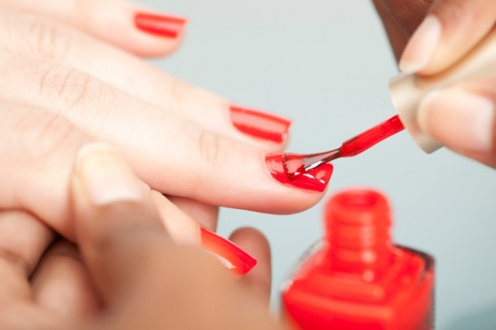

My conclusion is Alina's Nail Studio will provide high-quality best nail treatments in a friendly and welcoming environment in Solihull. By aiming on excellent customer service, affordable prices, and making sure every customer has a positive experience, I hope to have a business with loyal customers. I also plan to use social media every day to promote the business and have a saloon that is environmentally friendly practices as well. With all this as part of my plan I think Alina's Nail Studio has very strong chance to grow and become a successful local business.

10. REFERENCE LIST

- Birmingham City Council (2026) Business and licensing information. Available at: https://www.birmingham.gov.uk (Accessed: 1 October 2026).
- GOV.UK (2026) Set up as a sole trader. Available at: https://www.gov.uk/set-up-sole-trader (Accessed: 1 October 2026).
- GOV.UK (2026) Business waste responsibilities. Available at: https://www.gov.uk/browse/business/waste (Accessed: 10 October 2026).
- Nail Garden Birmingham (2026) Treatments and prices. Available at: https://www.nailgardenbirmingham.co.uk (Accessed: 19 October 2026).
- Rush Hair & Beauty (2026) Birmingham salon services. Available at: https://www.rush.co.uk (Accessed: 19 October 2026).
- The Nail Club Birmingham (2026) Nail treatments and bookings. Available at: https://www.thenailclub.co.uk (Accessed: 10 October 2026).

