
WORKSHEET 5 – QUESTION

Note: This worksheet is open – it does not need to be
completed in class time.

Let’s Play Pointless!

Create a version of the BBC hit show Pointless.

The object of the game is give a correct answer, but also to
try to give an answer that few people know. For a wrong
answer, 100 points is scored. The aim is to score as
few points as possible.

If you have not seen the show before, here is an
example on YouTube:
https://www.youtube.com/watch?v=XTme4tcYNLA

You may choose how simple/complex you make your
program. For example, you might ask the user just
one question, or you might have multiple questions. You
could implement more than one player, or just have one
player.

You should use at least one function in your program.

Extra credits will be given for more complex implementations, but do not worry if you cannot implement a fully working game, implement as much as you can. A partially complete solution will still gain marks.

Below is an example of a possible game and of how the output of your game might look. In my game below, the question is “Cities in Wales”. There are 7 correct answers (Cardiff, Swansea, Newport, StDavids, StAsaph, Wrexham and Bangor). StAsaph, Wrexham and Bangor are Pointless answers.

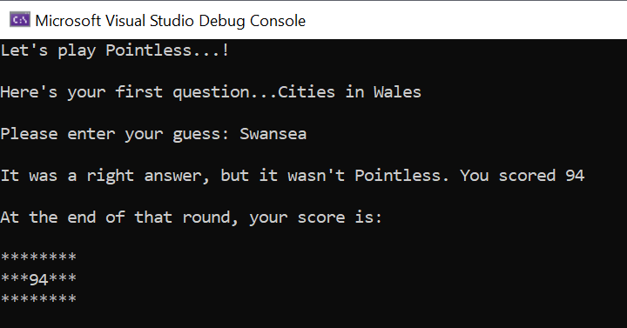
Right answer, but not pointless.

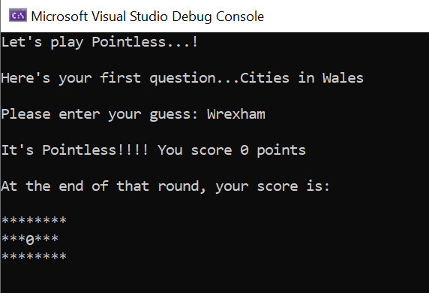
Pointless answer

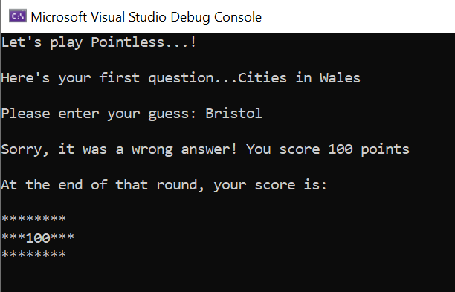
Wrong answer

Note: If you are using arrays to hold the potential answers, and you wish to involve these in your functions, it is permitted to make the array(s) for the board of global scope to reduce complexity. Any other variables should have local scope and should be passed between functions as parameters (if required)

