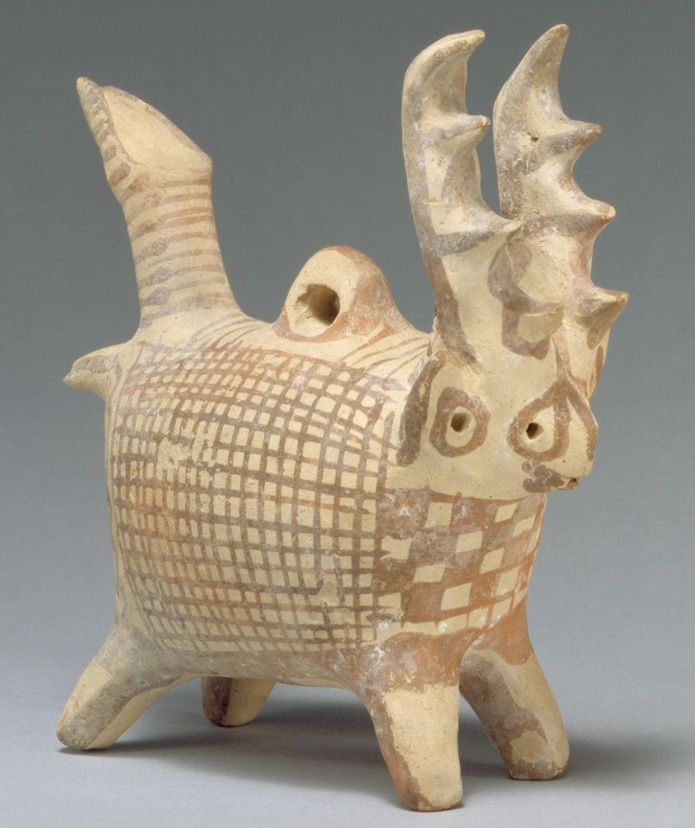
Terracotta Zoomorphic Askos:
Figure 1: Terracotta zoomorphic askos, The Metropolitan Museum of Art, New York City (2020)
This object is a small terracotta Askos sculpted to resemble a wild animal, possibly a regional species of deer due to the presence of antlers on the Askos (MET, 2020). The figurine stands at about 14.6 cm high and was said to be from Idalion (Potamia), which is in central Cyprus (MET, 2020). The object has been roughly dated to be from around c 1725–1600 B.C, which places it in the late Middle Cypriot period (MET, 2020).

The Askos displays the creature in a zoomorphic style, with the antlers, tail and body being over exaggerated. The creature has 4 small and stubby legs, which support the weight of the creature’s body which is very large compared to the rest of the vessel, suggesting that the body was used to store some form of liquid, as it is an Askos (Ben-Shlomo, 2008). The vessel is made out of Terracotta, which we can tell by the coloration of the object which is a light and pale cream (Ben-Shlomo, 2008). The Askos is also highly decorated with a number of linear and checkerboard patterns covering the entire body of the creature. The colour of these patterns is all the same, however it is hard to suggest whether it is a faded red or a light brown due to the object being so old and the likelihood of the colour degrading over time (Ben-Shlomo, 2008). There also appears to be no visible damage and limited wearing of the elaborated patterns on the Askos. A recent interpretation into the design and decoration of the askos done by Karageorghis in 1977 suggests that the Askos’ design is meant to be humourous and is part of a long tradition with Cyprian art, portraying a humorous spirit in their culture (Karageorghis, 1977). This view seems to have some relevance with this object as the deer appears to be smirking, and its over exaggerated features may have come across as humourous to the people of Bronze Age Cyprus.
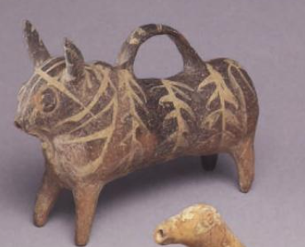
On the back of the object, there is an eye which has nothing attached to it. This suggest that the vessel may have been originally held/strung up with an organic material, either a piece of fabric or rope, as these would not survive beyond the decay process, explaining why the eye survives but not what was used to support it (Ben-Shlomo, 2008). This idea of the askos being threaded up is also supported by there being no handle present to lift or tilt the vessel, unlike other Askos that are of the period and region, as seen in figure 2 (Ben-Shlomo, 2008).
Figure 2: Terracotta zoomorphic askos, The Metropolitan Museum of Art, New York City (2020)

We can deduce that this object is an Askos because although it is in the style of a zoomorphic creature, the main features of an Askos are present such as a spout at the rear end of the creature and small holes at the front of the creature to allow for liquid to be poured out (Karageorghis, 1977). Also, this object, is very similar in fashion to other terracotta Askos from around the East Mediterranean, especially in modern day Palestine and Turkey, as many of them are also in the zoomorphic style (Karageorghis, 1977).
The Askos is part of the Cesnola Collection in the MET museum New York (MET, 2020). The collection was amassed over a period of a few years from 1865 by the American consul in Cyprus, Luigi Palma di Cesnola (Karageorghis, Merker, Mertens, 2004); he excavated and purchased a large number of Cyprian Artefacts, ranging from the Bronze Age all the way though to Antiquity (Karageorghis, Merker, Mertens, 2004). Also, very little recorded detail survives telling us if the artefacts were excavated or bought (Karageorghis, Merker, Mertens, 2004). Because of the mix of purchased and excavated artefacts, the Askos may not have been discovered in Idalion (Potamia) and could have actually been discovered elsewhere (Karageorghis, Merker, Mertens, 2004).

From the abundance and perfect condition of zoomorphic askos’ in the East Mediterranean, we can elude to the idea that these objects were handled with great care and weren’t throw away items (Ben-Shlomo, 2019). This is supported by the view that Askos’ were primarily used in religious ceremonies, and hence would have been handled by a priest or cult leader, meaning that they would have had great value to them and would have been handled with care (Ben-Shlomo, 2019). However, because we have conflicting evidence to where these objects are found, with some being discovered in households (Ben-Shlomo, 2008), while others on temple complexes (Karageorghis, 1977) It is unclear who may have handled these objects, priests or a member of a household (Ben-Shlomo, 2008).
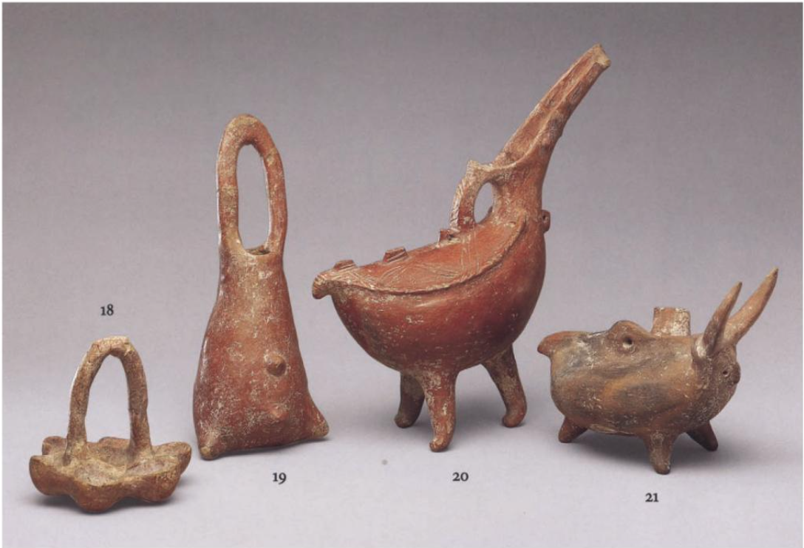
A recent interpretation from Ben-Shlomo in 2008 suggests that the Askos’ purpose was actually as a more sacrificial object (Ben-Shlomo, 2008). This interpretation was based on the work done by Marinatos and Hägg during the late 1980s (Ben-Shlomo, 2008). Ben-Shlomo implies, that similar askos from Palestine were being used to store the blood of sacrificed animals, (Ben-Shlomo, 2008). It was therefore reasonable of him to assume that as trade and cultural links were strong with between the Levant and Cyprus, that this practice would have been apparent in Cyprus too, seeing as though both cultures seemed very similar, such as the trade in zoomorphic Askos as seen in figure 3 (Ben-Shlomo, 2008). Therefore, it must have been priests who dealt with these objects and not members of a household, as only they would perform sacrifices (Ben-Shlomo, 2008).
Figure 3: Terracotta zoomorphic askos, The Metropolitan Museum of Art, New York City (2020)

From the evidence gathered, it is reasonable to suggest that this object had a daily ritual purpose to the religion/faith that the people of Bronze Age Cyprus believed in. As explained before, it appears that some form of liquid (either anointed oils or sacrificial blood) would have been stored in these vessels and then would have been poured out of the Askos during a particular ritual/event (Ben-Shlomo, 2008). As there are large number of these artefacts that have been discovered and their discovery locations are varied, it is reasonable to infer that these objects could have been a household item belonging to a household, or there could be multiple Askos stored in religious sanctuaries (Ben-Shlomo, 2008). In regard to who handled this object, it is reasonable to presume that if the object was for the household, then the owner of the household would have been the person to have most likely used it the most for when the household conducted a special religious ceremony (Ben-Shlomo, 2019), and similarly a priest or cult leader would handle the object if it was on a religious sanctuary (Ben-Shlomo, 2008). In both cases, the use of the object seems to be limited as on the majority of these Askos, there is little wear and tear on them, implying that they were reserved for rare occasions or may have been only used for a handful of events before being discarded (Ben-Shlomo, 2019).

Reference List
Ben-Shlomo. D (2008), ‘Zoomorphic Vessels from Tel Miqne-Ekron and the Different Styles of Philistine Pottery, Israel Exploration Journal, Vol. 58, pp. 24-47’, Israel, Israel Exploration Society, Stable URL: https://www.jstor.org/stable/27927184 Accessed: 25-03-2020 08:18 UTC

Ben-Shlomo. D (2019), ‘Philistine Cult and Religion According to Archaeological Evidence’, Ariel University, Department of Land of Israel Studies and Archaeology, ,

Karageorghis. V (1977), ‘Treasures of Cyprus, Archaeology, Vol. 30, pp. 132-134’, USA, Archaeological Institute of America, Stable URL: https://www.jstor.org/stable/41706140 Accessed: 26-03-2020 11:21 UTC

Karageorghis. V, Mertens J.R , Rose M.E (2000), ‘Ancient Art from Cyprus: The Cesnola Collection in the Metropolitan Museum of Art’, New York, Metropolitan Museum of Art

Karageorghis. V, Merker G.S , Mertens J.R, (2004), ‘The Cesnola Collection: Terracottas’, New York, Metropolitan Museum of Art

The Metropolitan Museum of Art, New York City (2020) ‘Terracotta zoomorphic askos (vessel) with antlers’, Available at: https://www.metmuseum.org/art/collection/search/240382 (Accessed: 17th March 2020)

The Metropolitan Museum of Art, New York City (2020) ‘The Cesnola Collection at The Metropolitan Museum of Art’, Available at: https://www.metmuseum.org/toah/hd/cesn/hd_cesn.htm (Accessed: 17th March 2020)

