ML- MODEL

Submitted By:
2221048
Sohaan Sureshkumar
Module: Artificial Intelligence and machine learning
Lecturer: Dr. Seena Joseph

Table of Contents
ABSTRACT 2
INTRODUCTION 3
PROBLEM STATEMENT & 4
LITERATURE REVIEW 4
3.1 Problem Statement 4
3.2 Literature Review 5
METHODOLOGY 6
4.1 Dataset Description & Exploratory Data Analysis 6
4.2 Data Preparation 6
4.3 Model Design 7
4.3.1 Decision Tree Classifier 7
4.3.2 Support Vector Machines 7
4.3.1 Clustering with K-means 8
4.4 Evaluation Metrics 8
EXPERIMENTS 9
5.1 Supervised Learning Experiments 9
5.2 Unsupervised Learning Experiments 10
RESULTS 11
RECOMMENDATIONS 12

ABSTRACT

This study examines how supervised and unsupervised machine learning approaches enable analysts to study player involvement within virtual gaming platforms. The ‘Predict Online Gaming Behaviour’ dataset serves as the basis for this analysis because it includes 40,034 player records that contain demographic information (age, gender and location) and gameplay statistics (play time, session frequency, session duration, in-game purchases) and three engagement levels (High, Medium, Low).

The analysis begins with data cleaning and encoding before Decision Tree and Support Vector Machine (SVM) models are trained to predict engagement levels. The Decision Tree model achieves 0.84 test accuracy at its base level but reaches 0.90 accuracy when its depth is optimized to 9. The linear SVM model using scaled features produces 0.82 test accuracy but the RBF SVM model with optimization reaches 0.88 accuracy.

The K-Means clustering algorithm analyzes two feature combinations which include Age versus PlayTimeHours and SessionsPerWeek versus AchievementsUnlocked. The three clusters obtained clusters demonstrate reasonable separation through their 0.39 silhouette scores which identify three distinct player groups based on their activity levels. The Decision Tree model achieves the highest prediction accuracy after optimization but clustering methods help identify concealed player groups.

INTRODUCTION

Online games succeed in the modern era because they focus on keeping players instead of making a single sale so analysts must identify which players remain active and which players tend to depart[1]. The commercial gaming industry uses behavioral data including play time and session frequency and in-game purchases to develop models for player engagement and retention[1][2]. The Predict Online Gaming Behaviour dataset contains simulated information which unites personal details (age and gender and location) with behavioral metrics (play hours and sessions per week and achievements and purchases) and a three-level engagement rating system (High, Medium, Low)[3][4].

This project applies supervised and unsupervised machine learning approaches to analyze the data information present in the provided dataset[4]. The supervised analysis uses Decision Tree and Support Vector Machine (SVM) classifiers with linear and RBF kernels to predict engagement levels which demonstrates the distinction between tree-based models and margin-based models. The k-means clustering algorithm identifies natural player groups through their behavioral data which gets evaluated against the predefined High, Medium and Low engagement categories. The research evaluates basic predictive models for engagement classification to discover valuable patterns which will help developers build improved online game retention systems.

PROBLEM STATEMENT &

LITERATURE REVIEW

3.1 Problem Statement

Online game developers must identify their most active players and their at-risk players because engagement levels determine both player retention and in-game spending and overall game revenue. The Predict Online Gaming Behaviour dataset[4] demonstrates that uniting player characteristics with their gaming activities enables developers to create models which support data-based design choices.

The project addresses a real-world challenge by asking users to predict EngagementLevel categories (Low, Medium or High) based on demographic and behavioral information for each player. The dataset includes 40,034 records with 13 variables that include Age, Gender, Location, GameGenre, PlayTimeHours, InGamePurchases, SessionsPerWeek, AvgSessionDurationMinutes, PlayerLevel, AchievementsUnlocked and the target EngagementLevel [5][4]. The three-level engagement prediction system enables developers to create specific re-engagement campaigns for underactive players and optimize game difficulty and content suggestions for players at intermediate levels and develop retention strategies for top performers [6].

The assignment demands researchers to move past basic prediction work by identifying specific behavioral patterns that exist among players. The project requires an unsupervised learning approach to cluster players based on their age and their gaming activities including playtime and session frequency and achievement progress [6]. The analysis of cluster groups against engagement labels enables researchers to understand how different player behaviours match the defined High, Medium and Low engagement categories [6].

3.2 Literature Review
Decision Trees (DTs) serve as popular tools for customer and behavior modeling because they transform complicated choices into easy-to-understand sequential rules which business users can visualize [7]. The model selection process in marketing and customer-analytics environments favors Decision Trees because they provide transparent results and clear feature importance alongside their predictive accuracy [7] [8]. Support Vector Machines (SVMs) operate as max-margin classifiers which excel in high-dimensional spaces and achieve non-linear decision boundaries through radial basis function (RBF) kernel application [9}. Research studies about consumer behavior prediction demonstrate that SVMs and their ensemble variants deliver superior accuracy than Decision Trees but users must sacrifice model interpretability [10].

The marketing and game analytics industries use k-means clustering as their primary method to segment customers and users based on their behavioral patterns [11]. The clustering method helps identify specific user segments which can be targeted through customized content and reward programs [11][12].

The evaluation of model performance in classification and clustering tasks relies on accuracy metrics together with precision and recall values and F1-score measurements when applicable [13]. The accuracy metric shows the total number of correct predictions but precision and recall evaluate performance for specific classes and F1-score unites precision and recall for imbalanced class distributions [12][13].

Research studies about gaming data have primarily concentrated on studying the binary outcomes between player churn and non-churn behavior [6][2]. The research investigates three engagement levels (Low, Medium, High) while evaluating Decision Trees against RBF and linear SVM models and performing k-means clustering to discover behavioral patterns from the same dataset.

METHODOLOGY

4.1 Dataset Description & Exploratory Data Analysis
The ‘Predict Online Gaming Behaviour’ dataset [4] contains 40,034 rows across 13 columns for this project. The df.info() function shows that the dataset contains two main categories of data as seen in the figure:
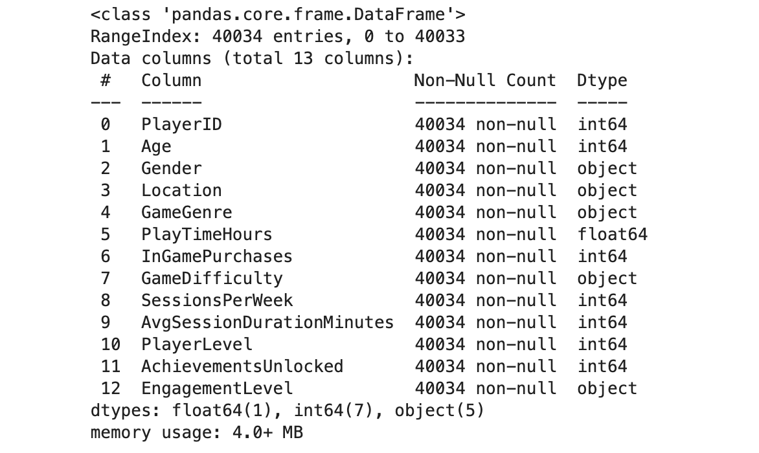
The first three rows and last three rows and summary statistics from describe() function demonstrate that each entry represents an individual player while the numerical data points fall within expected ranges. The Age distribution spans from 15 to 50 while PlayTimeHours range from 0 to 24 and SessionsPerWeek occur between 4 to 14 times per week. The histogram analysis confirms that there are no abnormal data points and players distribute across different activity levels.
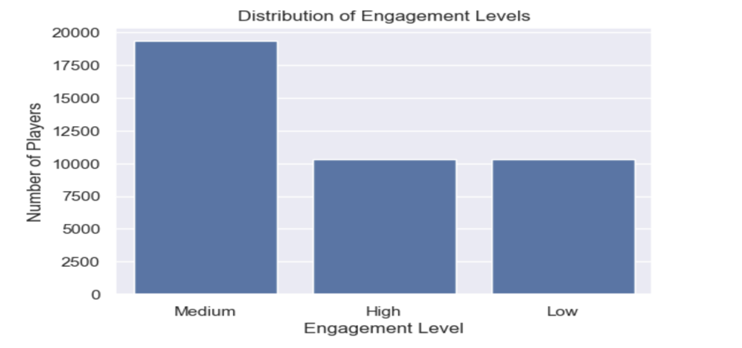
The EngagementLevel variable contains three distinct categories. The distribution of players shows Medium as the dominant group with 19,374 players (≈ 48.4%) followed by High and Low groups which each represent about 25.8% of the total players. The main numerical variables display minimal off-diagonal correlations according to their correlation heatmap.

4.2 Data Preparation
The data preparation process follows a standardized method which remains consistent throughout the entire process. The isnull().sum() function revealed that all features contained zero missing values so no deletion became necessary.
The PlayerID variable was removed from the dataset as it contained a distinct value for almost every entry which does not add any meaningful information about player behavior.
The categorical variables Gender, Location, GameGenre, and GameDifficulty went through one-hot encoding through pd.get_dummies() to transform them into numeric values. The process generated new binary indicator variables for all categories.

The feature matrix and target vector underwent train_test_split with an 70/30 ratio to create training and testing sets. The same data split was applied to all models for achieving equal conditions that enable Decision Tree and SVM comparison.

The StandardScaler performed feature scaling on training data before applying its transformation to both X_train and X_test datasets which resulted in X_train_scaled and X_test_scaled. The Decision Tree classifier operated with unscaled features because tree-based models do not need standardization.

4.3 Model Design

4.3.1 Decision Tree Classifier
The first model of the Decision Tree classifier was served as the initial baseline model. The trained Decision Tree model achieved a test accuracy of approximately 0.838 when evaluating the training data.
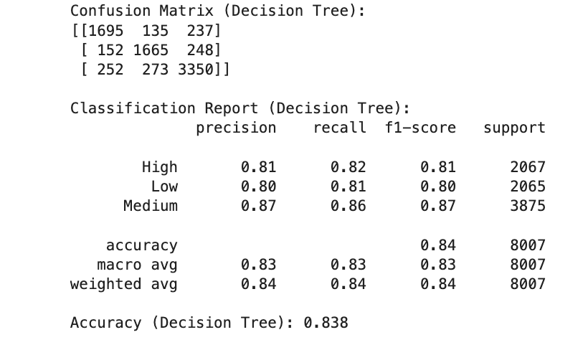
The tree's maximum depth received optimization as to improve the performance. The model achieved its highest test accuracy at 0.896 when max_depth was set to 9 but the accuracy dropped to 0.838 when no depth restriction was applied. The best performing Decision Tree model used max_depth = 9 which became the final model for comparison purposes. The tree plot shows only the top levels to display the essential decision rules.
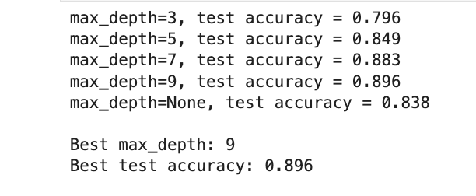

4.3.2 Support Vector Machines
The scaled features enabled the development of two SVM classifiers.
The first model uses a linear kernel (kernel='linear') for classification. The model searches for a linear boundary that separates the three engagement classes within the scaled feature space to provide a direct comparison with the Decision Tree baseline.

The second model employs an RBF kernel (kernel='rbf', C=2.0, gamma='scale') for classification. The RBF kernel enables non-linear boundary creation because the correlation analysis showed weak linear relationships between variables. The model receives a slightly increased C value of 2.0 to enhance its margin flexibility. The tuned SVM model receives evaluation against the tuned Decision Tree model.

4.3.1 Clustering with K-means
The unsupervised analysis of player segments used K-Means clustering as its method. The study conducted two independent experiments which used different data combinations.
The first experiment combined Age data with PlayTimeHours data to generate Cluster_Age_Play results. The second experiment combined SessionsPerWeek data with AchievementsUnlocked data to generate Cluster_Sessions_Ach results.
The analysis evaluated k values between 1 and 8 for each feature pairs. The WCSS measurement allowed the creation of an elbow curve while silhouette scores for multiple k values were computed. The combination of low cluster spread, and high interpretability made k = 3 the optimal choice because it produced silhouette scores of 0.39 in both experiments.
The K-Means algorithm operated without any reference to the EngagementLevel labels during its execution.

4.4 Evaluation Metrics

The classification models including the baseline model DT, the tuned Decision Tree. linear SVM and RBF SVM received their evaluation through:
• Confusion matrix analysis which revealed the specific points where predictions fail to match actual labels.
• Its accuracy metric from which represents the percentage of successful predictions.
• The evaluation system uses macro and weighted precision, recall and F1-score metrics to measure performance across all three classes because the Medium class has the largest size.
The evaluation of clustering results used WCSS, silhouette scores, visual analysis of scatter plots and crosstab results to determine cluster quality.

EXPERIMENTS

5.1 Supervised Learning Experiments

The research used Decision Trees and SVMs to predict the three-class target EngagementLevel in supervised learning experiments.

Experiment 1 - Baseline Decision Tree
The default DecisionTreeClassifier with random_state=42 processed the entire training data before testing its performance on the test data. The experiment recorded both the confusion matrix and all essential performance metrics which included accuracy, precision, recall and F1 score as the starting point.

Experiment 2 - Decision Tree Depth Tuning
The model complexity control used max_depth values which included 3, 5, 7, 9 and None. The process involved training separate trees for each depth setting on the training data before calculating their test performance results. The model achieved its best test accuracy at max_depth = 9 which became the final Decision Tree model.

Experiment 3 - Linear SVM
The SVM model used linear kernel processing on X_train_scaled data for training. The model produced predictions for both training and test data which allowed us to calculate performance metrics for comparison with the tree model.

Experiment 4 - RBF SVM (tuned)
The SVM model used an RBF kernel with C=2.0 and gamma='scale' for training on scaled data. The model produced training and test results which helped evaluate the advantages of using a non-linear boundary.

Experiment 5 - Tuned Model Comparison
The results table presented accuracy and weighted precision and weighted recall and weighted F1 scores for the max_depth=9 Decision Tree(tuned) and the RBF SVM model to enable direct model evaluation.

5.2 Unsupervised Learning Experiments

Experiment 6 - K-Means on Age vs PlayTimeHours
The K-Means clustering algorithm processed data points through the Age-PlayTimeHours two-dimensional space. The analysis evaluated different values of k which ranged from 1 to 8. The algorithm calculated within-cluster sum of squares (WCSS) for each k value before creating an elbow curve from the results. The algorithm generated silhouette scores for k values ranging from 2 to 8. The combination of elbow bend shape and silhouette values led to the selection of k = 3 which produced three clusters that were displayed through a scatter plot.

Experiment 7 - K-Means on SessionsPerWeek vs AchievementsUnlocked
The second K-Means analysis processed data points through the SessionsPerWeek-AchievementsUnlocked space by testing different k values from 1 to 8 and calculating WCSS and silhouette scores. The analysis selected three clusters because they achieved a balance between cluster tightness and understanding of the data patterns and these clusters were displayed through a scatter plot.

Experiment 8 - Linking Clusters to EngagementLevel
The analysis used pd.crosstab to generate a Cluster_Sessions_Ach vs EngagementLevel table. The table served as a foundation to study how different engagement levels (High, Medium and Low) spread across the three behavioural clusters which would guide the results and discussion sections.

RESULTS
The baseline Decision Tree achieved a test accuracy of 0.838. The model achieved F1-scores between 0.81 and 0.87 for each class but the Medium class performed best while High and Low engagement classes showed significant confusion.

The model achieved its best test accuracy of 0.896 when max_depth was tuned to 9. The model performed best at depth 9 because it achieved 0.896 accuracy but shallower models at depth 3 reached only 0.796 accuracy and an unrestricted tree without depth limits performed at 0.838 but lost test set performance. The final Decision Tree model used the tuned tree as its base.

The linear SVM model that used scaled features achieved training and test accuracy rates of 0.826 and 0.819 respectively. The model achieved its best recall performance for Medium engagement at 0.87 but it struggled to identify Low engagement at 0.70 which shows that a linear boundary does not work well for all three classes.

The RBF SVM model with C = 2.0 and gamma set to 'scale' achieved training and test accuracy rates of 0.913 and 0.881 respectively. The non-linear kernel in the RBF SVM model produced better results than the linear model because it improved the precision and recall values for High and Low engagement classes.

The comparison table revealed that the Decision Tree model with max_depth set to 9 achieved the highest test accuracy and weighted F1-score of approximately 0.896 while the RBF SVM model achieved 0.881 on both metrics. The two hypertuned models performed better than their initial versions.

The K-Means algorithm applied to Age and PlayTimeHours data produced an elbow curve that showed a distinct point at k = 3 while the silhouette score reached 0.39 for moderate cluster separation. The three clusters show a general pattern of younger players who play a lot and players from different age groups who play at medium levels and older players who play less. The analysis of SessionsPerWeek and AchievementsUnlocked data produced three distinct clusters when k=3 was used to identify high-activity, medium-activity and low-activity groups. The Cluster_Sessions_Ach variable against EngagementLevel showed Medium engagement appearing in every cluster while High engagement occurred more frequently in the high-activity group and Low engagement appeared more often in the low-activity group.

RECOMMENDATIONS

The results show that a Decision Tree model with its optimized parameters represents the optimal solution for deployment because it achieves top performance and provides simple understanding of results [14]. The Decision Tree model enables designers and analysts to use a basic method for determining which player actions between sessions per week and achievement unlocks affect High or Low engagement levels [14].
The RBF SVM model works best for situations that need a more advanced yet stable predictive system which can operate in back-end systems for automated player intervention[15].
The K-Means clustering results help developers establish marketing strategies. The studio should provide advanced challenges and competitive events to players who show high activity while offering tutorials and difficulty adjustments and rewards to players who show low activity [16]. The studio can use engagement prediction results together with cluster identification to find players who need help for creating individualized intervention plans based on their behavioural groups [16].

REFERENCES

[1]
“Retention Rate Secrets to Reduce User Churn — GameAnalytics,” Gameanalytics.com, 2023. Available: https://www.gameanalytics.com/blog/reducing-user-churn?. [Accessed: Dec. 08, 2025]

[2]
C. Team and C. Team, “Innovative Strategies for Increasing Player Retention in Gaming,” CacheFly, May 10, 2024. Available: https://www.cachefly.com/news/innovative-strategies-for-increasing-player-retention-in-gaming/

[3]
N. Rismayanti, “Predicting Online Gaming Behaviour Using Machine Learning Techniques,” Indonesian Journal of Data and Science, vol. 5, no. 2, Jul. 2024, doi: https://doi.org/10.56705/ijodas.v5i2.166

[4]
Rabie El Kharoua, “🎮 Predict Online Gaming Behavior Dataset,” Kaggle.com, 2024. Available: https://www.kaggle.com/datasets/rabieelkharoua/predict-online-gaming-behavior-dataset/code. [Accessed: Dec. 08, 2025]

[5]
T. Xie, “Predicting Online Gaming Behavior: A Comparative Analysis of Random Forest and Gaussian Naive Bayes Models,” Science and Technology of Engineering, Chemistry and Environmental Protection, vol. 1, no. 9, Oct. 2024, doi: https://doi.org/10.61173/5hthrr73

[6]
N. Rismayanti, “Predicting Online Gaming Behaviour Using Machine Learning Techniques,” Indonesian Journal of Data and Science, vol. 5, no. 2, Jul. 2024, doi: https://doi.org/10.56705/ijodas.v5i2.166

[7]
Anshul, “Decision Tree Algorithm,” Analytics Vidhya, Aug. 29, 2021. Available: https://www.analyticsvidhya.com/blog/2021/08/decision-tree-algorithm

[8]
J. Domaleski, “Smarter Marketing with Decision Trees: A Practical Introduction Using R and Python,” Medium, Mar. 09, 2025. Available: https://blog.marketingdatascience.ai/smarter-marketing-with-decision-trees-a-practical-introduction-using-r-and-python-11077a964f34

[9]
Wikipedia Contributors, “Support-vector machine,” Wikipedia, Apr. 20, 2019. Available: https://en.wikipedia.org/wiki/Support_vector_machine

[10]
scikit-learn, “1.4. Support Vector Machines,” Scikit-learn.org, 2018. Available: https://scikit-learn.org/stable/modules/svm.html

[11]
A. Strahl, “Project Tutorial: Customer Segmentation Using K-Means Clustering – Dataquest,” Dataquest, May 14, 2025. Available: https://www.dataquest.io/blog/customer-segmentation-using-k-means-clustering/

[12]
Optimove, “Customer Clustering: Cluster Segmentation Analysis,” Optimove. Available: https://www.optimove.com/resources/learning-center/customer-segmentation-via-cluster-analysis

[13]
S. K. Agrawal, “Evaluation Metrics For Classification Model | Classification Model Metrics,” Analytics Vidhya, Jul. 20, 2021. Available: https://www.analyticsvidhya.com/blog/2021/07/metrics-to-evaluate-your-classification-model-to-take-the-right-decisions/

[14]
A. Sikri, R. Jameel, Sheikh Mohammad Idrees, and H. Kaur, “Enhancing customer retention in telecom industry with machine learning driven churn prediction,” Scientific reports, vol. 14, no. 1, Jun. 2024, doi: https://doi.org/10.1038/s41598-024-63750-0

[15]
Sumana Sharma Poudel, Suresh Pokharel, and Mohan Timilsina, “Explaining customer churn prediction in telecom industry using tabular machine learning models,” Machine learning with applications, vol. 17, pp. 100567–100567, Jun. 2024, doi: https://doi.org/10.1016/j.mlwa.2024.100567

[16]
M. Imani, Majid Joudaki, A. Beikmohammadi, and Hamid Reza Arabnia, “Customer Churn Prediction: A Systematic Review of Recent Advances, Trends, and Challenges in Machine Learning and Deep Learning,” Machine Learning and Knowledge Extraction, vol. 7, no. 3, pp. 105–105, Sep. 2025, doi: https://doi.org/10.3390/make7030105

