Ethical fashion
by Stacey smith

The purpose of this study is to explore the values and motivations underpinning ethical fashion, within the fashion industry. The three key words surrounding this report are

- Sustainability
- Natural Materials
- Ideology
  - Emotional design
  - Tribal fashion

Within these key words I shall be examining the work of various eco conscious fashion designers evaluating whether the fashion industry is evolving to become more sustainable. These will be Vivienne Westwood, Yohji Yammamoto, Stella McCartney, Wayne Hemingway alongside Patagonia and People Tree. Each of these designers use natural sustainable materials and employ a eco-conscious ideology within their designs and clothing.

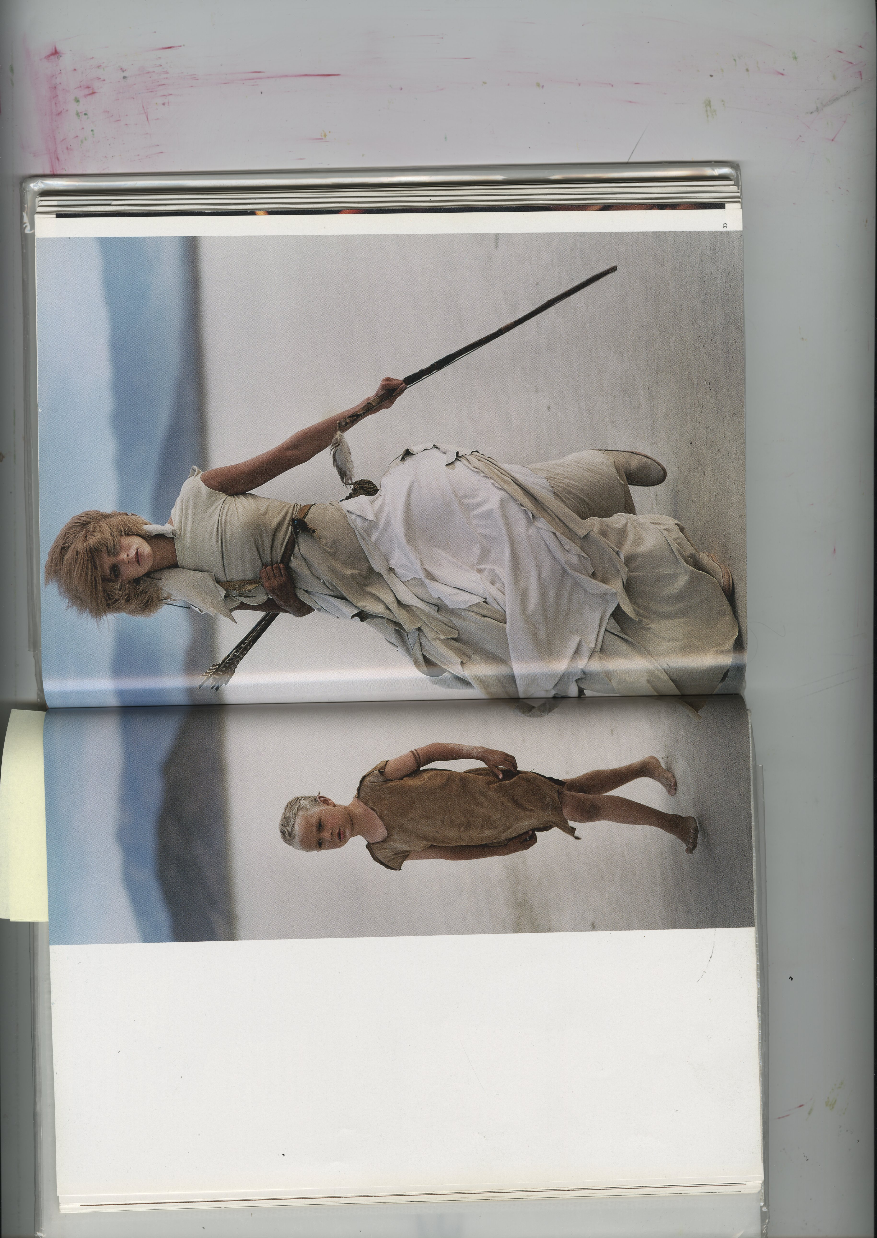 Yohi Yamamoto (2000-2001)

Sustainability

With sustainability becoming a growing trend within society, people are leaning towards more eco, health conscience lifestyles and ideologies; it makes sense that nature friendly choices effectively mean being kinder to the environment and ourselves. So why choose to be part of the growing sustainable fashion trend? The choices we make as consumers play a key role in what happens to our planet. More care is needed when paying special attention to alternative anthropological decisions; it is our personal responsibility to determine what we become involved with. Considering that a promoter of social change can address the sustainability issues in fashion and textiles, consumers can contribute to the reduction and elimination of negative materials and processes that are contributing to the persisting global challenges that are damaging to our surroundings. The implications that this can have on the environment, could have a major positive impact on how we shape our future.

materials play an emphatic role in our current understanding of the ways in which fashion and textiles can contribute towards sustainability. They are, more often or not, our starting point to change and a valuable commodity for farmer, designer, manufacturing industry, consumer and recycler which works to reinforce their role (Fletcher, 2014)

Links have been made between ethical practices and the state of mind with sustainability being seen as connected to the welfare of humankind as well as the natural environment. I shall be considering the work of Tony Fry and his resolve on the inadequacy of unsustainability; the need to progress with sustainable urban design.

When deciding on becoming a part of the sustainable fashion industry, which is usually quite different from the normal high street, you are no longer following the designated fashion branding. You have chosen to not be taken in by the psychological and dysfunctional behaviours of consumerism, instead choosing to be different and engage with fashion in a completely different way; moving away from the pluralistic fashion norms of today’s society. It is becoming increasingly more fashionable in contemporary society however to be eco-conscious and follow an ethically conscious lifestyle as promoted by bloggers and online. More fashion designers are following this trend and creating a sustainable fashion market however this is not becoming as widespread amongst everyday high street consumers.

Often clothing made from natural sustainable materials is not seen to be part of mainstream commercial fashion. Many fashion designers/ gurus would consider hemp and other natural fabrics as heavy and unsightly compared to the plush look and feel of other more elegantly textured fabrics. However some of these materials are cheaply produced for a fast fashion market causing damage to water supplies and the environment.

[I]n a sustainable society, the fashion industry will need to consider the relationship between people and their clothing (Black, 2002)

Hemp and other natural fabrics are more durable which is why they last longer, which is more cost effective in the long run. These natural fibres are also very warm and have a wonderful ‘drape’. Hemp also absorbs co2 whilst it grows, through natural photosynthesis, making it carbon negative, which means it also saves trees. The ideology of living a natural way of life is something that I will investigate further within this dissertation.

In a sustainable society, the fashion industry will need to consider the relationship between people and their clothing (Black, 2012)

Each small choice can make a difference, inspiring and influencing others to make greener choices too. John Thackara, a British born writer employs this thinking also, focusing on social and ecological design. Our choices can no longer be made blindly but greater consideration must be used to evaluate our decisions whether with food, clothing or furniture. Buying organically sourced quality materials can sometimes mean a more expensive price-tag, there is however another perspective;

buying long-lasting craftmanship, highest quality and unique items means they will be treasured for a long time, becoming heirlooms of the future. And contributing to a lower rate of consumption (Black 2008)

Natural materials

Choosing good threads and supporting ethical clothing companies that use eco-friendly, organic materials can help us to make the small changes needed within society. Many people are discouraged by the belief that choosing eco-friendly products can be more expensive and inconvenient. If more people were educated about the wider benefits of how the use and consumption of natural materials can have a positive impact on their lives and wellbeing, we could all live in healthy harmony with nature.

There is much that can be done on a personal level to bring about change. When we each take greater responsibility for the way we live, we can create so many personal advantages and obvious environmental benefits. Choosing to shop with companies that use renewable material resources such as leather, wool, silk and hemp or bamboo cottons that are environmentally friendly and can also be recycled, will play a key role in reducing the effects of global warming.

For the dissertation it is my intention to build case studies around natural materials such as Pineapple (ananas-anam.com, 2017) and mushroom leather. Both use natural products and chemical free processes to produce hardwearing leather that is both vegan and vegetarian. These ethically produced materials recycle whilst regenerating the natural world instead of damaging as many materials currently do. The purpose of this will be to examine the role of natural materials within material creation in juxtaposition with the more damaging cotton and silk processes for example, that are more relied upon within the fashion industry.

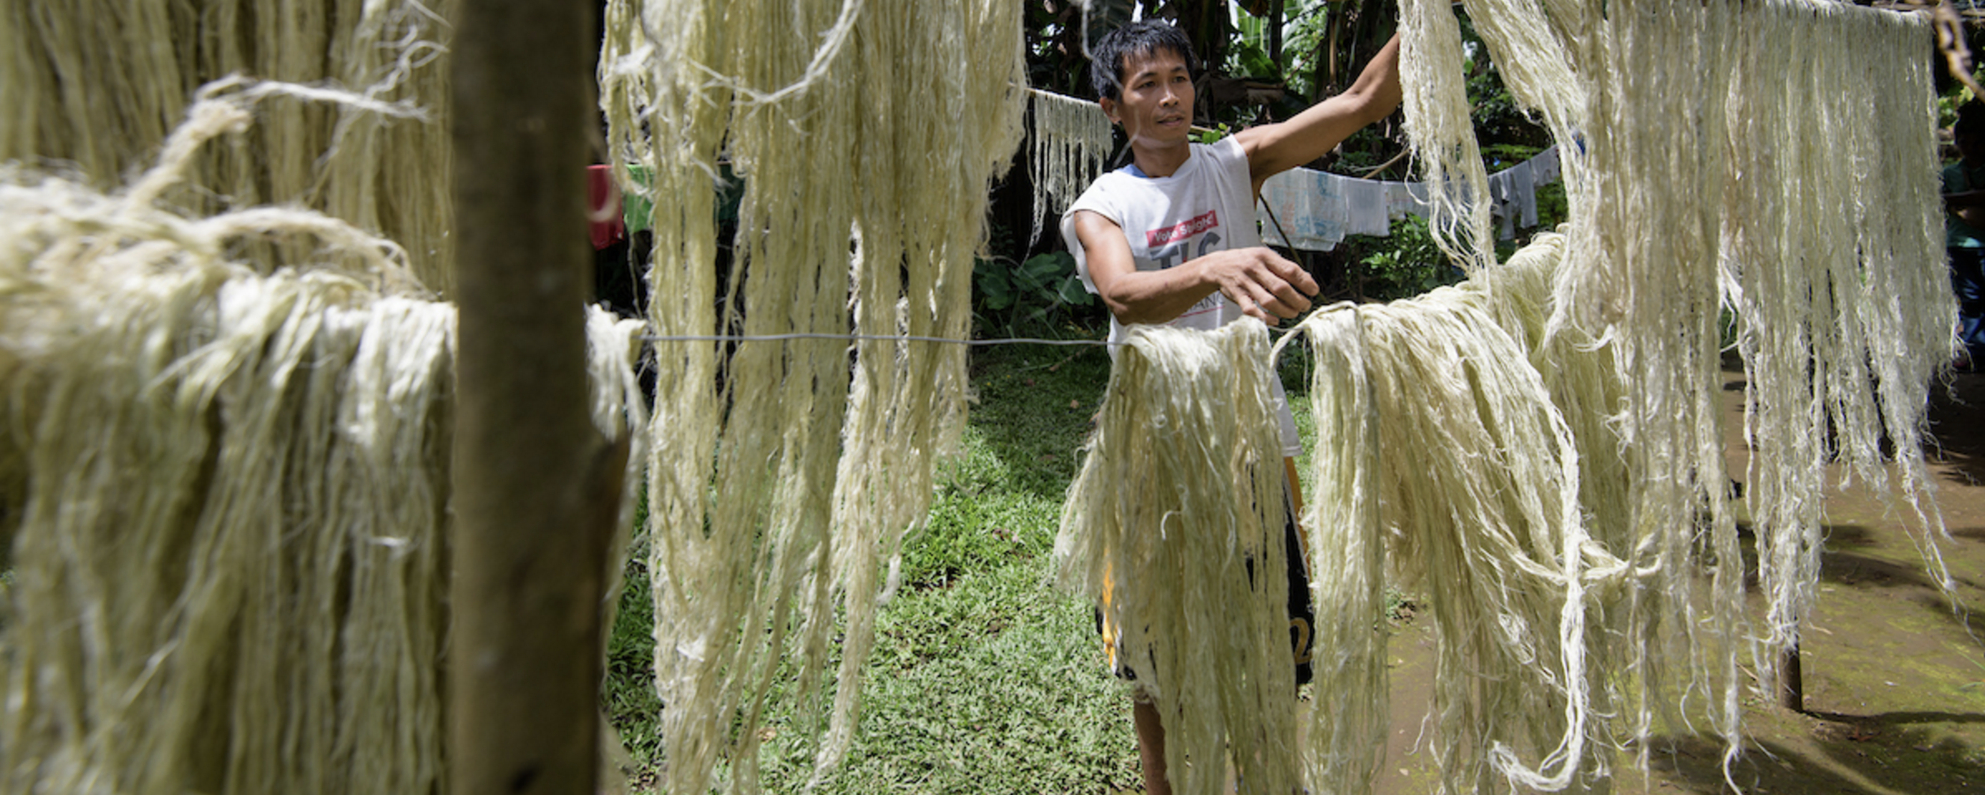
Image of the drying process of pineapple leaves. Pinatex (2017)

The growing universal problem, occurring from plastic and un-natural materials currently polluting our world, is a major concern. Choosing to purchase products made from natural and organic materials will mean a reduction in demand for raw materials; in the form of forest, fuels and chemical pollutants, it also means less goes to landfill. Small conscious changes to our choices when purchasing, means that everyone can make a difference to the planet, support the growth and development of ethical businesses and effectively pave the way for a cleaner, greener environment.

Yes, eco fashion must have the same qualities as less environmentally friendly fibres, for eco to be chic, design must lead the way (Black, 2008)

Looking back through history, originally traditions and ideologies were passed down through generations and this influenced the lifestyle they upheld and the materials they used. Clothing would be made from the products to hand whether by-products of food capture and adapted vegetation. These are processes we are now starting to admire within society as we become more aware of the damage being caused to the environment. These people were sustainable in terms of they caught what they ate and made clothes from the same lifestyle.

Dyed, natural fabrics have been found in pre-historic caves, which is evidence that plants were being used to change the colour of materials this demonstrates how textiles and fashion were an important factor in ancient traditions. Why would cloth be dyed other than for decorative, religious and symbolic purposes?

Within many plants lie hidden treasures- remarkable tinctorial properties that bring a myriad of hues to the dye pot for those with the knowledge to unlock their secrets (Dean, 1999)

It seems unreasonable that today’s society has changed the ways and traditions of the pre-historic natural dying techniques. Many now include the use of heavy toxic pollutants that are destroying our water supplies and are in turn damaging our eco systems and natural habitats.

using natural dyes from plants is a miraculous way of bringing the colours of nature into everyday life (Dean, 1999)

This is something I will focus on in more detail in the dissertation. I intend to investigate the nature of natural dyes, their production and integration within society today and their original use.

- Ideology
  - Emotional design
  - Tribal fashion

For this keyword I will investigate the ancient sociological traditions and ideologies of different tribe’s people around the world, specifically looking into their ethics underpinning fashion within their culture, and how fashion and emotions are interconnected.

Design is what draws us to fashion, the combination of colour, texture and the feel of the fabric coupled with how it makes us feel and look when we put it on is what makes it attractive (Black, 2008)

In the Oxford English Dictionary (OED)(2018) tribes are defined as..

a social division in a traditional society consisting of families or communities linked by social, economic, religious or blood ties, with a common culture and dialect, typically having a recognised leader.

The very first fashionistas of mankind were the natives. A group of people that lived with and off the land; “human beings are the only creatures that can consciously recognise themselves” (Gronin, 1997)

How we see ourselves and how we think others see us has a great importance to how we feel emotionally; people effectively refashion themselves as works of art.

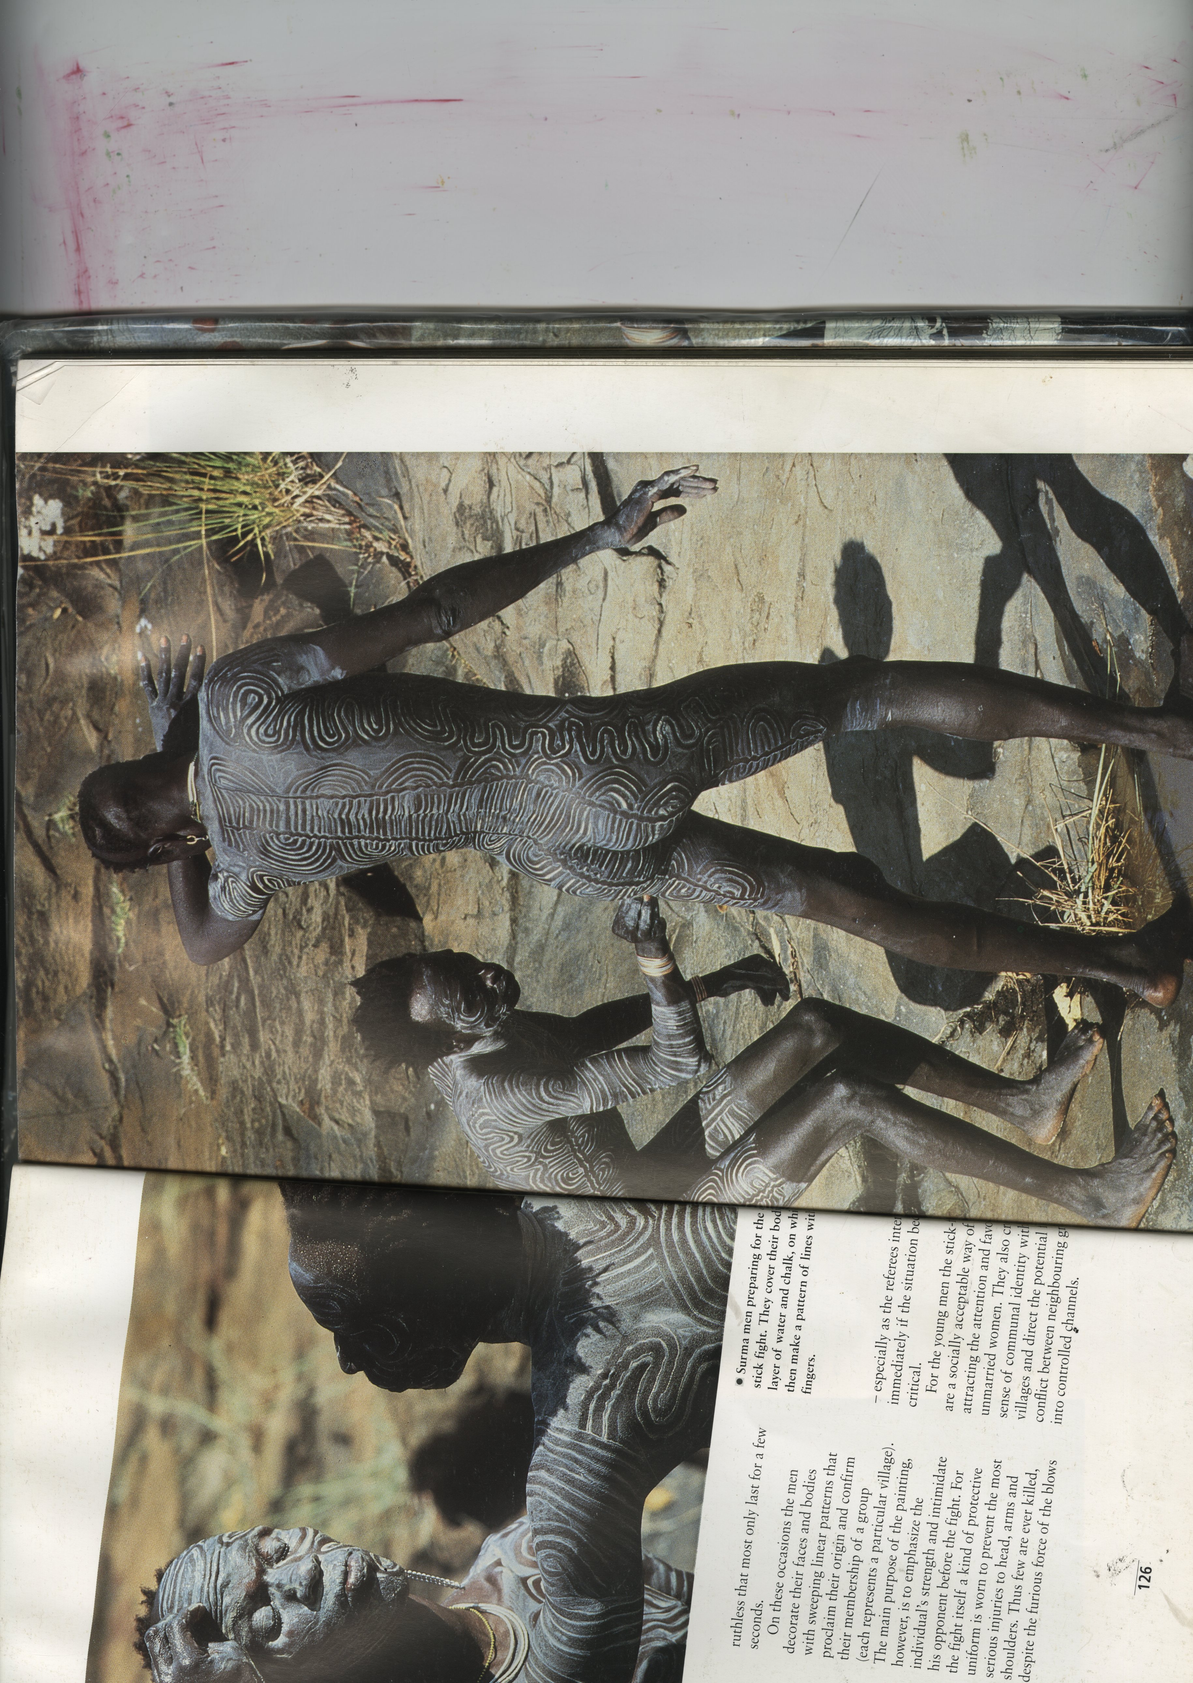 Surma men, (Estall)
[T]hrough art they show their relationship with society and at the same time demonstrate their personal self and creativity’s (Gronin, 1997)

Even after thousands of years the ideas and characteristics of humankind have much remained the same. To this day people still decorate themselves with threads, make up and adornments displaying this self- realisation of individualism through visual form.

The rise of the fashion industry through the millennia has seen a dramatic change in the social identities in which we now see ourselves, with textiles being a key element in how we determine our feelings and understanding of ourselves. We are effectively communicating through textiles and through what we decide to wear. Creating a persona of how you would like to be seen. This emotional design process has always been there, the only difference is that as humankind has evolved, we now cover ourselves with cloth rather than paint, still expressing ourselves, and placing ourselves into different social categories. An ideology formed through emotional connections, our emotions and how things make us feel, play a strong role in determining our choices.

Native people used natural materials to paint their bodies and it was the distinct patterns that separated them and told different stories about their social status. The native’s characteristics in terms of fashion were more than sustainable and ecological, using all-natural found or made materials to decorate themselves whether it be in cloth or paint, the principles are basically the same. Their ‘no waste’ ethics are admirable, using every bit of their kill or capture of food for decoration purposes; nothing was left to waste, something we could learn from today. We have the option of being more sustainable, yet many fashion brands choose to be less eco-conscious, and instead choose to save money, which in long term is neither sustainable nor environmentally friendly.

Making these morally and ethically sound choices has been said to increase your mental health and give ‘feel good’ emotions, as sub-consciously you are aware that it is a good choice to make. Within this I shall be examining the work of Jonathan Chapman whose philosophy is to not simply buy things with the aim of throwing them away but rather make educated emotional choices, instead attributing value to our possessions.

The clothes we choose to wear have a direct connection with our emotional selves. “Textiles as materials … signify the nature of cultural identity” (Fletcher, 2018) Whether they are passed down through family or cultural traditions and beliefs, we each make these choices whether they have been influenced by others or not, we make these choices from interconnecting with our emotions.

Kate Fletcher within her ‘Textile and Place’ conference describes textiles as:

a socially dynamic, communicative and active material offer[ing] a rich seam of enquiry into how textile participates in and influences our lives. (Fletcher, 2018)

Within the conference Kate discusses how textiles are interwoven with different concepts and this must influence how the material is understood; “textiles connect with the idea of place in its histories, its production, sustainable future ecologies and in its narratives of migration, sociability and politics” (Fletcher, 2018). This is an area I will investigate further within my dissertation considering the ideology behind the clothing choices we make; how it has become, with the move to sustainability, an emotional and moral choice as juxtaposed to the survival choice of early years.

Possible questions this report could lead to?

- How can designers use the notion of contemporary tribes to explore the use of natural materials in local communities?

- Investigate the impact of sustainability and ethics within the fashion industry today

- How has contemporary fashion utilised the concept of tribes creating a more ethical and sustainable fashion outlook/ concept?

Bibliography

Ananas-anam. 2017. Pinatex. [Online] Available at:< https://www.ananas-anam.com/about-us/ [Accessed on: 2 May 2018]

Black, S., 2008. Eco-Chic The Fashion Paradox. London: Black Dog Publishing

Dean, J., 1999. Wild colour. The Complete Guide to Making and Using Natural Dyes. New York: Watson-Guptill Publications.

Estell, R., photographs. Berlin: Staatliche Museen zu Berlin-Preussischer kulturbesitz

Fletcher, K., 2014. Sustainable Fashion and Textiles- Design Journeys. 2nd ed. Oxon: Routledge.

Groning, K., 1997. Decorated Skin-A World Survey of Body Art. London: Thames and Hudson Ltd.

Manchester Metropolitan University. 2018. Faculty of Arts and Humanities- Textile and Place Conference. [online] Available at:
<https://www2.mmu.ac.uk/artshumanities/rah/events/detail/index.php?id=8175 [Accessed on: 3 May 2018]

Pinatex, Photograph. Drying process of pineapple leaves[Online]Available at:>https:/www.ananas-anam.com/about-us/[accessed on:2 may 2018]

The Metropolitan Museum of Art., 2004. Wild Fashion Untamed. New York: Yale University Press.

Yamamoto,Y,. Photographs. Esemble: 2000-2001. Vogue- conde nast publications inc. photograph: Arthur Elgort. Wild, fashion untamed.

