
BA Business Management
Assignment 2

Module Name: ACADEMIC SKILLS
Module Code: LCBB4006
Lecturer: Dr Lizeta Demetriou

Student Name and ID: Veaceslav Stanciu 2131027
Elena Daniela Tirpan 2133460
Razvan Pavel Mocanu 2131739
Maria Alexandra Chesoiu 2123374
Adem Saudy Zarbash

Submitted on: 20th August 2022

Table of Contents

- Introduction 3
- Motivation 4
  - Concept 4
  - Theories 4
  - Methods and types of motivation 6
- Time Management 7
  - Concept 7
  - Steps to effective time management 8
- Critical thinking 9
  - Concept and short explanation of why critical skills matter 9
- Conclusion 10
- References 11

Introduction
In academic and professional life, the key responsibility for success lies on the individual. Therefore, in order to succeed either in their academic or professional life, individuals must develop a set of skills. These can be classified in two groups: soft skills and technical skills. Soft skills are transferable, meaning that they are not designed for a specific job only, for example communication, time management, problem-solving, team work and others, whereas technical skills are the skills needed to perform specialized tasks in a particular profession, job or industry, for example computer programming, mathematics, or law.
In order to understand more about the skills mentioned above this group report will discuss few of the soft transferable skills: motivation, time management and critical thinking skills and their importance for academic and professional success.
In the first section, the report will discuss the concept of motivation, will evaluate the theories and the methods of motivation.
In the second section will focus on the discussion about time management and its importance in workplace.
Third section is dedicated to discuss what is critical thinking and why do critical thinking skills matter as well as highlighting some barriers to critical thinking.
Lastly, the report will summarise the entire discussion into a conclusion.

Motivation

Concept
Motivation is extremely important in succeeding not only in the life as a student but also in your career. According to Ebert and Griffin (2013), motivation is the set of forces that cause people to behave in certain ways. But certainly, the set of these forces can vary from a person to another person because individuals are not the same. Therefore, there are some reasons that could apply for everyone for instance the need to earn money in order to survive, however some reasons have more importance for particular individuals than from others, for example some workers can be motivated by money only, whereas other employees can be motivated by the prestige of their job (Hall et al, 2008).
As mentioned above motivation can definitely make people to achieve great things, not only in their professional life but also in every aspect of their life but the level of motivation can affect individual’s success. Therefore, when referring to professional work, motivation it is extremely important and can have multiple benefits in the workplace such as increasing productivity, improves employee satisfaction or fosters innovation and creativity (Indeed, 2021). On the other hand, the lack of motivation can have negative impacts for both, the individuals and organisation they working for. For instance, in the short run a lack of motivation can lead to reduced effort and lack of commitment from the employees when in a long term, this may result in high levels of absenteeism and falling productivity and profit for a business (Hall et al, 2008).
Having defined what is motivation and why it is important, the report will now move on discussing some of the theories.

Theories
In order to establish different reasons of motivation at workplace and to understand why people get motivated by different things, some experts have tried to explain these through different theories. According to Hall et al (2008) the theories of motivation can be categorised in two main groups, content theories of motivation and process theories of motivation. The first group explains the specific factors that motivates people and includes the following theories: theory of Maslow’s hierarchy of needs theory, Mc Gregor’s Theory X and Theory Y, McClelland managerial needs and Herzberg’s two factor theory. The second group of theories are focused on the processes that influence behaviour. This group includes Vroom and Porter-Lawler’s expectancy theories and Adam’s equity theory (Hall et al, 2008).
In the next section, the report will discuss and explain in more detail one each of the theories from these two groups.
Maslow’s Hierarchy of Needs is part of content theories and was proposed by the psychologist Abraham Maslow in 1954. This theory explains that people have multiple different needs that they attempt to achieve in their workplace, therefore Maslow has classified these needs in five needs and the hierarchy is presented as a pyramid with each level consisting a certain class of needs. The needs are hierarchical because lower needs are basic needs concerned with survival which must be met before a person can move to the higher-level needs (Ebert and Griffin, 2013).
Having explained what Maslow’s theory is, in the next paragraph the report will analyse the five classes of needs providing examples related to the professional work.
Physiological needs are the first class of needs located at the base of the pyramid, for example good working conditions or enough wages to be able to pay for food, medicine or bills.
Second class are the safety needs and this includes job security or safe working conditions. Third class of needs refers to love and belonging and includes teamwork or communicating with others. The fourth class of the pyramid is esteem needs and refers to needs like recognition for carrying out well in the job. And lastly, at the top of the pyramid, the fifth class are self-actualisation needs, for example being promoted and given more responsibility (Hall et al, 2008). According to this theory each level of needs depending on the level below. For example, an employee has been motivated at work by the opportunity to take on more responsibility but finds that his position is at risk to be made redundant. In this case, the pyramid theory fails as the employee’s motivation will go back on the physiological needs as the need to feed and provide for him and his family becomes again the most important.
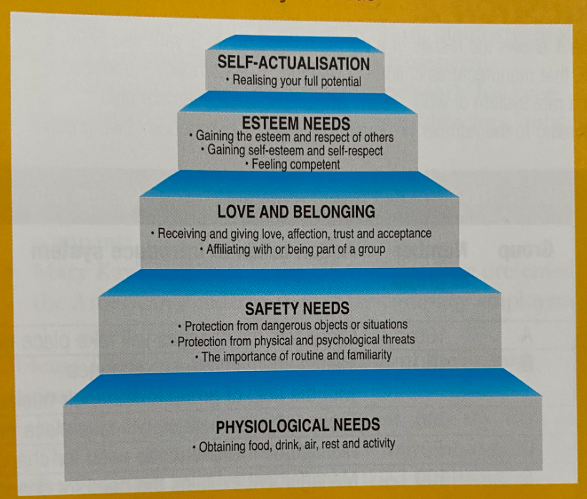

Figure 1. Maslow’s hierarchy of needs (Hall et al, 2008)
Now, the report will move on to discuss Adam’s equity theory which according to the classification above is part of the process theories. This theory suggests that people are evaluating the way they are treated by their organisation by comparing to the treatment of others. This approach explains that in return for an input for example effort or skills the employee receives an outcome for instance pay, status or some benefits. Therefore, this creates a ratio of input to outcome and equity is achieved when the ratios are the same in the organisation (Hall et al, 2008). However, according to Ebert and Griffin (2013) the two ratios do not have to be identical, only equitable. For example, a new employee with a bachelor degree and two years’ experience comparing his salary with another employee with an advanced degree and 10 years’ experience. At first this may come across as inequity however the new employee may conclude that the person who he was comparing is actually contributing more to the organisation. To conclude this, individuals are more likely to feel motivated at their workplace when they feel that they are treated equitable and fairly.
This section with theories of motivation has demonstrated that individual’s motivation can be influenced by different particular factors and that the individuals are feeling much more motivated when their needs or expectations regarding their job are satisfied. The next part of this report will briefly discuss some of the methods and types of motivation.

Methods and types of motivation
According to Hall et all (2008) for a long-time financial reward has been used to try motivate people at workplace, however some of businesses have realised that the financial reward is not sufficient and cannot be applied to every individual, therefore, they have started to design some non-financial methods to motivate. Financial methods of motivation refer to the financial incentives made by employers in order to motivate such as salaries and wages, profit sharing, performance related pay and shared ownership while non-financial methods of motivation take in consideration the other factors which may be important in motivating employees rather than money, for example job design and redesign, job enrichment, team working, participative management and empowerment, work-life balance.
According to Indeed (2022), one of the biggest employment websites, the types of motivation can be classified in two big categories: Intrinsic and Extrinsic. Intrinsic motivation refers to the motivation where the individual wants to do a particular task because finds it personally rewarding and includes competence and learning motivation, attitude motivation and creative motivation. Extrinsic motivation referrers to the motivation which comes from an external source and includes achievement motivation, affiliation motivation and incentive motivation.
This section has discussed some of the methods and theories of motivation highlighting once again the idea that ever individual is different therefore for one person can apply one of the methods and types when for another person applies absolutely different one. The next part of this paper will discuss another important skill, the time management and its importance for academic and professional work.

Time Management

Concept
Similarly, to the subject discussed above about motivation, time management skills are also extremely important not only for academic and professional life but also personal life. According to Cottrell (2019) time management is an essential key element for success in academic and professional work. In other words, we can say that time management skills are associated with the productive use of time whilst studying or working.
According to Hall at all (2008) there are some factors which need to be considered when deciding how much time to take to study or work. Firstly, it is important to set when to start and when to finish by setting up some deadlines.
Secondly needs to establish how long it will take, for example in academic work some pieces of work can take longer than others such as a project will take longer while short answer questions will take less time. Thirdly, establishing how long to work because the length of time spent can affect its quality. For instance, when referring to the professional work, it is normal that some people work some extra hours on top of their normal work schedule, however if they constantly work those extra hours this can lead into burn out which can then lead to other consequences such as health issues or absenteeism. And lastly, when to study or work, this will depend on the individual’s availability. For example, if the person has a family and have to look after their children the part-time work or flexible hours work programmes may be the suitable option for them.
Similarly, to Hall et al, Cottrell (2019) suggests that for example, for academic success it is extremely important how much time the student spends in studying and how well the student uses that time. In author’s perspective these two factors can help students to achieve high results.
This section has discussed what time management skills are and what it refers to, next section of this report will analyse what are the steps to effective management and how these steps can help to improve individuals time management skills.

Steps to effective time management
According to Cottrell (2019) there are some steps which can be followed in order to improve time management skills.
First step is being systematic, this means that planning how to use time and working out how best to manage time in order to achieve daily priorities can actually be a good start on developing time management skills.
Second step is to find out time requirements. Here the author refers to look for the activities which needs to be completed and to find out how much time each activity would take.
Third step is to clarify how the individuals currently using their time, referring to list all the activities they are currently carrying out and to understand where the time is spent more and where can be adjusted, for example by reducing the time spent on their phone.
Next two steps coming hand in hand. Deciding how the individual want to use time and prioritising what is most and least important. Essential is to decide how long it would take for each activity to be completed as well as how much time the individual is willing to spend on each of those activities as well as to know which activity is most important needing completion as soon as possible and which activity can be left for later. For example, if the individual has a set deadline for an upcoming project but at the same time has to work on other small projects but without a deadline, then it would be helpful to focus his attention by spending more time on the biggest project.
Again, next three steps can easily be combined together. These are plan and do it and apply time management techniques. The author here suggests that after making a clear plan about spending time then this plan need to be put in action. This way the individual would find out if the plan is working well. Also, when putting in action the individual may use some techniques or time-saving strategies for example when writing a report, the individual can use word limit technique to focus the energy.
In end, the last two steps are managing the distraction such as understanding what distracts the individual to follow the plan and monitor, meaning to stick to the plan and making adjustments where needed (Cottrell, 2019).
Having discussed about time management and the steps which can improve time management skills, the final section of this report will discuss the critical thinking skills and its impact in academic and professional life.

Critical thinking

Concept and short explanation of why critical skills matter
Similarly, to the other two soft skills described above, critical thinking skills is a transferable skill which can be developed. In her book, Critical thinking Skills, Cottrell (2017) explains that ‘‘critical thinking is a complex process of deliberations which involves a wide range of skills and attitudes’’. According to Indeed (2022), critical thinking is a key soft skill which helps individuals not only to solve problems but also to be better in everything they do, for example to do a good job in their workplace.
The definitions given above emphasizes the importance of critical thinking skills for academic and professional success. A good critical thinking gives the individual not only the ability to identify his own and other people’s views but also offers the possibility to see the world with different eyes for example by noticing what is more significant which can then help the individual to make more accurate decisions regarding a particular problem. Furthermore, critical thinking skills is useful on helping people to make decisions about where to focus their energy and time as well as helping to make life choices (Cottrell, 2017).
While critical thinking skills are valued in colleges and universities is also highly recognised by employers, especially in the industries where preparing strategy is part of the job. Furthermore, in this situation, in their interviews, employers often would ask a series of questions that would involve critical thinking, this way they can test candidate’s critical thinking skills. Sometimes people with a critical thinking are considered the ones ‘‘thinking outside the box’’, meaning that their judgement, problem-solving and evaluation abilities are on a higher level comparing to others.
In conclusion, critical thinking skills are very important skills and brings multiple benefits to those people who have and uses in a correct manner.

Conclusion
The report has discussed three of soft skills and explained why they are important for academic and professional work success.
First skill discussed was motivation. We, the members of the group decided this to be discussed at the very beginning of the report because we believe that with a good level of motivation a person can achieve almost everything. Also, motivation makes individuals to be eager to carry out the activities in a more pleasant manner rather than feeling obliged to do them or having the feeling ‘must be done’. Having motivation means having expectations of some kind of results and we believe that this is a factor which can drive people to work hard.
Then, we discussed time management and its importance. We chose this to be a second skill because we believe motivation and time management are closely related. Sometimes being motivated to achieve certain things just is not enough without taking in consideration the time when those things must be achieved.
Lastly, we discussed the critical thinking skill because we consider that this particular skill can give confidence in taking more complex problems and challenges which would bring greater results.
In conclusion, we believe that having motivation, strong time management skills and good critical thinking can bring success.

References

- Cottrell S., 2017. Critical Thinking Skills: effective analysis, argument and reflection. 3rd Edn. UK, London: Red Global Press
- Cottrell S., 2019. The study skills Handbook. 5th Edn. UK, London: Red Global Press
- Ebert, R.J. and Griffin, R.W., 2013. Business essentials. 9th Edn. Edinburg Gate, Harlow: Pearson Education.
- Hall D., Jones R., Raffo C. and Anderton A., 2008. Business studies. 4th Edn. Edinburg Gate, Harlow: Pearson Education.
- Indeed, Editorial Team (2022). 6 Common types of Workplace motivation. Available at www.indeed.com/career-advice/career-development/types-of-workplace-motivation [Accessed: 12 August 2022].
- Indeed, Editorial Team (2021). 35 Examples of motivation in workplace. Available at www.indeed.com/career-advice/career-development/examples-of-motivation-in-the-workplace [Accessed: 12 August 2022].
- Indeed, Editorial Team (2022). Critical Thinking: What It Is and Why It's Important. Available at www.indeed.com/career-advice/career-development/importance-of-critical-thinking [Accessed: 12 August 2022].

