

Msc Public health and social care in Practice
Module Title: Quality Assurance and Service improvement
Module Code: LCHS7006
Student Name: Ikechukwu Nzediegwu
Student ID: 2226941
Institution: University of Wales, trinity saint David
Assignment Title: Component 2 - Service Improvement Report
Lecturer: Christopher Mafuva
Submission Date: 14th august 2026

ACKNOWLEDGEMENT

I hereby acknowledge the use of AI for the proof reading of this report.

Table of Contents
Introduction 3
Fishbone Diagram Analysis 4
5 Whys Analysis 7
Donabedian Model Analysis 8
SWOT Analysis 9
Recommendations and Implementation Strategies 11
Conclusion 14
References 15

Component 2 - Service Improvement Report

Introduction
From a public inquiry led by Sir Robert in 2010, a report was published in 2013 indicating the higher-than-normal mortality rates and appalling hospital conditions at Stafford Hospital in England. This was his second inquiry into the hospital, the first one being in 2009 after there were widespread concerns about patient care in the hospital. Mid Staffordshire NHS Foundation Trust managed Stafford Hospital and Cannock Chase Hospital in Staffordshire, England. The trust achieved foundation trust status in February 2008, which meant that they had more autonomy and freedom from the government’s Department of Health. This pursuit of foundation trust status would later be cited as one of the major root causes of the scandal that the hospital faced. Between 2005 and 2009, there were a total of 4,253 deaths in Stafford Hospital, 2,510 of which were examined by the coroner (Weinberg, 2013).. There were rising concerns that the Trust’s mortality rates were higher than average as compared to other trusts, which led to an investigation by the Healthcare Commission in 2008. Reports later showed that there were as many as 400 avoidable deaths between 2005 and 2009, indicating the severe patient neglect and poor hospital conditions at Stafford (Weinberg, 2013).
The quality concern experienced at Stafford Hospital was poor patient care leading to unnecessary deaths, poor quality of life, and misdiagnosis. Many patients, their relatives, and friends complained about the level of care they received at the hospital, citing cases where relatives lacked food and basic hygiene attendance (Vizard and Burchardt, 2023). The concerns at the hospital boiled down to poor management and oversight by the NHS trust, where there were limited feedback mechanisms, escalation techniques, and quality management policies. As the trust sought foundation status, they cut back their expenses to balance their financial statements, which led them to reduce staff and equipment available at the hospital. This means that the hospital was severely understaffed and the available staff was burnt out, leading to poor quality of care. It also meant that untrained staff such as receptionists were responding to triage and leading to dangerous patient delays and misdiagnosis of critical conditions (Stirton. 2017). The trust was able to achieve foundation trust status because the reports indicated that their level of care was sufficient, which was backed by their financial reports that showed the hospital was doing well. In reality, the trust had prioritised cost-cutting over patient safety, while the system continually ignored rising complaints from patients and various warning signs, including rising mortality rates (Bright, 2025).
The purpose of this report is to highlight and examine the public health issue at Stafford Hospital using a thorough root cause analysis through various methods, including the fishbone diagram, the 5 Whys, and the Donabedian model. It is a service improvement tool that will also include analysis of the hospital using the SWOT analysis and include other real-life examples that the stakeholders could have applied. The report includes recommendations based on the root causes, and how they could be implemented using a hybrid approach of Plan-Do-Study-Act (PDSA) tools and Lean principles. These frameworks can guide service improvement initiatives in a quality-focused environment such as hospitals, reducing cases of avoidable deaths and poor patient life quality.

Fishbone Diagram Analysis
A fishbone diagram is an effective way to visually map out all the possible causes of a given problem using a fish-like skeleton to divide various causes into logical sub-sections (Kumah et al., 2024). The main issue being solved is placed at the head of the fish, which in this case is the patient neglect and poor quality of care delivered at Stafford Hospital. The main logical subdivisions can be categorised into people, processes, environment, policies, measurements, and resources. Under the people category, the hospital was experiencing staff shortages, given that about 150 nurses were laid off from their jobs in a bid to cut expenses of $10 million from their budget (Powell, 2023). The culture of fear and silence at the hospital led clinicians and other staff to avoid raising concerns. Furthermore, patients highlighted in many cases that the available staff in the hospital was uncompassionate and insensitive to their needs, which could be a result of the severe workload at the hospital.
Under the process category, there were various inefficient systems in the hospital, including incident reporting systems, escalation procedures, and complaint management. Since the trust was focused on achieving foundation trust status, they ignored patient complaints and dismissed any clinical updates in terms of necessary feedback systems. In the case of Julie Bailey, the famous whistle-blower in this scandal, she reported how her mother was attended to by untrained staff due to absence of trained personnel, leading to delay in her care until she died eight weeks later (Edwards, 2021). This case demonstrates the weak processes and systems that were in place at the hospital leading to lack of trained personnel and sufficient reporting mechanisms. Under the environment category, there was excess workload, low staff morale, poor sanitation, and resource constraints in the hospital (Bass, 2023; Leamy et al., 2023). The nursing shortage meant that there were less trained personnel left to care for patients in need of urgent care, hence the ones available excess workloads. The report by Sir Francis highlighted that these nurses were desensitised to patients’ needs, which led to low patient satisfaction (Francis, 2013). The nurses who tried to speak out felt ignored, which lowered their morale and perpetuated a culture of silence. Sir Francis reported the extremely poor hygienic conditions in the hospital, where used bandages were left in public areas and patients’ need to use the toilets were ignored such that they soiled themselves on the hospital sheets (Campbell, 2013).
In the bid to reduce expenses, resources were heavily limited at Stafford Hospital. The report by Sir Francis from the public inquiry indicated that food and drinks were out of the reach of patients, forcing them to rely on their relatives for such basic needs (Francis, 2013). The available water was provided to patients to drink from water vases instead of proper utensils. This indicates that there was poor oversight over resources by the management, indicating a flow in budget management and resource distribution (Boakye et al., 2021). Under the policies category, there were various concerning policies in place which led to poor patient care, including excessive focus on national targets and inadequate policy monitoring frameworks. The trust board governing this hospital was focused on achieving foundation status, which led them to focus more on financial access rather than patient-focused care. Another issue that is highlighted is the fact that regulatory bodies such as the Healthcare Commission, Monitor, and the Care Quality Commission had failed to address these issues early on, indicating poor monitoring frameworks available (Dacre et al., 2024). These bodies relied on self-reported results and operated in silos most of the time, which led to systemic blindness so that an organisation assumed the other was doing the necessary oversight (Entwistle & Doering, 2024). Under the measurements category, there was an overreliance on financial indicators rather than qualitative measures such as patient safety and care satisfaction. These measures should complement each other to ensure that a hospital remains sustainable while delivering high-quality care to its patients.
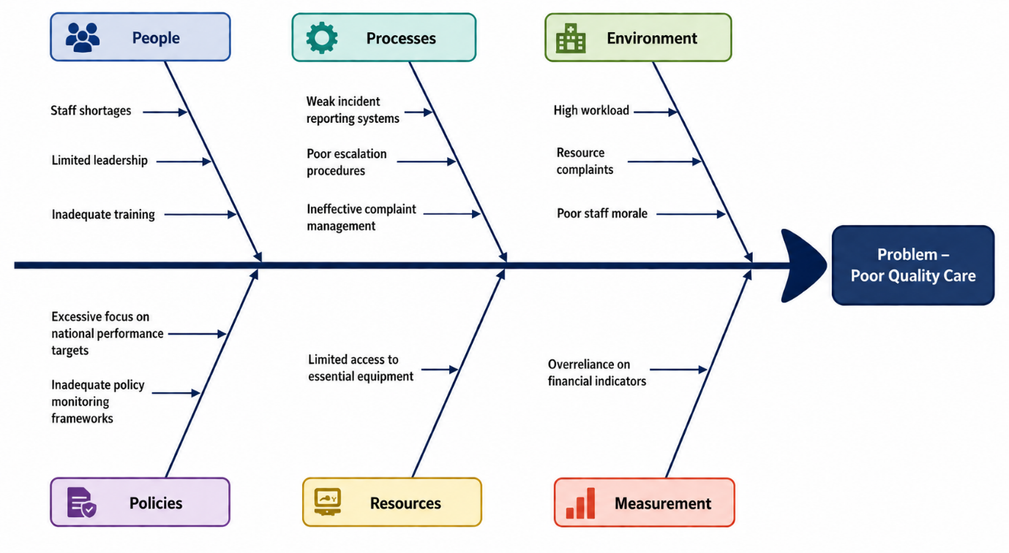
Figure 1: fishbone diagram

5 Whys Analysis
The 5 Whys analysis is an iterative technique used to explore the root cause of a problem by asking questions until one reaches an actionable solution (Mukti & Rochmoeljati, 2026). The answers should be based on facts and focus on processes rather than people to find out what caused something adverse to happen. In the case of Mid Staffordshire NHS Foundation Trust, the main problem is that patients were not receiving quality care at the hospital (Peerally, 2021). After asking the first ‘why’, a possible answer could be because the wards were critically understaffed due to nurse shortage, which led to the available nurses being unable to cater for all patients. The next question should be why the hospital was understaffed, and the reason is because the management had cut costs by a big margin, causing the hospital to reduce their nurses by about 150. The next question is why the hospital management was cutting costs by such a big margin, whose answer is because they wanted to acquire foundation trust basis through their financial balance. After this, the next question is why the organisation was focusing on acquiring financial status while overlooking quality indicators of health, and the answer is because external organisations such as the government rewarded such financial targets over the actual care metrics that show the quality of care received by patients. The final question shows that the issue is systemic, because the reason why the government rewarded financial compliance was because of poor organisational culture and toxic corporate cultures. Therefore, change could only be achieved by changing the culture and prioritising patient care from the national level, to the hospital level, and to the community level.

Donabedian Model Analysis
The Donabedian model is a healthcare framework which focuses on three core dimensions of health systems namely, structure, processes, and outcomes. It evaluates healthcare effectiveness by using a basic link whereby sound structures enable proper clinical processes, ultimately leading to excellent patient outcomes (Endeshaw, 2021). There were fundamental structural failures at Mid Staffordshire NHS Foundation Trust, as there was inadequate staffing, poor leadership frames, and limited resources. The trust board governing the hospital was in charge of resource and labour allocation, but they opted to cut costs without considering their resource requirements. This is an indication of poor governance structures and decision-making, as it ignores hospital evidence and requirements (Herepath & Kitchener, 2016). There was also inadequate staff which made attending to patients ineffective, as well as lack of basic resources such as food and water.
The hospital also failed in its clinical processes, as there were communication breakdowns, poor feedback mechanisms, and inadequate incident reporting. Communication breakdowns occurred such that nurses failed to relay information appropriately to patients, while patients could not communicate their concerns as well. Despite there being a reporting protocol in place as required by regulatory bodies, there was no feedback or action taken to address complaints (Barach & Phelps, 2013). This is shown by how patients tried reporting their concerns for a while without seeing any changes. Furthermore, there was poor incident reporting which led to untrained professionals taking over other roles that compromised patient lives. For example, Julie Bailey reported that her mother was dropped on a chair by untrained staff without being given the oxygen treatment she needed (Edwards, 2021). Since there were weak structures in place, clinical processes were flawed and failing, which led directly to poor patient outcomes, increased mortality, and declining public trust in the NHS.
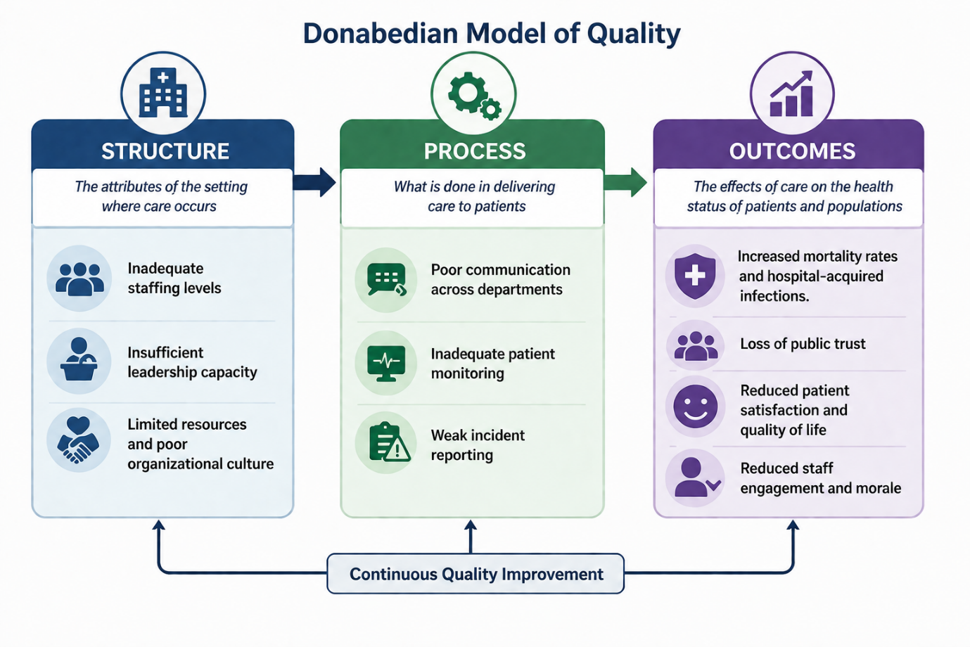
Figure 2: Donabedian model of quality

SWOT Analysis
A SWOT analysis is a framework used to analyse the internal strengths and weaknesses an organisation faces against the external opportunities and threats, which helps in making informed decisions and improve quality. In the case of Mid Staffordshire NHS Foundation Trust, a SWOT analysis can indicate how internal factors interacted with external pressures leading to serious failures in delivery of patient care. Some of the strengths of the hospital at the time included its achievement of foundation trust status and achievement of national targets. Since the trust had achieved the coveted foundation trust status, it had more financial and operational autonomy. It was focused on achieving financial metrics and reaching government standards in terms of waiting times and performance, which put them in a good position with the regulators at the time (Thomas & Cooper, 2020). The weaknesses of the institution included poor organisational culture that prioritised financial achievements over patient care, severely low nursing staff levels which led to burnout and poor nurse-patient engagement, and fragmented communication systems that meant issues were not properly escalated or addressed (Entwistle & Doering, 2024). This led to the eventual public outcry due to poor patient care, which eroded public trust and damaged the reputation of the NHS.
The institution had various opportunities, including community engagement, expansion of services, and advancement of digital technologies. As a district general hospital serving a large local population, Stafford Hospital had an opportunity to gain community trust and become a reliable regional healthcare provider. Instead, the hospital dismissed patient concerns and had an ineffective complaint system, leaving professionals disengaged from the patients. As a foundation trust, the hospital had the opportunity to expand its services and acquire more dominance in the region. However, the nursing shortages and resource limitations made it challenging for them to scale (Rafferty & Leary, 2023). They could have made use of digital technologies for monitoring patient outcomes and automatic reporting systems. The threats that the hospital faced include financial pressures, the need to achieve national performance targets, and reputational risks. There were financial pressures across the NHS that required them to maintain financial balance to achieve foundation trust status, which led them to cut costs aggressively (Staffordshire, n.d.). The need to achieve targets set by the government such as standard waiting terms threatened to shift focus away from patient care, which led to poor quality of care. Furthermore, the organisation risked a poor reputation that followed once their poor standards were exposed to the public, which led to its dissolvement and extensive legal costs (Martin, 2023).

Recommendations and Implementation Strategies
Based on the root cause analysis tools, it is evident that there is need for organisational change within the NHS to improve patient care. By improving systems, everyone can be encouraged to adhere to ensuring patient safety by being accountable at all levels to achieve better patient care. Some of the recommendations to improve organisational culture include patient-centred care, clear and working incidence reporting mechanisms, professional training channels, improving staffing governance, integrating digital monitoring tools, and better collaboration between regulatory bodies. Patient-centred care is one of the most critical recommendations offered by Sir Francis, as he encouraged healthcare organisations to always prioritise patient healthcare (Francis, 2013). The shift in priorities from patient-centred care to financially driven goals at Mid Staffordshire NHS Foundation Trust led to adverse outcomes, including poor reputation and financial loss. Being a safety-critical industry, it is critical for hospitals to provide basic rights, prevent avoidable harm, and deliver high quality of care to patients. There should be clear and working incidence reporting mechanisms to ensure that the needs of patients and frontline staff are adequately attended to. While Stafford Hospital had incidence reporting systems as a mechanism, they were not functional, which led to breakdown in various communications between patients and hospital administrators (Delpino et al., 2023).
Professional training channels are essential when it comes to training and recruiting staff into hospitals. In the case of Stafford Hospital, untrained staff such as receptionists were left to attend to patients and triage requirements, which led to fatalities and misdiagnoses (Stirton, 2017). To counter this, it is essential for hospitals to put in place various professional training channels for all staff to learn basic attendance skills such as first aid, bedside manner, and infection control actions. These channels should also be applied to leaders to teach various leadership styles such as transformational and servant leadership, which are essential in hospital settings. It is essential to improve staffing governance by having regulatory and government bodies examining the nurse-to-patient ratio and nurse satisfaction rates, ensuring the staff is well-take care of and has proper work-life balance (Tuckwood et al., 2025; Morgan, 2022). This ensures that by taking care of the needs of nurses, they can deliver quality care to patients without being overwhelmed or working under environments with heavy resource restrictions. Furthermore, another recommendation is integrating digital monitoring tools, where hospitals have easily accessible dashboards dedicated to storing patient information securely (Bolous et al., 2023). The management and hospital personnel can then use the information to improve care metrics, identify warning signs, and respond to various concerns. Another essential recommendation is ensuring better collaboration between regulatory bodies because, as highlighted by Sir Francis, working in fragmented manners meant that one institution would assume the other was performing necessary regulatory work (Francis, 2013; Martin et al., 2023). Instead of having such assumptions, it is essential to have one regulatory organisation performing the necessary oversight to ensure compliance standards are thoroughly adhered to.
Implementing these recommendations requires such as tools as Plan-Do-Study-Act (PDSA) and Lean principles. PDSA is a tool that originates from the work of Deming and can be applied in healthcare contexts to implement and evaluate action plans. It involved a four-stage process as highlighted, where the planning phase involves defining the specific problem an organisation is facing and setting measurable objectives to address it. The issue at Stafford hospital is poor quality care, and the recommendations such as professional training, patient-centred care, staffing governance, and integration of digital monitoring tools are the objectives (Wosny et al., 2023; Jamil et al., 2020). In the implementation phase, these issues are introduced at a small scale using a pilot project to observe their effectiveness while minimising their risk. For example, the pilot project can be conducted in one section of the hospital to observe its benefits and adverse effects, after which it can be scaled accordingly. In the study phase, the qualitative and quantitative data from the intervention are collected and examined, which helps in identifying risks and measuring them against the benefits achieved. After the study phase, the acting phase is implemented, where the gathered data is used to refine and standardise processes before they can be scaled within an organisation. This is an iterative approach in implementing changes that enables organisations to learn from past mistakes and use evidence-based data to improve outcomes.
Lean principles are methodologies that focus on eliminating waste while providing added value to the consumer, and they can complement the PDSA tools to ensure effective implementation of various recommendations. According to lean, five core principles namely value, value stream, flow, pull, and perfection are conducted in an iterative process to improve efficiency while reducing costs (Kumah et al., 2024). In this process, value is about determining what a consumer is willing to pay for, which is safe and effective care at Stafford hospital. Any action that is not contributing to delivering safe and effective care should be eliminated, which should lead to improvements such as increased staffing and improved hygienic levels (Umoren et al., 2024). The rest of the processes include mapping every process to ensure it brings value (value stream), processes are running without delays (flow), work is only done when the customer requires it (pull), and continuous improvement is achieved.

Conclusion
This report highlights the case study of Mid Staffordshire NHS Foundation Trust Scandal, one of the biggest scandals within the NHS UK. This scandal highlighted systemic issues within trusts in the NHS, indicating their financial-focused approach in safety-critical area such as hospitals. In this hospital, the bid of the trust to achieve foundation trust status led them to shift their priorities from patient-cantered care and focus on cutting costs to simulate financial stability. This resulted in unnecessary patient suffering as patients experienced poor quality health, common misdiagnosis, premature deaths, and loss of dignity as they received healthcare. Using various root cause analysis tools, it is evident that the underlying issues that led to poor patient care included poor leadership, weak regulatory oversight, understaffing, and low staff morale. The fishbone diagram, the 5 Whys, and the Donabedian model highlighted that organisational change was necessary to improve the quality of care at Stafford hospital. Some recommendations included patient-centred care, integrating professional training for nursing staff and managers, using digital tools for monitoring and response, improving incidence response protocols, and encouraging the development of a unified regulatory body to avoid silos. Implementing these recommendations using PDSA and lean principles can improve outcomes and ensure patients receive quality care while the hospital remains financially stable.

References
Barach, P. and Phelps, G., 2013. Clinical sensemaking: a systematic approach to reduce the impact of normalised deviance in the medical profession. Journal of the Royal Society of Medicine, 106(10), pp.387-390. https://doi.org/10.1177/0141076813505045
Bass, S., 2023. Compassion in healthcare leadership and the reality of balancing it with effective and efficient service delivery at a time of crisis. International Journal of Palliative Nursing, 29(9), pp.455-458. https://doi.org/10.12968/ijpn.2023.29.9.455
Boakye, P.N., Peter, E., Simmonds, A. and Richter, S., 2021. An examination of the moral habitability of resource-constrained obstetrical settings. Nursing Ethics, 28(6), pp.1026-1040. https://doi.org/10.1177/0969733020988311
Bolous, N.S., Graetz, D.E., Ashrafian, H., Barlow, J., Bhakta, N., Sounderajah, V. and Dowdeswell, B., 2023. Harnessing a clinician-led governance model to overcome healthcare tribalism and drive innovation: a case study of Northumbria NHS Foundation Trust. Journal of Health Organisation and Management, 37(9), pp.1-16. https://doi.org/10.1108/JHOM-05-2022-0157
Bright, M., 2025. Whistleblowing in an empty room. Index on Censorship, 54(1), 52-57. https://doi.org/10.1177/03064220251332627a
Campbell, D., 2013. Mid Staffs hospital scandal: the essential guide. The Guardian, 6. https://www.theguardian.com/society/2013/feb/06/mid-staffs-hospital-scandal-guide
Dacre, J., Cave, E., Charlesworth, A., Pearson, D., Peckham, S., Amrin, M., Gill, S., Reid, F., Sallberg, Y., Stevenson, E. and Woolf, K., 2024. Expert Panel: Evaluation of the Government’s progress on meeting patient safety recommendations Second Special Report of Session 2023-24.
Delpino, R., Lees-Deutsch, L. and Solanki, B., 2023. ‘Speaking Up’for patient safety and staff well-being: a qualitative study. BMJ Open Quality, 12(2). https://bmjopenquality.bmj.com/content/12/2/e002047
Edwards, B., 2021. The dark side of healthcare: issues, cases, and lessons for the future. https://doi.org/10.1142/9789811231384_0001
Endeshaw, B., 2021. Healthcare service quality-measurement models: a review. Journal of Health Research, 35(2), pp.106-117. https://doi.org/10.1108/JHR-07-2019-0152
Entwistle, T. and Doering, H., 2024. Amoral management and the normalisation of deviance: The case of Stafford hospital. Journal of Business Ethics, 190(3), pp.723-738. https://doi.org/10.1007/s10551-023-05445-6
Francis, R., 2013. Report of the Mid Staffordshire NHS Foundation Trust public inquiry: executive summary (Vol. 947). The Stationery Office. https://assets.publishing.service.gov.uk/media/5a7ba0faed915d13110607c8/0947.pdf
Herepath, A. and Kitchener, M., 2016. When small bandages fail: The field-level repair of severe and protracted institutional breaches. Organisation Studies, 37(8), pp.1113-1139. https://doi.org/10.1177/0170840615622065
Jamil, F., Ahmad, S., Iqbal, N. and Kim, D.H., 2020. Towards a remote monitoring of patient vital signs based on IoT-based blockchain integrity management platforms in smart hospitals. Sensors, 20(8), p.2195. https://doi.org/10.3390/s20082195
Kumah, A., Nwogu, C.N., Issah, A.R., Obot, E., Kanamitie, D.T., Sifa, J.S. and Aidoo, L.A., 2024. Cause-and-effect (fishbone) diagram: a tool for generating and organising quality improvement ideas. Global Journal on Quality and Safety in Healthcare, 7(2), pp.85-87. https://doi.org/10.36401/JQSH-23-42
Leamy, M., Sims, S., Levenson, R., Davies, N., Brearley, S., Gourlay, S., Favato, G., Ross, F. and Harris, R., 2023. Intentional rounding: a realist evaluation using case studies in acute and care of older people hospital wards. BMC Health Services Research, 23(1), p.1341. https://doi.org/10.1186/s12913-023-10358-1
Martin, G., Chew, S., McCarthy, I., Dawson, J. and Dixon-Woods, M., 2023. Encouraging openness in health care: Policy and practice implications of a mixed-methods study in the English National Health Service. Journal of Health Services Research & Policy, 28(1), pp.14-24. https://doi.org/10.1177/13558196221109053
Morgan, B., 2022. NHS staffing shortages. Why do politicians struggle to give the NHS the staff it needs. https://assets.kingsfund.org.uk/f/256914/x/151509726c/nhs_staffing_shortages_engage_britain_2022.pdf
Mukti, P. and Rochmoeljati, R., 2026. Analysis of Time Waste in Healthcare Services Using Lean Healthcare and the 5 Whys Root Cause Analysis: Case Study Neurology Outpatient Clinic at Dr. Darsono Regional General Hospital, Pacitan. Golden Ratio of Mapping Idea and Literature Format, 6(2), pp.1871-1889. https://doi.org/10.52970/grmilf.v6i2.2102
Peerally, F.M., 2021. Improving risk controls following root cause analysis of serious incidents in healthcare (Doctoral dissertation, University of Leicester). https://doi.org/10.25392/leicester.data.15112434
Powell, M., 2023. Comparing perspectives on organisational silence: an analysis of the Gosport inquiry. Journal of Health Organisation and Management, 37(1), pp.67-83. https://doi.org/10.1108/JHOM-07-2022-0202
Rafferty, A.M. and Leary, A., 2023. Nursing notes on a scandal. Future Healthcare Journal, 10(1), pp.3-6. https://doi.org/10.7861/fhj.2023-FR102
Staffordshire, M., NZNO analysis of the Mid Staffordshire NHS Foundation Trust public inquiry. https://www.nzno.org.nz
Stirton, R., 2017. The Health and Social Care Act 2008 (regulated activities) regulations 2014: a litany of fundamental flaws? https://doi.org/10.1111/1468-2230.12255
Thomas, O. and Cooper, S., 2020. Understanding issue salience, social inequality and the (non) appointment of UK public inquiries: a new research agenda. Public Money & Management, 40(6), pp.457-467. https://doi.org/10.1080/09540962.2019.1689635
Tuckwood, S.J., Griffiths, P., Prince, A. and Ward, D., 2025. Hospital staff’s experiences of unsafe staffing levels and employers’ responses to their concerns: a survey. Nursing Management, 32(5). doi: 10.7748/nm.2024.e2143
Umoren, O.D., Olukotun, S.T.A., Kehinde, V.V., Okonkwo, C.J., Gbadebo, A.J. and Alani, O.A., 2024. Enhancing the acute ward's care quality through a safer staffing approach. Journal of Health, Applied Sciences and Management, 8(1), pp.96-105. https://dx.doi.org/10.4314/johasam.v8i1.11
Vizard, P. and Burchardt, T., 2023. Older people's experiences of dignity and support with eating during hospital stays: analytical framework, policies and outcomes. Ageing & Society, 43(7), pp.1661-1695. https://doi.org/10.1017/S0144686X21000568
Weinberg, I., 2013. The Mid Staffs scandal. BMJ, 346. https://doi.org/10.1136/sbmj.f941
Wosny, M., Strasser, L.M. and Hastings, J., 2023. Experience of health care professionals using digital tools in the hospital: qualitative systematic review. JMIR Human Factors, 10(1), p.e50357. https://doi.org/10.2196/50357

