

The mental wellbeing of current police officers within South Wales Police following a traumatic event.

BSc (Hons) Professional Policing Practice

Jonathan Ryan
Student number: 2023853
Acknowledgements

First, I must thank my dissertation tutor Samantha Wilson for all her help and support through this dissertation. Your help and support have helped me achieve what I believed could not be achieved.

I addition I would also like to thank all the staff at University of Wales Trinity Saint David. The support and development have been challenging but rewarding, thank you.

I would also like to thank my mother, thank you for teaching me the values and ethics which have enabled me to become the professional police officer I am today. I will not ever be able to repay your kindness.

Finally, I must express my very profound gratitude to my partner Nicola for providing me with unfailing support and continuous encouragement throughout my time studying for my degree. You have been a pillar of support when I have worked late, had cancelled rest days, and worked long into the night all of which has been done whilst raising our family.

Declaration
This work has not previously been accepted in substance for any degree and is not being concurrently submitted in candidature for any degree.
Signed:

Date: 04/10/2023

STATEMENT 1
This dissertation is being submitted in partial fulfilment of the requirements for the degree of BA.
Signed:
Date: 04/10/2023

STATEMENT 2
This dissertation is the result of my own independent work/investigation, except where otherwise stated. Other sources are acknowledged by footnotes giving explicit references. A bibliography is appended.
Signed:
Date: 04/10/2023

STATEMENT 3
I hereby give consent for my dissertation, if accepted, to be available for photocopying and for interlibrary loan, and for the title and summary to be made available to outside organisations.
Signed:
Date: 04/10/2023

STATEMENT 4
I hereby give consent for my dissertation, if accepted, to be available on the university’s IT system to those who have consent to use the system.
Signed:
Date: 04/10/2023

Table of Contents

1.0 Introduction 7

2.0 Review of Literature 9
2.1 Introduction ...………………. 10
2.2 Conclusion 16

3.0 Research Methodology.…………………………………………………………………………………………………………….17
3.1 Introduction………………………………………………………………………………………………………………….18
3.2 Research Rationale and Hypothesis ………………………………………………………………………………18
3.3 Aims and Objectives ……………………………………………………………………………………………………..19
3.4 Quantitative and Qualitative Research Methods……………………………………………………………20
3.5 Quantitative Methods …………………………………………………………………………………………………..20
3.6 Qualitative Methods …………………………………………………………………………………………………….20
3.7 Primary Research………………………………………………………………………………………………………….22
3.8 Timeframe ……………………………………………………………………………………………………………………22
3.9 Sampling ………………………………………………………………………………………………………………………22
3.10 Ethical Consideration ………………………………………………………………………………………………….23
3.11 Limitations of the Study ……………………………………………………………………………………………..23

4.0 Analysis of Results ..………………………………………………………………………………………………………………….24
4.1 Introduction …………………………………………………………………………………………………………………25
4.2 Question 1 ……………………………………………………………………………………………………………………25
4.3 Question 2 ……………………………………………………………………………………………………………………26
4.4 Question 3 ……………………………………………………………………………………………………………………27
4.5 Question 4 ……………………………………………………………………………………………………………………28
4.6 Question 5 ……………………………………………………………………………………………………………………29
4.7 Question 6 ……………………………………………………………………………………………………………………30
4.8 Question 7 ……………………………………………………………………………………………………………………31
4.9 Question 8 ……………………………………………………………………………………………………………………32
4.10 Question 9 ………………………………………………………………………………………………………………….33
4.11 Question 10…………………………………………………………………………………………………………………34
4.12 Conclusion ………………………………………………………………………………………………………………….35

5.0 Findings and Conclusion……………………………………………………………………………………………………………36
5.1 Conclusion ……………………………………………………………………………………………………………………39
5.2 Recommendations ……………………………………………………………………………………………………….40

Bibliography ……………………………………………………………………………………………………………………………………42

Appendices …………………………………………………………………………………………………………………………………….50
Appendix A ………………………………………………………………………………………………………………………..51
Appendix B ………………………………………………………………………………………………………………………..55
Appendix C ………………………………………………………………………………………………………………………..75

List of Tables
Table 1: Advantages of Quantitative and Qualitative Research ……………………………………………………….21
Table 2: Disadvantages of Quantitative and Qualitative Research……………………………………………………22

Abstract

This dissertation examines the mental wellbeing of current police officers within South Wales Police following a traumatic event. According to research carried out by the Mental Health Foundation (2023) 1 in 3 adults have reported having at least one traumatic incident in their lives. The Police Federation (2021) have reported that the average police officer will attend 400-600 traumatic events. As a serving South Wales Police officer, I have already attended many traumatic events to which not all of them I have been referred to mental health support.

My dissertation focuses on serving South Wales Police officers who are exposed to traumatic events each with different length of service. My research has identified a gap in understanding the mental health service which is available to South Wales Police and if this service is fit for use.

I will incorporate research already conducted by other authors and websites and investigate if any stigma is preventing officers reaching out for help.

Chapter 1

Introduction

1.0 Introduction
As a current serving South Wales Police officer, I have attended many traumatic incidents that have been detrimental to my mental health. At the time I was not aware of the mental health services available to me and how I would access them. This dissertation explores the mental health of serving South Wales Police officers and the services available to them and if they are meeting their needs.

This dissertation looks at the mental wellbeing of current police officers within South Wales Police following a traumatic event.

The aim looks at three specific areas:

- What support do South Wales Police officers receive when they attend the scene of a traumatic event?

- Do South Wales Police do enough to support its officers following a traumatic event and do current serving officers believe this is enough?

- Is there a stigma about mental health that prevents police officers reaching out for help?

This dissertation will look at research already completed by other authors and will explore their results. I will add to research already completed by sending out a survey to serving South Wales Police officers and then examining the results and give any recommendations I feel is necessary.

Chapter 2

Review of Literature

2.0 Literature review.

2.1 Introduction.

The author has a particular interest in the chosen title from working within the police force for over 2 years. Through this time the author has encountered situations which can contribute to impacts on their mental health and is interested in finding out the impacts of mental health on the police officers.

It is though analysing perceptions specifically that the research will be able to gain a greater knowledge of the support offered to South Wales Police officers to manage their mental health following a traumatic incident, adding to previous research authors such as Brendan Burchell, Rachel Rogers, Louise Watson, Leanne Andrews, and Mary Elliot-Davies.

The purpose of this study’s aims therefore is to add to research by acknowledging attitudes of individuals perceptions of mental health within the police force and how this effects their policing day to day.

As a serving police officer, I understand that there is a level of poor mental health within the organisation. I recently have suffered a traumatic event and experienced poor mental health which is why I decided to write a dissertation about poor mental health following a traumatic event. In my opinion I would agree that there is a very high amount of officers suffering and there is a lack of immediate organisational support and training to cope with the demands of the job.

Police Constables will attend a call and deal with the situation put in front of them and from my experience being a serving police constable with South Wales Police the people you often meet people who have just suffered or experienced a traumatic event. As police officers we do not have a switch off button so we simply cannot forget what we have seen. Sometimes officers will attend several calls a day which can all be traumatic in one way.
According to the Mental Health Foundation 1 in 3 adults have reported experienced at least one traumatic event (Mental Health Foundation, 2023). Managing their feelings as well as your own is a challenge as the situation you must manage can be stressful and challenging.

This study aims to review the mental wellbeing of current police officers within South Wales Police following a traumatic event.

The investigated topic is to discover and meet the following objectives:
- What support do South Wales Police officers receive when they attend the scene of a traumatic event?

- Do South Wales Police do enough to support its officers following a traumatic event and do current serving officers believe this is enough?

- Is there a stigma about mental health that prevents police officers reaching out for help?

Research carried out by Mary Elliot-Davies (2021), conducted on behalf of the Police Federation demonstrates the poor mental health of serving police officers. The report demonstrates that police officers suffer with poor mental health over the period of 12 months.

“Respondents indicated that their psychological difficulties had been caused
or made worse by work.”

The role of a police constable is a varied one and is constantly challenging. Police constables are the front line in policing and are trained to prevent and detect crime and then report offences to the justice system (College of Police, 2023). The exposure to traumatic events is a frequent one and if poorly managed has long term consequences such as anxiety and panic attacks (Police Federation, 2019). The role of a constable is busy one with no day being the same which means officers can be exposed to issues affecting their mental health on a regular basis. A police constables mental wellbeing is important and if poorly managed can be harmful to the constable.

The UK Trauma Council (2023) describes a traumatic event as an extreme or intense that it overwhelms a person’s ability to cope which has a lasting negative impact.

According to the Mental Health Foundation (2023), 1 in 3 adults have reported experienced at least one traumatic event. Managing their feelings as well as your own is a challenge as the situation you must manage can be stressful and challenging.

The World Health Organization (2022) describes mental health as a state of mind that helps you deal with the stresses of life, how we learn, how well you work and how you realise your abilities. Your state of mental health is an integral component that assist with decision making, building relationships and shapes the world we live in.

Your ability to manage your mental health comes from your exposure to various factors such as poor economics, geopolitical, environmental, violence, crime, inequality, lack of income and other resources. Each one or an accumulation of these factors exposes you to having poor mental health (Hafal, 2023).

There are many different forms of poor mental health such as anger issues with friends, family or colleagues. The feeling of anxiety and uncontrollable panic attacks. Further mental health issues can also develop such as bipolar disorder and Body dysmorphic disorder (BDD) (St John Ambulance, 2023). The charity Mind (2017) explains there are further mental health issues such as

“Depression, hearing voices, eating problems, panic attacks, paranoia, phobias, stress and self-harm”.

Your mental health is like your physical health and consequently must be exercised. Regular breaks or taking part in a short brisk exercise can help towards a healthy wellbeing. However, these options are not always available when you are a response officer.

Police constables are the front line in policing to prevent and detect crime and then report offences to the justice system (College of Police, 2023). There is very limited to no additional training for officers to understand the mental health complications of poorly managed mental health. The college of Policing (2019) offer a 4-and-a-half-minute video explaining the neuroscience of trauma.

Police officers need to have their mental health better protected, South Wales police need to do more, should they fail, its officers can develop complex mental health issues (Mind, 2020). No Internal information is available to officers to prepare for a traumatic event. Information is available only once you have experienced a traumatic event however this is often too late and provides no support to prepare its officers (pdtrust.org, 2023).

The nature of the role of a police constable is high risk which can cause mental health issues. The role of a constable is busy one with no day being the same. Many of the call’s constables attend come from a person calling 101 or 999 to report an emergency and as a constable you cannot choose what call you attend unless you are in a specialist role. This means you cannot avoid traumatic events and are expected to manage a situation you are placed in.

The average police office will experience 400 to 600 traumatic events (Police Federation, 2021) in their career as constables. A member of the public will experience at least one traumatic event in their life (Mental Health Foundation, 2023) which is staggering to what a police officer is exposed to. Currently Police officers are under more pressure than ever before, and this is taking its toll. Current serving Welsh police officers, 82% saying they are feeling stressed, frequently experiencing a low mood, anxiety and have other difficulties with their health within the last 12 months in 2022 (Police Federation, 2022).

The Police Federation (2022) report that poor mental health effects 82% of current serving police officers and NARPO (2021) report 53% of retired police officers. This alarming figure demonstrates that serving police officers are suffering not only during their career but then when they retire.

Police officers often spend most of their day helping others but find it difficult to reach out for help themselves. There is a stigma within the police force about struggling with mental health that stops police officers speaking about their feelings. Some constables have told the mental health charity Mind (2022) that they feel they’ve “failed”.

An article from a police officer called Zoe explains how she developed Post-Traumatic Stress Disorder following a traumatic incident she dealt with. Zoe explains because of the TRiM she did not feel she could talk to anyone about it and worried she would be labelled as weak or a sicknote (Zoe, 2020). Charities recognise there is a stigma within policing and address this such as Mind (2023).

Currently South Wales Police will refer any police officer to TRiM if they have had any dealings with a traumatic event. TRiM has evolved out of the Royal Marines Stress Trauma Project and South Wales Police force now use this programme within the organisation. TRiM is a peer group which current serving South Wales Police officers mentor officers through an event (Andrews, L 2017). The aim is to risk assess how much you have been affected following an incident and give the needed support.

There are third party charities and organisations set up to assist constables dealing with poor mental health. Call4Backup.org is a UK registered charity set up to help any constable going through a crisis by having a support line which is manned by serving and ex-serving officers. Call4Backup.org can also arrange counselling and treatment for array of issues (Call4Backup, 2023).

Another way police officers can reach out for support is through the Thin Blue Line UK (2019). This is an organisation set up specifically to support police constables and staff dealing with mental health issues. Their service is through a phone application that lets you connect with a therapist at the touch of a button. To use this service, you must call them yourself as South Wales Police do not refer you to them.
Research conducted into the effectiveness of TRiM has been conducted. This has shown that TRiM did not improve the mental health of those who participated. The use of TRiM has been questioned by a survey and shown that it did not worsen the participants mental health (Greenberg, Langston, V., Everitt, B., Iversen, A., Fear, N. T., Jones, N., & Wessely, S, 2010). The study suggests that there is no benefit of the use of TRiM to a person’s mental health.

Research I have conducted shows that TRiM does have benefits. Research has demonstrated that the use of TRiM has shown officers developing less symptoms of PTSD. (Post-traumatic Stress Disorder) (Watson, & Andrews, L, 2018).

A lot of research has been conducted into the effectiveness of TRiM with military populations such as Gould, M., Greenberg, N., & Hetherton, J. (2007). However, research into the effectiveness on serving police officers is limited. It is important to understand if the service South Wales Police refers its officers to is understood by them and if it has had a positive effect on them.

It is important that mental health is taken seriously. Research has already been carried out into the mental health of police officers within South Wales Police. A survey conducted by the Police Federation asked South Wales Police officers about their wellbeing. 69% of officers said they have experienced difficulties with their mental health within the last 12 months. 45% of police officers have sought help for their mental health wellbeing within the last 12 months (Elliot-Davies, 2021).

Louise Watson and Leanne Andrews has conducted research into the use of TRiM. They also noted the limited studies into the use of Trim. The research carried out also address the stigma and barriers towards police officers seeking help. The report discusses police officers not wanting to seek help because of any perceived psychological help may threaten further development in their career (Louise Watson and Leanne Andrews, 2018).

Research conducted by the University of Cambridge explains that police officers deal with high levels of trauma-related mental health disorders and manage difficult situations without the correct support (Burchell, B, 2022). My research will add to this by evidencing the lack of support and understanding available to its officers.
2.2 Conclusion.

In conclusion as I have a particular interest in the chosen area from Working within the South Wales Police Force as I am currently a serving Police constable within this police force and have recently experienced a traumatic event. Throughout this time, I have established that South Wales Police do not support its constables enough following a traumatic event. From the research I have conducted I believe there to be a gap in literature.

This dissertation will explore some of the reasons why police officers do not seek help themselves following a traumatic event and if this is because of a stigma. To do this I will investigate what support South Wales Police officers receive when they managed the scene of a traumatic event compared to other police forces. I will investigate if this service is fit for purpose and what if any success stories they have.

Chapter 3

Research Methodology

  - Research Methodology
3.1 Introduction

“Research methodology is about how a researcher systematically designs a study to ensure valid and reliable results that address the research aims, objectives and research questions”
(Jansen D & Warren K, 2020).

The purpose of this chapter is to investigate and evaluate research methods available for this study and to justify approaches taken in relation to the aims and objectives. Additionally, this chapter also assess the limitations of the chosen method for this study which might have possible restrictive findings.

In this chapter I will explain why I have chosen this topic and the hypothesis. I will discuss the aims, objectives, investigate what is quantitative and qualitative research and how this will fit into my research. I will also explain what primary and secondary research is and how I will also use this in my research.

Research takes many forms, from primary and secondary research. The University of Southampton describes primary research as “gathering data that has not been collected before” (2023).
Secondary research is the collection of data that has already been researched (Teesside University, 2022).

Qualitative techniques were used in this study using surveys to collect data. These were based on the research aims and objectives to find the most suitable and realistic method in generating the relevant data and creating important conclusions. However, there is help available to officers.

3.2 Research Rationale and Hypothesis

This study is focussed on the mental wellbeing of current police officers within South Wales Police following a traumatic event and if there is a stigma that prevents police officers reaching out for help.

South Wales police support its police officers when they have been involved in a traumatic or potentially traumatic event. This service is known as TRiM (Trauma Risk Management) which South Wales Police refer its officers to following a traumatic incident. (Blue Light Together, 2021)

TRiM is a peer support programme that was established in the late 1990’s. A police force will recommend its services to police officers, and they will then contact TRiM on a voluntary basis themselves. TRIM is not considered as a counselling session or a form of treatment but instead it helps officers understand their reactions to a traumatic incident (British Transport Police Federation, 2019).

This project was chosen to focus and discuss the mental wellbeing of current police officers within South Wales Police following a traumatic event. The author will also discuss if there is a stigma that prevents police officers reaching out for help as the mental health impact of Police officers with South Wales Police may create many positive and negative issues. For example, getting an insight to mental health, how to deal with a traumatic event and how not to, ways to deal and not deal with a traumatic incident and how to mentally cope.

3.3 Aims and objectives.

The aim of this study was to focus on the mental wellbeing of current police officers within South Wales Police following a traumatic event and if there is a stigma that prevents police officers reaching out for help.

The topic was investigated to establish:
- What support do South Wales Police officers receive when they attend the scene of a traumatic event?

- Do South Wales Police do enough to support its officers following a traumatic event and do current serving officers believe this is enough?

- Is there a stigma about mental health that prevents police officers reaching out for help?
To collect this information, there are many forms of data collection. A few to mention are Qualitive and Quantitative methods.

3.4 Quantitative and Qualitative research methods
Research can be conducted by using either quantitative analysis or qualitative analysis. The chosen method of research will depend on the type of data you as a researcher need to acquire. If you are measuring a general sample of data, then quantitative research method will be better suited. If you require a more specific sample of data then qualitative research will be more appropriate (Sonyel Oflazoglu, & Oflazoglu Dora, S, 2017).

3.5 Quantitative methods
Quantitative research methods are based on fixed data which can be measured and statistically analysed and presented in the forms of graphs and charts. An example of this may be a banker presenting a presentation on interest rates which does not require any human opinion.

There are many ways to gather quantitative data can be collected such as interviews or surveys. As a researcher you can control the responses you get by putting in closed questions as opposed to data that needs to be explained. This is enables me to gather the exact data that I require and specifically target South Wales police officers. However, this may also restrict the officer’s responses by limiting their ability to expand on their answers.

3.6 Qualitative methods
The National Library of Medicine describes qualitative research methods as a way of understanding people’s beliefs, attitudes, and behaviour (Vibha, Jena & Kalra, 2023). The data is not non-numeric which can be best suited in studies such as psychological research. The data obtained can allow the researcher in-depth insights into their research. Qualitative research method opposed to qualitative research methods allows the research to collect opinions, voice recordings and feelings. However, there are also weaknesses in this method.
The success of a research method depends on the number of factors, these are crucial to the research. There are many advantages and disadvantages of using Qualitative and Quantitative methods which are summarised in table 1.

Table 1 - Advantages of Quantitative and Qualitive research.
Quantitative | Qualitative
Random sampling is possible | Attitudes can be releveled
Easy to analyse the data statistically | Observation possible
Large populations can be surveyed | Open ended sensitive topics explored
Rapid data collection | Findings are often relevant and applicable
Unbiased survey from the data | Possible to identify real behaviour
Easy to replicate the data collected | Data based on grounded theory
Data can be presented in graphs and tables | Restricts ambiguity and contradiction

(Mander, J, 2022)

Table 2 – Disadvantages of Quantitative and Qualitative research
Quantitative | Qualitative
Limited outcomes due to structed method | Subject to researcher bias, which can lead to subjective or inaccurate conclusions
Generally, more expensive and time consuming | Small sample sizes can limit the applicability of findings and validation
Fixed questionnaire structure | Unable to generalize results
Closed responses | May require multiple sessions
No in-depth responses | Lack of statistical representation

(Dade, M, 2023)

3.7 Primary Research
Oxford Research (2023) explains that primary research is different to secondary research because secondary research uses data already collected by others. Primary research includes qualitive and quantitative research which can include surveys and questionnaires.

Primary research does have its disadvantages. It can be expensive and time consuming to collect the data you require. Secondary research is often researched and exhausted before any primary data is researched.

My research will be designed using the qualitative research method because qualitative method in a survey best suits the data I require. As attitudes can be revealed and open-ended sensitive topics such ]as stigmas can be explored, the qualitative research method suits my research.

I will also be using secondary research by collecting data already collected online. This allows me gather data that has already been researched saving me a great deal of time. This data will be collected from reliable sources that has already been researched. I will use the data and use it with the primary data that I collect and see if the two come together.

3.8 Timeframe
I will keep the questionnaire open for 7 days. This will allow all participants a reasonable amount of time to take part if they choose to. This timeframe allows participants to complete the survey over a period of 7 days and not make them feel rushed. This timescale also allows any officers who may not have access to Bob or their emails time to come from any rest days and participate if they chose.

3.9 Sampling
There are many ways in which I can collect data such as surveys and interviews. I will be sending out a questionnaire by email to approximately 50 serving South Wales police officers all with different levels of service, experience, and genders. This research method allows me to get the best data I require in a timely manner. By sending the questionnaire by email it ensures that all responses are from current serving South Wales police officers.

I may also advertise the survey by the police forces home page known as Bob. Here I can create a post and explain the ethical considerations and a link to the survey. This will allow me to get as much responses as possible using methods only available to my chosen audience.

3.10 Ethical Considerations

As this is a potentially sensitive topic, I feel it is also Important that I stress to the participants that all information they provide will be kept confidential. This then helps tackle the limitations of reliable answers as some officers may feel they cannot be open and honest about their personal experiences.
I will also make it clear that participants can opt-out at any time, and I will add sign posting to support services if they find the topic to upsetting to discuss.

3.11 Limitations of the study
This method does have some limitations. Once the survey is sent out to its precipitants, I cannot edit the questionnaire. I am also unable to ask for the officers to expand on the answer they have given. There is a risk that the precipitants will not understand the question and therefore may not answer the question correctly or to the best of their ability.

One barrier I may have to overcome may be the lack of responses. To overcome this, I will send out reminders and leave the survey open for longer if required.

Chapter 4
Analysis of results

4.0 Analysis of Results
4.1 Introduction.
The purpose of this chapter is to analyse the data gathered from the primary data I have collected. I sent a 10-question questionnaire to serving front line South Wales Police officers. I have received 52 responses. However, due to limitations of the survey website I am only able to capture 10 officer’s responses. Some of the questions allow officers to select more than one answer.

4.2 Question 1.
Figure 1
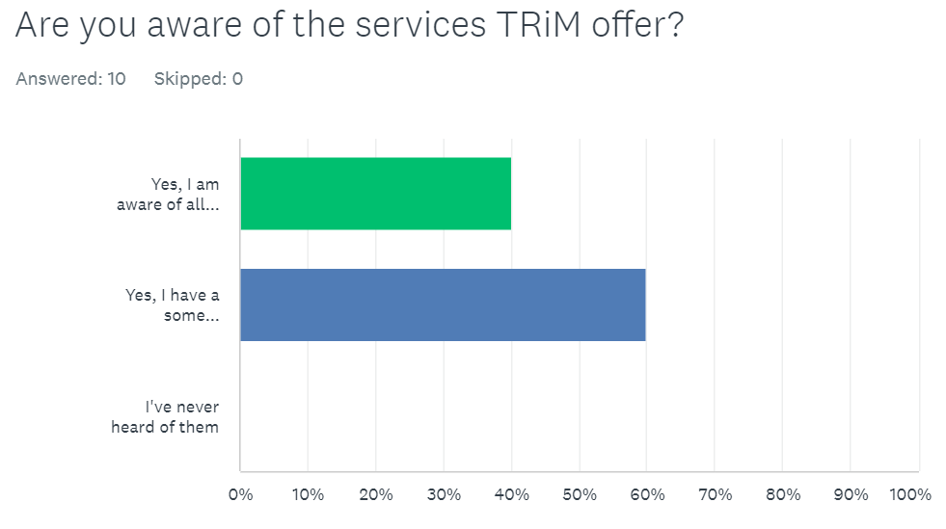

This graph shows that 40% respondents are aware of all the services TRiM offer. None of the respondents replied that they have no knowledge of the services. It is encouraging that all respondents have some knowledge of TRiM.

4.3 Question 2
Figure 2

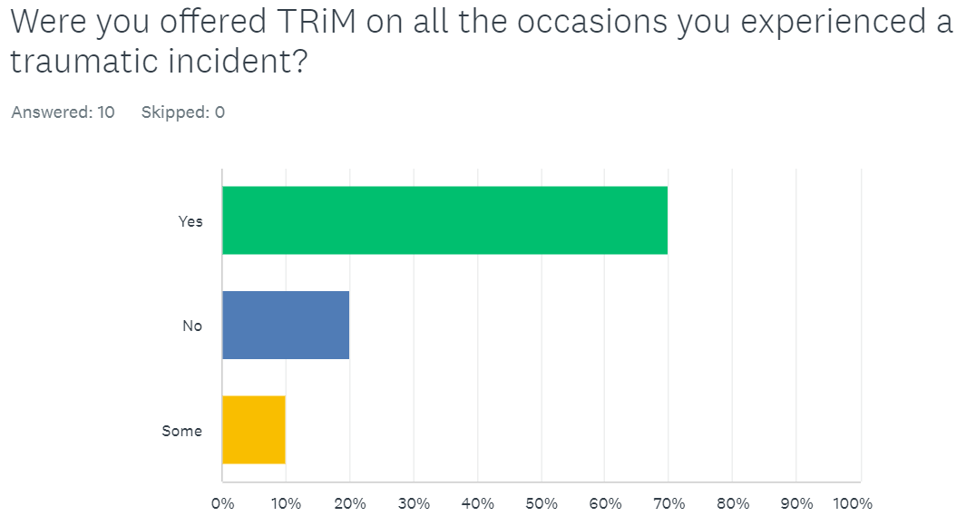

This graph shows that 70% of respondents have been offered TRiM following a traumatic incident. This graph also shows on 20% occasions the services of TRiM were not offered and 10% respondent responding by stating TRiM was offered sometimes. This shows that a vast majority of the respondents were offered TRiM but improvement is needed.

4.4 Question 3
Figure 3

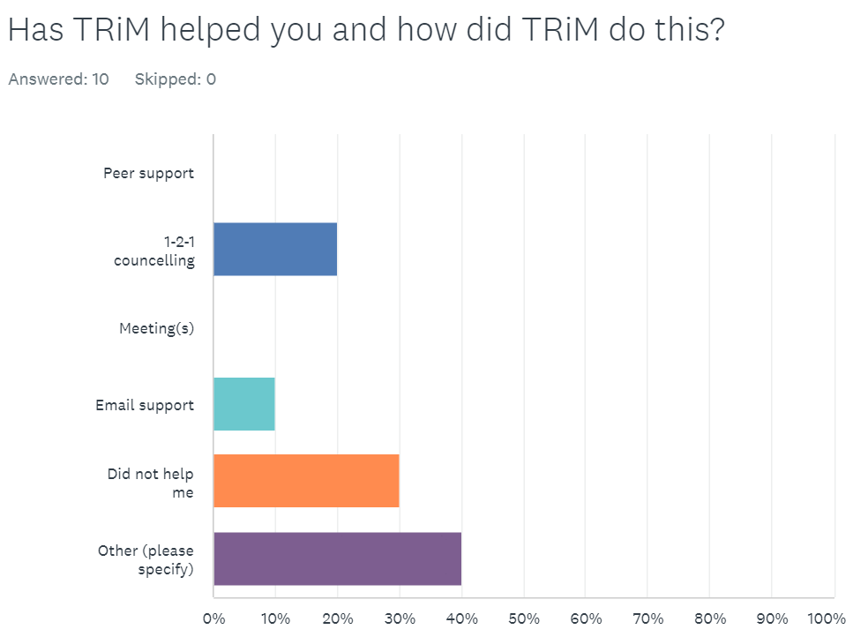

This is a two-part question asking if TRiM has helped them and how this was done. The answers respondents could select were the services TRiM offer as part of their services. Combined, 1-2-1 counselling and email support have scored 30% with the same percentage saying it did not help. This question allowed respondents to answer with other and then add free text to explain their answer. 40% of people chose this option and replies read Not used, didn’t need it, not had TRiM services, and never utilised.

4.5 Question 4
Figure 4.
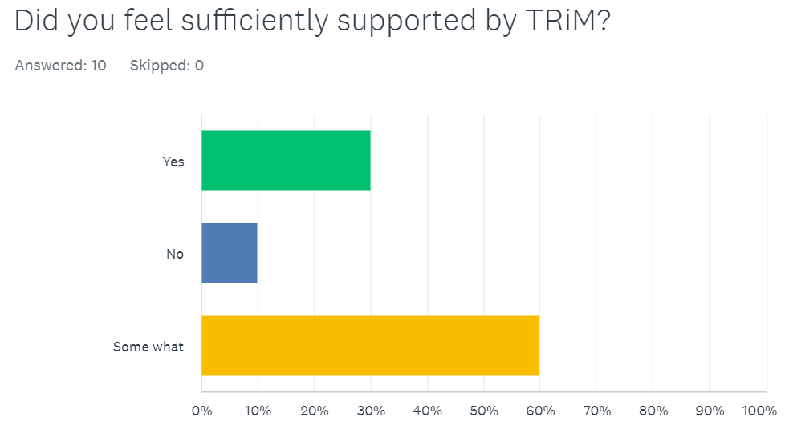

Question 4 is asking if officers feel sufficiently supported by TRiM. 30% of respondents felt fully supported and 10% replied no.

60% of respondents replied they only felt somewhat supported. This demonstrated that improvement is needed as mentioned in question two.

4.6 Question 5.
Figure 5.

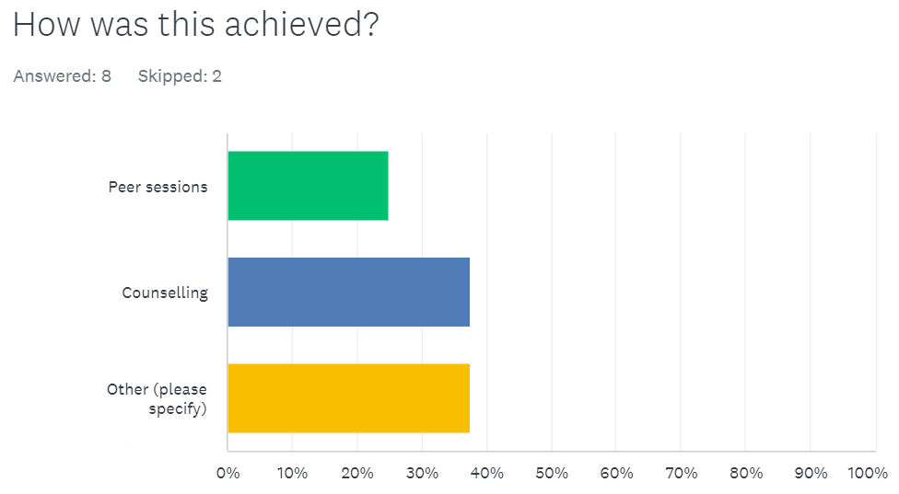

Not all 10 respondents answered question five. Eight respondents replied and two respondents skipped the question.

25% respondents replied by stating that peer sessions worked for them, and 37.5% respondents stated counselling worked for them. Just as question 3 allowed others to select other and then add free text it was important that if respondents wanted to reply with their own free text they could. 37.5% chose this option and added text such as not had TRiM service, never used and unknown.

4.7 Question 6
Figure 6

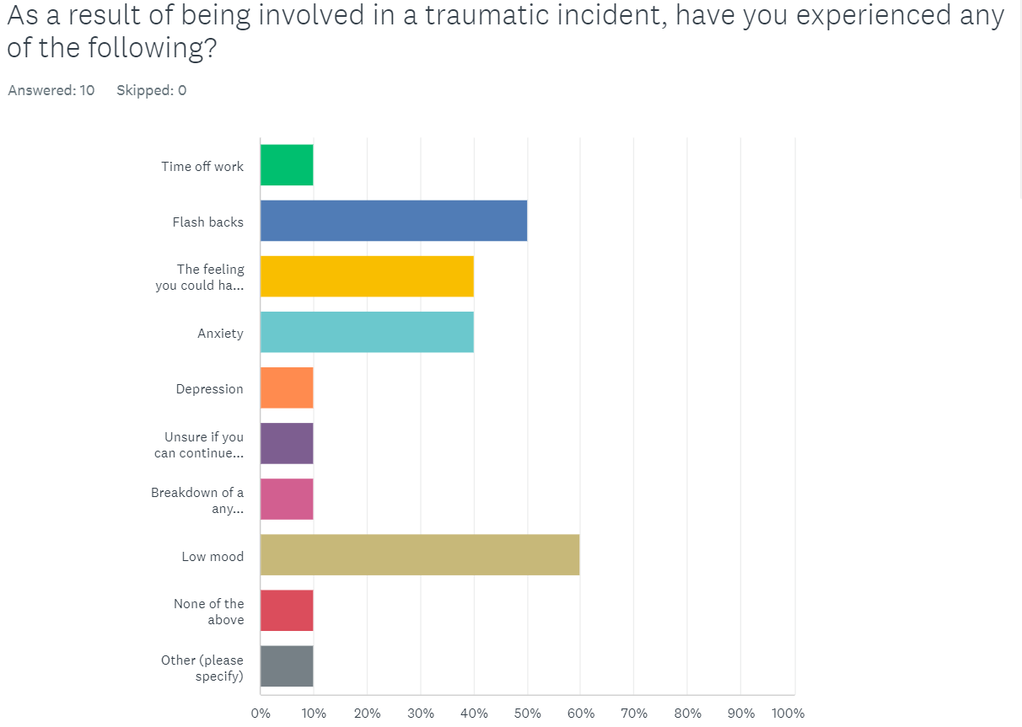

As this graph shows question 6 is exploring the symptoms officers have suffered because of being involved in a traumatic incident. Unlike previous questions respondents were able to select more than one choice. This allowed officers to demonstrate that having experienced a traumatic event you can experience more than one symptom of poor mental health. It also allowed respondents to select other and enter their own free text.

Flash backs and a low mood both scored the highest here with a feeling officers could have done more and anxiety scoring just below.

4.8 Question 7
Figure 7

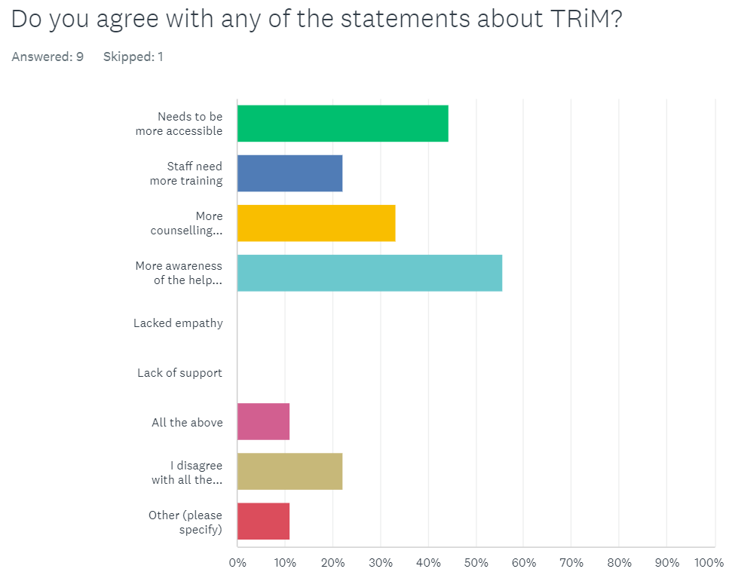

This chart shows 56% of the respondents agree that there needs to be more awareness of the help TRiM offers. Whilst 44% of the respondent’s state TRiM needs to be more accessible to officers following a traumatic event.

Research conducted within the literature chapter references Greenberg, Langston, V., Everitt, B., Iversen, A., Fear, N. T., Jones, N., & Wessely, S (2010) questioned the effectiveness of TRiM. The study suggested that there is no benefit of the use of TRiM to a person’s mental health. Respondents have recognised the need for improvement.

4.9 Question 8
Figure 8

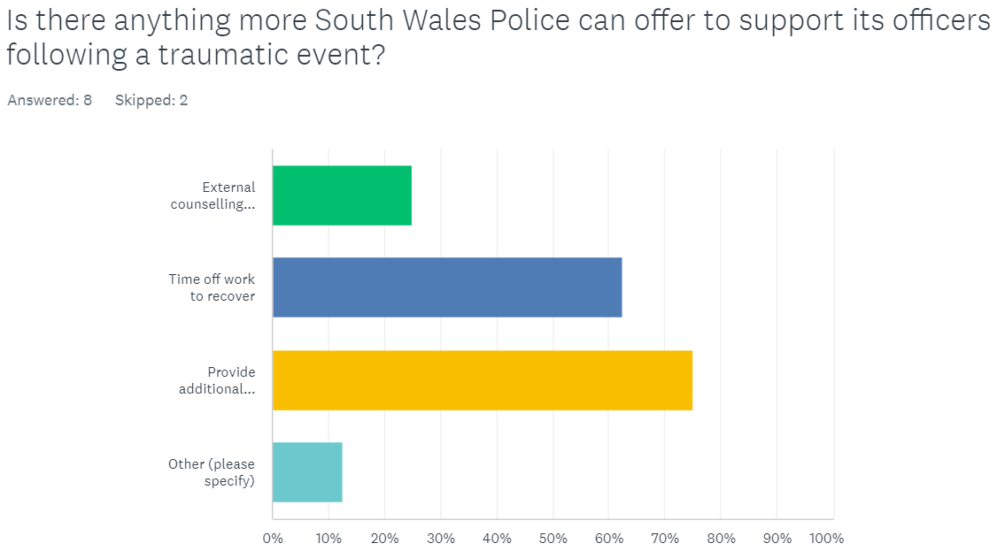

Just like the previous question, respondents can select more than one answer and add their own text if they wished allowing them freedom to express themselves. This question explored what South Wales police could do to support its officers. From the responses 75% selected to have additional mental health services and 63% choosing to have time off work to recover. This demonstrates officers want to tackle the problem of mental health and the need for more services other than TRiM.

4.10 Question 9
Figure 9.

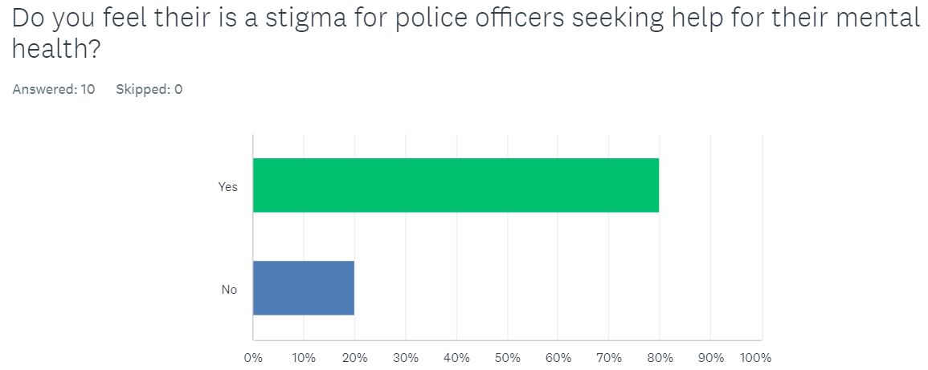

80% of respondents have agreed there is a stigma for police officers seeking help for their mental health. This suggests there is a potential barrier preventing them getting the help they need. This corresponds with the research conducted in my literature review where a charity Mind (2023) confirms there is a stigma for police officers reaching out for help.

4.11 Question 10
Figure 10

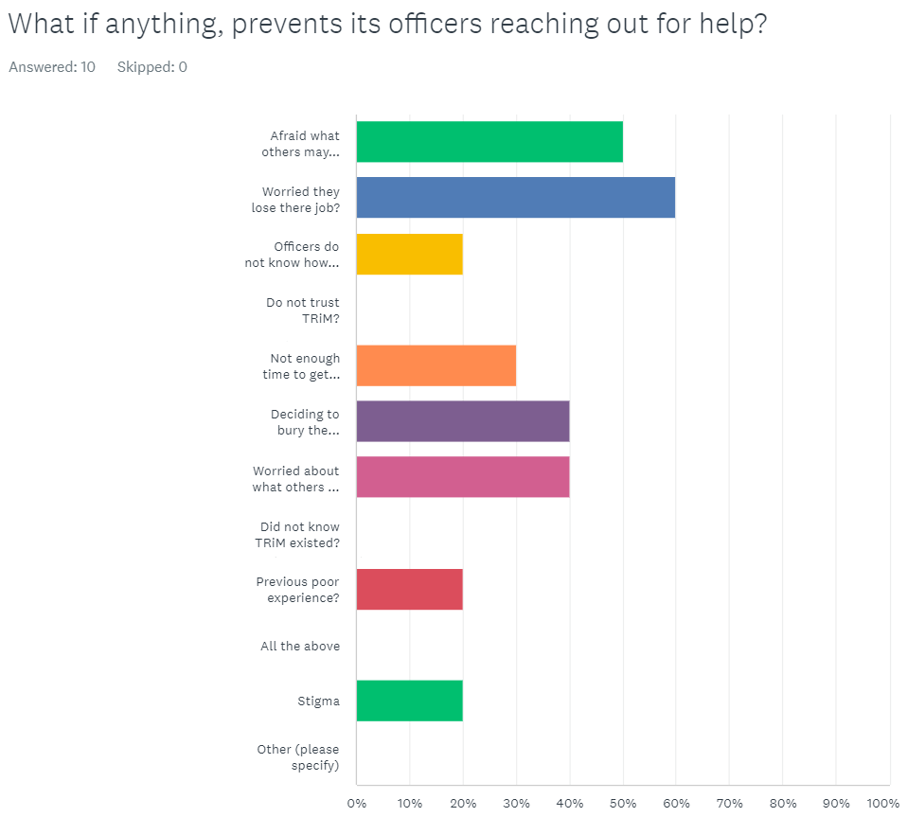

Respondents could select multiple answers with this final question. This allowed for everyone to express their true feelings with a “other” box should they have wanted to write something that I did not include.

The standout figure here is 60% of respondents not reaching out for help because of a fear they would lose their jobs.
Just below this at 50% is respondents not reaching out for help because they are worried about what others may think.

4.12 Conclusion.

The aim of this study was to focus on the mental wellbeing of current police officers within South Wales Police following a traumatic event and if there is a stigma that prevents police officers reaching out for help.

Respondents have feedback on a majority (70%) of traumatic calls they attend TRiM is offered but they are not fully aware of all the services of TRiM have to offer. It is good to see that South Wales Police offer the service however from the research, improvement is needed.

It is clear from the results respondents are suffering with mental health problems and want help, but the service of TRiM is not meeting their needs as figure 4 and 6 demonstrates. Respondents have stated they want to be aware of additional mental health services available to them.

This chapter confirms there is a stigma that stops respondents getting the help with the main reason being they are worried they may lose their job as figure 10 demonstrates. Stigma is not new in policing as research conducted in my literature review by Mind (2022) (2023) confirms. South Wales Police is no different when it comes to its police officers reaching out for help.

Further analyses of the above results will be discussed in more depth in the next chapter where I will look at the aims of this dissertation.

Chapter 5
Findings and Conclusion

5.0 Findings and Conclusions.

This study aimed to review the mental wellbeing of current police officers within South Wales Police following a traumatic event.

Within this chapter of my dissertation, I will review the objectives set and answer the questions I set from the start. I will complete a conclusion and suggest any recommendations.

The topic of this study has been to discuss the impact on mental health of police officers in South Wales Police following a traumatic incident, and if there is a stigma that prevents its officers reaching out for help.

I will now answer each of the three topics using the data I have gathered from previous chapters and see if the data I have gathered corresponds with any information already available. I will include any reconditions in each of the topics. The investigated topic has been to discover and meet the following objectives:

- What support do South Wales Police officers receive when they attend the scene of a traumatic event?

South Wales Police refers its officers to a service known as TRiM. As mentioned in my literature review TRiM is an in-house counselling service that specialises in trauma which is available to officers following a traumatic incident (Andrews, L, 2017). It is clear from my research results 100% of South Wales Police officers who replied to my survey are aware of TRiM. This is far greater compared to other police forces. A survey completed by Mind (2019) said that only 57.7% of its officers are aware of the mental health support available to them via there police force. It is great to see that South Wales Police has managed to make all respondents aware of TRiM.

- Do South Wales Police do enough to support its officers following a traumatic event and do current serving officers believe this is enough?
From my primary research it is clear to see that not enough support is being offered to officers following a traumatic incident leaving them vulnerable. Another clear issue from the primary research is that officers are not getting enough support via TRiM. This

If South Wales Police continue to fail its officers, mental health following a traumatic incident it can lead to long term mental health problems such as Post Traumatic Stress Disorder (PTSD) (Watson, & Andrews, L, 2018) as discussed within my literature review. A way of tackling this is, following a traumatic event officers need a debrief with TRiM, so they can assess if you may need to use their services or have regular catch ups with officers so there is that option there to talk if needed.

- Is there a stigma about mental health that prevents police officers reaching out for help?
Respondents clearly agree there is a stigma to its officers reaching out for help. 80% of South Wales police officers who completed my survey agreed stigma exists and prevents them from seeking help. Most officers are worried about losing their jobs and worried about what others may think. From this particular result, it is particularly important that these officers are not only supported by TRiM but also reassured that by asking for help, their job is not at risk. As discussed in previous chapters, failure to address your poor mental health can lead to such mental health illness such as PTSD.

Stigma within my police force is not just limited to this force. The issue is a national problem as research completed by Edwards, & Kotera, Y. (2021). These results are extremely concerning. South Wales Police need to address this issue by reassuring its officers that they are there to help and support its officers who are exposed to high levels of trauma. If more communication is more readily available regarding TRiM along with messages of support from South Wales Police, this may normalise officers reaching out for help and elevate and potential stigma.

There are many ways to address this issue to make speaking out about how these events have had a detrimental impact on mental health is by have pop up sessions for people just to pop in and speak to them, make TRiM the norm. I learn courses so it keeps their services fresh in their minds. TRiM needs to be a service that’s not always associated with a traumatic event. This will help remove stigma which is associated with using the services they provide.

5.1 Conclusion

In conclusion the primary research has shown that not all serving South Wales police officers are aware of the services TRiM offer. Officers have a basic understanding of the support available to them. It is clear from the results that there is a need for more communication about their services and how they will engage with you should you require them. The services TRiM offer needs a better explanation as all officers are aware of TRiM but not how they will help.

The services TRiM offer needs improving. This is evident by the fact that not all correspondents from the primary data agree that the services offered by TRiM has helped. Correspondents need more counselling sessions and staff need additional training.

Unfortunately, stigma exists within not just South Wales Police, but many other forces and its officers are affected by the lack of understanding and knowledge of what support is available. More information about trauma and its affects needs to be communicated openly and be more accessible.

The leading reason for Police officers not reaching out for help was the fear of losing their jobs and being worried about losing their jobs. Reassurance needs to be given to its officers as secondary research has shown that should they fail to protect their mental health its affect could lead to PTSD further into their career. This is important as it may not only affect their future career, but this has potential impact on their personal life as there are issues which have not been addressed.

Dr Yvonne Taylor has reported on behalf of the College of Policing that between 2011 to 2019, 163 police officers excluding special constables, committed suicide (Dr Yvonne Taylor, 2022). Of these deaths some of the leading causes to suicide is PTSD and other mental health problems. The report does recognise that stigma does put up barriers to police officers getting help. There is a clear need to address the mental state of police officers and the stigma that prevents officers from reaching out for help.

An independent review conducted by Stevenson & Farmer (Stevenson & Farmer, 2017) recognises the role of a police constable is high risk and more should be done to help. Based on this information the author feels there should be more responsibility on South Wales Police to do more for its officers to ensure their mental health needs are looked after.

South Wales Police needs to demonstrate a better support network for its officers which openly discusses stigma and its effects of not reaching out for help. This can only provide a positive impact within the police force which will help other servicing offers for many years to come.

5.2 Recommendations.

South Wales Police must continue to make its Police officers aware of TRiM. All new recruits must be made aware of TRiM and the services they can offer. However, through my research I have found there is very little information about TRiM linked with South Wales Police via a Google search or on South Wales Police website. I would recommend that more signposting is done online to ensure awareness is readily available. A campaign can be launched on web home pages drawing the attention to officers every time they go online.

South Wales Police must reassure its officers that seeking mental health help is ok and the organisation fully supports them. This can be achieved when officers are signposted to TRiM or other mental health services by their line manager.

The primary data shows that TRiM does not meet the needs of all its officers who replied to the survey. There are two recommendations I must make here, the first is my police force must feedback and improve on the service by taking on the feedback within the Analysis chapter. The service must be more accessible to officers which can be achieved by open seminars, information about the service given to officers on team training days. Respondents to the survey have said they require more counselling sessions which must be done to prevent long term effects of poor mental health.

The second is for other services to be signposted such as Call4Backup.org which through research conducted within the literature chapter shows they also offer services like TRiM such as counselling (Call4Backup, 2023). Officers should be given the choice of more than one service mental health service as this research has shown TRiM is failing officers, not just locally but nationally.

The final recommendation is regarding stigma. Research has shown that stigma is not new to the national police force, but South Wales Police must act. 80% of officers who took part in the survey agreed that there is a stigma attached to officers seeking help. Investigating this needs to be a priority not only for South Wales Police, but for every force. This can be achieved by holding compulsory training sessions around the need to change the attitude towards stigma and the dangers if we continue the way we are.

Bibliography

Bibliography
Bhat, A. (2023). Secondary research: Definition, methods and Examples. [Online]. Question Pro. Available at: https://www.questionpro.com/blog/secondary-research/#:~:text=Secondary%20research%20is%20an%20import [Accessed 14 June 2023].

Andrews, A. (2017). The Effect of a Trauma Risk Management (TRiM) Program on Stigma and Barriers to Help-Seeking in the Police. [Online]. Research Gate. Last Updated: May 2017. Available at: https://www.researchgate.net/publication/316871375_The_Effect_of_a_Trauma_Risk_Management_TRiM_Progr [Accessed 4 October 2023].

Blue Light Together. (2021). Trauma risk management (TRiM) in the police. [Online]. Blue Light Together. Available at: https://bluelighttogether.org.uk/police/trauma-risk-management-trim-in-the-police/ [Accessed 14 June 2023].

Burchell, B. (2022). UK policing: psychological damage among officers heightened by bad working conditions. [Online]. University of Cambridge. Last Updated: 19th October 2022. Available at: https://www.cam.ac.uk/research/news/uk-policing-psychological-damage-among-officers-heightened-by-ba [Accessed 2 May 2023].

British Library. (2023). What is quantitative research? [Online]. British Library. Available at: https://www.bl.uk/business-and-ip-centre/articles/what-is-quantitative-research [Accessed 14 June 2023].

British Transport Police Federation. (2019). An introduction to TRiM. [Online]. British Transport Police Federation. Last Updated: 10 September 2019. Available at: https://btpolfed.org.uk/pubs/trim.htm [Accessed 13 June 2023].

Bryant, L., Sutton, C., & Bunyard, T. (2000). The integration of sea service: Evaluation study. Unpublished manuscript. University of Plymouth, United Kingdom (Accessed 20th July 2023).

Call4Backup. (2023). Get Support. [Online]. Call4Backup. Available at: https://policecharitiesuk.org/charities-list/for-police-officers/call4backup/ [Accessed 2 May 2023].

Child Welfare Information Gateway. (2023). Adverse Childhood Experiences (ACEs). [Online]. Child Welfare Information Gateway. Available at: https://www.childwelfare.gov/topics/preventing/overview/framework/aces/#:~:text=Children%20thrive%20 [Accessed 25 April 2023].

College of Policing. (2023). Police constable. [Online]. College of Policing. Available at: https://profdev.college.police.uk/professional-profile/police-constable/ [Accessed 25 April 2023].

Jansen, D (MBA) AND Kerry Warren (PhD). (2020). What Is Research Methodology?. [Online]. Gradcoach.com. Last Updated: April 2023. Available at: https://gradcoach.com/what-is-research-methodology/ [Accessed 17 June 2023].

Dr Taylor, Yvonne. (2022). Suicide prevention in policing. [Online]. College Of Policing. Available at: https://assets.college.police.uk/s3fs-public/2022-02/Suicide-prevention-current-landscape.pdf [Accessed 13 July 2023].

Edwards, & Kotera, Y. (2021). Mental Health in the UK Police Force: a Qualitative Investigation into the Stigma with Mental Illness. International Journal of Mental Health and Addiction, 19(4), 1116–1134. https://doi.org/10.1007/s11469-019-00214-x (Accessed 13 July 2023)

Gould, M., Greenberg, N., & Hetherton, J. (2007). Stigma and the military: Evaluation of a PTSD psychoeducational program. Journal of Traumatic Stress, 20, 505–515. http://dx.doi.org/10.1002/jts .20233

Greenberg, Langston, V., Everitt, B., Iversen, A., Fear, N. T., Jones, N., & Wessely, S. (2010). A cluster randomized controlled trial to determine the efficacy of Trauma Risk Management (TRiM) in a military population. Journal of Traumatic Stress, 23(4), 430–436. https://doi.org/10.1002/jts.20538

Hafal. (2023). Welcome to Hafal. [Online]. Hafal.co.uk. Available at: https://hafal.org/ [Accessed 25 April 2023].

HMICFRS. (2018). Policing and Mental Health Picking Up the Pieces. [Online]. Her Majesty’s Inspectorate of Constabulary and Fire & Rescue Service. Last Updated: November 2018. Available at: https://www.justiceinspectorates.gov.uk/hmicfrs/wp-content/uploads/policing-and-mental-health-pickin [Accessed 2 May 2023].

Mander, J. (2022). How to use qualitative and quantitative research to your advantage. [Online]. GWI. Last Updated: 8 March 2022. Available at: https://blog.gwi.com/trends/qualitative-vs-quantitative/ [Accessed 30 July 2023].

Warren, J. (2023). Met Police commissioner defends thin blue line badge ban. BBC News. [Online]. 5th July 2023. Available at https://www.bbc.co.uk/news/uk-england-london-66109073 [Accessed 19th July 2023].

Watson, L, Andrews, L. (2018). The Effect of a Trauma Risk Management (TRiM) Program on Stigma and Barriers to Help-Seeking in the Police. [Online]. University of Wales Trinity Saint David. Available at: https://web-s-ebscohost-com.ezproxy.uwtsd.ac.uk/ehost/pdfviewer/pdfviewer?vid=0&sid=6a6aa925-d17c-47 [Accessed 8 May 2023].

Elliot-Davies, M. (2021). Demand Capacity & Welfare Survey Mental health and wellbeing support June 2021. [Online]. Police Federation. Last Updated: June 2021. Available at: https://www.polfed.org/media/17125/mental-health-and-wellbeing-support-june-2021-report.pdf [Accessed 2 May 2023].

Mental Health Foundation. (2023). The impact of traumatic events on mental health. [Online]. Mental Health Foundation. Available at: https://www.mentalhealth.org.uk/explore-mental-health/publications/impact-traumatic-events-mental-he [Accessed 27 April 2023].

Mental Health Foundation. (2023). The impact of traumatic events on mental health. [Online]. Mental Health Foundation. Available at: https://www.mentalhealth.org.uk/explore-mental-health/publications/impact-traumatic-events-mental-he [Accessed 18 July 2023].

Mind. (2017). Mental health problems – an introduction. [Online]. Mind. Last Updated: October 2017. Available at: https://www.mind.org.uk/information-support/types-of-mental-health-problems/mental-health-problems-i [Accessed 5 May 2023].

Mind. (2019). Mental Health in the Emergency Services. [Online]. Mind. Last Updated: 1st January 2019. Available at: https://www.mind.org.uk/media-a/4849/2019-survey-police-service-summary.pdf [Accessed 4 October 2023].

Mind. (2020). Trauma. [Online]. Mind. Available at: https://www.mind.org.uk/information-support/types-of-mental-health-problems/trauma/effects-of-trauma [Accessed 18 July 2023].

Mind. (2022). Coping with what you experience in the police. [Online]. Mind. Last Updated: May 2022. Available at: https://www.mind.org.uk/news-campaigns/campaigns/blue-light-programme/blue-light-information/coping- [Accessed 29 April 2023].

Mind. (2023). Supporting someone in the police service. [Online]. Mind. Available at: https://www.mind.org.uk/news-campaigns/campaigns/blue-light-programme/blue-light-information/support [Accessed 19 July 2023].

NARPO. (2021). Mental health and wellbeing support for retired police officers. [Online]. National Association Retired Police Officers. Available at: https://www.derbysnarpo.co.uk/uploads/1/0/5/3/10539891/narpo_-_mental_health_and_wellbeing_briefing_ [Accessed 5 May 2023].

Oxford Research. (2023). primary research. [Online]. Oxford Reference. Available at: https://www.oxfordreference.com/display/10.1093/oi/authority.20110803100345447 [Accessed 14 June 2023].

Police Dependant Trust. (2023). Self-support techniques after a traumatic incident. [Online]. Police Dependant Trust. Available at: file:///C:/Users/SWP6873/Downloads/Traumatic%20Incident%20self%20help.pdf [Accessed 18 July 2023].

Police Federation. (2019). Repeated exposure to trauma is seriously effecting officer mental health. [Online]. Police Federation. Last Updated: 31st January 2019. Available at: https://www.polfed.org/kent/news/2019/repeated-exposure-to-trauma-is-seriously-effecting-officer-men [Accessed 18 July 2023].

Police federation. (2021). Capture Data On Traumatic Incidents. [Online]. Police federation. Last Updated: 15th September 2021. Available at: https://www.polfed.org/avonsom/news/news-articles/capture-data-on-traumatic-incidents/ [Accessed 6 July 2023].

Police Federation. (2021). Capture Data On Traumatic Incidents. [Online]. Police federation. Last Updated: 15th September 2021. Available at: https://www.polfed.org/avonsom/news/news-articles/capture-data-on-traumatic-incidents/#:~:text=He%20 [Accessed 27 April 2023].

Police Federation. (2022). PFEW Pay and Morale Survey 2022 Welsh Report. [Online]. Police Federation. Available at: https://www.polfed.org/media/18247/pay-and-morale-2022_welsh-report.pdf [Accessed 27 April 2023].

Rogers, R. (2023). The police – why and how we should care. [Online]. The British Psychological Society. Last Updated: 2 March 2023. Available at: https://www.bps.org.uk/psychologist/police-why-and-how-we-should-care [Accessed 2 May 2023].

Research Qualitative Methods: Definition and Examples. (2023). Max Dade. [Online]. First Editing. Available at: https://www.firstediting.com/research-qualitative-methods-definition-and-examples/ [Accessed 30 July 2023].

Oflazoglu, S & Oflazoglu, D. (2017). Qualitative versus quantitative research (Oflazoglu, D, Ed.). IntechOpen. Available at Qualitative versus Quantitative Research - Google Books (Accessed 2 May 2023)

St John Ambulance. (2023). Signs that someone may be experiencing poor mental health. [Online]. St John Ambulance. Available at: https://www.sja.org.uk/course-information/guidance-and-help/mental-health-resources/signs-that-someo [Accessed 18 July 2023].

Stevenson & Farmer. (2017). Thriving at work. [Online]. United Kingdom Government. Available at: https://assets.publishing.service.gov.uk/government/uploads/system/uploads/attachment_data/file/6581 [Accessed 13 July 2023].

Teesside University. (2022). Research Methods. [Online]. Teesside University. Last Updated: 11th August 2022. Available at: https://libguides.tees.ac.uk/researchmethods/secondary [Accessed 23 July 2023].

Thin Blue Line. (2019). Mental health and well-being. [Online]. Police Charities. Available at: https://policecharitiesuk.org/charities-list/for-police-officers/thin-blue-line-uk/ [Accessed 2 May 2023].

UK Trauma Council. (2023). Trauma. [Online]. UK Trauma Council. Available at: https://uktraumacouncil.org/trauma/trauma?cn-reloaded=1 [Accessed 8 May 2023].
University Of Cambridge. (2023). Police workforce: Almost one in five suffer with a form of PTSD. [Online]. University Of Cambridge. Available at: https://www.cam.ac.uk/policeptsd [Accessed 8 July 2023].

University of Southampton. (2023). Primary research. [Online]. University of Southampton. Available at: https://library.soton.ac.uk/sash/primary-research#:~:text=Primary%20research%20involves%20gathering% [Accessed 23 July 2023].

Velazquez, & Hernandez, M. (2019). Effects of police officer exposure to traumatic experiences and recognizing the stigma associated with police officer mental health: A state-of-the-art review. Policing : an International Journal of Police Strategies & Management, 42(4), 711–724. https://doi.org/10.1108/PIJPSM-09-2018-0147 (Accessed 8 July 2023)

Pathak, V, Jena, B, Kalra, S. (2023). Qualitative research. [Online]. National Library of Medicine. Available at: https://www.ncbi.nlm.nih.gov/pmc/articles/PMC3757586/#:~:text=Qualitative%20method%20is%20used%20to, [Accessed 14 June 2023].

Watson, & Andrews, L. (2018). The Effect of a Trauma Risk Management (TRiM) Program on Stigma and Barriers to Help-Seeking in the Police. International Journal of Stress Management, 25(4), 348–356. https://doi.org/10.1037/str0000071 (Accessed 25 April 2023)

World Health Organisation. (2022). Mental Health. [Online]. World Health Organisation. Last Updated: 17 June 2022. Available at: https://www.who.int/news-room/fact-sheets/detail/mental-health-strengthening-our-response [Accessed 25 April 2023].

Zoe. (2020). Zoe's story. [Online]. Mind. Last Updated: 14 January 2020. Available at: https://www.mind.org.uk/information-support/your-stories/zoe-s-story/ [Accessed 29 April 2023].

Appendices

Appendix A



UNDERGRADUATE DISSERTATION
RESEARCH PROPOSAL FORM

Please complete the following research proposal and submit it to Turnitin.

Which project option are you taking? Please tick:

8,000 word project: X
OR
4,000 word project and presentation:

NAME: Jonathan Ryan | STUDENT ID No.: 2023853
DRAFT RESEARCH TITLE QUESTION:
INTRODUCTION:

I am serving police officer within South Wales Police, and I would like to conduct research into the mental wellbeing of current police officers within South Wales Police following a traumatic event.

The mental health of a police officer is of great importance as they are exposed to regular forms of violence and other crimes daily. By the very nature of the profession, policing is a dangerous career. The average police officer is exposed to 400-600 (Police Federation, 2021) traumatic events in their career, so the welfare of its officers is important to whom the police officer has contact with and the officer.

The support South Wales Police signpost its officers is a Trauma Risk Management TRIM (Andrews, L 2017). I will create a survey and send this to South Wales Police and from the correspondents I will examine if this service meets the needs of its officers.

According to the charity Mind (2023) stigma is a national problem. Stigma is not new within the police force and my research will investigate if the correspondents agree with this statement and what, if any prevents them from reaching out for help.

The aim looks at three specific areas:

- What support do South Wales Police officers receive when they attend the scene of a traumatic event?
- Do South Wales Police do enough to support its officers following a traumatic event and do current serving officers believe this is enough?
- Is there a stigma about mental health that prevents police officers reaching out for help?

As a police officer who has experienced more than one traumatic event I want to investigate if fellow Serving South Wales officers are aware of the service that is available to them which is TRiM.

SUMMARY OF RESEARCH OBJECTIVES:

Data and research will be gathered through a questionnaire which will focus on serving South Wales Police officers who have a vested interest in the police, who are available and perceived to have detailed information and understanding of the research topic via the use of 10 questions acting as an interview schedule.

This dissertation looks at the mental wellbeing of current police officers within South Wales Police following a traumatic event.

The aim looks at three specific areas:

- What support do South Wales Police officers receive when they attend the scene of a traumatic event?
- Do South Wales Police do enough to support its officers following a traumatic event and do current serving officers believe this is enough?
- Is there a stigma about mental health that prevents police officers reaching out for help?
LITERATURE REVIEW:

- I will be examining the mental health service South Wales Police refer its officers to and what impact this has on its officers.
- Using creditable sources such as internet, journals, reports and government web sites.
- Investigating how effective the mental health service South Wales Police is
- Investigating if South Wales Police officers are aware of the services TRiM are
- If there is a stigma associated with getting help to manage their mental health.
- What prevents South Wales Police officers reaching out for help
- The implications for not reaching out for help.
There is limited research on the comparison between individual forces.

SUMMARY OF RESEARCH –SURVEY METHOD:

This will allow those I send the surveys to complete them in their own free time and allow them to comment without being monitored by others. I believe this will allow them to express themselves more without any external pressures.

I will be targeting other police officers and students. These people will be better to target as they are serving South Wales Police officers who are exposed to traumatic incidents in their everyday professional careers. With this regular exposure I will research what stigmas, if any, prevent them reaching out for help.

SUMMARY OF SAMPLING FRAMEWORK:

The sample size will be around 10 people and focused on persons who have a vested interest in police who were available and perceived to have details information and understanding of the research topic.

ETHICAL ISSUES:

The sample size will be small and focused on persons who have a vested interest in police and their budgets, who were available and perceived to have details information and understanding of the research topic. I appreciate that confidentiality of answers may be a concern. However, I will take every step to ensure participants confidentiality.

TIME SCALE:

Research topic – January 2023
Research method – January 2023
Research data for review of literature – May 2023
Pilot interview and adjust – June 2023
Contact interview sample and arrange suitable meeting schedule – June/ July 2023
Conduct interviews – July 2023
Review of literature – July 2023
Research methodology – August 2023
Analyse results -August 2023
Conclusion and recommendations – September 2023
Submit final dissertation – October 2023.

REFERENCE LIST:

Andrews, A. (2017). The Effect of a Trauma Risk Management (TRiM) Program on Stigma and Barriers to Help-Seeking in the Police. [Online]. Research Gate. Last Updated: May 2017. Available at: https://www.researchgate.net/publication/316871375_The_Effect_of_a_Trauma_Risk_Management_TRiM_Progr [Accessed 4 October 2023].

Police federation. (2021). Capture Data On Traumatic Incidents. [Online]. Police federation. Last Updated: 15th September 2021. Available at: https://www.polfed.org/avonsom/news/news-articles/capture-data-on-traumatic-incidents/ [Accessed 6 July 2023].

Mind. (2023). Supporting someone in the police service. [Online]. Mind. Available at: https://www.mind.org.uk/news-campaigns/campaigns/blue-light-programme/blue-light-information/support [Accessed 19 July 2023].

Appendix B

APPLICATION FOR ETHICAL APPROVAL

In order for research to result in benefit and minimise risk of harm, it must be conducted ethically. A researcher may not be covered by the University’s insurance if ethical approval has not been obtained prior to commencement.

The University follows the OECD Frascati manual definition of research activity: “creative work undertaken on a systematic basis in order to increase the stock of knowledge, including knowledge of man, culture and society, and the use of this stock of knowledge to devise new applications”. As such this covers activities undertaken by members of staff, postgraduate research students, and both taught postgraduate and undergraduate students working on dissertations/projects.

The individual undertaking the research activity is known as the “principal researcher”.

Ethical approval is not required for routine audits, performance reviews, quality assurance studies, testing within normal educational requirements, and literary or artistic criticism.

Please read the notes for guidance before completing ALL sections of the form.

This form must be completed and approved prior to undertaking any research activity. Please see Checklist for details of process for different categories of application.

Delete the Guidance Notes at the end of the form BEFORE submitting your application

SECTION A: About You (Principal Researcher)
Full Name: Jonathan Ryan |  | Student: 2023853
Tick all boxes which apply: |  | Member of staff: | ☐ | Honorary research fellow: | ☐
Undergraduate Student | ☒ | Taught Postgraduate Student | ☐ | Postgraduate Research Student | ☐

Institute/Academic Discipline/Centre: | IMH
Campus: | Swansea
E-mail address: | 2023853@student.uwtsd.ac.uk
Contact Telephone Number:
For students:
Student Number: | 2023853
Programme of Study: | BSc (Hons) Professional Policing Practice
Director of Studies/Supervisor: | Samantha Mcalister Wilson

SECTION B: Approval for Research Activity
Has the research activity received approval in principle?  (please check the Guidance Notes as to the appropriate approval process for different levels of research by different categories of individual) |  | YES | ☒ | NO | ☐
 |  |  |  | Date
If Yes, please indicate source of approval (and date where known): Approval in principle must be obtained from the relevant source prior to seeking ethical approval | Research Degrees Committee |  | ☐
 | Institute Research Committee |  | ☐
 | Other (write in) Samantha Mcalister Wilson |  | ☒

SECTION C: Internal and External Ethical Guidance Materials
Please list the core ethical guidance documents that have been referred to during the completion of this form (including any discipline-specific codes of research ethics, and also any specific ethical guidance relating to the proposed methodology). Please tick to confirm that your research proposal adheres to these codes and guidelines.
UWTSD Research Ethics & Integrity Code of Practice | ☒
UWTSD Research Data Management Policy | ☒
 | ☐

SECTION D: External Collaborative Research Activity
Does the research activity involve collaborators outside of the University? |  | YES | ☐ | NO | ☒
If Yes, please provide the name of the external organisation and name and contact details for the main contact person and confirmation this person has consented to their personal data being shared.as part of this collaboration.
Institution
Contact person name
Contact person e-mail address

Has this individual consented to sharing their details on this form? |  | YES | ☐ | NO |  |  | ☐
Are you in receipt of a KESS scholarship? |  | YES | ☐ | NO |  |  | ☐
Is your research externally funded |  | YES | ☐ | NO |  |  | ☐
Are you specifically employed to undertake this research in either a paid or voluntary capacity? | Voluntary | YES | ☐ | NO |  | ☐
 | Employed | YES | ☐ | NO |  | ☐
Is the research being undertaken within an existing UWTSD Athrofa Professional Learning Partnership (APLP) | If YES then the permission question below does not need to be answered. | YES | ☐ | NO |  |  | ☐
Permission to undertake the research has been provided by the partner organisation | (If YES attach copy)  If NO the application cannot continue | YES | ☐ | NO |  |  | ☐

Where research activity is carried out in collaboration with an external organisation
Does this organisation have its own ethics approval system? | YES | ☐ | NO | ☐
If Yes, please attach a copy of any final approval (or interim approval) from the organisation

SECTION E: Details of Research Activity
Indicative title: | This Study is aimed to investigate and review police budget cuts and their impact on policing standards within South Wales Police.
Proposed start date: | 02/01/2023 | Proposed end date: | 25/12/2023
Introduction to the Research (maximum 300 words)
Ensure that you write for a Non-Specialist Audience when outlining your response to the three points below:
- Purpose of Research Activity
- Proposed Research Question
- Aims of Research Activity
- Objectives of Research Activity
Demonstrate, briefly, how Existing Research has informed the proposed activity and explain
- What the research activity will add to the body of knowledge
- How it addresses an area of importance.
Purpose of Research Activity

I am serving police officer within South Wales Police, and I would like to conduct research into the mental wellbeing of current police officers within South Wales Police following a traumatic event.

The mental health of a police officer is of great importance as they are exposed to regular forms of violence and other crimes daily. By the very nature of the profession, policing is a dangerous career. The average police officer is exposed to 400-600 (Police Federation, 2021) traumatic events in their career, so the welfare of its officers is important to whom the police officer has contact with and the officer.

The support South Wales Police signpost its officers is a Trauma Risk Management TRIM (Andrews, L 2017). I will create a survey and send this to South Wales Police and from the correspondents I will examine if this service meets the needs of its officers.

According to the charity Mind (2023) stigma is a national problem. Stigma is not new within the police force and my research will investigate if the correspondents agree with this statement and what, if any prevents them from reaching out for help. My dissertation will investigate the mental wellbeing of current police officers within South Wales Police following a traumatic event.

The aim looks at three specific areas:

- What support do South Wales Police officers receive when they attend the scene of a traumatic event?
- Do South Wales Police do enough to support its officers following a traumatic event and do current serving officers believe this is enough?
- Is there a stigma about mental health that prevents police officers reaching out for help?

(this box should expand as you type)
Research Question

This dissertation looks at the mental wellbeing of current police officers within South Wales Police following a traumatic event.

(this box should expand as you type)
Aims of Research Activity

I will be targeting serving fellow South Wales Police officers. I will ask for these officers if they are willing to take part in a survey. This will be optional and the questions can be left unanswered if they choose to. All data gathered will be made public which correspondents will be made aware of before taking part.

(this box should expand as you type)
Objectives of Research Activity

Data and research will be gathered through a series of interviews which will focus on persons who have a vested interest in the police, who are available and perceived to have detailed information and understanding of the research topic via the use of 10 questions acting as an interview schedule.

The aim looks at three specific areas, which are:

- What support do South Wales Police officers receive when they attend the scene of a traumatic event?

- Do South Wales Police do enough to support its officers following a traumatic event and do current serving officers believe this is enough?

- Is there a stigma about mental health that prevents police officers reaching out for help?

(this box should expand as you type)
Proposed methods (maximum 600 words)
Provide a brief summary of all the methods that may be used in the research activity, making it clear what specific techniques may be used. If methods other than those listed in this section are deemed appropriate later, additional ethical approval for those methods will be needed.
Questionnaire method.

This will allow those I send the questionnaire to complete them in their own free time and allow them to comment without being monitored by others. I believe this will allow them to open up more without any external pressures.
I will be targeting serving South Wales Police officers. These people will be better to target as they are impacted by the budget cuts in their everyday professional careers.

(this box should expand as you type)

Location of research activity
Identify all locations where research activity will take place.
Morriston, Swansea.

(this box should expand as you type)
Research activity outside of the UK
If research activity will take place overseas, you are responsible for ensuring that local ethical considerations are complied with and that the relevant permissions are sought. Specify any local guidelines (e.g. from local professional associations/learned societies/universities) that exist and whether these involve any ethical stipulations beyond those usual in the UK (provide details of any licenses or permissions required). Also specify whether there are any specific ethical issues raised by the local context in which the research activity is taking place, for example, particular cultural and/or legal sensitivities or vulnerabilities of participants.
None

(this box should expand as you type)
Use of documentation not in the public domain: Are any documents NOT publicly available? | NO | ☒
 | YES | ☐
If Yes, please provide details here of how you will gain access to specific documentation that is not in the public domain and that this is in accordance with prevailing data protection law of the country in question and England and Wales.

(this box should expand as you type)

SECTION F: Scope of Research Activity
Will the research activity include: | YES | NO
Use of a questionnaire or similar research instrument? | ☒ | ☐
Use of interviews? | ☐ | ☒
Use of diaries? | ☐ | ☒
Participant observation with their knowledge? | ☐ | ☒
Participant observation without their knowledge? | ☐ | ☒
Use of video or audio recording? | ☐ | ☒
Access to personal or confidential information without the participants’ specific consent? | ☐ | ☒
Administration of any questions, test stimuli, presentation that may be experienced as physically, mentally or emotionally harmful / offensive? | ☐ | ☒
Performance of any acts which may cause embarrassment or affect self-esteem? | ☐ | ☒
Investigation of participants involved in illegal activities? | ☐ | ☒
Use of procedures that involve deception? | ☐ | ☒
Administration of any substance, agent or placebo? | ☐ | ☒
Working with live vertebrate animals? | ☐ | ☒
Other primary data collection methods, please explain in this box  For example, ‘focus groups’. Please indicate the type of data collection method(s) in this box and tick the accompany box. | ☐ | ☒
Details of any other primary data collection method:  (this box should expand as you type) | ☐ | ☒
If NO to every question, then the research activity is (ethically) low risk and may be exempt from some of the following sections (please refer to Guidance Notes).

If YES to any question, then no research activity should be undertaken until full ethical approval has been obtained.

SECTION G: Intended Participants
Who are the intended participants: | YES | NO
Students or staff at the University? | ☒ | ☐
Adults (over the age of 18 and competent to give consent)? | ☒ | ☐
Vulnerable adults? | ☐ | ☒
Children and Young People under the age of 18? (Consent from Parent, Carer or Guardian will be required) | ☐ | ☒
Prisoners? | ☐ | ☒
Young offenders? | ☐ | ☒
Those who could be considered to have a particularly dependent relationship with the investigator or a gatekeeper? | ☐ | ☒
People engaged in illegal activities? | ☐ | ☒
Others (please identify specifically any group who may be unable to give consent) please indicate here and tick the appropriate box. | ☐ | ☒
Other – please indicate here:  (this box should expand as you type) | ☐ | ☒

Participant numbers and source
Provide an estimate of the expected number of participants. How will you identify participants and how will they be recruited?
How many participants are expected? | 10  (this box should expand as you type)
Who will the participants be? | Serving South Wales Police officers.  (this box should expand as you type)
How will you identify the participants? | Participants will be identified by sending out a survey to South Wales Police officers using a WhatsApp message. This is managed by senior ranking police officers.  (this box should expand as you type)

Information for participants: | YES | NO | N/A
Will you describe the main research procedures to participants in advance, so that they are informed about what to expect? | ☒ | ☐ | ☐
Will you tell participants that their participation is voluntary? | ☒ | ☐ | ☐
Will you obtain written consent for participation? | ☐ | ☐ | ☒
Will you explain to participants that refusal to participate in the research will not affect their treatment or education (if relevant)? | ☐ | ☐ | ☒
If the research is observational, will you ask participants for their consent to being observed? | ☐ | ☐ | ☒
Will you tell participants that they may withdraw from the research at any time and for any reason? | ☒ | ☐ | ☐
With questionnaires, will you give participants the option of omitting questions they do not want to answer? | ☒ | ☐ | ☐
Will you tell participants that their data will be treated with full confidentiality and that, if published, it will not be identifiable as theirs? | ☒ | ☐ | ☐
Will you debrief participants at the end of their participation, in a way appropriate to the type of research undertaken? | ☒ | ☐ | ☐
If NO to any of above questions, please give an explanation
(this box should expand as you type)

Information for participants: | YES | NO | N/A
Will participants be paid? | ☐ | ☒ | ☐
Is specialist electrical or other equipment to be used with participants? | ☐ | ☒ | ☐
Are there any financial or other interests to the investigator or University arising from this study? | ☐ | ☒ | ☐
Will the research activity involve deliberately misleading participants in any way, or the partial or full concealment of the specific study aims? | ☐ | ☒ | ☐
If YES to any question, please provide full details
(this box should expand as you type)

SECTION H: Anticipated Risks

Outline any anticipated risks that may adversely affect any of the participants, the researchers and/or the University, and the steps that will be taken to address them.

If you have completed a full risk assessment (for example as required by a laboratory, or external research collaborator) you may append that to this form.
Full risk assessment completed and appended? |  | Yes | ☐
 |  | No | ☐
Risks to participants
For example: emotional distress, financial disclosure, physical harm, transfer of personal data, sensitive organisational information
Risk to Participant:  No risk  (this box should expand as you type) | How will you mitigate the Risk to Participant  (this box should expand as you type)
If research activity may include sensitive, embarrassing or upsetting topics (e.g. sexual activity, drug use) or issues likely to disclose information requiring further action (e.g. criminal activity), give details of the procedures to deal with these issues, including any support/advice (e.g. helpline numbers) to be offered to participants. Note that where applicable, consent procedures should make it clear that if something potentially or actually illegal is discovered in the course of a project, it may need to be disclosed to the proper authorities
(this box should expand as you type)
Risks to investigator
For example: personal safety, physical harm, emotional distress, risk of accusation of harm/impropriety, conflict of interest
Risk to Investigator:  No risk  (this box should expand as you type) | How will you mitigate the Risk to Investigator:  (this box should expand as you type)
University/institutional risks
For example: adverse publicity, financial loss, data protection
Risk to University:  No risk  (this box should expand as you type) | How will you mitigate the Risk to University:  (this box should expand as you type)

Disclosure and Barring Service
If the research activity involves children or vulnerable adults, a Disclosure and Barring Service (DBS) certificate must be obtained before any contact with such participants. | YES | NO | N/A
Does your research require you to hold a current DBS Certificate? | ☐ | ☐ | ☒

SECTION I: Feedback, Consent and Confidentiality
Feedback
What de-briefing and feedback will be provided to participants, how will this be done and when?
Those who I ask questions to will be informed that there information will be submitted as part of my dissertation. Should they request any feedback they will be informed that they can have a copy of my dissertation.

(this box should expand as you type)
Informed consent
Describe the arrangements to inform potential participants, before providing consent, of what is involved in participating. Describe the arrangements for participants to provide full consent before data collection begins. If gaining consent in this way is inappropriate, explain how consent will be obtained and recorded in accordance with prevailing data protection legislation.
All participants will be informed that the reason I am collecting data is for my dissertation. They will be given the title of the dissertation and the aims. Their participation is voluntary and can discontinue at any time. They will be aware that they will be presented with 10 questions and if they wish to answer their data will be collected and presented in my dissertation.

(this box should expand as you type)
Confidentiality / Anonymity
Set out how anonymity of participants and confidentiality will be ensured in any outputs. If anonymity is not being offered, explain why this is the case.
confidentiality information will be held.

(this box should expand as you type)

SECTION J: Data Protection and Storage
In completing this section refer to the University’s Research Data Management Policy and the extensive resources on the University’s Research Data Management web pages (http://uwtsd.ac.uk/library/research-data-management/).
Does the research activity involve personal data (as defined by the General Data Protection Regulation 2016 “GDPR” and the Data Protection Act 2018 “DPA”)? | YES | NO
“Personal data” means any information relating to an identified or identifiable natural person (‘data subject’). An identifiable natural person is one who can be identified, directly or indirectly, in particular by reference to an identifier such as a name, an identification number, location data, an online identifier or to one or more factors specific to the physical, physiological, genetic, mental, economic, cultural or social identity of that natural person. | ☐ | X
If YES, provide a description of the data and explain why this data needs to be collected:
(this box should expand as you type)
Does it involve special category data (as defined by the GDPR)? | YES | NO
“Special category data” means sensitive personal data consisting of information as to the data subjects’ –  (a) racial or ethnic origin,  (b) political opinions,  (c ) religious beliefs or other beliefs of a similar nature,  (d) membership of a trade union (within the meaning of the Trade Union and Labour Relations (Consolidation) Act 1992),  (e) physical or mental health or condition,  (f) sexual life,  (g) genetics,  (h) biometric data (as used for ID purposes), | ☐ | X
If YES, provide a description of the special category data and explain why this data needs to be collected:
(this box should expand as you type)
Will the research activity involve storing personal data and/or special category data on one of the following: | YES | NO
Manual files (i.e. in paper form)? | ☐ | ☒
University computers? | ☐ | ☒
Private company computers? | ☐ | ☒
Home or other personal computers? | ☒ | ☐
Laptop computers/ CDs/ Portable disk-drives/ memory sticks? | ☐ | ☒
“Cloud” storage or websites? | ☐ | ☒
Other – specify: | ☐ | ☒
For all stored data, explain the measures in place to ensure the security of the data collected, data confidentiality, including details of password protection, encryption, anonymisation and pseudonymisation:
I will be using my work laptop to save my records. This device has two tier security in place. The first is a numeric code to start the laptop and the second is my email and password. Both are unique and only I know these passwords.

(this box should expand as you type)
All Data Storage
Will the research activity involve any of the following activities: | YES | NO
Electronic transfer of data in any form? | ☒ | ☐
Sharing of data with others at the University? | ☐ | ☒
Sharing of data with other organisations? | ☐ | ☒
Export of data outside the European Union or importing of data from outside the UK? | ☐ | ☒
Use of personal addresses, postcodes, faxes, emails or telephone numbers? | ☐ | ☒
Publication of data that might allow identification of individuals? | ☐ | ☒
Use of data management system? | ☐ | ☒
Data archiving? | ☐ | ☒
If YES to any question, please provide full details, explaining how this will be conducted in accordance with the GDPR and DPA (and/or any international equivalent):
Any questionnaires I may conduct will not contain any sensitive information. The questionnaires will be sent by a WhatsApp link directly to the participants and then once completed will be sent back to me.

(this box should expand as you type)
List all who will have access to the data generated by the research activity:
Myself only.

(this box should expand as you type)
List who will have control of, and act as custodian(s) for, data generated by the research activity:
Myself only.

(this box should expand as you type)
Give details of data storage arrangements, including security measures in place to protect the data, where data will be stored, how long for, and in what form. Will data be archived – if so how and if not why not.
No personal data will be stored.

(this box should expand as you type)
Please indicate if your data will be stored in the UWTSD Research Data Repository (see https://researchdata.uwtsd.ac.uk/ ). If so please explain. (Most relevant to academic staff)
No

(this box should expand as you type)
Confirm that you have read the UWTSD guidance on data management (see https://www.uwtsd.ac.uk/library/research-data-management/) | YES | ☒
 | NO | ☐
Confirm that you are aware that you need to keep all data until after your research has completed or the end of your funding | YES | ☒
 | NO | ☐

SECTION K: Declaration
The information which I have provided is correct and complete to the best of my knowledge. I have attempted to identify any risks and issues related to the research activity and acknowledge my obligations and the rights of the participants.

In submitting this application I hereby confirm that I undertake to ensure that the above named research activity will meet the University’s Research Ethics and Integrity Code of Practice which is published on the website: https://www.uwtsd.ac.uk/research/research-ethics/
Signature of applicant: |  | Date: 25/2/2023

For STUDENT Submissions:
Director of Studies/Supervisor: |  | Date:
Signature: |  | Date:

For STAFF Submissions:
Academic Director/ Assistant Dean: |  | Date:
Signature: |  | Date:

Checklist: Please complete the checklist below to ensure that you have completed the form according to the guidelines and attached any required documentation:
☒ | I have read the guidance notes supplied before completing the form.
☒ | I have completed ALL RELEVANT sections of the form in full.
☒ | I confirm that the research activity has received approval in principle
☒ | I have attached a copy of final/interim approval from external organisation (where appropriate)
☒ | I have attached a full risk assessment (and have NOT completed Section H of this form) (where appropriate) ONLY TICK IF YOU HAVE ATTACHED A FULL RISK ASSESSMENT
☒ | I understand that it is my responsibility to ensure that the above named research activity will meet the University’s Research Ethics and Integrity Code of Practice.
☒ | I understand that before commencing data collection all documents aimed at respondents (including information sheets, consent forms, questionnaires, interview schedules etc.) must be confirmed by the DoS/Supervisor, module tutor or Academic Director.
☒ | I have deleted the guidance notes before submitting the PG2 for consideration

RESEARCH STUDENTS AND STAFF ONLY
All communications relating to this application during its processing must be in writing and emailed to pgresearch@uwtsd.ac.uk , with the title ‘Ethical Approval’ followed by your name.
You will be informed of the outcome of your claim by email; therefore it is important that you check your University and personal email accounts regularly.

STUDENTS ON UNDERGRADUATE OR TAUGHT MASTERS PROGRAMMES should submit this form (and receive the outcome) via systems explained to you by the supervisor/module leader.

This form is available electronically from the Academic Office web pages: https://www.uwtsd.ac.uk/academic-office/appendices-and-forms/

Application Process

All staff research projects and all research students must submit the Ethical Approval Form to the University Research Ethics Committee via the Academic Office (pgresearch@uwtsd.ac.uk). Staff research directly in relation to personal study for taught undergraduate or Masters programmes should be submitted via the Institute procedures explained below.

Taught masters and taught undergraduate research Ethical Approval Forms are considered within Institutes. Institutes will provide details of the specific processes for this. Where the Ethical issues within any single ethical application are of particular concern the Institute will refer these to the University Research Ethics Committee. Any student activity that involves the collection of primary data needs to undergo Ethical approval, this includes assignment work as well as dissertations.

Appendix C

