E-portfolio report
Learning in the Digital Era – BMPL4007/BMPS4009

Matthew Rees
0952210

Table of Contents

Task 1 – Written summary 2
Task 2 – Mind map 3
Task 3 – Presentation 4
Task 4 – Reflection 5
Reference list 6

Task 1 - Summary

Preparing for Higher Education

No matter how cultivated, the notion of Higher Education can be a daunting process for anyone valiant enough to accept. However, in order to achieve and perpetuate in Higher Education, preparation is paramount.

“Before anything else, preparation is the key to success” (Bell, 1906)

One of the absolute necessities when Preparing for Higher Education is Time Management. Only fragments of your days are formally timetabled, therefore it is crucial that you employ your own perspicacity as to organise the rest of your affairs, such as a work/study life balance, alongside social and family commitments (Cottrell, 2013). An additional method of using Time Management effectively would be that of Eisenhower’s Urgent/Important principle, 1954.

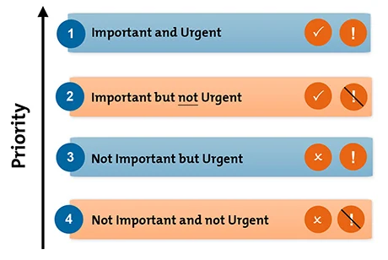

The above image, adapted from (Mind Tools, 2022), demonstrates Eisenhower’s Urgent/Important principle. Essentially by using this tool, you can decide what you believe to be important with relevance to your personal life, work commitments and studies. The principle works as filter, categorising your commitments allowing you to truly use your time sufficiently.

Another very useful concept to consider, when preparing for Higher education, is the utilisation of an appropriate workspace. Maintaining and keeping your workspace clean is a basic principle as to avoid clutter as this may cause unnecessary stress (Timestead, 2020) Following this principle, should avoid the temptation of procrastination as structure and format are key factors to reduce the urge to procrastinate (Penn, 2019)
Preparing for Higher Education is just as important as knowing when to rest. 50-60 minutes is the recommended time, this can amplify your energy, productivity and ability to focus (Cornell, 2021).

Overall, combining a self-awareness of responsibilities and utilising appropriate rest times, but most importantly making use of Time Management efficiently will determine all aspects of your academic juncture whilst preparing for Higher Education.

Task 2 – Mind Map

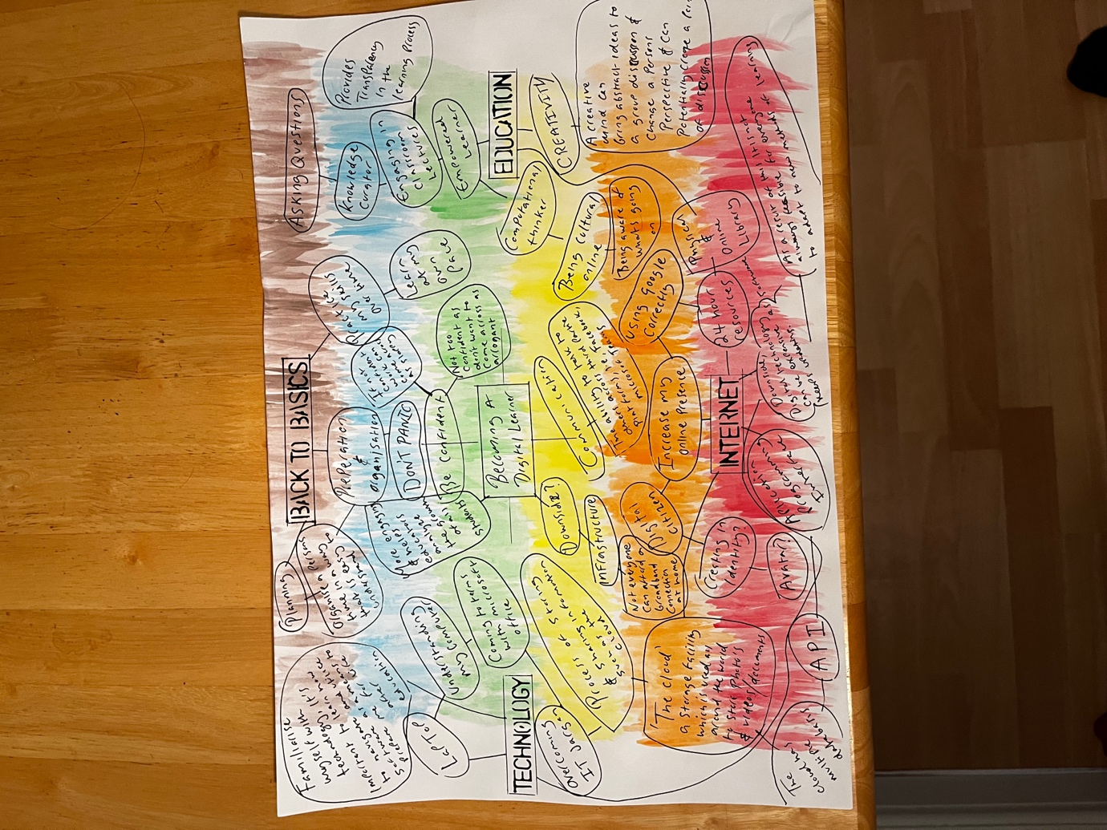

Task 3 – Presentation
Please follow the links to my video presentation

Below are my links to my video presentation regarding Identity. I have provided two links, should one of the links not connect properly.
The first link is from google drive of which you will have to download onto your computer.

https://drive.google.com/file/d/1DX9XZe59-XS6I0Z_1rllIsvsfU3d382n/view?usp=share_link

The second link is from YouTube.

https://youtu.be/OFdhC42EZKs

Task 4 – Reflective Report

Starting University presented itself with a kaleidoscope of emotion: the eagerness and desire to do well faced with simultaneous apprehension as to what challenges the course would present. There is an expected level of antonymous learning associated with, Higher Education. This was certainly a component that I allowed to conflict myself longer than I anticipated. The main reason for my confliction was not knowing if I would genuinely be able to maintain a schedule that would enable me to oversee studying whilst working full time and conduct a social life.

Once learning of the structure and timetable that the university comply with, I was then able to liaison with my employer and discuss an appropriate shift pattern and hours of work that would be suitable for me, to withstand the workload that the University provides.

A concept that certainly consumed me for a while was the notion of online learning. We live in a digital world. Adjusting to an online format of learning was something that I was going to have to adapt to fast, in addition to revising the application of Microsoft office. (Wiley & Sons 2016)

The process of writing my first assignment was primarily an abundance of overthinking and over analysing what the assignment questions were asking of me. This was an extremely frustrating intersection I faced multiple times. After reviewing the assignment questions one last time and administrating my notes more effectively, the original feeling of helplessness became non-existent. The utilisation of digital resources such as the online library became a very useful tool, providing me with sufficient and sound-based evidence I could reference in my assignments (McMillan & Weyers, 2012).

In short, my university experience thus far has been innovating, exciting with brief moments of exasperation. However, long may it continue.

References:

Task 1:

Alexander Graham Bell. (1906). The Mechanism of Speech. London: Funk and Wagnails. P.82

Cornell Health. (2/12/21). Study Breaks& Stress-Busters. [Online].CornHealth.Available at https://health.cornell.edu/about/news/study-breaks-stress-busters [Accessed 30 October].

Mind Tools. (2022). Eisenhower's Urgent/Important Principle. [Online]. www.mindtools.com>article. Last Updated: 2022. Available at: https://www.mindtools.com/pagesarticle/newHTE_91.htm [Accessed 9 November 2022].

Paul Penn. (2019).The Psychology of studying effectively. [Online]. Taylor & Francis. Available at htts://books.google.co.uk/books/about/The_Psychology_of_Effective_Studying.html [Accessed 30 October].

Stella Cottrell. (2013). The Study Skills Handbook. 4th ed. London: Palgrave Macmillan.
p.37,38.

Timestead. (2020). 5 benefits of a clean and tidy workplace. [Online]. Timestead. Last updated: 20 September 2020. Available at: https://www.timestead.com [Accessed 26 October 2022]

Task 2:

Alex Davies. (2020). Digital frame work. [Online]. youtube. Last Updated: 2020. Available at: https://www.youtube.com/becoming a digital learner [Accessed 2 November 2022].

Cloudflare, inc. (2010). What is the cloud. [Online]. www.cloudflare.com. Last Updated: 2021. Available at: https://www.cloudflare.com/learning/cloud/what-is-the-cloud/ [Accessed 10 November 2022].

Edward C. Baig. (2016). Macs for dummies. 14th ed. Canada: John Wiley & Sons, Inc. p.110,111.[Accessed 31 October 2022].

The Global Hues. (2021). Digital Learning. [Online]. www.youtube.com.TheGlobalHues. Last Updated: 2021. Available at: https://www.youtube.com/TheGlobalHues [Accessed 9 November 2022].

Task 3:

Florain Coulmas. (2019). IDENTITY A very short introduction. 2nd ed. London: Oxford University Press. p.99.

John Simpson & Edmund Weiner. (2012). Oxford English Dictionary. 7th ed. London: Oxford University Press. p.358.

Matthew McConaughey. (2020). Greenlights. New York: Crown. p.Chapter, ‘Find Your Frequency’.

Task 4:

Kathleen McMillan & Jonathan Weyers. (2011). How To Write Essays & Assignments. 2nd ed. Harlow, United Kingdom: Pearson Education Limited. p.56,57,60.

Dr Nic Hoper. (2021). The Unbreakable Student. London: Little, Brown Book Group, United Kingdom.

