
Module: International Business Concepts
Module code: LCMB7034
Selected Country: Germany

Industry: Automotive Industry

Lecturer : Syed Mansoob Murshed
Student Name : Pratikkumar Jagdishbhai Kevadiya
Student ID : 2435897
Word Count: 5238

Table of Contents
Section 1: Business Report 4
1. Introduction to the report 4
2. Industry and Country Overview 4
2.1 Automotive industry within the context of Germany 4
2.2 Size, scope, and economic importance of the industry 5
2.3 Major firms and their competitive position in the German Automotive industry 6
3. Application of Porter’s Diamond Model to the German Automotive Industry 10
4. Macro-Environmental Analysis and Market Attractiveness of the German Automotive Industry 15
4.1 Introduction & Framework Justification 15
4.2 Political & Legal Factors 17
4.3. Economic Factors 21
4.4. Socio-Cultural Factors 25
4.5. Synthesis: Overall Market Attractiveness and Success Factors 27
5. Conclusion to the report 28
Section 2: Reflective Account of the Research and Analysis Process 29
1. Description 29
2. Feelings 30
3. Evaluation 30
4. Analysis 31
5. Conclusion 31
6. Action Plan 31
Reference List 33

Section 1: Business Report

1. Introduction to the report
The automobile industry is a highly competitive and technologically developed market which focusing on the development of nations economically and industrially. Germany is one of the leading countries in the automotive industry and is known for its engineering prowess, quality production of vehicles, and breakthrough technology in mobility. This report will look into the German automotive industry to know the factors that have helped it gain and maintain world leadership. This rapport focusses on identifying the size, structure and key players of the automotive industry and then the assessment of the competitive position among the industry giants. Using of the Diamond Model by Michael Porter helps to critically analyse the national competitive advantage of Germany. Then this report also compares a key foreign multinational which is focused on active participation in Germany and ends up with some key strategic points by following various kinds of strategic frameworks to identify the role of various factors in the business.

2. Industry and Country Overview

2.1 Automotive industry within the context of Germany
The automotive industry is one of the pillars of German industrial identity, as this sector is often referred to as the driver of the German economy, and this has been since the nation has a long history of precision engineering, innovation and manufacturing excellence. The German automotive industry is also evolving to meet the global changes with the firm support of the government towards innovations and the stringent environmental standards (Nettekoven, 2023). It will help to meet the demand in the global market as it has been a model company in manufacturing cars across the world.

2.2 Size, scope, and economic importance of the industry
Automobile industry is regarded as one of the largest and most economic sectors in Germany. It contributes a substantial percentage to GDP in the country, and it is a major industrial employer of importance to the country, both directly and indirectly, with millions of jobs being supported.
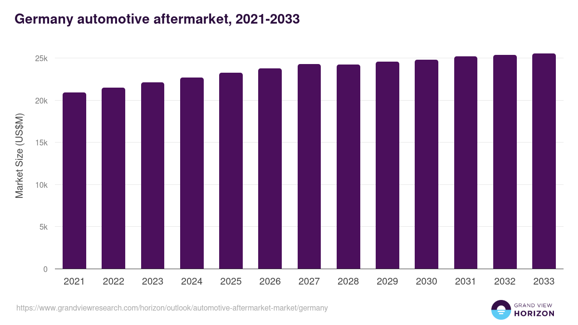
Figure 1: Automotive market of German (2021-2033)
(Source: Grandviewresearch.com, 2024)
The German automotive market developing revenue of USD 23,262.8 million in 2025 and it is predicted to reach USD 25,540.7 million by 2033 (Grandviewresearch.com, 2024).
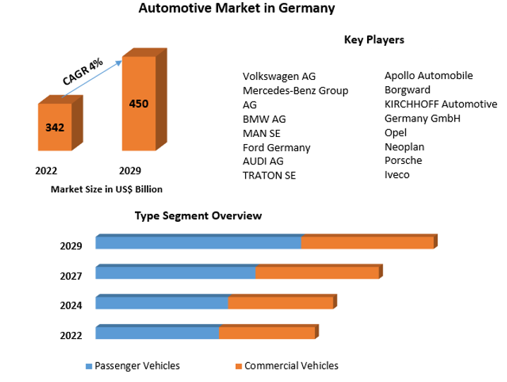
Figure 2: Segment-wise overview of the Automotive industry market in Germany
(Source: MAXIMISE MARKET RESEARCH, 2023)
One of the largest investors in R&D in Germany is automotive companies, which help to constant growth in the passenger and commercial vehicles day by day.

2.3 Major firms and their competitive position in the German Automotive industry
The German automotive industry is characterised with few strong local players, and these are backed by a broad chain of multinational suppliers and international car brands.
Major domestic firms
Volkswagen Group (VW)
VW Group, or Volkswagen in Germany, is one of the largest automaker in Germany.
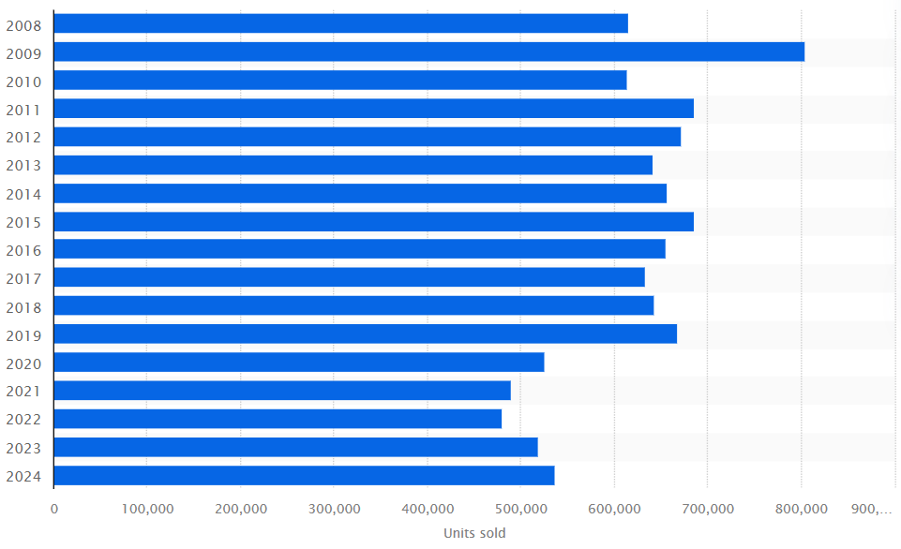
Figure 3: Number of Volkswagen cars sold in Germany (2008 - 2024)
(Source: VDA, 2025)
VW focus on to multi-brand and high-volume strategy, which is performs for enables it to cater to multiple market segments from economy cars to luxury sports cars for drive sales after the pandemic (VDA, 2025). The company is performing for develop ID series, massive battery technology, and software platform investments (Pérez-Moure et al., 2023).
BMW Group
BMW Group places itself as a luxury performance innovator by using strategy to focus on performance, digitalisation, and sustainability. In comparison with Volkswagen, BMW has high production volumes and greater profit margins by drawing attention towards the premium consumers to make better brand image (Wuori, 2023).
Mercedes-Benz Group
Mercedes-Benz Group follows the successful premium strategy through its luxury, comfort, and technological-appropriateness-limiting focus to higher profitability, although its sales volumes diminished, which is why the strategy has to emphasize gaining competitive position (KBA, 2025).
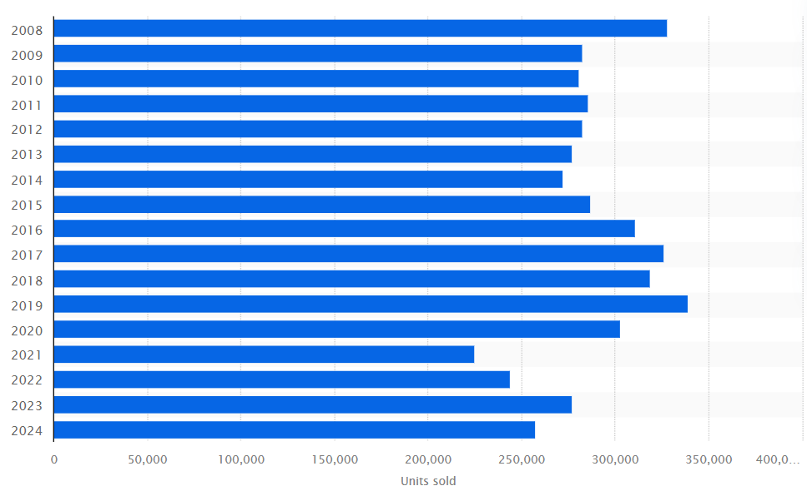
Figure 4: Number of Mercedes cars sold in Germany from 2008 to 2024
(Source: ‌KBA, 2025)
Other German firms
Following the high-end segment with Audi (Volkswagen Group) directly competing with both BMW and Mercedes in innovation in designing, digital interiors and All Wheel Drive systems (Sali, 2024). Porsche is the leader of the luxury sports cars segment with a solid brand loyalty and great profit margins (Nettekoven, 2023).
Multinationals Firms Operating in Germany
Tesla
Tesla has set up own Gigafactory in Brandenburg, which is Berlin, Europe. Tesla's strategy is focused only on not only electric cars but also batteries, and software-powered mobility however organising facing the decline in EV sales in Germany in September (ET Auto, 2025).
Toyota and Hyundai-Kia
Toyota and Hyundai-Kia advertisement by means of low-end distributors in the marketing of themselves to promote efficiency in production, reliability, and value.
Ford and Stellantis (Peugeot, Fiat, Opel)
Germany is the location of its manufacturing and RandD centres by Ford and Stellantis (Peugeot, Fiat, Opel).
Relative Competitive Positioning
- Luxury automotive market is dominated by Mercedes-Benz, BMW, Audi and Porsche where the organisation is preoccupied with the innovation, design, performance, and brand value as opposed to prices.
- The business of electric vehicles is quite competitive, and Tesla has been viable in electric vehicle technology with VW, BMW, and Mercedes establishing wider electric vehicle portfolios (Hong, 2024).
- The performance and sports cars market is dominated by Porsche and BMW M as well as Mercedes-AMG.
Performance Comparison
VW tops in volume and revenue BMW and Mercedes are higher in their margins (Pillai, 2024). Tesla is a leader on the development of selling EVs, yet the largest investments in R&D were seen in the German companies that allow Tesla manufacturers to be creative in the long-term perspective and remain competitive in the world.
Table 1: Major firms and their competitive position in the German Automotive industry
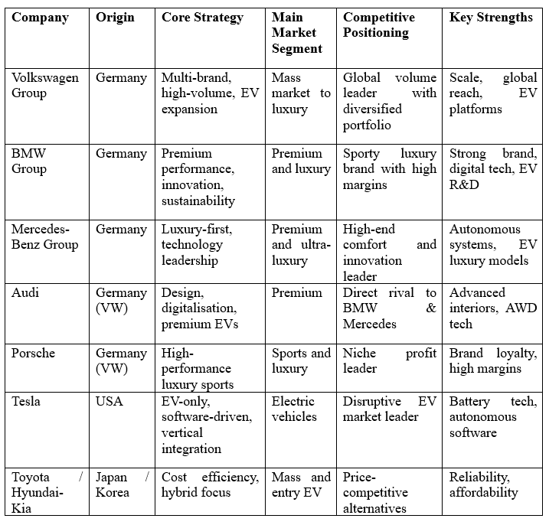

3. Application of Porter’s Diamond Model to the German Automotive Industry
The Diamond Model, presented by Michael Porter, describes reason for some industries in particular countries gain and maintain a competitive advantage worldwide. The model comprises of four fundamental determinants, such as factor conditions, demand conditions, related and supporting industries, staff strategy, structure and rivalry, with the assistance of the functions of government and chance.
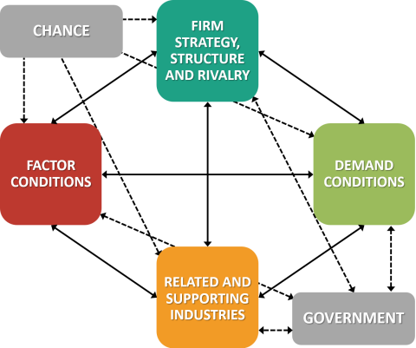
Figure 5: Porter’s Diamond Model
(Source: de Bruin, 2018)
Factor Conditions
Using of the advanced conditions of factors by Germany aids to improving the automotive industry and German dominance in this sector. The labour force is high quality labour in the country particularly in the field of mechanical engineering, automotive design, robotics and software systems. One of the ways to increase R&D in the automotive industry is through the provision of industry-qualified engineers and researchers by German higher learning institutions, such as TUM, RWTH Aachen, and Fraunhofer Institutes (Yeung, 2024).
The automotive companies are the largest privateers in research and development that follows the good R&D infrastructure in Germany. This has facilitated continuous innovation in engine performance, electric powertrains, autonomous vehicles, and computer-based vehicle platforms (Bodade, 2025).
For the purpose of following the physical infrastructure, Germany has world-class highways that help to maintain the logistics, hubs, ports and railway networks to make better efficiency in domestic and international distribution management (Pekarcikova et al., 2025). The availability of capital, the knowledge of suppliers and sophisticated technologies of manufacturing (Industry 4.0, automation, AI-based production) are additional factors contributing to Germany's factor advantages.
Demand Conditions
The domestic market in Germany is advanced and challenging thus valuable in determining global competitiveness. German customers are very quality-seeking and technologically-minded and seek vehicles with features in performance, safety, sustainability, and digital performance (Kim et al., 2022).
Following the environment and strict emission standards in Germany has driven the acceleration of electric and hybrid technologies, forcing companies include Volkswagen, BMW, and Mercedes-Benz, to become world leaders in EV changes (Bodade, 2025). The domestic market focuses on the luxury cars that have high performance, which contributes to the German brands having a significant reputation in the global luxury markets.
Germany's focus on developing new mobility solutions (connected vehicles, hydrogen technologies, and autonomous systems) means that companies remain on the trends of the other automotive industries in the world. Demand sophistication follows the export-oriented consumers, for the purpose of handling the constant innovation management (Ceelen, 2023).
Related and Supporting Industries.
Germany possesses one of the most robust automotive supply ecosystems in the world, where major international suppliers, Bosch, Continental, Schaeffer and Siemens are located due to the large presence in Germany. These companies have advanced parts in vehicle braking systems, electronics, sensors, batteries, and AI car technologies.
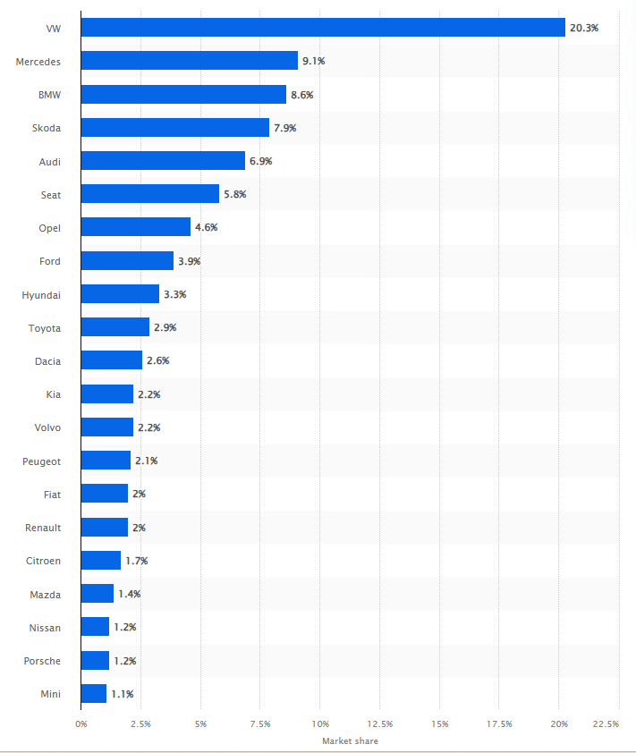
Figure 6: Market shares of the leading car brand on Jan to July 2025
(Source: ‌KBA, 2025)
German automakers and suppliers help to build rapid innovation, many are economical, and joint product development and the sales of the automotive sector are high in Volkswagen (Yeung, 2024). Furthermore, the industries of Germany such as chemical, steel, electronics, and software are also powerful, and it highly involved in the production of vehicles. There are research organisations, testing centres and start-ups that form an active innovation cluster which increases the rate of diffusion of technological innovations in the automotive sector and facilitates continuous improvement, which in turn has a successful impact of ensuring a sustained competitive edge in Germany within the automotive industry.
Firm Strategy, Structure, and Rivalry
One of the drivers of excellence is having huge domestic competition. The industry is well-competed with German manufacturers, including Volkswagen, BMW, Mercedes-Benz, Audi, and Porsche, being very innovative, designed, performance-focused, as well as sustainable (Wuori, 2023). This drive makes one continually improve the technology, efficiency and branding. German company systems are oriented to the long-term investment, quality management and engineering without a focus on a short-term profit (Gerlich, 2023). The companies are engaging in strong research and development, digitalisation and sustainability. Wolswagen, in that case, is specialised in scale and diversification, BMW in sporting luxury, and Mercedes-Benz in luxury focused innovation. Otherwise, foreign brands and firms like Tesla, Toyota, and Hyundai-Kia also strain local corporations, which forces them to implement faster EV strategies and online sources, which, in turn, leads to making global companies more competitive (Jiang-Min, 2023).
Role of Government
The role of the German government is supportive, and the government's efficiency, strict concern for innovation, environments aids to motivate workers to maintain the quality and environmental requirements, and invests in digital infrastructure (Jeong et al., 2024). The policy of encouraging electric mobility, green energy, and smart manufacturing fosters innovation by following international regulations.
Role of Chance
Having multiple international forces, such as technological disruption, climate change policies, and digitalisation have accelerated the transition in Germany towards electric and smart mobility aids to bring the opportunities of innovation leadership.
This way, the success of the German automotive industry has seen to maintain the reinforcement of benefits in all four dimensions of Porter's Diamond. The national system of innovation is very strong with the combination of highly skilled labour, demanding consumers, world-class suppliers, high competition and favourable government policies. This is the reason why Germany has maintained a lead in the world automotive industry, regardless of the increasing global rivalry.
Table 2: Application of Porter’s Diamond Model to the German Automotive Industry
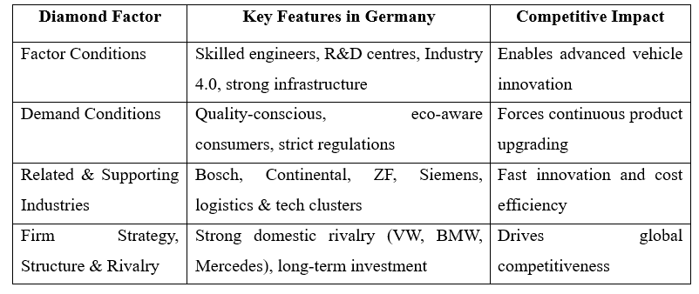

4. Macro-Environmental Analysis and Market Attractiveness of the German Automotive Industry

4.1 Introduction & Framework Justification
In this section, an evaluative analysis of how attractive Germany is as a host country for Volkswagen (VW) is carried out by evaluating the macro-environmental forces on its operations and its long-term competitiveness. VW is integrated into Germany's institutional, economic, and social-cultural systems. Moreover, the existing global change in favour of electric motility, digitalisation and sustainability has dramatically changed the number of risks versus opportunities in the German automobile market.
PESTLE can enable an organised consideration of external factors that can affect operational viability, legal compliance, cost models, and consumer behaviour. In the meantime, it uses the CAGE framework (Cultural, Administrative, Geographic, and Economic distance) to make sense of the strategic opportunities and structural constraints of institutional proximity to VW in Germany.
Table 3: CAGE framework
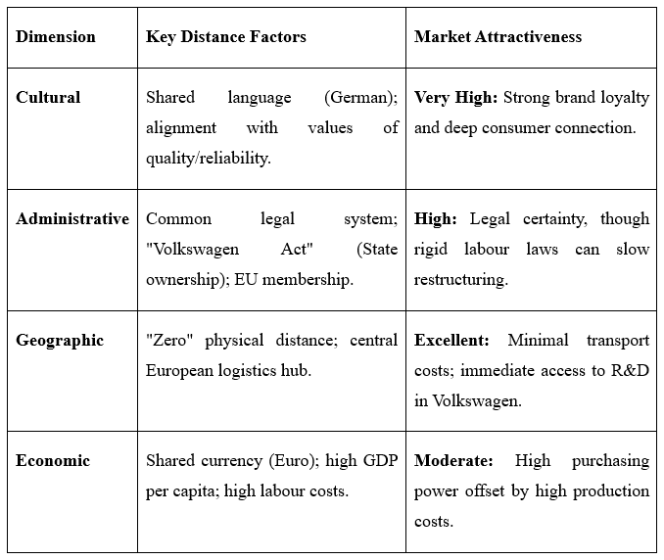
Table 4: PESTEL framework
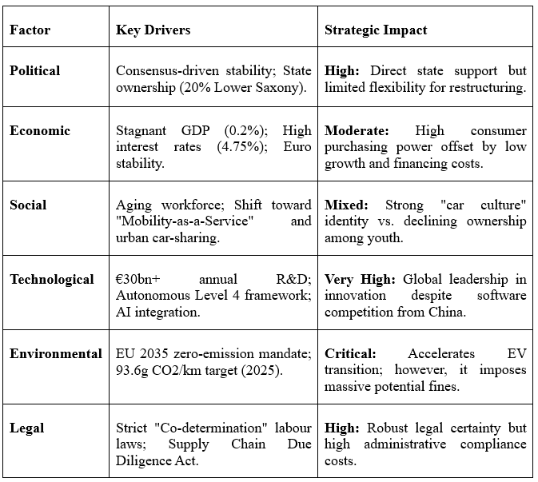

4.2 Political & Legal Factors
The political and legal environment in Germany is complicated and highly dynamic, and cannot be separated from the success of Volkswagen (VW). Being the biggest industrial employer in Germany, the VW company works in the framework of the so-called co-determination model, where all the political interests, labour rights, and environmental regulations meet to form both considerable support and limiting forces.
This section analyses the Administrative Pillar of the German market, which is the political and legal framework of the operation of Volkswagen.
4.2.1. Political Stability and Government Stance
Germany has been at the forefront of political stability, but there is a sign of a transition period in the automotive industry in the current policies. The state has a two-sided policy: the green transformation and the global protectionism aftermath. One such policy change is the danger of de-risking the trade relationships with China, especially as it pushes MNCs such as VW to transfer some of the main supply chains to the EU (Sinnarkar, 2024). Nevertheless, the political climate is also most appealing, with an infrastructure fund of about 500 billion and a climate fund of about 100 billion passed in March 2025, which are indicators of the persistence of state funding on the modernisation of industries (Rödel and Pauls, 2024).
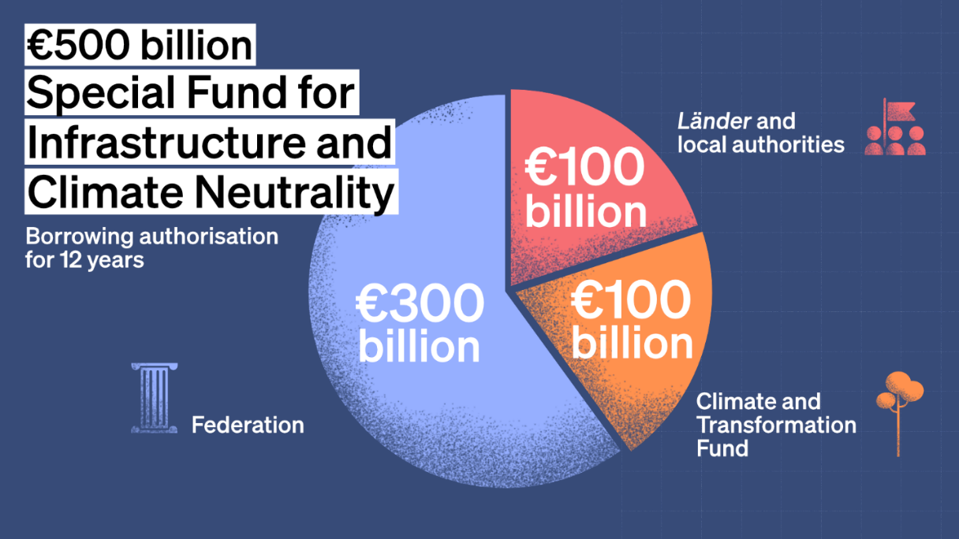
Figure 7: €500 Billion State Infrastructure & Climate Fund (Political Stability)
(Source: Federal Ministry of Finance, 2025)
4.2.2. Regulatory Compliance and Legal Requirements
VW is built on a strict regulatory regime that spells out its cost base and operation boundaries:
- Labour Laws: Without reference to legislative acts, the law of Co-determination in Germany provides the Works Councils with legal disenfranchisement power against the closure of plants. More recent legal changes in 2025, like the Bureaucracy Relief Act, have changed the digital standards of employment, but have not reduced the high legal barricades granted to employees (Muschal and Jüngst, 2025).
- Environmental Standards: Legally required is the EU Automotive Package (Dec 2025), whereby a fleet-wide CO 2 target and 93.6 g/km is to be reached in 2025 (Bruneau et al., 2026). Though meeting these goals may include a June 2025 amendment that permits averaging over three years (20252027), the zero-emission goal of 2035 will continue to provide the main force in the product strategy of VW.
- Supply Chain Act: The German Supply Chain Due Diligence Act now responds with highly punitive measures in case of human rights or environmental breach in any part of the global network of VW, and thus, compliance has become one of the central legal obligations (Federal Ministry for Economic Cooperation and Development, 2022).
4.2.3. Government Incentives and Subsidies
After a break in the subsidy in 2024, the government created the EV Incentive Programme of 2026 to boost demand:
- Direct Subsidies: A 3 billion fund provides grants of up to 6,000 on electric vehicles (EVs) retrospective to January 1, 2026, to households with incomes not more than 80,000.
- Corporate Tax Breaks: Under a new turbo Depreciation, firms can claim 40% of the value of an EV in the first year of ownership of vehicles bought between 2025-2027 (General Motors Company., 2025). In addition, the benefit-in-kind tax of 0.25% tax on electric company vehicles was increased to be payable on the gross list price up to 100 thousand euros in early 2026.
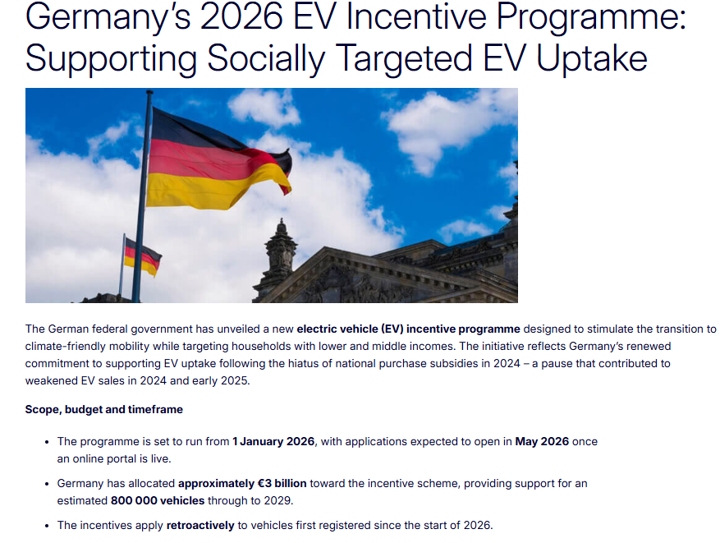
Figure 8: 2026 EV Incentive Programme (Government Incentives)
(Source: European Alternative Fuels Observatory, 2024)
4.2.4. CAGE Link: Administrative Distance
The ‘Administrative Distance’ of VW in Germany is essentially zero since it is the native market of the company. This is a zero distance that creates a strong competitive edge.
On one hand, the distance is eliminated, which guarantees stability; on the other hand, the "Institutional Voids" typical of foreign markets are substituted by the so-called "Institutional Density", a network of regulations and labour power, which can slow down radical change, unlike its competitors in the international arena.

4.3. Economic Factors
This is a highly structural cost and low domestic demand environment, which characterises the economic environment associated with Volkswagen (VW) in Germany, a country that was once a growth powerhouse. Being an MNC that provides about 8% of the German GDP, the success of VW is inherently tied to the national Economic Pillar.
4.3.1. Macro Indicators
Recently, the macroeconomic performance of Germany has shifted to fragility:
- GDP Growth: Germany regained its lost ground of moving on to marginal growth of 0.2% in 2025 after 2 years of recession (Federal Statistical Office, 2026). This low level of performance curtails the general appeal of the market to high-value manufacturing.
- Inflation and Purchasing Power: Headline inflation has been improving to 2.3% in 2025; however, the cumulative effect of past increases in prices in the past is still there. Though the real wages start to grow at the end of 2025, the consumer sentiment is not a booming one yet, and the savings rate reaches 11.4 per cent, as people are not willing to spend much on significant car purchases (Federal Statistical Office, 2025).
- Monetary Stability: VW enjoyed a stable currency as a member of the Eurozone, although the high-interest context (topping at 4.75) has always been expensive to finance its vehicles, pushing consumers to the used cars market.
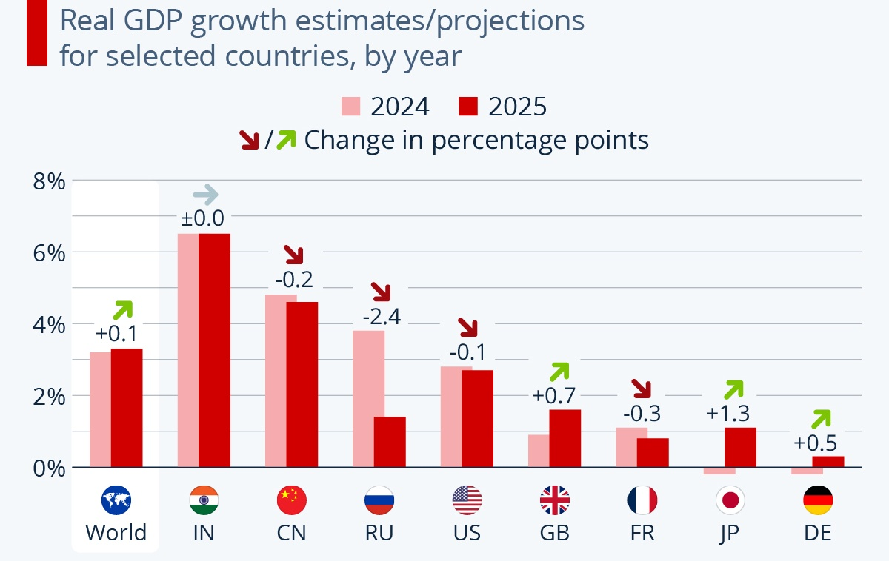
Figure 9: Germany’s GDP Growth Comparison Chart
(Source: Fleck, 2024)
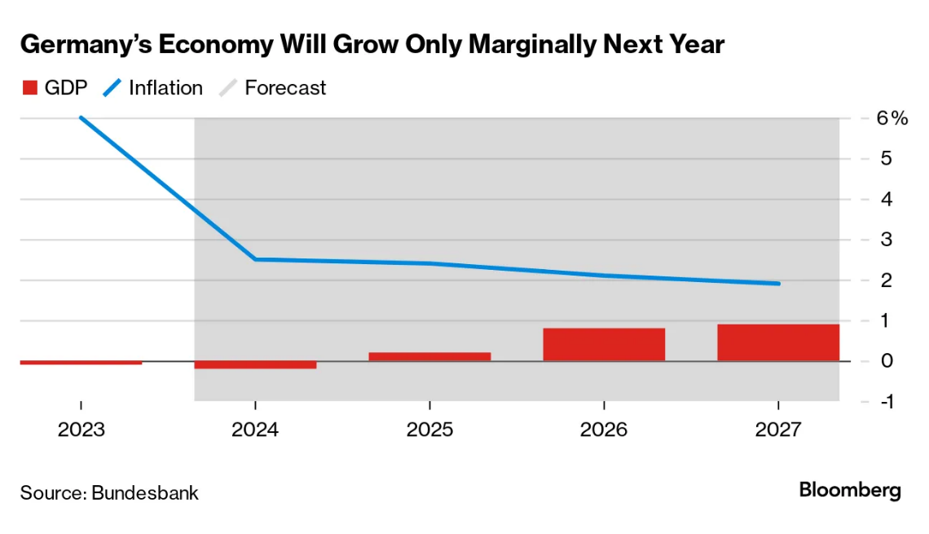
Figure 10: GDP & Inflation Trend Chart
(Source: Sorge, 2024)
4.3.2. Infrastructure and Labour
German physical and human capital present a mobile and swift-paced environment to VW:
- Infrastructure Quality: Though Germany has the highest level of motorway and railway network in Europe, most specifically in ports such as Bremerhaven and Hamburg. In 2025, the government increased investment in the Special Fund of transport and climate neutrality, amounting to 500 billion Euros, where 52 billion Euros was dedicated to highways to sustain the industrial efficiency (Federal Ministry of Finance, 2025).
- Skilled Labour Supply: Although Germany boasts of a highly qualified workforce, there is an acute lack of this population. Secondly, as per the automotive industry, jobs reached a 14-year low of 721,400 individuals at the end of 2025 (Xinhua News Agency, 2025). VW, in particular, is facing a skills gap in STEM fields as it changes towards digital and autonomous technologies, with almost 27% of companies reporting labour shortages in the face of industrial layoffs.
4.3.3. Exchange Rates and International Trade
VW is very sensitive to the exchange rate of the Euro, with 40% of its total world revenue being linked to exports made in Germany.
- Trade Profitability: Although a stable Euro will streamline intra-EU trade, the exchange against the USD and CNY will affect the competitiveness in key markets such as the USA (15.6% of exports) and China (6.8% of exports). As of 2024, the value of automotive exports has declined by 5% to reach the level of export of 372.2 billion due to the increased competition and adverse currency impacts across non-Euro markets (Germany Trade & Invest, 2025).
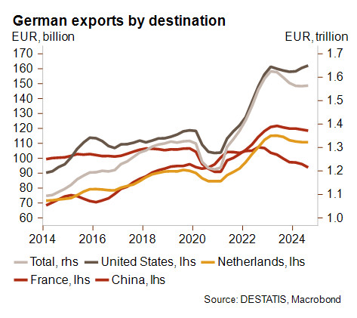
Figure 11: Exports by Key Destinations
(Source: Credendo, 2025)
4.3.4. CAGE Link: Economic Distance
Economic Distance in the CAGE approach is generally used to gauge variations in consumer income and cost formations. In the case of VW in Germany, the distance here is zero with respect to the domestic market, though there has grown a wide "Internal Economic Gap":
- Cost Disparity: The first economic problem is the distance among the cost of production between Germany and its competitors. German labour is almost twice that of Southern Europe at a rate of 62 per hour (Schröder, 2022).
- Market Attractiveness: It does not have a distance between itself and its consumer due to a lack of economic distance, yet the expensive domestic structure is a drag on global competitiveness. This compels VW to pursue cost efficiency by cutting wages by 10% and plant restructuring in order to close the gap between it and the international low-cost entrants.
Economic Factor | Current Status (2025-26) | Impact on VW Success
GDP Growth | 0.2% (Stagnant) | Low domestic sales growth
Labor Cost | €62/hour (Highest in EU) | Pressure on operating margins (2%)
Inflation | 2.3% (Easing) | Gradual recovery of purchasing power
Infrastructure | Excellent (New €500bn fund) | High logistics and R&D efficiency

4.4. Socio-Cultural Factors
In Germany, the trends in the socio-cultural environment have given Volkswagen (VW) a solid yet ageing consumer base that appreciates precision and high quality but is concerned about technological disruption.
4.4.1. Demographics and Consumer Behaviour
Germany is experiencing a major demographic change; the median age in Germany is 46.5 years, and it is among the most mature societies in the whole world. Just 13.9% of the population is aged below 15, and 24 per cent old (65 and above), which is a declining contributor to the labour force, and the market is becoming more geared towards convenience and safety rather than cut-throat performance (Population Pyramids, 2025). Germany has a high score in Uncertainty Avoidance (65) as it applies to Hofstede Cultural Dimensions. This is reflected in a management culture focusing on experience and formal education, and a consumer preference for well-established brands such as VW, which has a sense of mechanical certainty.
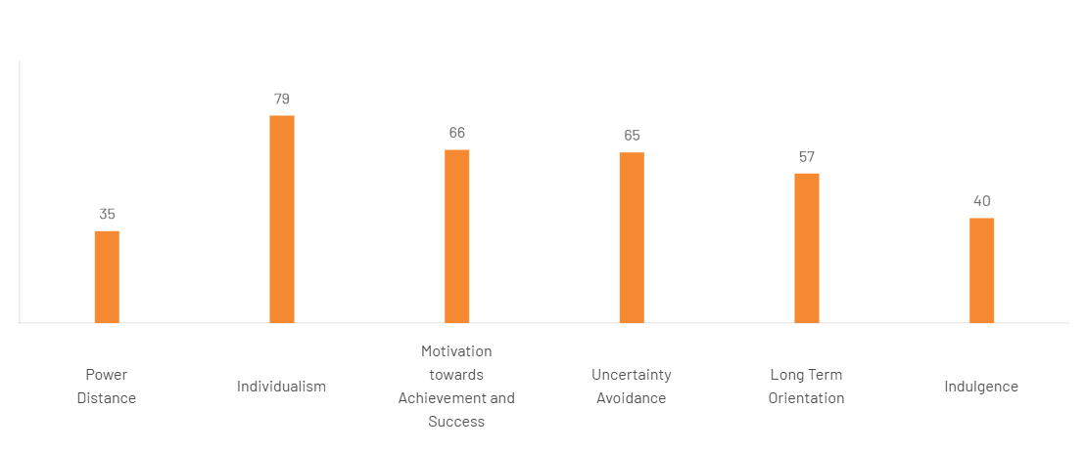
Figure 12: Hofstede’s Cultural Dimension Score, Germany
(Source: The Culture Factor, 2026)
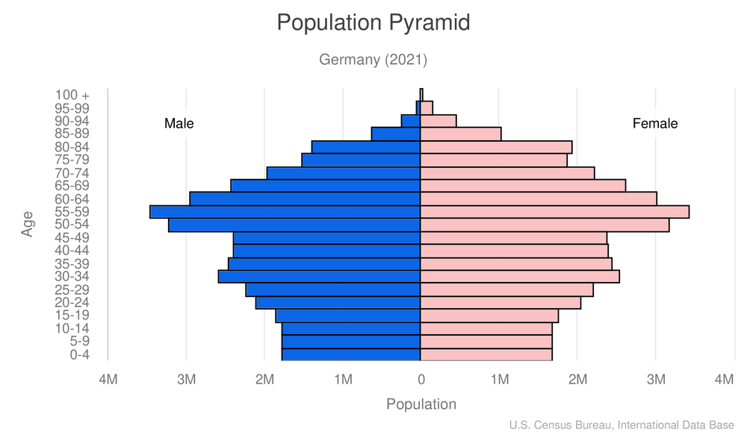
Figure 13: Population pyramid
(Source: Central Intelligence Agency, 2021)
4.4.2. Values, Beliefs, and CAGE Link
One of the basic German values is environmental sustainability, but 2025 tendencies demonstrate a lack of a sustainability-price gap. Although 70 per cent of Germans are worried about climate change, 23 per cent are willing to pay a premium to buy green products, and that is why VW would have to create its EVs more as a value than as a luxury niche product.
Cultural Distance of VW in Germany in the CAGE framework is small. No language barriers or religious difference has to be taken into consideration, and the social norms, including the Made in Germany insignia of quality, fit the VW brand image perfectly well. Nonetheless, VW has to localise its online strategy in such a way that it targets Gen Z individuals who prefer mobility-as-a-service to traditional car ownership, which is an indication of the change in social convention of status-seeking to usefulness.

4.5. Synthesis: Overall Market Attractiveness and Success Factors
Volkswagen Germany follows an effective strategy which aids to make structurally challenging market for the automotive sector. In its political domain, a strong state contribution through infrastructure, climate change, and innovation sets the climate of stability in investment. On the other hand, legal factor highlights that strict labour policies and the cost of environmental compliance increase the complexity of operations. The economic scenario highlights that Germany has infrastructure and high labour standards, which not only support GDP growth, but having the high interest rates and increasing production costs, declining domestic demand and margins. As a result, the sales of Volkswagen are declining in Germany.
On the other hand, following the socio-cultural factor, Germany offers VW a commitment-based quality consumer base which fits in its engineering background. In that case, the use of demographic ageing and the change in preferences towards sustainability and mobility-as-a-service verify the necessity to quickly transform the business models of the automobile sector. Use of the CAGE framework indicates that VW follows minimal administrative and cultural distance in the country, based on the same institutional proximity and the contradiction of flexibility as appreciated by competitors to run their businesses in less regulated and lower-cost settings.
From this discussion, it has been understood that Germany is a fairly appealing market and follows the commercially vital market. The high cost and regulatory rationales are offset by the capacity to innovate, state funding, consumer confidence, and robust supplier ecosystems. The success of Volkswagen is using digitisation to reorganise resources in affluent operations, and aids in favouring government encouragement which align to changing consumer values.

5. Conclusion to the report
This report has critically examined the German automotive industry, and Volkswagen's strategic position, explaining the reason about Germany has been one of the most competitive automotive nations in the world despite facing structural and transformational pressures. The industry analysis revealed that Germany was ahead of technology in terms of high-quality engineering, exportation of products, and innovation ability, which are backed by global companies like Volkswagen, BMW, and Mercedes-Benz. Competitive positioning analysis revealed that German firms can continue to dominate by creating strategic differentiation, well-developed branding and technological investment in response to disruption by electric and digital mobility players like Tesla. In that case, using of the Porter Diamond Model has shown that the factors behind the success of Germany include superior factor conditions, demanding domestic consumers, well-established supplier networks, and high domestic competition, reinforcing processes to maintain the automotive global competitive edge of Germany.
The country-level analysis of the Volkswagen case, based on the PESTLE and CAGE frameworks, demonstrated a complex business environment. Germany is politically and legally stable, with a robust government backing green transformation and is also heavy-handed with regulatory and labour restrictions.
For this reason, Germany has a strategically important market; however, it develops a structurally challenging market for Volkswagen. The key to the success of the company in the long-term perspective will lie in its capacity to strike the right balance between regulatory compliance and cost-efficiency, leverage technological leadership, and match sustainability-oriented consumer demands. Despite that, Volkswagen focus on restructuring operations and making the company faster in its current innovative development, which will be able to sustain itself in its competitive roles and contribute further to the future of mobility worldwide.

Section 2: Reflective Account of the Research and Analysis Process
The reflection below applies the Reflective Cycle of Gibbs (1988) in analysing the journey of conducting research and writing the international industry report on Volkswagen in Germany. The purpose of this account is to reconcile the difference between the applied academic theories and the individual development in the professional field acquired during the module.
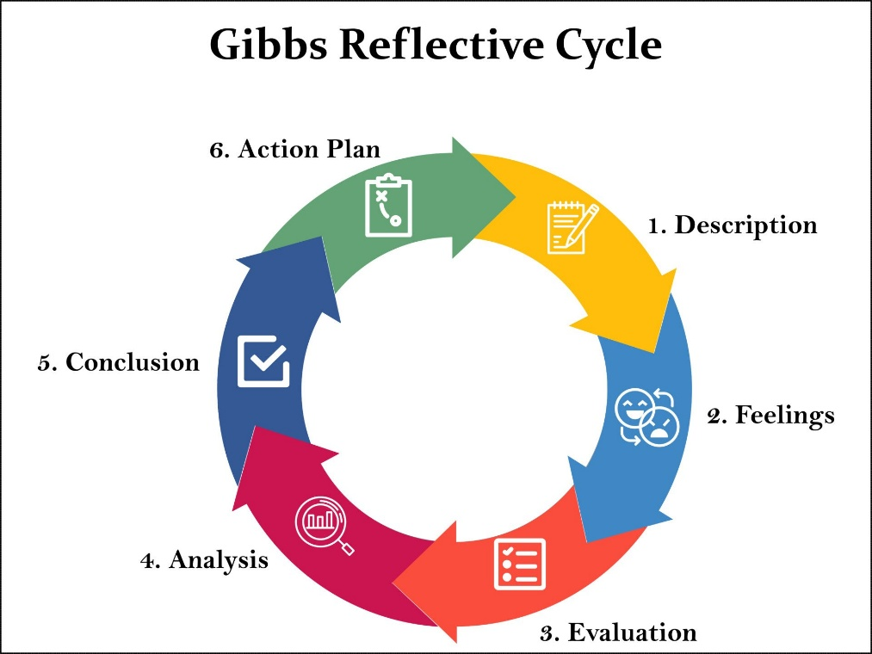
Figure 14: Gibbs' Reflective Cycle
(Source: McLeod, 2024)

1. Description
The task entailed the choice of a multinational company and a host country in order to assess factors of market attractiveness as well as operational success. I selected a case of Volkswagen (VW) and Germany, as I concentrated on the process of electrifying the car industry. This was done through a systematic search of secondary data through annual reports, government databases such as Destatis, and industry projections through Germany Trade and Invest. I used the PESTEL framework to scan the macro-environment and the CAGE Distance Framework to test bilateral attractiveness. I acted as an independent researcher and was able to synthesise Wall Street of data into a critical report. It resulted in a holistic examination of the reasons why political, economic, and socio-cultural issues are now threatening the domestic dominance that VW enjoys in spite of the zero-distance advantage provided by the domestic market.

2. Feelings
First, I was overloaded by the mass of information produced on such a scale as a national champion as Volkswagen. It felt like pressure to give a distinct insight into a company that is so well-documented. The issue that I found myself frustrated with during the data collection phase was trying to reconcile the ambitious political rhetoric around the country being so green with the abrupt stoppage of EV subsidies, which was a so-called policy shock (Mukherjee, 2024). But when I started using the data to map it across to the CAGE table, I experienced a considerable change in confusion to clarity. Understanding that Administrative Distance might be a two-sided sword, providing security and at the same time exerting the same effect through inflexible labour legislation as a form of organisational inertia, was a source of intellectual fulfilment that gave me a slightly stronger feeling of assurance in using advanced IB frameworks.

3. Evaluation
The quality of the high-quality, transparent data presented by German institutions and the Investor Relations of VW made this process the most positive one. This permitted a PESTEL analysis that was founded on data and went beyond the surface. The application of the CAGE framework in revealing the "Economic Distance" about labour costs was also another success that turned out to be the most important finding of the report (Cuofano, 2024). On the other hand, the stage of the Analysis was rather tricky; it was hard to write in an unbiased key when addressing the topic of the 2024-2025 profit alerts of VW. Another issue was controlling the amount of words as in the case of the legal section wherein, owing to the complexity of the EU-level versus the German national level regulations, I had to control the use of the available space and had to sort through what I would include and what I would not, rather than just trim my arguments to fit in the space allocated.

4. Analysis
My experiences in overcoming the challenges also portray the complexity of IB research pointed out in the module, as the outside environments are hardly fixed. The analysis of the policy shock on subsidies can be viewed through the prism of the implications of the so-called Political Risk, even in well-established democracies, unanticipated changes in fiscal policy may interfere with the industrial capabilities. My difficulty in balancing the "Legal section was because I was working with the EU and Germany independently of each other and not under one legal structure, the Supranational. The application of the CAGE model made it clearer to me that the strongest asset (strong institutional association in Germany) of VW is also a strategic weakness according to the Diamond Model proposed by Porter because the Factor Conditions (high labour cost) are no longer favourable compared with that of emerging Chinese rivals who are able to work in a more agile and less burdensome manner.

5. Conclusion
As a result of this experience, I came to understand that the research of international business involves not only data collection but also a process of critical filtering of all that the macro-factors do not include: upon it, only the ones that are really transformative are observed. I understood that my first one was too descriptive; in subsequent reports, I should allocate more time to the so what wherein I provide what the data means to the organisation, which I do not simply give the figures. Now I know that even a domestic market may have a wide range of distances in the context of the competitiveness of economies and outgoing social standards. I have gained more skills on how to synthesise conflicting data and have better understood more about the importance of internal organisational culture (co-determination), which is legally obliged to the external political environment in Germany context.

6. Action Plan
To ensure that I will exercise a framework-first method in my professional practice and future assignments, I will apply the same practice. I will use the categories of PESTEL and CAGE to inform my preliminary search terms, rather than collecting data and attempting to fit it into some model, and thus avoid the excess information that I had. To work on my critical writing, I will consider using more synthesis tables at the very beginning of the entire writing process so that my arguments can balance between positive and negative factors. Also, I will work on shaping a more sophisticated perception of supranational (EU) and national legal systems to enable me to observe the activities of MNCs. In my next project, I would like to use such enhanced research methods to get a more efficient and theoretically sound analysis.
This reflection has given a critical chance to absorb the intricacy of global business strategy. Through a systematic analysis of my research experience, I have managed to structure a demanding schooling undertaking into a principle of analytical abilities that I will bring with me into the profession of management.

Reference List
Article references
Bodade, M.S.M., (2025). FUTURE TRENDS IN CAD–BY THE PERSPECTIVE OF AUTOMOTIVE INDUSTRY. FUTURE, 10(01). https://ijiird.com/VBK25/ME032.pdf
Bruneau, M., de Rohan Chabot, A., and de Kondratowicz, S. (2026, January 15). The EU automotive package: Increased compliance flexibility but growing “made in the EU” conditionality. Global Policy Watch. https://www.globalpolicywatch.com/2026/01/the-eu-automotive-package-increased-compliance-flexibility-but-growing-made-in-the-eu-conditionality/
Ceelen, H.L.H., (2023). The Effect of Disruptive Innovations in the Automotive Industry on Incumbent Car Manufacturers’ Business Models. DESSY RUTTEN, p.146. https://science-media.org/userfiles/1058/papers/1058_paper_1204.pdf#page=157
Cuofano, G. (2024). CAGE distance framework in a nutshell. FourWeekMBA. https://fourweekmba.com/cage-distance-framework/
Federal Ministry for Economic Cooperation and Development. (2022). Factsheet: Act on Corporate Due Diligence Obligations in Supply Chains [Brochure]. Federal Office for Economic Affairs and Export Control. https://www.bafa.de/SharedDocs/Downloads/EN/Supply_Chain_Act/bmz_factsheet_lksg.pdf
Federal Ministry of Finance. (2025, June 24). Government draft for the 2025 federal budget and financial plan to 2028 (Press release). https://www.bundesfinanzministerium.de/Content/EN/Pressemitteilungen/2025/2025-06-24-2-government-draft-2025-federal-budget.html
Federal Statistical Office. (2025, March 10). German exports in January 2025: -0.8% on December 2024 (Press release No. 093). https://www.destatis.de/EN/Press/2025/03/PE25_093_611.html
Federal Statistical Office. (2026, January 15). Gross domestic product in 2025: German economy stagnates (Press release No. 017). https://www.destatis.de/EN/Press/2026/01/PE26_017_811.html
General Motors Company. (2025, January 28). Form 10-K for the fiscal year ended December 31, 2024. U.S. Securities and Exchange Commission. https://www.stocktitan.net/sec-filings/GM/10-k-general-motors-co-files-annual-report-4bc94594eb76.html
Gerlich, M., (2023). How short-term orientation dominates western businesses and the challenges they face—an example using Germany, the UK, and the USA. Administrative Sciences, 13(1), p.25. https://www.mdpi.com/2076-3387/13/1/25
Germany Trade & Invest. (2025). The automotive industry in Germany: Industry overview 2024/25. https://www.gtai.de/resource/blob/64100/ebdfca790aa0df33b694bfc4e653f998/20250520_IO_Automotive_WEB.pdf
Hong, J., (2024). Competitive Strategies and Market Positions of Global Automotive Giants: Toyota, Tesla, and BMW. In International Conference on Educational Information Technology (Vol. 6, No. 2). https://www.cpcig-colepuli.com/uploads/soft/20240815/1-240Q516162U10.pdf
Jeong, J.H., Kim, C. and Jo, H.J., (2024). Three major challenges in the shift to electric vehicles: Industrial organisation, industrial policy, and a just transition. Sociology Compass, 18(5), p.e13218. https://compass.onlinelibrary.wiley.com/doi/pdfdirect/10.1111/soc4.13218
Jiang-Min, D.I.N.G., (2023). Analysing Tesla's International Business Strategies: A Closer Look at the Korean and Chinese Markets. The Journal of Economics, Marketing and Management, 11(5), pp.15-27. https://koreascience.kr/article/JAKO202329757604681.pdf
Kim, J., Paek, B. and Lee, H., (2022). Exploring innovation ecosystem of incumbents in the face of technological discontinuities: Automobile firms. Sustainability, 14(3), p.1606. https://www.mdpi.com/2071-1050/14/3/1606
Mukherjee, N. (2024, May 6). Fragile green bond market exposes the limits of India’s net-zero push. Outlook Business. https://www.outlookbusiness.com/magazine/fragile-green-bond-market-exposes-the-limits-of-indias-net-zero-push
Muschal, H., and Jüngst, U. (2025, January 8). Key developments in German labor and employment law in 2025. The National Law Review. https://natlawreview.com/article/key-developments-german-labor-and-employment-law-2025
Nettekoven, Z.M., (2023). Automotive industry transformation and industrial policy in the EU and Germany: A critical perspective (No. 208/2023). Working Paper. https://www.econstor.eu/bitstream/10419/271001/1/1840242728.pdf
Pekarcikova, M., Sujova, E., Mizerak, M., Trojan, J. and Edl, M., (2025). Key performance indicators as a tool for evaluating efficiency of production processes. Acta Logist, 12, pp.223-228. https://actalogistica.eu/issues/2025/II_2025_Abstracts.pdf
Pérez-Moure, H., Lampón, J.F., Velando-Rodriguez, M.E. and Rodríguez-Comesaña, L., (2023). Revolutionising the road: How sustainable, autonomous, and connected vehicles are changing digital mobility business models. European Research on Management and Business Economics, 29(3), p.100230. https://www.sciencedirect.com/science/article/pii/S2444883423000177
Pillai, K., (2024). A Comparative Analysis of R&D Strategies and Their Impact on BMW and Mercedes-Benz's Market Dominance. Available at SSRN 4850759. https://papers.ssrn.com/sol3/Delivery.cfm?abstractid=4850759
Population Pyramids. (2025). Germany population pyramid 2025. https://www.populationpyramids.org/germany
Rödel, T., and Pauls, S. (2024, December 16). Germany’s €500 billion infrastructure fund: Practical insights and opportunities. Latham & Watkins. https://www.lw.com/en/insights/germanys-500-billion-infrastructure-fund-practical-insights-and-opportunities
Sali, M., (2024). Designing an Innovetive Modular Platform for Sports Car Using the Generative Design Method. https://amsdottorato.unibo.it/id/eprint/11438/1/Merve_Sali_36th_Cycle.pdf
Schröder, C. (2022, October 21). An international comparison of unit labour costs: The cost competitiveness of German industry in times of multiple crises (IW-Trends No. 3). German Economic Institute (IW). https://www.iwkoeln.de/en/studies/christoph-schroeder-the-cost-competitiveness-of-german-industry-in-times-of-multiple-crises.html
Sinnarkar, M. (2024, December 15). De-risking China: How global supply chains are rewiring for 2025. LinkedIn. https://www.linkedin.com/pulse/de-risking-china-how-global-supply-chains-rewiring-2025-sinnarkar-y9wdf
Wuori, P.E.M., (2023). Analysing the Differences Between Luxury and Premium in Marketing–Case Study: BMW and Rolls-Royce. https://www.theseus.fi/bitstream/handle/10024/802349/Wuori_Paula.pdf?sequence=2
Xinhua News Agency. (2025, November 21). Germany's economic prospects remain clouded by global uncertainties. https://english.news.cn/20251121/1b3f990f4af348e4be549f0b122db9a1/c.html
Yeung, G., (2024). Competitive dynamics of lead firms and their systems suppliers in the automotive industry. Environment and Planning A: Economy and Space, 56(2), pp.454-475. https://journals.sagepub.com/doi/pdf/10.1177/0308518X231202390
Website references
Central Intelligence Agency. (2021). Population pyramid Germany 2021 [Infographic]. Wikimedia Commons. https://commons.wikimedia.org/wiki/File:Population_Pyramid_Germany_2021_(CIA_World_Factbook).png
Credendo. (2025, January 27). Germany: German economy contracts for second consecutive year amid manufacturing sector's existential crisis. https://credendo.com/en/knowledge-hub/germany-german-economy-contracts-second-consecutive-year-amid-manufacturing-sectors
de Bruin , L. (2018). Porter’s Diamond Model EXPLAINED with EXAMPLES | B2U. [online] B2U - Business-to-you.com. Available at: https://www.business-to-you.com/porter-diamond-model/.
ET Auto (2025). Tesla’s German car sales fall in September though wider EV sales jump. [online] ETAuto.com. Available at: https://auto.economictimes.indiatimes.com/news/passenger-vehicle/tesla-german-car-sales-decline-in-september-despite-ev-sales-increase/124354440 [Accessed 31 Jan. 2026].
European Alternative Fuels Observatory. (2024, November 13). Germany’s 2026 EV incentive programme: Supporting socially targeted EV adoption. https://alternative-fuels-observatory.ec.europa.eu/general-information/news/germanys-2026-ev-incentive-programme-supporting-socially-targeted-ev
Federal Ministry of Finance. (2025). Special fund for infrastructure and climate neutrality. https://www.bundesfinanzministerium.de/Web/EN/Issues/Public-Finances/SVIK/special-fund-infrastructure-and-climate-neutrality.html
Fleck, A. (2024, July 23). Germany: From economic powerhouse to G7 laggard. Statista. https://www.statista.com/chart/33347/gdp-growth-projections-for-selected-countries/
Grandviewresearch.com. (2024). Germany Automotive After Market Size & Outlook, 2030. [online] Available at: https://www.grandviewresearch.com/horizon/outlook/automotive-aftermarket-market/germany.
‌KBA, VDA. (2025). Number of Mercedes cars sold in Germany from 2008 to 2024. Statista. Statista Inc.. Accessed: January 31, 2026. https://www.statista.com/statistics/414921/mercedes-car-sales-in-germany/?srsltid=AfmBOorbQ4TIxVpjs8-9M6BirwauV4UCkiYNq9mm_1rsQgl71Kcvr31Z
‌KBA. (2025). Market shares of the leading car brands in Germany from January to July 2025, by number of new car registrations. Statista. Statista Inc.. Accessed: January 31, 2026. https://www.statista.com/statistics/1005575/leading-car-brands-market-share-new-registrations-germany/?srsltid=AfmBOor9vDCkSkSRK8Zg5XhLUGx-neOMhxZK_u8dhEcCB3lghc_G1YG6
‌MAXIMISE MARKET RESEARCH. (2023). Automotive Market in Germany: Industry: The World’s Automotive Hub of Innovation (2023-2029). [online] Available at: https://www.maximizemarketresearch.com/market-report/automotive-market-in-germany/86571/
Mcleod, S. (2024, January 24). Gibbs' reflective cycle. Simply Psychology. https://www.simplypsychology.org/gibbs-reflective-cycle.html
Sorge, P. (2024, December 13). German economy will hardly grow in 2025, Bundesbank says. Bloomberg. https://www.bloomberg.com/news/articles/2024-12-13/german-economy-will-hardly-grow-in-2025-bundesbank-says
The Culture Factor. (2026). Country comparison tool: Germany. https://www.theculturefactor.com/country-comparison-tool?countries=germany
VDA, KBA. (2025). Number of Volkswagen cars sold in Germany from 2008 to 2024. Statista. Statista Inc.. Accessed: January 31, 2026. https://www.statista.com/statistics/412999/volkswagen-car-sales-in-germany/

