ASSIGNMENT 1

MANAGING PEOPLE

By Mariya Krasimirova Staneva
Student № 2030579

Tutor: Nishi Ramsurrun
Model code: LCBB5004

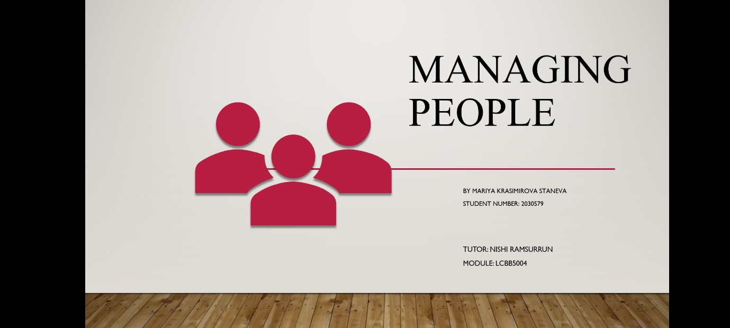

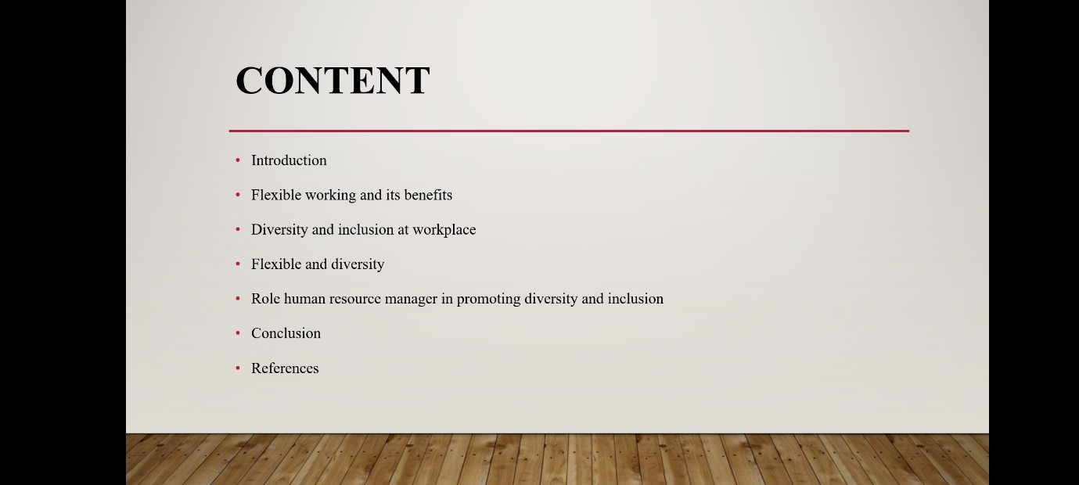
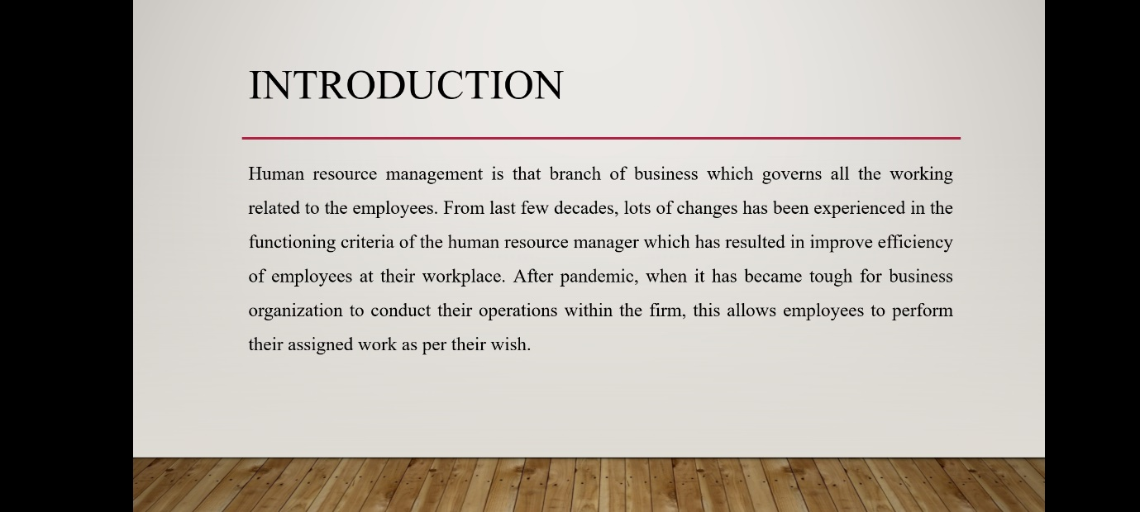
Introduction

Flexible working is the concept where company allows their employees to work according to their own choice, without following any strict working hours which has been mentioned in the policies.

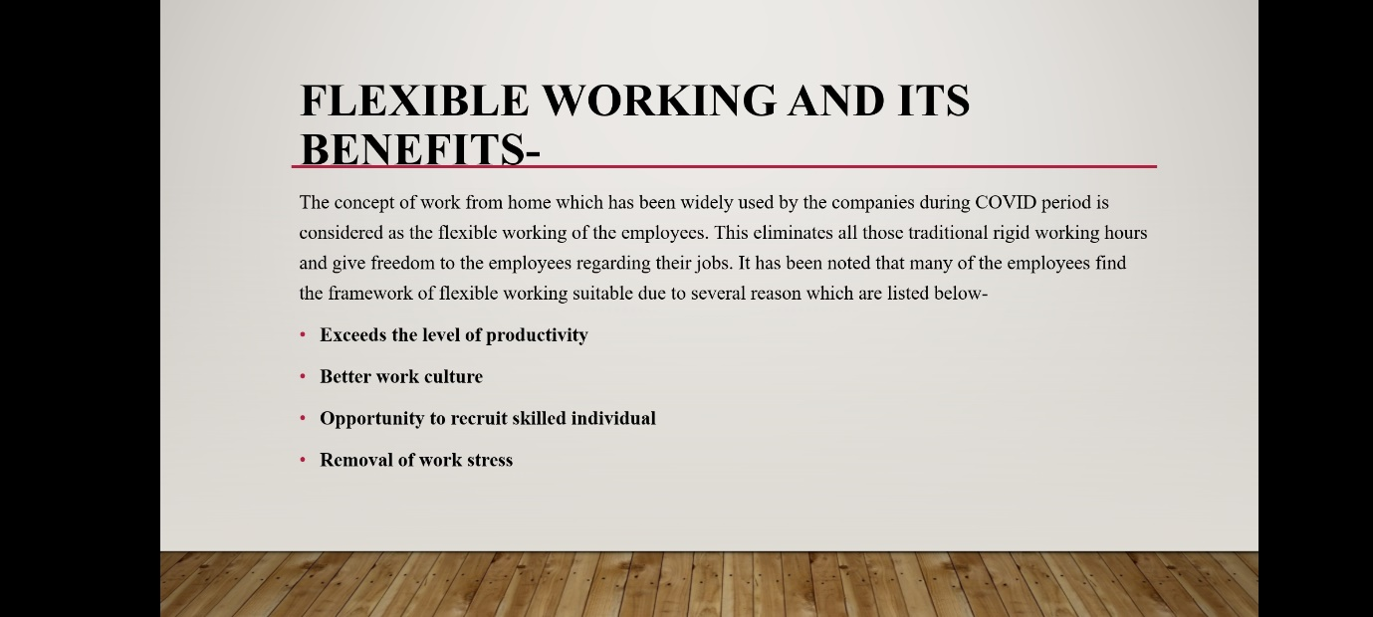

Flexible working and its benefits

Exceeds the level of productivity- Employees are able to think more effectively about the on the different aspects of the work which has been allotted to them which enhance their creativity and improves their overall productivity.
Better work culture- When workers start working from their home, then they will get the chance where they a maintain their work-life as well as social life which assist in achieving a good work balance.
Opportunity to recruit skilled individual- Flexible working does not limit the company to certain area to hire talented employees for the specific job roles. It allows to select best and efficient employees for the given vacancy.
Removal of work stress- This is the most important attribute of flexible working out of all the above discussed advantages as it will help the employees to perform their work without any tension and keep them positive.
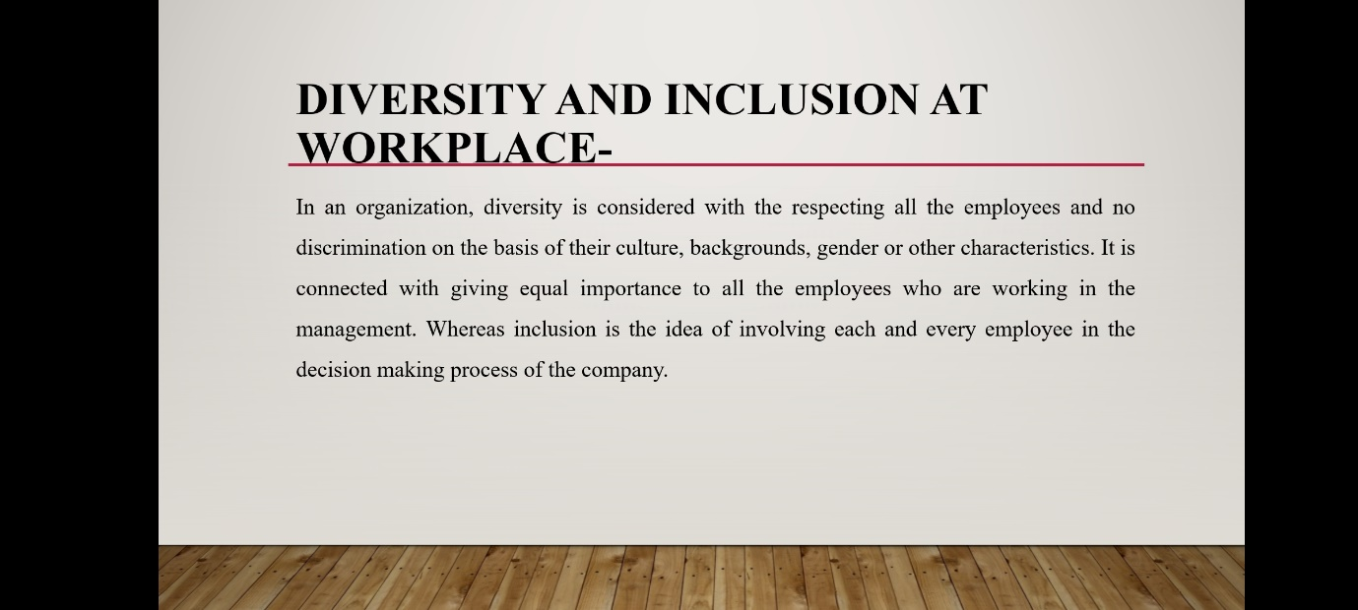

Diversity and inclusion at workplace-
This can be follow by acknowledging the idea and thoughts of the employees while constructing any plan and appreciating them for their better performance. It helps in gaining the trust and faith of the team, which is essential for the growth of the business.

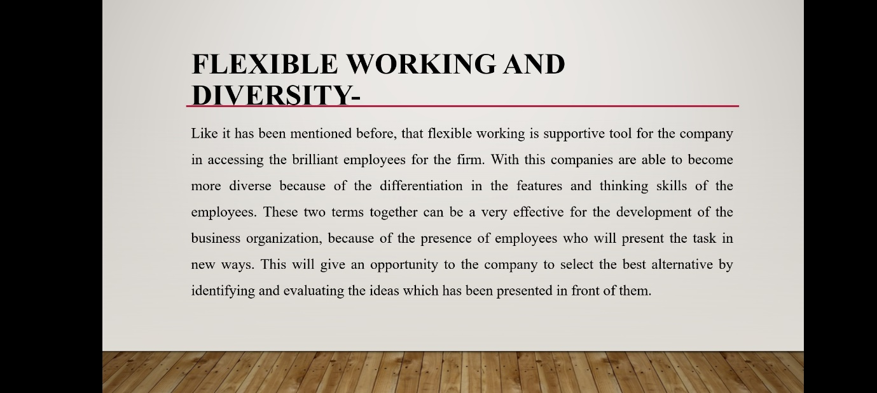

Flexible working and diversity-
For more diversification at the workplace, company should start focusing in building the morale of the workers and this will support them in expanding their thinking abilities to explore more beneficial idea to develop the working ability of the firm.
Moreover, it has been seen when company start making their workplace more diverse then it will get maximum chances to do work more accurately and in the direction of attaining the set target of institution. Creation of healthy and friendly working environment in which every employee support each other and praise them in their achievements without having any hard feelings. Company is able to hold their employees for the longer period of time by providing their optimum satisfaction in their job and valuing their contribution in the success of the business. So, there are various advantageous elements which a company can experiences by following the structure of flexible working and diversity.

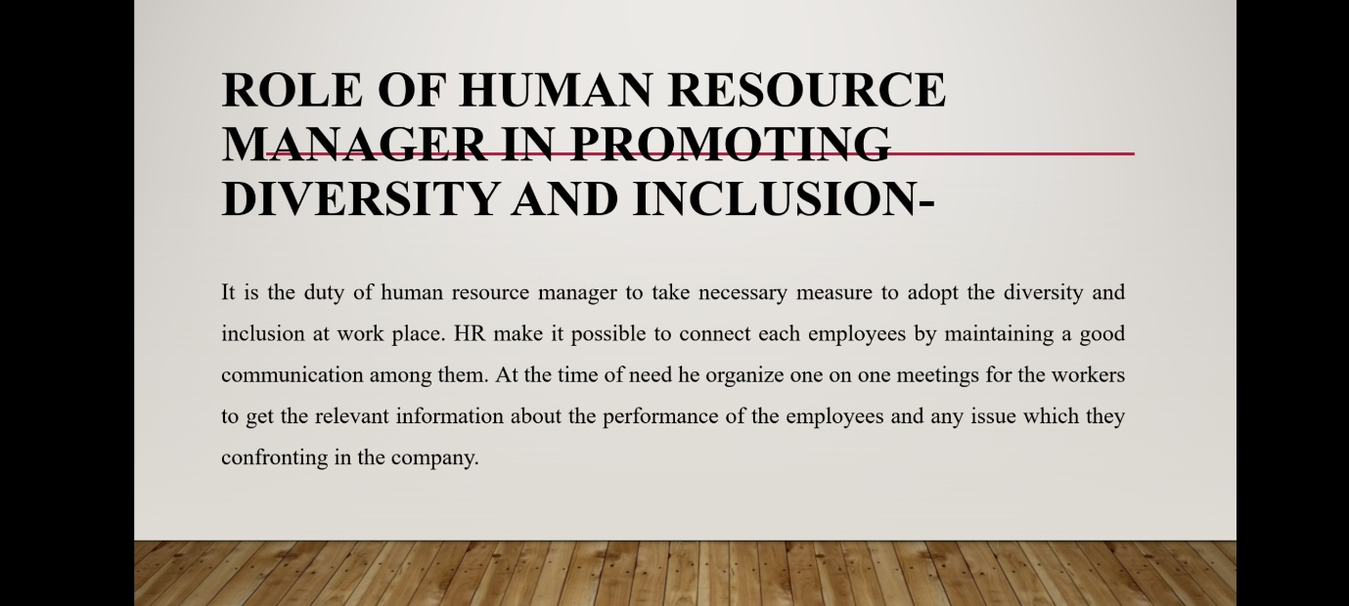

Role of human resource manager in promoting diversity and inclusion-
To make more growth in this retail organization HR needs to monitor employees, because this will make him more aware about the employees and how they are dealing with each other in the firm. As a leader for the workforce, it is important for HR to think about the interest of the employees, to provide them better environment for working.

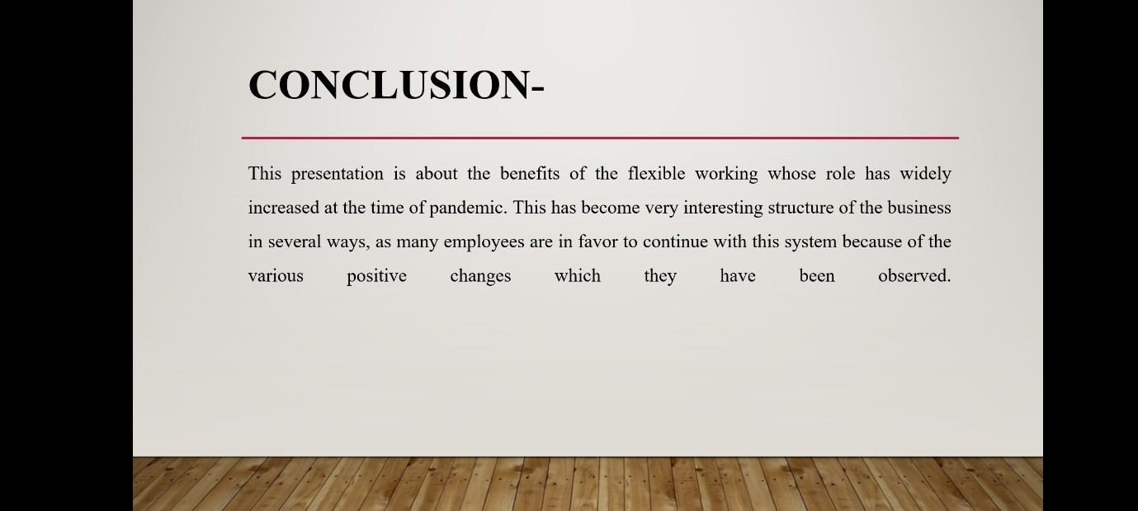
Conclusion
Flexibility also improves the diversity at the workplace which is crucial for any organization to gain the proper functioning of the management. In addition to this, role of the human resource manager to stimulate the idea of inclusion and diversity in the firm.



