Chapter 4 – Findings and Analysis

4.1 Introduction
Public perceptions of substance misuse among young adults in Wales are examined in this chapter through analysis of an online questionnaire designed to address the study’s three objectives: exploring current policing strategies for prevention and intervention, identifying the key challenges faced by police, and assessing the perceived effectiveness of existing responses. A mixed-methods approach is used, combining quantitative analysis of response patterns with qualitative interpretation of open-ended comments to capture both patterns and depth. The chapter is organised into three parts: the presentation of key quantitative results, including demographic patterns and overall attitudes, the thematic analysis of qualitative responses emerging from participants’ narrative responses, and an integrated discussion that connects these findings to the research objectives and wider evidence base.
The demographic profile establishes that the survey of Welsh residents reflects mainly working-age adults with a broadly balanced gender split and a predominantly White ethnic background. …………
4.2 Quantitative Analysis
4.2.1 Demographic Profile of Respondents
The survey attracted predominantly working-age adults, with respondents aged 25-34 forming the largest group (38%), followed by those aged 35-44 (30%). Smaller proportions were observed among participants aged 45-54 (15%), 55+ (10%), and 18-24 (8%). This distribution indicates that the sample is concentrated among early-to mid-career individuals, which may shape the perspectives reflected in subsequent findings and should be considered when assessing the representativeness of the dataset.
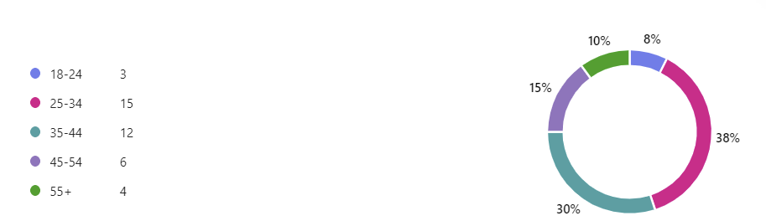
The gender distribution of respondents was relatively balanced, with 55% identifying as men and 45% as women. While the sample shows a slight male majority, the overall split is broadly even, providing a reasonably representative basis for examining gender-related patterns within the dataset.
The dominance of White respondents suggests that the survey primarily reflects the experiences and perspectives of this group. The presence of Black respondents is notable but still limited, and the very small numbers in Mixed and Asian categories mean that any subgroup analysis would lack statistical power. This distribution indicates limited ethnic diversity within the sample, which should be considered when interpreting findings that may vary across ethnic groups.

4.2.2 Overall Attitudes and Perceptions
Perceptions of the impact of substance misuse on young adults were mixed, with just over half of respondents believing it affects their community either ‘quite a lot’ or ‘a great deal’, while more than a third were unsure, indicating both a recognised level of concern and a notable degree of uncertainty or limited visibility around the issue.
In terms of safety in relation to substance-misuse issues views are notably varied, with no single viewpoint dominating. A combined 51% of respondents reported feeling very safe or somewhat safe, suggesting that just over half experience a degree of reassurance within their community. However, a substantial proportion expressed discomfort: 23% felt ‘somewhat unsafe’ and 8% ‘very unsafe’, indicating that nearly one-third perceive meaningful risk or unease. The remaining 20% felt ‘neither safe nor unsafe’, reflecting a neutral or ambivalent stance. This distribution points to a community where feelings of safety are mixed, with a slight lean toward perceived safety but a significant minority experiencing concern, which may influence how residents engage with local services or public spaces.
Perspectives of young adults’ willingness to seek help from the police were largely sceptical, with a clear majority expressing doubt. Only a small proportion felt young people would be ‘very’ or ‘somewhat likely’ to approach the police, while most respondents viewed this as ‘somewhat’ or ‘very unlikely’, and a notable minority remained neutral. This pattern suggests limited confidence in police as a help-seeking avenue for substance-misuse issues, reflecting potential barriers around trust, stigma, or perceived relevance of policing in support-focused contexts.
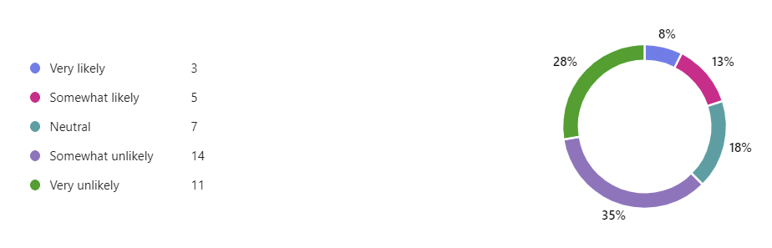
Perceptions on police visibility and accessibility in addressing substance-misuse issues were mixed, with only a small minority feeling consistently positive. Just one-fifth of respondents believed the police are sufficiently visible and accessible, while a larger group felt they are not, and a third selected ‘sometimes’, indicating inconsistency rather than confidence. Smaller proportions reported that the police are ‘never’ visible or were ‘unsure’. These responses suggest that community members experience police presence as uneven and often inadequate in the context of substance-misuse concerns, which may shape trust, help-seeking behaviour, and perceptions of local support.
Attitudes toward whether police have the resources and training to respond to mental-health crises linked to substance misuse were largely sceptical. Just under half of respondents felt the police do not have sufficient capacity, while only a quarter believed they do, and a third were unsure. This pattern points to a community that perceives significant gaps in preparedness and capability, with uncertainty itself signalling limited public confidence or visibility around how such situations are handled.
Overall, respondents expressed low confidence in young adults seeking help from the police, viewed police visibility and accessibility around substance-misuse issues as inconsistent, and showed limited belief that officers have the resources and training needed to respond effectively to related mental-health crises.
4.3 Qualitative Analysis
4.3.1 Approach to Qualitative Coding
The open-text responses were analysed and themes were built inductively, with the structure of the analysis shaped directly by participants views. Initial open codes were generated to capture key ideas within each response, which were then refined and grouped into broader conceptual categories. These categories were examined for recurring patterns, leading to the development of emergent themes that reflected shared concerns across participants. This process ensured that the qualitative insights were grounded in the data and could be meaningfully integrated with the quantitative findings to provide a fuller understanding of perceived barriers to police involvement in addressing substance misuse among young people. ??
4.3.2 Emergent Themes
4.3.2.1 Need for Multi-Agency Collaboration
A recurring theme was the belief that policing alone cannot address youth substance misuse. Respondents emphasised gaps in coordination with health, education, and social services, and highlighted the need for integrated approaches rather than isolated police action. Several open-text responses questioned whether substance-misuse prevention should be a policing responsibility at all. Participants suggested that schools, health services, social care, probation, and courts may be better placed to lead, indicating a broader debate about role boundaries and system design. This theme aligns with concerns about limited police capacity and the belief that effective prevention depends on broader system-level collaboration.
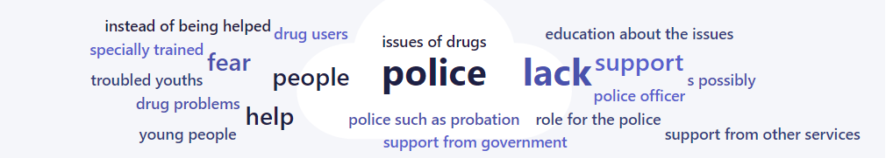
4.3.2.2 Fairness and Consistency in Policing
Responses to the question on whether policing practices related to substance misuse are applied fairly and equally reveal a broader theme of perceived inconsistency and conditional fairness. Only a minority of participants expressed confidence that policing is applied fairly (20%), while a larger proportion explicitly believed it is not (27%). The most common response, 'Sometimes’ (40%) indicates that many respondents view fairness as situational rather than embedded within policing practice. This pattern suggests that participants do not necessarily see policing as uniformly biased, but rather as uneven, dependent on factors such as officer discretion, local context, or the background of the individual being policed. The presence of an ‘Unsure’ group (13%) further highlights a degree of opacity around how substance misuse policing operates, pointing to gaps in public understanding or communication.
Perceived vulnerability of minority youth to unequal policing responses indicate a broad, moderate level of concern about the potential targeting of minority young adults, and this aligns closely with earlier findings on perceived inconsistency and unequal treatment in policing. Just over half of respondents express some degree of concern, with ‘Somewhat concerned’ dominating, while a quarter remain neutral and only a small minority are ‘unconcerned’. This mirrors the pattern seen in the fairness question, where most participants did not view policing as consistently fair and instead described it as conditional or uneven. These results suggest that respondents perceive a general risk of unequal treatment, particularly for minority youth, even if they do not always frame it as deliberate or systemic.
4.3.2.3 Mistrust and Relational Barriers Between Young People and Police
A dominant theme across both quantitative and qualitative responses was the persistent mistrust between young people and the police. Participants described fear of criminalisation, stigma, and negative past experiences as key reasons young people avoid seeking help. Several comments highlighted that this mistrust is particularly acute in marginalised communities, where police are not perceived as supportive, approachable, or aligned with young people’s needs. These relational barriers shape how young people interpret police presence and influence their willingness to engage with officers around substance-misuse concerns.
What prevents young adults from seeking help from the police regarding substance misuse?
Young adults are widely perceived as avoiding police support for substance-misuse issues primarily because they do not trust the police and fear being criminalised, with both factors emerging as the strongest barriers. Additional obstacles such as negative past experiences, stigma, and a belief that the police cannot help are present but less influential. This pattern aligns closely with earlier findings on fairness and equality: respondents already expressed doubts about the consistency and impartiality of policing, and concerns about the disproportionate targeting of minority young adults. These responses suggest that perceptions of unequal or unpredictable treatment do not just shape abstract attitudes toward policing, they have practical consequences, discouraging help-seeking and reinforcing a wider theme of limited procedural trust among young adults.
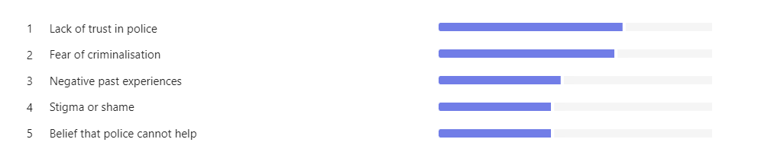
The comments in the additional open-text strengthen the narrative that young adults’ reluctance to seek help is shaped by a combination of mistrust, fear of consequences, both legal and social, and uncertainty about what police involvement would entail. One respondent questioned whether the police are fundamentally about prevention or enforcement, signalling uncertainty about what help-seeking would actually lead to. This reinforces the theme of unclear expectations and procedural opacity. While another respondent raised concerns about consequences from gangs or organised groups, introducing an external, community-level barrier that sits alongside fear of criminalisation. This suggests that help-seeking is shaped not only by perceptions of police behaviour but also by perceived risks within young people’s social environments.
4.3.3 Objective-Linked Quantitative Findings
The obstacles respondents believe police face in preventing substance misuse among young people, and the data point to a clear hierarchy of concerns. The distribution suggests that respondents see the challenges as both relational and structural. Trust and communication gaps appear to be the most significant barrier, but these sit alongside concerns about capacity, training, and inter-agency coordination. Together, these obstacles paint a picture of a system where frontline officers are expected to respond to complex issues without the full set of tools, relationships, or frameworks needed to do so effectively.
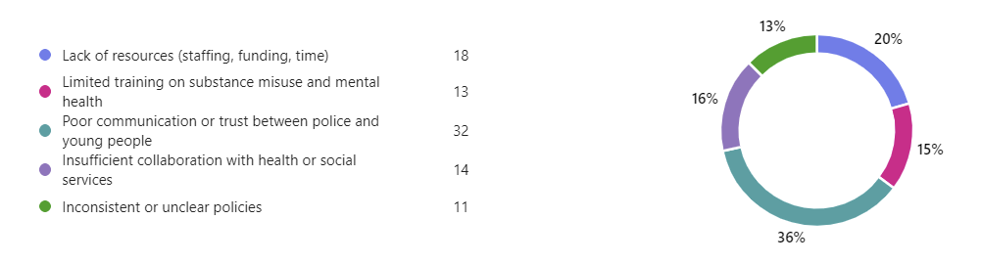
4.3.3.1 Current policing strategies
…..
4.3.3.2 Key challenges in implementing prevention and intervention efforts
Respondents elaborated on additional barriers police face in effectively preventing substance misuse in young people in their open-text comments, offering insights that extend beyond the predefined survey options. Several emphasised that young people often avoid approaching the police due to fear of criminalisation, stigma, or a belief that officers lack the capacity or willingness to help. Others highlighted structural issues such as chronic under-funding, insufficient staffing, and the absence of specialist teams trained to work with vulnerable young people. A number of respondents questioned whether prevention should sit with the police at all, suggesting that schools, health services, social care, probation, and the courts may be better placed to lead. Additional concerns included mistrust in marginalised communities, perceived corruption or apathy, and practical challenges such as identifying substance use. These insights reinforce the relational and systemic barriers identified in the quantitative data and link directly to the broader objectives of understanding the limits of policing in addressing youth substance misuse.
4.3.3.3 Perceived effectiveness of current strategies ???
Views on the effectiveness of current police strategies were broadly sceptical, with only a small minority judging them to be effective. Most respondents positioned themselves at the neutral or negative end of the scale, with a sizeable proportion describing current approaches as ‘somewhat’ or ‘very ineffective’. This pattern suggests limited public confidence in existing policing responses to substance misuse among young adults, reinforcing earlier concerns about trust, visibility, resources, and the suitability of police-led interventions. Many respondents rated current police strategies as ‘neutral’ or ‘ineffective’, a view that aligns with wider relational concerns and may further reinforce existing mistrust between young people and the police
question 16
4.4 Conclusion
….

