UNIVERSITY OF WALES TRINITY SAINT DAVID


Student Name: Meron Banger
Student ID: 2430071
Programme: BSc (Hons) Health and Social care
Module code: BMHP5014
Lecturer: Caroline Salami
Assignment title: component 2 (Report)

Title: Mind Link UK: An AI-Driven digital innovation for enhancing dementia care and support

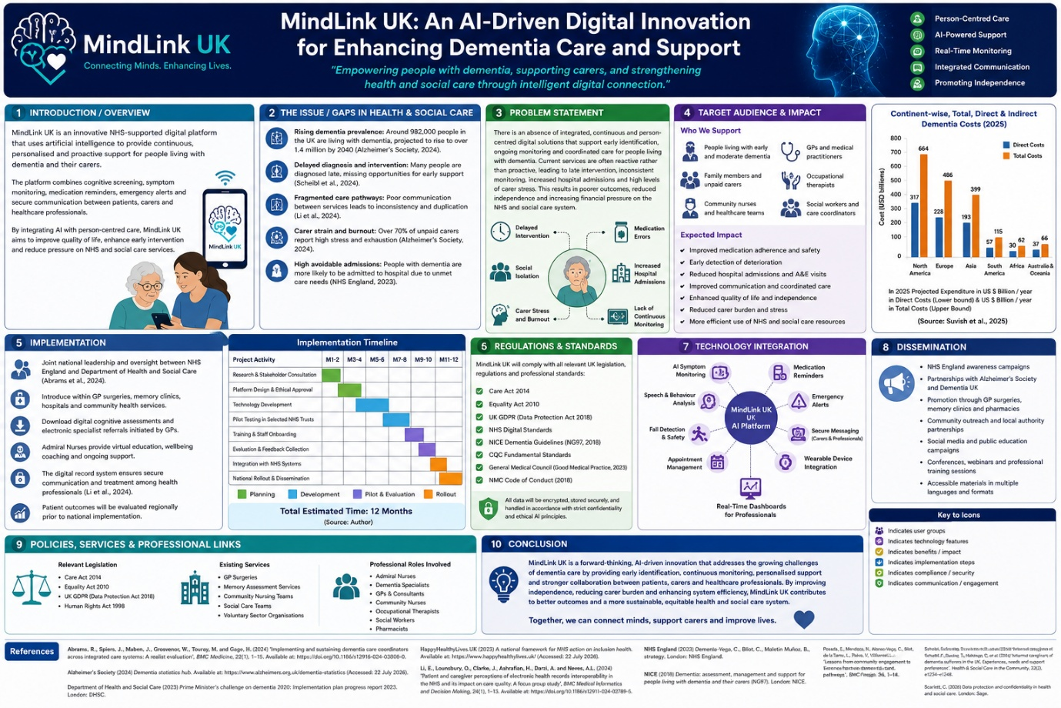

1. Introduction
The increasing prevalence of dementia presents one of the greatest challenges facing health and social care services in the United Kingdom. As the population ages, there is a growing need for innovative, sustainable and person-centred approaches that improve the quality of life of individuals living with dementia while reducing pressure on the National Health Service (NHS) and adult social care services. Although current dementia care has improved through national strategies and multidisciplinary working, many individuals continue to experience fragmented care, delayed interventions and inconsistent communication between healthcare professionals and family carers (NHS England, 2019).
MindLink UK is an Artificial Intelligence (AI)-driven digital platform designed to complement existing dementia services by providing continuous monitoring, personalised support and secure communication between patients, carers and healthcare professionals. The innovation aims to improve early intervention, promote independent living and strengthen integrated care. By combining digital technology with person-centred practice, Mind Link UK aligns with the NHS Long Term Plan and supports the future transformation of dementia care through innovation, collaboration and evidence-based practice.

2. Background
Dementia is a progressive neurological syndrome that affects memory, cognitive functioning, behaviour and an individual's ability to perform everyday activities independently. Alzheimer's disease accounts for approximately 60–70% of dementia cases, although vascular dementia, Lewy body dementia and frontotemporal dementia are also common (World Health Organization, 2023). According to Alzheimer's Society (2024), approximately 982,000 people are currently living with dementia in the United Kingdom, with projections estimating this figure will rise to more than 1.4 million by 2040. This increasing prevalence presents significant challenges for health and social care services, particularly regarding workforce capacity, continuity of care and long-term financial sustainability.
The impact of dementia extends beyond those diagnosed with the condition. Family members and unpaid carers frequently provide extensive physical, emotional and financial support, often experiencing high levels of stress, anxiety and burnout (Dementia UK, 2023). Many carers report feeling unsupported between routine appointments, particularly when managing behavioural changes, medication adherence and deteriorating cognitive function. As a result, avoidable hospital admissions and delayed interventions remain common within dementia care pathways.
The NHS Long Term Plan (2019) identifies digital transformation and integrated care as essential priorities for improving patient outcomes. Similarly, the Department of Health and Social Care (2023) highlights the importance of adopting innovative technologies that enhance prevention, early intervention and coordinated multidisciplinary care. Artificial Intelligence offers significant opportunities to support these ambitions by enabling proactive monitoring, analysing patient data in real time and improving communication across healthcare settings. Consequently, there is a clear need for innovative solutions such as Mind Link UK that complement existing dementia services while enhancing patient safety, independence and quality of care. Dementia also places a considerable financial burden on the United Kingdom's health and social care system. The cost of dementia care continues to increase due to rising demand for residential care, community services, hospital admissions and unpaid caregiving. As the ageing population grows, healthcare services must adopt innovative and sustainable approaches that improve efficiency while maintaining high-quality, person-centred care. Digital technologies, including Artificial Intelligence, are increasingly recognised as valuable tools for supporting early diagnosis, improving communication between professionals and enabling proactive rather than reactive care. Consequently, investment in digital innovation is essential to meet future healthcare demands while improving outcomes for individuals living with dementia (Department of Health and Social Care, 2023).

3. Innovation Description
Mind Link UK is an integrated digital health platform specifically developed to enhance dementia care through Artificial Intelligence and secure digital communication. Unlike many existing applications that provide isolated functions, such as medication reminders or appointment scheduling, Mind Link UK combines multiple evidence-based features within a single platform to support patients, carers and healthcare professionals throughout the dementia journey.
The platform incorporates AI-powered cognitive monitoring, medication management, emergency alert systems, behavioural pattern recognition, appointment scheduling, secure messaging and electronic care planning. By analysing changes in an individual's daily routine, mobility, medication adherence and cognitive performance, the system can identify early indicators of deterioration and automatically notify carers or healthcare professionals when further assessment may be required. This proactive approach enables earlier intervention, reducing the likelihood of preventable complications and emergency hospital admissions.
Mind Link UK also strengthens multidisciplinary collaboration by allowing authorised professionals, including General Practitioners, community nurses, occupational therapists, social workers and memory clinic specialists, to securely access relevant patient information. Improved communication supports coordinated care planning, reduces duplication of assessments and promotes continuity of care across health and social care services.
A distinctive feature of MindLink UK is its commitment to person-centred care. The platform adapts reminders, cognitive stimulation activities and wellbeing recommendations according to each individual's needs, preferences and stage of dementia. Rather than replacing professional judgement, the innovation provides additional clinical intelligence that supports informed decision-making while empowering individuals to remain independent for as long as possible. Through continuous monitoring and personalised support, MindLink UK represents a practical and scalable innovation capable of improving dementia care across the United Kingdom. MindLink UK has also been designed with future development in mind. As Artificial Intelligence continues to evolve, future versions of the platform could incorporate predictive analytics capable of identifying subtle changes in cognition before significant deterioration occurs. Integration with wearable technology would enable continuous monitoring of mobility, sleep patterns, heart rate and physical activity, providing healthcare professionals with more comprehensive information to support personalised care planning. Furthermore, integration with NHS electronic patient records would strengthen multidisciplinary collaboration and reduce duplication of assessments. These future developments would ensure that the platform remains sustainable, evidence-based and responsive to changing healthcare needs.

4. Impact on Health and Social Care
Mind Link UK has the potential to transform dementia care by improving patient outcomes, enhancing multidisciplinary collaboration and reducing pressures on health and social care services. One of its greatest strengths is its ability to facilitate early intervention through continuous AI-assisted monitoring. By identifying changes in cognitive function, behaviour, medication adherence and daily routines, healthcare professionals can intervene before minor concerns escalate into medical emergencies. This proactive approach may reduce avoidable hospital admissions, improve patient safety and support more effective long-term care planning (NICE, 2018).
The innovation also strengthens person-centred care by enabling individuals with dementia to maintain greater independence while remaining actively involved in decisions regarding their care. Personalised reminders, cognitive support activities and wellbeing monitoring empower service users to manage aspects of their daily lives more confidently, improving both autonomy and quality of life. In addition, carers benefit from secure communication, real-time alerts and reassurance that changes in their loved one's condition are being monitored. This may reduce caregiver burden, stress and emotional exhaustion, which are common challenges experienced by unpaid carers (Dementia UK, 2023).
For healthcare professionals, MindLink UK promotes integrated working across NHS organisations and local authority services by providing secure access to relevant patient information. Improved communication between General Practitioners, community nurses, occupational therapists, social workers and memory clinics supports coordinated care planning, reduces duplication of services and encourages more efficient use of healthcare resources. Consequently, the innovation contributes to the NHS Long Term Plan's vision of delivering digitally enabled, integrated and preventative healthcare services that improve outcomes while ensuring sustainability (NHS England, 2019). Although MindLink UK offers significant opportunities to improve dementia care, several challenges must be considered before implementation. One of the principal concerns is digital exclusion, as many older adults living with dementia may have limited digital literacy or lack confidence when using smartphones, tablets or wearable technology. To overcome this barrier, the platform would be designed with a simple and accessible interface incorporating voice assistance, large icons and personalised training for patients and carers. Ongoing technical support would also be essential to encourage long-term engagement and maximise accessibility.
Another important consideration relates to data protection and cybersecurity. As the platform stores sensitive health information, strict compliance with the UK General Data Protection Regulation (UK GDPR) and the Data Protection Act 2018 would be essential. Secure encryption, multi-factor authentication, regular security updates and robust consent procedures would ensure that patient information remains confidential while maintaining public trust in the technology. Financial investment would also be required to develop the platform, integrate it with existing NHS digital systems and provide workforce training. However, these initial costs may be offset by long-term savings through reduced emergency admissions, earlier intervention and more efficient use of healthcare resources (NHS England, 2019).
Despite these challenges, Mind Link UK represents a valuable innovation because it supports the transition from reactive healthcare to preventative, person-centred care. The platform complements professional judgement by providing healthcare teams with timely information that supports informed clinical decision-making rather than replacing human expertise. It also promotes health equity by improving access to specialist support for individuals living in rural areas or those with limited mobility. Through continuous evaluation, stakeholder feedback and future technological developments, Mind Link UK has the potential to become a sustainable and scalable model for dementia care across the United Kingdom.

5. Public and Stakeholder Involvement
Successful implementation of Mind Link UK depends upon meaningful collaboration with individuals living with dementia, family carers, healthcare professionals and voluntary organisations. Adopting a co-production approach ensures that the platform is developed in partnership with those who will use it, enabling the innovation to reflect real experiences, preferences and care needs. People living with dementia and their carers would participate in pilot testing, focus groups and user evaluations to provide feedback on accessibility, usability and overall effectiveness.
Healthcare professionals, including General Practitioners, dementia specialists, community nurses, occupational therapists and social workers, would contribute to the design and evaluation of clinical features to ensure the platform complements existing practice. Collaboration with organisations such as Alzheimer's Society and Dementia UK would further support public engagement, awareness campaigns and educational resources, promoting wider acceptance and accessibility across diverse communities.

6. Policies, Services and Professional Links
Mind Link UK aligns with key legislation, national policies and professional standards that underpin safe and effective health and social care practice. The innovation supports the principles of the Care Act 2014 by promoting wellbeing, independence and personalised care, while complying with the Equality Act 2010 by ensuring equitable access for individuals with diverse needs. All personal information would be managed in accordance with the UK General Data Protection Regulation (UK GDPR) and the Data Protection Act 2018, ensuring confidentiality, informed consent and secure data management.
The platform also reflects the recommendations of NICE Guideline NG97 on dementia care by promoting coordinated, person-centred support. Its implementation would complement existing NHS dementia pathways and multidisciplinary working practices involving GPs, memory clinics, community nursing teams and adult social care services. This integrated approach strengthens collaboration between professionals while supporting high-quality, evidence-based care.

7. Conclusion
Mind Link UK represents an innovative and practical response to the increasing challenges associated with dementia care in the United Kingdom. By integrating Artificial Intelligence with person-centred practice, the platform has the potential to improve early intervention, strengthen communication between health and social care professionals and enhance the quality of life of individuals living with dementia. Through collaboration, digital innovation and evidence-based practice, Mind Link UK supports the future development of sustainable, integrated and compassionate dementia services that benefit patients, carers and the wider healthcare system. Mind Link UK represents an innovative and practical response to the increasing challenges associated with dementia care in the United Kingdom. By integrating Artificial Intelligence with person-centred practice, the platform has the potential to improve early intervention, strengthen communication between health and social care professionals and enhance the quality of life of individuals living with dementia. Through continuous monitoring, personalised support and secure information sharing, the innovation promotes more coordinated, proactive and efficient care while empowering individuals to maintain independence for as long as possible.
Furthermore, Mind Link UK aligns with key NHS priorities by supporting digital transformation, integrated care and preventative healthcare. Although challenges such as digital literacy, implementation costs and data security must be carefully managed, these barriers can be addressed through effective planning, stakeholder engagement and ongoing evaluation. By combining technological innovation with compassionate, evidence-based practice, Mind Link UK offers a sustainable solution that benefits patients, carers, healthcare professionals and the wider health and social care system. Ultimately, the platform demonstrates how innovation can improve patient outcomes, reduce service pressures and contribute to the future development of high-quality dementia care across the United Kingdom.

References
Alzheimer's Society (2024) Dementia UK: Update. London: Alzheimer's Society. Available at: https://www.alzheimers.org.uk (Accessed: 6 August 2026).
Care Act 2014 (c.23). London: The Stationery Office. Available at: https://www.legislation.gov.uk/ukpga/2014/23/contents (Accessed: 6 August 2026).
Data Protection Act 2018 (c.12). London: The Stationery Office. Available at: https://www.legislation.gov.uk/ukpga/2018/12/contents (Accessed: 6 August 2026).
Department of Health and Social Care (2023) People at the Heart of Care: Adult Social Care Reform White Paper. London: DHSC. Available at: https://www.gov.uk/government/organisations/department-of-health-and-social-care (Accessed: 6 August 2026).
Dementia UK (2023) What is Dementia? London: Dementia UK. Available at: https://www.dementiauk.org (Accessed: 6 August 2026).
Equality Act 2010 (c.15). London: The Stationery Office. Available at: https://www.legislation.gov.uk/ukpga/2010/15/contents (Accessed: 6 August 2026).
National Institute for Health and Care Excellence (2018) Dementia: Assessment, Management and Support for People Living with Dementia and their Carers (NG97). London: NICE. Available at: https://www.nice.org.uk/guidance/ng97 (Accessed: 6 August 2026).
NHS England (2019) The NHS Long Term Plan. London: NHS England. Available at: https://www.longtermplan.nhs.uk (Accessed: 6 August 2026).
NHS England (2023) NHS England Dementia Programme. London: NHS England. Available at: https://www.england.nhs.uk (Accessed: 6 August 2026).
Office for National Statistics (2023) Health State Life Expectancies, UK. Newport: ONS. Available at: https://www.ons.gov.uk (Accessed: 6 August 2026).
Royal College of Nursing (2023) Dementia Nursing: Position Statement. London: RCN. Available at: https://www.rcn.org.uk (Accessed: 6 August 2026).
Skills for Care (2023) The State of the Adult Social Care Sector and Workforce in England. Leeds: Skills for Care. Available at: https://www.skillsforcare.org.uk (Accessed: 6 August 2026).
UK Government (2024) UK General Data Protection Regulation (UK GDPR). Available at: https://www.gov.uk/data-protection (Accessed: 6 August 2026).
World Health Organization (2023) Dementia. Geneva: World Health Organization. Available at: https://www.who.int/news-room/fact-sheets/detail/dementia (Accessed: 6 August 2026).

