Question 1

[a] Design the circuit using simulation software.
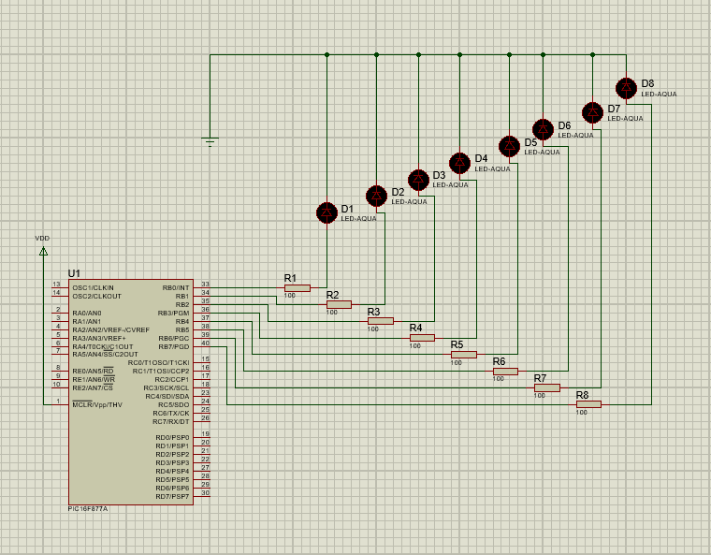

[b] Write a C program to accomplish the specified counting task.
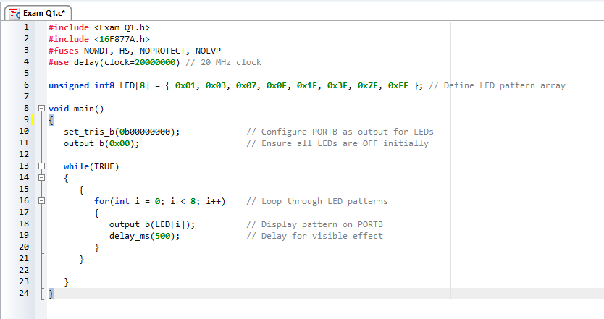

[c] Execute the simulation to verify the operation of the circuit and program.
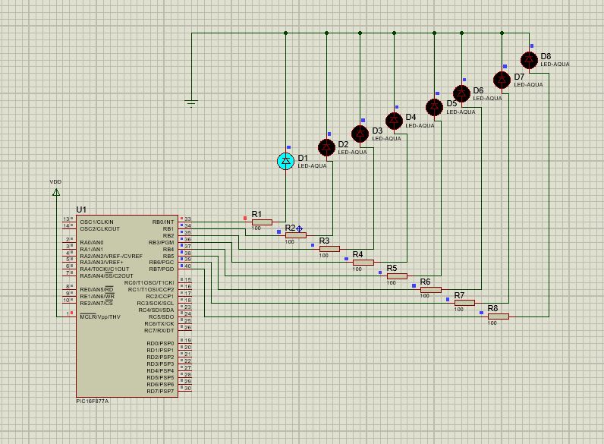

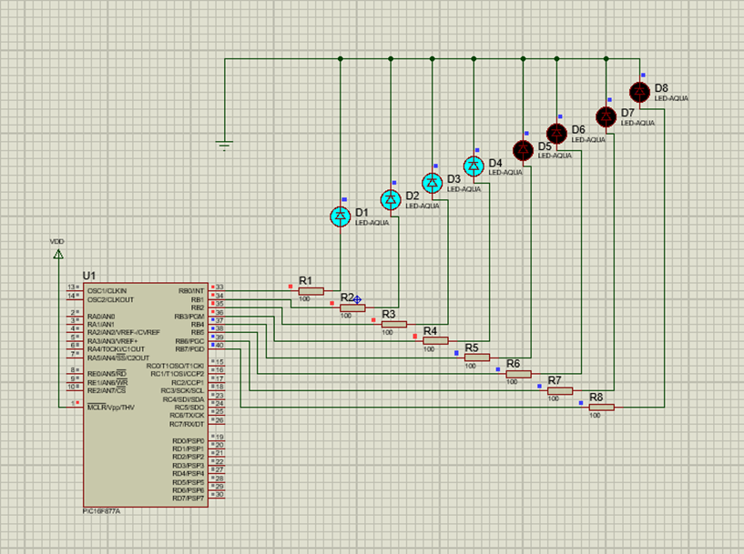
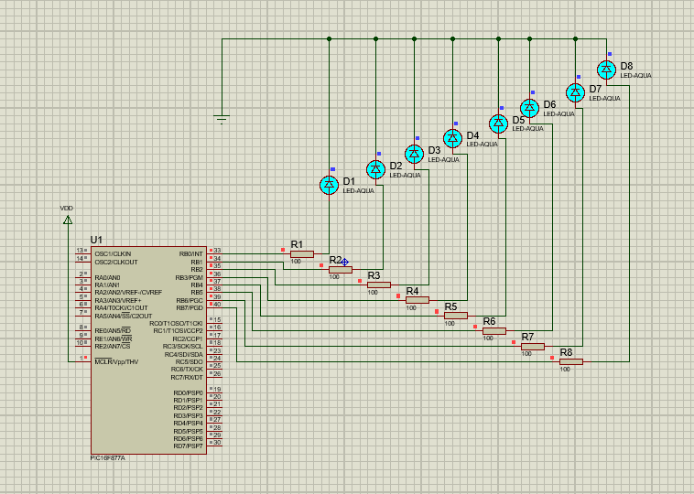

Question 2

[a] Design the circuit using simulation software
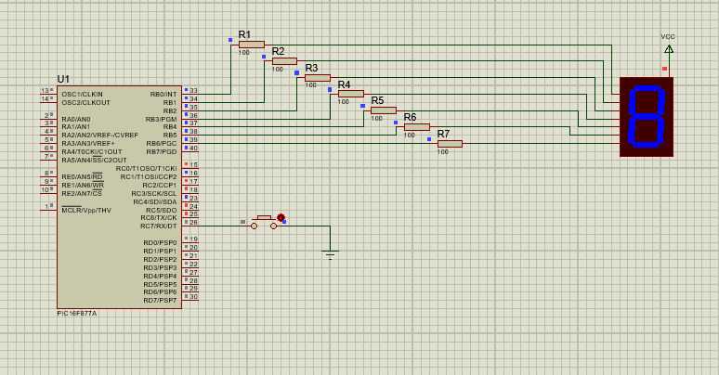

[b] Write a C program to accomplish the specified counting task


