Ellie Coates (1901611)

Ecad5008
Learning the learning: what, how and why am i tecahing?

Introduction

This paper will look to critically evaluate how assessment for learning strategies can be effectively utilised throughout various learning opportunities to assist and encourage progression across areas of learning and experience. Progression is an essential part of a learner’s journey through their education, and this is shown in the Curriculum for Wales. Assessment plays an important role throughout education which not only allows each individual learner to make progress at an appropriate pace, but helps practitioners ensure that the learners are supported and challenged. (HWB, 2020).

The paper will highlight how effective lesson planning including a broad range of AFL strategies and AOLE’s can develop working practices and guide progression. I will discuss the process in which I created my lesson plans and include any concepts that support or disagree with the use of strategies such as differentiation. I will be expanding on the ideologies that surround the importance that learners have the same opportunities and experiences as their peers, this will help broaden students’ knowledge and understanding. To evaluate progression teachers must use assessment and review in order to monitor, this will in turn develop lesson plans and accommodate for change in children’s expansion of ability and knowledge. Teachers must facilitate for all ages and ability groups, again this can be seen in the Welsh curriculum.

The Welsh government created the five professional standards of teaching and leadership to support all practitioners on their teaching journey. The standards focus on five vital elements: pedagogy, collaboration, leadership, innovation, and professional learning. All elements have been divided with descriptors that exemplify how the standards could apply to a teacher’s work (Welsh Government, 2022).

During my teaching experience I worked with a specific group of young learners that I had to prepare lessons for. These included various areas of learning as well as assessment for learning strategies. I worked with a year 4 class where the pupils ranged between 8 and 9 years of age. Prior to my placement, the class had been introduced to different leaders around the world and had started to take part in activities regarding the Victorians and that era. The 3 areas I decided to focus on were: expressive arts, maths and numeracy and literacy, languages, and communication.
Subjects within schools have been categorised into areas of learning with the aim of broadening pupils experience and exposure to different topics, learning this has allowed teachers the opportunity to integrate all topics such as none key elements, for example expressive arts, avoiding narrow teaching and children that thrive in different areas are able to display their strengths (UNESCO, 2013).

The 12 Pedagogical principles were created as a catalyst to invite good teaching and learning in schools, a few examples of these pedagogies would be to focus on the 4 purposes of the curriculum, challenge pupils to sustain their efforts, employ assessment and encourage collaboration. The principles are not necessarily tasks to be completed whilst in class, however they are small statements that underpin Donaldsons implementation of his new curriculum by encouraging best teaching practices. (Impact, 2022).

Considering what Donaldson has proposed in his new curriculum, the 4 purposes are a staple of his work. The strong message that the purposes imply is that if teachers do not know why they teach, then how can they know what to do. The 4 purposes are a guidance for all future decisions with education and the children at its heart. The purposes strive for ambitious and capable learners who are ready to learn throughout their lives, enterprising creative contributors who are ready to take part in life and work, form ethical and informed citizens that will be an asset to Wales and the world and finally have healthy and confident individuals who are ready to live fulfilling lives (Welsh Parliament, 2015).

Literature Review

Donaldson (2015) provides an overview of the strategies that needs to be implemented into the current curriculum. Donaldson states that to support learners’ progression it is no longer appropriate to measure progression in phases or key stages, it must be monitored fluidly using the newly introduced progression steps. The intention of Donaldsons work highlights the importance of educational experiences help to broaden the horizons of learners whilst promoting imagination and enjoyment in their learning. This is achieved by ensuring AFL strategies are implemented throughout your lessons. Donaldson also argues that the use of progression steps structures how children and young people further their learning, improving characteristics such as an individual’s capacity to engage with the work and to attempt complex concepts.
At its foundation Donaldson produced the conception of a what matters statement. The statements of what matters are mandatory requirements for those designing their curriculum and assessment arrangements. It provides teachers the freedom to tailor their teaching and assessing to match the individuals in class. Within each AOLE there are what matters statements that are followed by progression steps. During a teacher’s lesson and assessment planning it is crucial for them to follow these guidelines in order to further pupils’ knowledge, understanding and progression (Welsh Government (2021).
Main, P. (2020) highlights that assessment is a vital part of the teaching process. Good quality assessments provide the opportunity to investigate for any improvements not only for a student to progress in their learning, but teachers can also scrutinise their own work and develop teaching practices in the future. For instance, without checking a student’s understanding, teaching staff are oblivious on the importance of targets and progression.

Briggs, Woodfield, Swatton, Martin (2008) have expressed that the process of an assessment helps us to determine a learner’s level of understanding. It can be beneficial when used appropriately as it gives us an insight and provides the clarity that planning is most effective when we use the information attained and this allows us to set achievable targets. However, at its very least the assessment is a process that allows us to gather a large amount of data that can have the downfall of not being fed back effectively.

Briggs, Woodfield, Swatton, Martin (2008) have also gone on to say that for an assessment to be useful it requires a strong relationship towards the purposes and relevant learning outcomes of teaching and learning. For a learner to progress efficiently and succeed it is important that they’re provided with the information related to the learning objective. It is essential for teachers to use a variety of assessment techniques to carefully select the most effective strategy to create the best path to the outcome chosen. In order to accumulate the knowledge whether the learning outcome has been achieved during a learning episode, we must include the use of assessment during that specific episode of education
Donaldson, G (2015) also argues that children must ascertain the ability to self-assess, this attribute will allow them to dictate their own outcomes and recognise their own progress. This presents the opportunity to learn a valuable life skill of independence and continue to learn throughout every stage of life. In turn this will encourage young learners to be more responsible and accountable for their own learning and reflect on their current understanding. Being able to set clear success criteria that is easily accessible to pupils throughout learning activities will in turn help them discover any areas that may have missed.

There are two elements within assessment. Formative assessment encourages monitoring learners continuously in order to provide constructive feedback instantly, which hands learners the opportunity to make corrections during that lesson. This makes it easier for learners to identify their strengths and weaknesses and allows them to confidently set themselves achievable targets.

Summative assessments main focus is to conclude a learning unit by means of an exam or test to help determine the learner’s level of understanding after completion (Carnegie Mellon University, 2023). However, this element is challenged by Spendlove (2009) as he believes it encourages narrow minded teaching and learning, Spendlove presents this as a challenge to summative assessment as results represent what you do not know and therefore does not show how you can improve.

Blooms taxonomy is a system that was developed in 1956 by psychologists, this allows teaching practitioners to identify the levels in which the pupils are working at, the different categories include thinking, learning, and understanding. This system has been a guide for educators to plan and develop assessment. The framework fundamentally collects data and tracks progression in the following categories such as knowledge, comprehension, application, analysis, and evaluation. Using this information teachers can develop lesson plans and set targets for individuals. Therefore, this model supports the idea of formative assessment (Great Schools, 2014).

However, Ruhl (2021) heavily criticises the first adaption of the Blooms Taxonomy even though it is still used today. Ruhl believes that the format in which it is set out encourages teachers to prioritise the elements in the wrong order and gives the impression that the elements must be worked on independently when it would benefit a learner to work on various elements at the same time. Although this was altered in the revised version in 2001 where they included action verbs which helps to further express an action whether it be physical or mental (YourDictionary, 2023), it still received criticism. Ruhl (2021) also suggests that the pyramid structure of the taxonomy creates an image of certain skills being more difficult than others. If a teacher adopts this mindset, they will lose sight of how essential it is for a learner to improve their knowledge and comprehension just as much as the other processes in order to progress in their learning.
The importance of planning to individuals needs is vital and is presented in the idea that every teacher must understand all learners present in their classroom, understanding the pace in which children learn, any learning disabilities that are present and individual aspirations, it must also be understood that these can change at any time, and this must be catered for IQualifyUK (2020).

Discussion of lesson planning decisions

There are four elements to assessment for learning that helped me determine what strategies would support myself as a student teacher and the learners progression which are: sharing criteria with learners, quality of questions and quality of talk, use and quality of feedback and peer and self-assessment.

The three AoLEs I have selected as the focus for the group of learners are: mathematics and numeracy, literacy languages and communication and expressive arts.

There is an ongoing theme throughout the lesson plans which is the Victorians. The school I completed my teaching practice in, focused heavily on leaders, and the Victorian era was chosen as the topic of study for year 4.

Lesson 1 – Mathematics and Numeracy
The aspect I decided to focus on in this area of learning was area and perimeter.
Mathematics is a fundamental kingpin in the way we process thought and logic, it is essential to understanding the world around us. Maths gives us an effective way of developing mental discipline and encourages individuals to use logical thinking and establish rigidity. As well as this, maths is key to understanding other school subjects such as science and social studies (ICMI, 2023).

The aim was to further the learner’s knowledge in this area of learning as it provides skills useful for every day. Prior to introducing this new topic, the whole class had covered addition, subtraction, multiplication, and division and with this foundational knowledge of maths it will further support their progression onto area and perimeter.

The afl strategy that I used during this lesson was the traffic light system. This system uses three different traffic light colours, green, amber and redd. The different colours indicate to the teacher whether a pupil has a good, partial, or little understanding of the topic at hand. This is a simple method that provides the teacher with an easy communication method to express their confidence. A benefit of this strategy is that it is easy to implement into class and does not take up room. As well as the teacher being able to note the depth of understanding and identify where further support is needed, this can be added to future learning episodes (Geoffhollygeorgina, 2015).
I implemented this strategy when I was notified that a pupil in the class was a selective mute, this allowed her to communicate with me without using her voice, hence encouraging engagement with their studies, and helping them to feel valued and supported.
It has been argued however that the ability to keep track of the traffic lights used in class is not efficient, pupils have been seen to lose their traffic light or misuse them, and without making physical note of pupils progress it can be hard to remember what had been said. In addition to this the validity of the traffic system is questioned as if regular checks are not done and they are only used at the end of a lesson, we are missing opportunities to track progress (The Lanarkshire Council, 2016)

Lesson 2 – Literacy, Languages and Communication
The aspect I decided to focus on in this area of learning was narrative writing. During the first couple of days in my placement experience I quickly noticed the overall ability of reading, writing, and spelling was lower than normally expected for a class of that age. I believe the coronavirus has played a huge part in this. In an article by the BBC, it is shown to be believed that it's affected pupils' numeracy and literacy skills, particularly oracy - the ability to express oneself fluently and grammatically in speech (Lewis, 2022, p.1) This meant that during my planning I would have to further differentiation to support all learners.

The aim was to aid all learner’s progression in spelling and grammar during my time in the classroom. In order to achieve this, I felt it was important to use the learners creative strengths to help build the core literacy skills required for everyday life. Prior to the lesson I had planned, the whole class had taken part in a free writing session where they wrote a short story. They then received lessons on various elements to help them improve their narrative writing skills. This included: the use of similes, metaphors and adjectives, character and location descriptions and using correct punctuation and grammar.

The AFL strategies I used throughout this lesson were providing the learners with a success criteria which falls under the AFL element of sharing criteria with learners. The second strategy was supplying the learners with time to self and peer assess their work which happens to be another element of AFL.

Before my lesson, success criteria were created and it included all the previously learnt skills to help the learners have a clear understanding of what they need to achieve, and it enables them to think and work independently during their second attempt of story writing.
Hattie (2008) suggests that success criteria informs learners of when they’ve achieved the goal however, it doesn’t come as a surprise that learners disengage from their learning. We can avoid this by not only sharing the success criteria but providing students with the responsibility of being involved with the creation of the success criteria. Donaldson (2015) tells us that this will ensure the continuous engagement and enjoyment of challenges that learners face and will spark determination within their learning which supports Donaldsons theory of improving children’s learning experiences throughout education.
For my lesson I created a table for each learner which was stuck into their literacy books, and it included the success criteria and 2 columns for self and peer assessment opportunities. Self and peer assessment will only work well in a classroom that has created an environment where mistakes are valued as learning opportunities and encouraging learners to admit when they don’t understand information is great way for teachers to receive feedback in order to further aid learners progression (NFER, 2020).
It is important when self and peer assessing that time is set aside for learners to act when receiving feedback from peers. If you have a minority of learners who didn’t understand the task, bring them together to revisit the activity whilst an extension task has been pre-planned for the learners who are ready for the next step Royal Society of Chemistry (2023). This shows that you are aiding progression for each individual learner.
Black, P. J William, D (2010) highlights that an aspect of self-assessment to be wary of, is without clear targets and success criteria learners are unable to identify and have quality discussions and cross reference what they have understood

Lesson 3 – Expressive Arts
The aspect I decided to focus on in this area of learning was song writing and performance. The class topic was Victorians, and the aim of the lesson was for the pupils to create a short Welsh song that explained the activities that a Victorian child would undertake.
Expressive arts is a topic that is often disregarded and not seen as equally important as other subjects and this debate has been outlined by Watson (2019) whereby she states that educators argue the importance of a fundamental understanding of core subjects such as English and maths being more relevant in the use of everyday life, rather than having the basic drawing or music ability.
Catts, J (2018) expresses that Experiencing the expressive arts can enable learners to identify their creative strengths and utilise them effectively. Expressive arts in education are crucial and it becomes easy for learners to be overwhelmed by academic theory, which is why practical learning experiences are essential in order to provide learners with a balanced education. Learners need to be offered a wide range of exciting opportunities that encourage independent thinking and give them the preparation they require to embed the valuable life skills which they’ll carry through their life.
In order for the lesson to be successful the learners would already need to have a good understanding of what life was like for a Victorian child. Various lessons had been covered prior to this one regarding a Victorian child’s lifestyle and therefore it was important to activate prior knowledge at the start of this lesson. Activating prior knowledge allows learners to make important connections between any previous learning and any new knowledge which helps learners to build on the information they already know.
This provides a framework that grants the ability for pupils to understand new information clearly and subsequently guides teachers’ formative assessment data and adapts their instructions (Virginia Tech, 2023). The AFL strategy I used at the beginning of the lesson is called hot seating. This strategy is when a learner is questioned by a group about their characters background, behaviour, and motivation. In this case the learners I was working with were completing the activity as Victorian children to ensure their previous learning is activated to help them achieve the objective for the next lesson. Originally this technique was used purely for drama purposes, this strategy has previously been introduced into a classroom setting and has found success in aiding pupils’ depth of learning (Twinkl, 2021). However, it is argued that whilst it is an effective learning method, it is also a time-consuming activity that rarely catches the engagement of the whole class (Burts Drama, 2019).
To improve the use of this strategy in the future I would ensure all learners understand the purpose and aim of the task. I would also alter the activity to ensure that all learners are in the hotseat to encourage constant engagement.

When planning the learning episodes, I always catered for the lesson with an AFL strategy as a key element. As shown in the research it is clear that the use of AFL aids pupil progression and can benefit not only the quality of work produced by pupils, but also the quality of work produced by teachers. The use of AFL is having an effect on the atmosphere in the classroom enabling learners to become less passive and engage more with their studies, further on in the pupils lives they will become more independent, reflective, and innovative learners (Cambridge assessment, 2015). When planning lessons and considering the 12 pedagogical principles, the 4 purposes and AFL strategies, I believe that teaching will promote a better working environment as children feel highly valued as each individual will have the opportunity to engage more deeply with the work and moulding capable and independent people. This can be directly linked to the use of the afl strategy of self and peer assessment, a benefit of this is that this style of assessments will create opportunities to critically assess their performances, whilst subsequently teaching pupils to be more accountable for their share of the work when knowing peers are assessing you (NIU, 2023). However, I would question the ability to use this often as peer assessment may be affected by peer pressure and its adverse effects on grades given by friends, and students may question the fairness of results given as extroverted students can be marked higher than more quiet children (AR Assessment, 2010). Furthermore, we can see that this afl strategy can be developed in order to support the lesson plan process. The use it gives a clear understanding of pupils prior knowledge and advising teachers what the pupils already know. It is important to include the learners opinion, making them valued and active participants in their education, it also discloses what individual pupils took away from the teaching episode. This can aid your ability to differentiate in further lessons and plan for supportive work (Twinkl, 2012). In Donaldsons new curriculum, we can see that the use of afl strategies is linked to the 4 purposes. We can observe this when considering the self and peer assessment, the link between the strategy and purpose is that where self-assessment has been seen to form independent learners, we are consequently striving for ambitious and capable learners which is one of the 4 purposes.

Reference List
AR Assessment. (2010) Self and Peer Assessment. Available at: https://ar.cetl.hku.hk/self_peer.htm (Accessed: January 6th)
Black, P.J. William, D. (2010) ‘Inside the Black Box Raising Standards Through Classroom Assessment. Phi Delta Kappa. Available at: https://www.researchgate.net/profile/Dylan-Wiliam/publication/44836144_Inside_the_Black_Box_Raising_Standards_Through_Classroom_Assessment/links/0c9605262f8852f2dd000000/Inside-the-Black-Box-Raising-Standards-Through-Classroom-Assessment.pdf?origin=publication_detail (reference 9) (Accessed: 12th December 2022)
Briggs, M. Woodfield, A. Swatton, P. Martin, C. (2008) Assessment for learning and teaching in primary schools. London: Learning Matters (reference 12) (Accessed: 12th December 2022)
Burts Drama (2019) How to improve Hot seating to achieve better learning in your lesson Available at: https://burtsdrama.com/2012/06/06/improvehotseating/ (reference 22) (Accessed: 5th January 2023)
Cambridge Assessment, (2022) Getting Started with Assessment for Learning. Available at: https://cambridge-community.org.uk/professional-development/gswafl/index.html#:~:text=AFL%20enables%20learners%20to%20become,responsibility%20for%20their%20own%20learning (Accessed: January 6th)
Carnegie Mellon University (2023) What is the Difference Between Formative and Summative Assessment. Available at: https://www.cmu.edu/teaching/assessment/basics/formative-summative.html (reference 5) (Accessed: 2nd January 2023)
Catts, J (2018) ‘The Importance of Creative and Expressive Arts in School’. School Search [blog] 5th July. Available at:https://www.schoolsearch.co.uk/news/the-importance-of-creative-and-expressive-arts-in-school (reference 17) (Accessed: 4th January 2023)
Donaldson, G (2015) Successful Futures. Gov Wales: Scarlet Design International Ltd. Available at: https://www.gov.wales/sites/default/files/publications/2018-03/successful-futures.pdf (reference 4 and 14) (Accessed: 2nd January 2023)
Great Schools (2014) ‘Blooms Taxonomy’. Education Reform. Available at: https://www.edglossary.org/blooms-taxonomy/ (reference 7) (Accessed: 2nd January 2023)
Geoffhollygeorgina, (2015) Assessment for Learning – Peer and Self-Assessment. Available at: https://geoffhollygeorgina.wordpress.com/assessment-for-learning-peer-and-self-assessment/#:~:text=Traffic%20Light%20Strategy&text=This%20is%20a%20strategy%20that,their%20confidence%20in%20their%20work. (Accessed: 5th January 2023)
Hattie, J. (2018) ‘Visible Learning for Teachers’ Available at: https://www.creatingrounds.com/uploads/9/6/2/4/96240662/visible_learning_for_teachers_summary_2.pdf (reference 23) (Accessed: 5th January 2023)
https://research.senedd.wales/research-articles/donaldson-review-the-purposes-and-content-of-a-curriculum-for-wales/ (Accessed: January 6th)
https://www.impact.wales/news/12-pedagogical-principles/ (Accessed: January 6th)
HWB (2020) Supporting Learner Progression: Assessment Guidance. Available at: (https://hwb.gov.wales/curriculum-for-wales/assessment-arrangements/supporting-learner-progression-assessment-guidance#the-purpose-of-assessment (Accessed: 2nd January 2023)
ICMI (2023) The Role of Mathematics in the Overall Curriculum. Available at: https://www.mathunion.org/icmi/role-mathematics-overall-curriculum (reference 18) (Accessed: 4th January 2023)
Impact (2022) What are the 12 Pedagogical Principles & How should you use them? Available at:
IQualifyUK (2020) Why is it Important to Identify and Meet Individual Learner Needs When Teaching?. Available at:https://www.iqualifyuk.com/library/teacher-training-section/why-is-it-important-to-identify-and-meet-individual-learner-needs-when-teaching/ (reference 10) (Accessed: 12th December 2022)
Lewis, B. (2022) ‘Schools in Wales: Five Challenges Found by Estyn’, BBC News, 28th September. https://www.bbc.co.uk/news/uk-wales-63048706 (reference 16) (Accessed: 4th January 2023)
Main, P. (2020) ‘Strategies for Assessment for Learning’. Structural Learning [blog]. 5 February. Available at: https://www.structural-learning.com/post/strategies-for-assessment-for-learning (Accessed: 2nd January 2023) (reference 6)
NFER (2020) Self and Peer Assessment Available at: https://www.nfer.ac.uk/media/3113/self_and_peer_assessment.pdf (reference 24) (Accessed: 5th January 2023)
NIU. (2023) Peer and Self-Assessment. Available at: https://www.niu.edu/citl/resources/guides/instructional-guide/peer-and-self-assessment.shtml#:~:text=Peer%2D%20and%20self%2Dassessment%20gives,will%20be%20assessing%20one%20another. (Accessed: January 6th)
Reference List
Royal Society of Chemistry (2023) Self and Peer Assessment. Available at: https://edu.rsc.org/assessment-for-learning/self-and-peer-assessment-principles-of-assessment-for-learning/4012318.article (reference 25) (Accessed: 5th January 2023)
Ruhl, C. (2021) ‘Blooms Taxonomy of Learning’. Simply Psychology [blog]. May 24. Available at: https://www.simplypsychology.org/blooms-taxonomy.html (reference 8) (Accessed: 2nd January 2023)
Spendlove, D. (2009) Putting assessment for learning into practice. London: Continuum International Publishing Group (Accessed: 12th December 2022)
Twinkl (2021) What is the Hot Seating Method. Available at: https://www.twinkl.co.uk/teaching-wiki/hotseating-method-of-teaching (reference 21) (Accessed: 5th January 2023)
Twinkl (2012) KWL Grid. Available at: https://www.twinkl.co.uk/resource/t-he-176-new-blank-kwl-grid-template (Accessed: 5th January 2023)
The Lanarkshire Council (2016) What happens in the classroom when traffic lights are used as a self-assessment tool?. Available at: https://www.nlprobationers.co.uk/wp-content/uploads/2019/05/Groub-4B-Thompson-A.pdf (Accessed: 12th December 2022)
UNESCO (2013) Learning Area. International Bureau of Education. Available at: http://www.ibe.unesco.org/en/glossary-curriculum-terminology/l/learning-area (Accessed: 2nd January 2023)
Virginia Tech (2023) Activating Prior Knowledge. Available at: https://teaching.vt.edu/teachingresources/adjustinginstruction/priorknowledge.html (reference 20) (Accessed: 5th January 2023)
Watson, R (2019) ‘Academic Subjects are More Important than the Arts’. Arts Award [blog]. 11th June. Available at: https://www.voicemag.uk/blog/5568/academic-subjects-are-more-important-than-the-arts (reference 19) (Accessed: 4th January 2023)
Welsh Government (2021) Statements for Wales – Statements for What Matters. Available at: https://www.gov.wales/sites/default/files/publications/2021-11/curriculum-for-wales-statements-of-what-matters-code.pdf (Accessed: 12th December 2022)
Welsh Government (2022) Professional Standards for Teaching and Leadership. Available at: https://hwb.gov.wales/api/storage/19bc948b-8a3f-41e0-944a-7bf2cadf7d18/professional-standards-for-teaching-and-leadership-interactive-pdf-for-pc.pdf (Accessed: 2nd January 2023)
Welsh Parliament, (2015) Donaldson Review: The ‘purposes’ and content of a Curriculum for Wales. Available at:
YourDictionary (2023) Action Verbs. Available at: https://examples.yourdictionary.com/action-verb-examples.html (reference 13) (Accessed: 12th December 2022)

Appendix
Lesson 1 – Maths and Numeracy
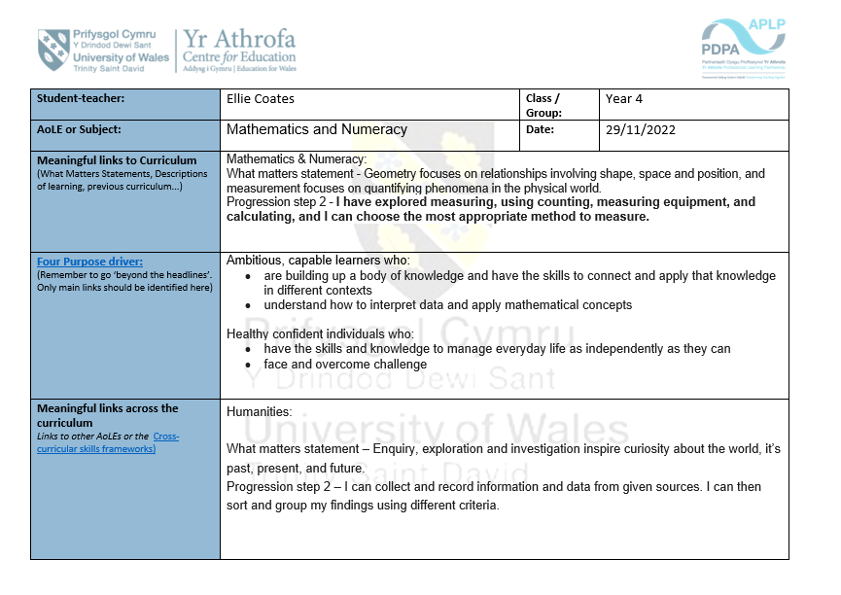
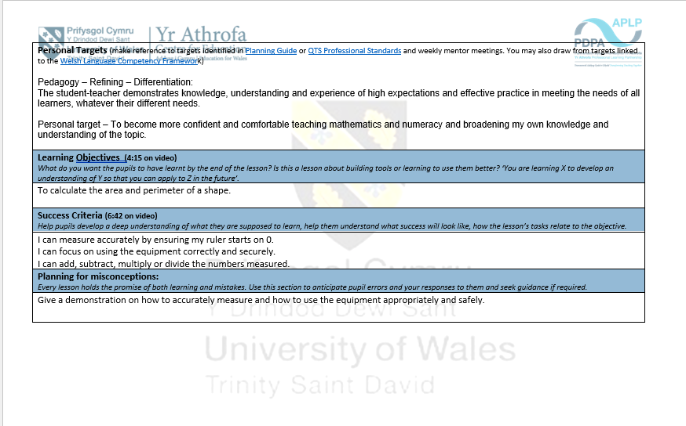
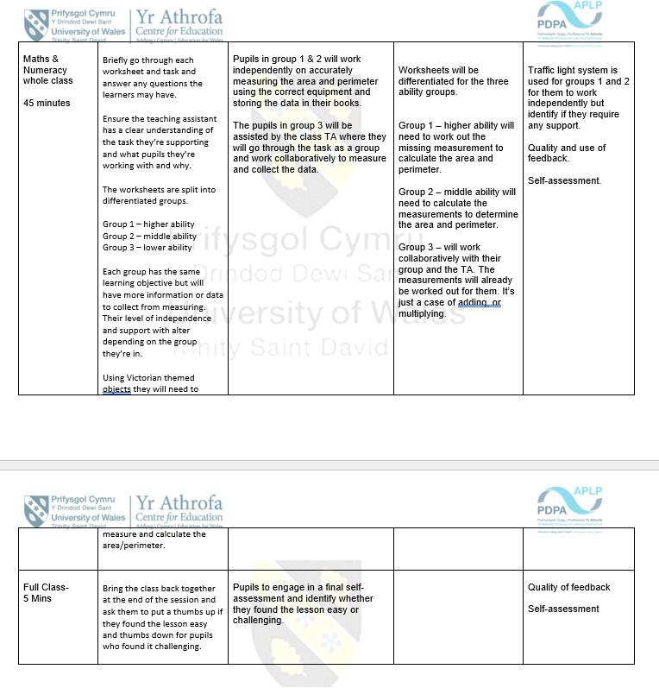
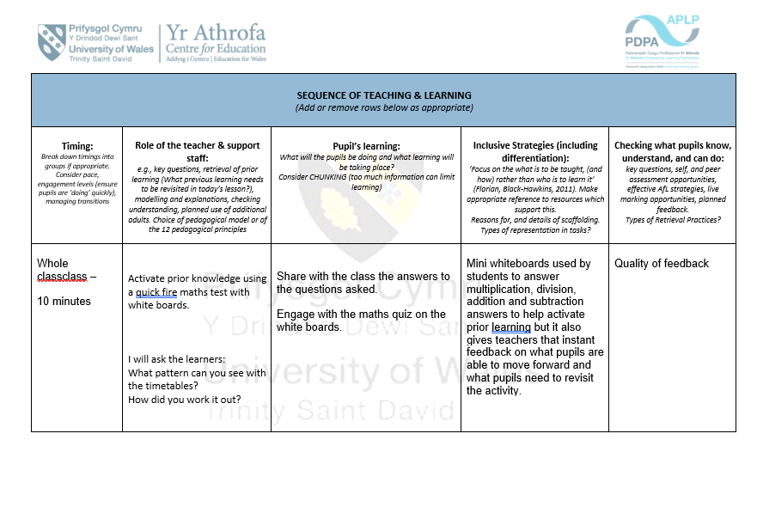
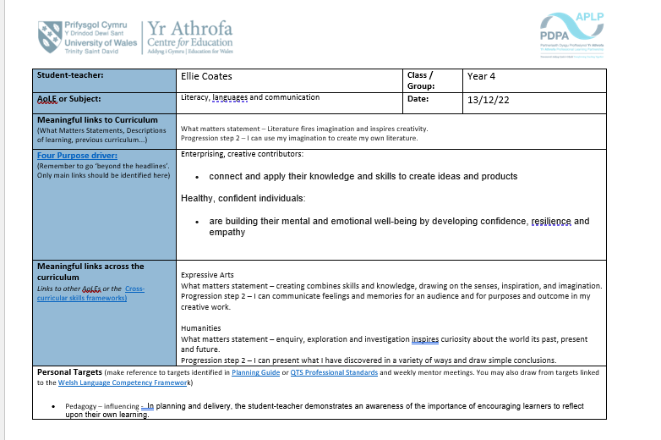
Lesson 2 – Literacy, Languages and Communication

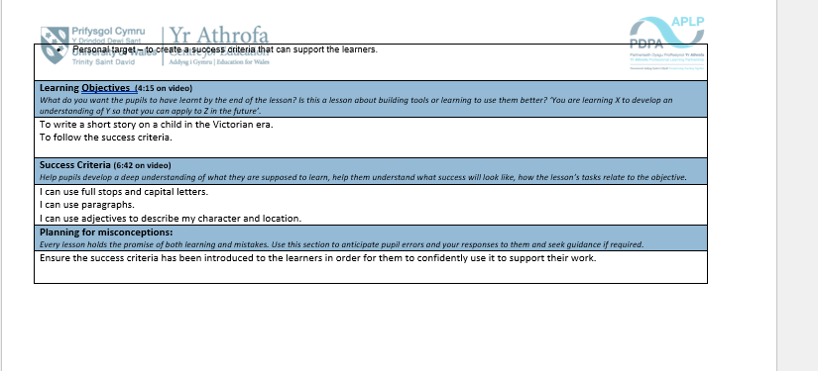
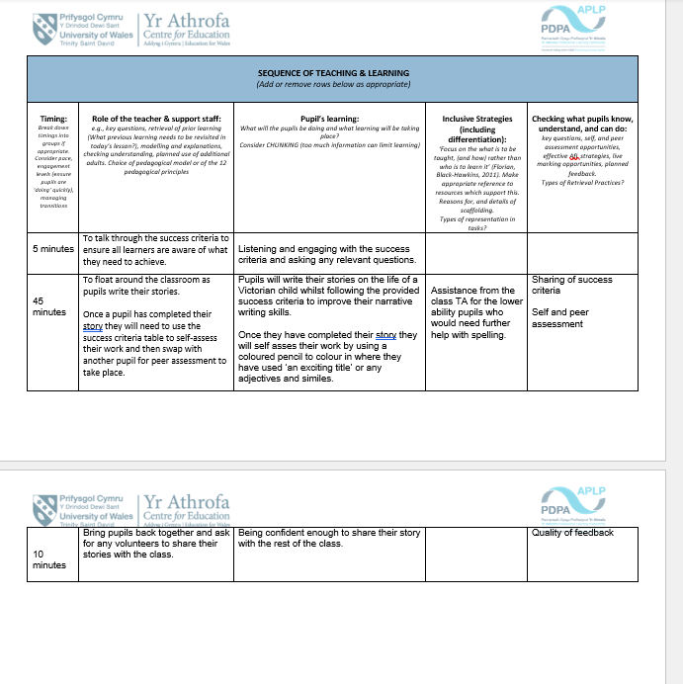
Lesson 3



