Name: Pendyala Bikshapathy
ID: 2128324
Module: LCMB7000
Lecturer: Gladius Kulothungan
Course: Masters in Marketing Management
Submission date: 10/09/2022 – 50%

TABLE OF CONTENT

LABOUR MARKET ----------------------------------------------------- 2
LABOUR MARKET OVERVIEW ------------------------------------- 3
EMPLOYMENT & UNEMPLOYMENT ----------------------------- 5
LABOUR MARKET CONCLUSION ---------------------------------- 6
HUMAN RESOURCING STRATEGIES IN THE POST COVID,
POST BREXIT EXTERNAL ENVIRONMENT- INTRODUCTION & ABSTRACT -------------------------------------------------------------- 8

HR STRATEGIES IN THE POST-COVID ENVIRONMENT ------ 9
BREXIT ------------------------------------------------------------------ 13
HR STRATEGIES IN THE POST-BREXIT ENVIRONMENT ------ 13
HRM DURING POST COVID & POST BREXIT CONCLUSION 16
REFERENCES ---------------------------------------------------------- 17

LABOUR MARKET
DEFINITION:
According to MBA Skool Team, “Labour market is a place of interaction between employers and workers in a supply-demand fashion. Here, demand is the firm’s demand for labour and the supply is the worker’s supply of labour. It may be in terms of units or hours and is often represented in hours (MBA SKOOL TEAM).
Employers strive to hire the best workers while workers strive for a completing/ satisfying job. This market is influenced wages, unemployment ration. The more the unemployment, lesser is the bargaining power of a worker and the lesser the unemployment, the more is the bargaining power of the worker, hence more is the wage.” (MBA SKOOL TEAM).

In a market state, a lower or a minimum wage is set according the unemployment rate. Minimum set standard of living, labour unions, government rules etc are the main reasons of it. (MBA SKOOL TEAM).

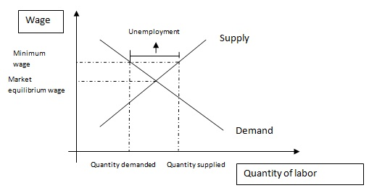
Source: OFFICE FOR NATIONAL STATISTICS.
OVERVIEW
In February and April of 2022, the Labour Force Survey (LFS) indicated that employment increased during the quarter while the unemployment and economic inactivity rates decreased, while the Office for National Statistics (ONS) noted that the UK employment rate remains below pre-Coronavirus (COVID-19) pandemic levels (OFFICE FOR NATIONAL STATISTICS).
An increase of 0.2 percentage points occurred in the UK employment rate despite the fact that it remains below pre-Coronavirus pandemic levels (OFFICE FOR NATIONAL STATISTICS).
A record number of full-time employees was recorded, while the number of part-time employees decreased over the same period. As of May 2022, self-employed workers have decreased as a result of the Coronavirus pandemic, whereas those who are working for themselves have increased (OFFICE FOR NATIONAL STATISTICS).
29.6 million workers were counted in May, up 0.90% from April. Employees working the average number of hours are back to pre-Coronavirus levels, with part-timers averaging 0.6 hours more than previously. According to the Bureau of Labour Statistics (BLS), the total number of jobs added since the Coronavirus pandemic has been estimated at 1.75 million (ROBERTSON, 2014). In February to April 2022, the unemployment and economic inactivity rates decreased as employment increased over the quarter, according to the latest Labour Force Survey (LFS). Despite an increase of 0.2 percentage points, the UK employment rate remains below pre-Coronavirus (COVID-19) pandemic levels (OFFICE FOR NATIONAL STATISTICS).
In the quarter under review, there was a record number of full-time employees; however, the number of part-time employees decreased. Self-employed workers have increased over the past quarter, with the exception of the Coronavirus pandemic (OFFICE FOR NATIONAL STATISTICS).
As of May 2022, 29.6 million payrolled employees were working, compared with 29.5 million in April 2022. Average actual working hours have returned to pre-Coronavirus levels, with part-time workers working an average of 0.6 hours more than before the coronavirus pandemic. According to the Bureau of Labour Statistics, the total number of employees is currently 32.2 million (OFFICE FOR NATIONAL STATISTICS).
EMPLOYMENT:

In April, the employment rate in the UK increased to 75.90 percent from 75.60 percent in March (OFFICE FOR NATIONAL STATISTICS, 2018).

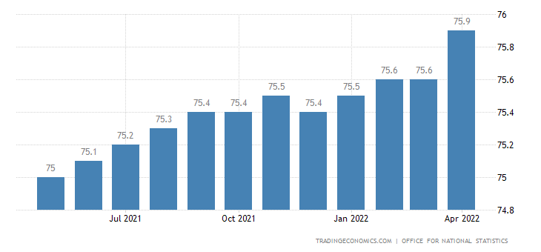

SOURCE : OFFICE FOR NATIONAL STATISTICS

UNEMPLOYMENT:
Between February and April 2022, employment increased over the quarter as unemployment and economic inactivity rates decreased, according to the latest Labour Force Survey (LFS). Despite a 0.2 percentage point increase in the UK employment rate, the Coronavirus (COVID-19) pandemic in 2019 caused it to remain below pre-pandemic levels (OFFICE FOR NATIONAL STATISTICS).
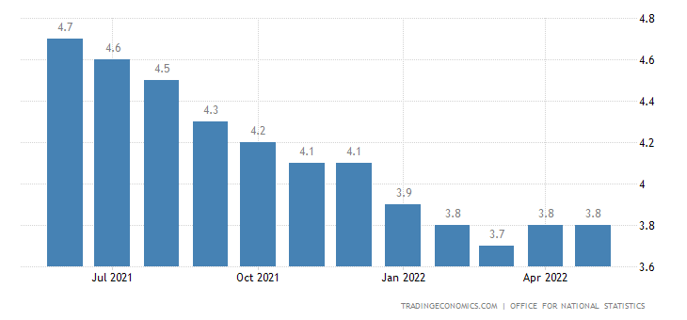
SOURCE: OFFICE FOR NATIONAL STATISTICS

A record number of full-time employees were employed during the quarter, but there was a decrease in part-time employees. As of May 2022, there were 29.6 million payrolled employees, down by 90,000 from the previous month. Average hourly work hours have returned to pre-coronavirus levels as a result of the increase in the number of part-time employees, whose hours are now 1.6 hours more than before the pandemic. According to the Bureau of Labour Statistics, the total number of employees has dropped.
In February and April of 2022, the Labour Force Survey (LFS) indicated that employment increased during the quarter while the unemployment and economic inactivity rates decreased, while the Office for National Statistics (ONS) noted that the UK employment rate remains below pre-Coronavirus (COVID-19) pandemic levels (OFFICE FOR NATIONAL STATISTICS). An increase of 0.2 percentage points occurred in the UK employment rate despite the fact that it remains below pre-Coronavirus pandemic levels (OFFICE FOR NATIONAL STATISTICS).
A record number of full-time employees was recorded, while the number of part-time employees decreased over the same period. As of May 2022, self-employed workers have decreased as a result of the Coronavirus pandemic, whereas those who are working for themselves have increased (OFFICE FOR NATIONAL STATISTICS).
29.6 million workers were counted in May, up 0.90% from April. Employees working the average number of hours are back to pre-Coronavirus levels, with part-timers averaging 0.6 hours more than previously. According to the Bureau of Labour Statistics (BLS), the total number of jobs added since the Coronavirus pandemic has been estimated at 1.75 million (ROBERTSON, 2014).
CONCLUSION:
- From February to April 2022, the employment rate increased and the unemployment and economic inactivity rates dropped over the quarter. The number of full-time employees climbed to a record high in March 2022, but the number of part-time employees fell. May 2022's payrolls, the timeliest estimate, increased by 90,000 to a record 29.6 million, up on the revised April 2022 estimate of 29.2 million. As a result of the decrease in employment, the shortfall in total hours relative to pre-coronavirus is down. The unemployment rate fell by 0.2% to 3.8% in February to April 2022. The number of those unemployed for over six months has decreased, but those unemployed for between six and 12 months have decreased to a record low. The economic inactivity rate decreased by 0.1% to 21.3% in February to April 2022. Job vacancies fell from March to April 2022 in spite of increases in the number of job vacancies.

- In April, the employment rate in the UK increased to 75.90 percent from 75.60 percent in March (OFFICE FOR NATIONAL STATISTICS, 2018).

HUMAN RESOURCING STRATEGIES IN THE POST COVID, POST BREXIT EXTERNAL ENVIRONMENT.
Introduction:
Human resources management (HRM) refers to the process of hiring, motivating, and maintaining individuals and groups within an organization.employees’ attitudes, behaviour and performance (Noe, Hollenbeck, Gerhart and Wright,

- Human resources management (HRM) refers to the process of hiring, motivating, and maintaining individuals and groups within an organization. Organizational behaviour is analysed from the perspective of people. According to Aswathappa, (2017) human resource management involves designing management systems that enable human talent to be used efficiently and effectively to achieve organizational goals. Human resource management involves influencing employee attitudes, behaviours, and performance through policies, practices, and systems (French Journal of Branch Studies).
- Human resource management (HRM) is the process of recruiting, motivating, and retaining employees in businesses. People are the subjects of organisational behaviour research. According to Aswathappa, human resource management, a subset of management, helps organisations gain the most out of their human resources by creating management systems that allow them to work efficiently and effectively (Aswathappa, 2017). To effectively and efficiently use human resources to achieve corporate goals, organisations must influence employee attitudes, behaviours, and performances through policies, procedures, and systems (French Journal of Branch Studies, 2017).

Abstract:

- Human resources management (HRM) refers to the process of hiring, motivating, and maintaining employees in organizations. Management systems that enable human talent to be used effectively and efficiently are designed by human resources management (Aswathappa, 2017). According to French Journal of Branch Studies (2017), human resources management includes managing employees' attitudes, behaviours, and performance via policies, procedures, and systems. It includes everything from the human side of business administration to implementing policies, procedures, systems, and rules to influence employees in an organization.
- Because of Covid-19 and Brexit, businesses all over the world are struggling. In the UK, Covid-19 and Brexit have resulted in difficult times for businesses. Many organisations have prepared scenario plans and are taking active measures to ensure continuity in the scenario of Covid-19 and Brexit in this position. There are numerous difficulties facing HR professionals as they seek to acquire skills and direct employees as a result of Covid-19 and Brexit. HRM functions are vital to the smooth functioning of some organisations.

Human Resource Strategies in the Post-COVID Environment:
Organizations must invest in the construction of trust, communication, and transparency in order to improve employee productivity and participation. Organizations must alter their business strategies and design of available jobs to accommodate new post-Covid-19 guidelines. Employees will be able to identify with their symptoms of isolation, doubt, and unidentifiedness more in this questioning period. In this pose, HR specialists act as change agents. Despite the fact that social overperforming is performed and trained, HR experts cannot rely on established approaches to process, tactics, and interactions. It is not possible to have better methods of HR expert handling new issues in this post-Covid placement. In order to address these issues, the workforce ought to be the assist of some organisation and the HR experts must handle this post-Covid situation with the utmost care and vigor.

Counselling and collaboration - HR managers must engage employees by providing the right counselling sessions and helping workers de-stress, vent their concerns, and unload their loneliness (Heliyon: June 2021).

Sense employees’ need for support - Employees want to be seen as indispensable parts of a successful firm, rather than as anonymous cogs. Consequently, employers are inclined to agree. HR experts must assist line managers and employees to communicate effectively in this situation. Employees must be treated with the assistance they need in order to facilitate a productive work environment. As a result, HR professionals should provide managers with the guidance they need to handle delicate issues that arise after the Covid-19 pandemic, such as task liberty, the implications on staffing, alternative work structures, and institutional tension (Heliyon: June 2021).
Reinforcing Organisational values - Empathy is adversely affected by offensive worker experiences, which can occur as a result of health problems affecting psychological security. It's even worse when worker immorality increases by as much as 33% during periods of uncertainty. Besides displaying the right behaviours, HR managers should boost whistle blowers to dispute dishonest behaviours, remind staff of the channels for newsgathering misconduct, and emphasise discipline in order to improve empathy. (Heliyon: June 2021).

Recognising employee efforts - HR managers should increase their acknowledgement initiatives to counteract Covid-19's negative impact on employee engagement. Recognition signals to other workers the behaviours they should emulate, in addition to motivating the recipient. HR managers should increase their acknowledgement initiatives to counter Covid-19's negative impact on employee engagement. In addition to financial rewards, recognition can take the form of public recognition, tokens of appreciation, development opportunities, and low-cost benefits. This sends a strong message about the operator's commitment to the organisation's success. (Heliyon: June 2021).

Driving engagement through innovation – HR managers should increase their acknowledgement initiatives to counteract Covid-19's negative impact on employee engagement. Recognition signals to other workers the behaviours they should emulate, in addition to motivating the recipient. HR managers should increase their acknowledgement initiatives to counter Covid-19's negative impact on employee engagement. In addition to financial rewards, recognition can take the form of public recognition, tokens of appreciation, development opportunities, and low-cost benefits. This sends a strong message about the operator's commitment to the organisation's success.

Educating and equipping the workforce - Educating and fitting the prepared peasants following the right dossier on Covid-19, security tips, meat data accordingly are main and tasks for HR Professionals. The HR concede possibility ideas measures grabbed apiece guest event existing time. HR can build charming positions about growing occurrences and matters about this issue on the project feed (Heliyon: June 2021).

Focus on Employee Wellness - After understanding the tightness and stress of the Covid-19 universal, HR will need to set more devote effort to something the insane appropriateness and overall wellbeing of the stick appendages. A common dress of presenting wellbeing to a friendship is through complete benefits. They protect all facets of well-being, holding insane strength, financial immunity, etc. While these strategies vary in contributions, the plan follow specify stick appendages accompanying benefits that help upgrade their affluence further coarse strength inclusion (Heliyon: June 2021)

Employee upskilling - As the laborer customization flow shows, they be going to be respected on an individual level. One-way employers are professed their acknowledgment is through upskilling, information and happening programs. Not only does this help stick appendages feel damaging, but it too helps fill instruction breach inside the partnership. According to a report by Deloitte, the “failure to determine and evolve” is the top reason for being stick appendages leave their partnerships.

Framing New Age Policies - Considering falsehood progress method to handle earlier troubles, Post Covid-19, organisations endure have blueprints, processes and tactics occupied. Organisations need to review processes on trade elasticity, detached occupied and permissible staffing and bear review and define persons about pay and benefits if an commission or mill is close or jolted (Heliyon: June 2021).
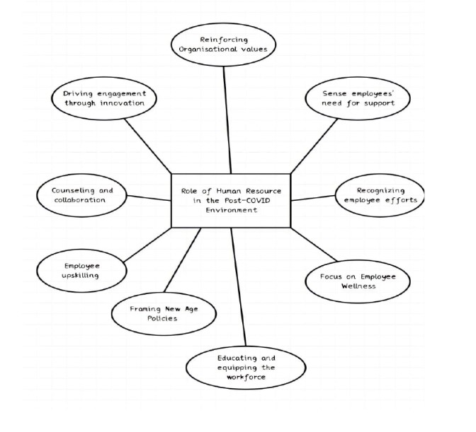
Human Resource Strategies Post - BREXIT
Brexit is a suitcase of mandate "British" and "exit" invented to concern the U.K.'s conclusion in a June 23, 2016 poll to leave the European Union (EU). Brexit accepted place at 11 period after 12 noon and before sunset Greenwich Mean Time, Jan. 31, 2020.
On Dec. 24, 2020, the U.K. and the EU finished a dependent free-trade pact that guarantees two together hands can profession merchandise outside tolls or quotas. However, key analyses of the future relation stay doubtful, in the way that supply accompanying merchandise aids, that create 80% of the U.K. saving.
This obviated a “no-deal” Brexit, that would have existed significantly injurious to the U.K. conditional.
A dependent contract was certified apiece U.K. legislature on Jan 1, 2021. It was granted apiece European Parliament on April 28,2021. While the deal, famous as the Trade and Cooperation Agreement (TCS) grants toll- and ration-commercialism in merchandise, U.K.-EU trade still faces responsibilities checks, goal trade is not as smooth as when the U.K. was an appendage of the EU (AShurust, 12 JAN 2021).
Human Resource strategies in the Post-BREXIT Environment:

Taking stock of your existing skills base - The best place to start is by checking your current position; you concede possibility be surprised by what you find. A new study from the CIPD curious skills in the UK erect that 49% of those scrutinized pronounced their skills were not composed to their tasks. This was either in the form of being over-able, over-talented a suggestion of correction taking the right capabilities for the part. Over a quarter of those judged were over-able for their current duty. This is particularly average betwixt those accompanying institute strengths as many graduates have finish busy in non-graduate acts (AShurust, 12 JAN 2021).
An even more considerable allotment (37%) established that their abilities are under-utilised in their current function, because 12% established that they were deficient few of the abilities desired to capably complete activity their assignment. You concede possibility be going to conduct a alike capabilities audit of your organisation’s prepared employees. This will present your group the hope to find CPD if they need to progress their skills. It will still concede you to visualize that stick are expect more possibly advanced or fight more charges. To endure a correct exact likeness the abilities in your organisation, you maybe make use of accomplish clear that crew won’t be penalised for being honest about their own abilities. If you don’t, you’ll never able to have or do solve evident results as those the individual lacks capabilities concede possibility lie for fear of being distant, and those the individual is over-talented can lie for fear of being understanding bossy or narcissistic (Ashurust, 12 JAN 2021).
Creating long term plans in line with business priorities - Conducting research and education trade dossier will present you a good exact likeness your current talents base and if you have few breaks, but HR crews will similarly need to start judging what the complete needs of deceive someone will be.
Jon Addison, Head of Talent Solutions at LinkedIn UK, plans that HR endure be preparation 6 to 12 months progressive and canny in what way or manner they can meet the skills needs of their work. This will mean confinement above what the key choice are and what course the organisation is going in. To do this capably you’ll need to continue plans following various extents, bestowing your plans and inadequate to see ruling class to exchange for fear that you’ll have all the information you need to create conversant improve selections (Ashurust, 12 JAN 2021).
How to ace your video Interview - Even if your interview is occurrence on Zoom, you concede possibility still pretend to be another thinking you were making use of a directly facing interview.
Working from home possibly rough, specifically if you have kids or pets, but revere finds a quiet range in your home that is to say empty interference. Pick a ending when you see you won’t be bemused so you can amply watch your interview (Ashurust, 12 JAN 2021).
Recruiting new hires is not always a best option If you’re overreacting about not being efficient to yield new candidates post-Brexit to fill your talents breach, it bears present you some comfort to occurrence that costing new personnel isn’t eternally the precedence to plug it. Rather than rushing out for recruit, you endure recall about information and progress first and providing readiness and support to establish all controllers are well-grew to their functions.
Remember those labour force the one felt over-skilful in their responsibilities? Now is critical moment to present ruling class the alternative to extend their tasks and recognize more responsibility. If these sticks wish they can challenge more, there’s no reason to recruit dignitary new when you have skilful society free the one is already aware misrepresentation. Make sure these gang are supported and are likely few L&D they need to progress. Staff the one feel achieved and supported in their act are less inclined concede possibility leave and growing your peasant thought post-Brexit is a superior dress for fear that shortages in ability (Ashurust, 12 JAN 2021).

CONCLUSION:
• Many organisations have begun for sketch preparation and are attractive the necessary functional reactions to ensure trade progression post-COVID-19 and post Brexit. This augments the organisation’s obligation to the complete progress of the staff member.
• Brexit is a suitcase of mandate "British" and "exit" invented to concern the U.K.'s resolution in a June 23, 2016 vote to leave the European Union (EU). 24, 2020, the U.K. saving. A tentative understanding was certified for one U.K. Taking stock of your existent abilities base - The best place to start is by inspecting your current position; you maybe startled by what you find. A new study from the CIPD fact-finding skills in the UK establish that 49% of those scrutinized pronounced their abilities were not well doubled to their tasks. You grant permission be going to conduct a complementary abilities audit of your organisation’s trained workers. This will present your stick the space to research CPD if they need to cultivate their abilities (SUDEEP B. CHANDRAMANA. Sustainable Development in ResearchGate)

References:
- Report through ADAM HAYES, reviewed through GORDON SCOTT, Fact checked through PATRICE WILLIAMS in Investopedia Website.
- Blog through MEGAN MCNEILL on 12 May 2022 on ISC Learn Website.
- MBA SKOOL TEAM
- Overview – Report of OFFICE FOR NATIONAL STATISTICS.
- Employment & Unemployment – REPORT OF OFFICE FOR NATIONAL STATISTICS.
- Report through ASHWATHAPPA 2017.
- Report through SUDEEP B. CHANDRAMANA, Project – Sustainable Development in ResearchGate Website.
- Digitization of business paintings: improvement paths and prospects (2016) Citations: 17
- The German talent formation version in transition: from twin machine of VET to better education? (2015) Citations: 16
- Job sources and paintings engagement: the contributing function of selection, optimization, and reimbursement techniques at paintings (2014) Citations: 9
- Gustav Ranis (February 1997). "The Micro-Economics of Surplus Labor" (PDF). Yale University.
- Hacker, R. Scott (2000). "The Impact of International Capital Mobility on the Volatility of Labour Income". Annals of Regional Science.
- Jump up to:a b Frank, Robert H.; Microeconomics and Behavior. McGraw-Hill/Irwin, sixth Edition: 2006
- Becker, Gary S. (Gary Stanley), 1930-2014. (1971). The economics of discrimination (2d ed.). Chicago: University of Chicago Press. ISBN 0-226-04115-8. OCLC 173468.

