Assignment two
Practical Tasks
Housekeeping Development Plan
Hotel Placement-
Operating Hotel Facilities.
(BMIH4006)
Student Name: Mr Naeem Qureshi
Student ID: 2027460
Lecturer-Lola Villard

Table of Contents
Introduction 3
Timetable for training 4
Training Activities 4
Safety training 6
Fire safety 6
COSHH 6
Health and safety training 7
Trinity's appropriate branding and logos 7
Conclusion 9
References 10

Introduction
The new team members will be given a warm welcome message while entering the hotel. There are various activities that will be performed. They will introduce themselves to each other. They will introduce themselves one by one. There will also be an announcement about the new teams to the employees who are still working in the company. The team members will then introduce themselves one by one to the individuals working in the company. The team members will be shown the different rooms of the four-star hotel Trinity. They will also be given the time to roam around the hotel campus which will give an idea to them while doing the training.

Timetable for training
Activity | Start  Time | End  Time | Week-1 | Week-2 | Week-3 | Week-4 | Week-5 | Week- 6 | Week-7 | Week-8
Uses of equipment | 10 AM | 8 PM
Time management skills | 10  AM | 8 PM
Communication skill | 10 AM | 8 PM
Cleaning skills | 10 AM | 8 PM
Presenting in front of Guests | 10 AM | 8 PM
Emergency training | 10 AM | 8 PM
Fire and safety training | 10 AM | 8 PM
Table 1: Training schedule
(Source: Created by a learner)

Training Activities
Uses of equipment: The first week will be the training about different equipment. To be a housekeeping team there are various types of equipment that have to be used while giving housekeeping services (Setiawan et al., 2021). These pieces of equipment include floor machines, brooms, vacuum cleaners and the use of various other types of equipment. The housekeeping team should know how to use these tools efficiently (Setiawan et al., 2021). These tools are necessary for the daily activities that are performed by housekeeping.

Time management skills: Time management skills are necessary for the housekeeping teams. They have to finish the work of one room and also have to go to other rooms for training (Khymdeit, 2022). The second week of training will be on time management skills (Khymdeit, 2022). There will be various techniques which will be taught to the new housekeeping team. These techniques will help them to manage their time effectively while performing their daily activities.

Communication skills: Communication skills are also essential for the housekeeper. They have to communicate with the guests on a daily basis. The third week of training will be done to increase their communication skill (Verma et al., 2020). There are various types of methods which will be used for improving communication skills. These methods will be taught to the new team members who will help them to improve their communication skills (Verma et al., 2020). The third week will focus on improving the communication skill of the new team members.

Cleaning skills: cleaning skills are an essential part of housekeeping services. These skills are to be acquired by the new team members who will be working in the company (Ng, 2021). There are various types of methods to improve these skills (Ng, 2021). These methods are will be taught to the new team members so that they can acquire these skills. The cleaning of the various types of rooms will be taught to the new team members. This training will be done on the fourth week of training.

Presentation in front of guests: This training will be done in a different room where one by one the new team will be called and judged by the training manager who will be presented as guests (Yick et al., 2020). This training will be done in the fifth week and there will be various methods which will be presented to the new team members which will help them to gain this skill.

Emergency training: Emergency training will also be given to the new team members. This training will be given to the new team members because there might be any situation that might arise in the hotel (Vijaya et al., 2020). The housekeeper visits the rooms of every guest suddenly that situation that guest might have a heart seizure then this training will be effective. This training will be done in the sixth week of the training schedule (Vijaya et al., 2020). Emergency training can be worked in any situation this training will also prove effective at the time of any natural disaster like an earthquake, flood or typhoon.

Fire and safety training: Fire safety training is also essential for the new housekeeping team. They can guide the guests when a fire breaks down in a hotel or room (Vijaya et al., 2020). This training will be given for two weeks. This will be the last training that will be given to the new team members.
The above-mentioned training activities will be given to the new team members. The team members will be given this training because these training skills are required by them at the time of providing services to the customers. The training schedule is for eight weeks and the training programs that are mentioned above are as per the job requirements for housekeeping.

Safety training
Safety training is essential for the housekeeping of the hotel. This will help them to ensure the safety of guests if any unpleasant situation arises in the hotel (Tra, 2020). Trinity is a four-star hotel and there is a possibility of being attacked by terrorists (Tra, 2020). During this situation, if housekeeping service providers have been provided with the instruction about this situation, then they can ensure the safety of guests.

Fire safety
Fire safety training is essential for the housekeeper. A fire can break out at any time. This training will provide instruction about how a housekeeper should act at the time of a fire breakout in a room or in the hotel (Hamida and Hassanain, 2019). This will help them when a fire breakout inside the hotel or room. They can ensure by providing them instructions about the different exits of the hotel (Hamida and Hassanain, 2019). If a fire breaks out inside the room, then they can use a fire extinguisher for controlling the fire.

COSHH
The COSHH stands for the “control of substances which are hazardous to health”. These substances are not good for health and will also pose a threat to the guests. These substances are rare to be found in a hotel (Ashurst, 2020). But if it is found the efficient training that is to be given to the housekeeping service providers. This training can enhance their skills for handling this kind of substance (Ashurst, 2020). If the training is not given properly then it might also pose danger to the health of housekeeping service providers.

Health and safety training
Health and safety training also has to be provided to the housekeeping service providers. The health and safety training will also ensure the safety of guests (Mejia et al., 2021). This training should be provided on the way that housekeeping service providers will get the information (Mejia et al., 2021). This training can save many lives if they are provided properly to the housekeeper.

Trinity's appropriate branding and logos


Figure 1: Trinity's logo
(Source: Trinity Hotels, 2021)
The above-mentioned picture is the logo of the four-star hotel Trinity (Trinity Groups, 2022). This is one of the logos of the Trinity a United Kingdom-based hotel group.
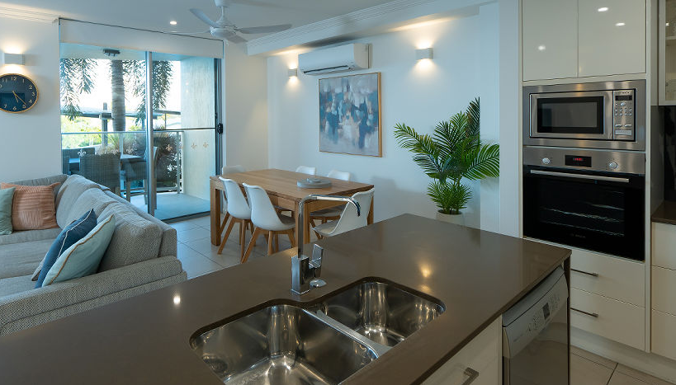
Figure 2: Single bedroom with a kitchen room of Trinity
(Source: Vue Trinity Beach, 2019)
The above-shown picture is one of the rooms that are provided by the Trinity hotels group in the United Kingdom (Trinity Groups, 2022). This is a single bedroom with a single kitchen which is considered a luxury apartment.

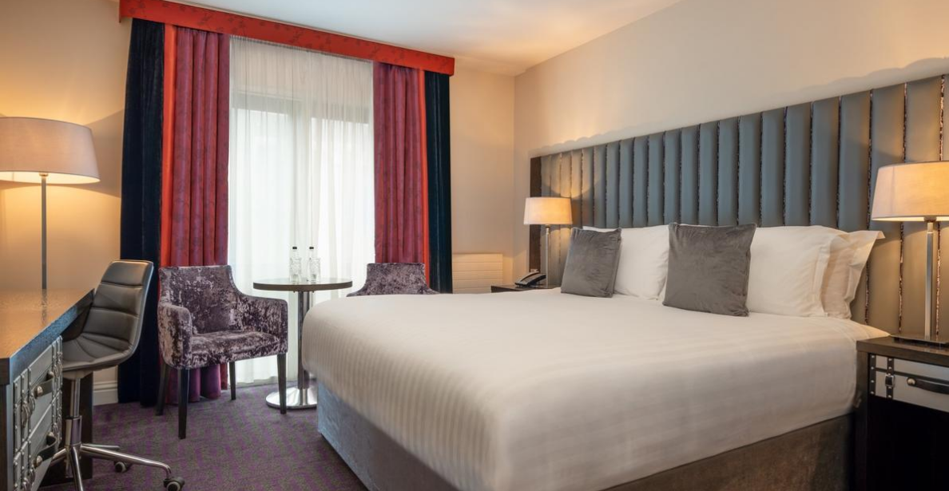
Figure 3: Dubin room
(Source: Trinity City Hotel, 2018)
The above-shown picture is known as the Queen’s room with a huge bedroom (Trinity Groups, 2022). This is one of the luxurious rooms that are provided by the Trinity.

Conclusion
Training housekeeping service providers efficiently will increase the rate of service that is provided by the hotels. There are various types of training activities that are to be done which will help the housekeeper to get many skills. These skills are necessary as per the job requirement of a housekeeper.

References
Ashurst, A., 2020. Developing the roles and responsibilities of ancillary personnel. Nursing And Residential Care, 22(4), pp.1-3.
Hamida, M.B. and Hassanain, M.A., 2019. Fire safety in the built-environment: a case study in a residential facility. Architecture, Civil Engineering, Environment, 12(2), pp.27-34.
Khymdeit, J., 2022. Project work on entrepreneurship topic: Housekeeping.
Mejia, C., Ciarlante, K. and Chheda, K., 2021. A wearable technology solution and research agenda for housekeeper safety and health. International Journal of Contemporary Hospitality Management.
Ng, A.M.L., 2021. Housekeeping Skills Training for Independent Living Among Malaysian Adolescents with Special Needs: A Case Study. Journal of Special Needs Education, 11, pp.30-50.
Setiawan, I.G.M., Triyuni, N.N., Budarma, I.K. and Antara, D.M.S., 2021. The Implementation of Green Housekeeping Management at The St. Regis Bali Resort. International Journal of Green Tourism Research and Applications, 3(2), pp.69-76.
Tra, T., 2020. Action plan for training new Housekeeping Employee: case: Hotel Indigo Helsinki.
Trinity City Hotel (2018) Trinity City Hotel Dublin: 4-star hotel in Dublin City, Trinity City Hotel Dublin | 4-Star Hotel in Dublin City. Available at: https://www.trinitycityhotel.com/en/ (Accessed: November 11, 2022).
Trinity Groups (2022) Trinity groups, Trinity Groups. Available at: https://trinityhotelgroups.com/ (Accessed: November 11, 2022).
Trinity Hotels (2021) Trinity Hotels Home Page, Trinity Hotels. Available at: https://trinity-hotels.com/ (Accessed: November 11, 2022).
Verma, P., Singh, M. and Aggarwal, N., 2020, June. The Effect of Next–Level Housekeeping via Technology on the Perceptions of the Hospitality Aspirants. In 2020 8th International Conference on Reliability, Infocom Technologies and Optimization (Trends and Future Directions) (ICRITO) (pp. 1150-1156). IEEE.
Vijaya, R., Sharma, A., Daga, A. and Gopichandran, L., 2020. Effectiveness of Structured Training Programme on Infection Control Measures among Housekeeping Workers in Selected Intensive Care Units at Tertiary Hospital. JoNSP, 10(2), pp.51-56.
Vue Trinity Beach (2019) Vue Trinity Beach Luxury Apartments Holiday Apartments Trinity Beach, Vue Trinity Beach. Available at: https://www.vuetrinitybeach.com.au/ (Accessed: November 11, 2022).
Yick, M.Y.Y., Köseoglu, M.A. and King, B., 2020. Gazing at hotel guests: Deconstructing elements of the host-gaze. International Journal of Hospitality Management, 87, p.102508.

