ACADEMIC AND EMPLOYMENT SKILLS
ASSIGNMENT 1
TASK 1
CLASS: BMSW4001

ACADEMIC REPORT

STUDENT NAME: Marinela Camelia Craciunel (1818825)
CLASS: BMSW4001
GP: 6
LECTURER: Lloyd Beharry

L
L

TABLE OF CONTENTS (ToC):

- Executive summary
- Skills
  - Employability skills
  - Hard skills
  - Soft skills description
    - Communication
    - The ability to understand and give instructions
    - Working with a team
    - Time management
    - Conclusion
- SWOT analysis introduction
  - The process
  - Conclusion
- Personal Development Plan (PDP)
- Research and note-taking
- Referencing and the avoidance of plagiarism
- Paraphrasing and summarising
- Conclusions
- Recommendation

- Executive Summary

The aim of this report is to provide the reader with an understanding of the important academic and employability skills in today’s world, through the prism of my own skills. These will be analysed using a couple of methods like a SWOT analysis and a PDP (personal development plan). This report will help the reader understand my perspective into the importance of certain skills, either soft or hard, how these skills are learned and also how they shape an individual, how they help him grow personally and academically/career-wise, also including fragments of literature review.

- Skills

Based on Oxford dictionary, a skill is “the ability to do something well; expertise”, so we can develop this by saying that having a skill makes you stand out for the crowd, defines you and helps you in advancing in your career or in your personal life. Having skills does not entirely depend on social class or economic status, nor does it depend on your academic path, but it is somehow influenced by those. Being a skilled individual does not mean that you possess a large number of various skills, but that you use the ones that you have in your advantage, to their maximum potential.

  - Employability skills

Employability skills are the set of skills you possess that are going to make your employer hire you. They are required in the field that you want to go in and are appreciated in most fields of practice. Everyone has a set of employability skills, and although they could differ from job to job or region to region, they are usually pretty standard worldwide. Employability skills are often called “soft skills”. They are developed over time and through life experiences, so you cannot simply read a book or watch a movie and end up developing those, it’s all about time and experience. While most jobs offer training for some of the difficult or custom task that they require you to know, they would not like to see that you don’t have this standard set of skills that they can work with. Not having these employability skills shows lack of initiative and laziness, which are 2 of the most hated characteristics by an employer. Such skills are often related to communication (verbal and non-verbal), the ability to work in a team and the willingness to learn and grow as an individual.

  - Hard skills

Since we’ve touched the subject of soft skills, we need to talk about their opposite, hard skills. These, on the other hand, are the ones that are easy to quantify and analyse, unlike soft skills, which are hard, if not impossible, to break down and describe accurately. It’s hard to prove that you have a certain soft skill, but it’s extremely easy to point out and prove a hard skill. Hard skills cannot be denied or ignored, and they refer to things such as being proficient in a foreign language (which can be measured with language tests), a degree or certificate (which has been approved by the institution who released it) and abilities like machine operation, programming, digital skills, all of which are quantifiable.

2.3 Soft skills analysis

In the next paragraph I’ll touch upon the basic soft skills an individual should possesses and how these can be described in daily situations.

2.3.1 Communication – when talking about soft or transferable skills, communication is always going to be one of the top ones, but it is also the most complex one. Communication comprises of verbal and non-verbal, writing and speaking. You may be good at one, but not at the other, and it’s very important to know what you are good at and try to improve the rest. No one is born with the ability to be a good listener or a good speaker, these are all characteristics that are modelling us like clay throughout our life.
2.3.2 The ability to understand and give instructions – this skill can also be interpreted as leadership and team work. The ability to give instructions that are easy to comprehend and to follow, although it is another skill under the communication umbrella, is also what makes a good leader. On the other hand, the ability to understand instructions can make you a great team player, knowing how to do a task in the most efficient way. Ideally, one should possess both of these skills in order to succeed, but only having one is enough to be able to work on the other.
2.3.3 Working with a team – Dependant on the task mentioned before, working with a team is ideal, no matter how many tasks you will have to undertake as an individual. There is no institution that work with one employee, so every person in this world needs to be able to work in a team, even if it’s not something they enjoy. Being good at something and liking that particular task are two very distinct things and should not interfere with each other.
2.3.4 Time management – this skill splits into two different areas: punctuality and using time efficiently. Punctuality is very important in today’s world, where everything is on demand and everyone is busy, working on a strict schedule. Missing a meeting that was supposed to happen 30 minutes could lead to a missed opportunity and a missed career path, that’s why having the punctuality skill is an important asset nowadays. Using time efficiently, on the other hand, while it’s still related to punctuality in a way, is more connected to how you spend your time with yourself, in general. Maximising your free time is going to lead to a more productive day and a more productive individual after all. Being aware of the things that distracts you from your goal and trying to work on avoiding doing these is another possible description of an individual that excels at using their own time efficiently.

2.3.5 Conclusion
You can now start to see a pattern of how these soft skills are interdependent, and the easiest one that needs all of them in order to be described is working with a team. In order to do that, you need to be a bit of everything- you need to learn how to communicate, both verbally and non-verbally, you need to be a good speaker (give instructions) and a good listener (understand instructions). Soft skills are transferable and also co-dependant

- SWOT analysis introduction
Using a mind tool, I’ve developed a SWOT analysis of my personal skillset that I will explain in the next section. Conducting a personal SWOT analysis is great for any individual that wants to find out more about themselves and wants to create a plan of advancing in their career. Spending time to think about your personal strengths, weaknesses, opportunities and threats offers you a new perspective into how you can improve yourself personally and therefore, in the workplace.

3.1 The process
To conduct this analysis, I had to ask myself a couple of questions that I would have been asked at any potential interview by a possible employer. I’ve started by asking myself “What am I good at?”, “What makes me stand out from my competitors?” and that’s how I came up with my strengths, which are my strong leadership skills, my experience in providing great customer service and my ability to adapt to changes in a short period of time, usually on the spot. When the time came to analyse my weaknesses, I thought about the things that I am not proud of, the things that I wouldn’t necessary share with the world, or the lack of these skills. Finding your weaknesses can be a hard process to go through, especially if you are usually a proud individual who does not want to hurt their ego, but it’s the only way to improve yourself and work with your own personality in order to get better and advance in your career. Therefore, I came up with the two most important weaknesses that I think define me: the difficulty of maintaining a healthy work/life balance and the lack of great communication skills with certain individuals. Finding potential opportunities is easy to do after you’ve analysed your weaknesses, become it’s direct proportional to those. Opportunities are a way to work on your weaknesses, so after asking myself “how can I make these weaknesses go away, or, if that is harder, how can I work on improving them and transforming them into strengths?” For me personally, enrolling in workshops and tutorials that would enhance my skillset and exploring more cultures in order to understand how to communicate properly with each individual are two things that would help me tremendously. To come up with the threats, I had to think about the things that I was unsure of in my future, such as competitors for a job, who may possess a more valuable skillset than me for the employer and people with a better grasp of the English language than me, possible natives.
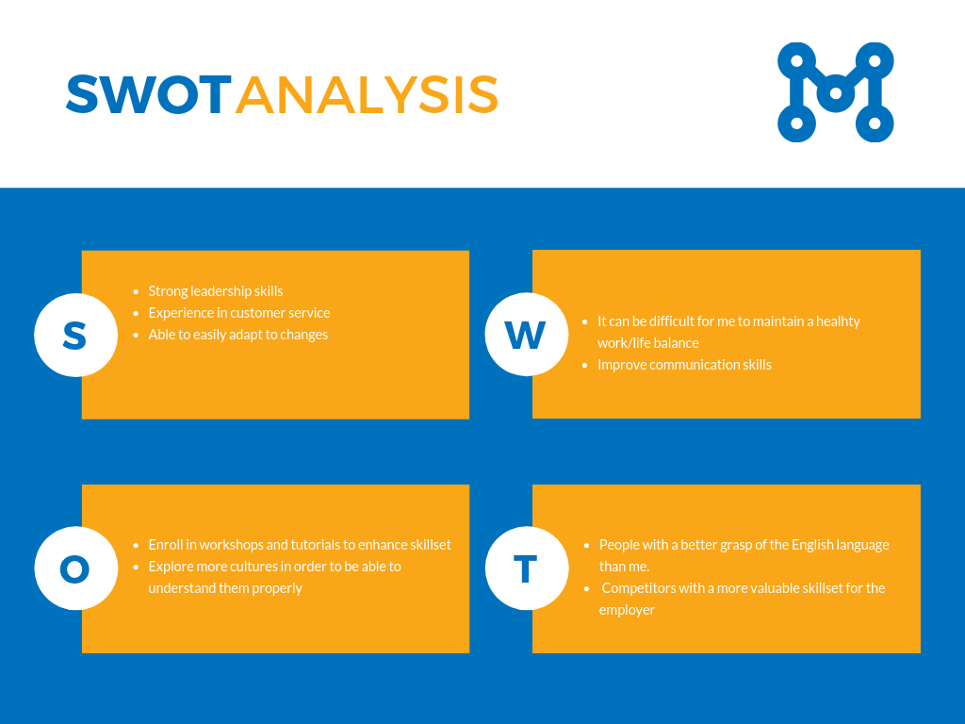

Source: Created by Author

3.2 Conclusion
This SWOT analysis, apart from the fact that made me understand in a clear way what are my strengths, weaknesses, opportunities and threats, made me more aware of the things that I need to do in my future in order to advance in my career and in order to grow personally, as an individual.

- Personal development plan (PDP)
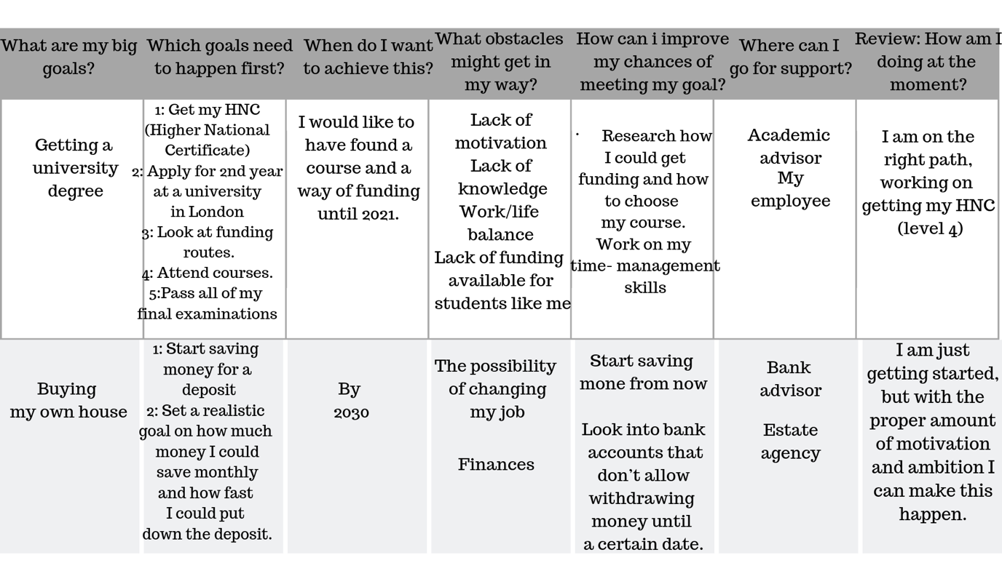
The SWOT analysis pursued earlier allowed me to go in-depth and explore some of my other future plans, which I grouped and organised in a Personal Development Plan (PDP):
Source: Created by Author

- Research and note-taking

A great way to improve your knowledge is to look for more information in every possible place and way. That involves research and note-taking techniques. The lack of those could lead do gathering too many information that may be irrelevant or the feeling of overwhelm. Both of these situations can be avoiding by using the right methods. Rowntree (1976) suggests that taking notes will indeed help your attention span extend. That’s why it’s so important to be able to take notes as efficiently as possible. Although some people may have an audio-graphic memory instead of a photographic memory, research has shown that writing things down will help you fix the information better and will make it more likely to be stored in the long-term memory.
Needless to say, not every piece of information that you receive during your academic path is one worth saving into the long-term memory, but this is where you need to come as an individual and distinguish the relevant ones from the irrelevant ones. One can do this simply by asking themselves the question: “Is this information going to be useful in 2 years’ time?” If the answer is no, then you might consider learning it just for the time being, in your short-term memory, without paying a lot of attention to how you can remember it in the future. But if the answer is yes, then you might want to start repeating the information frequently, until it’s properly set in your long-term memory and won’t need revisiting until a later time.
One of the methods proposed by Rowntree (1976) is called “SQ3R”. It stands from survey, question and the 3 Rs, which are read, recall and review. This is one of the many methods out there that have been proven to work based on multiple trials and will store the information learned in the long-term memory.

- Referencing and the avoidance of plagiarism

Another skill that is highly important in a student’s academic path is the ability to reference and avoid plagiarism. While referencing takes time to become a habit and a must, plagiarism is different. As a word, it means original, not inspired by other’s work. But the meaning behind it means that you need to know how to be inspired. Reading three books based on a specific subject and then creating your own analysis of the subject based on the research in that book is not plagiarism, as long as the ideas quoted directly are being referenced. Plagiarism is opening a book and copying word-by-word (or even slightly paraphrasing) and assuming the work is yours. This is not only trying to fool the reader, but it’s also fooling you, because you are assuming someone else’s work as if it was your own, getting the merits of it without deserving it. That is why in order to be an appreciated individual in your career or academically, you need to avoid all types of plagiarism at all cost. As Kassem (2011) said: “A true poet writes from the language and experiences of their own heart, not those of others.” And although you don’t need to be a poet, this quote represents the essence of why it is ethical to avoid plagiarism in order to be able to improve.

- Paraphrasing and summarising

While we are on the subject of plagiarism, we might as well address paraphrasing and summarising. Two extremely important skills that are not only applicable in an academic environment, but also in life, in general. Possessing the skill of paraphrasing means that you are able to communicate the same idea in different ways, which is a plus when you are dealing with people who do not understand what needs to be done or what it’s expected of them. In my opinion, paraphrasing goes hand in hand with the leadership skill, meaning that a good leader has to be able to properly communicate the idea he wants, no matter how many times he has to change its wording in order to be understood by its team. Summarising is a life-skill that will show itself useful in a multitude of situations. Each individual will have to do research and summarise it at some point in their life and having the skill of summarising from early on will be a great help. A good summary is based on multiple activities, such as note taking, organising, proofreading and of course, researching, so for an employee in today’s world, being able to summarise any piece of information shows how capable you are of multitasking and the fact that you possess lots of different skills and you know how to use them together to be more productive.

- Conclusion

The report’s aim was to make the reader understand my perspective and my opinion when it comes to the skillset you need to have nowadays in order to succeed, and this has been done through research and analysis of my own set of skills, and how these have shaped me into who I am today and will continue to shape me going forward.
9.Recommendation
The in-class exercises helped me to develop my academic skills as well to understand their importance on a workplace and in the carrier.

REFERENCE LIST

- Cottrell, S. (2008) The Study Skills Handbook 3rd edition. Hampshire: Palgrave MacMillan.
- Doyle, A. (2019) Important Communication Skills for Resumes & Cover Letters. Available at: https://www.thebalancecareers.com/communication-skills-list-2063737 (Accessed: 6th of August 2019)
- Doyle, A. (2019) Important Employability Skills For Workplace Success. Available at: https://www.thebalancecareers.com/employability-skills-list-and-examples-4143571 (Accessed: 6th of August 2019)
- Doyle, A. (2019) The Hard Skills Employers Seek. Available at: https://www.thebalancecareers.com/what-are-hard-skills-2060829 (Accessed: 6th of August 2019)
- Employability Skills: The Skills You Need to Get a Job (no year) Available at: https://www.skillsyouneed.com/general/employability-skills.html (Accessed: 9th of August 2019)
- Greetham, B. (2013) How to write better essays. Basingstoke: Palgrave Macmillan.
- Kassem, S. (2011) Rise Up and Salute the Sun: The Writings of Suzy Kassem. London: Awakened Press
- Maund, A. Schriek, M. and Tinkler, P. (2017). Certificate in Higher Education: Skills for the Workplace Student Yearbook. Sage Publications
- McMillan, K. and Weyers, J. (2006) The smarter student: Skills and strategies for success at university, London: Prentice Hall.
- Morgan, P. (2016). The Business Student’s Guide to Study and Employability. Sage Publications
- Pears, R. and Shields, G. (2010) Cite them right: The essential referencing guide. 8th edn. Basingstoke: Palgrave Macmillan
- Rowntree, D. (1976) Learn how to study. London: Macdonald and Jane’s.
- The Mind Tools Content Team (2019) SWOT Analysis: Discover New Opportunities, Manage and Eliminate Threats. Available at: https://www.mindtools.com/pages/article/newTMC_05.htm (Accessed: 8th of August 2019)
- Wilson, E A and Bedford, D (2009) Study Skills for Part-time Students Harlow: Pearson



