

RESULT

ASSIGNMENT DETAILS AND FEEDBACK
SOUTH WEST WALES CENTRE FOR TEACHER EDUCATION
Sections marked with * should be completed by module lead
Student name: | Kevin James | Student P number: | 1502206
Programme: * | PGCE Primary
Module: * | School Development and Pupil Progress | Module Level (6 or 7):* | 7
Module code: * | M7X02153 | Contribution to Overall  Module Assessment (%): * | 70%
Module Lead:* | Helen Lewis
Assignment Title:* | Written assessment 4,500 words | Assignment No (x of x):* | 1/2
Start date:* | 5/3/17 | Submission deadline:* | 30th May 2018
Return date of provisional marks & written feedback:* | 27th June 2018

Referencing: | In the main body of your submission you must give credit to authors on whose research your work is based. Append to your submission a reference list that indicates the books, articles, etc. that you have read or quoted in order to complete this assignment (e.g. for books: surname of author and initials, year of publication, title of book, edition, publisher: place of publication).
Submission: | All assignments must be submitted to Turnitin unless otherwise instructed by the Lecturer.  Note: the Turnitin version is the primary submission and acts as a receipt for the student. Late submission of the electronic version of the assignment will result in a late penalty. Penalties for late submission: Up to one week late, maximum grade D. Over one week late, Refer. Only the Extenuating Circumstances Panel may grant an extension. | Date: | 30th May 2018

Module lead to tick to indicate if a hard copy version of the assignment must be submitted.* | YES
 | NO

1

Student Self Evaluation Form

This section repeats in brief the common assessment criteria detailed on previous pages. The extent to which these are demonstrated by you determines your mark. Using these criteria, tick the box that best indicates the level of achievement you feel you have achieved with regard to each of them.

Common Assessment Criteria Applied
Common Assessment Criteria Applied | REFER |  | D |  | C |  | B | A
 | OUTRIGHT FAIL | UNSATISFACTORY | SATISFACTORY | GOOD |  | VERY GOOD |  | EXCELLENT
1. Subject Knowledge and Understanding (which includes using research-informed literature and knowledge and understanding of the subject)
 |  |  |  |  |  | 
2. Intellectual Skills (Analysis)
3. Pedagogic and Professional Applications (Practical Application and Deployment)
4. Key Transferable Skills

PLEASE COMMENT ON AREAS IN WHICH YOU FEEL THAT YOU HAVE PERFORMED WELL | PLEASE COMMENT ON AREAS you feel that you need TO DEVELOP
2-4 | 1

Student’s Name | Kevin James | Date | 30/05/2018
Student’s Signature | Kevin James

2
School Development and Pupil Progress- M7X02153

Table of Contents
Page 1/2: Assignment Details, Feedback and Self Evaluation
Page 3: Table of Contents and List of Appendices
Page 4: Introduction
Page 5/6/7: Data collection
Page 7/8/9/10/11: Analysis of Learner
Page 11/12/13/14: Next Steps
Page 14: Conclusion
Page 15/16/17: References

List of Appendices
Page 18: A-1/2 (UWTSD Permission Sheet)
Page 19/20/21: B-1-5 (P-MC Language Work)
Page 21/22/23/24: C-1-6 (P-MC Mathematical Work)
Page 24: D-1 (P-MC Topic Work- Geography)
Page 25: D-2/3 (P-MC Topic Work- ICT)
Page 26: D-4 (P-MC Topic Work- Music)
Page 26: E-1 (RAG- PSE/Literacy)
Page 27: F-1 (Observation notes using the Leuven scale (Wellbeing and Involvement)
Page 28/29: G-1 (Lesson plan for observation of Leuven scale
Page 30: H-1 (Interview questions)
Page 31: I-1 (Blooms Taxonomy Questioning)

School Development and Pupil Progress- M7X02153

Introduction
Throughout this assignment I will aim to conduct a detailed analysis of one child’s holistic development, with rationalisation for future steps on how to support pupil progress in learning further. The school I am presently working in (School A) and in which I will focus on one child’s holistic development is a large primary school located on the outskirts of an urban town in South Wales. School A opened in 2013 following the amalgamation of the junior and infant schools. The majority of pupils transferred to the new school which caters for children from three to eleven years old. In total there are 476 pupils on roll of which 83 children attend the nursery part-time. Nearly all pupils speak English as their home language with very few who communicate with Welsh as their first language. Approximately 22% of pupils are eligible for free school meals (FSM) which is close to the national average.

School A recognises 24% of pupils as having additional learning needs (ALN) however very few pupils have a statement of special educational needs (SEN). School A is 55th out of the 66 primary schools in their local authority in terms of its school budget per pupil receiving a solitary figure of £3,046 per pupil. Although Estyn (2015) state School A’s current performance and prospects for improvement are ‘Good’ they recommend the following in order to drive standards further: Improvement of pupils’ standards in creative and extended writing, an improvement of the provision for religious education (RE) and finally to ensure effective levels of challenge to raise standards for more able pupils supported by the development of the roles of middle leaders to monitor the curriculum more closely.

School A’s population has continued to grow partly due to the local authority’s closure of similar service settings in nearby areas and the school also have plans in place for a specialist provision to be opened that caters specifically for children with ALN. There are two classes for each year group and I am presently working in general with a lower ability class within Year 5 (5T). Class 5T contains 28 pupils (12 male, 16 female) of which 5 pupils are identified with having ALN. There is 1 teacher who usually teachers to a whole class however during morning sessions there is at large support available (1 Teaching assistant (TA)) to help with Literacy and Numeracy. The case pupil (P-MC) in which I will conduct my research with in order to identify potential gaps in attainment and moving forward suggesting strategies and intervention that could support and progress P-MC learning and attainment further is a conventional male pupil who lives locally. P-MC has a steady home life at School A he enjoys sport primarily football and engaging active lessons. P-MC on the whole participates and contributes within the majority of lessons in class 5T however occasionally he can go off task in which this has had an effect on reaching his full potential.

Data collection

Prior to beginning any exploration work and in advance to collecting any data on P-MC I examined recommended ethical guidance in which I then used as a foundation for all stakeholders involved in the research to build from BERA (2011), EWC, UNICEF and UWTSD (2017-2020). I referred to School A’s safeguarding polices and also identified the appointed child protection officer and I would aim to not disclose any data/information throughout the research unless required only by the appropriate appointed member of staff at the school and again in connection with UWTSD ‘Research Ethics and Integrity Code of Practice’ (2017-20) guidelines. Additionally any data collected was kept safely using a password protected storage device following guidelines from the Data Protection Act (1998). I also had to consider my own risk as a researcher and I limited any potential hazards during the observations and nonparticipant interview by informing all stakeholders and conducting my research with an open door method in reference to UWTSD ‘Research Ethics and Integrity Code of Practice’ (2017-20).

Furthermore in advance I gave School A (Class Teacher and Deputy head) a copy of UWTSD permission and confirmation letter and explained what the intentions of the exploration were and my own objectives which was agreed and signed by the Deputy head (Appendix: A-1). Initial assent was explained and given at the start and was further checked throughout the exploration research work with P-MC. Furthermore P-MC was reminded of his rights to withdraw at any stage or not answer any questions that he was not comfortable with and importantly without any discrimination referring to UWTSD ‘Research Ethics and Integrity Code of Practice’ (2017-20), BERA (2011) and the (EWC) Code of Practice. I endeavoured to respect and ensure anonymity of not just P-MC instead all stakeholders specifically not revealing any names throughout the research referring to guidelines (BERA, 2011). Lastly I encouraged throughout the research P-MC would have the freedom to express his views and opinions openly again without any judgment. Although every effort was taken to endeavour a safe, effective and professional research was undertaken in reference to guidance from BERA (2011) etc. however if I was to repeat this process again I would aim to make it a more whole stakeholder approach by working with UWTSD to produce an informed consent form for parent/careers.

Prior to conducting my exploration task I researched the recommended ‘Mosaic Approach’ which Clark (2017) endorses and explains further is a framework that uses interviews, mapping, tours (Learning Walks) and photographs in order to try and evidence how children think. Initially the approach was developed to use with younger learners (3/4 Year Olds) by researchers from the ‘Thomas Coram Research Unit in London’ however many researchers use with older learners adapting slightly to suit their needs (Clark, (2017). The core purpose of the ‘Mosaic Approach’ is to facilitate inclusive, research that enables children of all abilities to contribute purposely (Having a voice) to understanding their lives and decisions (Clark, (2017). I adapted this approach to suit and specifically allowed P-MC within my exploration research to become a meaning maker and also understand the power of his choice and rights. Additionally I focussed on an interview (Appendix: H-1) that discovers what helps pupils learn, why this is beneficial and after collecting further data which is listed underneath I returned revisit P-MC perspective focussing on if they had altered through having a conference. I discussed additional gathered data with P-MC however there was not much change from P-MC initial interview which highlights potential limitations of revisiting interviews. Furthermore I did not feel having a tour (Learning Walk) was relevant enough to justify time out of class to support my research especially as P-MC was confident in talking and explaining how he felt about his learning environment. If I was to repeat this process I would however use photographs to link data together and make my research more robust.

Additionally I used a broad range of data collection (Primary, Secondary Quantitative and Qualitative Data) methods throughout my exploration research in order to attain more robust evidence in which to analyse and identify in greater detail areas to improve moving forward P-MC general and academic progress subsequent motivating P-MC to reach his full potential. Firstly I decided to collect a cross section of subject work (Primary data) of P-MC with a more in-depth focus on Language and Maths (Appendix: B, C and D). Cornue (2018) suggests evidence from pupil work collected particularly accurately annotated pupil work has major strengths in contributing to pupil progress. Specifically In the short term annotated work allows pupils to have clear guidelines on how to adapt and improve prior, continued or future work. Brookhart (2017) concurs with Cornue (2018) and extends further that it can also give teachers the opportunity to make precise assessments of pupil progress and learning needs however Brookhart (2017) also identifies limitations of sample work particularly pupil work that is not annotated or annotated without any relevance.

Secondly I used a general observation method (notebook pen) with P-MC where I simply recorded any major influences in P-MC learning and in which produced some Qualitative data. O’Leary (2014) and Wragg (2012) also highlight the strengths of using observations in research suggesting that if used effectively it is an excellent method of attaining important data for pupil progression. Cohen et al (2011) also agrees that observation methods are more effective than surveys and experiments particularly when data is needed to analyse steps for progression because you are more subjective to all eventualities. However Cohen et al (2011) also highlights the potential limitations of how observations in research are conducted. Cohen et al (2011) advises you should remain a non-partial observer whilst a child performs a task when compared against ‘assessment’ where you would predominantly prompt children to do a specific task and as a result have less valid data results.

Additionally I used the acclaimed ‘Leuven Well-being and Involvement Scales’ (Appendix: F-1) to support my observation with P-MC which gave me some quantitative data to analyse and look for areas to improve. The template focussing on pupils Well-being and Involvement throughout observed lessons (Magic Nursery). Maslow (2013) highlights the importance of well-being in learners and identifies limitations for learners if one’s basic needs are not acknowledged as it results in poor self-esteem and little or no motivation to be involved in any work let alone progress. I also used an interview method with P-MC to support my research further. Cohen et al (2011) defines interviews (Appendix: H-1) as a qualitative research method with the aim to discover in this case pupils’ perspectives on learning. Additionally Cohen et al (2011) suggests there are generally 3 different layouts of interviews: structured, semi-structured and unstructured. I used an unstructured approach partially to allow a more open and honest interview that would hopefully generate more meaningful formative data. However there are some limitations to this approach and Cohen et al (2011) suggests research data can be infrequent and hard to attain patterns, however due to me using this with one pupil I felt the strengths outweighed the limitations. I also collected RAG ratings (Appendix: E-1) and looked at P-MC current levels and outcomes (Inserts) in order to obtain some Secondary data in to strengthen my research.

Analysis of Learner
WG (2007) have assembled compulsory guidelines in which schools in Wales should follow for analysing all learners’ progress. Firstly there is National Curriculum standards in which all subjects have their own set of targets which are broken down into a sequence of steps/levels (levels 1 to 8). The levels increase as children get older becoming more difficult and this helps teachers plan and match lessons in order to cover a wide range of areas to allow pupils to identify steps to improve progress (WG, (2007). P-MC is currently working at Level 3 (Middle) for English (Language), Maths and all other KS2 subject areas based on obtaining end Secondary data using ‘Incerts’ in my service setting from the class teacher. However after speaking with the class teacher who knows P-MC in greater depth she advises that through potential innovative tailored strategies P-MC should be aiming to reach Level 3 (Top) for the majority of KS2 subjects particularly English (Language) and Maths. Wales Online (November, 2011) highlighted the significant change in primary schools across Wales to adjust with today’s technological 21st century and in particular how they monitored pupil progress in education. Incerts has provided schools with a digital, paperless assessment tool to use with pupils (Levels). The Incerts programme breakdowns pupils learning and aims to identify any gaps in learning in which to address, improve and raise overall pupil standards (Wales Online, (November, 2011). Furthermore Incerts alerts teachers of any pupils falling behind identifying specific areas to improve quickly in addition to recognising areas of improvement for all. Incerts is liked by schools also as it provides a relatively quick and easy way of identifying steps for improvement with pupils and trends between cohorts within a school or compared in a cluster of schools. In 2011 over a third of primary schools in Wales (450) were using Incerts to assess pupils’ progress and areas for improvement (Wales Online, (November, 2011). However there are some limitations associated with Incerts chiefly the hefty subscription fee in which some schools due to increasing financial difficulties and reduction in budgets cannot justify (Wales Online, (November, 2011).

Figure 1- Welsh Governments (2007) guidance on expected attainment Levels
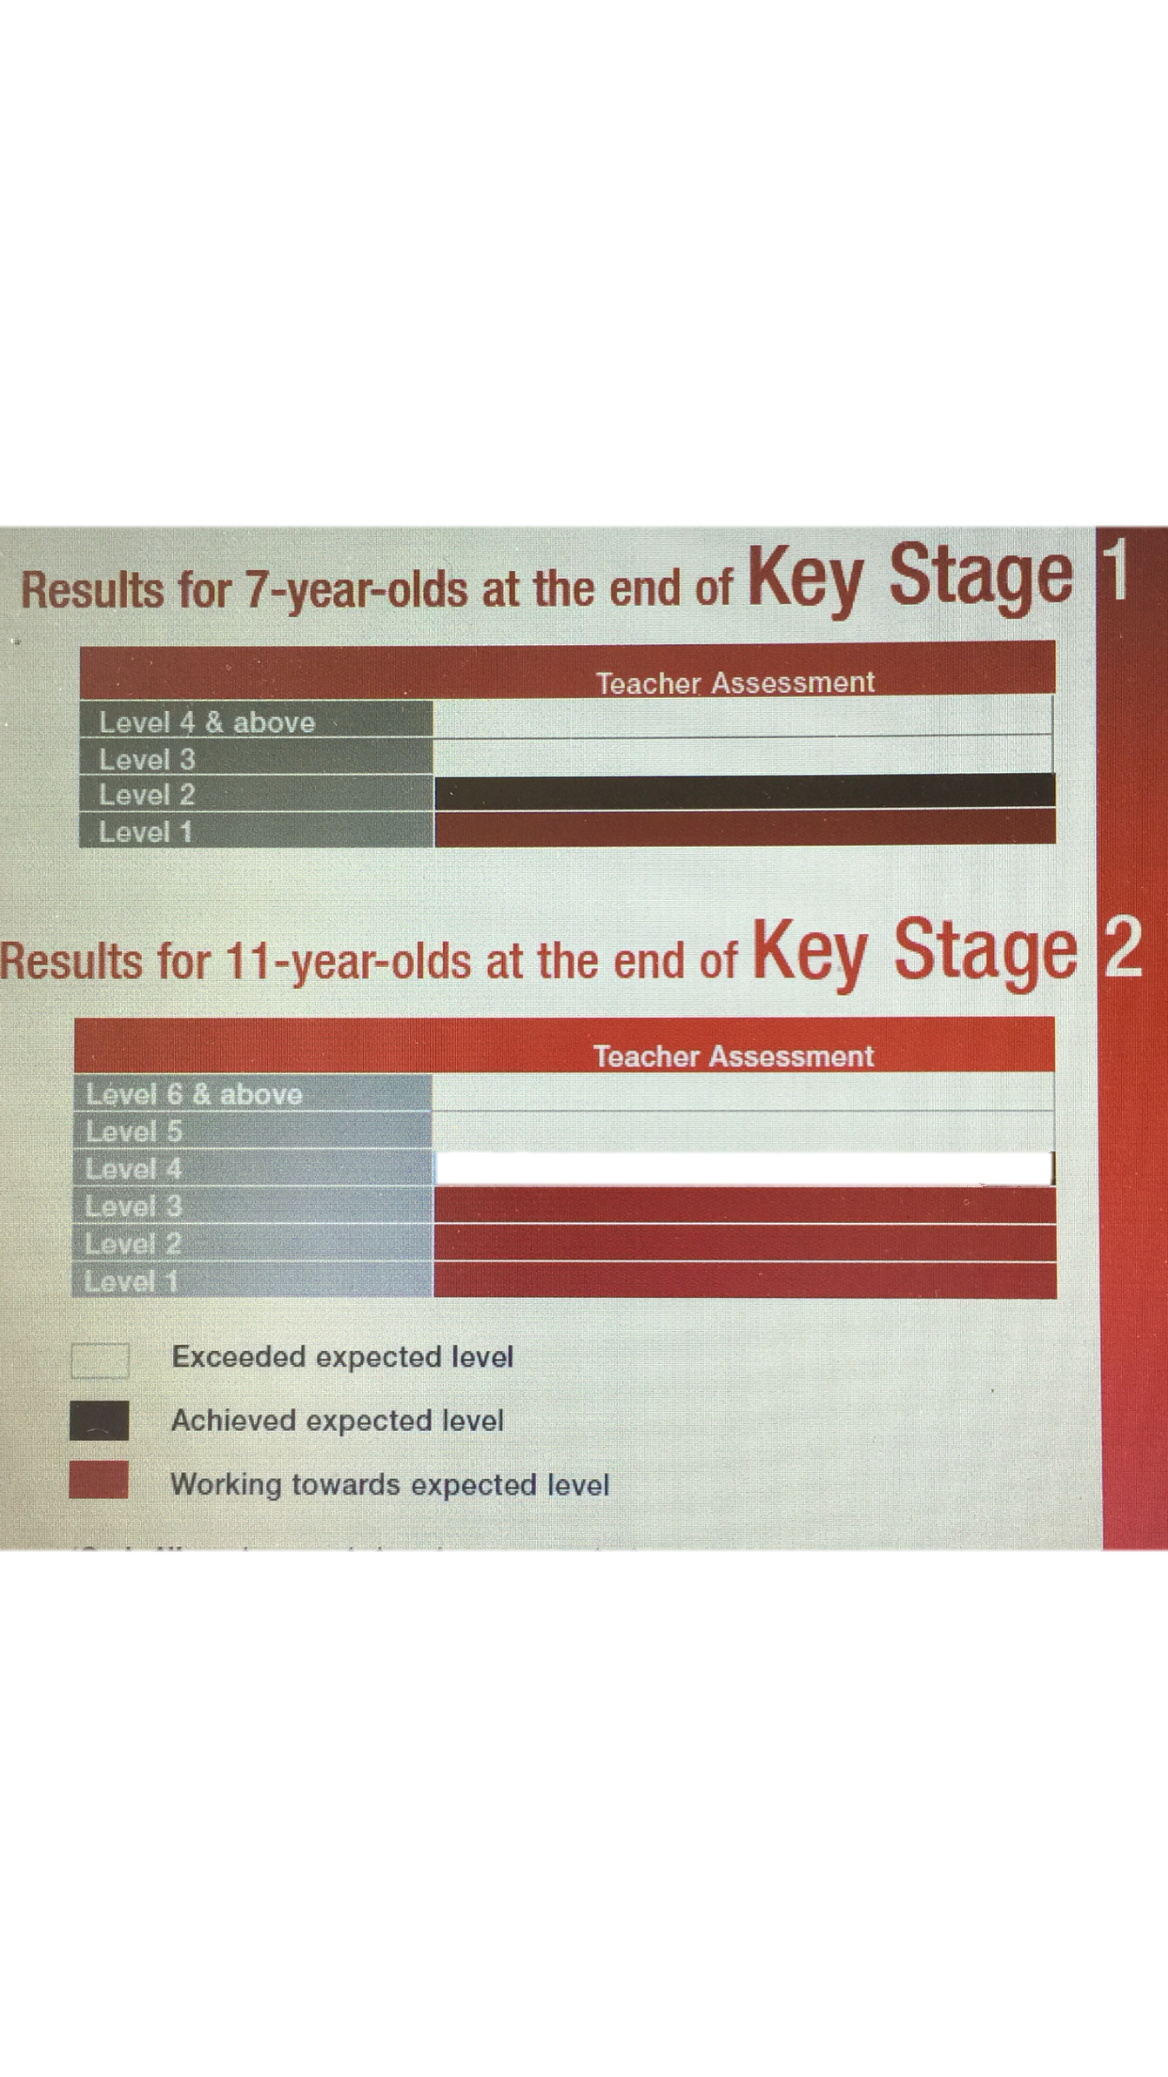

P-MC is working towards the expected level for 11 year olds at the end of KS2 where in English his writing is frequently organised, imaginative, clear and he uses prior knowledge to locate information. In Maths P-MC can mentally solve multiplication and division (Appendix: C-3, 4 and 5) problems by 10 or 100 with and without remainders and use and interpret mathematical symbols and diagrams (Appendix: C-2). In science P-MC can make relevant observations and measure quantities (Appendix: D-1) and he can justify why certain materials are used for specific tasks (WG, (2007).
In addition to Incerts which provides Quantitative Data that is my service settings chief resource to level and assess pupil progress the school also analyses pupil progress through the national Literacy and Numeracy tests. WG (2017) also strengthens the importance of the National Reading and Numeracy tests as they are used by teachers to analytically inform them of pupils’ present strengths in reading and numeracy whilst also highlighting areas to improve further. Fundamentally this chiefly Quantitative Data process is based on understanding steps for improvement whilst veering away from solely school performance hence why they are not included in the set of performance measures for school categorisation. However I have recognised there is a lack of consistency across different service settings where some primary schools are quite firm on effort and outcomes compared with other service settings who are more relaxed on outcomes and more focussed on pupils merely trying their best.
Furthermore WG (2007) states baseline assessment should take place where each child’s language, mathematical and personal skills should be assessed within the first term of starting school. The baseline assessment allows teachers to compare and contrast and importantly identify children’s abilities and requirements and which is shared with parent/careers. Additionally on-going teacher assessment takes place across the whole stages of schools in Wales and across all subjects particularly focusing at KS2 on progress in English (Welsh where first language) Mathematics and Science. Additionally teachers provide homework for a pupil that is then used to assess and gage areas for improvement (WG, (2007). Also my service setting annually get pupils to do an in-house reading test to assess areas for improvement however I have gained limited knowledge on this due to a specific teacher being allocated who withdraws pupils to perform the tests hence my question mark over the validity of the outcomes to improve progress.
Nottingham (2013) advocates the use of the Attitude, Skill and Knowledge (ASK) model that is being used across many sectors including within education. The ASK model is multifaceted tool that importantly incorporates all 3 aspects to identify potential gaps in learning and aid future progress as a result. Educators are advised to recognise the importance to use each of the 3 areas equally to identify gaps in learning and as a result direct curriculum targeted strategies to help reduce potential gaps in learning. Within each of the 3 areas of the ASK model there are specific steps to aid progress further: Attitudes; Curiosity; Desire to succeed; Open-mindedness; Resilience and Self-Regulation, Skill; Intellectual; Social; Communicative and Physical, Knowledge; Facts; Figures; Concepts and Ideas (Nottingham, (2013).
P-MC and the majority of pupils at my service setting are encouraged to use aspects of the ASK model to assess and improve their learning. Within the attitude area the school use a thematic approach to learning where pupils are encouraged to be open-minded and think positively when attempting tasks. Specifically within P4C pupils they build upon attitude further to support the other 2 areas and aid a deeper understanding and appreciation of tasks set. The Sill area of the ASK model is also frequently used in my service setting where specific morning skills sessions and tasks are used in morning to improve pupils reading of Language and reasoning within Mathematics. Lastly my service setting use a range of strategies (Peer, Self marking, annotating work, AFL) to embedded a thematic section of knowledge again to improve pupils’ progress further. All 3 related areas within the ASK model the school I work in breaks down into manageable chunks that as a result scaffolds pupils learning and allows them to reach a deeper level of understanding of a task reaching the Zone of Proximal Development (ZPD) (Russell & Cohn, (2012).
In addition to the use of the ASK model P-MC was supported in the short term to understand steps for improvement in English, Maths and additional subject areas with the aid of appropriately annotated work that was interrelated to the schools marking policy and advocates consistency in strategies across the school to improve pupil attainment by giving instant feedback (Appendix: B-1-5 & C-1-6). Specifically teachers advocate Self-assessment that encourages pupils to reflect honestly on their own work and identify potential areas to improve moving forward in relation to the Learning Objectives and Success Criteria. Ultimately the school aims to provide P-MC and all pupils the providing opportunity to identify if their work is good or is there room for improvement (Appendix: B-1-5 & C-1-6).

The school aim to encourage all pupils through Self-assessment to become reflective and independent learners using a purple pen for self and Peer assessment in addition to any teacher follow up tasks. Additionally all KS2 pupils are encouraged to use the ‘traffic light’ system to indicate how they found the work (Green-Easy, Orange-OK and Red-Hard) represented with an appropriate face or simply colour spot. Strengths of Self-evaluation are that it encourages pupils to be actively involved and reflect on their work and as an indirect result also improve their judgement, however there are some limitations for both Self and Peer assessment chiefly pupils feel underprepared to effectively mark theirs or others work and as a result marks are often inflated. I witnessed this specifically with M-CP where during a Mental Maths task after swapping to peer mark his work with a partner when he had his work returned he attempted to amend his results. Additionally the school encourages staff to use effective Assessment For Learning (AFL) strategies to gage pupils understanding (Formative Assessment) in addition to mini plenaries. Black & Harrison (2003) state AFL is the process of seeking and interpreting evidence within learners by teachers to decide where they go and how best they get there. Particularly I have used the ‘Thumbs’ AFL strategy and after trial and error improved it further by having pupils heads down while assessing themselves as they are year 5 class they are aware of others so this adaption prevents any bias at large. P-MC has a positive attitude and response towards Self, Peer assessment and my ‘Thumbs’ AFL strategy used in the classroom. Furthermore I also used ‘Pegs’ AFL questioning strategy (Similar to lollypop stick questioning) coupled with differentiated questions based from Blooms Taxonomy (Appendix: I-1). I had a range of different coloured pegs with levelled ability questions based on Blooms Taxonomy, P-MC loved this as he enjoys competition and extending over others and which also improved his overall Well-being.

In order to check P-MC Well-being I decided to use the ‘Leuven Well-being and Involvement Scales’ as a tool in which to reflect from and obtain some Quantitative data (Magic Nursery). Well-being is linked to self-confidence, self-esteem and resilience whereas Involvement refers to being engaged in activities and is considered to be a necessary condition for encouraging ZPD. I used the ‘Leuven Well-being and Involvement Scales’ with P-MC during a PSE lesson that included language (Appendix: G-1) and in which prior to the lesson starting P-MC was briefly explained of the scale. On the whole P-MC was highly involved in the lesson due to a high level of well-being (Appendix: F-1). Although P-MC at large is aware of steps to progress occasionally he can veer off task and during a recent Topic PSE task there was evidenced in this when reflecting back using RAG ratings (Appendix: E-1). P-MC had to be reminded about the success criteria as a result on him being distracted by another pupil in the class. However after a little support and guidance P-MC quickly got back on task.

Lastly in order to analyses P-MC further I used another methodology an interview (Appendix: H-1) in which I was less structured with my questioning in order to relax P-MC and in which its strength allowed answers to flow. However a limitation I noticed at the start was due partly to closed questions I was getting less in-depth information about how P-MC understood his learning. As a result I changed and incorporated more open questions which gave me more Qualitative data that synthesised a greater depth of P-MC understanding of where his learning is and importantly steps to move forward.

Next steps

Firstly I would look at using a pedagogical approach specifically looking at language, literacy and numeracy (LLN) for P-MC in order to progress his learning further. Although P-MC evidenced from previous research that he prefers Maths (Numeracy) I would aim to progress him further by breaking down any potential barriers to learning chiefly appreciating his basic needs (Appendix: B-1-5) (Appendix: C-1-6). Additionally I will aim to steadily increase motivation for numeracy and especially language and literacy using the main subject as the key focus and ensuring teaching is appropriately differentiated in order to engage and extend P-MC involvement in which Eldred (2005) also advises. As a result this will reduce the need for additional sessions and the potential for P-MC to go off task. Furthermore I will encourage throughout LLN for P-MC to occasionally where I judge beneficial integrate with the other higher ability Year 5P class in order to progress his development further and this overtime would improve his ability to reach the higher end of Level 3 this year furthermore he enjoys competition so would engage fully. However I will be mindful of potential limitation which could arise as a result of integrating P-MC into a lesson that could be too high for him and subsequently knock his confidence.

Underpinning P-MC progression in all subject areas I would equally concentrate and aim to raise P-MC Well-being and mental health which Professor Graham Donaldson has also highlighted in his recent reform of the welsh curriculum in “Successful Futures” is essential for pupils to progress their learning further (UWTSD, (2013). There are many more demands placed upon children in today’s ever changing technological 21st century and this as a result often this has a negative effect on their Social Emotional Aspects of Learning. The United Nations Children’s Fund (UNICEF) (2007) ranked children from the UK bottom (Average) on a range of well-being measures in comparison with other economical and richer countries (21). Furthermore Merrell and Gueldner (2010) suggest historically Western education from years gone by has focused and encourage more on cognitive ability rather than emotional well-being.
Specifically I will recognise the importance and build upon P-MC Well-being identifying next steps moving forward to fully harness well-being and mental health through cost effective strategies that are inclusive and can be embedded across the school seamlessly for all pupils. One of the AoLE identified by Donaldson is Health and Well-being (UWTSD) in which he suggests pupils should experience aspects of the psychological, emotional, cultural building emotional resilience and that enables all pupils to participate confidently not only in school but also in their communities.

Gallop (2018) suggests Well-being is made up from 5 elements that are interrelated and interdependent: Purpose- Liking what you do; Social- Having supportive relationships; Financial- Managing your economical life; Community- Feeling safe and liking where you live or even making the most and Physical- Having good health and enough energy to fully participate in day to day things also validated by the Welsh Government Well-being of Future Generations Act (2015). In order to improve Core subjects Welsh, English, Mathematics and Science; if a pupil has reached the expected level in each of the core subjects (Welsh OR English); he will have achieved the Core Subject Indicator (CSI). Nerveless Local Authorities and primary schools are starting to realise the importance of Social, Emotional, Learning (SEL) and investing in the many modern programmes that help support raising standards for all pupils.

I would look at introducing the Emotional Literacy Support Assistant (ELSA) model for P-MC and other targeted pupils in the school. ELSA was developed firstly in Southampton progressing to Hampshire by Shelia Burton who was a local education psychologist, simply put it works to help children’s SEL with specific areas to work on and importantly it is usually delivered by Learning Support Assistants (LSAs) who have the opportunity to receive training from educational psychologists on aspects of emotional literacy thus giving them a purpose and also freeing up teaching time. Educational psychologists also support LSA’s by observing usually once every half term ELSAs and furthermore schools may also ask them for additional advice. I will look to utilise the ELSA programme and continue to support professional development for support staff. A case study from Brune Park Community School (2015) strengthens the use of the ELSA strategy to be introduced to P-MC and other targeted pupils in my schools as there was conclusive, positive feedback from all stakeholders about research on ELSA supporting pupils’ wellbeing and improving attainment. However some limitations could be that the LSA’s within the school when equipped with ELSA could not be able to get to large cohorts of pupils due to time however I would push specific LSA’s to be taken off the timetable in order to combat this potential problem and fully harness ELSA.

Additionally I will look at introducing strategies such as: structured brain breaks, check in and check out and talk about groups in order for P-MC and pupils inclusively to build on experiences that will help them understanding skills that will enable them to develop positive and appropriate relationships, deal with the difficult issues and decisions they will face in day to day life. Furthermore I will look to promote P-MC and all pupils’ voice across the service setting in order to understand and aim to meet their needs to improve and progress learners in which P-MC suggests also in his interview (Appendix: H1). WG (2011) states ‘Article 12’ of the UNCRC highlights the right of children and young people to express an opinion and to have that opinion respected when decisions are being made on matters that affects them. I will encourage P-MC to have adequate opportunities to actively participate in decision-making at set times whilst also using an anonymous pot strategy where more honest and open issues can be considered and debated in a respectful manner. Additionally after listening to pupils views we will change if need be the way the school councils are run in order to improve well-being and overall attainment. Specifically we can improve P-MC subject knowledge further with targeted PSE lessons in order to strengthen his and other voice for positive change in the school.

Additional I will introduce a Co-operative learning pedagogical approach that will further improve P-MC progress in learning. DfES (2004) suggests regular productive group work embedded into the learning environment encourages pupils at large to develop a greater understanding of an idea through a collaborative process where ideas are shared resulting in an improvement of social and team working skills. The Guardian (2016) also strengthens Co-operative learning and states that during group work pupils should lead and teachers. Predominantly my service setting works in larger whole class for learning so by introducing smaller working groups this will specifically challenge and motivate P-MC further building on his speaking and listening skills and help him to reflect on other pupils use of non-verbal communication thus deepening learning and reflection further.

Conclusion

I have learnt from this process the importance of recognising and identifying each pupil’s present assessment levels and how schools use a range of tools to give them detailed, robust data in which to study and improve pupil progress further identifying specific and targeted steps. Additionally through this exploratory research process with P-MC I have justified pedagogical strategies that could excel P-MC progress further aiming to move him from Level 3 (Middle) to Level 3 (Top) or even Level 4 (LLN, Well-being, Pupil Voice, ELSA and Co-operative learning). However in order to fully harnesses the potential within P-MC and all pupils to progress further there are many other steps that help underpin my suggested pedagogical strategies. Firstly the child needs to be at the centre of the learning as suggested by Carl Rodgers in his Person-centered Approach Psychology Today (2018) and in which was evidenced within P-MC interview (Appendix: H1).

Additionally all stakeholders including parent/careers should know and be actively involved in steps to help progress and accelerate pupils learning. Schools should endeavour to use a whole school approach to embed more thematic and innovative themes to encourage and excel pupil progression in learning. P-MC loves challenges (Appendix: H1) as is the case with many pupils in the class, so by encouraging and developing a ‘Growth mind-set’ environment in schools where there is more of a focus on process rather than results this again would enhance learning progression (Dweck, (2008). Finally I would encourage schools to use a holistic approach and development alternate opportunities to accelerate learning further that includes outside learning opportunities in which Grigg & Lewis (2016) concur.

References

Grigg, R. & Lewis, H. (2016) A-Z of Learning Outside the Classroom. London: Bloomsbury.
BERA. (2011) “Ethical Guidelines for Educational Research” Available at: http://www.bbk.ac.uk/sshp/research/sshp-ethics-committee-and-procedures/BERA-Ethical-Guidelines-2011.pdf Accessed on 27/05/2018.

Black, P. & Harrison, C. (2003) Assessment For Learning: Putting it into Practice. Maidenhead: Open University Press.
Brookhart, M., S. (2017) How to Use Grading to Improve Learning. Kindle Edition.
Brune Park. (2015) “ELSA Case Study” Available at:
http://www.brunepark.co.uk/dashboardb/wp-content/uploads/2016/06/Case-study-ELSA.pdf Accessed on 25/05/18.
Bukatko, D. (2012) Child Development: A Thematic Approach (6th ed) Belmont (USA): Wadsworth
CEWC. “Philosophy for Children Pathways” Available at: http://www.hubcymru.org.uk/images/user/CEWC%20P4C%20Pathways%20Version%202.1%20-%20English.pdf Accessed on 27/05/2018.

Clark, A. (2017) Listening to Young Children, Expanded (3rd ed): A Guide to Understanding and Using the Mosaic Approach. London: Jessica Kingsley.
Cohen, L., Manion, L. & Morrison, K. (2011) Research Methods In Education, (7th ed). Abingdon: Routledge.
Cornue, J. (2018). Changing the Grade: A Step-by-Step Guide to Grading for Student Growth. Kindle Edition.
DfES. (2004) “Children’s Act” Available at: http://www.legislation.gov.uk/ukpga/2004/31/pdfs/ukpgaen_20040031_en.pdf Accessed on 28/05/18.
Dweck, S., C. (2008) Mindset. New York (USA): Ballantine.
EEF. (2018) “Teacher and Learning Toolkit- SEL” Available at:
https://educationendowmentfoundation.org.uk/pdf/generate/?u=https://educationendowmentfoundation.org.uk/pdf/toolkit/?id=146&t=Teaching%20and%20Learning%20Toolkit&e=146&s= Accessed on 28/05/18.

Eldred, J. (2005) Developing Embedded Literacy, Language and Numeracy: Supporting Achievement (Lifelines) (Lifelines Series). Leicester: National Institute of Adult Continuing Education.
ELSA Network. (2017) “ELSA Network” Available at: https://www.elsanetwork.org/about/the-network/ Accessed on 28/05/18.
EWC. “Code of Professional Conduct and Practice for Registrants with the Education Workforce Council”. Available at: https://www.ewc.wales/site/index.php/en/fitness-to-practise/code-of-professional-conduct-and-practice-pdf/file Accessed on 27/05/2018.
Gallup. (2018) “Methodology” Available at: http://www.gallup.com/175196/gallup-healthways-index-methodology.aspx Accessed on 28/05/18.
GOV.UK. (1998) “Data Protection Act” Available at: http://www.legislation.gov.uk/ukpga/1998/29/contents Accessed on 27/05/2018.
Iteach. (May, 2014) “Promoting and Managing Effective Collaborative Group Work”. Available at: http://www.belb.org.uk/Downloads/i_epd_promoting_and_managing_collaborative_group_work_may14.pdf Accessed on 27/05/2018.
Magic Nursery. “The Leuven scale for Well-being and Involvement” Available at: http://www.magicnursery.co.uk/pdf_documents/LevelsofWellBeing.pdf Accessed on 27/05/2018.
Maslow, H., A. (2013) A Theory of Human Motivation Radford (USA): Wilder.
Simple Psychology. (2007) “Lev Vygogsky” Available at: http://www.simplypsychology.org/vygotsky.html Accessed on 27/05/2018.
Merrell., W., K. and Gueldner., A., B. (2010) Social and Emotional Learning in the Classroom. New York (USA): Guilford.
Morris, I. (2015) Teaching Happiness and Well-being in schools (2nd ed). London: Bloomsbury.
Nottingham, J. (2013) Encouraging Learning. London: David Fulton.
O’Leary, M. (2014) Classroom Observation. Abingdon: Routledge.
Russell, J. & Cohn, R. (2012) Zone of Proximal Development. Idaho (USA): Bookvika.
Psychology Today. (2018) “Carl Rodgers Person-centered Approach “Available at: https://www.psychologytoday.com/us/blog/what-doesnt-kill-us/201503/carl-rogers-person-centered-approach Accessed on 28/05/18.
Simple Psychology. (2007) “Lev Vygogsky” Available at: http://www.simplypsychology.org/vygotsky.html Accessed on 28/05/18.
The Guardian. (2016) “Outdoor learning: teaching students in outside classrooms” Available at: https://www.theguardian.com/teacher-network/zurich-school-competition/teacher-blog/outdoor-learning-ideas Accessed on 28/05/18.
The Guardian. (31/03/2016) “Group work benefits pupils” Available at: https://www.theguardian.com/education/2006/mar/31/schools.uk2 Accessed on 27/05/2018.
UNICEF. (2007) “An overview of Child Well-being in Rich Countries” Available at: https://www.unicef.org/media/files/ChildPovertyReport.pdf Accessed on 28/05/18.
UNICEF. “How we protect children’s rights” Available at: https://www.unicef.org.uk/what-we-do/un-convention-child-rights/ Accessed on 27/05/2018.
UWTSD. (2017-2020) “Research Ethics & Integrity Code of Practice”. Available at: http://www.uwtsd.ac.uk/media/uwtsd-website/content-assets/documents/research/research-ethics-integrity-code-practice.pdf Accessed on 27/05/2018.
UWTSD. (2013) “Successful Futures” Available at: http://www.uwtsd.ac.uk/media/uwtsd-website/content-assets/documents/wcee/successful-futures.pdf Accessed on 27/05/2018.
Wales Online. (November, 2011) “Teaching technology takes another leap with inserts” Available at: https://www.walesonline.co.uk/news/local-news/teaching-technology-takes-another-leap-1797584 Accessed on 27/05/2018.
WG. (2007) “How is your child doing at school?” Available at: http://www.caerphilly.gov.uk/CaerphillyDocs/Schools/How-is-your-child-doing-at-Primary-School.aspx Accessed on 27/05/2018.
WG. (2017) “National Reading and Numeracy Tests” Available at: http://learning.gov.wales/resources/collections/national-reading-and-numeracy-tests?lang=en Accessed on 27/05/2018.
WG. (2015) “Well-being of Future Generations (Wales)” Available at: http://thewaleswewant.co.uk/sites/default/files/Guide%20to%20the%20WFGAct.pdf Accessed on 27/05/2018.
WG. (2011) “Pupil Participation- Good Practice Guide” Available at: file:///C:/Users/S1023-USER/Downloads/GoodPracticeGuide.pdf Accessed on 28/05/2018.
Wragg, C., E. (2012) An Introduction To Classroom Observation (Classic ed) Abingdon: Routledge.

Appendix
A-1
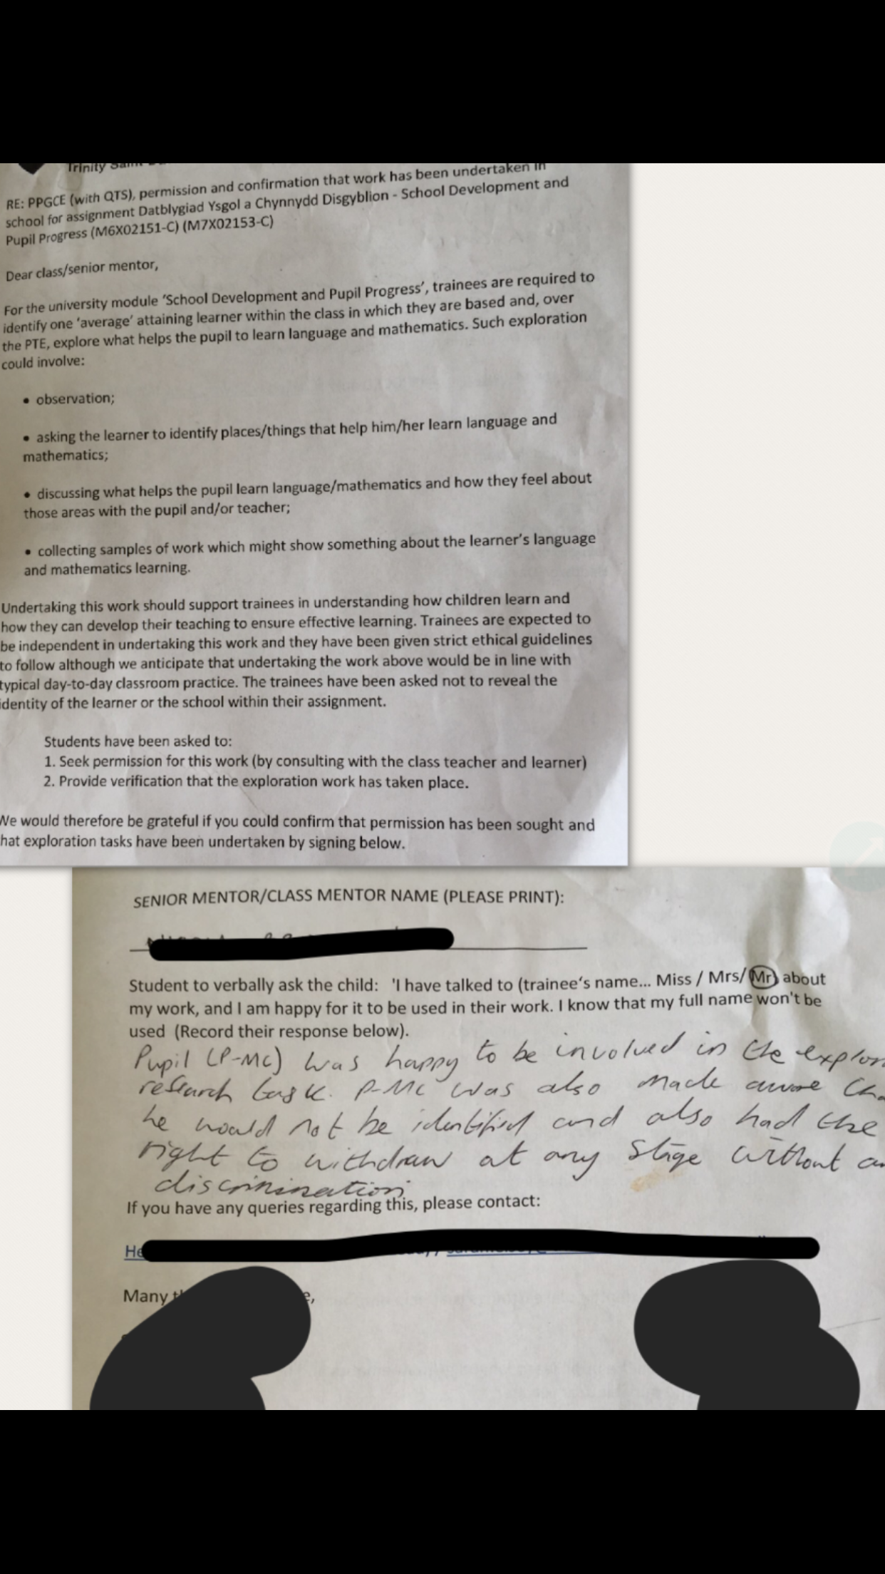

B-1
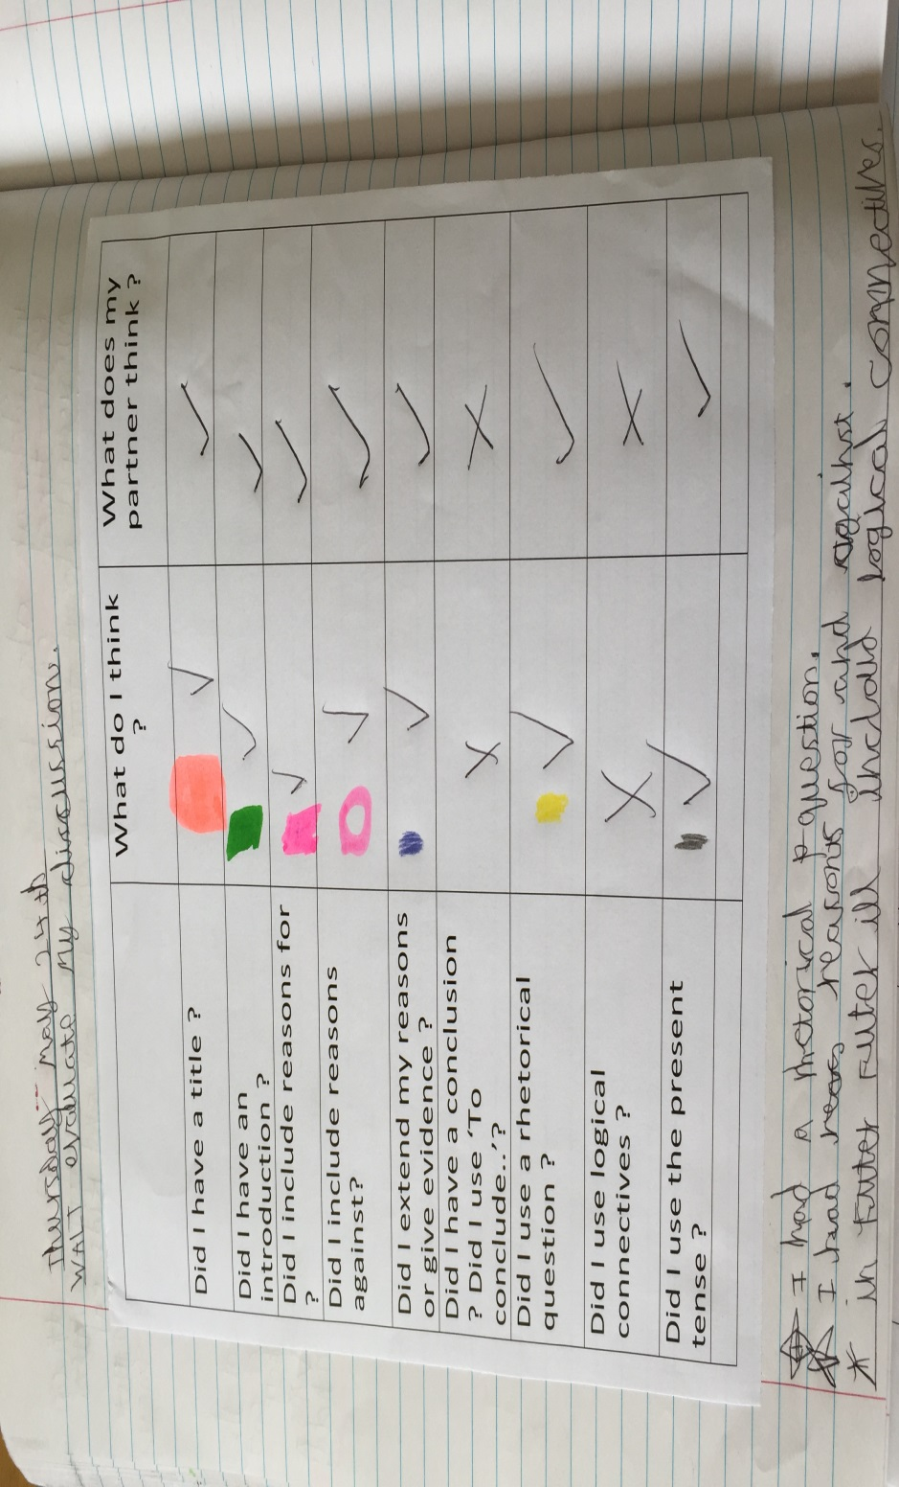
B-2
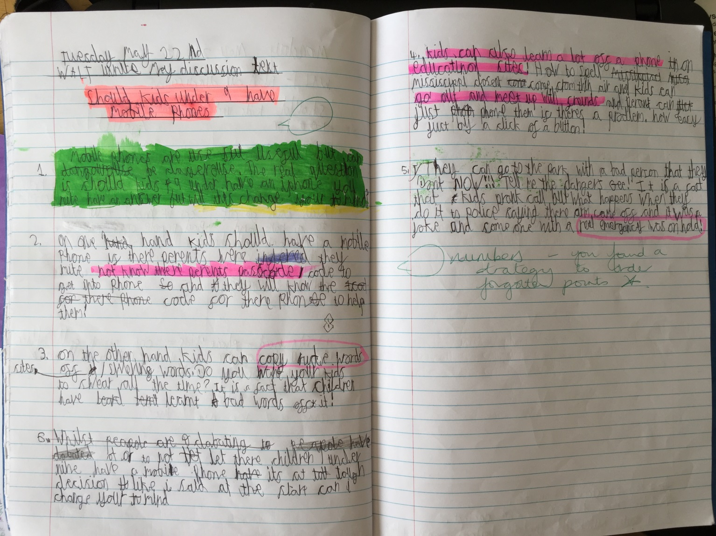
B-3
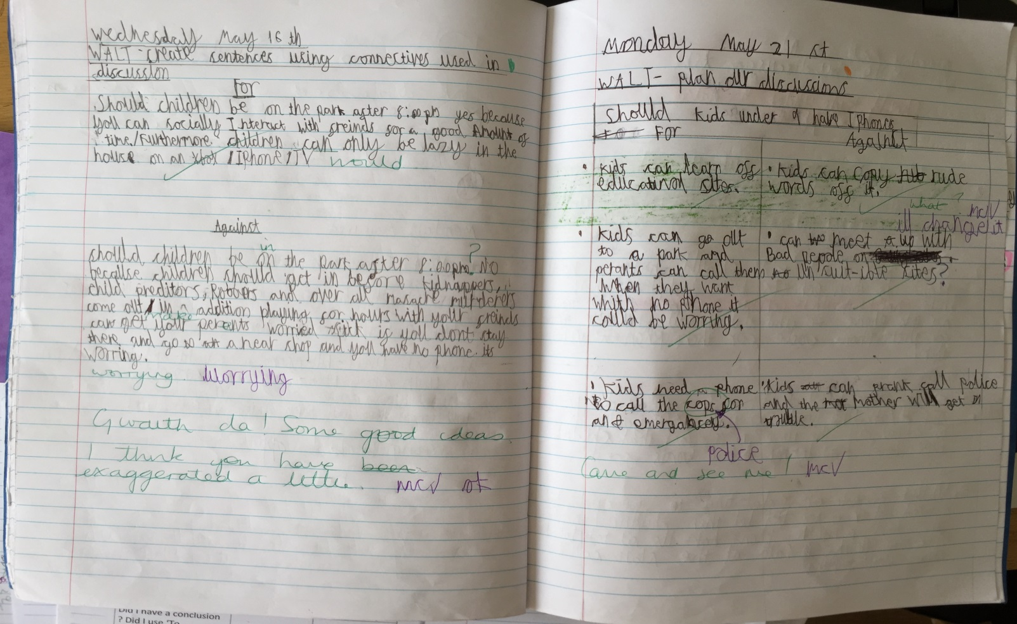
B-4
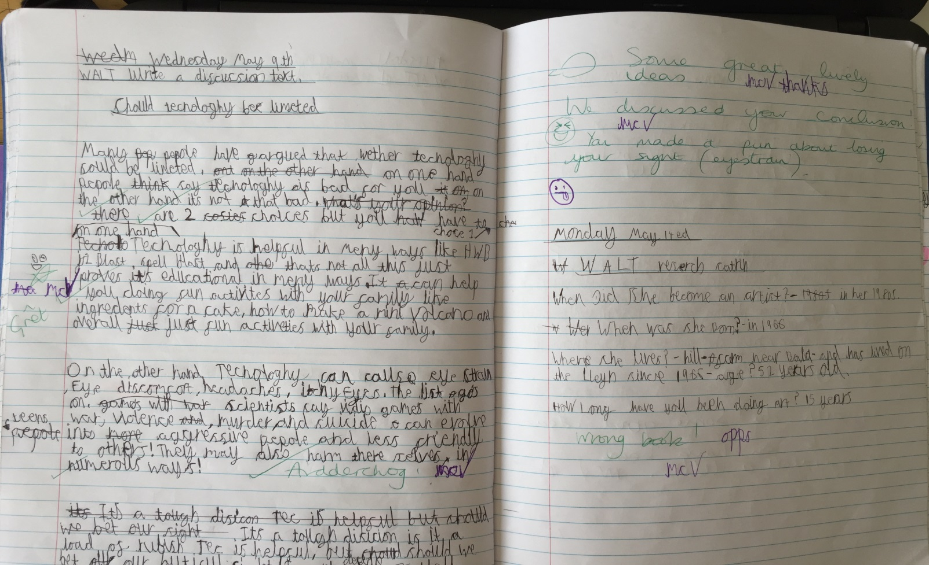

B-5
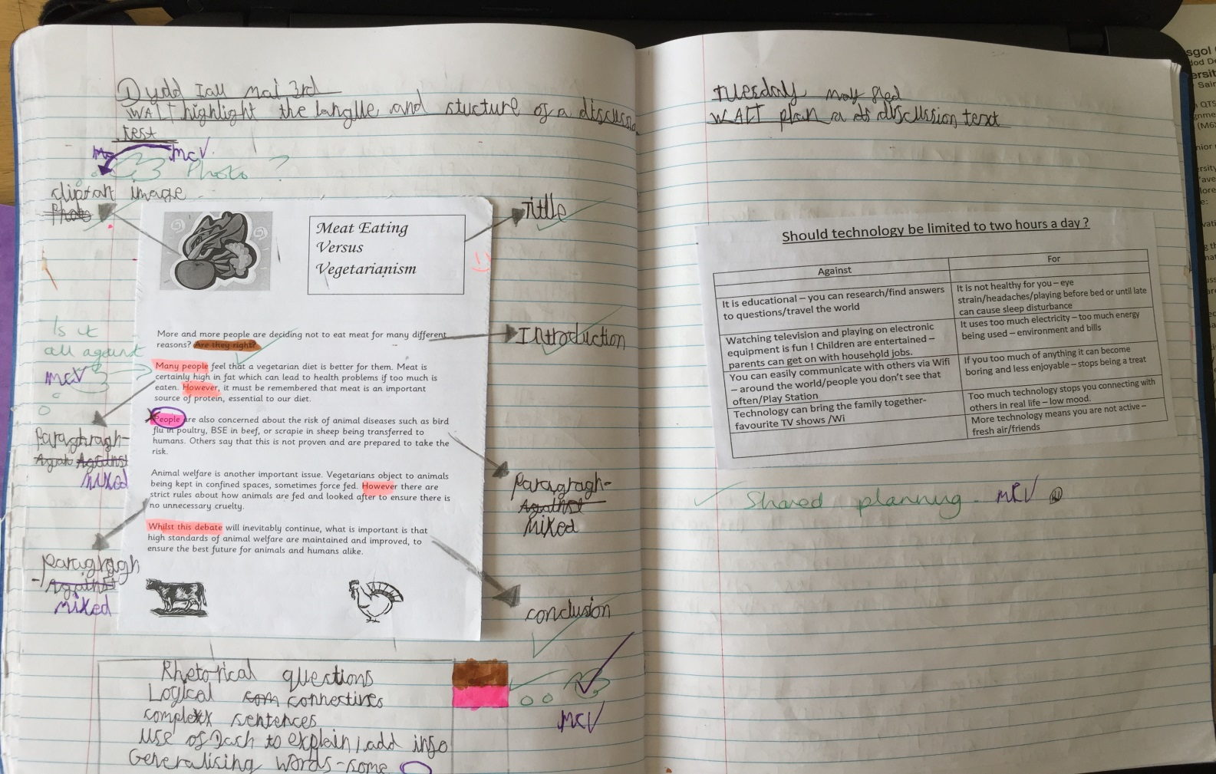
C-1
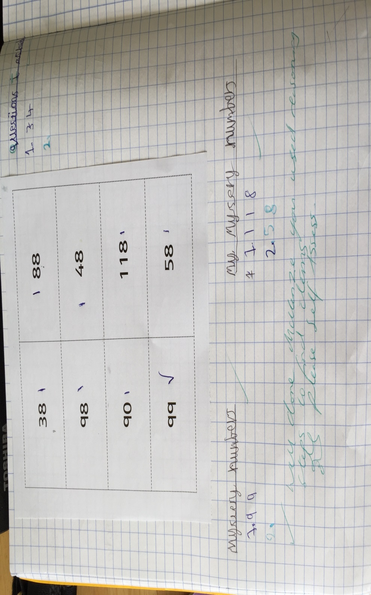

C-2
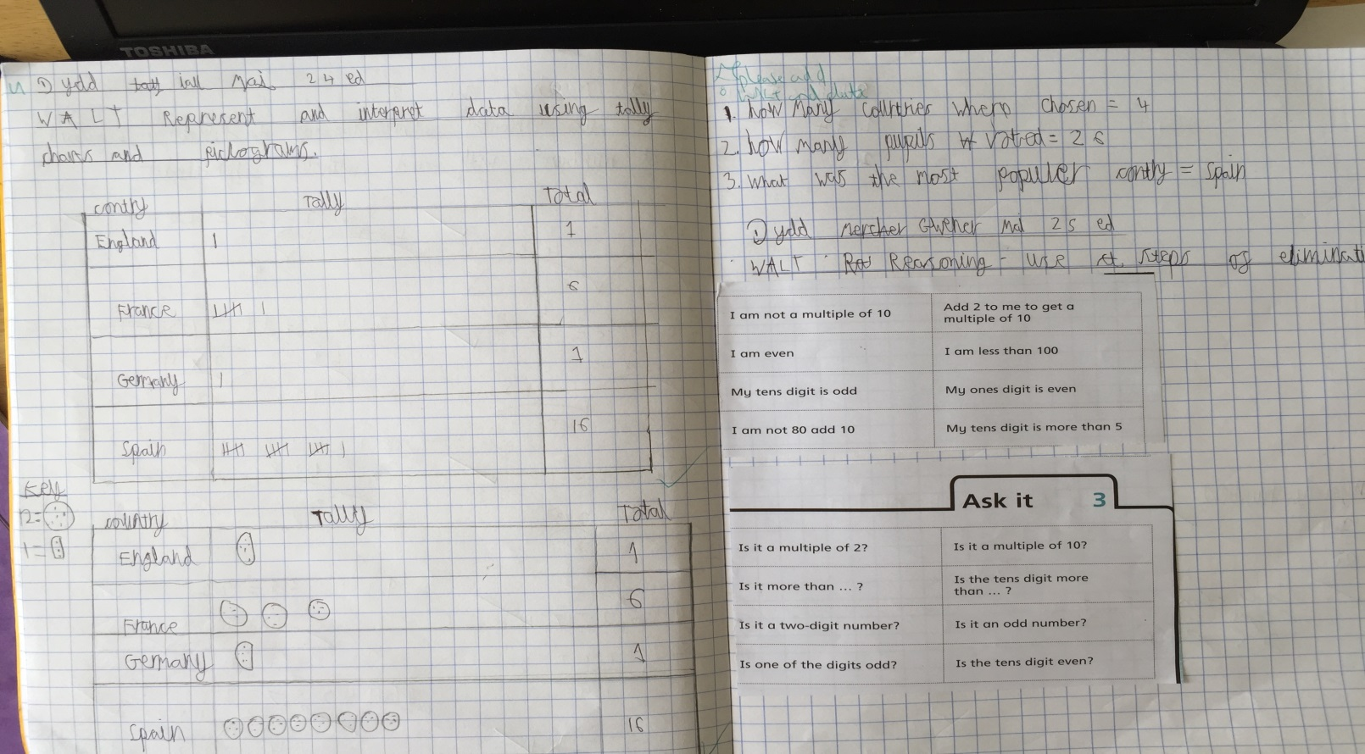
C-3
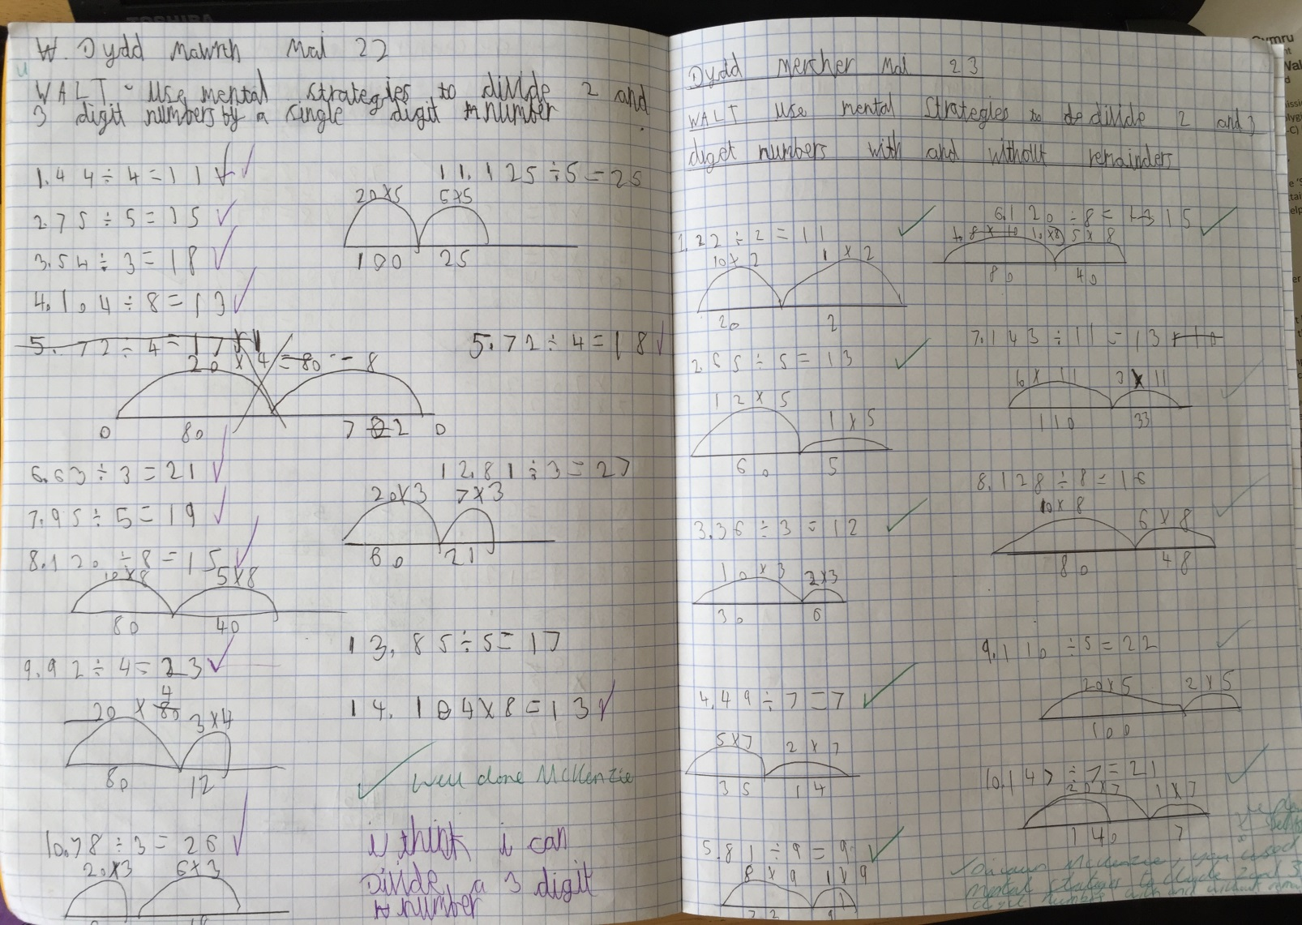

C-4
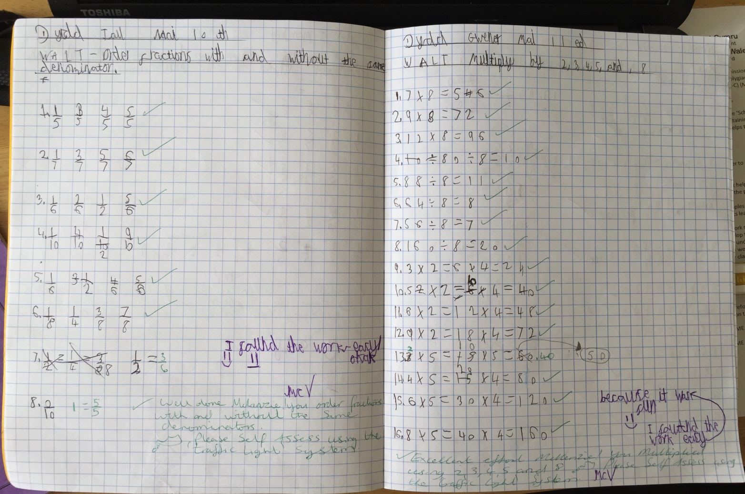
C-5
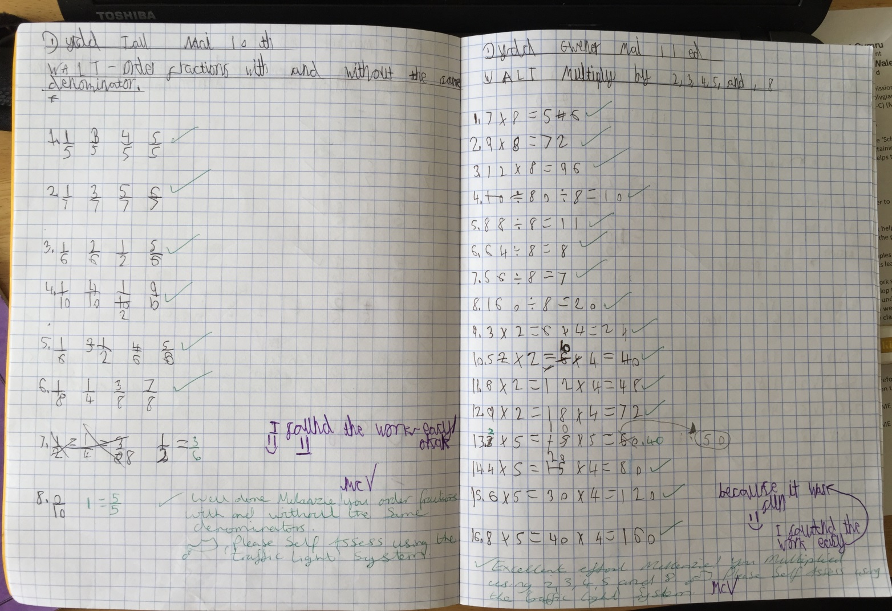
C-6
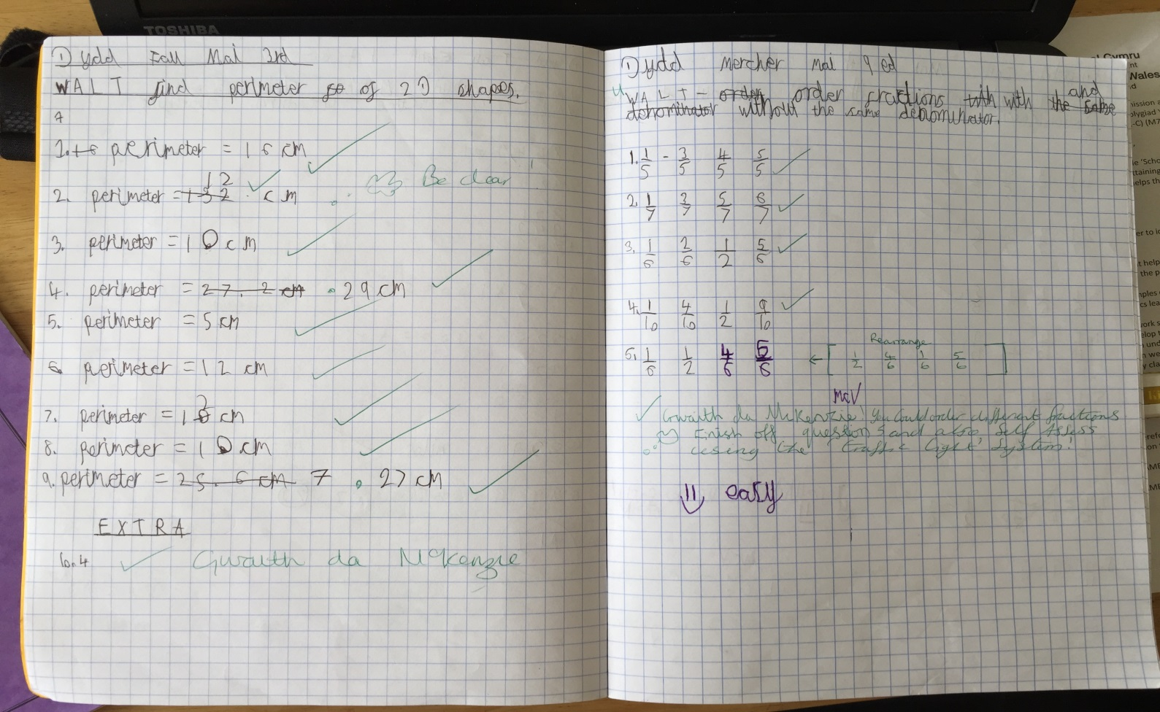
D-1
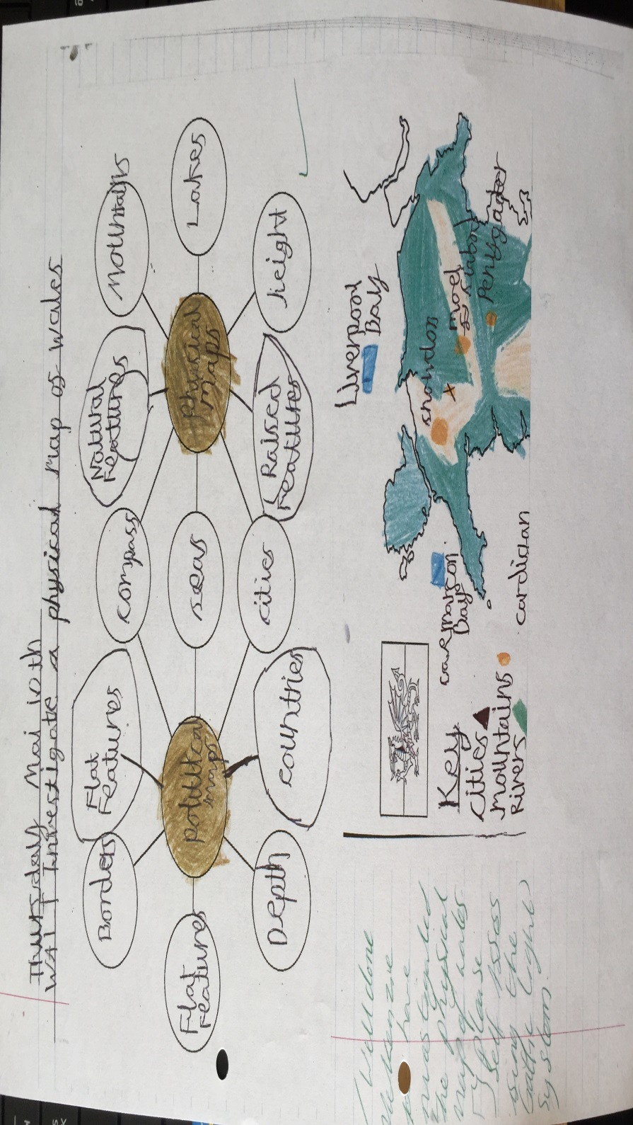

D-2
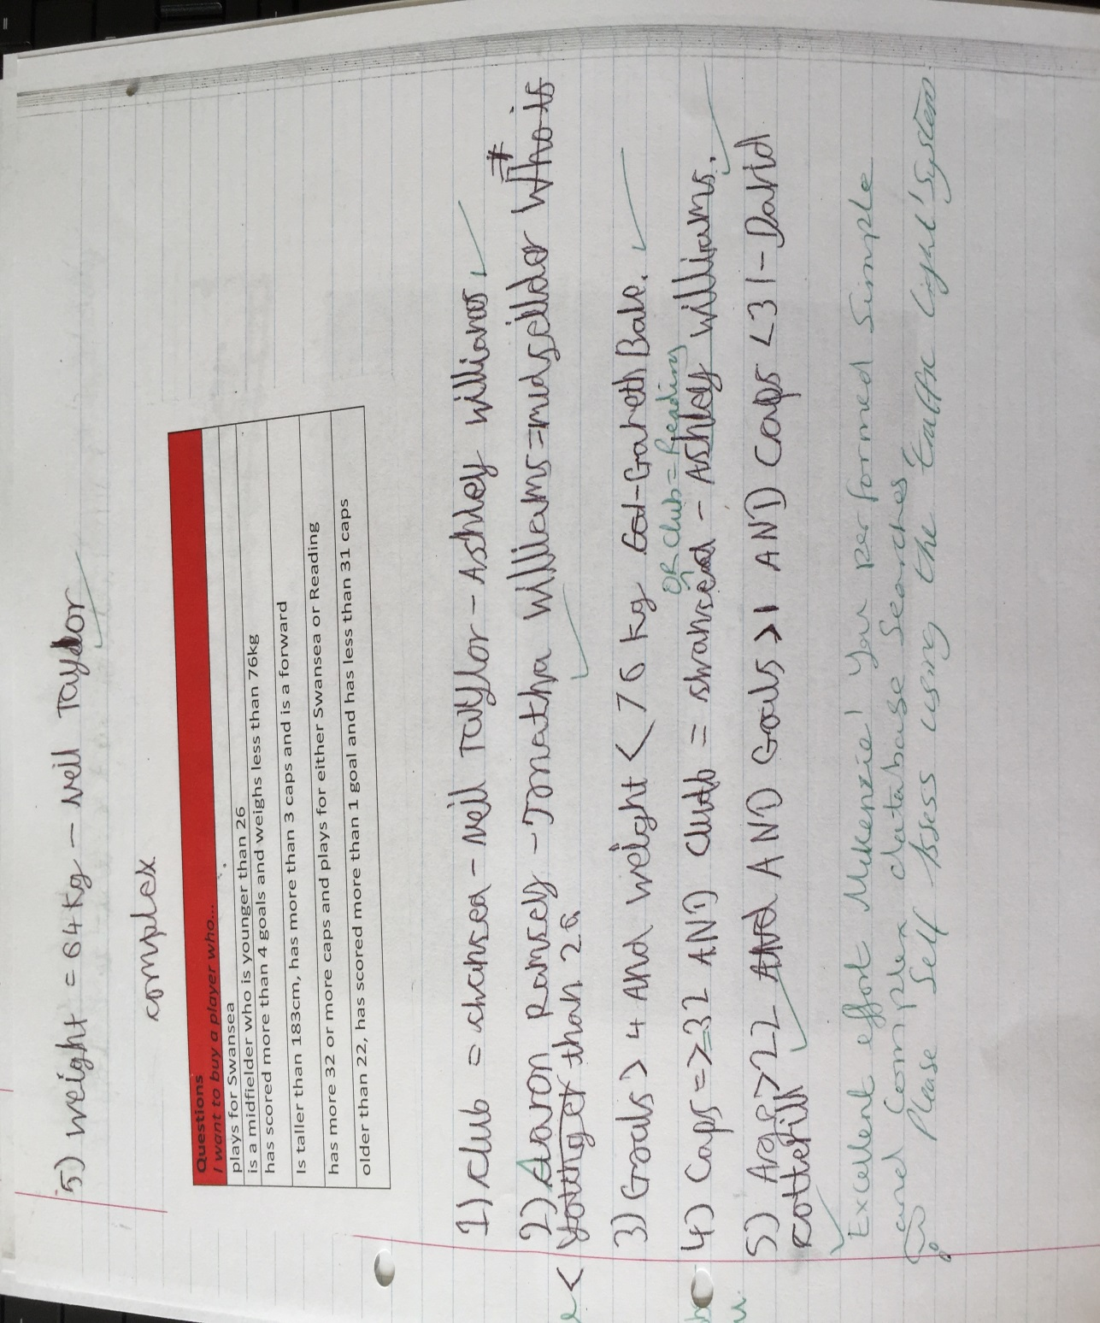
D-3
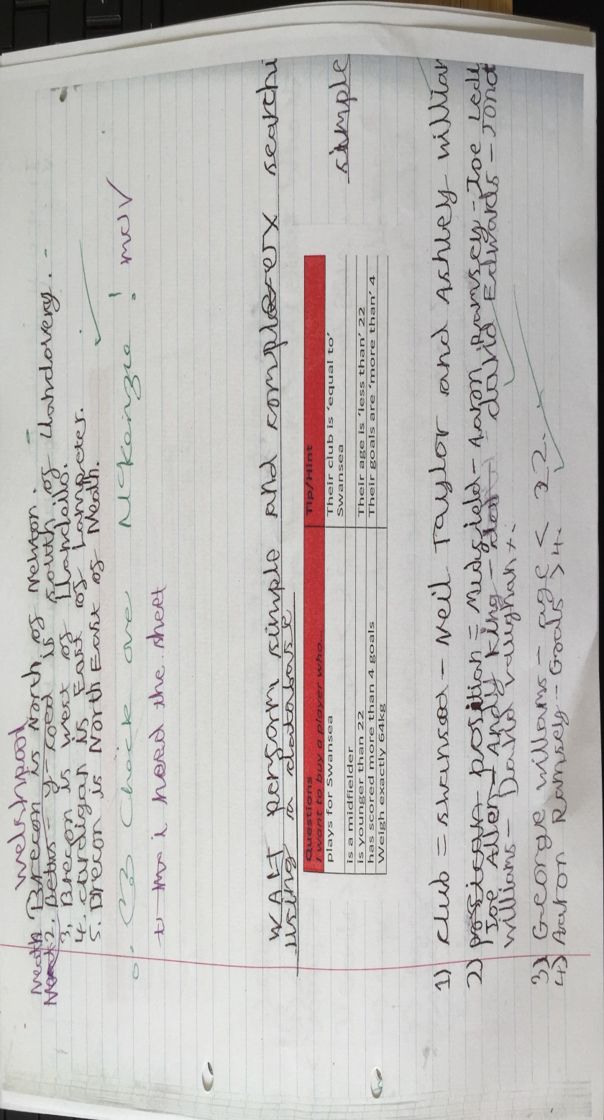
D-4
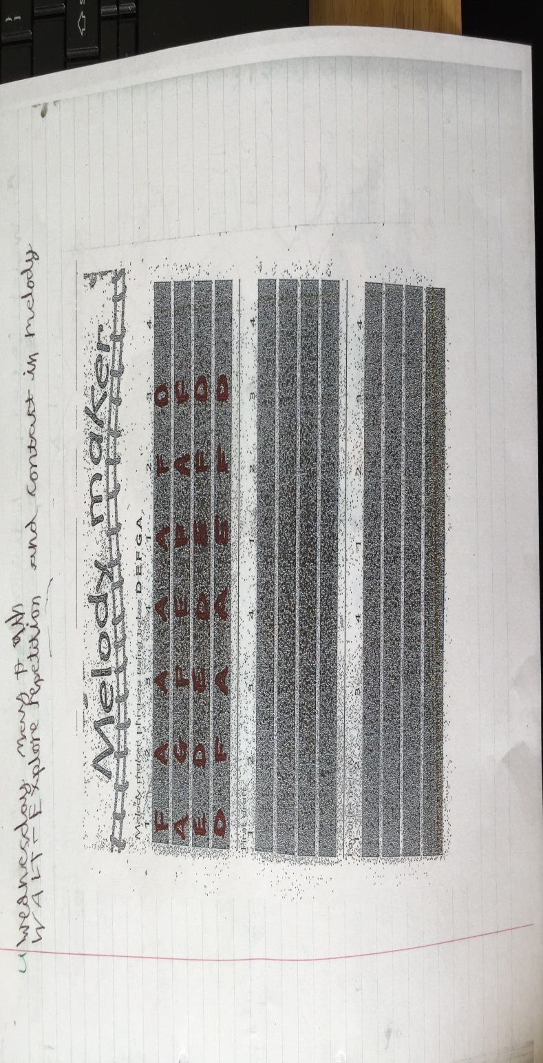
E-1
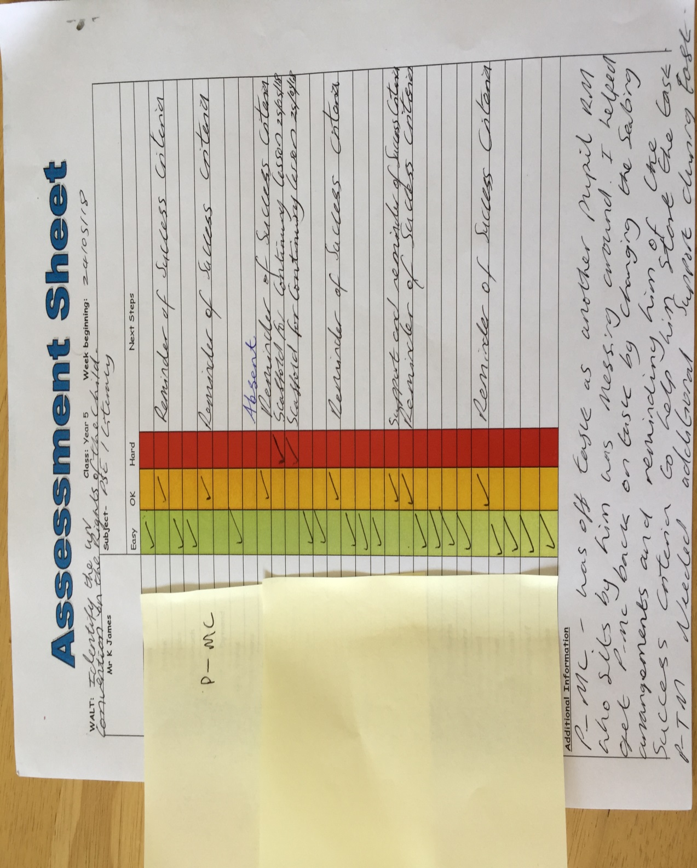

F-1
KJ Observation notes using the Leuven scale (Involvement) with P-MC on an individual Task
Pupil (P) | Scale | Involvement | Observation notes Signals | Lesson/Activity Part
MC | 4 | High | MC volunteered to read the WALT out to the class. When the teacher was talking he was looking at the teacher and responding to the teachers questions. | Introduction
MC | 5 | Extremely high | MC appeared to be on task. He kept his eyes on the whiteboard and happily read allowed in front of the group. He also contributed purposefully to opening discussions. | Task- Reading/Discussions
MC | 3 | Moderate | MC went off task slightly as a result of another pupil messing around. | Research DCF
MC | 4 | High | MC after reminder off the teacher of staying on task started to produce his poster online using the Hwb. | Starting the UNICEF poster
MC | 4 | High | MC listened accordingly to instructions of saving any work in preparation to continue with the task the next day after swimming. | Plenary
MC | 4 | High | Apart from the Research DCF part of the lesson where possibly a little too open instructions allowed MC to slightly veer off task nerveless on the whole MC was highly involved in the lesson. | Overall

KJ Observation notes using the Leuven scale (Well-being) with P-MC on an individual Task
Pupil (P) | Scale | Involvement | Observation notes Signals | Lesson/Activity Part
MC | 4 | High | MC shows clear signs of satisfaction (Body language). However these indicators are not constantly present with the same intensity. | Introduction
MC | 5 | Extremely high | MC appeared happy, cheerful and smiled. He presented as being lively and full of energy with actions spontaneous and expressive. Lastly MC appears relaxed and does not show any signs of stress or tension. | Task- Reading/Discussions
MC | 3 | Moderate | MC presented a more neutral posture and his facial expression and posture showed little emotion. | Research DCF
MC | 4 | High | MC shows clear signs of satisfaction (Body language). However these indicators were not constantly present with the same intensity. | Starting the UNICEF poster
MC | 4 | High | MC shows clear signs of satisfaction (Body language). However these indicators were not constantly present with the same intensity. | Plenary
MC | 4 | High | Apart from the Research DCF part of the lesson where possibly a little too open instructions allowed MC to slightly veer off task and present fewer emotions nerveless on the whole MC evidenced clear signs of satisfaction. | Overall

G-1
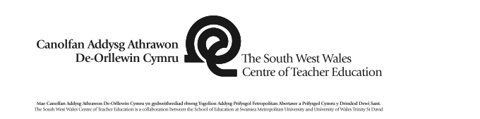 |  |  |  |  | 1B

Session Plan – Key Stage 2
Name of trainee: Kevin James |  | Session ref: PSE- Active Citizenship (24/05/18) 14.20-15.20.
Personal target(s) in relation to QTS:
S2.4 They understand how learners’ physical, intellectual, linguistic, cultural and emotional development can affect their learning.
S2.7 They know a range of strategies to promote good behaviour and establish a purposeful learning environment.
Year group: 5. | No. of learners: 28. |  | ALN: 5 Pupils: AF- GLD/SALT/ASD, TM- SALT/GLD/Paediatrician and Nurture/EBD, CP- GLD/Behavioural, RJ- Sp & L/LD/EBD, LF- ADHD. (Withdrawal cards also available to use if teacher deems fit).
Additional Adults: 0.
Learning objective(s): Identify the UN Convention on the Rights of the Child. |  |  | Success criteria:  - I will follow the PSE guidelines.  - I will listen to and respect others opinions/views.  - I will provide personal input at the appropriate time.  - I will question, respond and if appropriate challenge views of others in a respectful manner.  - I will produce a poster.  - I will turn take with others.
Links to previous learning: The class engage in P4C on a weekly basis so the children are aware of the routine and the expectations involved in the process and the theme/focus every week changes.
Curriculum coverage (range, skills)
Personal and Social Education- Active Citizenship – value diversity and recognise the importance of equality of opportunity, their rights, e.g. the UN Convention on the Rights of the Child, and responsibilities, how injustice and inequality affect people’s lives, the features and physical and emotional benefits of a healthy lifestyle, e.g. food and fitness.
ESDGC- Choices and Decisions, Identity and Culture.
Literacy(LNF)  Developing and presenting information and ideas – organise talk so that different audiences can follow what is being said, e.g. giving background information, providing a brief summary and including main points.  Developing and presenting information and ideas – adapt talk showing an understanding of the differences between informal talk with friends and more extended talk with a wider group. |  | Numeracy (LNF)  N/A
DCF  Finding and developing information and ideas.  Creating and presenting information and ideas about refugees and their lifestyles. | Thinking  Critical thinking-Independent thinking and sustained shared thinking. Entrepreneurial thinking- Thinking about cause and effect and making inferences. Considering evidence, information and ideas. Forming opinions and making decisions about refugees and their lifestyles. | ESDGC  Choices and decisions- Question statements and opinions and look for evidence and to understand that environment can be affected by the decisions we make individually and collectively.  Identity and Culture- recognise the impact of discrimination and prejudice on individuals and groups, we all have similarities and differences. |  | YCC  Incidental Welsh throughout (Edrychwch-Look, Da-Good, Da iawn-Very Good, Esiteddwch-Sit, Grandewch-Listen, Dewch I mewn- Enter, Bore da-Good morning, Cofiwch-Remember, Dim siarad- No talking, dwi yn mynd i gymryd y gofrestr- i am going to take the register, Dylio I fyny- put your hand up, Bachgen dda- Good Boy, Merched da- Good Girl.
Key vocabulary(English/Welsh): Gender, Refugee, challenges, pain, options, fear,, Feelings, Turn taking, Respect, Appropriate noise level, Collaboration, Discussion, Debate, Agree, Pressure, Stereotype, Disagree.

Time | Session activities, organisation and management | Key questions & Assessment for Learning opportunities
20m
20m | ~Work On- Moving forward I will plan ahead more effectively considering finer detail. (See ARC 23/05/18).  Introduction  Explain the learning objective (WALT) getting children from the class to read it out. Explain what the session will be about and explain expectations and behaviour strategies (Dojos).  Unicef uk day for change 2018 (Aim to help every child in danger across the world)  United Nations International Children's Emergency Fund, special program of the United Nations (UN) devoted to aiding national efforts to improve the health, nutrition, education, and general welfare of children.  YouTube clip on Refugees.  Research what refuges are?  Read story about |  | Is everyone aware of what is going to happen in today’s session?
20m |  |  | AFL  Heads on Desk- Thumbs up/Thumbs Half Way/Thumbs Down- Used throughout for children’s understanding of activity.  Who are UNCIEF?  Dojos awarded for effort and using thinking skills.  Mini Plenary (On-going)  Questioning on equality.  Encourage thinking time (Pose, Pose, Pounce, Bounce).  Critical Thinking- Reasoning-Evaluating-Analysing-Problem Solving-Decision Making.  AFL  Thumbs up/Thumbs Half Way/Thumbs Down- Used throughout for children’s understanding of activity.  Think, Pair, Share- Used throughout for children’s understanding of activity.  Looking at all sides of the debate- Proposition, Opposition.  On-going praise good behaviours – Dojo points.  Would anyone like to add anything?  Did you enjoy today’s session today?  What would you like to do in next week’s session?
40m | Main activities
40m | Design a poster that raises awareness of every Childs need for nutritious food and that celebrates child’s right to the best possible health.  Article 24 United Nations convention on the rights of the child states every child has the right to the best possible health and nutritious food.  Differentiation  HA- Picture, Colour, Title, Persuasive Sentences.  HA- Picture, Colour, Title.  LA and ALN - Picture, Colour, Title and support from TA.  Plenary  *Final Thoughts on children’s rights and refer to refugees.  Equipment: Ipads, Chrome books, Pens, whiteboards, paper.

H-1
Interview Questions
- Did you enjoy today’s lesson?
P-MC: Yes.

- What was the most enjoyable part of the lesson?
P-MC: Being in charge of our own learning.

- Did you like working in pair’s collaborative working?
P-MC: Yes.

- Why did you like it?
P-MC: It allows me to subtly get support if needed without making it obvious to the whole class.

- Are there good things about working independently?
PMC- Not allot however if you have a set task you could get work done quicker.

- What helped you engage with the lesson, if you did?
P-MC: Clear instructions and the faith of the teacher allowing pupils to be in charge of their own learning in how we set out our UNICEF posters.

- Does it make a difference if the work is fun and practical?
P-MC: Yes, because it is more interactive.

- If you had to do this lesson again, how could the teacher improve it?
P-MC: I would listen to other pupils’ ideas on my table.

- What is your favourite subject area?
P-MC: Maths because although it’s hard it is also fun and in particular I enjoy being in charge of my learning and solving equations. I do also enjoy English (Language) particularly when the teacher allows us to be creative with a story.

- How important is Wellbeing and Involvement to you across all subjects?
P-MC: Wellbeing and Involvement is extremely important the teacher respects our views and gives us trust in being in charge of our own learning often this makes me feel great and keeps me actively involved.

I-1


