Name | Student Number | Date | Lecturer’s Name | Your score
Orlando Brown | 2439406 | 30/06/2025 | ER | To be filled by the marker  ___/40
You will have 90 minutes to complete this assessment. It is divided into three sections: note-taking, paraphrasing and writing a paragraph.
---------------------------------------------------------------------------------------------------------------------
1. Take diagrammatic notes from the passage below using the space provided:

The university experience is not just about subject knowledge, but also about developing skills that will equip you for your future life. For starters, it's impossible to graduate without a range of people skills under your belt. You'll meet new people from different backgrounds. You'll also interact with lecturers, tutors and university staff almost daily. Another life lesson that university teaches you is taking responsibility for yourself, your own schedule and learning. A lot of university study is self-directed - it's up to you to plan and organise your work, juggle multiple projects and manage deadlines – you will need to develop self-motivation if you want to succeed. Let’s not forget learning how to overcome obstacles; whether academic, work-related or personal, you'll face your fair share of hurdles as a student, but you will develop resourcefulness and resilience in the process. If you were a bit unorganised before you went to university, you won't be by the time you leave. To successfully navigate student life you'll need to handle a variety of study, work, social and personal commitments and the only way to do this is with organisation and time management. Finally, university provides plenty of opportunities to work on and boost your confidence: you'll work in groups, deliver presentations, complete assessments and maybe even become a class representative.
Adapted from: https://www.prospects.ac.uk/applying-for-university/university-life/7-life-skills-youll-learn-at-university

Space for your notes (max 12 marks):
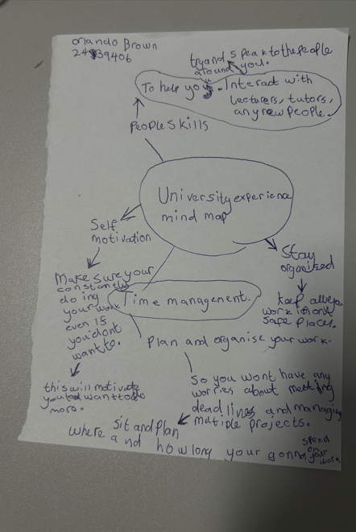

2. Paraphrase the following sentences (max 3 marks for each, max 12 marks in total):

a) To successfully navigate student life you will need to handle a variety commitments.

Juggling Multiple Commitments Will Help You Achieve and Steer to a successful Student life.

b) You will need to develop self-motivation if you want to succeed at university.

You Will Require Self-Motivation To successfully navigate at university.

c) Many students find it challenging to manage stress during assessment periods.

Numerous students find it tough to manage stress during assessment periods.

d) Frequent reading can help you become a more effective communicator.

Constant reading can help you become a more crucial communicator.

3. Write a well-structured paragraph (8 sentences) on the following topic:

Effective time management techniques for university students

Your paragraph must be written in full sentences (no bullet points) and in an academic style.

(max 16 marks in total)

Staying Organised Can help with your time management effectively.
Planning and organising your work frequently can help you have less stress and help you meet your deadlines.
Taking A couple hours out of your day can help you successfully learn more About your topic.
Working on your projects over a period can help you manage your time better.
Keeping your work in a safe and quick place to get to can help with your time management.
Self-motivation is a requirement for good time management as it will push you too keep going.
Note taking is crucial when it comes to time management.
Mind mapping ideas on your work can have a positive impact on your time management.

