ParcelCare Senior Management Report: How to attract, recruit and retain staff
- Strategic positioning in a competitive labour market (AC1.1)
In today’s highly competitive labour market, ParcelCare must adopt strategic and evidence-based approaches to attract and retain top talent. This requires a multidimensional strategy aligned with our organisational objectives, which uses our core strengths while also responding to the evolving expectations of the workforce, including changing demographics and career-switchers (CIPD, 2024a; Isherwood, 2025).
A key strategy component is the development of a compelling and authentic employer brand. It must communicate our core values, achievements and inclusive organisational culture. This brand should highlight employee well-being, flexibility and positive workplace experiences. Competitor analysis provides critical insights. 70% of jobseekers thoroughly research potential employers and seek alignment with their values before applying (Farrand, 2018). A strong employer brand can lead to a 28% reduction in staff turnover, a 50% increase in suitable applicants and significantly reduced recruitment costs (Samoliuk et al, 2022). Despite these advantages, only 12% of organisations currently evaluate the effectiveness of their employer branding initiatives (CIPD, 2022a).
Our Employer Value Proposition (EVP) must be distinctive and credible, offering clear value through benefits, opportunities, and meaningful work. Inauthentic EVPs risk short-term attrition, as unmet expectations can drive new hires to exit prematurely (Jacobs, 2021).
Competitive, transparent remuneration is vital. This extends beyond salary to include flexible work arrangements, wellness initiatives, performance incentives, opportunities for growth and additional leave entitlements. Contemporary candidates increasingly prioritise work-life balance, autonomy, and employability over traditional job security. Regular benchmarking against industry standards and local labour markets ensures ParcelCare’s offerings remain attractive and relevant (Zheltoukhova and Baczor, 2016).
Talent attraction should be supported by agile talent management practices. This includes proactive workforce planning, upskilling initiatives, and collaboration with external partners including universities, colleges, and specialist driver training providers. These partnerships enhance our visibility among emerging talent and provide early access to qualified candidates (CIPD, 2023a).
An integrated approach that positions ParcelCare as an employer of choice will not only improve recruitment outcomes but also enhance employee engagement and retention (Wilkinson and Taylor, 2022). Current staff are our most credible ambassadors who can strengthen our employer brand through positive testimonials and referrals (Burt, 2017). Furthermore, incorporating DEI and corporate social responsibility into our brand narrative enhances engagement and organisational appeal.
Figure 1: Conceptual Model: Impact of CSR (Hosseini 2021,p.104)

Building a robust employer brand and EVP requires strong leadership and cross-functional coordination. While complex, once embedded, these initiatives generate a self-sustaining cycle of attraction, development, and retention. Ultimately enhancing ParcelCare’s competitiveness and reputation in the market.
Figure 2: Integrated Brand Model (Mosley 2014,p.41)

Employees with positive workplace experiences are more productive, more likely to refer others, and contribute to a reputation that attracts both talent and customers seeking stable and values-driven partnerships therefore better strategically position ParcelCare (Anderson, 2024).

- Changing labour market conditions (AC1.2)
Resourcing strategies are increasingly shaped by rapidly evolving labour market dynamics. Tight labour markets restrict talent supply, increase costs, and will need more strategically aligned resourcing. Loose markets increase talent pools, enabling more cost-effective, flexible workforce strategies. Key PESTLE drivers include labour supply and demand, changing employee expectations, evolving skills requirements, and a more complex regulatory environment (Wilkinson and Taylor, 2022). 60% of employers report increased employment legislation as a major concern (Jephcott, 2025). All these factors directly influence organisations’ ability to attract, retain, and effectively deploy talent, with 70% reporting increased competition for qualified candidates (CIPD, 2022a).
Demographic changes, including an ageing population and declining numbers of younger and migrant workers, have increased labour market pressures. Increased flexible and remote working further requires agile resourcing frameworks that align workforce capabilities with operational needs (Wilkinson and Taylor, 2022; Peters, 2023a). Increased female labour market participation, now reaching 16.49 million, is also reshaping workforce planning (Farnham, 2015; Francis-Devine and Powell, 2025).
Economic and political uncertainties including global trade disruptions, inflation and UK increased national insurance have further complicated hiring leading to a slow down (Bon, 2025). There are 9.23 million economically inactive working-age adults. The UK remains the only G7 country where this rate has risen since 2019. Targeted strategies to support the re-entry of inactive populations, supported by robust DEI policies can offer competitive advantage. While the disability employment gap narrowed by 5% from 2014 to 2025, only 54% of disabled individuals are employed compared to 81.9% of non-disabled people, though the growth rate among disabled people is accelerating (Francis-Devine and Powell, 2025).
Legislative changes under different governments reinforces the importance of agile, evidence-based resourcing strategies (Bevan, 2023). Using multiple data sources, including CIPD, ONS and the Bank of England, mitigates recent concerns over data reliability due to declining survey response rates (Francis-Devine and Powell, 2025).
Technology is also redefining roles, with over half of organisations identifying automation is changing roles and widening skills gaps (Jephcott, 2025). However, only 19% of employees feel equipped to address these challenges, with 37% of employers reporting difficulty in filling vacancies, (CIPD, 2024b; Hudson, 2022).
Evolving attitudes toward work-life balance, geographic mobility and hybrid work are reshaping resourcing strategies (CMA, 2024). Global sustainability goals and net-zero targets will influence employer branding and cost structures in our sector (Peters, 2023b).
All these emerging trends highlight the critical role of skill-based hiring, internal development, and learning investment in strategic resourcing (CIPD, 2022a; Carriedo, 2020). Ignoring external PESTLE factors, risks poor recruitment and turnover. Utilising data from various credible sources enables cohesive strategies for ParcelCare’s recruitment, retention, and growth, ensuring successful resourcing in the everchanging labour market (Cockett, 2025; Taylor, 2014).

- Workforce Planning (AC2.1)
Workforce planning (WP) is a comprehensive strategic process enabling ParcelCare to assess both current and future labour demands. Aligning workforce supply with business objectives, this process facilitates improved operational efficiency, resilience, and long-term competitiveness through human resources (IOD, 2024). An integrated approach that engages all departments and considers external influences enhances ParcelCare’s capacity to respond effectively to evolving business and environmental conditions.
Figure 3: Workforce Planning: Processes and external content (Robinson and Hirsh 2008,p.3)
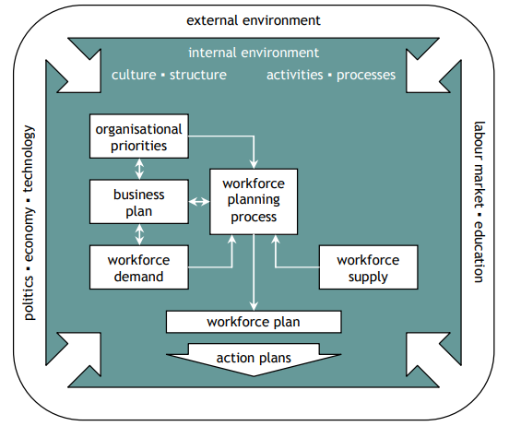
WP benefits include the optimisation of recruitment, development, and deployment practices. Therefore, reducing inefficiencies of overstaffing, premature terminations, talent underutilisation and urgent last-minute hiring. These improvements are achieved through systematic gap analysis, which supports more strategic forward forecasting (Link, 2025). Identifying critical roles ensures the retention of essential talent, sustained productivity, enhanced job quality, good work, reduced turnover and secures consistent service delivery. Timely responses to market-shifts, technological change, and political or legislative developments strengthens organisational agility (Ghoshal, 2022).
WP improves risk management by proactively identifying and preparing for potential scenarios and disruptions (Young, 2024). 90% of leaders anticipate that up to half of their workforce will require reskilling within five years (Brown, 2024). WP enables a unified organisational vision through cross-departmental collaboration, promoting mutual understanding and shared accountability. This inclusive approach strengthens talent pipelines, supports succession planning, boosts morale, and improves employee retention. It also cultivates leadership capability, strategic thinking, and improved organisational design through data-driven, evidence-based decision-making (Hayden, 2024). ParcelCare will be better equipped to allocate the right skills and personnel in the appropriate structure, location, and timeframe, with full awareness of associated risks.
Figure 4: Seven ‘rights’ of workforce planning (CIPD 2024c)
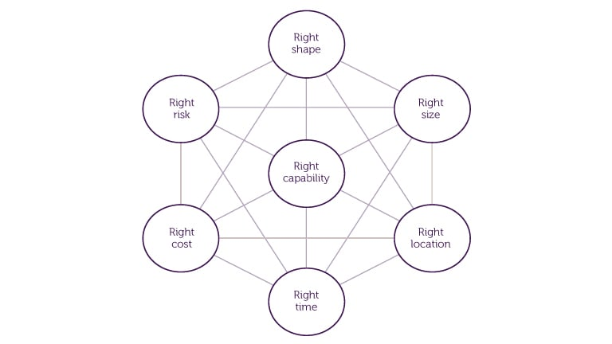
Establishing a workforce baseline, evaluating current capabilities, and formulating long-term plans also provide opportunities to embed DEI and employee well-being into strategic priorities. By identifying marginalised groups and implementing targeted interventions, ParcelCare can address disparities and create a more inclusive workforce (Sparkman, 2018; CIPD, 2025a).
Despite its advantages, WP remains underutilised, with only 30% of organisations effectively collecting relevant data or planning beyond six-months (CIPD, 2022a; Roper, 2024). This maybe due to the challenges and costs associated with gathering the right data and dealing with vague business plans (Armstrong, 2014). However, the CIPD do offer a checklist that can support ParcelCare (CIPD, 2023c). While data is important, we need to also educate our team, ask the right questions, agree standardised definitions, and ensure effective analytical skills to review results (Reilly, 2015). When implemented effectively, WP significantly enhances employee experience and engagement, strengthening ParcelCare’s capacity to adapt, innovate and maintain a competitive advantage in an increasingly complex environment (Crawshaw, Budhwer and Davies, 2017).

- Workforce Planning Techniques (AC2.2)
Workforce planning techniques are essential for implementing a structured and systematic approach to align organisational objectives and ParcelCare’s business plan with talent requirements. These techniques translate high-level strategy into actionable policies by analysing current workforce capabilities, forecasting future needs, and addressing skill gaps in line with internal priorities and external influences. Key tools within the workforce planning framework include data analytics, demand and supply forecasting, as well as scenario and horizon planning (Crawshaw, Budhwer and Davies, 2017).
Figure 5: Workforce Planning Flow Chart (Armstrong 2014,p.218).

Workforce analytics supports evidence-based decision-making by using historical trends, employee turnover rates, assessing current workforce competencies and projecting future talent needs aligned with organisational goals (Sparkman, 2018). However, only 12% of organisations report full workforce data accessibility for relevant stakeholders (Link, 2025). A lack of analytical expertise risks data misinterpretation, with only 24% of leaders believing they receive analytics that effectively integrates people and business metrics (Gibson, 2021).
The 9-box grid offers a performance–potential matrix that assesses employee capability and development potential. This helps to identify high-performers and succession candidates, while also highlighting underperformance. While easy to use, enabling an ability overview, greater visibility, and resource prioritisation, it risks oversimplification and subjective bias, which can demotivate if poorly communicated by managers (Personio, 2025a).

Figure 6: Building a 9 Grid box and outcomes (Updated from Personio, 2025b)
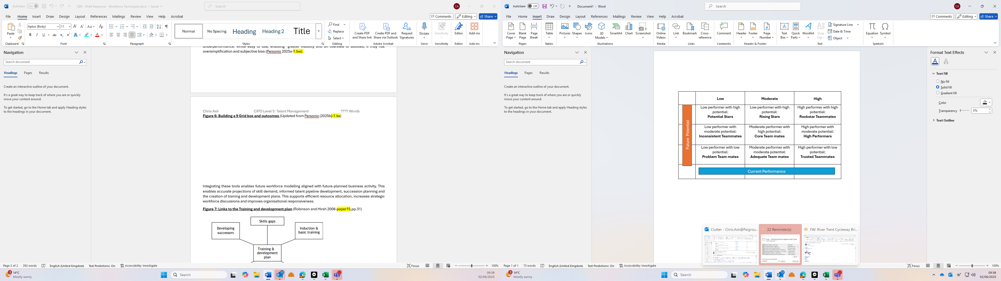
Integrating these tools enables future workforce modelling aligned with future-planned business activity. This enables accurate projections of skill demand, informed talent pipeline development, succession planning and creates training and development plans. This supports efficient resource allocation, increases strategic workforce discussions, and improves organisational responsiveness.
Figure 7: Links to the Training and development plan (Robinson and Hirsh 2008,p.31)
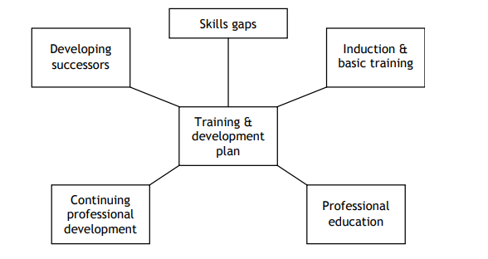
Supply analysis considers internal factors including retirement, promotion, attrition, and health-related absences. Also external PESTLE drivers include attitudes toward specific work-sectors, unemployment rates, legislative changes and global or national events affecting labour availability. Addressing workforce gaps through targeted training, recruitment and retention strategies for key talent ensures strategic alignment and agility (CIPD, 2024c).
Scenario and horizon planning allow ParcelCare to envision a range of potential futures and prepare for potential disruptions. Political developments like Brexit, technological advancements, or economic shifts can significantly impact talent supply and business continuity. Horizon planning enhances long-term workforce readiness by aligning strategies with future skills demand, improving adaptability to change, and creates organisational resilience (Wilkinson and Taylor, 2022).
- Recruitment and Selection Techniques (AC2.3)
Effective recruitment and selection are essential for attracting talent aligned with organisational objectives. However few organisations actively evaluate the effectiveness of these processes (CIPD, 2024d; McCartney, 2024a). ParcelCare’s current recruitment strategy of advertising vacancies solely through its own website and relying online manager-led interviews limits both the volume and diversity of applicants. While 47% of employers consider their corporate website an effective attraction tool (CIPD, 2022a), this assumes candidates are already aware of our organisation, which may be unrealistic given ParcelCare's limited external brand recognition.
To enhance reach and effectiveness, recruitment methods must align with the specific role, business needs and available internal capacity. Expanding to external platforms, including UK government's free 'Find a Job' service and Jobcentre Plus, can significantly increase visibility and provide access to additional services, including apprenticeship schemes and disability employment support (GOV.UK, 2025a). Paid platforms like Indeed.co.uk, with over thirty-four million monthly visits, offer access to a broader candidate pool and tools including automated messaging, salary benchmarking and applicant tracking (Indeed, 2025).
Online platforms can generate high volumes of unsuitable applications and may not be effective for sourcing certain talent. In such instances, specialist job boards or recruitment agencies may be more appropriate. Agencies supply industry-specific expertise and pre-screened candidates, often expediting hiring and reducing internal workload. This comes at a financial cost, typically a percentage of the candidate’s salary, and candidate quality can vary. Over-reliance on agencies may weaken our internal recruitment capabilities over time (Waite et al. 2021).
Selection methods must balance efficiency and fairness. Unstructured interviews, often favoured by line-managers, risk inconsistency and bias. Structured, competency-based interviews offer greater reliability, facilitate direct comparison between candidates, and mitigate bias (CIPD, 2022b; Taylor, 2014). They may however limit flexibility and rapport, though these drawbacks can be resolved through interviewer training (McCartney, 2024a).
Assessment centres, incorporating role plays, teamwork exercises, and skills testing, provide a robust evaluation of candidate suitability and reduce bias through multi-assessor input. Despite requiring significant resources and potentially increasing candidate anxiety, they are strong predictors of job performance (Wilkinson and Taylor, 2022). Psychometric testing, once prevalent, has declined in use due to concerns over fairness, cultural bias, and limited predictive validity (Thackary, 2022).
For ParcelCare, adopting a blended, cost-effective strategy, leveraging online platforms, social media, and structured interviews would enhance recruitment reach and improve quality selection and better meet workforce demands in a competitive delivery-service environment (Boolkak, 2021; CIPD, 2022b).

- Employee turnover rates (AC3.1)
Employee turnover is a critical concern in workforce management. ParcelCare must understand its various types and underlying causes to implement effective talent management and retention initiatives. Despite this importance, only 31% of employers assess the cost of labour turnover and just 20% evaluate the success of their retention strategies (CIPD, 2025b).
Employee turnover can be measured at both organisational and departmental levels. While turnover percentage is commonly used due to its simplicity, it may not provide a comprehensive view. Alternative metrics, including employee stability offer additional insight by capturing the proportion of staff with longer tenure, therefore reflecting organisational retention (Armstrong, 2014). 34% of UK employees leave their roles annually. Within our Transport and Storage sector, this is slightly lower at 30%. (Cockett, 2024a).
Not all turnover is necessarily negative as it enables new ideas and working practices to be introduced, also supporting internal promotions. Nevertheless, excessive turnover is widely recognised as disruptive and costly. Therefore, its best practice to monitor turnover using accurate data, benchmark against comparable organisations in both our industry and locality, to identify trends that inform strategic interventions (Allen and Bryant, 2012).
Turnover can be categorised as either avoidable or unavoidable. Avoidable turnover is when employee departures could have been prevented. 42% of turnover falls into this category, yet its root cause is frequently overlooked (Pendell, 2021). Common push factors include ineffective management, limited career progression, unsatisfactory working conditions, and uncompetitive compensation. There is often a disconnect between executive perceptions and the financial realities of lower-paid staff (King, 2024). Strategic interventions including leadership development, career pathway enhancement, job rotation and transparent, competitive compensation structures significantly improves retention (Taylor, 2014).
Pull factors enhances ParcelCare’s external appeal. Strengthening our EVP through employer branding is instrumental in attracting talent, particularly when comparing our offerings to competitors. A strong employer brand significantly increases application volume and quality compared to weaker brands, particularly with those not yet actively seeking new employment.
Figure 8: The pulling power of strong employer brands (Mosley 2014,p.13)


Benefits benchmarking, offering meaningful job roles, creating an inclusive workplace, promoting work-life balance, increasing employee voice, and improving recruitment and onboarding processes will help attract and retain the right candidates, while reducing early attrition (CIPD, 2025b).
Unavoidable turnover, including retirement, health-related exits, relocation, or personal life changes are largely beyond ParcelCare’s control. While some mitigations, including flexible or remote working arrangements, can reduce the impact, certain roles particularly driving positions can be less adaptable. Unavoidable cases are unlikely to reflect negatively on organisational practices (Aswal, 2024).
Understanding the distinction between avoidable and unavoidable turnover enables ParcelCare to focus its efforts and resources on reducing preventable attrition. This targeted approach ensures alignment with financial and operational realities while enhancing organisational resilience and employee engagement (Allen and Bryant, 2012).

- Retention Strategies (AC3.2)
Recent labour market trends indicate 28% of employees are planning to change jobs (Main and Howard, 2024), while within the transport and storage sector, 25% of employees have less than two years tenue (Cockett, 2024a). Increased competition and with 60% of vacancies being problematic to fill in our industry (Cockett, 2025), reinforces the urgent need for ParcelCare to adopt a robust, strategic employee retention framework. There is no one-fit all approach, particularly with different generations prioritising different aspects. ParcelCare should however use a combination of approaches, each offering distinct advantages across different stages of the employee lifecycle (Lumapps, 2021).
Realistic Job Previews (RJPs) presents prospective employees with an accurate and balanced representation of the role, including its positive and challenging aspects. Delivered most effectively in face-to-face settings, RJPs help manage expectations early on, creating a better person–job fit and reducing early exit driven by unmet expectations. However, this approach may discourage some candidates, therefore reducing the applicant pool. RJPs are typically applied during the recruitment phase and may not directly address long-term retention challenges (Allen and Bryant, 2012).
Well-structured induction processes are also critical for successful onboarding. Induction should encompass ParcelCare’s values, policies, role expectations and integration within the team. Executed effectively, it enhances early engagement, reduces anxiety, and promotes a sense of belonging (Wilkinson and Taylor, 2022). All these factors contribute to higher retention. However, poorly delivered inductions can result in isolation and early attrition. Importantly, induction should be an ongoing process, not one-off, though its impact is largely confined to early stages of employment (McCartney, 2024b).
Job enrichment, which involves redesigning roles to enhance autonomy, task variety, and meaningfulness, is another key approach. When feasible, it can significantly reduce absenteeism and turnover while improving job satisfaction and performance (Thomas, 2019; Thackary, 2022). Nonetheless, not all roles can be enriched, and such initiatives may require significant organisational restructuring and sustained managerial support to prevent employee stress or role ambiguity (Akers, 2025).
Finally, a reward strategy encompassing both financial and non-financial incentives is essential. While competitive pay and performance-based rewards are important, they should be complemented by recognition, personal development opportunities, well-being, and flexible working arrangements (CIPD, 2025c; Stuart-Turner, 2020). Over-reliance on financial incentives, in the absence of broader engagement initiatives, is unlikely to achieve long-term retention benefits (CIPD, 2025b).
In conclusion, with around half of EU employers believing attaining and retaining staff to be a major obstacle to growth (Williams, 2011), ParcelCare should adopt a blended retention strategy encompassing recruitment, onboarding, job design and ongoing recognition. Whilst compensation has one of the highest impacts (Rombaut and Guerry, 2019), integrating all these approaches will more effectively address warehouse staff turnover and enhance workforce stability, particularly with changing employee expectations (Burens, 2025).

- Dysfunctional Turnover (AC3.3)
Employee turnover can be categorised across several classifications, with dysfunctional turnover posing a significant risk to organisational performance. Dysfunctional turnover refers to the departure of high-performing or critical employees whose loss detrimentally affects business continuity, institutional knowledge, culture, and competitive advantage (Taylor, 2022).
Figure 9: Turnover classification scheme (Allen and Bryant 2012,p.5)

Dysfunctional turnover is particularly costly due to the direct costs related to payroll, temporary cover, recruitment, selection, and training, plus the additional time for management and people practice. Additionally, there are significant indirect costs including lost productivity, service disruptions, project delays and increased workloads on remaining staff. It’s estimated that indirect costs constitute 85–90% of the total expense of turnover amounting to significant additional financial burden (Armstrong, 2014). The departure of key personnel can trigger a chain-reaction, lowering morale, increasing uncertainty, and prompting further attrition. Approximately 40% of employees identify understaffing in their departments (Soliman, 2025). This can undermine ParcelCare’s reputation in both the labour market and among external stakeholders, including clients and suppliers who may question our stability or ongoing service continuity. Importantly when competitors acquire our top talent, they gain strategic advantage (Allen and Bryant, 2012).
This contrasts with functional turnover, which involves the exit of underperforming individuals. This can, in most cases, benefit the organisation (Taylor, 2014).
Avoidable dysfunctional turnover driven by dissatisfaction, accounts for approximately 90% of total turnover and can signal more deeper issues within the organisation including ineffective management, lack of career progression, insufficient employee voice, toxic workplace culture and uncompetitive compensation structures (Wilkinson and Taylor, 2022). 63% of businesses identified a deterioration in company culture due to high staff turnover, which again reduces productivity, innovation, and retention (Cholteeva, 2022).
High-performing staff often leave due to limited career and development opportunities, increasing workload, absenteeism, and errors among remaining employees (Maertz et al., 2023). Proactively addressing dysfunctional turnover through exit data analysis and strengthening employee voice mechanisms, including forums and one-to-ones enable early intervention. 45% of leavers reporting no prior managerial dialogue (CIPD, 2025b), therefore active line-manager engagement is critical in resolving burnout and preventing avoidable attrition (Pendell, 2021; Gouldsberry, 2022).
Given the substantial impact of dysfunctional turnover, it’s imperative ParcelCare’s senior management regularly assess their workforce, identify critical talent, and implement evidence-based strategies to minimise risk. This will improve organisational resilience, drive performance, and support long-term competitiveness (Allen and Bryant, 2012).
- Different contractual arrangements (AC4.1)
Operational requirements drive ParcelCare’s labour needs. To remain competitive and resilient, ParcelCare must adopt more flexible labour contractual arrangements rather than relying solely on traditional employment structures (Taylor, 2022). ParcelCare can retain a stable core of permanent staff, complemented with a peripheral tier of part-time or fixed-term contracts, and then supplement by agency workers.
Figure 10: The Flexible Firm (Taylor 2014,p.42)

Currently, ParcelCare’s reliance on full-time permanent delivery drivers provides employees with job security and continuity, which creates loyalty and facilitates strategic investment in training and development. Permanent contracts also have greater employee legal protections, contributing to higher job satisfaction and, potentially, enhanced productivity (Ayling, 2024). However, this lacks flexibility for ParcelCare as fixed overheads persist during periods of low demand, stretching budgets, while peak periods use overtime premiums which increases our labour costs.
Part-time or fixed-term contracts will enable ParcelCare to balance stability with adaptability during fluctuating demand including seasonal peaks like Christmas. Although these contracts maintain legal protections including protection from unfair dismissal and the right not to be treated less favourably than permanent staff, shorter hours may deter applicants, reduce organisational knowledge, and reduce workplace engagement (Daniels, 2022). Fixed-term contracts under three months still require one week’s notice of early termination, which can limit rapid adjustments (CIPD, 2023b). Nonetheless, ParcelCare’s semi-predictable demand cycles suggest such arrangements could produce cost efficiencies without compromising service quality.
Zero-hour or casual contracts, often called ‘gig-economy’ or agency worker agreements offer maximum flexibility, as workers are not guaranteed hours and can refuse assignments (CIPD, 2021a). Under the Agency Workers Regulations 2010, agency workers receive day-one rights, including notification of comparable vacancies, and after twelve weeks, entitlement to equivalent basic terms and conditions. They also qualify for statutory leave and minimum wage, although other employment rights are limited (CIPD 2024e). Zero-hour contracts may face further regulation enforcing minimum guaranteed hours under the planned new Employment Bill (Smyrl, 2025). While these arrangements allow ParcelCare to respond swiftly to demand fluctuations and optimise labour costs by paying only when required, it provides minimal job security and typically offers lower employee commitment (Daniels, 2022).
Engaging self-employed independent contractors could further enhance adaptability. Self-employed drivers are responsible for their own tax and insurance obligations and are again able to choose assignments. However, this risks driver unavailability during our critical periods and potential employment status reclassification if control and direction is proven (GOV.UK, 2025b). Nevertheless, contract-based work is gaining prominence, with 75% of leaders viewing freelancers and temporary staff as central to future employment strategies (Dennison, 2025)
Integrating various contract types of permanent, part-time, zero-hour, and self-employed will increase ParcelCare’s operational flexibility, reduce labour costs and strengthens resilience by aligning workforce capacity with demand (Taylor, 2022).

- Onboarding benefits (AC4.2)
Onboarding is the process through which an individual progresses from a new ParcelCare employee to achieving full competence. It’s not a one-off event. The psychological relationship, which is pivotal to successful onboarding begins before the official start date. This relationship develops through initial contact, clear communication, a seamless recruitment, and selection process, followed by an induction procedure with ongoing support and development (Waite et al, 2021). However, with only 12% of employees reporting that they were effectively onboarded, substantial improvements are still needed (Milburn, 2022).
Effective onboarding delivers multiple benefits to ParcelCare and the new employee. As a strategy, it enables a smooth transition, accelerates productivity, and supports engagement. Through a structured framework, newcomers receive clear guidance on role expectations, organisational culture, and operational practices. Therefore, gaining the tools and knowledge necessary for effective performance (Taylor, 2022).
A positive ParcelCare first impression significantly reduces uncertainty, with well-onboarded individuals displaying enhanced confidence and capability. 23% of employees who receive clearly communicated responsibilities have greater retention (Milburn, 2022), and effective onboarding can increase retention by 82% (STL, 2024). Improved retention removes re-recruitment costs and reduces knowledge loss by developing engagement and reducing feelings of isolation and anxiety (McCartney, 2024b). Furthermore, a comprehensive understanding of role requirements minimises early errors. Pairing new employees with mentors or ‘buddies’ further strengthens confidence and increases both individual and organisational performance, resulting in a 62% increase in new-employee productivity (Carucci, 2018).
Reinforcing ParcelCare’s mission, values, goals, and vision aligns behavioural expectations from the beginning and creates a shared understanding, therefore enhancing integration and belonging (Hirsch, 2017). Ensuring employees fully understand legal and procedural obligations guarantees compliance with regulations and best practices, reducing risk. Additionally, establishing robust relationships with colleagues expands communication networks and knowledge sharing, which supports socialisation and progress within ParcelCare new roles (Allen and Bryant, 2012).
Although technology can streamline onboarding and promote greater diversity (Otter, 2021), a blended approach employing multiple methods remains essential to better illustrate ParcelCare’s culture, beliefs, and support mechanisms (Milburn, 2022). Positive onboarding strengthens our employer brand, positioning ParcelCare as an employer of choice. Employees who experience a high-quality onboarding process are more likely to recommend our company to their networks, therefore expanding talent pools (Mosley, 2014).
In conclusion, effective onboarding offers both operational efficiency and personal growth. Organisations with comprehensive onboarding processes achieve 2.5 times greater revenue growth and twice the profit margin compared to those with less effective practices, highlighting also its critical impact on ParcelCare’s bottom line (Frogell, Jenner and Gustavsson, 2023).

