
University Of Wales Trinity Saint David

Module Title: Dissertation

Module Code: LCMB7020

Course: MBA Marketing

Dissertation Title: Assessing the impact of Social media marketing on consumer buying behaviour in the UK aviation industry

Supervisor: Amitave Banik
Student Name: Shemeka Williams
Student Number: 1913883


Master’s Degrees by Examination and Dissertation
Declaration Form.
1. This work has not previously been accepted in substance for any degree and is not being concurrently submitted in candidature for any degree.
Signed…Shemeka…Williams.………………………………………………………
Date 13/02/2024……………………………………………………………………………..

2. This dissertation is being submitted in partial fulfilment of the requirements for the degree of Master in Business Administration.
Signed Shemeka…Williams……………………………………………………………
Date 13/02/2024………………………………………………………………..…………...
3. This dissertation is the result of my own independent work/investigation, except where otherwise stated.
Other sources are acknowledged by footnotes giving explicit references.
A bibliography is appended.
Signed candidate: Shemeka…Williams…………………………………………….……………….
Date: 13/02/2024…………………………………………………….……………………….

4. I hereby give consent for my dissertation, if accepted, to be available for photocopying, inter- library loan, and for deposit in the University’s digital repository
Signed (candidate)Shemeka…Williams…………………………………….………….……
Date13/02/2024………………………………………………….…………….
Supervisor’s Declaration.
I am satisfied that this work is the result of the student’s own efforts.
Signed: Amitave Banik
Date: 13/02/2024

Abstract
This research study explores the relationship between social media marketing tools and consumer buying behaviour by using the case study of the aviation industry in the UK. In the aviation industry, the technological developments are shaping the operations and improving outcomes. Especially, in the marketing sector many ideas are initiated to develop strong customer engagement. The present study will focus on assessing the impact of social media marketing on consumer buying behaviour by using the case study of the aviation industry UK. The significance of the research work is proposed by using background analysis and subject evaluation. Moreover, the aim and objectives are identified to propose the path of the research study. The research questions are allocated to find the solution to the research problem.
The literature review utilised credible scholarly sources to identify the usage of social media marketing tools and trends in consumer buying behaviours. The marketing aspects of the aviation industry are stated by getting support from the research work of authors. In the end, the gap in the studies was identified to state the need for the present research study.
For the data collection, questionnaire-based surveys are used by selecting the users of the aviation industry as the participants from 20-55 years of age. SPSS statistical analysis toolbox was used to implement regression and correlation analysis to define the impact of social media marketing tools on consumer buying behaviour.
The findings showed the validity of the H1a and H1b hypothesis while rejecting the H1a⁰ and H1b⁰ considering the outcomes of data analysis. The strong positive correlation was observed in Facebook and Instagram marketing tools and consumer buying behaviour of aviation industry. In the future, there is a need to increase the sample size from 150 participants to enhance the validity of the research findings.
Keywords: social media, aviation industry, consumer, buying behaviour

Acknowledgement
First, I would like to say thank you to my parents who supported me in my research process by giving me constant emotional, physical, and mental assistance. I am grateful that they created ease for me in completing my work through motivation when I was on the verge of losing hope. I would like to say thank you to my classmates who helped me in implementing the ideas of the research process by facilitating learning. I had a great time with them, and they increased my motivation level when I faced major difficulties in this research process.
Additionally, I would like to express my gratitude to my supervisor, Amitave Banik, who was always there for me for guidance and helped me in the research work, especially in the data collection and analysis stage. I am also grateful to my university which gave me a chance to learn in a competitive educational environment that will support me in presenting great professionalism in the workplace.
Furthermore, I want to express my special thanks to my sister who spares her time to give me help in referencing process. It saved my time and helped me to cite the used sources effectively.
I hope that this thesis will help you in understanding my interesting concepts.
ThankYou!

Table of Contents
Abstract 3
Acknowledgement 4
List of Figures 8
List of Tables 8
1. Chapter One – Introduction 9
1.1. Introduction 9
1.2. Background of the Study 9
1.3. Problem Statement 11
1.4. Research Aim 12
1.5. Research Objectives 12
1.6. Research Questions 12
1.7. Significance of the Study 13
1.8. Dissertation Outline 13
1.9. Chapter Summary 14
2. Chapter Two – Literature Review 15
2.1. Introduction 15
2.2. Consumer Buying Behaviour 15
2.3. Factors affecting consumer buying behaviour 15
2.4. Maslow's Hierarchy of Needs Theory (1943) 17
2.5. Stimulus-organism-response (SOR) model 18
2.6. Social media marketing 18
2.7. Types of social media platforms 19
Facebook 19
LINKEDIN 20
Twitter 20
Instagram 20
TikTok 21
2.8. Influencer marketing 22
2.9. Social Influence Theory 22
2.10. Impact of Social Media Marketing on Consumer Buying Behaviour 23
2.11. Social Media Marketing in the Aviation Industry 24
2.12. Factors affecting consumer buying behaviour in the aviation industry 25
2.13. Technology acceptance model 26
2.14. AIDA Model 27
2.15. Gap in Literature 28
2.16. Conclusion 28
3. Chapter Three: Research Methodology 29
3.1. Introduction 29
3.2. Research Philosophy 30
3.3. Research Approach 30
3.4. Research Methodology 32
3.5. Strategy 33
3.6. Time Horizons 34
3.7. Techniques and procedures 34
3.8. Ethical Considerations 35
3.9. Conclusion 36
4. Chapter Four – Findings 37
4.1. Introduction 37
4.2. Response Rate 37
4.3. Preferred Social Media Channel 37
4.4. Instrument reliability analysis 39
4.5. Correlations between Facebook marketing tools and Consumer buying behaviour 39
4.6. Correlations between Instagram marketing tools and Consumer buying behaviour 40
4.7. Regression analysis between Facebook marketing tools and Consumer buying behaviour 41
4.8. Regression analysis between Instagram marketing tools and Consumer buying behaviour. 43
4.9. Conclusion 45
5. Chapter Five – Results and Discussion 45
5.1. Introduction 45
5.2. H1a: there is an impact of Facebook Marketing Tools on Consumer Buying Behaviour 45
5.3. H1a⁰: there is not impact of Facebook Marketing Tools on Consumer Buying Behaviour 46
5.4. H2a: there is an impact of Instagram Marketing Tools on Consumer Buying Behaviour 47
5.5. H2a⁰: there is not impact of Instagram Marketing Tools on Consumer Buying Behaviour 48
5.6. Summary 49
5.7. Conclusion 50
6. Chapter Six – Conclusion and Findings 51
6.1. Introduction 51
6.2. Conclusions 51
6.3. Recommendations 53
6.4. Limitations 54
6.5. Future Research 54
7. References 56
8. Appendix 61
8.1. Survey Questionnaire 61

List of Figures
Figure 1 Maslow Hierarchy of Needs (Yuliastina et al., 2021) 17
Figure 2 S-O-R Model (Datta, 2022) 18
Figure 3 Social influence theory (Yi et al., 2021) 23
Figure 4 Technology acceptance model (Turner et al., 2010) 26
Figure 5 AIDA Model (Abbas, 2022) 27
Figure 6 Saunder's research onion (Melnikovas, 2018). 29
Figure 7 Deductive vs inductive (Streefkark, 2022) 31
Figure 8 Frequency of Social Media Platform Usage 39

List of Tables
Table 1: Frequency of Social Media Platform Usage 38
Table 2:Reliability Statistics 40
Table 3: Correlation between Facebook marketing tools and Consumer buying behaviour 41
Table 4: Correlation between Instagram marketing tools and Consumer buying behaviour. 42
Table 5:Model Summary Table of Facebook Marketing Tools 42
Table 6:ANOVA of Facebook Marketing Tools and Consumer Buying Behaviour 43
Table 7: Table of Coefficients of Facebook Marketing Tools and Conquering Buying Behaviour 43
Table 8:Model Summary Table of Instagram Marketing Tools 44
Table 9:ANOVA of Instagram Marketing Tools and Consumer Buying Behaviour 45
Table 10:Table of Coefficients of Instagram Marketing Tools and Conquering Buying Behaviour 45

Chapter One – Introduction

Introduction
This chapter discusses the research study's aims and objectives in light of the problem studied. Moreover, it states the justification for doing research along with attention to focus on specific areas. Lastly, the entire picture of the dissertation content is presented. The background the study is discussed in detail to narrate the idea of selection of research topic. Moreover, the significance of the study helped to shape the path of present research work.

Background of the Study
In the modern world, social media has changed the course of life and people are now interacting efficiently with each other and sharing information using different social media platforms (Bigne et al., 2018). The statistics showed that till 2020, there were around 3.6 billion social media users on different platforms, including Facebook, Instagram, YouTube, Twitter and others (Atherton, 2023). The analysis showed that day by day, the number of social media users is increasing, and they are becoming members of the global community, which is linked with each other and able to share their interests and activities (Berthon et al., 2018). Along with it, social media provided multiple benefits to businesses. The firms are getting specific support from social media by connecting with the targeted customers and enhancing sales.
Facebook Ad Manager is a comprehensive tool offering a wide range of functionalities and features to reach users and target audiences to manage ad campaigns in a wide variety (Alvi, 2019). For the Ad manager, the advertisers can outline the demographics of the target audiences, behaviour, interests and various other criteria based on the type of advertisement, like gender and various age groups (Kite eta al., 2019). The platform provides a variety of formats for ads like still images, video ads, slideshow ads, carousel ads, and various other formats (Tavares et al., 2024). Tobias-Mamina et al. (2020) added that social media marketing following influencer marketing is one of the major sources to create interaction about tourism. The influencer-based campaigns are useful for conveying messages towards audiences. Users capturing and sharing their experiences also bring a change through Instagram, like travellers sharing their experiences, which is a form of information dissemination (Tobias-Mamina et al., 2020).
The study conducted by Arya and Kerti (2020) determined five types of ads used through Instagram, including photo ads, Instagram ads, video ads, carousel ads, and adverts ads. Instagram stories are found to be attractive to impact the buying behaviour of the customers. Sundström et al. (2021) assessed the customer perceived value and trust by following the LinkedIn-based action-oriented messages. However, it has been delivering value in the business-to-business marketing strategy. The content through LinkedIn was also found to increase user engagement (Sundström et al., 2021). As per Manzoor et al. (2020), social media marketing impacts and influences the trust level of customers due to social networking sites. Improved quality of the website content and quality increases customer intention and influences the decision-making process that creates the buying intention for the next purchases in the e-commerce industry.
Furthermore, the rapid growth of the online shopping industry is motivating firms to use e-commerce websites for sales. In the era of COVID-19 and after that, the firms realised the significance of online stores to attract customers who cannot visit physical stores for multiple reasons (Afaq et al., 2023). Social media platforms are helping to grow online businesses by attracting more customers and providing new ways to share products (Shareef et al., 2019). The major marketing and advertisements for online sales are done through social media platforms. The success of the firms is associated with high product purchases, which directly supports earning high profits.
The aviation industry in the UK is serving the needs of customers. It is the third largest aviation network in the world, which supports creating one million jobs through contributing to GDP with £ 22 billion (Heyes et al., 2023). The growth of the aviation industry relates to customers, including passengers, non-passengers and suppliers of services (Koch and Tritscher, 2017). Through social media, the aviation industry is implementing modern marketing strategies, which help provide customers with information about discounts and seasonal offers (Amaugo, 2022).
The analysis of the reports showed that social media is impacting the purchase of businesses (Gitto and Mancuso, 2019). There are multiple factors, including perceived purchase easiness, product usefulness, brand trust and word of mouth, which influence the purchase decisions of customers in online platforms (Karaağaoğlu and Çiçek, 2019). They motivate customers to buy more products by paying a suitable amount and getting the items while staying home. Therefore, this research study assesses the impact of social media marketing on consumer buying behaviour in the UK aviation industry.

Problem Statement
Customer behaviour is dependent on various factors, including technology adoption, customer expectations, global crisis, cultural trends, economic conditions, social trends, competitiveness and communication channels (Chou et al., 2020). The changing trends in communication and technology, and social media have developed new horizons for organisations to reach more customers in the target markets (Glogovețan et al., 2022). This is not only increasing awareness about the organisation and its products, but the aspects are changed to assess the customer needs through communication channels and to develop new products accordingly (Sundararaj and Rejeesh, 2021). The UK aviation industry has witnessed a significant shift in customer engagement that is basically social media platform-driven (Sigurdsson et al., 2020). Airlines are largely dependent on Twitter, Facebook, LinkedIn, Instagram and various other social media that are less common but increase the reach and connection with the social media platforms (Da Silva et al., 2021).
The shifting behaviour of social media-based marketing is contributing to shaping the customer buying experience. As per Mellado et al. (2021), the transformational impact of social media also changed the journey of customer buying behaviour and decision-making. The actual buying is based on various aspects of social media, including customer reviews, the type and content of the campaigns, social media developments, and the popularity of social media in the region (Wibowo et al., 2022). The communication channels in the form of social media are improving their services for marketing on the basis of consumer attention and following the rule for consistent engagement for buying further products.
Social media development and customer buying behaviour intention are linked with one another, as identified by Hassan et al. (2022), Zafar et al. (2022) and Naeem (2021). However, the main aspects are the social media types and the marketing strategies' impact on the customers. The problem lies in the social media marketing and its impact on the customer buying behavior in the aviation industry of the UK. The main social media under concern are Instagram, Facebook Ad Manager and LinkedIn Ad Manager. The social media tools and techniques applied by the UK aviation industry will be assessed first to investigate the social media tools, including Facebook Ads Manager, LinkedIn Campaign Manager, and Instagram and their impact on the buying behaviour of customers in the UK aviation sector. The further objective is to recommend strategies based on the outcomes of the aviation industry of the UK for managing social media marketing effectively.

Research Aim
This study aims to assess the impact of social media marketing on consumer buying behaviour in the UK aviation industry.
My attention to doing research is it helps the aviation industry to look at the possible ways of using social media for the sake of marketing and promotion to increase sales and earn more profit. The findings would help to make future decisions about focusing on effective usage of social media marketing to attract more customers and influence their buying behaviour.

Research Objectives
The underlying objectives accomplished through this research are:
- To critically analyse the social media tools and techniques used by the UK aviation industry.
- To investigate impact of Facebook Ads Manager as a social media tool on the buying behaviour of customers in the UK aviation sector
- To examine the influence of Instagram Marketing as a social media tool on the buying behaviour of customers in the UK aviation sector

Research Questions
Supported by the aim and objectives, the following questions are answered in this study:
- What are the social media tools and techniques used by the firms in the UK aviation industry?
- Is there any impact of Facebook Ads Manager as a social media tool on the buying behaviour of customers in the UK aviation sector?
- Is there any impact of Instagram Marketing as a social media tool on the buying behaviour of customers in the UK aviation sector?

Significance of the Study
Social media marketing is among the powerful tools to shape the buying behaviour of customers in the aviation industry of the UK (Varghese and Agrawal, 2021). The study will explore the transformative influence and impact on the decision-making process and engage customers to assess the organisation's activities. The outcomes of the current study will provide clarity about useful techniques that the aviation industry can apply to engage more customers in the critical analysis process. Furthermore, the study will also highlight the most effective media impacting customer buying behaviour in the UK, from Instagram, Facebook Ad Manager, and LinkedIn Ad Manager. The assessment of the particular type of social media and its implementation by the airline industry can establish a dynamic and direct connection with potential customers that are target audiences (Ibrahim and Aljarah, 2023). Moreover, better brand differentiation and positioning are possible by following the right social media platform that has a higher reach in the UK market. Managers assessing the right media as a marketing tool can directly engage with people, improve the sense of community and address their concerns. This can become the proactive approach to customer relationship management to increase customer loyalty and prolonged relationships with customers (Li et al., 2021). Aviation companies can develop positive and emotional connections with customers. There can be assessed which media and type of content can influence the buying behavior of customers. The study finding the impact of social media marketing on customer buying experience will assist managers in employing competitive strategies of content management, promotions, and trend setting in the market. Managers can reach the goals of competitive intelligence in aviation due to the vast amount of data generated by social media in the form of real-time feedback that can further lead to optimising the buying behaviour of customers (Calof et al., 2020).

Dissertation Outline
The 1st Chapter of the dissertation is the introduction section explaining the background of the study, problem statement, aim of research, objectives, research questions and significance of the study.
The 2nd Chapter of the study is of literature review enclosed with the concepts based on the existing literature and aspects supporting the need for the current study. A gap analysis is also developed to find out the aim of the current study and the reasons for its analysis.
The 3rd Chapter encloses the research paradigm, research approach, research methods, strategy, data collection, and data analysis. The chapter also includes the ethical considerations implemented in the current study.
The 4th Chapter is the analysis section that encloses the analysis tool implementation of the results of the empirical analysis. The significance of the hypothesis and the impact of the variables is assessed in this chapter.
The 5th Chapter is of conclusion that encloses recommendations on the basis of results, limitations of current study and future study considerations.

Chapter Summary
The introduction chapter of the dissertation elaborated on the background of the study to explain social media usage and its power in various industries. The problem statement is developed to explore the need for the current study. The research aims, objectives and questions are developed to set the aspect for the current study. Furthermore, hypotheses are developed on the basis of the research aim, and the significance of the current study is explained.

Chapter Two – Literature Review

Introduction
In this section, an analysis of previous literature is provided to evaluate the views of different researchers and authors on the impact of social media marketing on consumer buying behaviour in the aviation industry. The following section is also incorporated by using the relevant theories to provide a theoretical basis for the study. The research gap is stated at the end to propose the path for the future research.

Consumer Buying Behaviour
Tao et al. (2022) have defined buying behaviour as a specific behaviour that depicts people's needs, interests, and desires. In this context, Gandhi and Choudhry (2021) have defined consumer behaviour as the study of how people select, utilise and dispose of products and services to fulfil their requirements; both customers and society observe the repercussions of consumer behaviour at large. Taking this into account, consumer buying behaviour is defined as the culmination of a customer's preferences, objectives, decisions, and views on their response in the market during the purchase of a product (Gandhi and Choudhry, 2021).

Factors affecting consumer buying behaviour
Consumer buying behaviour is influenced by a range of factors, including social, cultural, situational, and demographic factors (Cici and Bilginer Özsaatcı, 2021). Gandhi and Choudhry (2021) have mentioned that personal, psychological, social and economic factors primarily impact the buying behaviour of customers.

Personal factors
Personal factors comprise the age, life cycle stages, occupation, lifestyle, values and personality of customers (Gandhi and Choudhry, 2021). These factors include both direct and indirect factors because of their diverse impacts on customer choices. For instance, age determines the preference of customers towards certain products and strategies; likewise occ,upation and lifestyle determine the response of customers to different pricing and marketing strategies of companies. Concerning this, Kotler and Keller (2016) have mentioned that companies should emphasise personal factors in determining marketing strategies to influence the buying behaviour of customers.

Psychological factor
Ramya and Ali (2016) have identified the impact of psychological factors on consumer buying behaviour. Psychological factors are also identified as internal factors because of their impact on the perception and preferences of customers (Ali and Ramya, 2016). Environment plays a crucial role in determining the purchasing process (Kotler and Keller, 2016). Other consumers in the environment influence the purchasing intention of customers because they are perceived as more reliable due to their personal or indirect association with the customer (Rani, 2014). The concept of psychological factors in the consumer buying process is complex and vast because it comprises the motivation, memory, perception and learning experience of customers (Kotler and Keller, 2016).

Social factor
Social factors are among the key factors that directly impact the buying behaviour of customers. It comprises the immediate connections, social network and online social network of the customers (Gandhi and Choudhry, 2021). The concept of word-of-mouth is also associated with the role of social factors in consumer buying behaviour. According to Gandhi and Choudhry (2021), the reference group also impacts consumer choices by serving as direct or indirect comprise points that influence the attitude and behaviour of customers. Apart from the direct social environment, secondary groups such as religious segments and professional associations of consumers also direct their choices and preferences in the purchase of certain products (Gandhi and Choudhry, 2021). Social networks, including online social networks, form the opinions and preferences of modern-day customers. This is why companies are paying more attention to online mediums and social platforms to influence the purchase process of customers (Ziyadin et al., 2019).

Economic factor
Lastly, the economic factor shapes the buying behaviour of consumers. The economic conditions impact the choice of products and services and the purchasing decisions of customers (Gandhi and Choudhry, 2021). Economic factors include several factors, including personal and family income, savings, consumer credit and income expectations of customers (Ali and Ramya, 2016). In addition to this, some other economic factors such as government policies, economic progress and inflation also determine the buying behaviour of customers.

Maslow's Hierarchy of Needs Theory (1943)
Maslow's hierarchy of needs theory divides the basic needs of customers into five categories: physiological, security, social, self-esteem and self-actualisation needs (Roy, 2022). According to this theory, certain needs can influence bodily weights that impact the behaviour of people. Here, physiological and security needs are part of survival needs that fulfil a person's demand for food, water, shelter and safety (Yuliastina et al., 2021). The fulfilment of these needs is essential for higher-level needs, including self-esteem and the ultimate level of self-actualisation (Yuliastina et al., 2021). This theory is associated with consumer buying behaviour because products that meet basic needs such as food, safety and shelter are likely to attract more customers. Likewise, customers will prioritise the price range, product offerings and overall value of a product to finalise the choice of buying a product (Roy, 2022). Customer who belongs to less privileged backgrounds and those who are facing economic challenges will prioritise the fulfilment of lower-level needs, whereas others who are in a comparatively comfortable position in their life will focus on the fulfilment of higher-level needs in making their purchase decision.
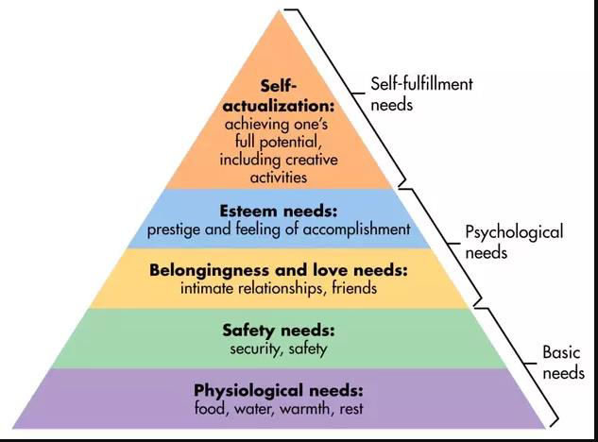
Figure 1 Maslow Hierarchy of Needs (Yuliastina et al., 2021)

Stimulus-organism-response (SOR) model
The SOR model examines the influence of the environment on the emotional state of an individual. Here, a stimulus is an environmental factor that influences the ability of an individual to respond to environmental cues (Datta, 2022). Organism is the emotional and cognitive state of the person, and response determines the actions of an individual to the external stimulus (Datta, 2022). In short, the SOR model suggests that a stimulus triggers cognitive and emotional changes in a person, which leads to different types of behaviours and responses (Tao et al., 2022). In the marketing context, experts use psychological tricks to influence the purchase behaviour of the customer towards certain products and services (Tao et al., 2022). Marketers focus on understanding the impact of external stimuli on buyer’s behaviour. The SOR model in the marketing context presents interactions between customer reactions, decision-making processes, internal traits of consumers and external stimuli.
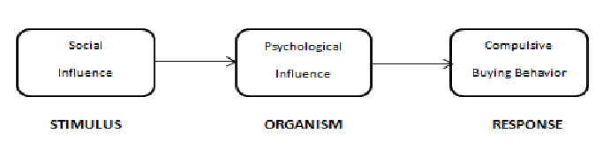
Figure 2 S-O-R Model (Datta, 2022)

Social media marketing
Social media marketing promotes communication between marketers and customers to increase brand awareness (Hafez, 2021). Social media platforms such as Facebook, Instagram and WhatsApp have grown immensely in the past few years (Chen and Qasim, 20210. The general public uses these platforms to communicate with each other, whereas marketing experts and businesses utilize social platforms to promote different products and services. Social media has brought activities from the real world to the virtual dimension of social networking sites. Companies consider these platforms important for achieving their marketing objectives (Ebrahim, 2020). Social media marketing enables promoting products and services to attract more customers through social media. However, social media marketing is still considered a new aspect of the marketing paradigm, and there is still limited research on this dimension of marketing on consumer intentions (Jamil et al., 2022). The research on social media marketing has largely emphasized creative strategies, outcomes of user-generated content and creative strategies to create a virtual community (Ibrahim, 2021).
On the other hand, Beig and Khan (2018) stated that social media is important for the marketers to establish a brand representation according to purchase intention of the customers. The study showed that influence of social media is strong to attract the customer by focusing on customized content sharing to develop strong interaction with customers. Mariani et al. (2019) proposed that purchase decisions and selection of brands is now totally related to modern marketing trends of social media which is far better than traditional advertising methods.

Types of social media platforms
Social networking platforms include Facebook, Google+, Twitter, Instagram, LinkedIn and various other platforms that facilitate communication between people. These sites enable users to improve their network and allow business owners to connect with their target audience (Chaudhary, 2021).

Facebook
Facebook marketing enables a brand to promote its services and maintain its presence on the application (Mariani et al., 2016). Facebook marketing strategies include organic strategies, where marketers endorse their products without paying any amount to the website and naturally grow their audience, and boost or paid posts, where the algorithm pushes brand posts to the target audience in exchange for a certain amount. Brands also collaborate with influencers on Facebook to promote their content through short videos and posts and display the brand's advertisement on their page (Lee et al., 2018).
Furthermore, Mariani et al. (2019) the hospitality and tourism sectors are investing in the Facebook advertisements to increase the engagement towards the potential customers. The study developed the narrative that unlike the other travel platforms like Trip Advisor, C-Trip and similar, the travelers have the positive consideration towards Facebook, and they are using it travel planning. Despite of changes in algorithm, they are finding it useful to check the trustworthiness of the advertising information.
On the other hand, Loo (2020) investigated the Facebook pages of the top four airlines who were successfully able to achieve the 2017 World Airline Awards. By using Stimulus Organism Response (SOR) model, the researchers stated the findings that the airlines who invested to use the cognitive and emotional competency in Facebook content posting were able to get the attention of customers. Moreover, the study helped to develop the perception that the past experiences of passengers who were posted on Facebook were supportive to achieve the high sales targets because they motivated them to purchase tickets for the highly satisfied airline for travel.
However, Godey et al. (2016) argued that the companies not only use social media for brand representation, but also for the customer engagement which is needed to earn high sale targets. The authors included the significance of Facebook in providing marketing opportunities through videos and images which are directly connected to the websites of businesses. The findings through used the survey data of 845 brands to state that Facebook like other social media platforms is effective to find the true demands of targeted customers by using customer messages and broadcast. Other businesses must also focus on highlighting the brand related information on Facebook pages and provide customized information by using the graphical supports.

LINKEDIN
LinkedIn allows marketers, sales representatives and creators to promote their content. The platform was originally designed to encourage professional connections (Amin, 2019). However, now, LinkedIn is used by brands to promote their content through organic and paid marketing strategies.

Twitter
Twitter marketing is an effective strategy used by different kinds of brands (Arora et al., 2019). Brands use Twitter to connect with customers, directly respond to their queries and stay relevant through engaging tweets. Twitter also provides a solid base for the launch of a company. Businesses can promote their content by using paid marketing strategies to ensure that they hashtag trends on the platform and attract the attention of a large percentage of potential customers (Arora et al., 2019).

Instagram
Instagram has become the global marketing hub. It is the most popular marketing tool widely used by companies across the globe (Singh, 2020). It enables marketers to promote their content directly through their Instagram profiles or by collaborating with Instagram influencers. Instagram was launched in 2010 as a photo sharing platform where customers would interact by sharing pictures and commenting on the shared pictures (Chaudhary, 2021). however, Instagram has transformed into a leading marketing channel where brands can engage with customers through photos, videos, stories and direct messages. Businesses can use both paid and organic marketing strategies on Instagram. The organic marketing approach allows brands to organically grow their audience, which is a slow process but ultimately provides access to relevant audiences to the brand (Chaudhary, 2021). On the other hand, paid marketing strategies provide a quick route to success. Instagram offers paid features where brand posts get a boost from the algorithm, stories are displayed to the target audience, reels can be displayed to target customers, and most importantly, Instagram influencers and celebrities with significant following and engagement can give a boost to the brand by promoting its services on their platform (Virtanen et al., 2017). Instagram is used by almost all kinds of businesses across the globe to connect with customers (Virtanen et al., 2017).
Furthermore, da Silva et al. (2021) provided the correlation between the Instagram and brand reputation by using the airline business as case study. The researchers stated that the Instagram is helpful for the airlines to build a strong brand reputation which is important to attract more customers. The researchers used Partial least squares structural equation modelling (PLS SEM) to provide the outcomes that the Instagram is helping the brand to develop strong engagement with customers which is important for purchase decision making in airline industry.
On the contrary, Pawar (2020) notified that social media especially Instagram helped to shape the marketing trends by shifting from the idea of seller-centered market to customer-centered market which the customers are now having the highest power to impact the decision making. The findings showed that Instagram is on the top charts in assisting the brands to show the products through filter services and advertisement to customers which is needed to initiate the consideration of high sales margin.

TikTok
TikTok is a comparatively new but leading marketing platform for businesses. This platform is used in the same way as Instagram, with comparatively fewer features (Guarda et al., 2021). However, a large percentage of the global population is using TikTok. Brands can collaborate with influencers who have millions of active followers to promote their services and increase their customer base (Guarda et al., 2021).

Influencer marketing
Influencer marketing is a new addition to the marketing industry thanks to social media platforms. Social media influencers are increasingly hired by companies because people tend to relate more with ‘non-celebrities’ who live just like a normal average person (Nouri, 2018). The word-of-mouth strategy is applied here when people believe the reviews of social media influencers and purchase products based on the recommendations of their favourite influencers (Saeed et al., 2014). Social media influencers are also a cheap alternative to maintaining stream celebrities who charge excessive amounts because of their face value (Schouten et al., 2020). Pricing and accessibility are two major reasons behind the success of social media influencers. Both small and large-scale businesses can collaborate with influences based on their unique requirements and budgets (Nouri, 2018). Despite the fact that social media influencers are far behind mainstream celebrities in terms of popularity quotient, their availability, accessibility and connection with followers make these influencers an effective choice for brands to promote their services.

Social Influence Theory
The social influence theory evaluates the interaction between an individual and society through conversations, which, in most cases, are now mediated through digital technology (Lim, 2022). Lim (2022) has incorporated the social interaction theory here to identify the extent to which the social interactions of people are positively impacted by social relationships between their desire to remain connected and associated with a certain social group. Social relationships are crucial for generating a desire in people to connect with others in society (Oliveria et al., 2020). In this context, the social influence theory suggests that people who are more distant and lonelier are less likely to feel the need to connect with others and become a part of a social structure. In the marketing field, this theory is used because of its role in determining and shaping the behaviour and response of customers (Oliveria et al., 2020). The social influence theory identifies three levels of psychological attachment in influencing the behaviour of a person. These elements include compliance, identification, and internalisation (Ifinedo, 2016). Here, compliance shows subjective norms, identification is associated with the social identity of a personal, and internalization highlights the group norms of an individual (Yi et al., 2021). Within the context of social media marketing, the social influence theory suggests that customers are more likely to connect with social media celebrities who match their status quo. Social media influencers influence the perception and demands of customers, which impacts the behaviour of other people as well (Lee and Hong, 2016). For example, the display of a good lifestyle and certain fashion statements by fashion influencers create fashion trends that are followed by young girls. These trends are even adopted by customers who are not following these influencers but are influenced by other people in their social group.
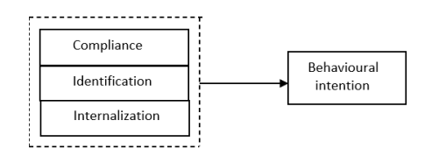
Figure 3 Social influence theory (Yi et al., 2021)

Impact of Social Media Marketing on Consumer Buying Behaviour
Social media marketing influences consumer buying behaviour through various strategies and activities (Godey et al., 2016). For example, social media platforms display target advertisements to customers based on their browsing history to ensure that customers are exposed to relevant products, which influences their purchase decisions. Likewise, the collaboration with influencers with good following and engagement impacts the brand perception of customers, which influences their buying behaviour. In this context, Jamil et al. (2022) analysed the role of SMM on the buying behaviour of customers. The sample population comprised Instagram and Facebook users of Pakistan. The research was conducted through an online questionnaire-based survey. The findings revealed a significant impact of SMM on the purchase intentions of customers. However, Jamil et al. (2022) also identified that social identification plays a crucial role in determining the response of customers to the marketing strategies of different brands (Jamil et al., 2022). In this context, Balakrishnan et al. (2014). studied the impact of SMM on Generation Y's purchase intentions and brand loyalty. The author identified that digital marketing communication strategies, online advertisement and online communities significantly promote customers' purchase intentions and brand loyalty. The findings revealed the critical role of social media in connecting brands to the young generation (Balakrishnan et al., 2014). SMM is largely associated with a positive impact on consumer purchase intentions (Hajli2014). Hajli (2014) conducted a survey to determine the advantages of social media for brands. The findings revealed a facilitating role of social media in improving brand-customer interactions and improving the trust and purchase intentions of consumers. However, Cox and McLeod (2014) identified contradictory results and mentioned that social media posts have drawbacks for brands. For example, social platforms provide accessibility to trolls to promote a negative impression of a brand (Cox and McLeod, 2014). Customers who have a bad experience with the brand also get an opportunity to publicly share their experience, which impacts the brand perception and purchase intentions of other customers.
On the other hand, Pawar (2020) stated that social media supported the companies in connecting with the customers as with the advancement of internet and excessive usage of smartphones, the traditional marketing trends are changed. The companies who are focusing on social media marketing can connect with customers. However, the usage of effective marketing strategies is important to eliminate the chances of issues. Varma et al. (2020) argued that the companies should include the gender, income and customer demands trends along with the promotional offers. These factors are important to target the real customers and offer the products to earn high profit.

Social Media Marketing in the Aviation Industry
The aviation industry comprises all dimensions of air travel and operations that facilitate this process, including the entire airline sector, aircraft production, research companies and military aviation (Keke, 2023). The aviation influence is extremely sensitive to uncertainties in the external environment, which is why companies need to pay attention to changes in the internal and external environment, primarily to the competitive environment (Elemonie, 2020). The airline brand image is the key to the market performance of the aviation industry. The aviation sector has been relying on social media marketing strategy for a while now, which has also replaced various traditional marketing strategies in the industry. However, social media marketing provides a direct role to customers to shape the image of aviation businesses by sharing their views and taking the lead in the marketing process, in contrast to traditional marketing strategies where brands only use different platforms to promote their services to the target audience. The importance of marketing in the aviation industry can be identified through the case studies of various businesses (Rauschnabel et al., 2016). For instance, United Airlines failed to deliver its services to passengers in 2010 (Seo and Park, 2018). The video went viral after it was translated into five different languages on social media. This incident directly impacted the brand image and performance of United Airlines (Seo and Park, 2018). Even though social media has become a key player in promoting and improving the sales of airline companies, it is also a challenging platform for various aviation businesses because passengers directly share information and experiences with the airline with other customers. The receivers of this information base their travel decisions on other customers' experiences. Hence, social media has pressured aviation companies to facilitate the requirements of every customer to avoid controversies and negative branding online. Social media is relevant and crucial for the aviation industry despite its drawbacks and challenges. For example, 1.6 million passengers in Korea use Facebook pages to check airline companies and book their trips through the most suitable airline company (Seo and Park, 2018).

Factors affecting consumer buying behaviour in the aviation industry
Different factors determine the buying behaviour of customers in the aviation industry.
First of all, price is a key factor that impacts the buying intentions of customers, which is also why a majority of companies use pricing as a key strategy in their positioning approach. The COVID-19 pandemic was a shock for the global aviation industry (Fan, 2021). The sudden decline in air travel forced most airline companies to opt for lower rates and discounts to sustain their market position (Fan, 2021). Even though airline companies offer packages where customers can pick a package that meets their budget range, a majority of companies prefer to keep their prices as per the budget range of a larger population.
The second factor is the quality of services (Wilson, 2018). With technological advancements and increased exposure, customers have the opportunity to form their opinion and purchase intentions after a thorough investigation of the most suitable option (Seo and Park, 2018). Social media emerges as a key tool here because most customers visit the official handles of airline companies are check their reviews by other customers to finalize their purchase decision.
Promotion is another key element that determines the purchase intention of customers (Fan, 2021). obviously, customers are more likely to pick a company that they can recall through an advertisement instead of the one they forgot long back due to a lack of exposure. Airline companies are trying to stay relevant by using social media platforms to promote their services and connect with the target audience (Bigne et al., 2018). Promotion is also important for airline companies because it reduces the impact of negative branding by allowing brands to clarify their position and resolve the concerns of customers.

Technology acceptance model
The technology acceptance model utilises the social psychology theory to assess the relationship between technology application and cognitive and emotional factors (Su and Li, 2021). This model is used in different industries to assess the impact of technology on the intentions, beliefs and attitudes of customers based on the observation of external variables (Su and Li, 2021). This theory is based on four elements, including behavioural intentions, user behaviour, perceived usefulness and perceived ease of use (Su and Li, 2021). User behaviour is the actual operating behaviour of the user to new technology; behavioural intentions depict the willingness of users to test new technologies; perceived usefulness shows the subjective understanding of different users of new technology, and perceived ease of use is the extent to which new technologies are used by the target audience (Tambun et al., 2020). In the context of social media marketing and consumer buying behaviour, the technology acceptance model can help aviation businesses identify the response of customers to marketing strategies on different social platforms. The model will allow aviation companies to track social platforms that appear more useful and easier to understand to customers. The impact of marketing strategies on these platforms will also depend on the extent to which customers find the marketing message beneficial and practical.
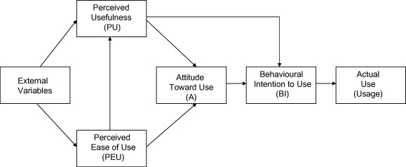
Figure 4 Technology acceptance model (Turner et al., 2010)

AIDA Model
The AIDA model presents the journey of customers towards a brand through four stages: attention, interest, desire and action (Hassan et al., 2015). These four elements share consumers' perception towards a brand's marketing messages. It shows that businesses can engage customers by using strategies that attract their attention, retain their interest in the brand, generate a desire to purchase the offered products and services, and ultimately act upon this desire by purchasing the offered services (Abbas, 2022). The AIDA model is an effective tool for understanding the impact of different marketing strategies on the intentions of customers. It allows brands to control the response of customers at each stage of the market and generate effective outcomes through their strategies (Abbas, 2022). As shown in the figure below, customers observe and perceive the marketing messages at different levels where they identify a new brand, find the brand interesting, think of trying out the brand and finally try the brand by purchasing its products or services.
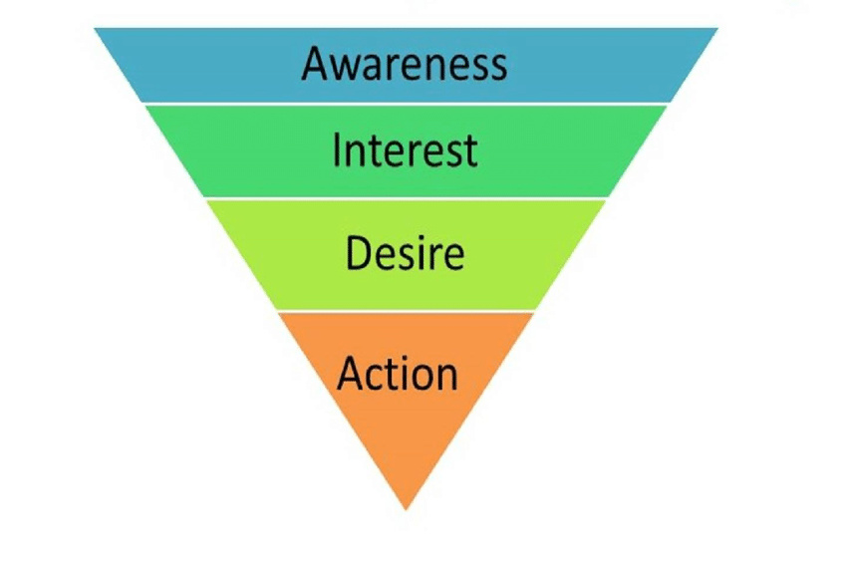
Figure 5 AIDA Model (Abbas, 2022)
Within the aviation industry, the AIDA model can help airline companies use social media platforms that are more likely to attract and retain new customers. By using this model, companies can improve their performance on different platforms and collaborate with influencers to use their power to attract more customers. The AIDA model will allow airline companies to track customer response at each stage of the model and modify or retain their strategy based on the response from customers. It will save their time and effort if the brand notices that customers are not showing an interest in the marketing strategy on a social platform. This way, the brand can identify whether the problem is with its marketing strategy or the use of a platform to modify its strategy and improve its customer base.

Gap in Literature
The analysis of the literature showed that there is a gap in the literature as studies did not able to locate the impact on social media on consumer buying behaviours specifically related to UK aviation industry. There is a need to focus on develop of ideas to locate the area of consumer buying behaviours for sake of better marketing of UK aviation industry. This study filled the gap of previous study by using the primary data analysis to identify the impact of social media marketing on consumer buying behaviour. The selected consumers of aviation industry are mainly from 22 to 50 years of age who are able to provide the better understanding of the influence of social media. Instead of summarizing, this study specifically focused on Instagram and Facebook as the prominent social media networks to locate the aviation industry trends of marketing.

Conclusion
This chapter discussed the detail analysis of the scholarly articles by explaining the impact of social media tools for marketing. The research studies are critical analysed to identify the different factors which are impacting the consumer buying behaviours. The marketing ideas of aviation industry of UK were evaluated by using the relevant scholarly sources. At the end, the gap in the literature was defined to propose the path for the present research study.

Chapter Three: Research Methodology

Introduction
Research methodology is a research approach which highlights measures for the successful completion of research (Melnikovas, 2018). It comprises a system of philosophical beliefs and assumptions that formulate the understanding of the research question and determine the choice of methods to be used in the study. It is an integration part of the thesis or dissertation and assists in ensuring consistency in the selected tools, techniques and philosophies relevant to the research. There are different ways to construct research methodology. Saunder’s research onion is one of the key models that provide an exhausting detail of the primary layers that formulate an effective research methodology (Raithatha, 2017). Saunder’s research onion starts with the identification of the research philosophy, moves to the selection of the right approaches and methods for the research, and ends with the selection of key techniques relevant to the completion of the research (Saunders, 2016). A visual description of Saunder’s research onion is provided below:]
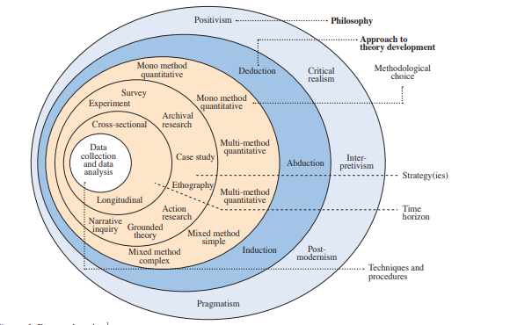
Figure 6 Saunder's research onion (Melnikovas, 2018).

Research Philosophy
The research philosophy is based on the belief about ways through which data about a certain phenomenon should be collected, analysed and applied in practical settings. Research philosophies can include positivism and interpretivism research philosophy (Alharahsheh. and Pius, 2020). The positivist research philosophy is used by scientists who examine real-world situations by focusing on observable and measurable factors to make generic statements about the obtained information. Positivism focuses on the use of natural facts and data without the influence of personal biases and opinions on data outcomes. However, researchers who use the positivist philosophy often overlook the actions and intentions of people who are relevant to the study, which research participants becomes crucial for certain research topics, which becomes a limitation for the primary research.
On the other hand, interpretivism philosophy examines the depth of variables and associated factors. It differentiates humans from a physical research phenomenon with an assumption that human reactions and responses cannot be measured in the same way as a physical phenomenon (Alborough and Hansen, 2023). Interpretivism forms different social realities by considering different in the circumstances, time and cultures. Interpretivism provides more in-depth financials that can be applied to everyone. However, researchers who use interpretivism research philosophy often struggle with the overload of information and challenges in the alignment of data between different research methods and groups, and they sometimes fail to deliver context-specific results due to the incorporation of unintended biases in data (Alborough and Hansen, 2023).
The following research will apply the positivism research philosophy to analyse the impact of SSM on the buying behaviour of customers in the UK aviation industry. The researcher will rely on the positivism philosophy because it provides a vigorous process of developing a hypothesis, empirical experimentation to verify the hypothesis, deep analysis of measuring the outcomes and codifying the outcomes as per a set of predictions and laws. The positivism philosophy will provide quantifiable results to the research and provide unbiased outcomes based on the requirements of the research.

Research Approach
The research approach can be divided into two categories: deductive and inductive research. The deductive approach moves from general to specific outcomes as it starts from the formulation of a theory, developing a hypothesis from the theory, testing the defined hypothesis and revising the initial theory based on the new findings (Woiceshyn and Daellenbach, 2018). In the deductive approach, a theoretical base is identified that facilitates the generation of a research hypothesis. Researchers who used this approach start the study with a substantial introduction, justification of theoretical points and deduced hypothesis for the study. A drawback of the deductive approach is its vulnerability to criticism (Woiceshyn and Daellenbach, 2018). A lack of empirical observation increases the vulnerability of a deductive approach to studies that measure the same phenomenon using a different theoretical base for the research.
On the other hand, the inductive approach moves from specific to general findings as it starts with establishing empirical observations about a particular phenomenon and developing theories and concepts based on the defined phenomenon (Streefkark, 2022). The inductive approach starts with the data collection process and identification of patterns to develop new patterns and hypotheses. The inductive approach primarily focuses on the development of a theory. It is mostly used by researchers to examine variables that have not been studied in great detail before. It consists of three stages: observation, seeking patterns and developing a general conclusion. A major drawback of the inductive approach is that the results can never be proved completely, and they can be invalidated ((Streefkark, 2022).
A visual representation of key elements of the deductive and inductive approach is provided below:
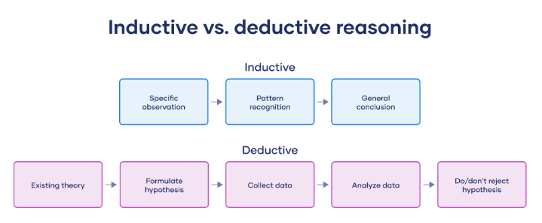
Figure 7 Deductive vs inductive (Streefkark, 2022)
The present study will use the deductive approach to test the research hypothesis. This approach is selected because it provides a clear structure to the study, offers precise predictions and objective results, reduces biases and complements the use of quantitative data in a study. The research relies on the deductive approach because it provides factual information by relying on already-established ideas instead of working on a new theory. This study is based on the idea of finding the impact of social media marketing on consumer buying behaviours. Four main hypothesis are designed to locate the impact of social media marketing by specifically focus on Facebook and Instagram.
H1a: There is an impact of Facebook marketing tools on consumer buying behaviours in the UK aviation industry
H1a⁰: There is no impact of Facebook marketing tools on consumer buying behaviours in the UK aviation industry
H2a: There is an impact of Instagram marketing tools on consumer buying behaviours in the UK aviation industry
H2a⁰: There is no impact of Instagram marketing tools on consumer buying behaviours in the UK aviation industry

Research Methodology
According to Alharahsheh and Pius (2020), research methods are largely associated with the collection and analysis strategies used for data to generate knowledge. The research methods can be divided into two categories: quantitative and qualitative research methodology. However, mixed research methods are also used in research studies.
The quantitative research is conducted through the collection and analysis of numerical data. It is used to identify patterns and averages, test causal dynamics, generate generalisable results and make predictions (Alharahsheh and Pius, 2020). It is widely used in the natural and social sciences field. The quantitative research methods can be applied in experimental, descriptive and correlational research. For example, in descriptive research, quantitative methods help with generating a summary of research variables, and in correlational research it assists in investigating the relationship between research variables (Alharahsheh and Pius, 2020). This approach is widely used by researchers because quantitative studies can be replicated easily because it relies on standardised protocols of data collections, and it provides a direct comparison of outcomes because of numerical figures and details (Alharahsheh and Pius, 2020). However, quantitative research can inadequately represent complex concepts like the emotions and moods of people. It also leads to the ignorance of other relevant observations due to a focus on a predetermined set of variables.
On the other hand, qualitative research explores real-world issues by generating and investigating the hypothesis (Tenny et al., 2022). At its core, qualitative research asks open-ended questions with complex structures whose answers cannot be put into numerical figures to define why or how something happens (Tenny et al., 2022). Due to its emphasis on open-ended questions, it appears less linear than quantitative research. However, qualitative research explains human behaviours and complex processes that cannot be measured through quantifiable strategies. It evaluates phenomena that concern the behaviours, attitudes and experiences of people in real-world settings (Tenny et al., 2022). Nonetheless, qualitative research has a high chance of researcher bias due to the involvement of personal knowledge and experiences of the researcher. It is also time-consuming, which makes it a less favourable choice for the current research (Tenny et al., 2022).
The present study research will rely on the quantitative research method to examine research variables. The quantitative approach will allow the researcher to avoid biases and, in a limited period, determine the impact of SMM on consumer buying behaviour in the aviation industry through factual and numerical results.

Strategy
According to Jones et al. (2013), this layer of Saunder’s research onion identifies relevant tools such as surveys, narrative inquiry, experiments, case studies and others to collect and analyse data. The following study will use primary data collected through the survey method. The survey will be based on close-ended questions to determine the correlation of research variables. According to Jones et al. (2013), the survey method is a unique approach to collection information from a large group of people. This approach is used in the current study because it is less time-consuming, has more statistical power and increases the availability of the validity model. However, the discrepancies in recall validity and accuracy and the costly nature of the survey are the primary drawbacks of this approach. The researcher will avoid discrepancies in recall validity and accuracy by ensuring that participants willingly participate in the study, are well-informed about the research goals and objectives and use reminders to remind research participants to return the questionnaire.

Time Horizons
Time horizons defined the research time frame by dividing it into two sections: longitudinal and cross-sectional studies. Longitudinal research is based on a repeated collection of data over a long duration whereas cross sectional research conducts data at a specific time (Melnikovas, 2018).
Longitudinal researchers used repeated and continuous strategies to examine particular individuals over a long duration over several decades or years (Caruana et al., 2015). The researcher generally relies on observation in natural settings without external influence and uses either qualitative or quantitative methods to collect the data. Longitudinal research is useful in the evaluation of the relationship between risk factors, treatment outcomes over different time lengths and disease development (Caruana et al., 2015). The researcher often uses statistical testing to analyse changes in research participants in groups or as an individual over a period of time. Even though longitudinal studies provide in-depth details about research variables, these studies are time-consuming and expensive in nature.
On the other hand, a cross-section study uses the short-term approach by collecting data at a single point in time. These are observational studies that examine population data one time only (Caruana et al., 2015). These types of studies are mostly used to measure health outcomes, examine health determinants and describe traits of a population. Cross-sectional method does not follow variables for a long time period. The short time nature of the cross-section approach makes it less expensive, less time-consuming, and easy to conduct (Caruana et al., 2015).
The present study will use the cross-sectional approach to examine research variables. The cross-section method is selected because data will be collected only one time through the survey method. The researcher has selected cross sectional approach because it consumes less time and resources.

Techniques and procedures
The techniques and procedures include measures for data collection and analysis, such as the sample group, the choice of primary or secondary data and the content of the survey questionnaire (Melnikovas, 2018). The research will identify and select research participants from the UK aviation industry to determine their response to the impact of SMM on their buying behaviour. A purposive sampling approach will be used to make sure that the selected sample group contributes to the fulfilment of the research purpose. The researcher will use primary data, which will be directly collected through a questionnaire-based survey. The questionnaire will be prepared by analysing and evaluating key trends and activities in the UK’s aviation industry, particularly the online marketing strategies and their impact on consumer behaviour. The researcher will focus on Instagram, Whatsapp and Facebook as key social media platforms in the questionnaire to determine the response of research participants towards the incorporation of these platforms in the marketing strategies of the UK’s aviation industry. The questionnaire will be created on google forms, which is an advanced tool for conducting research through survey methods. The link to the survey will be generated and distributed among 150 respondents of the study. A small sample size is selected to make sure that the research is completed within the selected time frame. The data analysis procedures are also critical for research because they indicate methods which assist in extracting research outcomes (McDermott, 2023). The collected data will be analysed through SPSS correlation and regression analysis. The selection of data analysis technique is important because a variety of data analysis techniques are available to assist in an in-depth analysis of data and predict outcomes after analysing the relationship between research variables (Dineva, 2023).

Ethical Considerations
Ethics must be considered from the initial stage of the research to avoid potential involvement in unethical conduct (Halej, 2017). Even though ethical considerations are crucial for all types of studies, they are more important in primary research components such as survey-based studies. This is because of the core principle of research ethics, which is based on the social responsibility of the researcher. It suggests that researchers must be aware of their duty towards their community and society, and they must ensure that their efforts are serving the public interest (Halej, 2017). Research should focus on maximising research benefits and avoiding potential harm to research participants and the researcher themselves. The potential risks can be mitigated through some precautions that include effective management of resources and strategic implementation of activities involved in the research process (Iphofen, 2017).
The ethical considerations of this study are primarily associated with the ethical limitations of quantitative research that rely on primary data. For instance, the anonymity and confidentiality of data and consent of research participants are three key areas where ethical dilemma emerges in research. In the present study, these situations will be avoided through the application of different strategies. For example, sensitive and personal information that can reveal the identity of participants will not be obtained in the survey. The researcher will ensure that each participant willingly participates in the research by briefing them about research goals and informing them of their right to withdraw from the research in the informed consent form. The confidentiality of data responses will be maintained by incorporating only the average percentage of responses in the research. The researcher will keep the data safe in a drive, which will only be accessible to authorised parties. The GDPR will be considered in managing the privacy and confidentiality of participant information.

Conclusion
An overview of research methodology was provided in this section using Saunder’s research onion. The section describes the selected approaches for the collection and analysis of data. In addition to this, all available options were evaluated and compared to finalise the choice of the right method for the research.

Chapter Four – Findings

Introduction
The chapter includes the presentation and explanation on the findings of survey data which was collected by using the close-ended questions. The quantitative data analysis was applied on the data to evaluate the consideration of the participations about the impact of social media marketing on consumer buying behavior in the United Kingdom aviation industry. The data analysis was done using the Statistical Package for Social Sciences (SPSS) software which supported in implementing the correlation by using Pearson Coefficient and regression analysis. The reliability of the variables is tested through Cronbach’s Alpha. The linear regression effectively helped to define the impact on social media marketing by defining relationship between variables. The graphical support is included along with descriptive ideas to enhance the significance of findings.

Response Rate
The analysis of the findings showed that in the selected 150 sample size, 108 responses were received by the researcher out of which some of the respondents did not answer a few questions, so the incomplete surveys were omitted. The remaining responses were 92 that were used to evaluate the impact of social media making especially on Facebook and Instagram on the consumer buying behavior on United Kingdom aviation industry. All these respondents were the users of UK airline services. The response rate in this scenario was about 61% which is showing the mix concern about the presentation of the participates. All these responses were from 20-55 years of age. The personal demographics were not included in the survey to implement the ethical consideration of anonymity of participation data.

Preferred Social Media Channel
The survey outcomes showed that most of the respondents were using both Facebook and Instagram for social media marketing. The first question of the survey was the tell about the social media platform which the users frequently use. However, on the individual basis the frequency of Facebook was higher than the Instagram. Table 1 included the information about the frequency, percentage, and valid percentage along with cumulative percentage of the social media platform user’s frequency from all the respondents of survey data. The data presented showed that the users of UK airline services of 20-55 years of age selected the Facebook 22 times than Instagram which was favored about 12 times. The frequency of both social media was 58. Mariani et al. (2019) also indicated the usage of Facebook as the preferable social media channel for advertising of the aviation industry for sake of consumer engagement. However, da Silva et al. (2021) supported Instagram to handle the consumer demand challenges to enhance the purchase decisions. The outcomes of the social media platform frequency analysis is backed with the literature review of this study. Below figure is providing the visual representation of the social media platform usage frequency which is supportive to get the summarize idea about outcomes.
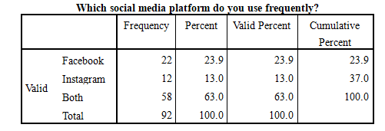
Table 1: Frequency of Social Media Platform Usage
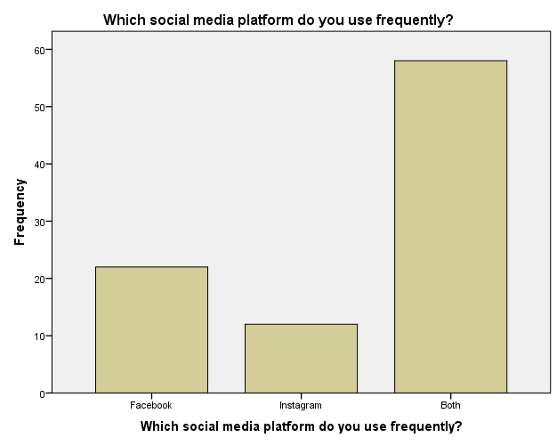
Figure 8 Frequency of Social Media Platform Usage

Instrument reliability analysis
The reliability testing is supportive for the understand the effectiveness of instrument used. For this study, especially Cronbach's Alpha is used to focus on evaluation of the internal consistency of the questionnaire. Cronbach's Alpha is effective to check that how well elements are correlated with the test by using the values ranges from 0 to 1. This research is having the value of Cronbach's Alpha of 0.856 with 13 number of items which is the clear indication of higher internal consistency. The research studies showed that the Cronbach's Alpha value above 0.70 is considered acceptable for the effectiveness of studies and reliability testing of research instrument. Table 2 is clearly showing the value of Cronbach's Alpha and number of items.
Cronbach's Alpha | N of Items
.865 | 13

Table 2:Reliability Statistics

Correlations between Facebook marketing tools and Consumer buying behaviour
The correlation is supportive in the market research to measure the strength of linear relationship between the available variables and develop the connection of association. For this study, Pearson Correlation is used by utilizing 2-tail through using the p-value and focusing on N number of observations. The variables of the study are Facebook Marketing Tools and Consumer buying behaviour. The Pearson Correlation of Facebook Marketing Tools and Consumer buying behaviour is r=.411 with the significant of 0.01 level which indicates the positive correlation and relationship between the variables. As the literature review specified, usage of Facebook marketing tools is impacting the consumer buying behaviour. The aviation companies in UK which are using the Facebook for social media marketing are getting the support through the increase in consumer buying behaviour (Loo, 2020). The significance level of the study is 0.000. The overall outcomes showed the variables are correlation with values (r =.411, n = 92, p<0.05). Thus, the regression analysis can be applied for the further statistical analysis. The p-value of 0.01 is showing the statistically significance of correlation.
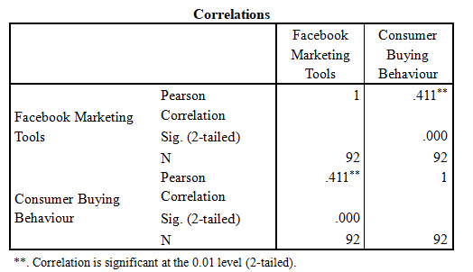
Table 3: Correlation between Facebook marketing tools and Consumer buying behaviour

Correlations between Instagram marketing tools and Consumer buying behaviour
On the other hand, Pearson Correlation is applied on the variables of Instagram marketing tools and consumer buying behaviour. Table 4 showed the correlation with values (r =.589, n = 92, p <0.05). The Pearson Correlation with the positive value is helpful to show the linear relationship between Instagram marketing tools and consumer buying behaviour. The higher value of about .589 is indication of the strong impact of Instagram marketing on the consumer buying behaviour. The p-value of 0.000 shows the significance of the relationship at level 0.01. For the sample size of 92 users of aviation industry UK, the strong positive outcomes are possible by engaging the customers through Instagram marketing. The low significance level of 0.000 is also another indication of high level of confidence. These outcomes are helpful to narrate the connection of the productive Instagram marketing techniques to affect the consumer buying behaviour (Pawar et al., 2020). The overall analysis showed that regression analysis can be used for statistical finding.

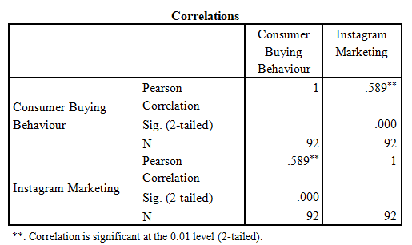
Table 4: Correlation between Instagram marketing tools and Consumer buying behaviour.

Regression analysis between Facebook marketing tools and Consumer buying behaviour
Regression analysis is used in this study to identify the linear connection between the independent and dependent variables which are marketing tools and consumer buying behaviour It is effective to implement the analysis idea that all the data points are distributed normally with no data points which lies outside the outline. The impact of Facebook marketing tools is identified by using regression analysis. The present study included the consideration of social media marketing tools on the user of aviation industry of UK to enhance the support for purchase decision making. The hypothesis is tested by using the below tables.
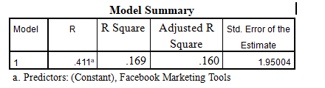
Table 5:Model Summary Table of Facebook Marketing Tools
The above model summary table 5 includes the statistical values are supportive to show the strength of relationship between the dependent and independent variables which are marketing tools and consumer buying behaviour in the available research study. The value of R=4.111 showing the strength of the relationship of the Facebook Marketing Tools and Consumer buying behaviour. The positive correlation shows the positive relation between the variables. Apart from it, R square value is .169 which is presenting the 16.9% variability in the outcomes de to Facebook Marketing Tools variable. The remaining percentage of variation in the consumer buying behaviour is dependent on other factors which are not defined here to eliminate the concern of complications.

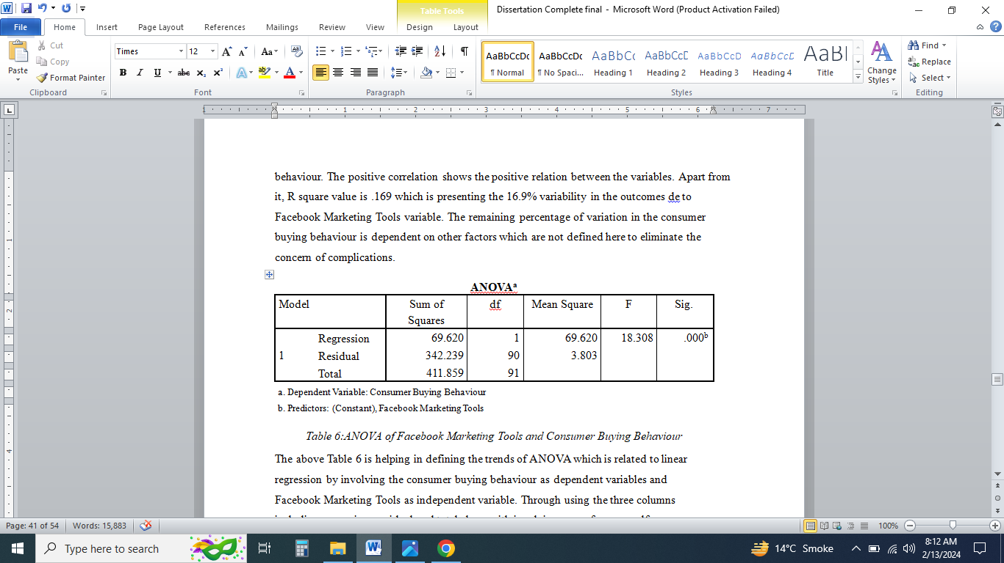
Table 6:ANOVA of Facebook Marketing Tools and Consumer Buying Behaviour

The above Table 6 is helping in defining the trends of ANOVA which is related to linear regression by involving the consumer buying behaviour as dependent variables and Facebook Marketing Tools as independent variable. Through using the three columns including regression, residual and total along with involving sum of squares, df, mean square, F and significance value, the regression model is stated through ANOVA. The data analysis showed the significance value in Table which is .000 that states the connection of Facebook Marketing Tools in the consumer buying behaviour. Moreover, the high F-static value that is 18.308 and low value of p=.000 shows the significance of used regression model. With 1 degree of freedom the variance is evident of value 69.620 which shows the total effect of independent variable.

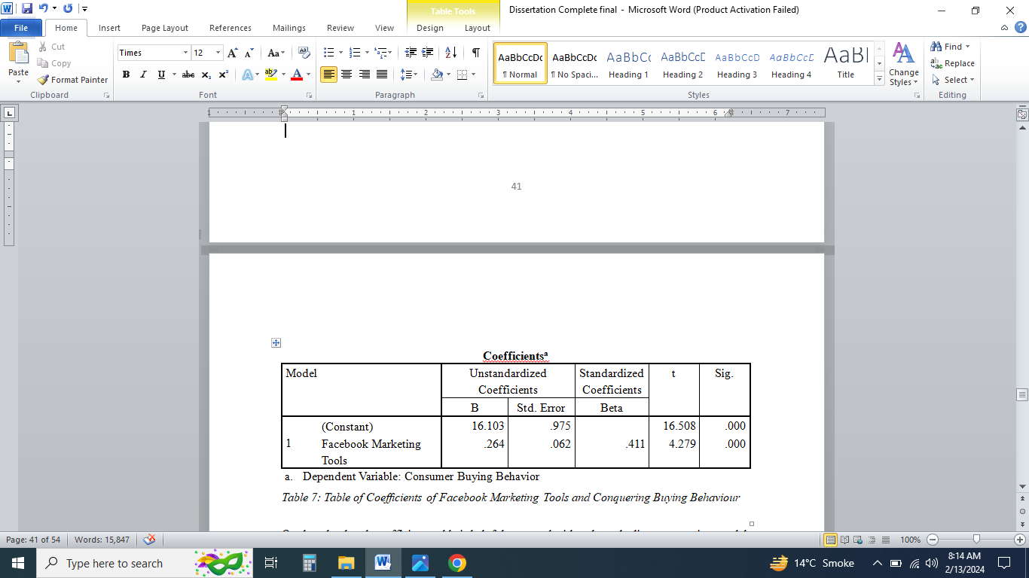
Table 7: Table of Coefficients of Facebook Marketing Tools and Conquering Buying Behaviour
On the other hand, coefficients table is helpful to state the idea about the linear regression model by involving consumer buying behaviour and Facebook Marketing tools as the dependent and independent variables. The unstandardized coefficient (B) is having value of 16.103 which shows that estimated outcomes of dependent variables when all the other predictor variables are approaching to zero. Moreover, the value of t-static of 16.508 with loss value of p=0.000 the connection is statistically significant.

Regression analysis between Instagram marketing tools and Consumer buying behaviour.
The regression analysis is also used to analysis the other two variables including Instagram marketing tools and consumer buying behaviour. The relationship between the independent variables which is Instagram marketing tools is defined with dependent variable which is consumer buying behaviour. The summary table is stating the value of R=.589 which is correlation coefficient are supportive to narrate the strong linear connection between variables. Moreover, R square value is stated .347 that is coefficient of determination outcomes which indicates the 34.6% variation in the trends of consumer buying behaviour. The other variation percentage is due to other external and internal factors which are not the part of study. However, the standard deviation error of estimation is 1.72837 which presents the idea of effectiveness of alignment of predicted outcomes with the actual values.
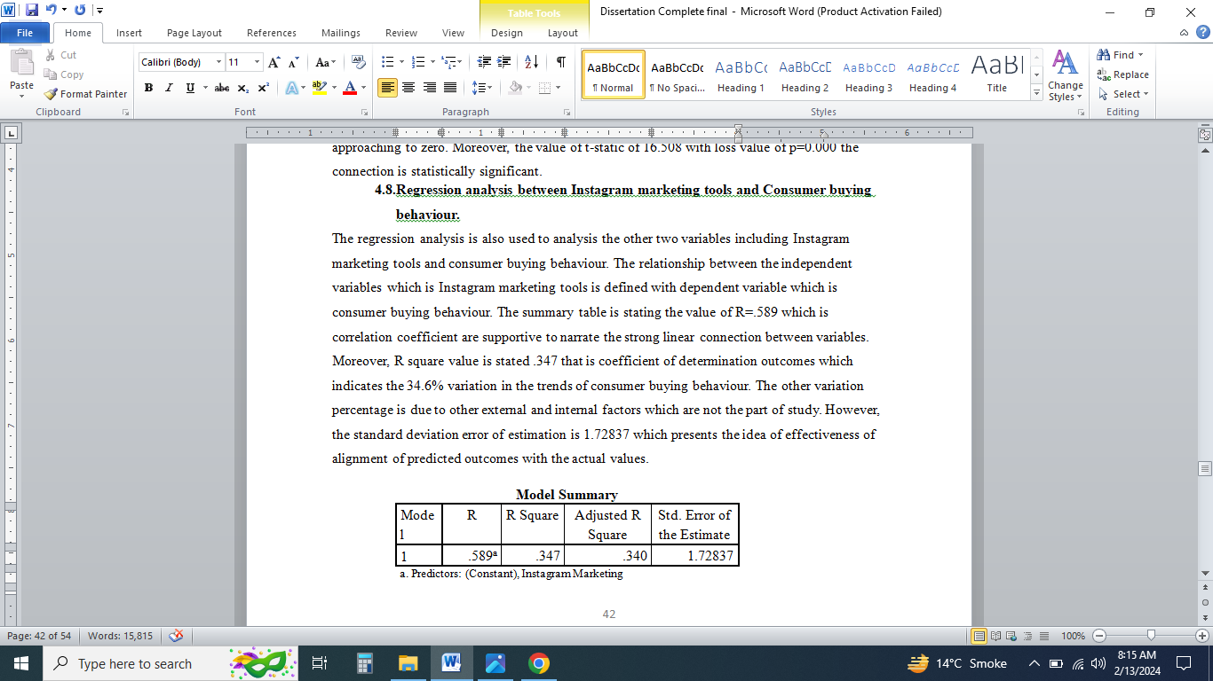
Table 8:Model Summary Table of Instagram Marketing Tools
On the other hand, the Table 9 is showing the value of ANOVA by keeping in consideration of two main variables including Consumer buying behaviour and Instagram marketing tools. The table is divided in two regression, residual and total part by involving sum of square, degree of freedom, F-static value and significant number. The data showed the regression of 143.005 between the dependent variable which is consumer buying behaviour and independent variable which is Instagram Marketing Tools. Furthermore, degree of freedom value of 1 with variance of 143.005 shows the strong impact of Instagram Marketing on consumer buying behaviour. With high value of F that is 47.872 and low value of p which is 0.000 the model is statistically significant.
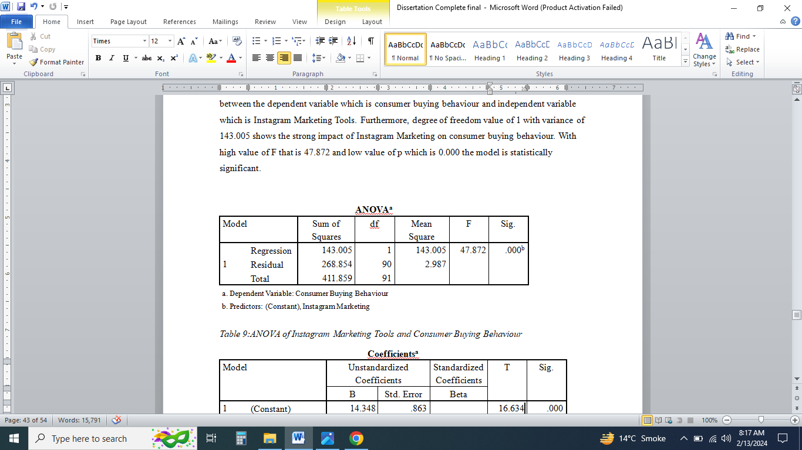
Table 9:ANOVA of Instagram Marketing Tools and Consumer Buying Behaviour
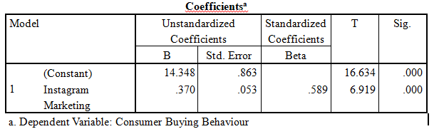
Table 10:Table of Coefficients of Instagram Marketing Tools and Conquering Buying Behaviour
The regression analysis in above totable showed the statically significant connection between the consumer buying behaviours and Instagram Marketing Tools. The unstandardized coefficient value of B is showing the estimated value of consumer buying behaviour by involving the predicators which can assisting s\is connection building.

Conclusion
The chapter includes the analysis of the finding of the users of aviation industry in the UK by using the Facebook and Instagram Marketing tools. The impact of indented candidate helped to share the harmony in the country.

Chapter Five – Results and Discussion

Introduction
This chapter includes the detail discussion on the findings of the study by comparing the results with the literature review and research studies. The research questions are tested by regression analysis by correlating the dependent and independent variables. Moreover, outcomes are explained to state the real impact of social media marketing by utilising the Facebook and Instagram Tools on the consumer buying behaviour in the UK aviation industry.

H1a: there is an impact of Facebook Marketing Tools on Consumer Buying Behaviour
The hypothesis (H1a) is supported by the findings of the research study as the Facebook Marketing Tools have strong influence on the consumer buying behaviour in the aviation industry of United Kingdom. The users of the aviation industry helped to shape these outcomes by giving responses in survey data which was analysed through regression analysis. The results of the regression analysis are showing that there is a strong association between the Facebook marketing tools and consumer buying behaviour which are two variables of this research study. These outcomes are also justified by the study of Mariani et al. (2019) which notified that the Facebook marketing is supportive to enhance the consumer buying behaviours of aviation industry due to strong engagement of customers and collaboration with the brands. Furthermore, Godey et al. (2016) also presented the same idea that the aviation brands which are using the Facebook for the customer engagement, advertisement and marketing are able to achieve high sales targets because it is directly impacting in linear fashion the consumer buying behaviour. The consumers who are able to visualise the attractive service packages and facilities of aviation companies on Facebook are willing to invest for the future travel plan. These cross examinations of findings and literature review are indication the truthfulness of the findings which Saeed et al. (2014) also supported in the research work.
On the other hand, the regression analysis provided the positive correlation idea in which the independent variable which is Facebook marketing tools was positively enhancing the dependent variables involving consumer buying behaviour. These outcomes are also supportive to state the answer to the research question that 'Is there any impact of Facebook Ads Manager as a social media tool on the buying behaviour of customers in the UK aviation sector?’ The correlation observation is also indicated the positive outcomes which are helpful to enhance the consumer buying behaviour. The outcomes specifically focused on the Facebook Marketing Tools including Facebook Ads Manager, Facebook Business Suit, Facebook Pixel, Messenger and Dynamics Ads. In the modern time, AI and machine learning models have provided the extensive support by creating ease in content design and graphical support for the better engagement of customers through Facebook and other social media (Lee et al., 2018; min, 2019; Arora et al., 2019). Loo (2020) also utilised the impact of these tools for the consumer buying behaviour. The respondents were mainly using Facebook and they had detail knowledge about the usage of all the Facebook Marketing Tools.

H1a⁰: there is not impact of Facebook Marketing Tools on Consumer Buying Behaviour
This hypothesis suggested that there is no impact of Facebook marketing tools on the consumer buying behaviour. The findings of this study are not related to this hypothesis. This it is not supported because the results showed the impact of Facebook marketing tools on consumer buying behaviour. The correlation analysis at the initial stage showed the association between the variables which were Facebook marketing tools and consumer buying behaviour. The strong positive association was observed between the selected variables which was against H1a⁰. the findings of correlation provided the supportive idea to move towards the regression analysis. The regression analysis showed that Facebook marketing tools are affecting the consumer buying behaviour. The research studies also argued this aspect that social media marketing is being used to develop the engagement with the brands that need the customers to meet high sales targets. Thus, this hypothesis will be invalid (Oliveria et al., 2020; Chaudhary, 2021; Jamil et al., 2022; Godey et al., 2016).

H2a: there is an impact of Instagram Marketing Tools on Consumer Buying Behaviour
The hypothesis (H2a) is also supported because the strong linear correlation is found between the Instagram marketing tools and consumer buying behaviour. The high positive value of r is indicating the positive correlation between the variables at value of p that is 0.000. The outcomes of the regression analysis showed that the aviation industry can use the Instagram marketing tools for the consumer buying behaviour enhancement. The literature review is also backed with these findings which states the strong influence of Instagram marketing tools. da Silva et al. (2021) stated that it is important for the aviation companies to influence the consumer buying behaviour which is possible effectively through using the photos and videos sharing features of Instagram. The research study of Chaudhary (2021) is also backed with the same perspective that Instagram is helpful because of the modern tools to develop the high customer engagement which is directly supportive to achieve high sales targets. On the other hand, Seo and Park (2018) argued that the Instagram marketing tools are complex, but the training of the employees of aviation industry can enhance the productive outcomes in the form of increase in consumer buying behaviour.
However, it is also important to note that the respondents selected Facebook marketing tools with majority than the Instagram marketing tools because it has new features, and it is developing day by day through good customer engagement (Ifinedo, 2016; Yi et al., 2021). The aviation sectors can use Instagram marketing tools including Instagram reels, stories, advertisements, IGTV, Creative Studio and business profiles (Lee and Hong, 2016; Oliveria et al., 2020). All these tools are helpful to connect with the customer and give them in-depth idea about the services of the aviation industry in the UK (Saeed et al., 2014). The findings are also supportive to answer the question that ' Is there any impact of Instagram Marketing as a social media tool on the buying behaviour of customers in the UK aviation sector?’ by showing that there is a strong impact of Instagram marketing as the social media tool on the buying behaviour of customers.

H2a⁰: there is not impact of Instagram Marketing Tools on Consumer Buying Behaviour
On the other hand, hypothesis (H2a⁰) stated that there is no impact of Instagram marketing tools on the consumer buying behaviour. This hypothesis is designed to propose the opposite outcomes of the H2a. The outcomes of the study showed that the hypothesis H2a⁰ is not valid because the impact of Instagram marketing tools is evident on the consumer buying behaviour by focusing on UK aviation industry. The findings section initially used the correlation analysis by using Pearson correlation which indicated the strong association between the variables which were Instagram marketing tools and consumer buying behaviour. At this stage this hypothesis was rejected. Afterwards, the regression analysis was further developed the consideration of strong positive association between variables by indicating the strong impact of Instagram marketing tools on the consumer buying behaviour. On the other hand, the evaluation of literary sources also indicated that Instagram like other social media is helping to provide a path for the high customer engagement which is impacting the buying behaviour (Elemonie, 2020; Wilson, 2018; Jamil et al., 2022; Godey et al., 2016). Especially by using the considerations of aviation industry in the UK, the researchers supported that the impact of Instagram marketing are strong, and they cannot be neglected to work on modern marketing techniques to attract customers around the globe (Nouri, 2018; Seo and Park, 2018; Keke, 2023). Thus, this hypothesis is rejected, and it is not the justified based on the findings of the present study.
It is important to understand that the technology acceptance model is implemented in the findings of the hypothesis H1a and H2a which states that the consumers are willing to adopt the new technological application because of emotional and cognitive factors. The aviation industry can use this model for evaluating the beliefs and behaviors of people which will assist in designing the effective marketing approach on social media with the hope to develop strong connectivity with the customers (Su and Li, 2021; Tambun et al., 2020). Unlike the traditional approaches, the technology acceptance model adoption will help to connect with the customers around the globe to work for the buying decision making which is needed for high sales target.
On the other hand, AIDA model is also effective to get the high outcomes from the Facebook and Instagram marketing tools by focusing on attention, interest, desire and action (Hassan et al., 2015; Abbas, 2022). The connectivity of the findings of the research study with the literature review showed that AIDA model is helpful to evaluate the real needs of the customers of aviation industry which can further incorporate in marketing plans to influence the purchase decision making. The aviation brands need to work on the better social media marketing strategies by using the effective tools and techniques to eliminate the risks.
Instead of the Facebook and Instagram marketing tools there were many other factors which were indicated in regression analysis which were impacting the consumer purchase decisions, However, by focusing on the ideas of research studies of Wilson (2018) and Fan (2021), other factors were eliminated because they were having the minor impact. The era COVID-19 showed us that even with the travel ban, the companies can connect with the consumers by using the social media which is widely used to share the ideas, choices and opinions for the better decision making.

Summary
The chapter provided the in-depth analysis on the findings of the study. The outcomes of the statistical analysis through correlation method are evaluated in detail. The quantitative data analysis by using the idea of regression analysis is supportive to show that social media marketing tools are impacting the consumer buying behaviour in the aviation industry in the UK. The participants of 20-55 years of age who were the users of aviation industry of UK favoured the Facebook over Instagram to get the better customer engagement. The participants showed the about 61% response rate which is efficient to run this research analysis.
The correlation by using the idea of Pearson correlation is supportive to locate the strength of connection along with association. The findings proposed that there is a strong positive association between Facebook marketing tools and consumer buying behaviour. Similar aspects are observed in Instagram marketing tools which were also positively correlated with the consumer buying behaviour. The research study has one dependent variable which was consumer buying behaviour and independent variables as Instagram marketing tools and Facebook marketing tools. The regression analysis effective supported the strong significance of the relationship between the dependent and independent variables. The outcomes of the study are justified on the basis of hypothesis. Moreover, they are backed with the findings of literature review of research work of Loo (2020), Mariani et al. (2019), Chaudhary (2021), Godey et al. (2016) and others.
In summarise manner, the chapter showed that the hypothesis H1a and H2a are justified on the basis of the findings of the research study. The correlation analysis by involving Pearson correlation showed the positive linear connection between the variables. The outcomes of the correlation analysis were used to further shift towards regression analysis which helped to identify the impact of Facebook marketing tools and Instagram marketing tools on the consumer buying behaviour. On the other hand, hypothesises H1a⁰and H2a⁰ were rejected because they were not justified as the findings did not back these hypotheses. The overall analysis showed that the study helped to implement the aim to assess the impact of social media marketing on consumer buying behaviour in the UK aviation industry.

Conclusion
This chapter included the discussion on the findings of the study by taking the considerations from the outcomes of regression analysis. The independent variables which are Facebook marketing tools and Instagram marketing tools are evaluated against the dependent variable of consumer buying behaviour to propose the considerations for the aviation industry UK. The validation of hypothesis is provided with the supportive evidence to connect the results with the aims of the study to access the impact of social media marketing tools on the consumer buying behaviour of the aviation industry UK.

Chapter Six – Conclusion and Findings

Introduction
This chapter included the detail discussion on the conclusion of this research study by providing the true evidence for the implementation of the research objectives. Moreover, the recommendations are proposed to enhance the effectiveness of the research in the future. On the other hand, research limitation and future research ideas are stated in detail.

Conclusions
The study used regression analysis which was helpful to evaluate the impact of social media marketing tools especially Facebook and Instagram on the consumer purchase decisions by taking the feedback from the users of aviation industry in the United Kingdom. The overall model should the strong positive correlation between the dependent and independent variables.
The evaluation of the correlation presented that the Facebook marketing tools has the significant association ((r =.411, n = 92, p<0.05) with the consumer buying behaviour to achieve the high sales of service targets in the aviation industry in the UK. Hence the hypothesis (H1a) is applicable in the case of Facebook marketing tools including Facebook Ads Manager, Facebook Business Suit and others.
However, the inspection of the hypothesis (H1a⁰) showed that the consideration in invalid because the statement that there is no impact of Facebook marketing tools on consumer buying behaviour is wrong. The outcomes of positive correlation and regression analysis further supported the invalidity of this hypothesis (Su and Li, 2021; Bigne et al., 2018; Pawar, 2020; Jamil et al. (2022) Godey et al., 2016 (Oliveria et al., 2020; Ifinedo, 2016; Nouri, 2018; Hajli 2014) biased we are focusing mainly on the social media development. .
The investigation of correlation of Instagram marketing tools and consumer buying behaviour shows high significance with value (r =.589, n = 92, p <0.05). Moreover, the regression analysis showed the impact of Instagram marketing tools including stories, IGTV and others on the consumer buying behaviours. Hence, the hypothesis (H1b) is accepted in case of Instagram marketing tools.
On the other hand, evaluation of hypothesis (H1b⁰) showed that validation is not effective as the impact of Instagram marketing tools on consumer buying behaviour is evident. Thus, the statement that there is no impact of Instagram marketing tools on buying behaviour is considered wrong. The results of the correlation analysis of Instagram marketing tools and consumer buying behaviour are supporting this perspective. Furthermore, regression analysis is helping to enhance the relation with consideration of proposed effects of Instagram marketing tools (Oliveria et al., 2020; Ifinedo, 2016; Nouri, 2018; Hajli 2014).
The objective one of this study is to critically analyse the social media tools and techniques used by the UK aviation industry is implemented through the survey study by using the 108 respondents in which only 92 were used because of omissions in data collection (Gandhi and Choudhry, 2021). The findings showed that the social media posts, media sharing, and other supportive tools are getting attention of the customers in selecting the aviation company in the UK (Abbas, 2022). Moreover, the advertisement designs, target audience identification, goal setting considerations and storytelling techniques are helping the business to locate the target customers and motivate them to purchase the services (Guarda et al., 2021; Hajli, 2014; Ibrahim, 2022).
On the other hand, the data analysis specifically focused on implementing the objective two of research study which is to investigate impact of Facebook Ads Manager as a social media tool on the buying behaviour of customers in the UK aviation sector by using the views and considerations of the aviation industry users who were from 20 to 55 years of age (Nouri, 2018; Ifinedo, 2016; Guarda et al., 2021; Hajli 2014). The results proposed that the Facebook marketing tools are supportive to enhance the reach of the business. Moreover, the Facebook marketing tools are utilising the innovative ideas and AI based algorithm which are supportive for the businesses of aviation industry to develop high engagement of the customers which is helping to impact their purchase decisions. The study proposed that the businesses can achieve effectiveness from the Facebook marketing which is the model example for other companies.
Apart from these, Instagram can provide the business platform to share the in-depth information about the services through stories, reflets, IGTV and highlights (Guarda et al., 2021; Jamil et al., 2022; Lee et al., 2018). The attractive features of Instagram are making it popular social media platform for business promotion. The third objective of the study to examine the influence of Instagram Marketing as a social media tool on the buying behaviour of customers in the UK aviation sector is implemented in the research study by using correlation and regression analysis. The results showed that aviation industry should focus on Instagram tools and techniques to connect with targeted customers to convince them to purchase the services of the companies.
In conclusion, the outcomes of this study are supported by the research works of the authors which are evaluated in the literature review (Amin, 2019; Chen and Qasim, 2021; Ebrahim, 2020). The small difference in the ideas is due to the selection of survey as the data collection instrument by using the users of aviation industry UK.

Recommendations
The future of marketing department is connected with the usage of the modern advertisement and customers engagement tools which can enhance the sales of services. The results of this research study presented that in aviation industries; the consideration of social media marketing tools can enhance the success factor by impacting the buying behaviours of the consumers. In the era of science and technology, the companies cab work for the development of profit by using social media which is connecting the millions of people around the globe (Ebrahim, 2020). The outcomes of this study are helpful for aviation industry users to help the aviation companies to improve the social media marketing tools usage by using the innovative ideas. Moreover, for the international operations, the aviation companies are needing the social media to provide the clear details of the service packages and the benefits to handle the competitio0n in the aviation industry in the UK (Amin, 2019; Chen and Qasim, 2021; Guarda, et al., 2021, Ebrahim, R.S., 2020. The findings of this study will support the top leadership of the aviation companies to develop market strategies which can attract the targeted customers and work for the engagement to convert the Facebook profile visitors into potential buyers of the service. Furthermore, this is a need to give training the marketing department about the usage of right social media tool to handle the needs of customers and work for brand recognitions. The companies should invest in purchasing the Facebook and Instagram business tools to get ease in linking with customers who are able to help companies in achieving high profit margin. The attractive story telling techniques will be further helpful to increase the productive outcomes in which the customers will be willing to pay the premium prices to the aviation companies which are giving them great details about past experience of customers and advantages of travel in attractive manner.

Limitations
There are multiple limitations of the study which are impacting the reliability and validity of the outcomes. The effective implementation of the outcomes is possible by handling the limitations. This study is based on collection of data from 150 participants in which only were available to move till the last stage of data analysis. Only limited number of participants are used in this research study because of the limited time, cost and other resources. The response rate of this study was about 61% which must be improved to enhance the support factor. The participation of the users of the aviation industry was limited which affect the results. Moreover, the data collection instrument was not able to include all Facebook and Instagram marketing tools which was needed to expand the impact of findings on high sales targets (Su and Li, 2021; Bigne et al., 2018; Pawar, 2020; Jamil et al., 2022). On the other hand, the generalisability aspect is not important because the concepts of this study will be applicable only in Pakistan.
Furthermore, the results can be replicated because of the age group speciation of this research study. The responses of the participants relate to the age group as with older age the people develop clarity in the decans making about the bands. The outcomes cannot be implemented on the age groups for. Different district to win the unethical case of father. On the other hand, there was limitation of time in managing the survey questions which affected the outcomes. The limited number of close-ended questions were not helping to share the clear narrative.

Future Research
For the future, the companies should investment in social media marketing to enhance the support for the customers. The survey data analysis along with the case study analysis should be used by increasing the number of participants to replicate the outcomes for the future growth of business. There is also a need to work for the social media marketing training to inaccurate the support for the marketing department in the UK. The data from other countries should also be incorporate to enhance the significance of the findings of the study.
Moreover, the sample size above 2000 participants should be used to increase the validity of testing. The results should be saved for the future research benefits. However, the consideration of employees is also needed to focus on this crucial time. The issues of social media marketing should be handled by using Facebook and Instagram by supporting the idea of usage of machine learning algorithms and AI contents. The issues in the compilation of social media advertisement will be reduced when the companies will ale to develop strong long terms impacts of high sales.
The multiple social media marketing tools should be tested on customers around the globe to enhance the strong balance on media engagement to meet the complex profit targets. The sales should be increased by connecting the Facebook advisements with the official websites of the aviation companies to assist in travel decision making. On the other hand, the constant feedback of the customers should be taken to enhance the support in decision making about social media marketing plans.

References
Abbas, S.A., 2022. A Qualitative Perspective on Essence of Higher Education Institutions’ Service Quality. Abbas, SA (2022). A Qualitative Perspective on Essence of Higher Education Institutions' Service Quality. Innovative Issues and Approaches in Social Sciences, 15, pp.194-224.
Amin, R., 2019. Effectiveness of LinkedIn as marketing tool.
Arora, A., Bansal, S., Kandpal, C., Aswani, R. and Dwivedi, Y., 2019. Measuring social media influencer index-insights from Facebook, Twitter and Instagram. Journal of retailing and consumer services, 49, pp.86-101.
Balakrishnan, B.K., Dahnil, M.I. and Yi, W.J., 2014. The impact of social media marketing medium toward purchase intention and brand loyalty among generation Y. Procedia-Social and Behavioral Sciences, 148, pp.177-185.
Bigne, E., Andreu, L., Hernandez, B. and Ruiz, C., 2018. The impact of social media and offline influences on consumer behaviour. An analysis of the low-cost airline industry. Current Issues in Tourism, 21(9), pp.1014-1032.
Beig, F.A. and Khan, M.F., 2018. Impact of social media marketing on brand experience: A study of select apparel brands on Facebook. Vision, 22(3), pp.264-275.
Chaudhary, M.U., 2021. Impact of Instagram as a tool of Social Media Marketing. Media and Communication Review, 1(1), pp.17-29.
Chen, X. and Qasim, H., 2021. Does E‐Brand experience matter in the consumer market? Explaining the impact of social media marketing activities on consumer‐based brand equity and love. Journal of Consumer Behaviour, 20(5), pp.1065-1077.
CİCİ, E.N. and ÖZSAATCI, F.G.B., 2021. The impact of crisis perception on consumer purchasing behaviors during the COVID-19 (coronavirus) period: a research on consumers in Turkey. Eskişehir Osmangazi Üniversitesi İktisadi ve İdari Bilimler Dergisi, 16(3), pp.727-754.
Cox, D. and McLeod, S., 2014. Social media marketing and communications strategies for school superintendents. Journal of Educational Administration, 52(6), pp.850-868.
Datta, D.D., 2022. Theory and Models of Consumer Buying Behaviour: A Descriptive Study. Available at SSRN 4193512.
da Silva, R.V., Marques, C., Martinho, D., Teixeira, N. and de Carvalho, J.C., 2021. Instagram: A gimmick or a serious reputation builder in the airline business?. Journal of Creative Communications, 16(3), pp.285-302.
Ebrahim, R.S., 2020. The role of trust in understanding the impact of social media marketing on brand equity and brand loyalty. Journal of Relationship Marketing, 19(4), pp.287-308.
Elemonie, A., 2020. The role of social media in shaping airline’s image. Jurnal Komunikasi Profesional, 4(2).
Fan, Z., 2021, August. Research on the Marketing Strategy of Airline Industry Influenced by COVID-19. In 1st International Symposium on Innovative Management and Economics (ISIME 2021) (pp. 331-336). Atlantis Press.
Gandhi, R. and Choudhry, P., 2021. A Conceptual Paper On Factors Influencing Consumer Buying Behaviour. Webology (ISSN: 1735-188X), 18(1).
Godey, B., Manthiou, A., Pederzoli, D., Rokka, J., Aiello, G., Donvito, R. and Singh, R., 2016. Social media marketing efforts of luxury brands: Influence on brand equity and consumer behavior. Journal of business research, 69(12), pp.5833-5841.
Guarda, T., Augusto, M.F., Victor, J.A., Mazón, L.M., Lopes, I. and Oliveira, P., 2021. The impact of tiktok on digital marketing. In Marketing and Smart Technologies: Proceedings of ICMarkTech 2020 (pp. 35-44). Singapore: Springer Singapore.
Hafez, M., 2021. The impact of social media marketing activities on brand equity in the banking sector in Bangladesh: the mediating role of brand love and brand trust. International Journal of Bank Marketing, 39(7), pp.1353-1376.
Hajli, M.N., 2014. A study of the impact of social media on consumers. International journal of market research, 56(3), pp.387-404.
Hassan, S., Nadzim, S.Z.A. and Shiratuddin, N., 2015. Strategic use of social media for small business based on the AIDA model. Procedia-Social and Behavioral Sciences, 172, pp.262-269.
Ibrahim, B., 2022. Social media marketing activities and brand loyalty: A meta-analysis examination. Journal of Promotion Management, 28(1), pp.60-90.
Ifinedo, P., 2016. Applying uses and gratifications theory and social influence processes to understand students' pervasive adoption of social networking sites: Perspectives from the Americas. International Journal of Information Management, 36(2), pp.192-206.
Jamil, K., Dunnan, L., Gul, R.F., Shehzad, M.U., Gillani, S.H.M. and Awan, F.H., 2022. Role of social media marketing activities in influencing customer intentions: a perspective of a new emerging era. Frontiers in Psychology, 12, p.808525.
Keke, M.E., 2023. Impact of digital marketing on the aviation industry. In E3S Web of Conferences (Vol. 402, p. 02009). EDP Sciences.
Kotler, P. and Keller, K. L., 2016. Marketing Management (14th edition). Shanghai: Shanghai People’s Publishing House.
Loo, P.T., 2020. Exploring airline Companies' engagement with their passengers through social network: An investigation from their Facebook pages. Tourism Management Perspectives, 34.
Lee, D., Hosanagar, K. and Nair, H.S., 2018. Advertising content and consumer engagement on social media: Evidence from Facebook. Management Science, 64(11), pp.5105-5131.
Lee, J. and Hong, I.B., 2016. Predicting positive user responses to social media advertising: The roles of emotional appeal, informativeness, and creativity. International Journal of Information Management, 36(3), pp.360-373.
Lim, W.M., 2022. Toward a theory of social influence in the new normal. Activities, Adaptation & Aging, 46(1), pp.1-8.
Mariani, M.M., Di Felice, M. and Mura, M., 2016. Facebook as a destination marketing tool: Evidence from Italian regional Destination Management Organizations. Tourism management, 54, pp.321-343.
Mariani, M., Ek Styven, M. and Ayeh, J.K., 2019. Using Facebook for travel decision-making: an international study of antecedents. International Journal of Contemporary Hospitality Management, 31(2), pp.1021-1044.
Nouri, M., 2018. The power of influence: traditional celebrity vs social media influencer.
Oliveira, T., Araujo, B. and Tam, C., 2020. Why do people share their travel experiences on social media?. Tourism Management, 78.
Pawar, A., Varma, M., Dhakane, N., and Pawar, A., 2020. Evaluation of Impact of Instagram on Customer Preferences: The Significance of Online Marketing. International Journal of Scientific & Technology Research, 9(2), pp.548-554.
Ramya, N.A.S.A.M. and Ali, S.M., 2016. Factors affecting consumer buying behavior. International journal of applied research, 2(10), pp.76-80.
Rani, P., 2014. Factors influencing consumerbehaviour. International journal of current research andacademic review
Rauschnabel, P.A., Kammerlander, N. and Ivens, B.S., 2016. Collaborative brand attacks in social media: Exploring the antecedents, characteristics, and consequences of a new form of brand crises. Journal of Marketing Theory and Practice, 24(4), pp.381-410.
Roy, P., 2022. Theory and Models of Consumer Buying Behaviour: A Descriptive Study. Available at SSRN 4205489.
Saeed, R., Naseer, R., Haider, S. and Naz, U., 2014. Impact of celebrity and non-celebrity advertisement on consumer perception. The business & management review, 4(3), p.154.
Schouten, A.P., Janssen, L. and Verspaget, M., 2021. Celebrity vs. Influencer endorsements in advertising: the role of identification, credibility, and Product-Endorser fit. In Leveraged Marketing Communications (pp. 208-231). Routledge.
Seo, E.J. and Park, J.W., 2018. A study on the effects of social media marketing activities on brand equity and customer response in the airline industry. Journal of Air Transport Management, 66, pp.36-41.
Singh, M., 2020. Instagram marketing—The ultimate marketing strategy. International Journal of Advance and Innovative Research, 7(1), pp.379-382.
Su, Y. and Li, M., 2021. Applying technology acceptance model in online entrepreneurship education for new entrepreneurs. Frontiers in Psychology, 12, p.713239.
Tambun, S., Sitorus, R.R. and Pramudya, T.A., 2020. Pengaruh Technology acceptance model dan digital taxation terhadap kepatuhan wajib pajak dengan pemahaman internet sebagai variabel moderating. Balance Vocation Accounting Journal, 4(1), p.1.
Tao, H., Sun, X., Liu, X., Tian, J. and Zhang, D., 2022. The impact of consumer purchase behavior changes on the business model design of consumer services companies over the course of COVID-19. Frontiers in Psychology, 13, p.818845.
Turner, M., Kitchenham, B., Brereton, P., Charters, S. and Budgen, D., 2010. Does the technology acceptance model predict actual use? A systematic literature review. Information and software technology, 52(5), pp.463-479.
Virtanen, H., Björk, P. and Sjöström, E., 2017. Follow for follow: marketing of a start-up company on Instagram. Journal of Small Business and Enterprise Development, 24(3), pp.468-484.
Wilson, N., 2018. The impact of service quality and brand image toward customer loyalty in the Indonesian airlines industry. Jurnal Manajemen Indonesia, 18(3), pp.222-234.
Yi, G., Zainuddin, N.M.M. and Bakar, N.A.B.A., 2021. Conceptual model on internet banking acceptance in China with social network influence. JOIV: International Journal on Informatics Visualization, 5(2), pp.177-186.
Yuliastina, M., Hudaya, M., Nor, W. and Ainun, B., 2021. New Remuneration System for Village Government Apparatus (APD): Can it Halt Fraud Incident (s). Journal of Accounting and Investment, 22(1), pp.1-22.
Ziyadin, S., Doszhan, R., Borodin, A., Omarova, A. and Ilyas, A., 2019. The role of social media marketing in consumer behaviour. In E3S Web of Conferences (Vol. 135, p. 04022). EDP Sciences.

Appendix

Survey Questionnaire

Assessing the Impact Of Social Media Marketing On Consumer Buying Behaviour In The UK Aviation Industry
This questionnaire is designed to collect data for academic research. The study ensures the confidentiality of your responses and there is no other benefactor involved in data collection. Therefore, no unique identification information has been asked. The data is being collected to assess the impact of Social media marketing on consumer buying behaviour in the UK aviation industry.
SECTION A – RESPONDENTS’ PROFILE
To Remember: Kindly answer the following questions by selecting the correct option.
1 | Which social media platform do you use frequently?
(a) | Facebook
(b) | Instagram
(c) | All of the above

SECTION B
To Remember: Please tick the best answer that indicates your level of agreement/ disagreement with the following statements.
 | Social Media Marketing – Facebook | SD | D | N | A | SA
2 | I like the marketing material share by the aviation firms in the UK on Facebook | 1 | 2 | 3 | 4 | 5
3 | I follow my preferred aviation brand on Facebook | 1 | 2 | 3 | 4 | 5
4 | I want aviation firms to increase their activities on Facebook | 1 | 2 | 3 | 4 | 5
5 | I am satisfied with the marketing of aviation sector firms on Facebook in the UK | 1 | 2 | 3 | 4 | 5
Social Media Marketing – Instagram
6 | I like the marketing material share by the aviation firms in the UK on Instagram | 1 | 2 | 3 | 4 | 5
7 | I follow my preferred aviation brand on Instagram | 1 | 2 | 3 | 4 | 5
8 | I want aviation firms to increase their activities on Instagram | 1 | 2 | 3 | 4 | 5
9 | I am satisfied with the marketing of aviation sector firms on Instagram in the UK | 1 | 2 | 3 | 4 | 5
Consumers’ Buying Behaviour
10 | I share my experience with UK aviation firms on social media to help others in purchasing | 1 | 2 | 3 | 4 | 5
11 | For me, social media is a main channel for information about the company that influence my purchasing decision | 1 | 2 | 3 | 4 | 5
12 | My purchasing behavior is influenced by the social media marketing of the company as it gives positive/negative impression | 1 | 2 | 3 | 4 | 5
13 | I read companies’ post before making purchase decision | 1 | 2 | 3 | 4 | 5
14 | Overall, my purchasing behavior is influenced by the social media activities of the brands in the UK aviation sector | 1 | 2 | 3 | 4 | 5

------------------------------------------- End of Questionnaire ------------------------------------------

Questionnaire Keys
Variable | Number of Questions | Question No. | Adapted From
Respondents’ Profile | 1 | Q1 | Author
Social Media Marketing - Facebook | 4 | Q2 – Q5 | (Kljucanin et al., 2012; Ali Alremeithi, 2017)
Social Media Marketing – Instagram | 4 | Q6 – Q9 | (Kljucanin et al., 2012; Alremeithi, 2017)
Consumer Buying Behaviour | 5 | Q10 – Q14 | (Kljucanin et al., 2012; Alremeithi, 2017)

Reference
Ali Alremeithi, S.F., 2017. The Effect of Using Social Media Marketing on Customer Engagement in the Public Sector: The Case of the Zakat Fund.
Kljucanin, N., Shahbazi, S. and Pourjanekikhani, P., 2012. Social Media Marketing: Social media impact on brand awareness in the case of Husqvarna Sverige's customers.

