Research on Path Planning and Tracking Control for Intelligent Vehicles

Abstract
As the economy develops rapidly, the increase in the number of private vehicles has led to a series of problems, such as traffic congestion and a rise in traffic accidents, which have negatively impacted people's lives. Intelligent vehicles with autonomous driving capabilities can address these issues in many ways, making them a key area of research. This thesis focuses on the study of path planning and tracking control modules for intelligent vehicles, employing the Artificial Potential Field (APF) method and Model Predictive Control (MPC) algorithm. The main contents include:
（1）In terms of path planning, the Artificial Potential Field method is modeled and analyzed, and improvement strategies are proposed for the issues of target non-reachability and local minima. To address the target non-reachability issue, potential energy filling is applied to the attractive potential field at the target point, with the filled potential energy value equal to the repulsive potential energy caused by surrounding obstacles. To solve the local minima problem, an escape force is introduced to help the vehicle overcome the local minima, with its magnitude calculated using a fuzzy control algorithm. A repulsive potential field for road boundaries is constructed to ensure that the planned path remains within structured roads. The effectiveness of the improved planning is validated through simulations.
（2）In terms of tracking control, based on MPC theory, the vehicle kinematic model is used as the predictive model. Constraints on the controller's inputs and outputs are designed, and a target function is introduced to solve for optimal control inputs through quadratic programming, which are then applied to the controlled vehicle to complete the controller design. Simulations verify that this control strategy preliminarily achieves tracking control of the reference path. To address its shortcomings, a decoupled control strategy for lateral and longitudinal control is proposed. For lateral control, the MPC algorithm is retained, a more precise vehicle dynamic model is selected and simplified to reduce computational complexity, the solution of control inputs in the target function is converted to the solution of control increments, and tire slip angle constraints are added to improve trajectory tracking safety. For longitudinal control, a displacement-velocity dual PID controller is designed based on the PID algorithm to control the longitudinal vehicle speed, achieving acceleration and braking.
（3）A joint simulation approach combining the path planning and tracking control modules is proposed to verify their collaborative effectiveness. The planned path is transmitted to the control layer as discrete points, which are modulated using polynomial interpolation to output the parameters of the fitted curve. The tracking layer performs interpolation operations internally based on these parameters to reconstruct the planned path. Finally, the effectiveness of the integration is validated through simulations.

Chapter 1 Introduction

1.1 Research Background and Significance of the Topic

1.1.1 Research Background
With the rapid economic development, private vehicle ownership has experienced explosive growth. While this phenomenon reflects the improvement in living standards and consumer purchasing power, it has also brought about a series of problems, such as increasingly severe traffic congestion and a rise in road traffic accidents. These issues have significantly impacted people's daily lives and the operational efficiency of urban transportation systems. Figure 1.1 shows the changes in car ownership in some countries from 1950 to 2020 (Chen, 2021; Road Traffic Management, 2018).
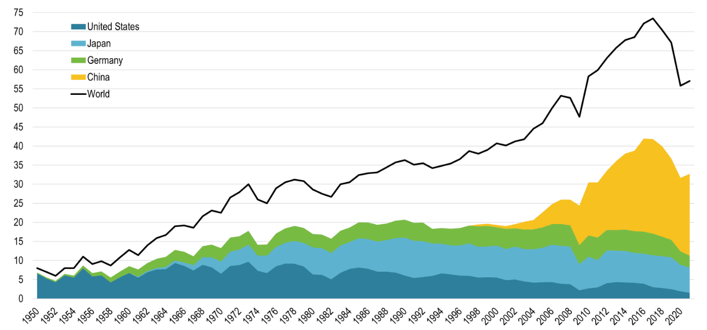
Figure 1.1 Automobile Production Selected Countries 1950-2022
The significant increase in vehicle ownership has led to numerous issues, with road safety being the most prominent. Globally, road safety remains a critical concern, causing substantial loss of life and property. Shockingly, one-fifth of all annual fatalities worldwide result from traffic accidents. In China alone, hundreds of thousands of people lose their lives to traffic accidents each year, millions are injured, and countless property losses are incurred (Jiang et al., 2017; Bi, 2012). The causes of traffic accidents are multifaceted, including road conditions, weather, vehicle defects, and driver errors. Human driving capabilities are inherently limited, and drivers often face issues such as lack of awareness, improper actions, and fatigue, all of which contribute to road safety incidents. Addressing the limitations of human driving is thus a key research direction for enhancing traffic safety. This need has driven the development of autonomous intelligent vehicles, which have garnered significant attention from global automotive corporations and technology enterprises.
In the development of autonomous driving technology, an intelligent transportation system centered around it has emerged. This system integrates various advanced technologies, including cloud computing, the Internet of Things (IoT), big data processing, and financial technology. It not only surpasses traditional highways in terms of improving transportation efficiency and generating economic benefits but also significantly reduces traffic safety issues caused by human driving errors (Chen, 2016).
In conclusion, autonomous driving technology in intelligent vehicles effectively addresses many issues caused by traditional human driving. Additionally, it plays a significant role in alleviating traffic congestion and reducing accident rates. With its promising prospects, autonomous driving technology has the potential to integrate with other emerging technologies, gradually driving a transformation in the transportation sector and reshaping people's lives. Therefore, the development of autonomous driving technology has become a major focus of research efforts worldwide.

1.1.2 Significance of the Research
The development of intelligent vehicles represents a significant revolution in the automotive industry, integrating advancements from multiple cutting-edge fields. It requires the application of advanced communication, computing, networking, and control technologies to enable real-time and continuous control of vehicles. The progress in these technologies has facilitated the research and development of intelligent driving systems. Moreover, the substantial demand in the field of autonomous driving has further driven the continuous advancement of these related technologies (Peng, 2019).
Firstly, the primary causes of traffic accidents in traditional road driving are driver fatigue and inadequate responses in critical situations. Autonomous driving technology in intelligent vehicles overcomes many of the limitations of human drivers in detecting dangers and making accurate decisions. Compared to human drivers, it provides more stable, precise, and efficient control, effectively addressing these issues, reducing the likelihood of accidents, and significantly enhancing driving safety (Yang et al., 2018).
Secondly, intelligent vehicles not only represent a revolution in driving technology but also contribute to the advancement of the entire transportation system. With the development of autonomous driving technology, a new modern intelligent transportation system is gradually taking shape (Ji et al., 2020). This intelligent transportation system integrates various advanced technologies, utilizing the powerful data collection capabilities of the Internet of Things (IoT) to manage road traffic, employing sensing technologies and AI-based vision systems to regulate the movement of different vehicles, and leveraging automated control technologies to ensure the system operates in a stable and efficient manner (Feng, 2020; Cui, 2017).
Thirdly, the development of intelligent vehicles is beneficial for conserving resources and reducing waste (Clements & Kockelman, 2017). In traditional human driving, differences in drivers' habits and techniques often lead to inefficient practices, resulting in fuel waste. Autonomous driving technology, however, can optimize operations based on road conditions, achieving better throttle control to save energy and minimize waste. Additionally, although vehicle ownership has increased significantly, the utilization rate of vehicles remains low. Autonomous driving systems, with the help of big data management, can repurpose idle vehicles, effectively reducing the waste of automotive resources.

1.2 The Current Research Status of Autonomous Intelligent Vehicle Technology
Intelligent vehicles integrate a variety of advanced scientific and technological innovations and have garnered significant attention since their inception. Their technological sophistication serves as a benchmark for a nation's research and development capabilities in the field of intelligent technologies (Chang, 2018).
The United States began exploring autonomous driving as early as the 1960s and remains a leader in the field today. In 2005, a team from Stanford University developed the intelligent vehicle Stanley, which successfully completed the DARPA Grand Challenge and won the competition (Buehler et al., 2009). In 2007, the DARPA challenge shifted to urban environments for the first time, significantly increasing the difficulty and aligning the competition closer to real-world driving conditions. Carnegie Mellon University, in collaboration with multiple institutions, developed the intelligent vehicle Boss, equipped with LiDAR and GPS, and won the Urban Challenge that year.In 2016, Waymo spun off from Google, focusing on the development of L4 and L5 autonomous vehicles. By designing its own autonomous driving hardware sensors, Waymo reduced costs, created technological advantages, accelerated development, and achieved seamless integration of hardware and software (Joseph & Lu, 2015). Additionally, Tesla has emerged as a frontrunner in the field of autonomous driving, leveraging its proprietary chips, ADAS platform, outstanding hardware cost efficiency, globally leading autonomous driving features, and intelligent cockpit designs. Tesla's autonomous driving capabilities are operational across a variety of scenarios, further cementing its position as a leader in this era (Chen, 2020).
Japan boasts a robust automotive industry, and its autonomous driving technology is also flourishing. As early as 2004, Japan proposed the construction of its first intelligent road, laying the foundation for the development of an intelligent transportation system. In 2020, Japan introduced a new road traffic law, providing legal protection for autonomous intelligent vehicles for the first time (Li & Shen, 2020).Many major automakers in Japan have positioned autonomous driving technology development as a strategic priority. Toyota, as one of the earliest companies to engage in this field, has established autonomous vehicle technology laboratories in both Japan and the United States. At the 2019 CES, Toyota introduced the TRI-P4, an autonomous test vehicle based on the Lexus LS500 platform. In the same year, Toyota launched the e-Palette, the world’s first comprehensive vehicle equipped with a mobile service platform. This vehicle combines intelligent dialogue, autonomous driving, and electrification, with plans for deployment the following year.
European countries have also been ambitious in the research and development of autonomous intelligent vehicles. As a leading automotive powerhouse, Germany has made substantial investments in recent years to support the autonomous vehicle industry. The country has built extensive infrastructure for autonomous driving and established a dedicated testing track for autonomous vehicles in Berlin, where real-time traffic data is collected to support technological advancements.Audi, a pioneer in autonomous driving, began investing in research and development in this field early on. In 2013 and 2014, Audi applied for and obtained autonomous driving licenses in several U.S. states, conducting extensive real-world testing and technical upgrades in realistic scenarios (Chen & Zhou, 2019).
China's autonomous driving technology has seen significant advancements in recent years. In the 1980s, Tsinghua University developed the THMR series of intelligent vehicles. However, due to the immature technology and underdeveloped sensor systems at the time, these vehicles could only rely on LiDAR and cameras to collect real-time road condition data for lane-keeping (Zhao, 2012).Subsequently, the National University of Defense Technology (NUDT), in collaboration with other universities, successfully developed the ATB-1 (Autonomous Test Bed-1) in 1992, which had independent intellectual property rights and greatly advanced the progress of China's autonomous vehicle technology. In July 2011, NUDT accelerated its research accumulation and technological advancements in autonomous driving and began collaborating closely with FAW Group in the same year (Yang, 2018). Together, they co-developed the Hongqi HQ3, which achieved a high level of autonomous driving capability.
In addition to research and exploration by universities and traditional automotive enterprises, the rapid development of autonomous driving technology has also given rise to numerous high-tech companies in the field, such as UISEE, Pony.ai, and AutoX, which have made significant progress. Major internet companies have also actively invested in this sector, seizing the opportunities of the times. For example, Baidu began allocating substantial resources to research autonomous vehicle technology in 2013 and has achieved remarkable success. Since 2016, the number of its patent applications has increased annually, with the growth rate of patents in autonomous driving and intelligent transportation surpassing the global average in recent years (BlackBerry, 2021; Baidu Apollo, 2021).

1.3 The Current Development Status of Local Path Planning Technologies
Local path planning involves dynamically generating plans in response to varying real-time road conditions encountered during vehicle navigation, such as emergency obstacle avoidance or lane changing. The paths generated through local planning are characterized by their temporal relevance and spatial locality (Feng, 2019; Zhang & Zhang, 2019).
In planning, global path planning does not account for real-time environmental information, such as road width and obstacle details. Instead, it primarily considers macro-level factors like traffic signs, total road length, and congestion levels. In contrast, local path planning generates paths based on real-time environmental data from the vehicle's current position. This data is obtained through in-vehicle sensors and radar devices, capturing signals, vehicle states, and information about both static and dynamic obstacles. To address varying road environments and driving requirements, numerous research institutions have conducted extensive experiments on local path planning and proposed a variety of algorithms.
Moritz Werling and Julius Ziegler proposed a trajectory generation method based on the concept of search, which operates in a discrete space and is closely integrated with the behavior layer (Karaman & Frazzoli, 2010). The method involves selecting the target configuration for the vehicle's motion in the Frenet coordinate system and then using polynomials to generate a set of navigable trajectories. From this set, the optimal trajectory is selected as the predicted path, with collision detection employed to assess its safety. Extensive experiments have demonstrated that this approach is practical and effective in structured road environments.
Hart introduced the A* algorithm in the 1960s, a search-based method that incorporates heuristic information into the mathematical retrieval process to reduce search efforts and complexity. Building on the A* algorithm, Likhachev and colleagues proposed the ARA* (Anytime Repairing A*) algorithm, which enables heuristic searches at any point in time (Likhachev et al., 2003). To address the issue of excessive sharp turns and lack of smoothness in the paths generated by the APA* algorithm, Zhao Xin and Hu Guangdi from Southwest Jiaotong University developed a key-point smoothing-based APA* algorithm. This improvement results in smoother paths, enhancing the algorithm's practicality for real-world applications (Zhao & Hu, 2017).
Algorithms similar to the RRT (Rapidly-Exploring Random Tree) algorithm have already been applied to real vehicles in the context of autonomous driving. To address issues such as excessive curvature discontinuities and suboptimal paths in the results of the RRT algorithm, Karaman and Frazzoli proposed an improved RRT* algorithm. This enhancement effectively mitigates these problems while optimizing the computational complexity and stability of feasible solutions (Kuffner & Lavalle, 2000).
Additionally, James I. Kuffner and colleagues introduced a bidirectional RRT algorithm, known as RRT-Connect (Kuffner & Lavalle, 2000). This method uses the planned start and goal points as root nodes to expand the random tree in both directions, significantly improving planning efficiency and contributing to the algorithm's real-time performance.
The Probabilistic Roadmap (PRM) method is another common path planning algorithm. It constructs a graph by randomly generating nodes in the state space and searches for the optimal path to connect the start and goal points within the graph (Kavraki et al., 1998). Que Jialan and Ding Guitao from Nankai University developed a new path planning algorithm based on the basic PRM method. This algorithm leverages heuristic information to guide the generation of high-quality nodes, significantly improving planning efficiency and success rates in complex environments (Que et al., 2003).
The Artificial Potential Field (APF) method is a path planning algorithm that creates virtual potential fields and forces to guide motion. It simulates the movement of an autonomous vehicle within a composite force field, where obstacles exert repulsive forces and the target point exerts attractive forces. The resultant force determines the vehicle's trajectory (Song et al., 2017). Compared to other path planning algorithms, the APF method generates the smoothest and safest paths (Fan et al., 2020).
In unstructured road scenarios, Takahashi A. and colleagues represented the planned path using quintic polynomials and selected path parameters based on the desired state of the vehicle. This approach is computationally simple and easy to implement. The continuity of the curvature in quintic polynomials plays a critical role in ensuring control stability (Takahashi et al., 1989).Werling M. and colleagues transformed environmental information into the Frenet coordinate system, making the positional relationships between the vehicle and other vehicles clearer. By determining the relative positions of other vehicles, quintic polynomials were used for path planning, resulting in more stable and adaptable local paths for varying environments (Werling et al., 2010).

1.4 The Current Development Status of Longitudinal and Lateral Control Technologies
The control module of autonomous intelligent vehicles represents the final layer of the system, responsible for tracking and executing the paths planned by the upper layers. Essentially, this module governs vehicle control, making it a critical focus of current autonomous driving research. To achieve better tracking performance, decoupled control methods are often employed. This approach involves designing two independent yet collaboratively functioning controllers, one for lateral control and the other for longitudinal control (Jiang, 2019).
Lateral control governs the vehicle's direction by manipulating the front wheel steering angle. A well-designed lateral control system prevents excessive lateral deviation, ensuring the stability of vehicle handling and enabling the vehicle to accurately follow the intended path. The effectiveness of lateral control is influenced by various factors, such as the vehicle's position, road curvature, and longitudinal speed. These factors must be carefully considered when designing the lateral controller to ensure optimal performance.Numerous research institutions worldwide have conducted extensive studies on vehicle lateral control, achieving significant successes in this field.
Based on the optimal preview control theory, Sharp et al. designed an adaptive trajectory tracking controller by sampling random errors and preview nodes. Using the collected samples, they calculated the desired steering angle for the vehicle, demonstrating strong performance in dynamic adaptability and trajectory tracking (Sharp et al., 2000).Ma Ying and Li Keqiang incorporated vehicle trajectory as part of trajectory control. They designed a performance index function effective over a local time frame based on the current deviation, preview deviation, and control variables. They also proposed a time-constrained optimal preview control algorithm (Ma et al., 2006). This algorithm can compute relevant parameters even in offline conditions, which is crucial for improving the real-time performance of the controller.
Soualmi and Sentouh designed a T-S fuzzy controller, which employs a fuzzy T-S approach to derive a linear matrix inequality (LMI) that enables the lateral control system to adapt to vehicle speed variations. This design ensures that the vehicle is not excessively affected by speed fluctuations during tracking (Soualmi et al., 2012).Li Yuan and Ma Rong from Northwestern Polytechnical University developed a variable structure sliding mode controller. This controller effectively addresses disturbances and parameter uncertainties encountered during vehicle motion. Extensive simulation tests demonstrated that it enhances control precision while ensuring the effectiveness and stability of the control system (Li et al., 2012).
Lateral control algorithms developed based on Model Predictive Control (MPC) theory heavily rely on the vehicle's own model. They can obtain predictive information within a finite time horizon and calculate optimal control variables based on this information. Compared to other lateral control algorithms, MPC can fully account for various constraints encountered during real-world driving, offering strong stability in control performance. This makes it particularly suitable for driving on structured roads, and it has already achieved significant success in practical tracking and driving operations. However, this method also has drawbacks, such as high computational costs and potential tracking instability caused by errors in constraint settings.
Longitudinal control, also known as speed control, involves the planning layer determining the appropriate throttle and brake actions in real-time based on the desired longitudinal speed to ensure the vehicle reaches the target position within the specified time frame. Accurate longitudinal control is critical to the operation of autonomous vehicles, with a primary focus on avoiding collision incidents in the longitudinal direction.
E. Jullierme and Augusto utilized parameter identification methods to establish a longitudinal kinematic model of the vehicle and thoroughly analyzed the nonlinear characteristics of longitudinal motion. They applied this model to compensate for model deviations in the control loop design and developed a longitudinal tracking system based on PI control theory, achieving favorable control results in simulation experiments (Dias et al., 2014).To address varying driving environments, J. Wang and colleagues designed an automatic reverse speed tracking controller based on a dynamic model. This controller adapts effectively to driving scenarios with different gradient resistances. Real-world vehicle experiments demonstrated its faster tracking response and higher control accuracy (Wang et al., 2013).
The longitudinal control algorithm developed based on PID control theory is widely applied to vehicle speed and position control. This algorithm collects vehicle state information in real time and adjusts throttle and brake signals according to the set control targets, thereby achieving precise longitudinal control. Compared to other longitudinal control algorithms, PID control offers advantages such as simple structure and ease of implementation. By adjusting proportional, integral, and derivative parameters, it enhances system response speed and control accuracy, making it suitable for various road scenarios.However, this control method has certain limitations, such as insufficient responsiveness to rapidly changing nonlinear environments and potential stability issues under high-load conditions. Therefore, in practical applications, integrating improved PID algorithms or other optimization strategies to address these shortcomings remains a key focus of further research.

1.5 Main Research Content and Chapter Arrangement of This Paper
In the context of the intelligent development of transportation systems, this paper conducts research on local path planning and trajectory tracking control for autonomous intelligent vehicles. For path planning, the Artificial Potential Field (APF) method is selected for analysis and improvement, addressing the shortcomings of the traditional APF method. In trajectory tracking control, Model Predictive Control (MPC) is used for controller design, leveraging its advantage of fully considering the vehicle's actual model and various constraints during road driving. Finally, a combined simulation of the proposed path planning and tracking control algorithms is conducted to verify the overall planning and control performance.
Chapter 1 is the introduction. It first highlights the continuous increase in private vehicle ownership and the numerous challenges faced in road driving, emphasizing the significance of developing autonomous intelligent vehicles. It then discusses the current state of autonomous vehicle development and the advancements in local path planning and lateral-longitudinal control technologies within autonomous driving. Finally, it outlines the strategic importance of these technologies for future industrial development.
Chapter 2 focuses on the design of the local path planning algorithm. The Artificial Potential Field (APF) method is selected as the local path planning algorithm, and improvements are made to address its existing issues of local minima and target non-reachability. To resolve the target non-reachability problem, the attractive potential energy at the target point is increased to enhance the attraction, enabling the vehicle to reach the target. To address the local minima issue, an escape force based on fuzzy control is introduced to help the vehicle overcome this condition. Additionally, a road boundary potential field is constructed to ensure the vehicle operates within structured roads. Finally, simulations are conducted to verify the effectiveness of the proposed improvements to the APF method.
Chapter 3 begins by introducing the fundamental principles of Model Predictive Control (MPC) and establishing a kinematic model. Based on this model, a trajectory tracking controller is designed. The effectiveness of the controller is validated through trajectory tracking simulations on an elliptical reference path. The results demonstrate that the controller can preliminarily accomplish trajectory tracking, though certain limitations remain.
Chapter 4 focuses on improving the shortcomings of the trajectory tracking controller presented earlier. The specific approach involves adopting a decoupled control strategy, with separate designs for a lateral front-wheel steering angle controller and a longitudinal speed controller. For lateral control, a simplified three-degree-of-freedom dynamic model is used as the predictive model, and tire slip angle constraints are incorporated into the design of the MPC controller. For longitudinal control, a dual-PID controller based on displacement and speed is designed. Simulation results demonstrate the effectiveness of the lateral and longitudinal control strategies, as well as the validity of the added tire slip angle constraints.
Chapter 5 proposes a joint simulation approach for the path planning algorithm and trajectory tracking algorithm, where the planned path is transmitted to the control layer in a discrete form. During the path transmission process, the discrete points are modulated using polynomial interpolation and then transmitted to the control layer. A simulation environment is subsequently set up for experimentation. The simulation results demonstrate that the planning layer and tracking layer can achieve efficient joint simulation.

Chapter 2 Local Path Planning Algorithm Based on the Improved Artificial Potential Field Method
Among various local path planning algorithms, the artificial potential field (APF) method is chosen as the path planning approach in this study. First, the fundamental principles and models of the APF method are introduced, including attractive and repulsive potential fields, as well as the potential field functions involved in these fields. The forces acting on the vehicle within the potential field and the planning principles are also described. Next, the shortcomings of the APF method are addressed through improvements, and the effectiveness of these improvements is validated through simulations.

2.1 Basic principles of the artificial potential field method
The Artificial Potential Field (APF) method is a local path planning algorithm based on a virtual force field, proposed by Dr. Khatib (Khatib, 1986). The core idea of this algorithm is to represent the road conditions encountered during actual driving by constructing a virtual potential field space. The primary components include the attractive potential field generated by the target point and the repulsive potential field generated by obstacles. These fields exert forces on the intelligent vehicle: the attractive potential field pulls the vehicle toward the target, while the repulsive potential field drives the vehicle away from obstacles. Under the influence of these two forces, the intelligent vehicle continuously plans its upcoming path and ultimately reaches the target point guided by the resultant force.
The Artificial Potential Field (APF) method not only introduces the concept of potential field forces but also the concept of potential field functions. Constructing potential field functions is a critical aspect of the APF method, with many variations, the most common being the gradient potential field approach. In this method, the attractive and repulsive forces acting on an intelligent vehicle within the potential field environment are represented by the negative gradients of the attractive and repulsive potential fields (Khatib, 1986; Kuffner et al., 2000). During the vehicle's journey, onboard sensors continuously perceive the surrounding environment, collect data, and detect potential hazards. Based on the road condition information gathered by the sensors, an attractive potential field is generated by the target point, and a repulsive potential field is created by obstacles. These fields guide the unmanned vehicle's path planning. The target point, as the endpoint of the path planning, generates an attractive potential field that represents the lowest potential energy in the process, resembling a valley that draws the planned path toward it. Conversely, the potential fields created by obstacles have higher values, acting like peaks, driving the vehicle to avoid them during the planning process.
In path planning, it is necessary to represent the potential field function for each position during the intelligent vehicle's journey. Therefore, a reasonable virtual potential field function is first established. Let the potential field function at the current position of the intelligent vehicle be U_{p}, which consists of the following two components:
- The attractive potential field function, U_{att}, generated by the target point represents the lowest potential energy along the path and serves as the primary driving force guiding the intelligent vehicle in path planning. The vehicle moves toward regions with lower potential energy, and as it approaches the target point, the distance between its position and the target decreases, leading to a gradual reduction in the attractive force. Eventually, the vehicle reaches the target point, where the attraction becomes minimal. The attractive force F_{att}, acting on the vehicle, is derived from the gradient of U_{att}, and its direction aligns with the steepest descent of the potential energy, corresponding to the negative gradient of the attractive potential field.
- The repulsive potential field function, U_{rep}, created by obstacles forms a repulsive potential field. The intelligent vehicle follows the principle of avoiding regions with high potential energy and moving toward areas of lower potential energy. As a result, the repulsive field values are generally high, resembling peaks on a three-dimensional potential energy map. The repulsive force acting on the vehicle depends on the real-time distance between the vehicle and the obstacles. When the distance is small, the repulsive force is large, and as the distance increases, the repulsive force diminishes. The magnitude of the repulsive force is determined by the gradient of the repulsive potential field function, and the repulsive force F_{rep} is defined as the negative gradient of the field, indicating the direction of the steepest decline in potential energy. In path planning, the vehicle is affected by the combined repulsive fields of multiple obstacles, so the total repulsive force is the sum of the repulsive forces generated by all obstacles.
The attractive potential field function and the repulsive potential field function, as mentioned earlier, combine through vector addition to form the potential field function U_{p}, expressed as $U_{p}=U_{att}+U_{rep}$. According to the basic principles of the artificial potential field method, the intelligent vehicle plans its path by avoiding high-potential obstacles and moving toward low-potential regions. Guided by the attraction of the attractive field and the repulsion of the repulsive field, the vehicle gradually reaches the target point. The descent path of the potential field function during path planning is determined by the resultant force direction formed by the attractive and repulsive potential fields. Onboard sensors continuously update road condition information and calculate the resultant force using the artificial potential field, ensuring the smooth execution of the path planning process.
In summary, the core concept of the artificial potential field (APF) method is to establish a virtual potential field and guide unmanned vehicles in path planning through potential energy differences within the field. This method is advantageous due to its ease of understanding, low computational complexity, and strong real-time performance. It delivers effective results in both global and local path planning. Additionally, the paths generated by this method are relatively smooth, making vehicle control easier to implement, enhancing comfort, and ensuring higher safety. However, the APF method has certain limitations that restrict its application in many fields, necessitating optimizations to address these shortcomings.

2.2 Construction of the potential field function
(1) Attractive potential field
The attractive potential field function is defined as U_{att} ​, which generates an attractive force to guide the intelligent vehicle. To simplify calculations, the vehicle is reduced to a point mass during the path planning process. Assuming the intelligent vehicle's position in two-dimensional space is p(x,y), in the traditional artificial potential field method, the attractive potential field function is expressed as:
$U_{att}=\frac{1}{2}k_{att}ρ^{n}(X,X_{g})$ (2.1)
In the formula, k_{att} is the attraction coefficient of the attractive potential field, X represents the coordinate position of the unmanned vehicle, X_{g} represents the coordinate position of the target point in the attractive potential field, n is the factor of the attractive potential field, and $ρ（X,X_{g}）$ is the relative distance between the target point and the unmanned vehicle.
In the above formula, the values of the attractive potential field factor n and the attraction coefficient k_{att} control the magnitude of the potential energy in the attractive potential field, playing a crucial role in path planning. In this study, the value of the attractive potential field factor n is set to 2, and its three-dimensional distribution is shown in Figure 2.1. The potential energy at the target point represents the global minimum potential energy, which corresponds to the lowest value in the figure. At this point, the attractive potential field function U_{att} is expressed as:
$U_{att}=\frac{1}{2}k_{att}ρ^{2}(X,X_{g})$ (2.2)
From this formula, it can be seen that the value of the attractive potential field acting on the intelligent vehicle is proportional to the square of the distance between the vehicle and the target point. The farther the vehicle is from the target point, the smaller the influence of the potential energy function. Its direction is essentially aligned with the straight line connecting the vehicle and the target point.
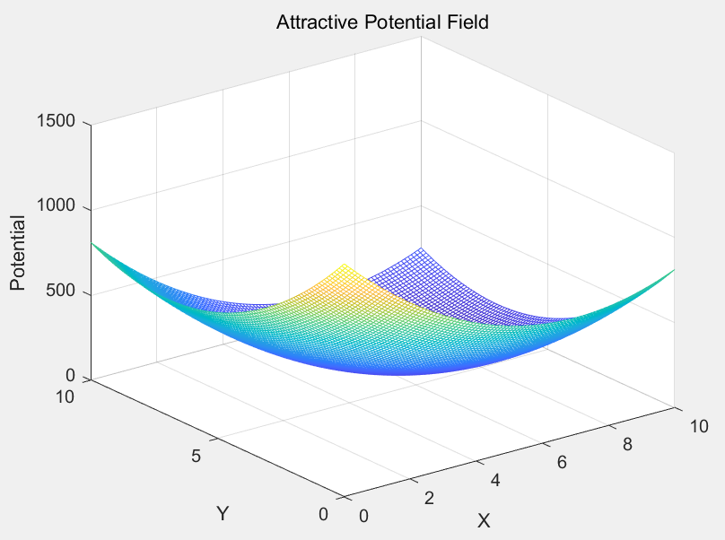
Figure 2.1 Attractive Potential Field
By deriving the attractive potential field function, the attractive force F_{att} can be obtained. Based on the theory of the gradient descent method, its direction is the direction of the steepest decrease in the potential energy of the unmanned vehicle. The expression for F_{att} is:
$-\frac{1}{2}k_{att}*∇ρ^{2}(X,X_{g})=-\frac{1}{2}k_{att}(X-X_{g})$ (2.3)
From the above equation, the magnitude of the attractive force F_{att} is adjusted by the attraction coefficient k_{att} and is a linear function. Its value decreases as the distance between the vehicle and the target position decreases.
(2) Repulsive potential field
Let the repulsive potential field formed by obstacles be U_{rep}. In the three-dimensional potential field diagram, the potential energy values generated by the repulsive potential field function are relatively high, resembling peaks. Under the influence of the repulsive potential field, the unmanned vehicle moves in a direction that avoids the repulsive field, achieving obstacle avoidance. The repulsive potential field of obstacles has an effective range of influence on the vehicle. Within this range, the closer the vehicle is to the obstacle, the greater the repulsive force it experiences; conversely, the farther it is, the smaller the repulsive force.
According to the description of the repulsive potential field, its mathematical expression can be written as:
$U_{rep}=\left\{\begin{aligned}&\frac{1}{2}k_{rep}{\left(\frac{1}{ρ(X,X_{obs})}-\frac{1}{ρ_{0}}\right)}^{2},ρ(X,X_{obs})≤ρ_{0} \\ &0,ρ(X,X_{obs})>ρ_{0}\end{aligned}\right.$ (2.4)
In the above equation, k_{rep} is the proportional coefficient of the repulsive potential field, X represents the coordinate position of the vehicle, X_{obs} represents the coordinate position of the obstacle, $ρ_{0}$ is the influence range of the obstacle, and $ρ（X,X_{obs}）$ represents the distance between the unmanned vehicle and the obstacle.
From the above equation, the magnitude of the repulsive potential field U_{rep} is determined by the repulsive potential field proportional coefficient k_{rep} and the distance between the unmanned vehicle and the obstacle. The farther the unmanned vehicle is from the obstacle, the smaller the value of the repulsive potential field function. Its direction aligns with the line connecting the vehicle and the obstacle.
In the three-dimensional diagram, the potential field of the obstacle is depicted as shown in Figure 2.2, resembling a high-value peak region. In path planning, the vehicle moves from regions of high potential energy to regions of low potential energy. Once the vehicle enters the influence range of an obstacle, it begins to experience a repulsive force, gradually moving away from the obstacle under this influence, thereby completing the obstacle avoidance path planning. The entire obstacle avoidance planning process fully considers the smoothness of vehicle braking, resulting in a relatively smooth and continuous path. When the vehicle enters an area influenced by the repulsive potential fields of multiple obstacles, the resultant repulsive force acting on it is the vector sum of the repulsive forces exerted by different obstacles. This vector sum is continuously recalculated as the vehicle moves.
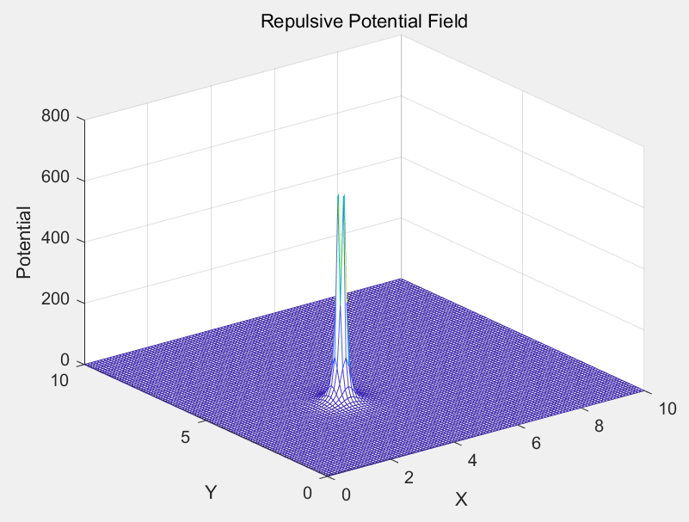
Figure 2.2 Repulsive Potential Field
Let the repulsive force be F_{rep}, which is derived from the repulsive potential field function U_{rep}. According to the theorem of the gradient descent method, its direction corresponds to the direction of the steepest decrease in repulsive potential energy, i.e., the negative gradient of the repulsive potential field. The expression is as follows:
$F_{rep}=-∇U_{rep}=\left\{\begin{aligned}&k_{rep}(\frac{1}{ρ(X,X_{obs})}-\frac{1}{ρ_{0}})\frac{∇ρ(X,X_{obs})}{ρ^{2}(X,X_{obs})},ρ(X,X_{obs})≤ρ_{0} \\ &0,ρ(X,X_{obs})>ρ_{0}\end{aligned}\right.$ (2.5)
From the equation, it can be observed that when the vehicle's position is close to the obstacle, the repulsive force becomes very large. As the vehicle's position moves farther away from the obstacle, the repulsive force gradually decreases, and when the distance reaches $ρ_{0}$, the repulsive force disappears completely. The magnitude of the repulsive force F_{rep} is determined by the repulsive proportional coefficient and the distance between the obstacle and the target. In obstacle avoidance planning, if the obstacles are not concentrated but rather dispersed, and there are significant differences in obstacle sizes, $ρ_{0}$ is typically set based on the value for large obstacles. For obstacles near the target point, a smaller $ρ_{0}$ is often chosen to plan a more reasonable path.
(3) Combined potential field
The attractive potential field function and the repulsive potential field function have been derived earlier. The combined potential field function is obtained by superimposing the two and can be expressed as:
$U_{p}=U_{rep}+U_{att}$ (2.6)
In the three-dimensional potential field, the combined potential field is depicted as a three-dimensional diagram, shown in Figure 2.3. This diagram includes both the repulsive potential field of obstacles and the attractive potential field of the target point. As shown in the figure, the potential energy at the obstacles represents the global maximum, while the potential energy at the target point represents the global minimum. The repulsive force acting on the intelligent vehicle at a given position is determined by the distance between the vehicle and the obstacle, while the magnitude of the attractive force is determined by the distance between the vehicle's position and the target point.
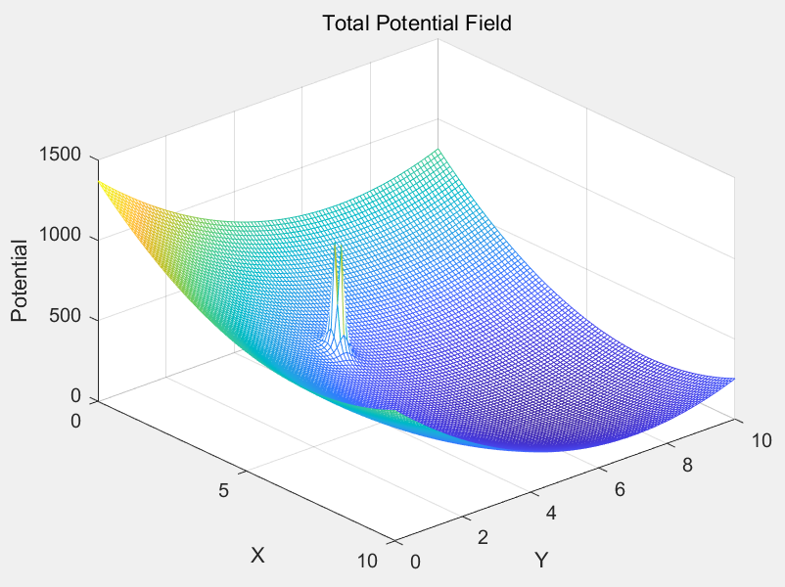
Figure 2.3 Total Potential Field
By superimposing the repulsive force function F_{rep} and the attractive force function F_{att}, the resultant force function F_{p} acting on the unmanned vehicle in the potential field can be obtained. Its mathematical expression is:
$F=-∇U_{P}=-∇U_{rep}=F_{att}+F_{rep}$ (2.7)
Therefore, during the path planning process, the potential field value and the resultant force at any position in the potential field space for the intelligent vehicle can be calculated. Under the influence of the resultant force, the vehicle moves, and real-time calculations are performed using the artificial potential field method to ensure a smooth and efficient path planning process, ultimately reaching the target point.

2.3 Analysis of the deficiencies of the artificial potential field method

2.3.1 Goal unreachability problem
In path planning, the intelligent vehicle is constantly influenced by the attractive force from the target's attractive potential field and the repulsive force from the obstacles' repulsive potential field. When obstacles are located near the target point, the unmanned vehicle may easily encounter situations where the target becomes unreachable. A typical scenario is when the unmanned vehicle, the target point, and the obstacle are aligned on the same straight line, as illustrated in Figure 2.4.

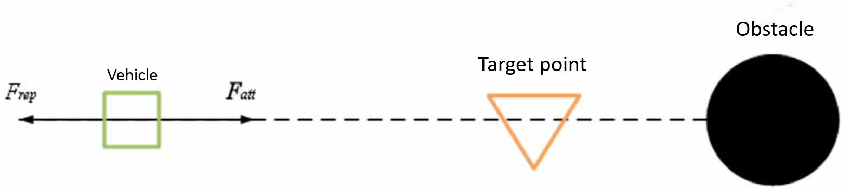
Figure 2.4 Example of unreachable target problem
In this scenario, as the intelligent vehicle approaches the target point, it enters the repulsive influence range of the obstacles surrounding the target and starts experiencing the repulsive force from the obstacles. As the distance between the vehicle, the target point, and the obstacles decreases, the attractive force of the target point diminishes, while the repulsive force of the obstacles increases (Khatib, 1986; Zhang et al., 2003). At this point, the vehicle may reach a position where the attractive force from the target point and the repulsive force from the obstacle are equal in magnitude and opposite in direction, creating a balance in potential energy—referred to as a zero-potential-energy point. The intelligent vehicle may become stuck at this zero-potential-energy point, unable to proceed further, resulting in the failure to reach the target point. This phenomenon is a typical example of the target unattainability problem in the traditional artificial potential field method.

2.3.2 Local minima problem
When using the artificial potential field method for local path planning, the intelligent vehicle may, in certain situations, experience a resultant force where the combined effect of the attractive and repulsive forces becomes zero. In such cases, the vehicle cannot continue to move forward, getting stuck in a local minimum rather than a global minimum, which results in path planning failure (Khatib, 1986; Zhang et al., 2003; Song et al., 2017). Local minimum issues can be categorized into two scenarios: one caused by a single obstacle aligned with the target, and the other caused by multiple obstacles. The following sections will provide a detailed analysis of these two scenarios.
- Local minimum problem caused by collinear single obstacle
Analyze the typical force scenario when the unmanned vehicle is trapped in this local minimum. In such cases, the vehicle's position, the obstacle, and the target point are collinear, with the obstacle located between the vehicle and the target point, positioned relatively close to the vehicle. A force analysis diagram for this situation is illustrated in Figure 2.5:
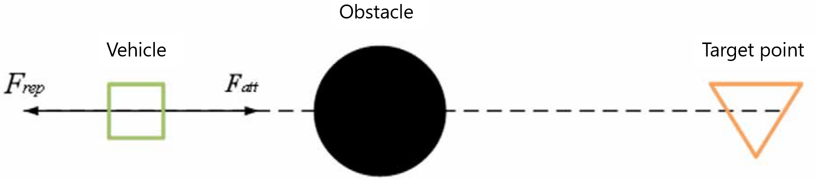
Figure 2.5 Single Obstacle Local Minimal Value
When performing path planning, the unmanned vehicle moves under the combined effect of the attractive force from the target point and the repulsive force from the obstacle. In this scenario, due to the obstacle being close to the target point, the repulsive force acting on the vehicle is significant and equals the magnitude of the attractive force from the target point. Since these forces are in opposite directions, the vehicle experiences a resultant force of zero, preventing it from moving forward.
- Local minimum problem caused by multiple obstacles
Since the road conditions faced by vehicles during actual driving are more complex and involve multiple obstacles, the local minimum scenarios caused by multiple obstacles are more common. When the resultant repulsive force exerted by multiple obstacles equals the resultant attractive force from the target point in magnitude but is opposite in direction, the vehicle becomes trapped in a local minimum caused by multiple obstacles. A typical scenario of a local minimum caused by multiple obstacles is illustrated in Figure 2.6:
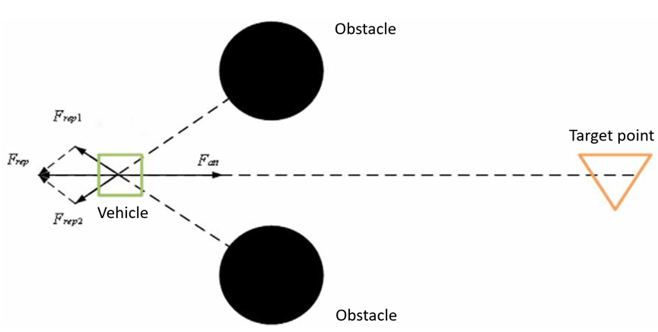
Figure 2.6 Multi-Obstacle Local Minimal Value
In this scenario, the unmanned vehicle is subjected to the combined repulsive force of two obstacles. When it reaches a region where the resultant force is zero, it can no longer move forward. Instead, it exhibits irregular wandering motion and is unable to continue progressing toward the target point.

2.4 Improvement of the goal unreachability problem
As discussed earlier, the reason why the intelligent vehicle cannot reach the target is that the attractive force near the target point is too weak, while the repulsive force generated by obstacles is too strong. To address this issue, this study proposes a method of potential energy filling for the target point to enable the autonomous vehicle to overcome the target unattainability problem. This method increases the potential energy value of the target point to enhance the attractive force acting on the autonomous vehicle, ensuring that the vehicle's zero-potential-energy point coincides with the target point, thereby resolving the issue of failing to reach the target.
According to Equation 2.3, the attractive force decays to zero at the target point. Therefore, the potential energy filling value at the target point must be equal to the repulsive potential energy value caused by the obstacle. This value is expressed as:
$U_{sup}=\frac{1}{2}k_{rep}{\left(\frac{1}{ρ_{1}}-\frac{1}{ρ_{0}}\right)}^{2}$ (2.8)
In this formula, $ρ_{1}$ represents the relative distance between the obstacle and the target point, which generates a repulsive force near the target point, defined as $ρ_{1}=\left|X_{obs}-X_{g}\right|$. Substituting Equation 2.8 into the attractive potential field function, the attractive potential field function becomes:
$U_{att}=\frac{1}{2}k_{att}ρ^{2}(X,X_{g})+\frac{1}{2}k_{rep}(\frac{1}{ρ_{1}}-\frac{1}{ρ_{0}})^{2}$ (2.9)
The combined potential field function becomes:
$U_{total}=\left\{\begin{aligned}&\frac{1}{2}k_{att}ρ^{2}(X,X_{g})+\frac{1}{2}k_{rep}(\frac{1}{ρ_{1}}-\frac{1}{ρ_{0}})^{2}+\frac{1}{2}k_{rep}{\left(\frac{1}{ρ(X,X_{obs})}-\frac{1}{ρ_{0}}\right)}^{2},ρ≤ρ_{0} \\ &\frac{1}{2}k_{att}ρ^{2}(X,X_{g})+\frac{1}{2}k_{rep}(\frac{1}{ρ_{1}}-\frac{1}{ρ_{0}})^{2},ρ>ρ_{0}\end{aligned}\right.$ (2.10)
The potential energy filling scheme in actual path planning must account for the issue of excessive potential energy filling. If the potential energy is overfilled, the zero-potential-energy point will lie beyond the target point, causing the vehicle to overshoot the target and resulting in planning failure. To address this issue, this study proposes a solution by introducing a distance ratio function, which is incorporated into both the repulsive potential field function and the attractive potential field function. Its form is as follows:
$V(x)=\frac{d_{1}(x)}{d_{2}(x)}$ (2.11)
In the above formula, $d_{1}(x)$ represents the distance between the intelligent vehicle and the target point, expressed as $d_{1}\left(x\right)=X-X_{g}$. To avoid the situation where this formula becomes undefined, $d_{2}(x)$ must not be zero. It is therefore defined as $d_{2}\left(x\right)=d_{1}\left(x\right)+c$, where c is a constant. Thus, V(x) can be expressed as:
$V(x)=\frac{X-X_{g}}{X-X_{g}+c}$ (2.12)
The mathematical properties of the distance ratio function are:
$\begin{aligned}&\lim_{X-X_{g}→∞} V(X)=\lim_{X-X_{g}→∞} \frac{X-X_{g}}{X-X_{g}+c}=\lim_{X-X_{g}} \frac{1}{1+\frac{1}{X-X_{g}}}=1 \\ &\lim_{X-X_{g}→0} V(X)=\lim_{X-X_{g}→0} \frac{X-X_{g}}{X-X_{g}+c}=0\end{aligned}$ (2.13)
Add the distance ratio function to the gravitational potential field function to obtain:
$U_{att}=(\frac{1}{2}k_{att}ρ^{2}(X,X_{g})+U_{sup})(V\left(x\right))^{n}$ (2.14)
The above formula can be expressed as:
$U_{att}=(\frac{1}{2}k_{att}ρ^{2}(X,X_{g})+U_{sup})(\frac{X-X_{g}}{X-X_{g}+c})^{n}$ (2.15)
Add the distance ratio function to the repulsive potential field function to obtain:
$U_{rep}=\left\{\begin{aligned}&\frac{1}{2}k_{rep}(\frac{1}{ρ(X,X_{obs})}-\frac{1}{ρ_{0}})^{2}(V(X))^{n},ρ≤ρ_{0} \\ &0,ρ>ρ_{0}\end{aligned}\right.$ (2.16)
So the resultant potential field function is:
$U_{total}=\left\{\begin{aligned}&(\frac{1}{2}k_{att}ρ^{2}(X,X_{g})+U_{sup}+\frac{1}{2}k_{rep}(\frac{1}{ρ(X,X_{obs})}-\frac{1}{ρ_{0}})^{2})(\frac{X-X_{g}}{X-X_{g}+c})^{n},ρ≤ρ_{0} \\ &(\frac{1}{2}k_{att}ρ^{2}(X,X_{g})+U_{sup})(\frac{X-X_{g}}{X-X_{g}+c})^{n},ρ>ρ_{0}\end{aligned}\right.$ (2.17)
From this equation and the introduced distance ratio function, it can be observed that the influence of the distance ratio function on the potential energy value at the target point is closely related to the distance between the autonomous vehicle and the target point. The farther the distance, the smaller the influence. When the distance is zero, the combined potential energy value at the target point also becomes exactly zero.

2.5 Improvement of the local minima problem
Aiming at the problem that intelligent vehicles are prone to fall into local minima, this paper proposes a breakaway force based on fuzzy control as an improvement method.
The local optimum problem arises when the attractive and repulsive forces acting on the unmanned vehicle are collinear or when the resultant force is zero. This study employs the method of adding an escape force to help the unmanned vehicle break free from local traps. When the unmanned vehicle is detected to have reached a local minimum, an escape force is applied, with its magnitude calculated using a fuzzy algorithm. Taking the scenario of collinear attractive and repulsive forces as an example, as shown in Figure 2.7, the attractive and repulsive forces are in opposite directions, causing the unmanned vehicle to wander at the local minimum point. The escape force F_{f} is applied at an angle of 90°to the resultant force of the potential field acting on the vehicle.
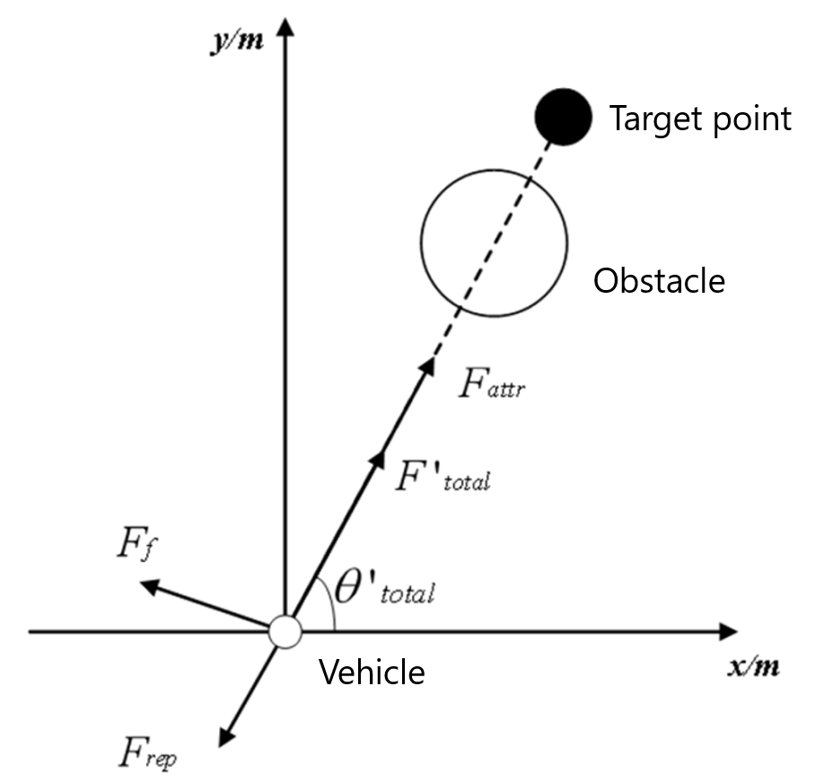
Figure 2.7 Breakaway force based on fuzzy control
The magnitude of the escape force is calculated using a fuzzy algorithm, and the fuzzy inference process adopts the Mamdani fuzzy model. To achieve accurate fuzzy inference results, the fuzzy controller in this study uses a dual-input, single-output format. The inputs are the angle $α$ between the attractive and repulsive forces and the magnitude difference F between the attractive and repulsive forces, while the output is F_{fuzzy}. The range of F_{fuzzy} is [-1, 1]. To achieve better control performance, F_{fuzzy} needs to be amplified, expressed as:
$F_{f}=F_{fuzzy}*ω$ (2.18)
In the formula, F_{f} represents the magnitude of the escape force, F_{fuzzy} is the output of the fuzzy controller, and $ω$ is the gain coefficient of the escape force. The angle $α$ between the attractive and repulsive forces lies within $\left[-π,π\right]$, and after fuzzification, its fuzzy set is M = {NB, NM, ZO, PM, PB}. The domain of the magnitude difference F between the attractive and repulsive forces is [-1, 1] , and after fuzzification, its fuzzy set is N = {NB, NM, ZO, PM, PB}.
The domain of F_{fuzzy} is [-1, 1], and after fuzzification, its fuzzy set is Q = {NB, NM, ZO, PM, PB}. Both the inputs and output of the fuzzy controller use triangular membership functions, as shown in Figures 2.8 to 2.10.

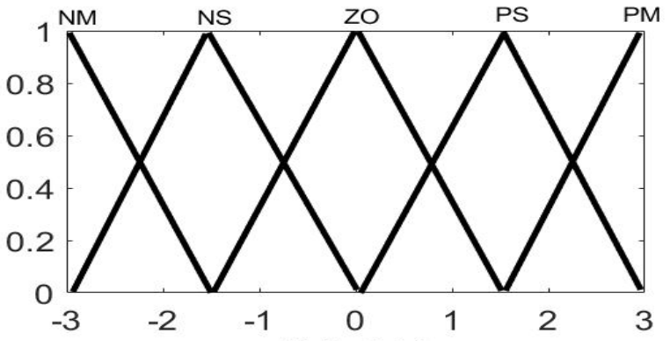
Figure 2.8 The affiliation function of $α$
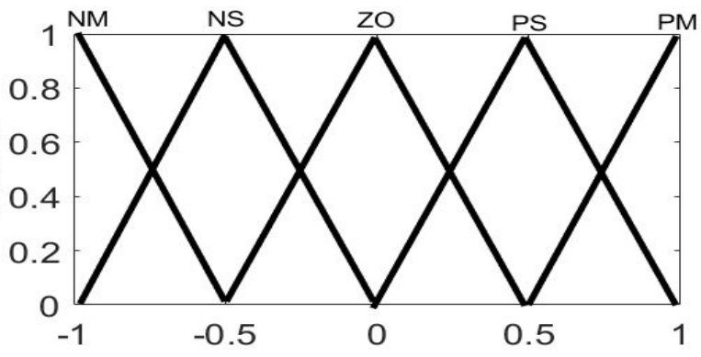
Figure 2.9 The affiliation function of $F$
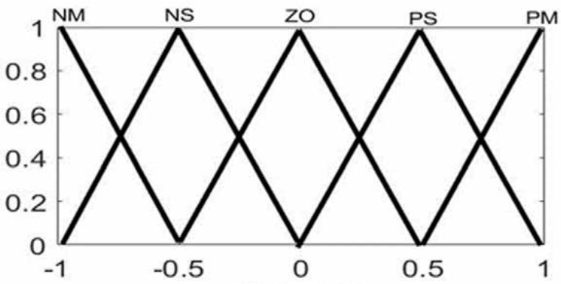
Figure 2.10 The affiliation function of $F_{fuzzy}$
The fuzzy reasoning rules in this paper are as follows:
$\begin{aligned}&R^{i}:if α {is M}^{i},F is N^{i},then{ F}_{fuzzy} is{ Q}^{i} \\ &i=1,2,⋯,n\end{aligned}$ (2.19)
The fuzzy rule table is shown in Table 2.1. The defuzzification of the inference results is done using the centroid method.
Table 2.1 Fuzzy rules
F | $$α$$
F | NB | NM | ZO | PM | PB
NB | NB | NM | NM | ZO | PM
NM | NB | NM | ZO | ZO | PM
ZO | NM | NM | ZO | PM | PM
PM | NM | ZO | ZO | PM | PB
PB | NM | ZO | PM | PM | PB

2.6 Construction of repulsive potential field for road boundaries
Autonomous intelligent vehicles traveling on structured roads must not cross the boundaries during path planning. Therefore, it is necessary to construct a repulsive potential field for the road boundaries. The idea behind constructing the road boundary repulsive potential field is to ensure that as the autonomous vehicle approaches the lane boundary, the potential energy value increases rapidly, reaching its maximum at the boundary line. This generates the maximum repulsive force to prevent the vehicle from crossing the road boundary. The faster the potential energy value changes as the vehicle approaches the boundary line, the safer the path planning becomes. Based on this characteristic, the potential field function is constructed as follows:
$U_{road,j}=A_{road}{\left(\frac{1}{(y-y_{road,j})}\right)}^{2}$ (2.20)
In the formula, $A_{road}$ is the potential field coefficient of the road boundary, and $y_{road,j}$ represents the position of the boundary line of the j-th road.
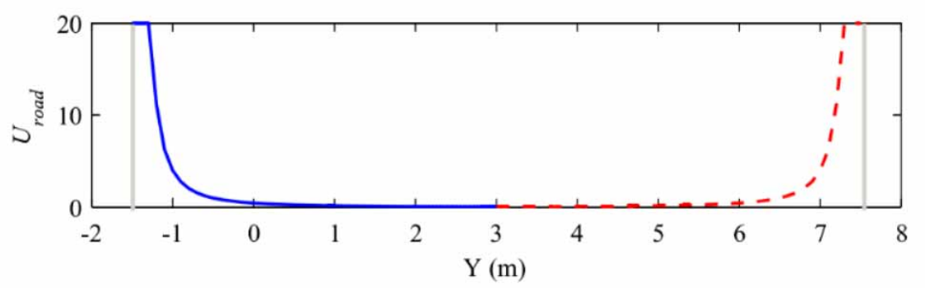
Figure 2.11 Road boundary repulsion potential field value
Figure 2.11 shows the repulsive potential field diagram of boundary lines for a straight three-lane road. It can be observed that the potential values rise rapidly on both sides of the road, generating a significant repulsive force to prevent the vehicle from crossing the road boundaries.

2.7 Simulation and result analysis
To verify the effectiveness of the improved APF algorithm based on potential field filling and fuzzy escape force proposed in this chapter, two simulation scenarios were designed to address the local minima and unreachable target problems. Simulations were conducted in MATLAB to analyze and compare the conventional APF algorithm with the proposed algorithm. The simulation results are shown in Figures 2.12 to 2.15. In the figures, the blue rectangle represents the starting point of the path planning, the red pentagram denotes the target point, circles indicate obstacles, red lines represent the planned path, the horizontal axis corresponds to the longitudinal position coordinates of the road, and the vertical axis corresponds to the lateral position coordinates of the road. The main parameters used in the simulations are listed in Table 2.2.
Table 2.2 Path planning simulation parameters
Parameter Name and Symbol | Value
Attractive Potential Field Coefficient $k_{att}$ | 13
Repulsive Potential Field Coefficient $k_{rep}$ | 7
Obstacle Influence Distance Range $ρ_{0}$ | 1m
Escape Force Gain Coefficient $ω$ | 150
Road Boundary Potential Field Coefficient $A_{road}$ | 10
- Local Minima
In the conventional APF algorithm, situations may arise where the resultant potential field force becomes zero, causing the vehicle to be unable to move forward and fall into a local minimum. In such cases, the vehicle exhibits irregular wandering around obstacles, as shown in Figure 2.12. However, the improved algorithm proposed in this study introduces a fuzzy escape force, effectively enabling the vehicle to overcome the condition of zero resultant force. This allows the vehicle to continue moving forward and eventually reach the target point, as illustrated in Figure 2.13.
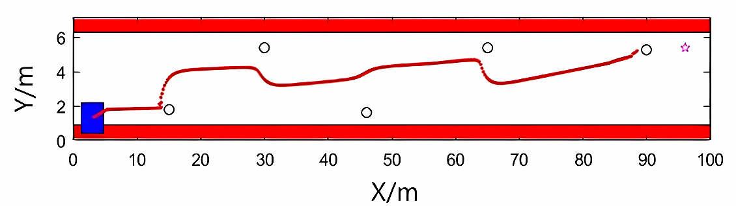
Figure 2.12 Conventional APF method local minima situation
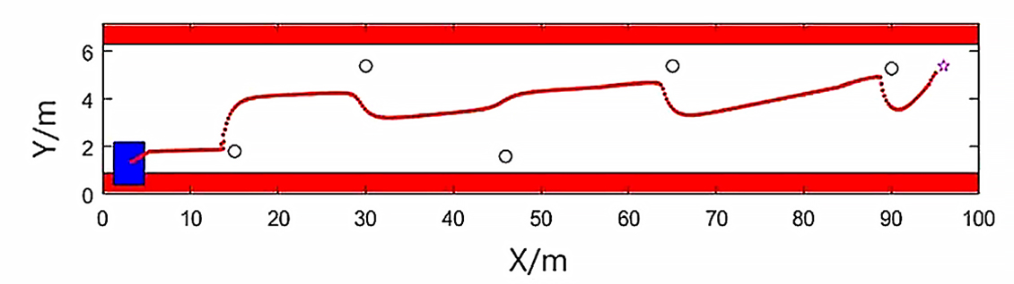
Figure 2.13 Improved APF method local minima situation
- Unreachable target problem
When a large repulsive obstacle is located near the target point, the attractive force around the target point gradually diminishes to zero, while the repulsive potential field of the obstacle continues to exert repulsive forces that increase as the distance decreases. In this situation, the vehicle cannot be guided to the target point by the attractive force, preventing it from reaching the target. As shown in the path planning simulation in Figure 2.14, under the conventional APF algorithm, the vehicle stops moving forward at a distance of approximately 5 meters from the target point due to the obstacle's repulsive force. In contrast, the proposed algorithm increases the potential value of the target point through potential field filling, enhancing the attractive force at the target point. As shown in Figure 2.15, the strengthened attractive force successfully overcomes the significant repulsive force of the obstacle, enabling the vehicle to reach the target point smoothly.
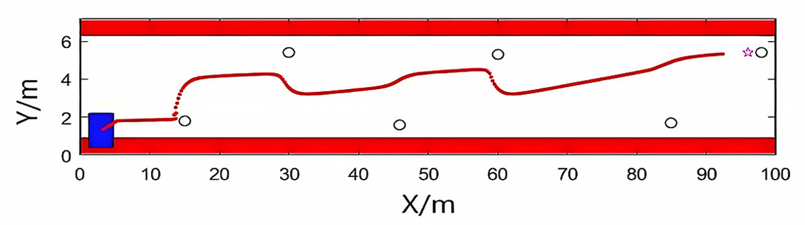
Figure 2.14 Conventional APF method target unreachable situation
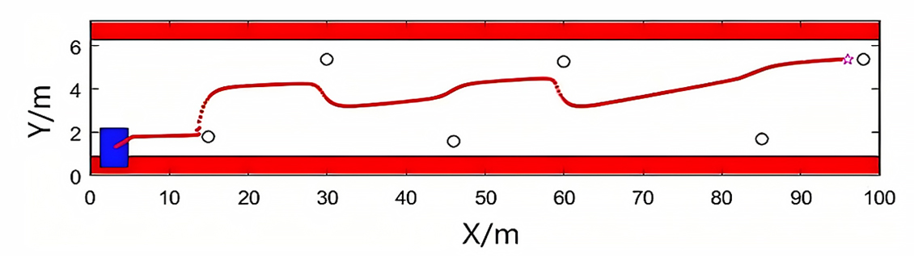
Figure 2.15 Improving APF method target unreachable situation
From the above simulations, it can be seen that the proposed improved algorithm effectively overcomes the issues of unreachable targets and local minima faced by the conventional APF algorithm, significantly improving the success rate of path planning. Therefore, applying this algorithm to practical scenarios of autonomous driving offers higher safety.

Summary of This Chapter
This chapter first introduces the artificial potential field (APF) method and its basic principles, explaining how intelligent vehicles perform path planning within a potential field. It then analyzes two major issues of the APF method: unreachable targets and local minima. To address these problems, improvements are made by employing potential field filling at the target point and introducing the concept of escape force. Additionally, a road boundary repulsive potential field is incorporated to enable the vehicle to navigate structured roads more effectively. Finally, simulation environments are set up to conduct experiments on the APF method designed in this chapter. The experimental results demonstrate that the proposed method significantly improves the handling of unreachable targets and local minima.

Chapter 3 MPC Trajectory Tracking Controller Based on the Kinematic Model
Model predictive control (MPC) theory offers significant advantages for trajectory tracking in intelligent vehicles. This algorithm can address complex technical problems with various constraints, introducing limitations during autonomous vehicle control while providing better motion control. Therefore, this chapter designs a model predictive controller based on a kinematic model.

3.1 Basic principles of model predictive control
Model Predictive Control (MPC), also known as Receding Horizon Control, is a rolling optimization method used to solve optimal control problems. The MPC algorithm typically consists of three steps: predicting the future output of the system, solving the optimal control sequence for the system, and applying the first element of the solved optimal control sequence to the controlled system (Lorenzen et al., 2017). The control principle is illustrated in Figure 3.1.
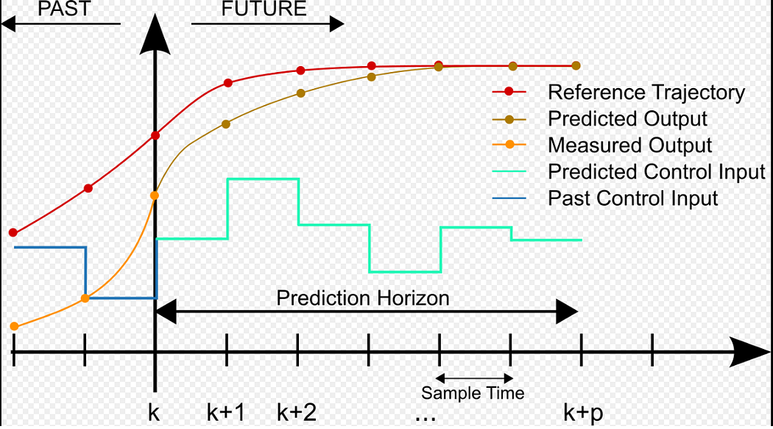
Figure 3.1 MPC control principle
MPC and optimal control are both methods for solving optimization problems. Optimal control requires specifying and solving the entire control horizon to ensure global optimization. However, it struggles with nonlinear and complex constraints, demands high model accuracy, and cannot solve problems in real-time. In contrast, MPC effectively addresses these challenges by performing optimization over a rolling time horizon, enabling real-time online solutions with greater flexibility for handling constraints and model inaccuracies.
Unlike PID control, MPC integrates multiple PID controllers to handle multiple input/output problems, making it challenging to address the coupling between different control loops. This complicates parameter tuning for each PID controller. Moreover, PID lacks the ability to impose constraints on system state variables and cannot predict future control variables. MPC, on the other hand, excels in multi-input multi-output (MIMO) systems by easily predicting future control sequences, as well as constrained state and control variables. To a certain extent, it achieves local optimality within its prediction horizon.
In summary, MPC is one of the most effective methods to deal with multi-optimization objective and multi-constraint system control problems.

3.2 Vehicle kinematic model
The vehicle kinematic model is often used in studies of vehicle-related control problems. It accurately describes the motion states of a vehicle and facilitates the establishment of reliable motion state equations. In this study, the vehicle kinematic model is also considered for designing the trajectory tracking controller. The modeling begins by treating the entire vehicle as a rigid particle, as shown in Figure 3.2. In the inertial coordinate system XOY, $φ$ represents the vehicle's yaw angle, and $σ_{f}$ represents the front wheel steering angle.
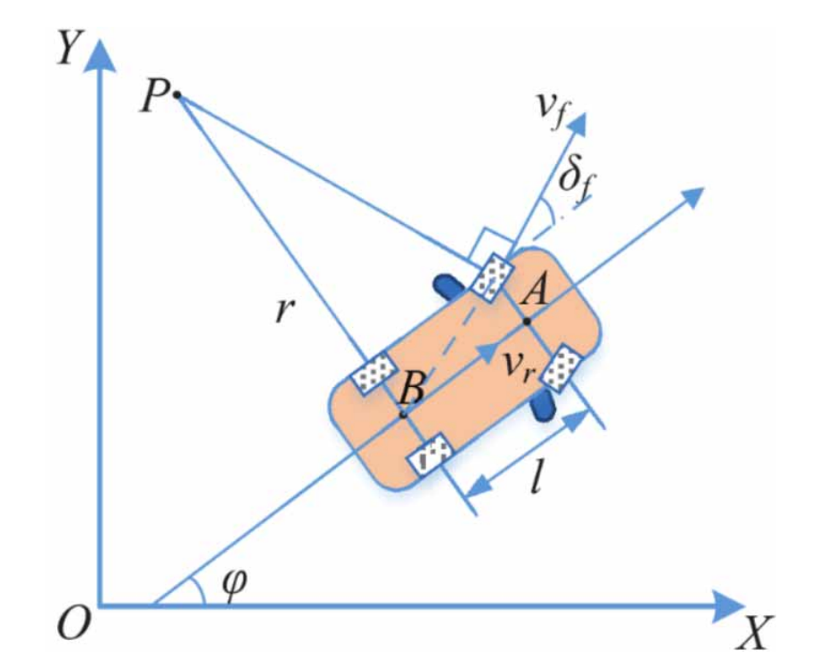
Figure 3.2 Vehicle kinematic model
Assuming that no sliding occurs during the vehicle's steering motion, the following kinematic constraints can be established:
$\left\{\begin{aligned}& \\ &\dot{x_{f}}sin⁡(φ+σ_{f})-\dot{y_{f}}cos⁡(φ+σ_{f})=0 \\ & \\ &\dot{x_{r}}sin⁡φ-\dot{y_{r}}cos⁡φ=0 &&\end{aligned}\right.$ (3.1)
At the rear wheel axis, its velocity $v_{r}$ is expressed as:
$v_{r}=\dot{x_{r}}cos⁡φ+\dot{y_{r}}sin⁡φ$ (3.2)
Combining equations 3.1 and 3.2, we can get the relationship between the coordinates of the rear wheel axis of the vehicle and its speed:
$\left\{\begin{aligned}& \\ &\dot{x_{r}}=ν_{r}cos⁡φ \\ & \\ &\dot{y_{r}}=ν_{r}sin⁡φ\end{aligned}\right.$ (3.3)
The relationship between the front and rear axle positions and the wheelbase of the vehicle is:
$\left\{\begin{aligned}&x_{f}=x_{r}+lcos⁡φ \\ &y_{f}=y_{r}+lsin⁡φ\end{aligned}\right.$ (3.4)
The vehicle's instantaneous turning radius can be denoted as $PB=r$. Based on the above mechanical analysis, the yaw rate of the vehicle can be expressed as:
$\dot{φ}=\frac{ν_{r}}{l}tan⁡δ_{f}$ (3.5)
By selecting $x={\left[\begin{aligned}x_{r},y_{r},φ\end{aligned}\right]}^{T}$ as the vehicle's state vector and $u={\left[\begin{aligned}ν_{r},δ_{f}\end{aligned}\right]}^{T}$ as the control input vector, the vehicle kinematic model can be expressed as:
$\left[\begin{aligned}\dot{x_{r}} \\ \dot{y_{r}} \\ \dot{φ}\end{aligned}\right]=\left[\begin{aligned}cos⁡φ \\ sin⁡φ \\ \frac{tan⁡δ_{f}}{l}\end{aligned}\right]ν_{r}$ (3.6)
The vehicle kinematic model can be further expressed in the general form:
$\dot{x}=f(x,u)$ (3.7)
Thus, through the mechanical analysis of the vehicle's motion process, the kinematic modeling of the autonomous vehicle is completed. This model will serve as the predictive model for subsequent controller design.

3.3 Design of MPC trajectory tracking controller
In the previous section, a kinematic model describing the vehicle's motion state was established. Next, an MPC trajectory tracking controller based on the kinematic model will be designed.
In this chapter's study, the control inputs for the controller are set as the front wheel steering angle $δ_{f}$ and the rear axle velocity $v_{r}$​. By controlling the steering angle of the front wheels and the velocity of the rear axle, the vehicle achieves lateral and longitudinal control to perform maneuvers such as overtaking, lane changing, and obstacle avoidance during road driving. First, the kinematic model is expressed in the form of state-space equations, which are given as:
$\left\{\begin{aligned}&\dot{x}=Ax+Bu \\ &y_{0}=Cx\end{aligned}\right.$ (3.8)
Where A , B , and C are as follows:
$$A=\left[\begin{matrix}0 & 0 & -ν_{r}sin⁡φ \\ 0 & 0 & ν_{r}cos⁡φ \\ 0 & 0 & 0\end{matrix}\right]$$
$$B=\left[\begin{matrix}\cos{φ} & 0 \\ \sin{φ} & 0 \\ \frac{\tan{δ}}{l} & \frac{ν_{r}}{l\cos^{2}{δ}}\end{matrix}\right]$$
$$C=\left[\begin{matrix}1 & 0 & 0 \\ 0 & 1 & 0 \\ 0 & 0 & 1\end{matrix}\right]$$
The form of this prediction model is a system model in a continuous time state, while the model used to design the model prediction controller is generally a discrete model. Therefore, this model cannot be used directly and needs to be discretized according to the linear system theory. The mathematical essence of the time discretization problem of a linear continuous system is to derive an equivalent discrete state space equation from the continuous state space model of the system under certain sampling and holding methods. The prediction model is discretized as follows:
$\left\{\begin{aligned}&x(k+1)=A_{c}x(k)+B_{c}u(k) \\ &y_{0}(k)=C_{c}x(k)\end{aligned}\right.$ (3.9)
Where A_{c} , B_{c} , C_{c} are as follows:
$$A_{c}=e^{AT_{s}}=\left[\begin{matrix}1 & 0 & -ν_{r}T_{s}\sin{φ} \\ 0 & 1 & ν_{r}T_{s}\cos{φ} \\ 0 & 0 & 1\end{matrix}\right]$$
$$\begin{aligned}&B_{c}=B\int_{0}^{T_{s}}{ }e^{Ar}d_{r} \\ &=\left[\begin{matrix}\cos{φ} & 0 \\ \sin{φ} & 0 \\ \frac{\tan{δ_{f}}}{l} & \frac{ν_{r}}{l\cos^{2}{δ_{f}}}\end{matrix}\right]\int_{0}^{T_{s}}{ }e^{Ar}d_{r} \\ &=\left[\begin{matrix}\cos{φ} & 0 \\ \sin{φ} & 0 \\ \frac{\tan{δ_{f}}}{l} & \frac{ν_{r}}{l\cos^{2}{δ_{f}}}\end{matrix}\right]T_{s}\end{aligned}$$
$$C_{c}=\left[\begin{matrix}1 & 0 & 0 \\ 0 & 1 & 0 \\ 0 & 0 & 1\end{matrix}\right]$$
According to the basic principles of model predictive control theory, in this chapter, the prediction time domain of the control system is P, and the control time domain is N. Assume that N = P, so that the iterative optimization in the rolling optimization process can be studied more intuitively. At the same time, it is assumed that all control variables of the system are constants outside the control time domain.
The system state quantities at different times in the P-step prediction time domain are as follows:
$\begin{aligned}&x(k+1∣k)=A_{c}x(k∣k)+B_{c}u(k∣k) \\ &x(k+2∣k)=A_{c}^{2}x(k∣k)+A_{c}B_{c}u(k∣k)+B_{c}u(k+1∣k) \\ &x\left(k+3\right| k)=A_{c}^{3}x(k|k)+A_{c}^{2}B_{c}u(k|k)+A_{c}B_{c}u(k+1|k)+B_{c}u(k+2|k) \\ &\text{:} \\ &x(k+P∣k)=A_{c}^{P}x(k∣k)+A_{c}^{P-1}B_{c}u(k∣k)+⋯+B_{c}u(k+P-1∣k)\end{aligned}$ (3.10)
The system prediction output at different times in the P-step prediction time domain is as follows:
$\begin{aligned}&y_{0}(k+1∣k)=C_{c}A_{c}x(k∣k)+C_{c}B_{c}u(k∣k) \\ &y_{0}(k+2∣k)=C_{c}A_{c}^{2}x(k∣k)+C_{c}A_{c}B_{c}u(k∣k)+C_{c}B_{c}u(k+1∣k) \\ &\text{:} \\ &y_{0}(k+P|k)=C_{c}A_{c}^{P}x(k|k)+C_{c}A_{c}^{P-1}B_{c}u(k|k)+...C_{c}B_{c}u(k+P-1|k)\end{aligned}$ (3.11)
Define the predicted system state at time k as:
$X(k+1|k)=\left[\begin{aligned}x(k+1|k) \\ x(k+2|k) \\ ... \\ x(k+P|k)\end{aligned}\right]$ (3.12)
Then the P-step prediction output at time k is:
$Y(k+1∣k)=\left[\begin{aligned}y_{0}(k+1∣k) \\ y_{0}(k+2∣k) \\ ... \\ y_{0}(k+P∣k)\end{aligned}\right]$ (3.13)
The P-step control input at time k is:
$U(k)=\left[\begin{aligned}u(k∣k) \\ u(k+1∣k) \\ ⋯ \\ u(k+P-1∣k)\end{aligned}\right]$ (3.14)
A key principle in designing the trajectory tracking controller is to ensure that the vehicle can effectively follow the reference path while adhering to road boundary constraints and safe driving rules. The vehicle must not cross the road boundaries to avoid potential hazards and should aim to drive along the road centerline. Consequently, the selection of the reference path must also comply with these rules and adhere to the road boundary constraints.
The reference trajectory input sequence that the controller follows is defined as:
$R(k)=\left[\begin{aligned}r(k+1|k) \\ r(k+2|k) \\ ... \\ r(k+P|k)\end{aligned}\right]$ (3.15)
To implement the constraints on the reference path as mentioned above—ensuring that the vehicle does not leave the road boundaries, follows the road centerline, and maintains smooth changes in vehicle speed and front wheel steering angle during turning—the following cost function is designed:
$j(k)={∥Y(k+1|k)-R(k)∥}_{Q}^{2}+{∥U(k)∥}_{R}^{2}$ (3.16)
In this equation, the first term represents the tracking error, while the second term corresponds to the control sequence. Q and R are weighting matrices that balance the conflict between these two objectives.
In order to ensure that the vehicle can drive smoothly and safely during the tracking process, it is necessary to add constraints to the control quantity and output in the prediction time domain.
Control input constraints:
$\begin{aligned}&u_{min}(k+i∣k)≤u(k+i∣k)≤u_{max}(k+i∣k) \\ &i=0,1,2,…,P-1\end{aligned}$ (3.17)
Output constraints:
$\begin{aligned}&y_{min}(k+i∣k)≤y(k+i∣k)≤y_{max}(k+i∣k) \\ &i=1,2,...,P\end{aligned}$ (3.18)
Based on the above analysis, the design of the trajectory tracking controller in this chapter, grounded in model predictive control theory, ultimately translates into solving the following optimization problem:
$\begin{aligned}&U^{*}(k)=minJ(y,u) \\ &s.t.\left\{\begin{aligned}x(k+1)=A_{c}x(k)+B_{c}u(k) \\ y_{0}(k)=C_{c}x(k)\end{aligned}\right. \\ &u_{min}(k+i|k)≤u(k+i|k)≤u_{max}(k+i|k) \\ &y_{min}(k+i|k)≤y(k+i|k)≤y_{max}(k+i|k)\end{aligned}$ (3.19)
By using quadratic programming, the optimal control sequence $U^{*}(k)$ is solved from Equation 3.19. The first element of the obtained control sequence is then applied to the controlled system, thereby completing the predictive control process.

3.4 Simulation and result analysis
To validate the tracking performance of the MPC trajectory tracking controller designed in this chapter based on the vehicle kinematic model, simulation experiments were conducted. The simulation platform includes CarSim and MATLAB/Simulink, with the simulation interface shown in Figure 3.3. CarSim, developed by the University of Michigan Transportation Research Institute, is a vehicle system simulation software that can serve as the vehicle model to provide real-time outputs of the controlled vehicle's state.
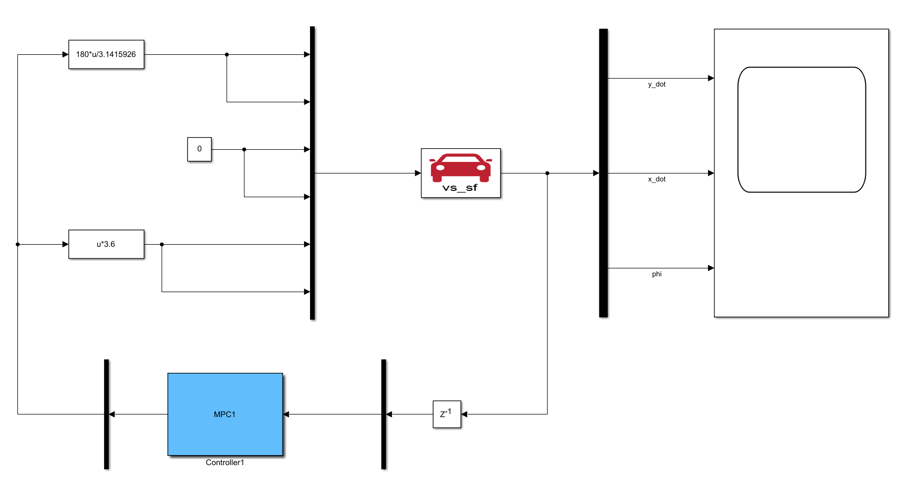
Figure 3.3 Trajectory tracking simulation interface
In this study, an elliptical path was selected as the reference path for trajectory tracking. The tracking performance of the controller was analyzed from multiple perspectives. The parameters required for the controller in the simulation experiments are listed in Table 3.1.
Table 3.1 MPC Controller parameters
Parameters | Value
N=P | 15
$$T_{S}$$ | 0.04
$$δ_{f}$$ | -32°~32°
R | [5×10⁴]
Q | $$\left[\begin{matrix}220 & 0 & 0 \\ 0 & 100 & 0 \\ 0 & 0 & 100\end{matrix}\right]$$
Simulation analysis was conducted on the MPC controller designed in this chapter, and the following simulation results were obtained. Figure 3.4 illustrates the tracking performance of the controller for the reference trajectory. It can be observed that the trajectory tracking controller initially achieves preliminary tracking of the reference path. Although some errors occur in the first half of the tracking, the rolling optimization gradually reduces these errors, bringing the trajectory closer to the reference path.
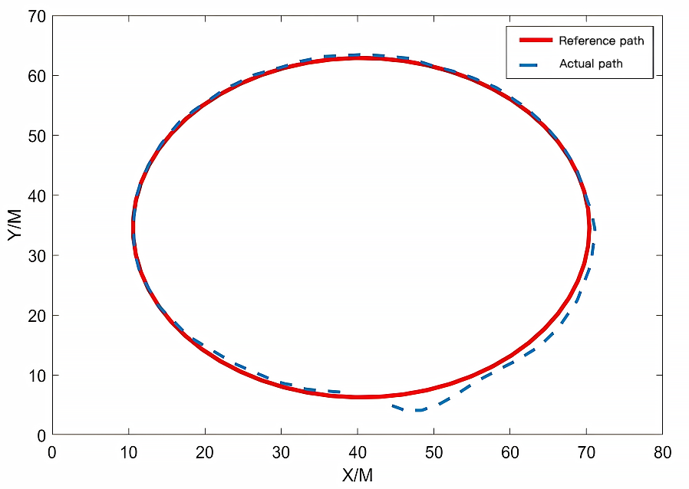
Figure 3.4 Track tracking effect
Figures 3.5 and 3.6 show the variation curves of the actual vehicle speed and the front wheel steering angle of the controlled vehicle during the trajectory tracking process of the MPC controller. From the figures, it can be observed that the vehicle speed exhibits significant fluctuations and continuous oscillations, indicating a lack of smoothness and difficulty in achieving stable speed control. Similarly, the front wheel steering angle also shows frequent oscillations and poor stability in the initial phase, which may impact driving safety.
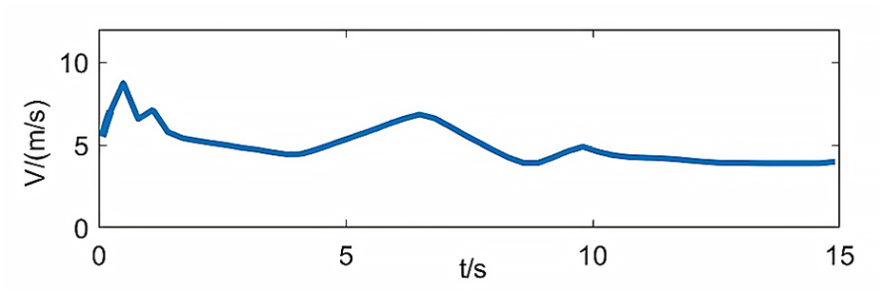
Figure 3.5 Vehicle speed curve
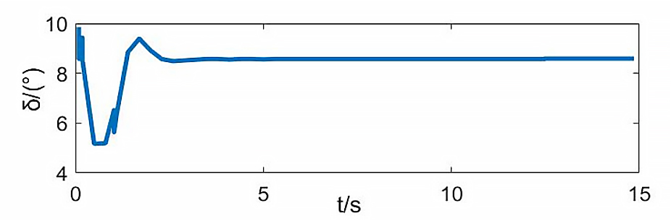
Figure 3.6 Vehicle front wheel turning angle curve
Figures 3.7 to 3.9 show the error curves of the controlled vehicle during the trajectory tracking process, including lateral error, longitudinal error, and yaw angle error. It can be observed that during the 15-second simulation, the vehicle took 5 seconds to adjust the errors, which is relatively long. Furthermore, a certain level of error remains in the later stages. Overall, the vehicle achieved basic stable tracking of the reference path under the control of this controller. However, the controller's performance in autonomously adjusting errors is suboptimal and still requires improvement.
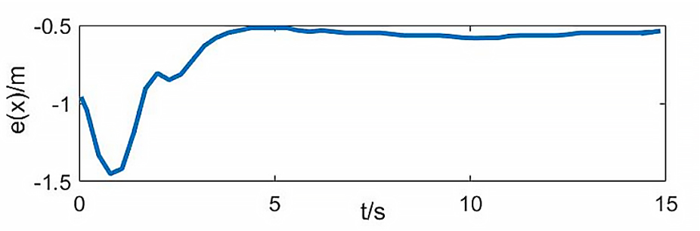
Figure 3.7 Longitudinal error curve
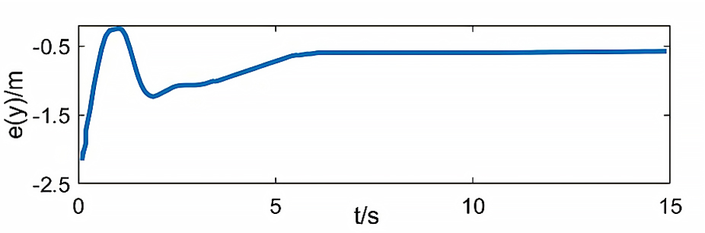
Figure 3.8 Lateral error curve
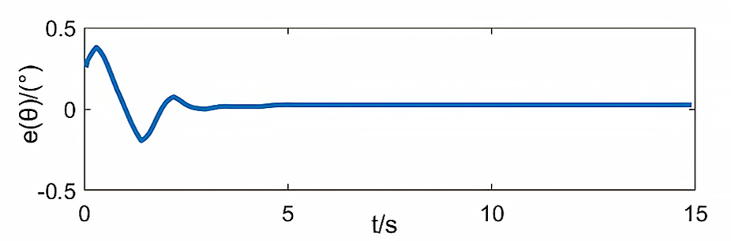
Figure 3.9 Yaw Angle Error Curve

Summary of This Chapter
This chapter first introduced the basic principles of Model Predictive Control (MPC) and then derived the vehicle kinematic model used for controller design. Based on the kinematic model, the controller was designed and validated through simulation experiments to evaluate its tracking performance for the reference path from multiple perspectives. The simulation results show that the controller designed in this chapter can initially achieve trajectory tracking of the reference path. However, it has shortcomings such as relatively large errors, prolonged error adjustment time, and insufficient speed stability control. These issues will be further analyzed and improved in future research.

Chapter 4 Decoupled Lateral and Longitudinal Trajectory Tracking Controller
To address the shortcomings of the previously designed MPC controller, this chapter adopts a decoupling strategy for lateral front wheel steering angle control and longitudinal speed control. The tracking controls for these two aspects are designed separately, improving the control accuracy.

4.1 MPC lateral controller based on a simplified three-degree-of-freedom dynamic model

4.1.1 Vehicle dynamics modeling
The vehicle kinematic model offers advantages such as simplicity, low computational requirements, and wide applicability when designing trajectory tracking controllers. However, it has drawbacks, including slightly lower tracking accuracy and reduced stability. Therefore, in this chapter, to balance tracking accuracy and computational complexity in the design of the MPC controller, a vehicle dynamic model is introduced and reasonably simplified. The vehicle's force conditions are illustrated in Figure 4.1.
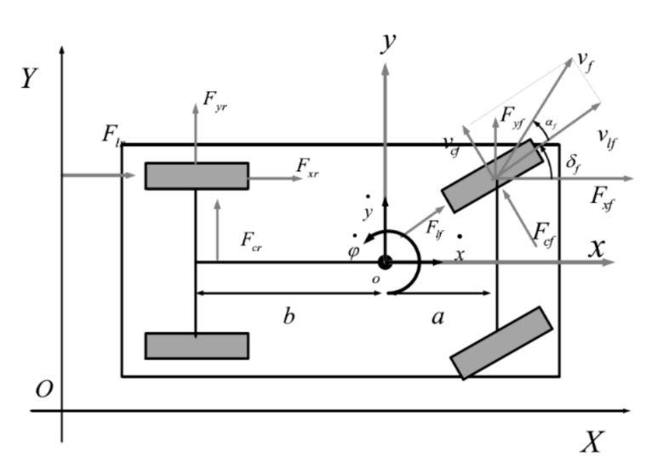
Figure 4.1 Vehicle dynamics model
In Figure 4.1, OXY represents the global coordinate system, which is used to describe the vehicle's position on the ground, and oxy represents the vehicle body coordinate system, which reflects the overall condition of the vehicle. F_{cf} and F_{cr} are the lateral forces acting on the front and rear wheels, respectively; F_{lf} and F_{lr} are the longitudinal forces acting on the front and rear wheels, respectively; F_{yf} and F_{yr} are the forces in the y-axis direction acting on the front and rear wheels, respectively; F_{xf} and F_{xr} are the forces in the x-axis direction acting on the front and rear wheels, respectively; a and b are the distances from the vehicle's center of gravity to the front and rear axle centers, respectively.
The vehicle dynamics model required in this study only needs to consider the dynamic characteristics in the lateral, longitudinal, and yaw directions. Therefore, degrees of freedom in these three directions are introduced, leading to the following model:
$m\ddot{x}=m\dot{y}\dot{ϕ}+2F_{xf}+2F_{xr}$ (4.1)
$m\ddot{y}=-m\dot{x}\dot{ϕ}+2F_{yf}+2F_{yr}$ (4.2)
$I_{z}\ddot{ϕ}=2aF_{yf}-2bF_{yr}$ (4.3)
The motion equations of the vehicle in the inertial coordinate system are as follows:
$\dot{Y}=\dot{x}sin⁡δ+\dot{y}cosδ$ (4.4)
$\dot{X}=\dot{x}cos⁡δ-\dot{y}sinδ$ (4.5)
The forces in the x-axis and y-axis directions can be calculated based on the longitudinal and lateral forces acting on the tires:
$F_{y}=F_{l}sin⁡δ+F_{c}cosδ$ (4.6)
$F_{x}=F_{l}cos⁡δ-F_{c}sinδ$ (4.7)
The lateral and longitudinal forces acting on the tires are obtained using the tire model, expressed as:
$F_{l}=f_{l}(α,s,μ,F_{z})$ (4.8)
$F_{c}=f_{c}(α,s,μ,F_{z})$ (4.9)
In this equation, $α$ is the tire slip angle, which reflects the angle between the tire's direction of motion and its longitudinal component of velocity (Dias et al., 2014); s is the tire slip ratio, representing the proportion of the sliding component in the wheel's motion; $μ$ is the ground friction coefficient, indicating the roughness of the surface; and F_{z} is the vertical force acting on the tire.
The calculation formula of $α$ is:
$α=\tan^{-1}\frac{ν_{c}}{ν_{l}}$ (4.10)
In this equation, v_{l} and v_{c} are the longitudinal and lateral velocities of the tire, which are obtained from the tire's velocities in the x-axis and y-axis directions, v_{x} and v_{y}, respectively. Their expressions are as follows:
$ν_{l}=ν_{y}sin⁡δ+ν_{x}cosδ$ (4.11)
$ν_{c}=ν_{y}cosδ-ν_{x}sinδ$ (4.12)
v_{x} and v_{y} cannot be directly obtained and are calculated indirectly from the vehicle's velocity. Based on Figure 4.1, their relationship is as follows:
$ν_{yf}=\dot{y}+a\dot{ϕ}{ ν}_{xf}=\dot{x}$ (4.13)
$ν_{yr}=\dot{y}+a\dot{∅} { ν}_{xr}=\dot{x}$ (4.14)
Combining Equations 4.10 to 4.14, the calculation formulas for the slip angles of the front and rear tires are as follows:
$α_{f}=\tan^{-1}\frac{\left(\dot{y}+a\dot{∅}\right)\cos{δ_{f}}-\dot{x}sinδ_{f}}{\left(\dot{y}+a\dot{∅}\right)\sin{δ_{f}}+\dot{x}\cos{δ_{f}}}$ (4.15)
$α_{r}=\tan^{-1}\frac{\left(\dot{y}-b\dot{∅}\right)\cos{δ_{r}}-\dot{x}sinδ_{r}}{\left(\dot{y}-b\dot{∅}\right)\sin{δ_{r}}+\dot{x}\cos{δ_{r}}}$ (4.16)
The tire slip ratio s is defined as:
$s=\left\{\begin{aligned}&\frac{rω}{ν_{l}}-1 &&\text{ if }ν_{l}>rω,ν≠0 &&\text{ for breaking } \\ & \\ &1-\frac{ν_{l}}{rω} &&\text{ if }ν_{l}<rω,ω≠0 &&\text{ for breaking }\end{aligned}\right.$ (4.17)
In this equation, r is the radius of the tire and $ω$ is the angular velocity of the tire.
Ignoring the load variation between the four tires due to vehicle acceleration, and assuming the forces on the left and right wheels are the same, based on the force analysis in Figure 4.1, the vertical load on each front and rear tire of the vehicle can be expressed as follows:
$F_{zf}=\frac{bmg}{2(a+b)}$ (4.18)
$F_{zr}=\frac{amg}{2(a+b)}$ (4.19)
Equations 4.1 to 4.19 lead to a nonlinear vehicle dynamics model. However, this model becomes overly complex at higher speeds and requires further simplification (Karaman & Frazzoli, 2010). The widely used "magic formula" tire model involves many nonlinear operations, and the tire slip angle includes excessive trigonometric function calculations, which increase computational complexity. Therefore, in this chapter, a simplified dynamics model is obtained by simplifying the vehicle tire model and the tire slip angle.
When the longitudinal slip rate and tire slip angle of the tire are small, the longitudinal force and lateral force acting on the tire can be expressed in the form of a function. Specifically, when s<5% and α<5%, the longitudinal force and lateral force can be expressed as a function, and the formula is as follows:
$F_{l}=C_{l}s,F_{c}=C_{c}s$ (4.20)
Where $C_{c}$ is the tire's lateral stiffness and $C_{l}$ is the tire's longitudinal stiffness.
The tire slip angle mentioned earlier is relatively complex, which increases computational complexity. Considering that the value of $∅$ is small, simplifications are made to the trigonometric functions as follows:
$$cos⁡ϕ≈1,sin⁡ϕ≈ϕ,tan⁡ϕ≈ϕ$$
In normal road driving, the vehicle speed is typically not too low, and the changes in various angles, such as the front wheel steering angle $δ_{f}$, rear wheel steering angle $δ_{r}$, front tire slip angle $α_{f}$, and rear tire slip angle $α_{r}$, are not drastic, all satisfying the assumption of small angles. In this study, the focus is on the front wheel steering angle, with the rear wheel steering angle $δ_{r}$ set to 0. Therefore, the tire slip angle formula from earlier is simplified, resulting in the following new formula:
$α_{f}=\frac{\dot{y}+\dot{a}\dot{φ}}{\dot{x}}-δ_{f}$ (4.21)
$α_{r}=\frac{\dot{y}-\dot{a}\dot{φ}}{\dot{x}}$ (4.22)
Substituting Equations 4.20, 4.21, and 4.22 into the dynamics equations, the simplified three-degree-of-freedom dynamic model is obtained as:
$\left\{\begin{aligned}&m\ddot{y}=-m\dot{x}\dot{φ}+2[C_{cf}(δ_{f}-\frac{\dot{y}+a\dot{φ}}{\dot{x}})+C_{cr}\frac{b\dot{φ}-\dot{y}}{\dot{x}}] \\ &m\ddot{x}=m\dot{y}\dot{φ}+2[C_{lf}s_{f}(δ_{f}-\frac{\dot{y}+a\dot{φ}}{\dot{x}})δ_{f}+C_{lr}s_{r}] \\ &I_{z}\ddot{φ}=2[aC_{cf}(δ_{f}-\frac{\dot{y}+a\dot{φ}}{\dot{x}})] \\ &\dot{Y}=\dot{x}sinφ+\dot{y}cosφ \\ &\dot{X}=\dot{x}cosφ-\dot{y}sinφ\end{aligned}\right.$ (4.23)

4.1.2 Design of model predictive controller
Since the model predictive control (MPC) requires a linear discrete model, the obtained three-degree-of-freedom dynamic model needs to be linearized and discretized (Likhachev et al., 2003). Linearization is performed using the Taylor series expansion. The specific method is as follows.
The equation (4.23) can be expressed as ${\dot{ξ}}_{dyn}=f_{dyn}(ξ_{dyn},u_{dyn})$, where the state vector is ${\left[\dot{y} \dot{x} φ \dot{φ} \dot{Y} X\right]}^{T}$ and the control input is $u_{dyn}=δ_{f}$. Assuming the system operates at an equilibrium point $\left[\begin{aligned}ξ_{0},u_{0}\end{aligned}\right]$, ${\hat{ξ}}_{0}(k+1)$ is the next state obtained after applying the control input $μ_{0}$, and the relationship is given as:
${\hat{ξ}}_{0}(k+1)=f({\hat{ξ}}_{0}(k),u_{0})$ (4.24)
At a reference point $[{\hat{ξ}}_{0},u_{0}]$, the system will perform a step expansion of ${\dot{ξ}}_{dyn}=f_{dyn}(ξ_{dyn},u_{dyn})$:
${\dot{ξ}}_{dyn}=f_{dyn}({\hat{ξ}}_{0}(k),u_{0})+\frac{∂f}{∂ξ}|_{\begin{aligned}ξ={\hat{ξ}}_{0} \\ u=u_{0}\end{aligned}}(ξ-{\hat{ξ}}_{0})+\frac{∂f}{∂u}|_{\begin{aligned}ξ={\hat{ξ}}_{0} \\ u=u_{0}\end{aligned}}(u-u_{0})$ (4.25)
Can also be written as:
${\dot{ξ}}_{dyn}=f_{dyn}({\hat{ξ}}_{0},u_{0})+J_{f}(ξ)(ξ-{\hat{ξ}}_{0})+J_{f}(u)(u-u_{0})$ (4.26)
Subtracting Equation 4.26 from Equation 4.25 yields:
$\dot{ξ}=A(t)\dot{ξ}+B(t)\dot{u}$ (4.27)
In this equation, $\dot{ξ}=ξ-\hat{ξ_{0}}\text{,}\dot{u}=u-u_{0}\text{,}A(t)=J_{f}(ξ)\text{,}B(t)=J_{f}(u)$.
Through the above process, the corresponding linear equation is obtained. However, this equation is continuous and needs to be further discretized for use in the design of the model predictive controller. Therefore, Equation 4.27 is discretized using an approximation method, resulting in the following equation:
$\begin{aligned}&A_{k,t}=I+TA(t) \\ &B_{k,t}=TB(t)\end{aligned}$ (4.28)
By combining Equations 4.27 and 4.28, the linear discrete system at any reference point $[ξ_{0},u_{0}]$ can be derived as:
$ξ^{*}(k+1)=A_{k,t}ξ^{*}(k)+B_{k,t}u^{*}(k)$ (4.29)
In the equation,
$$A_{k,t}=\left[\begin{matrix}1+\frac{-2\left(C_{cf}+C_{cr}\right)T}{m{\dot{x}}_{t}} & \frac{∂{\dot{f}}_{y}T}{∂\dot{x}} & 0 & -{\dot{x}}_{t}T+\frac{2\left(bC_{cf}-aC_{cf}\right)T}{m{\dot{x}}_{t}} & 0 & 0 \\ φ\dot{T}-\frac{2C_{cf}δ_{f,t-1}T}{m{\dot{x}}_{i}} & 1+\frac{∂\dot{f_{x}}T}{∂\dot{x}} & 0 & {\dot{y}}_{t}T-\frac{2aC_{cf}δ_{f,t-1}T}{m{\dot{x}}_{t}} & 0 & 0 \\ 0 & 0 & 1 & T & 0 & 0 \\ \frac{2\left(bC_{cr}-aC_{cf}\right)T}{I_{z}{\dot{x}}_{t}} & \frac{∂\dot{f_{φ}}T}{∂\dot{x}} & 0 & 1+\frac{-2\left(a^{2}C_{cf}+b^{2}C_{cr}\right)T}{I_{z}{\dot{x}}_{t}} & 0 & 0 \\ cos⁡(φ_{t})T & sin⁡(φ_{t})T & \left({\dot{x}}_{t}cos⁡(φ_{t})-y_{t}sin⁡(φ_{t})\right)T & 0 & 1 & 0 \\ -sin⁡(φ_{t})T & cos⁡(φ_{t})T & \left(-{\dot{y}}_{t}cos⁡(φ_{t})-{\dot{x}}_{t}sin⁡(φ_{t})\right)T & 0 & 0 & 1\end{matrix}\right]$$
$$B_{k,t}={\left[\frac{2C_{cf}T}{m},\frac{2C_{cf}\left(2δ_{f,t-1}-\frac{{\dot{y}}_{t}-b{\dot{φ}}_{t}}{{\dot{x}}_{t}}\right)T}{m},0,\frac{2aC_{cf}T}{I_{z}},0,0\right]}^{T}$$
Thus, a linear discrete system model suitable for designing the trajectory tracking controller is obtained, where the control input is the vehicle's front wheel steering angle. Based on this, a new state-space equation is designed, where the change in the front wheel steering angle is used as the control input, allowing for more precise control. The new state variables are defined as:
$γ(k|t)=\left[\begin{aligned}ξ^{*}(k|t) \\ u^{*}(k-1|t)\end{aligned}\right]$ (4.30)
Thus, the new state-space expression is obtained as:
$\begin{aligned}&γ(k+1|t)=A_{k,t}^{*}γ(k|t)+B_{k,t}^{*}Δu(k|t) \\ &η(k|t)=C_{k,t}^{*}γ(k|t)\end{aligned}$ (4.31)
The matrices in the above expression are represented as:$A_{k,t}^{*}=\left[\begin{matrix}A_{k,t} & B_{k,t} \\ 0_{m*n} & I_{m}\end{matrix}\right],B_{k,t}^{*}=\left[\begin{aligned}B_{k,t} \\ I_{m}\end{aligned}\right],C_{k,t}^{*}=\left[\begin{matrix}C_{k,t} & 0_{o*m}\end{matrix}\right]$.
In the equation, n represents the number of state variables in the original model; m represents the number of control inputs in the original system; and o represents the number of output variables in the original system. To simplify the calculations, the following assumptions are made:
$A_{k,t}^{*}=A_{t}^{*},k=t+1,…,t+N_{p} { B}_{k,t}^{*}=B_{t}^{*},k=t+1,…,t+N_{p}$ (4.32)
In the equation, N_{p} represents the system's prediction horizon.
Based on the above assumptions, the state variables within the prediction horizon of the predictive control can be expressed as:
$γ(k+N_{p}|t)=A_{t}^{*N_{p}}γ(t|t)+A_{t}^{*N_{p}-1}B_{t}Δu(t|t)+…+A_{t}^{*N_{p}-N_{c}-1}B_{t}^{*}Δu(t+N_{c}|t)$ (4.33)
The output variables within the prediction horizon can be expressed as:
$$η\left(k+N_{p} ∣ t\right)=C_{t}^{*}A_{t}^{*N_{p}}γ\left(t ∣ t\right)+C_{t}^{*}A_{t}^{*N_{p}-1}B_{t}^{*}Δu\left(t ∣ t\right)+...+C_{t}^{*}A_{t}^{*N_{p}-N_{c}-1}B_{t}^{*}Δu\left(t+N_{c} ∣ t\right) (4.34)$$
The prediction equation for the prediction horizon is given by:
$Y(t)=ψ_{t}γ(t∣t)+Θ_{Δ}U(t)$ (4.35)
In the equation:
$$\begin{aligned}&Y(t)={\left[\begin{aligned}η(t+1|t) \\ η(t+2|t) \\ ⋯ \\ η(t+N_{c}|t) \\ ⋯ \\ η(t+N_{p}|t)\end{aligned}\right]}_{N_{p}×1},ψ(t)={\left[\begin{aligned}C_{t}^{*}A_{t}^{*} \\ C_{t}^{*}{A_{t}^{*}}^{2} \\ C_{t}^{*}{A_{t}^{*}}^{N_{c}} \\ ⋯ \\ C_{t}^{*}{A_{t}^{*}}^{N_{p}}\end{aligned}\right]}_{N_{p}×1},ΔU(t)={\left[\begin{aligned}Δu(t|t) \\ Δu(t+1|t) \\ ⋯ \\ Δu(t+N_{c}|t)\end{aligned}\right]}_{N_{c}×1}\end{aligned}$$
$$Θ=\left[\begin{aligned}\begin{matrix}\begin{matrix}C_{t}^{*}B_{t}^{*} & \begin{matrix}0 & ⋯ & 0\end{matrix}\end{matrix} \\ \begin{matrix}C_{t}^{*}{A_{t}^{*}B}_{t}^{*} & \begin{matrix}C_{t}^{*}B_{t}^{*} & ⋯ & 0\end{matrix}\end{matrix} \\ \begin{matrix}⋯ & C_{t}^{*}{A_{t}^{*}B}_{t}^{*} & \begin{matrix}⋯ & ⋯\end{matrix}\end{matrix}\end{matrix} \\ \begin{matrix}C_{t}^{*}{{A_{t}^{*}}^{N_{P}-1}B}_{t}^{*} & C_{t}^{*}{{A_{t}^{*}}^{N_{P}-2}B}_{t}^{*} & \begin{matrix}⋯ & C_{t}^{*}{{A_{t}^{*}}^{N_{P}-N_{c}-1}B}_{t}^{*}\end{matrix}\end{matrix}\end{aligned}\right]$$
From Equation 4.35, it can be concluded that given the current state and control input values of the system, the vehicle's following state within the prediction horizon can be predicted.
Next, the objective function is designed to calculate the optimal control increment sequence $∆U(t)$ for achieving lateral control of the vehicle. The specific form is as follows:
$J(k)=\sum_{j=1}^{N_{p}}{ }∥η_{dyn}(k+j|k)-μ_{dyn,yef}(k+j|k)∥_{Q}^{2}+\sum_{i=1}^{N_{c}}{ }∥Δu_{dyn}(k+i|k)∥_{R}^{2}$ (4.36)
In this equation, $η_{dyn}$ represents the vehicle's output state, $μ_{dyn,yef}$ represents the reference target output state, and $Δu_{dyn}$ represents the control increment of the vehicle. The objective of this function is to minimize both the error between the output and the reference state, and the control increment fed back to the vehicle within the prediction horizon. By reformulating the optimization from solving for control inputs to solving for control increments, the control increment offers better constrainability compared to direct control inputs. The gradual changes in control increments prevent drastic effects on the control inputs, ensuring the safety of vehicle operation.
As a practical and advanced control algorithm, the model predictive control algorithm can effectively address constraint problems. In this chapter, constraints are imposed on the tire slip angle to enhance the safety of vehicle operation.
The control input constraints are:
$u_{min}(k+t)<u(k+t)<u_{max}(k+t),k=0,1,…,N-1$ (4.37)
The control increment constraints are:
$Δu_{min}(k+t)<Δu(k+t)<Δu_{max}(k+t),k=0,1,…,N-1$ (4.38)
Since the objective function solves for the control increment, the control input is expressed in terms of the control increment as:
$\left\{\begin{aligned}u\left(t+1\right)=Δu\left(t\right)+u\left(t\right) \\ u\left(t+2\right)=Δu\left(t+1\right)+u\left(t+1\right)=Δu\left(t+1\right)+Δu\left(t\right)+u\left(t\right) \\ u\left(t+3\right)=Δu\left(t+2\right)+u\left(t+2\right)=Δu\left(t+2\right)+Δu\left(t+1\right)+Δu\left(t\right)+u(t) \\ ⋯ \\ u(t+N)=Δu(t+N-1)+Δu(t+N-2)+Δu(t+N-3)+…+u(t)\end{aligned}\right.$ (4.39)
Transform this equation into the form $U_{min}≤AΔU+U_{t}≤U_{max}$, where:
$$A={\left[\begin{matrix}1 & 0 & ... & 0 \\ 1 & 1 & 0 & ... \\ ... & ... & 1 & 0 \\ 1 & 1 & ... & 1\end{matrix}\right]}_{N×N},ΔU={\left[\begin{aligned}Δu_{min}(t+1) \\ Δu_{min}(t+2) \\ ... \\ Δu_{min}(t+N)\end{aligned}\right]}_{N×1}$$
To ensure safe driving and prevent vehicle sideslip, the tire slip angle $α$ needs to be constrained so that its value is less than $α_{max}$. Based on the relationship between the tire slip angle and the state variables in the vehicle dynamics model proposed in this chapter, the tire slip angle constraint is converted into constraints on the state variables.
As previously mentioned, the tire slip angle calculation formula is:
$\begin{aligned}&α_{f}=\frac{\dot{y}+\dot{a}\dot{φ}}{\dot{x}}-δ_{f} \\ &α_{r}=\frac{\dot{y}-\dot{a}\dot{φ}}{\dot{x}}\end{aligned}$ (4.40)
By linearizing the tire slip angle, it can be expressed in terms of the system's state variables $ξ_{dyn}$ and control inputs $u_{dyn}$. The equation is:
$α=Eξ_{dyn}(k,t)+Fu_{dyn}(k,t)$ (4.41)
In the equation, $α={\left[\begin{matrix}α_{f} & α_{r}\end{matrix}\right]}^{T},F={\left[\begin{matrix}-1 & 0\end{matrix}\right]}^{T},E=\left[\begin{matrix}\frac{1}{\dot{x}} & -\frac{\dot{y}+a\dot{φ}}{{\dot{x}}^{2}} & 0 & \frac{a}{\dot{x}} & 0 & 0 \\ \frac{1}{\dot{x}} & -\frac{\dot{y}-b\dot{φ}}{{\dot{x}}^{2}} & 0 & -\frac{b}{\dot{x}} & 0 & 0\end{matrix}\right]$
By performing a spatial transformation on this equation, it becomes:
$α=\tilde{E}ξ(k,t)$ (4.42)
In the equation, $\tilde{E}=\left[\begin{matrix}E(t) & F(t) \\ 0_{m^{*}n} & I_{m}\end{matrix}\right]$.
In summary, the control problem of the trajectory tracking controller in this chapter is transformed into the following optimization problem:
$\begin{aligned}&\min_{ΔU,E} {∥η(k+j|k)-η_{ref}(k+j|k)∥}_{Q}^{2}+\sum_{J=1}^{N}{ }{∥Δu(k+j|k)∥}_{R}^{2}+ρε^{2} \\ &\left\{\begin{aligned}U_{min}≤_{Δ}U≤U_{max} \\ U_{min}≤A_{Δ}U+U_{t}≤U_{max} \\ α_{min}≤α≤α_{max} \\ ε≥0\end{aligned}\right.\end{aligned}$ (4.43)
The above equation is solved using the quadratic programming method.

4.2 PID-based longitudinal controller

4.2.1 Basic principles of the PID algorithm
PID control, also known as Proportional-Integral-Derivative control, adjusts the controller output based on the error between the current measured value and the reference value through proportional, integral, and derivative calculations. This iterative adjustment drives the system error toward zero, achieving precise system control. It is widely used in the field of autonomous driving.
The expression for the PID algorithm is:
$u(t)=K_{p}e(t)+K_{i}\int_{0}^{t}{ }e(t^{'})dt^{'}+K_{d}\frac{de(t)}{dt}$ （4.44）
$u(t)$ represents the controller's output at time t, $e(t)$ represents the error between the system's current state value and the reference value, and $K_{p}$, $K_{i}$, and $K_{d}$ represent the proportional gain, integral gain, and derivative gain, respectively.
Proportional control adjusts the controller's output based on the magnitude of the current error using the proportional gain $K_{p}$, helping the system quickly approach the setpoint by producing a response proportional to the error. Integral control, using the integral gain $K_{i}$, adjusts the output based on the accumulated error over time to eliminate steady-state errors, though it may lead to integral saturation due to its cumulative effect. Derivative control, governed by the derivative gain $K_{d}$, modifies the output based on the rate of error change, aiming to suppress excessive oscillations and enhance stability by predicting error trends and moderating the system's response speed.

4.2.2 Throttle and brake calibration table
The main function of the longitudinal control module is to control the vehicle's acceleration and deceleration. However, in practice, the vehicle's speed cannot be directly controlled. Instead, speed control is achieved by adjusting the throttle opening and braking force. Therefore, it is necessary to establish the relationship between speed, acceleration, throttle opening, and braking force, which requires the creation of a throttle/brake calibration table.
First, throttle and acceleration calibration is conducted. Before calibration, the braking pressure in CarSim is set to 0 MPa, and the throttle opening is set to 0.01. The simulation time is set to 5 seconds for each run, and speed and acceleration data are recorded. This process is repeated until the throttle opening reaches 100%. Next, brake calibration is performed. In CarSim, the vehicle speed is set to 180 km/h, and the braking pressure is set to 0.1 MPa. The simulation time is set to 10 seconds for each run, and speed and deceleration data are recorded. This process is repeated until the braking pressure reaches 8 MPa. After completing all calibration steps, the throttle calibration table and brake calibration table are merged to obtain the throttle/brake calibration table.

4.2.3 Design of longitudinal dual PID controller
Firstly, the target position, target speed, and target acceleration at the reference points are derived based on the reference path. The position PID controller calculates a speed compensation value using the positional deviation between the target position and the actual position of the vehicle as its input. The onboard sensors of the autonomous vehicle provide the vehicle's current actual position and speed. The deviation between the target speed and the actual speed, along with the speed compensation value, is used as input for the speed controller. The speed controller computes an acceleration compensation value, which, along with the target acceleration at the reference point and the vehicle's actual speed, is input into the throttle/brake calibration table. This process determines the corresponding throttle opening and braking force, enabling the autonomous vehicle to accelerate or decelerate accordingly.

4.3 Simulation and result analysis
Simulation experiments were conducted for the lateral and longitudinal control algorithms designed in this chapter, with the simulation interface shown in Figure 4.2. To verify the speed control performance, a simulation environment was set with a desired speed of 5 m/s. To evaluate the improvements of the model predictive controller designed in this chapter, the same reference path and MPC controller parameters as those used in the previous chapter's simulation experiments were adopted for lateral control to construct a consistent simulation environment. For longitudinal control, the initial parameters of the PID controller were set as $K_{p}=3$, $K_{i}=0$, and $K_{d}=0.1$. Finally, simulation experiments were conducted under different road friction coefficients \( \mu \) with and without tire slip angle constraints to verify whether the tire slip angle constraints introduced in this chapter were effective.
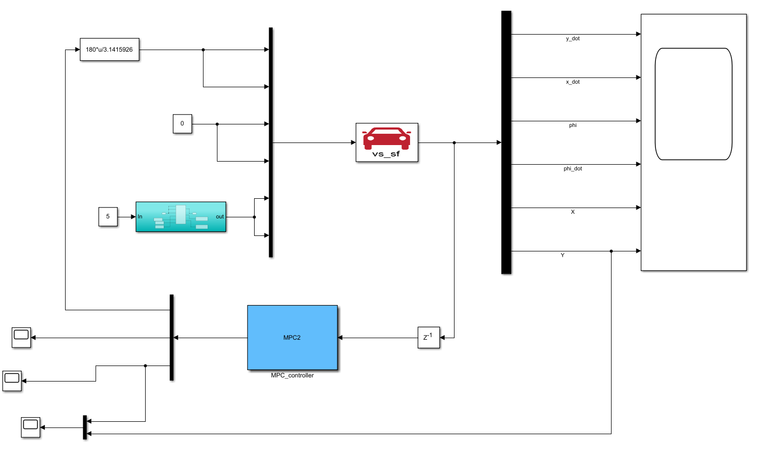
Figure 4.2 Lateral and Longitudinal Control Simulation Interface
Figure 4.3 illustrates the trajectory tracking performance of the lateral and longitudinal decoupled control algorithm for an elliptical path at a desired speed of 5 m/s. As shown in Figure 4.3, the improved lateral and longitudinal decoupled controller proposed in this chapter demonstrates excellent tracking performance for the elliptical path, with no significant errors. The controller's adaptive error adjustment capability has been enhanced, enabling stable path tracking within a shorter time. Compared to the kinematics-based MPC controller, the improved control algorithm in this chapter exhibits better path tracking performance.
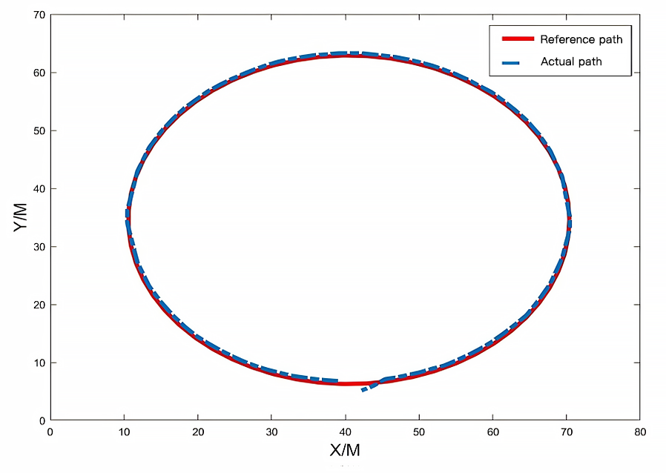
Figure 4.3 Trajectory tracking effect at 5m/s desired speed
Figures 4.4 and 4.5 show the real-time variations in vehicle speed and front wheel steering angle during the trajectory tracking process of the lateral and longitudinal decoupled controller for the elliptical path at a desired speed of 5 m/s. From the figures, it can be observed that the controller achieves the desired speed within a short time, with minimal oscillations during the transition and a stable acceleration trend. Regarding the front wheel steering angle, the range of motion is small, ensuring vehicle stability. Additionally, no oscillations occur, which enhances driving safety.
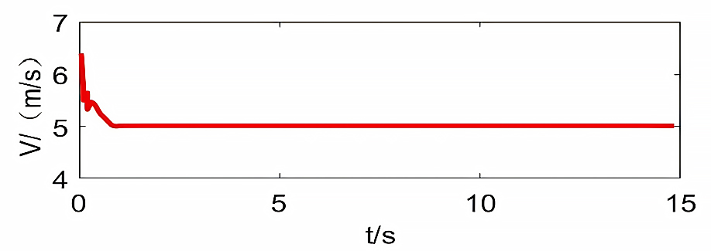
Figure 4.4 Vehicle speed curve
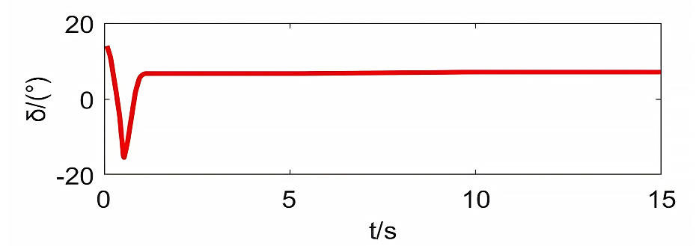
Figure 4.5 Vehicle front wheel turning angle curve
Figures 4.6 to 4.8 show the error analysis during the trajectory tracking process of the lateral and longitudinal decoupled controller at a desired speed of 5 m/s. From the figures, it can be observed that the values of lateral error, longitudinal error, and yaw angle error are all small and change smoothly without fluctuations or oscillations. The errors converge quickly, demonstrating good stability during tracking. Compared to the kinematics-based trajectory tracking controller described earlier, the proposed controller achieves better tracking control performance.
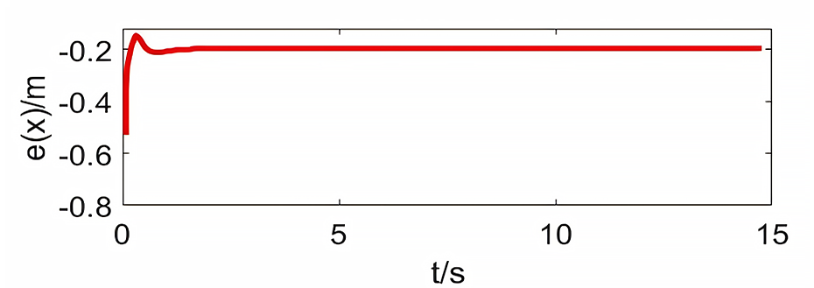
Figure 4.6 Longitudinal error curve
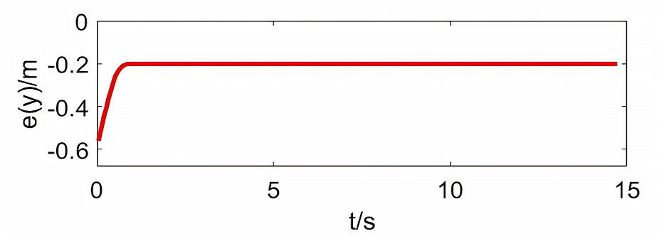
Figure 4.7 Lateral Error Curve
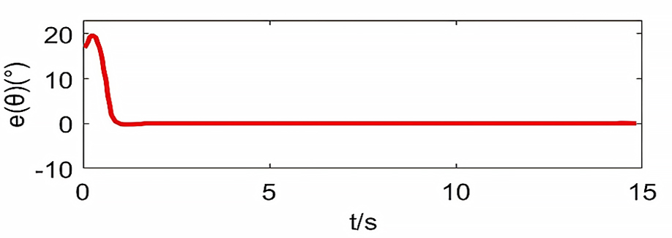
Figure 4.8 Yaw Angle Error Curve
The trajectory tracking algorithm proposed in this study incorporates constraints on the tire slip angle. Next, simulation experiments will be conducted to verify whether adding this constraint has a significant effect on actual path tracking. The comparative experiments are designed with the presence or absence of tire slip angle constraints as one experimental variable. To explore the differences under various road conditions, the road surface friction coefficient is set as another comparative condition. The road friction coefficient on typical dry structured roads is generally 0.6, while under wet and slippery conditions such as rain or snow, it is around 0.3. Therefore, in this experiment, the road surface friction coefficient $μ$ is set to 0.3 and 0.6. A double lane-change reference path is used to analyze the tracking control performance for the reference path and the variations in the front wheel steering angle.
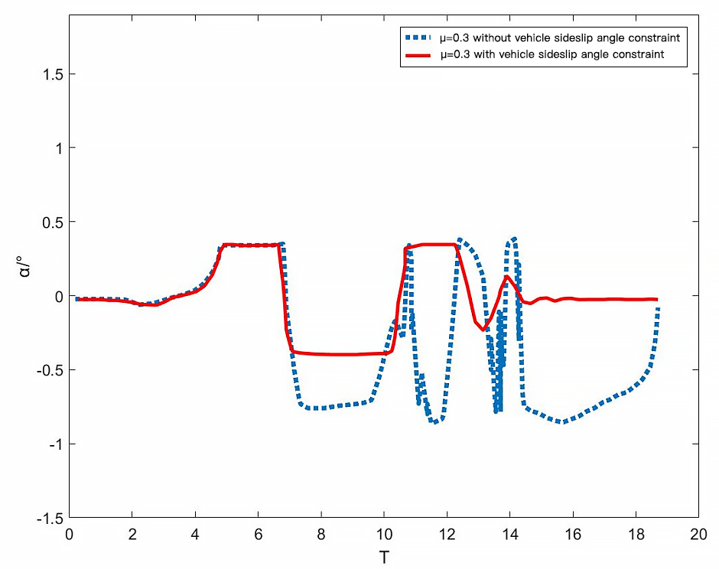
Figure 4.9 Vehicle front wheel rotation angle curve at $μ=0.3$
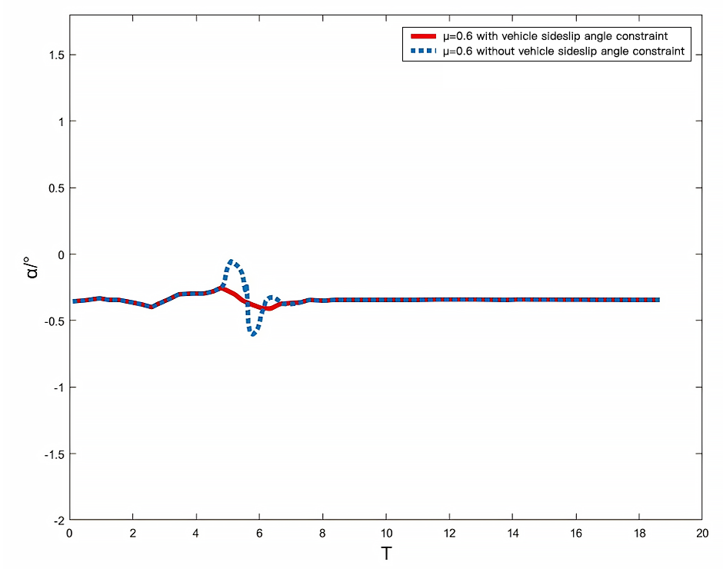
Figure 4.10 Vehicle front wheel rotation angle curve at $μ=0.6$
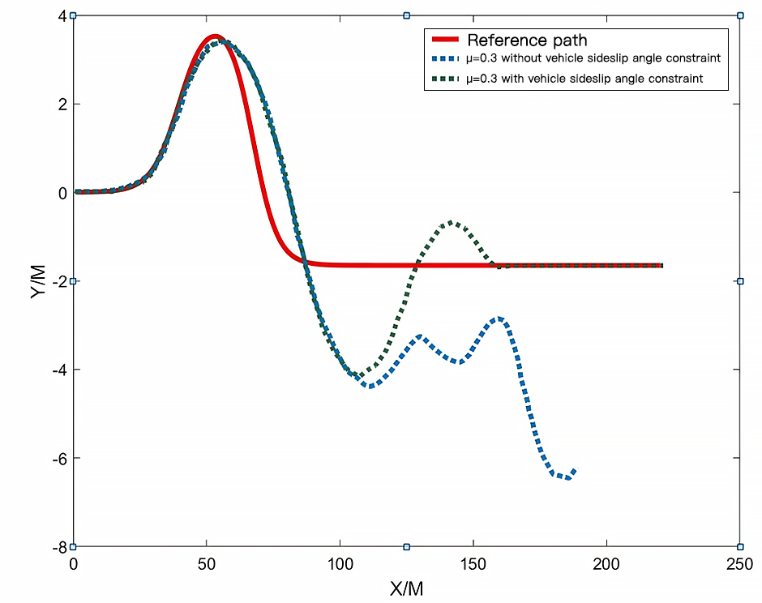
Figure 4.11 Vehicle track tracking effect at $μ=0.3$
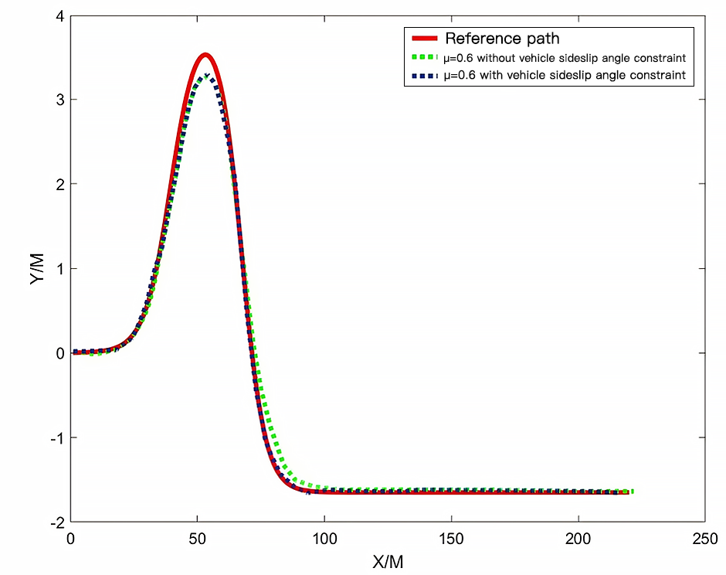
Figure 4.12 Vehicle track tracking effect at $μ=0.6$
From the above experimental results, it can be concluded that when the road friction coefficient is 0.6, the road conditions are favorable, and the tracker achieves good tracking performance for the reference path. The case with tire slip angle constraints shows smaller errors compared to the case without tire slip angle constraints, indicating higher precision. Regarding the front wheel steering angle, the changes are smoother, suggesting that the vehicle can maintain stable steering. The group with tire slip angle constraints exhibits smaller and more stable changes compared to the group without tire slip angle constraints.
When the road friction coefficient is set to 0.3, the road conditions are poor, requiring higher safety performance from the tracker. As shown in Figure 4.9, the group without tire slip angle constraints experiences sideslip during the turning process, followed by uncontrollable rotation, ultimately resulting in an inability to continue tracking the reference trajectory and posing traffic risks. In contrast, the group with tire slip angle constraints, although exhibiting larger front wheel steering angle variations, shows smaller fluctuations and stronger self-regulation capability. As seen in Figure 4.11, during the vehicle's trajectory tracking process, significant deviations occur in both groups when encountering sharp turns. However, the group with tire slip angle constraints can correct the deviations and return to the correct driving trajectory. On the other hand, the group without tire slip angle constraints, despite attempting self-correction, fails to suppress the increasing error, ultimately leading to tracking failure.
From this set of simulation data, it can be observed that the tire slip angle constraints added in this study demonstrate good effectiveness on both dry and slippery roads. Particularly on slippery surfaces, these constraints significantly enhance path tracking and improve driving safety performance.

Summary of This Chapter
This chapter addresses the shortcomings of the MPC trajectory tracking controller from the previous chapter and proposes a decoupled lateral and longitudinal control method. For lateral control, the MPC algorithm is still used, incorporating a more accurate three-degree-of-freedom vehicle dynamic model, which is reasonably simplified. The optimization in the objective function is transformed from solving for control inputs to solving for control increments. Additionally, constraints on the tire slip angle are introduced to enhance the safety and stability of the MPC lateral controller. Finally, simulation experiments demonstrate that the decoupled lateral and longitudinal controller achieves excellent trajectory and speed tracking performance.

Chapter 5 Joint Simulation of Local Path Planning and Trajectory Tracking Control
In practical autonomous driving of intelligent vehicles, path planning should be integrated with trajectory tracking control. This chapter proposes a joint simulation approach for the planning and tracking layers. The path planned by the planning layer is transmitted to the tracking layer in the form of discrete points, and this path information is used as the reference trajectory for the tracking layer to perform tracking control.

5.1 Implementation Plan for "Planning + Tracking" Joint Simulation
In the previous research, local path planning and trajectory tracking control were discussed separately, without fully considering the integration of these two modules. However, in an actual autonomous driving system, local path planning and trajectory tracking control need to be unified (Chen & Ren, 2017). The path planning module analyzes obstacle information and the vehicle's real-time data based on the actual road conditions to plan the optimal local path, which is then used as the reference trajectory for the tracking controller. The trajectory tracking control module calculates the corresponding control inputs based on the collected reference trajectory and outputs them to the controlled vehicle (Ziegler & Werling, 2011).
The planned path is transmitted to the control layer in the form of a discrete sequence. Since the discrete points forming the path are numerous, this approach results in significant workload and makes it difficult to handle complex real-time road conditions. To reduce the workload and improve efficiency, the discrete data points planned by the planning layer need to be specially modulated. In this study, a polynomial fitting approach is used to modulate the discrete points. Only the parameters of the fitted curve are transmitted, and the tracking layer reconstructs the planned path internally through interpolation based on these parameters. This greatly enhances transmission efficiency.

The specific form of the quartic polynomial fitting curve used is:
$Y=c_{4}t^{4}+c_{3}t^{3}+c_{2}t^{2}+c_{1}t^{1}+c_{0}$ (5.1)
A randomly distributed sequence of discrete points at a certain moment is selected and fitted with a quartic polynomial. The result is shown in Figure 5.1, where the discrete points are represented by asterisks, and the curve represents the planned path obtained through quartic polynomial fitting.
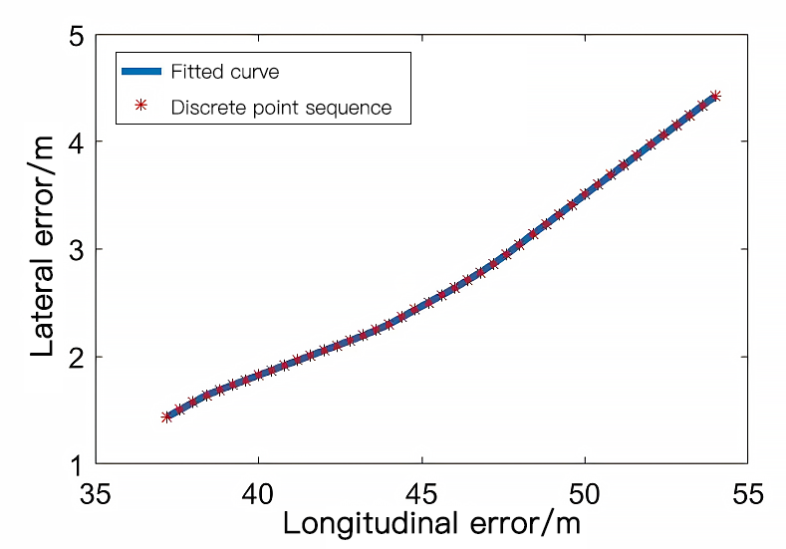
Figure 5.1 Discrete point fitting curve
The effectiveness of curve fitting is evaluated by the norm of the lateral error for the fitted discrete points. The calculated norm of the lateral position error for the intelligent vehicle in Figure 5.1 is 0.0320 m, indicating high fitting accuracy and achieving efficient transmission of the planned path to the tracking layer.

5.2 Simulation and Result Analysis
Based on the previous discussion, joint simulations of path planning and tracking control are conducted under two different road conditions with obstacle information. The simulation interface is shown in Figure 5.2, where the planning layer is added before the trajectory tracking layer. Simulation parameters are set as listed in Table 5.1. In this simulation experiment, the results of the planning and tracking layers are analyzed from three perspectives. First, whether the planning layer can successfully perform obstacle avoidance path planning and reach the target point. Second, whether the path planned by the planning layer can be transmitted to the control layer with high accuracy. Finally, whether the control layer can effectively track the fitted and interpolated path.
Table 5.1 Co-simulation parameters
Parameters | Value
Attractive Potential Field Coefficient $k_{att}$ | 13
Repulsive Potential Field Coefficient $k_{rep}$ | 7
N=P | 15
$$T_{s}$$ | 0.04
$$δ_{f}$$ | -32°~32°
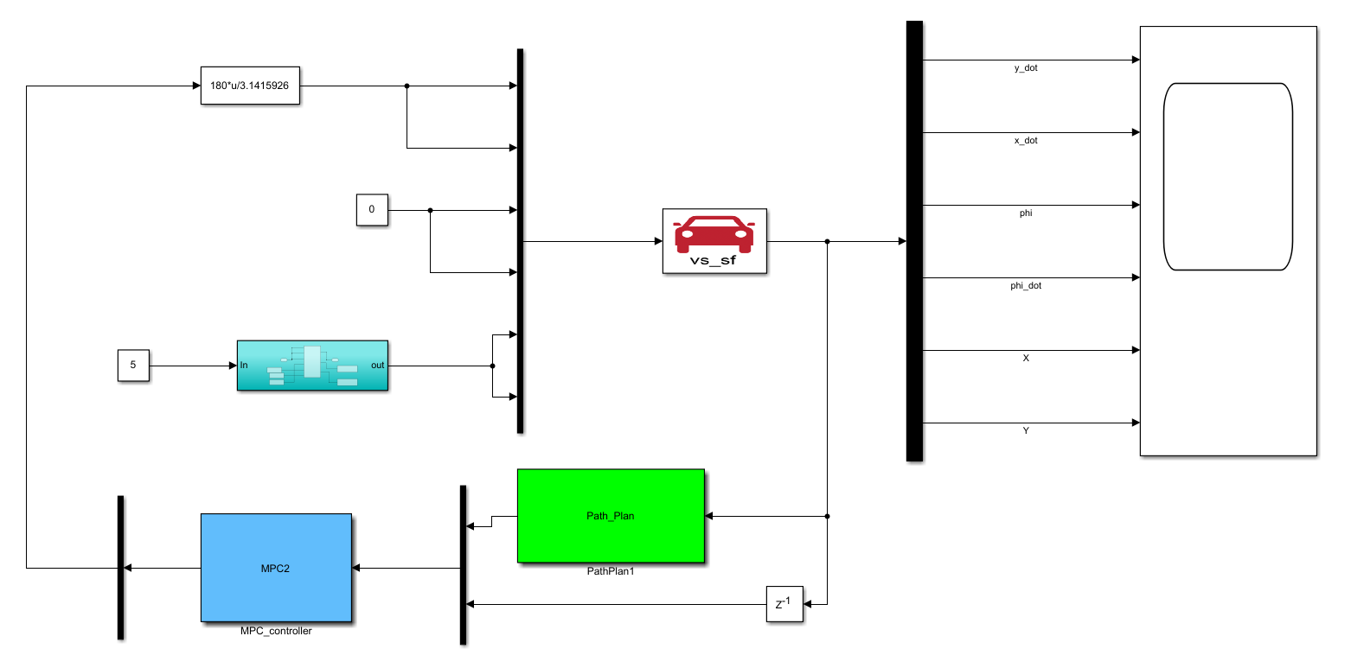
Figure 5.2 Integrated Planning and Tracking Simulation Interface
Figure 5.3 shows the obstacle avoidance driving path planned by the planning layer under Scenario 1. Figure 5.4 illustrates the controller's tracking performance for this trajectory, and Figure 5.5 presents the curve of fitting quality changes for the discrete sampling points of the planned path in the tracking layer.
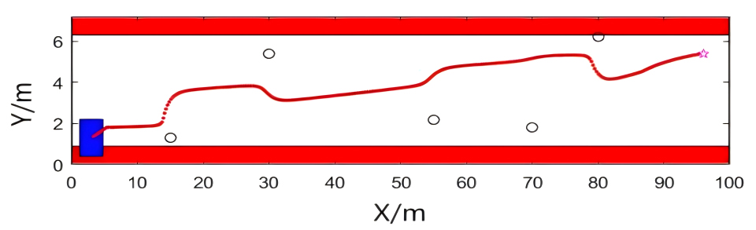
Figure 5.3 Scenario 1 path planning results
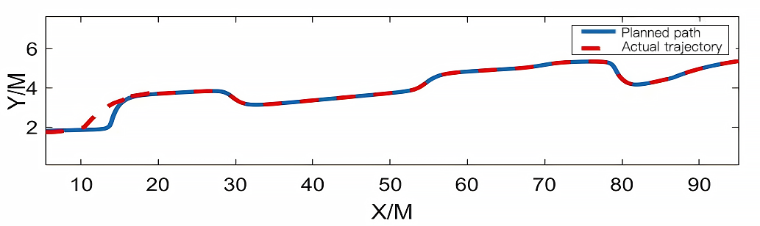
Figure 5.4 Scenario 1 track tracking results
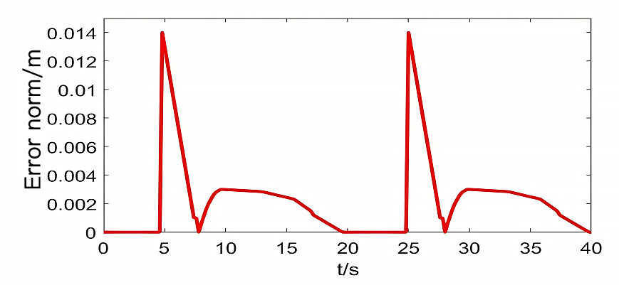
Figure 5.5 Scenario 1 sampling point fitting quality
From Figure 5.3, it can be observed that the planning layer successfully generated a smooth path that avoids obstacles and reaches the target point without encountering local minima or unreachable target issues. In Figure 5.4, it is evident that the tracking control layer achieved excellent tracking performance for this path, quickly eliminating errors. From Figure 5.5, the maximum norm of the intelligent vehicle's lateral error is 0.0140, indicating high fitting accuracy and minimal transmission error for the planning layer's path.
Figure 5.6 shows the obstacle avoidance driving path planned by the planning layer under Scenario 2. Figure 5.7 illustrates the controller's tracking performance for this trajectory, and Figure 5.8 presents the curve showing the fitting quality changes for the discrete sampling points of the planned path in the tracking layer.
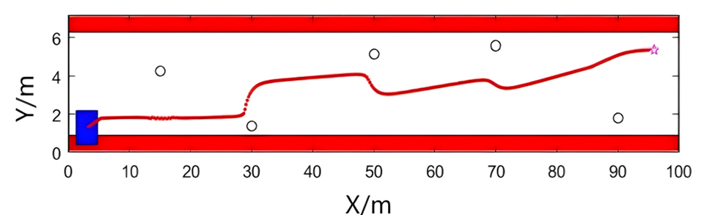
Figure 5.6 Scenario 2 path planning results
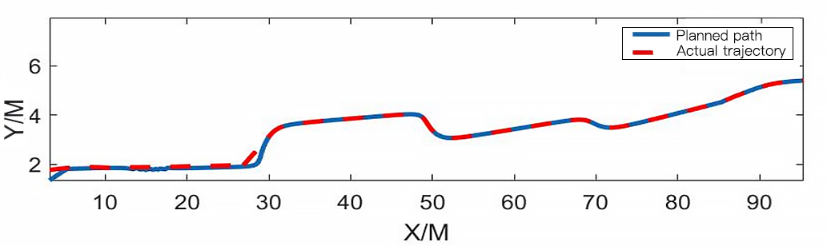
Figure 5.7 Scenario 2 track tracking results
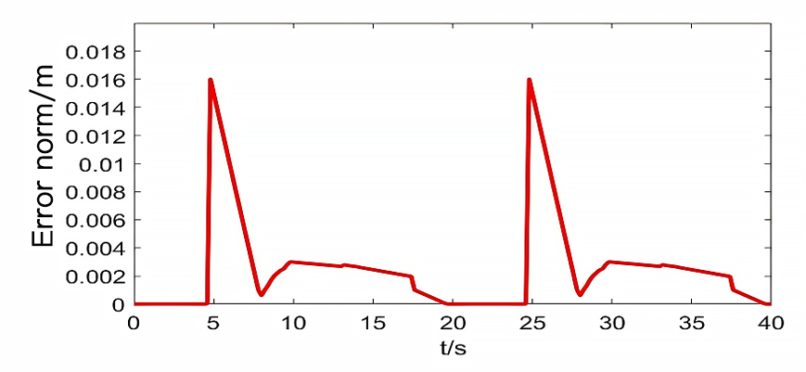
Figure 5.8 Scenario 2 sampling point fitting quality
From Figure 5.6, it can be observed that the planning layer achieved good path planning, successfully avoiding obstacles and reaching the target point. In Figure 5.7, the tracking control layer effectively followed the planned path with minimal errors. From Figure 5.8, it is evident that in this road condition simulation, the maximum norm of the error is 0.016, indicating high fitting accuracy.
From the above simulation results, it can be concluded that the path planning module and the trajectory tracking module can achieve high-precision joint simulation.

Summary of This Chapter
This chapter first proposed the concept of joint simulation for path planning and trajectory tracking algorithms, where the planned path is transmitted to the control layer in a discrete form. To reduce computational load and improve data transmission efficiency, a polynomial interpolation fitting method was selected to modulate the discrete points before transmitting them to the control layer. Subsequently, experiments were conducted to validate the approach. The results demonstrated that the planning layer could successfully plan collision-free paths based on the obstacle road conditions encountered by the vehicle. The curve fitting method effectively transmitted the path information with high accuracy and minimal error, enabling the tracking layer to perform stable and precise tracking control of the path.

Conclusion
This study primarily focuses on the issues of local path planning and trajectory tracking control for autonomous intelligent vehicles, achieving the following results.
(1) This study improved the traditional artificial potential field (APF) method. First, the APF method was analyzed and modeled, with targeted improvements addressing its goal unreachability and local minima issues. To solve the goal unreachability problem, potential energy was added at the target point, increasing the attractive potential energy to enable the autonomous vehicle to overcome obstacle repulsion and reach the target. For the local minima problem, a fuzzy control-based escape force was proposed, allowing the vehicle to escape from zero resultant force situations and continue moving. Finally, three simulation environments were set up to compare the improved APF method with the traditional one. Simulation results proved that the improved APF method achieves effective obstacle avoidance path planning while successfully overcoming goal unreachability and local minima problems.
(2) A trajectory tracking controller based on Model Predictive Control (MPC) was designed and improved. First, the vehicle's kinematics were analyzed to construct a kinematic mathematical model as the predictive model for the MPC controller, which predicts the system's future outputs. By inputting a reference path and designing an objective function, the control input sequence that minimizes the error between the predicted output and the reference path was obtained, completing the controller design. Simulation on an elliptical reference path showed initial tracking capability but revealed some limitations. To address these, a decoupled lateral and longitudinal control strategy was adopted, separately controlling the front wheel steering angle and vehicle speed. The lateral control used a vehicle dynamic model with simplified tire models and tire sideslip angle formulas to design the MPC controller. The objective function was modified to solve for control increments and included tire sideslip angle constraints, enhancing safety in tracking control. For longitudinal control, a displacement-velocity-based dual PID controller was employed for speed control. Simulations demonstrated that the improved controller achieved accurate and smooth trajectory tracking, as well as efficient and stable speed tracking. Additional tests on different road friction coefficients validated the improvements in driving performance introduced by the tire sideslip angle constraints.
(3) Joint simulations were conducted for the improved artificial potential field method and the trajectory tracking controller proposed in this study. Various road scenarios with different obstacle information were set up. First, the path planning module performed the path planning, and the planned path was then discretized and transmitted using polynomial interpolation fitting. In the control layer, the fitted path was tracked. Simulation results demonstrated that the path planning module and the tracking control module could perform efficient joint simulations, showcasing practical significance.
APF has a relatively low economic cost, making it suitable for low-cost hardware and embedded systems. Due to its simple computational logic, the implementation of APF does not require expensive hardware support, and compared to other path planning algorithms such as A* or Dijkstra, its implementation and development costs are lower. At the same time, the computational overhead of the APF method is relatively small, making it suitable for real-time path planning in dynamic environments. However, its computational efficiency may decrease when dealing with complex maps or large-scale environments. In contrast, A* and Dijkstra algorithms, while more precise and capable of handling complex environments, have higher computational complexity. Particularly in large-scale environments, their computational cost is significantly higher than that of APF. In terms of engineering implementation, APF is relatively simple to implement and can easily adapt to different environments and tasks. On the other hand, A* and Dijkstra algorithms require more debugging and optimization, especially in dynamic or complex environments, making their implementation more challenging.
MPC (Model Predictive Control) has a higher economic cost because it involves complex optimization problems and real-time computation, requiring a powerful computational platform and high-frequency processing capability. Compared to traditional PID control, MPC has significantly higher hardware demands and development costs, but its advantages become more apparent in high-precision and complex environments. In terms of computational cost, MPC needs to solve a complex optimization problem during each control cycle, which results in a heavy computational burden, especially in dynamic environments. However, MPC offers stronger adaptability and accuracy compared to other trajectory tracking control algorithms. Particularly in complex dynamic scenarios, MPC can optimize control inputs in real-time, providing precise trajectory tracking, whereas PID and LQR control methods often struggle to meet the demands for high precision and complex control.

Reference
Baidu Apollo releases a Lego-style vehicle intelligence solution, 2021. Intelligent Building and Smart City, 290(01), p.6.
Bi, J., 2012. Analysis of human factors in road traffic accidents and driver reliability research. PhD. Beijing Jiaotong University.
BlackBerry collaborates with Baidu to deepen next-generation autonomous driving technology, 2021. Automobile & Accessories, 1(03), p.20.
Buehler, M., Iagnemma, K. & Singh, S., 2009. The DARPA Urban Challenge: Autonomous Vehicles in City Traffic. Springer.
Chang, H., 2018. Analysis and suggestions on the current state of autonomous vehicles. Internal Combustion Engine & Accessories, 6(9), p.240.
Chen, J. & Zhou, J., 2019. The all-new Audi A8L: A walking piece of cutting-edge technology. Sedan Intelligence, 8(2), pp.21–22.
Chen, M. & Ren, Y., 2017. MPC-based path tracking control for autonomous vehicles with multi-constraints. Proceedings of the 2017 International Conference on Advanced Mechatronic Systems (ICAMechS), pp.61–65.
Chen, N., 2020. Challenging Tesla's FSD, Baidu Apollo launches Navigation Assisted Driving ANP. Enterprise Observer, 10(9), p.17.
Chen, X., 2016. Challenges and future prospects for the development of autonomous vehicles. Comprehensive Transportation, 38(11), pp.9–13.
Chen, X., 2021. The total number of vehicles nationwide has reached 281 million. Automobile Observation, 190(01), p.7.
Clements, L.M. & Kockelman, K.M., 2017. Economic Effects of Automated Vehicles. Transportation Research Record, 2606(1), pp.106–114.
Cui, X., 2017. Research on regional unsignalized intersection control methods based on vehicle-road collaboration. PhD. Beijing Jiaotong University.
Dias, J.E.A., Pereira, G.A.S. & Palhares, R.M., 2014. Longitudinal model identification and velocity control of an autonomous car. IEEE Transactions on Intelligent Transportation Systems, 16(2), pp.776–786.
Fan, X., Guo, Y., Liu, H., et al., 2020. Improved artificial potential field method applied for AUV path planning. Mathematical Problems in Engineering, 21(2), pp.1–21.
Feng, G., 2020. Research on vehicle-road collaborative applications based on smart roads. Proceedings of the 15th China Intelligent Transportation Annual Conference (2).
Feng, Y., 2019. Design and experimental research of a path planning algorithm for an autonomous vehicle. PhD. Jilin University.
Gao, X., 2020. Research on dynamic obstacle avoidance for autonomous robots based on an improved artificial potential field method. PhD. Zhengzhou University.
Gong, Y., 2014. Research on a path tracking control method for autonomous vehicles. PhD. Nanjing University of Science and Technology.
Ji, H., Xie, H. & Liu, Z., 2020. Research on urban traffic signal control methods under vehicle-road coordination environments. Journal of Research on Science and Engineering, 2(10), pp.1–12.
Jiang, B., Liang, S., Peng, Z.R., et al., 2017. Transport and public health in China: the road to a healthy future. The Lancet (London, England), 390(10104), pp.181–191.
Jiang, H., 2019. Research on trajectory tracking control of intelligent vehicles. PhD. Jilin University.
Joseph, L. & Lu, L., 2015. How Google's self-driving cars will change everything. China Science and Technology Translation, 28(2), pp.61–64.
Karaman, S. & Frazzoli, E., 2010. Optimal kinodynamic motion planning using incremental sampling-based methods. Proceedings of the 49th IEEE Conference on Decision and Control (CDC), pp.7681–7687.
Kavraki, L.E., Kolountzakis, M.N. & Latombe, J.-C., 1998. Analysis of probabilistic roadmaps for path planning. IEEE Transactions on Robotics and Automation, 14(1), pp.166–171.
Kuffner, J.J. & Lavalle, S.M., 2000. RRT-connect: An efficient approach to single-query path planning. Proceedings of the IEEE International Conference on Robotics and Automation (ICRA), pp.995–1001.
Kumar, P.B., Rawat, H. & Parhi, D.R., 2019. Path planning of humanoids based on the artificial potential field method in unknown environments. Expert Systems, 36(2), e12360.
Li, Q. & Shen, T., 2020. Analysis of the current state and trends of autonomous vehicle development abroad. New Material Industry, 5(3), p.12.
Li, Y., Ma, R. & Fu, W., 2012. Sliding mode trajectory tracking control of intelligent vehicles. Measurement and Control Technology, 31(9), pp.71–74.
Likhachev, M., Gordon, G.J. & Thrun, S., 2003. ARA*: Anytime A* with provable bounds on sub-optimality. Advances in Neural Information Processing Systems, 16, pp.64–70.
Lorenzen, M., Allgöwer, F. & Cannon, M., 2017. Adaptive model predictive control with robust constraint satisfaction. IFAC-PapersOnLine, 50(1), pp.3313–3318.
Ma, Y., Li, K., Gao, F., et al., 2006. Design of an improved finite-time optimal preview lateral controller. Automotive Engineering, 28(5), pp.433–438.
National motor vehicles and drivers maintained high growth in 2017, 2018. Road Traffic Management, 402(02), p.6.
Niu, G., Li, W. & Wei, H., 2021. Lane-changing trajectory planning for intelligent vehicles based on double quintic polynomials. Automotive Engineering, 2(7), p.78.
Peng, D., 2019. Research on path planning of autonomous vehicles in urban road network environments. PhD. Shanxi University.
Que, J., Ding, G. & Huang, Y., 2003. PRM path planning method based on heuristic node enhancement strategy. Robot, 25(6), pp.544–547.
Sharp, R.S., Casanova, D. & Symonds, P., 2000. A mathematical model for driver steering control, with design, tuning, and performance results. Vehicle System Dynamics, 33(5), pp.289–326.
Song, J., Dai, T. & Liu, Y., 2017. Mobile robot path planning based on an improved artificial potential field method. Computer Engineering and Science, 39(7), pp.328–332.
Soualmi, B., Sentouh, C., Popieul, J.-C., et al., 2012. Fuzzy Takagi-Sugeno LQ controller for lateral control assistance of a vehicle. Proceedings of the 2012 IEEE Intelligent Vehicles Symposium, pp.337–342.
Takahashi, A., Hongo, T., Ninomiya, Y., et al., 1989. Local path planning and motion control for AGV in positioning. Proceedings of the IEEE/RSJ International Workshop on Intelligent Robots and Systems (IROS'89), pp.507–512.
Wang, J., Sun, Z., Xu, X., et al., 2013. Adaptive speed tracking control for autonomous land vehicles in all-terrain navigation: An experimental study. Journal of Field Robotics, 30(1), pp.102–128.
Werling, M., Ziegler, J., Kammel, S., et al., 2010. Optimal trajectory generation for dynamic street scenarios in a Frenet frame. Proceedings of the 2010 IEEE International Conference on Robotics and Automation (ICRA), pp.987–993.
Yang, C., 2016. Design of an intelligent vehicle control system and research on path tracking algorithms. PhD. Beijing University of Technology.
Yang, C., Zhuang, C., Sun, J., et al., 2018. Multi-factor analysis of road traffic accidents. Journal of Chongqing Jiaotong University (Natural Science Edition), 37(04), pp.87–95.
Yang, H., 2018. Analysis and evaluation of the intelligence level of autonomous vehicles. PhD. Hebei University of Engineering.
Yang, Y., Ding, B., Xu, Z., et al., 2019. Tube-based output feedback model predictive control of polytopic uncertain systems with bounded disturbances. Journal of the Franklin Institute, 356(15), pp.7990–8011.
Yuan, J. & Shen, H., 2019. Research on local path planning of mobile robots based on the artificial potential field method. Proceedings of the 2019 IEEE Advanced Information Management, Communications, Electronics and Automation Control Conference (IMCEC), pp.121–126.
Zhang, N., Zhang, Y., Ma, C., et al., 2017. Path planning of six-DOF serial robots based on an improved artificial potential field method. Proceedings of the 2017 IEEE International Conference on Robotics and Biomimetics (ROBIO), pp.1293–1298.
Zhang, X. & Zhang, J., 2019. Research progress on decision-making and path planning for intelligent vehicles. Proceedings of the 23rd Annual Conference on New Network Technologies and Applications, pp.5.
Zhao, P., 2012. Research on motion control methods for autonomous vehicles in urban environments. PhD. University of Science and Technology of China.
Zhao, X. & Hu, G., 2017. Application of the smoothed ARA* algorithm in intelligent vehicle path planning. Mechanical Science and Technology, 36(8), pp.72–75.

