Distributed Intelligence Systems (ACDC5009)
  - For electronics
James T | 2322728 | Embedded Electronics | 03/11/2025

Contents
- Introduction
- Literature Review
  - Quality Management System
- Type of Data Transmission
  - Point-to-Point
  - Point-to-Multipoint
  - Multi-Master
- Practical Application
  - Design
    - Master
    - Slave
  - Programme Development
  - Analysis
  - Future Work
- Conclusion
- Bibliography
- Appendices
  - Appendix A – Master Code
  - Appendix B – Slave Code

Figures
- Figure 1 – Quality Control Flowchart
- Figure 2 – Overall Proteus car headlight circuit
- Figure 3 – Master circuit overview
- Figure 4 – Pull-up resistors on I2C data lines
- Figure 5 – Button inputs on Port B
- Figure 6 – Slave circuit overview
- Figure 7 – Specification of Proteus LED
- Figure 8 – 555 timer circuit for Indicator LED
- Figure 9 – Master Flowchart
- Figure 10 – Slave Flowchart
- Figure 11 – DRL switch closed, Dipped beam off
- Figure 12 – DRL switch closed, Main beam off and Fog light still works
- Figure 13 – DRL turned off, Dipped beam now works
- Figure 14 – DRL turned off, Main beam now works
- Figure 15 – Fog light working, Main beam on
- Figure 16 – Side light working, Dipped beam on
- Figure 17 – Indicator switch on, Indicator light at off state, DRL on
- Figure 18 – Indicator switch on, Indicator light at on state, DRL on
- Figure 19 – Hazard on, Indicator off, Indicator light blink on stage
- Figure 20 – Hazard on, Indicator off, Indicator light blink off stage

Introduction
This report will be looking at the importance of a good Quality Management System and how it helps to boost companies popularity with customers, alongside saving money. It then will move onto different transmission types, researching into how they work and examples of where each one is used. Finally, it will cover a multi-processor system on Proteus to simulate how a car’s front right headlight system may work, with the accuracy of real cars taken into consideration for the design. Alongside this, it thinks about what future work could be done to improve upon the model created.

Literature review

Quality Management System
[1] [2]Quality Management System (QMS) is a formal set of responsibilities and processes tailored to each organisation, defining how the business is run. QMS consists of well documented processes, policies and procedures to enhance and standardise the quality control across all business operations. These should comply with the relevant industry standards and regulatory requirements to help deliver high quality products to the consumer. A QMS will have the processes associated for controlling quality in each activity the business uses, which can be roughly shown in the flowchart below.
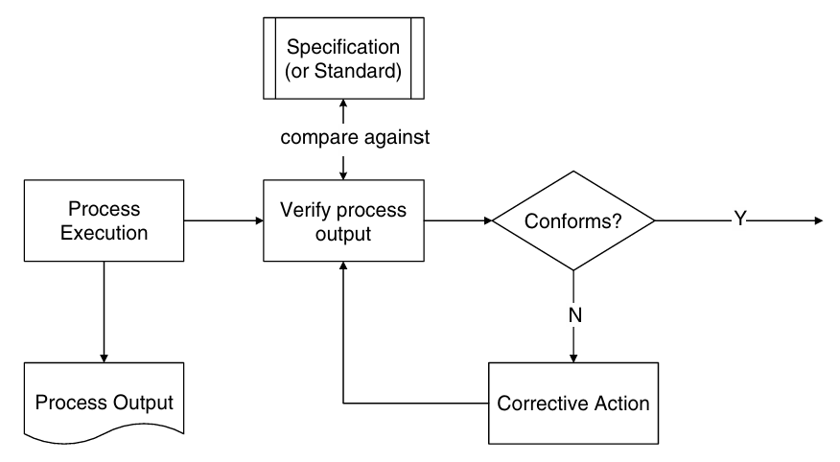
[3]Figure 1 – Quality Control Flowchart
There are several QMS frameworks available to guide constant development, which include
- ISO 9000 series
- ISO 9001 (the most recognised QMS standard worldwide)
- ISO 14000 series (QMS for Environmental management systems)
- ISO 13485 (QMS for medical devices)
- ISO 19011 (QMS for Auditing management systems)
- IATF 16949 (QMS for Automotive industry)
- AS 9100 (QMS for defence, space and aviation)
[2] [4]The ISO 9001 standard is designed around seven core principles, which ensure long-term success from the viewpoint of stakeholders, employees and consumers. The principles from ISO 9001:2015 are:
- Customer focus – For businesses to succeed, customers are at the root of growth, therefore meeting or exceeding expectations are key for loyalty and repeated business
- Leadership – Prioritising quality management to create a tradition of quality is an important part of strong leadership
- Engagement of people – Having employees at all levels involved helps utilise their knowledge, skills and creativity
- Process approach – Improve efficiency and helps get consistency by viewing all processes that influence quality as interconnected processes, considering how each task effects the next
- Continual improvement – Businesses should try to continually improve their QMS
- Evidence-based decision-making – Analysing data is important to use for reducing risk and continuing improvement
- Relationship management – Having good relations with suppliers and stakeholders enhances consistency
[5]Most checks for a high quality QMS are automated, with many of the experts involved in QMSs agreeing that it is ten times more efficient, and cheaper, to have an automated QMS for each organisation. Automated QMSs can be created for three core areas: Regulations and customer requirements, material process management and Quality Assurance.
[5]Having regulations and customer requirements automated significantly reduces the time required to document compliance with the quality standards. Bringing down human influence on quality control, and automating the data collection and analysis, will bring down the cost of quality procedures.
[3]Some other benefits of a good QMS include:
- Improved Organisational effectiveness by having solutions which correct and prevent causes of quality issues
- Continual improvement by monitoring and analysing business processes
- Grow revenue through delivering on time, productivity improvements and budget related work
- Increase in quality of the product/services
- Improved customer satisfaction through the improved products/services
- Organisations can establish themselves as being the best by their consumers, retaining and bringing in new customers
- Some customers may require the supplier to have a QMS in place, giving the organisation a competitive edge
- Increased confidence that the products the customer will receive will be to a consistent quality
- Reduces the chances of being reliant on certain individuals for information about critical processes, since they will be formally documented
- Ensures staff understand that quality is everyone’s responsibility, improving morale since they are empowered to continually improve their processes
[6] [7]While the benefits don’t have direct impact on business performance, it does indirectly moderate operational performance, assisting in business growth. Companies are recognising the importance of QMS, and over the last few decades, it has become a popular topic of interest and challenge for researchers.
[7]The last comprehensive review on the impact of QMSs was in 2002, based on articles published between 1994 and 1999. Emerald Publishing reviewed 253 papers between 2000 and 2017, which found gaps in the research, including the implementation of multiple QMS’, identification of leading indicators of firm’s performance, standardisation of performance measures, environment, safety and health-related performance measures and more. Past literature reviews focused on Total quality management (TQM), missing out on other QM systems, such as Toyota Production System, Total productive maintenance (TPM), Theory of constraints (TOC) and ISO 9001, which is now the most recognised QMS standard in the world.
[8]Top management at a small winery based in Paros Island, Greece, wanted to improve the inside operations of the organisation, increase market share and infiltrate into potential new markets. They ran into issues around the documentation process due to a lack of knowledge on the ISO 9000 family, lack of time, resources and commitment. In smaller companies, these are especially noticeable due to the low number of staff. The company overcame the issues with both internal and external training, training all employees on the QMS standard. The cost of this was quite high, however they found the benefits, such as an increase in customer satisfaction, cost saving and an increase in market share were worth the initial cost.

Type of Data Transmission

Point-to-Point
[9] [10] [11]This form of network topology is where two devices are communicated to each other directly. This allows it to be reliable, efficient, simple and scalable, with unimpeded data transfer. It being a dedicated connection, the communication is private and secure. Point-to-point also has its downfalls, such as being more complicated and expensive as the number of nodes increases. The standards involved with this communication include the IEEE 802.3 (Ethernet), IEEE, 802.11 (Wi-Fi) and RFC 791 Internet protocol. Examples of this include a PC connected to a printer or Wi-Fi.

Point-to-Multipoint
[12] [13] [14] [15]This communication method refers to a single central hub which communicates to multiple receivers simultaneously. It is regularly used for efficient data distribution in wireless internet services and is the most favoured approach to fixed broadband wireless construction. The benefits of having one point talk to multiple points simultaneously is its easily scalable and less complex when adding new links. It can also be cheaper than Point-to-point since there is less wiring required.

Multi-Master
[16] [17] [18]A system using multiple master devices is a multi-master transmission system. When one master is transmitting, then the other masters must cease transmission when they have lost a selection process called arbitration. It acts on a first-come first-served bases. When a master loses, it must go into slave mode. Since some of the masters can run at different serial clock frequencies, there must be a scheme in place to synchronise them all. This topology is used is in robotics, training applications and surgical operations.

Practical Application
This section of the report will cover the design, construction and simulation of the front right side of a car head light system. The model works using a master/slave architecture through I2C, where there will be a brief explanation of what it is and how it works.

Design
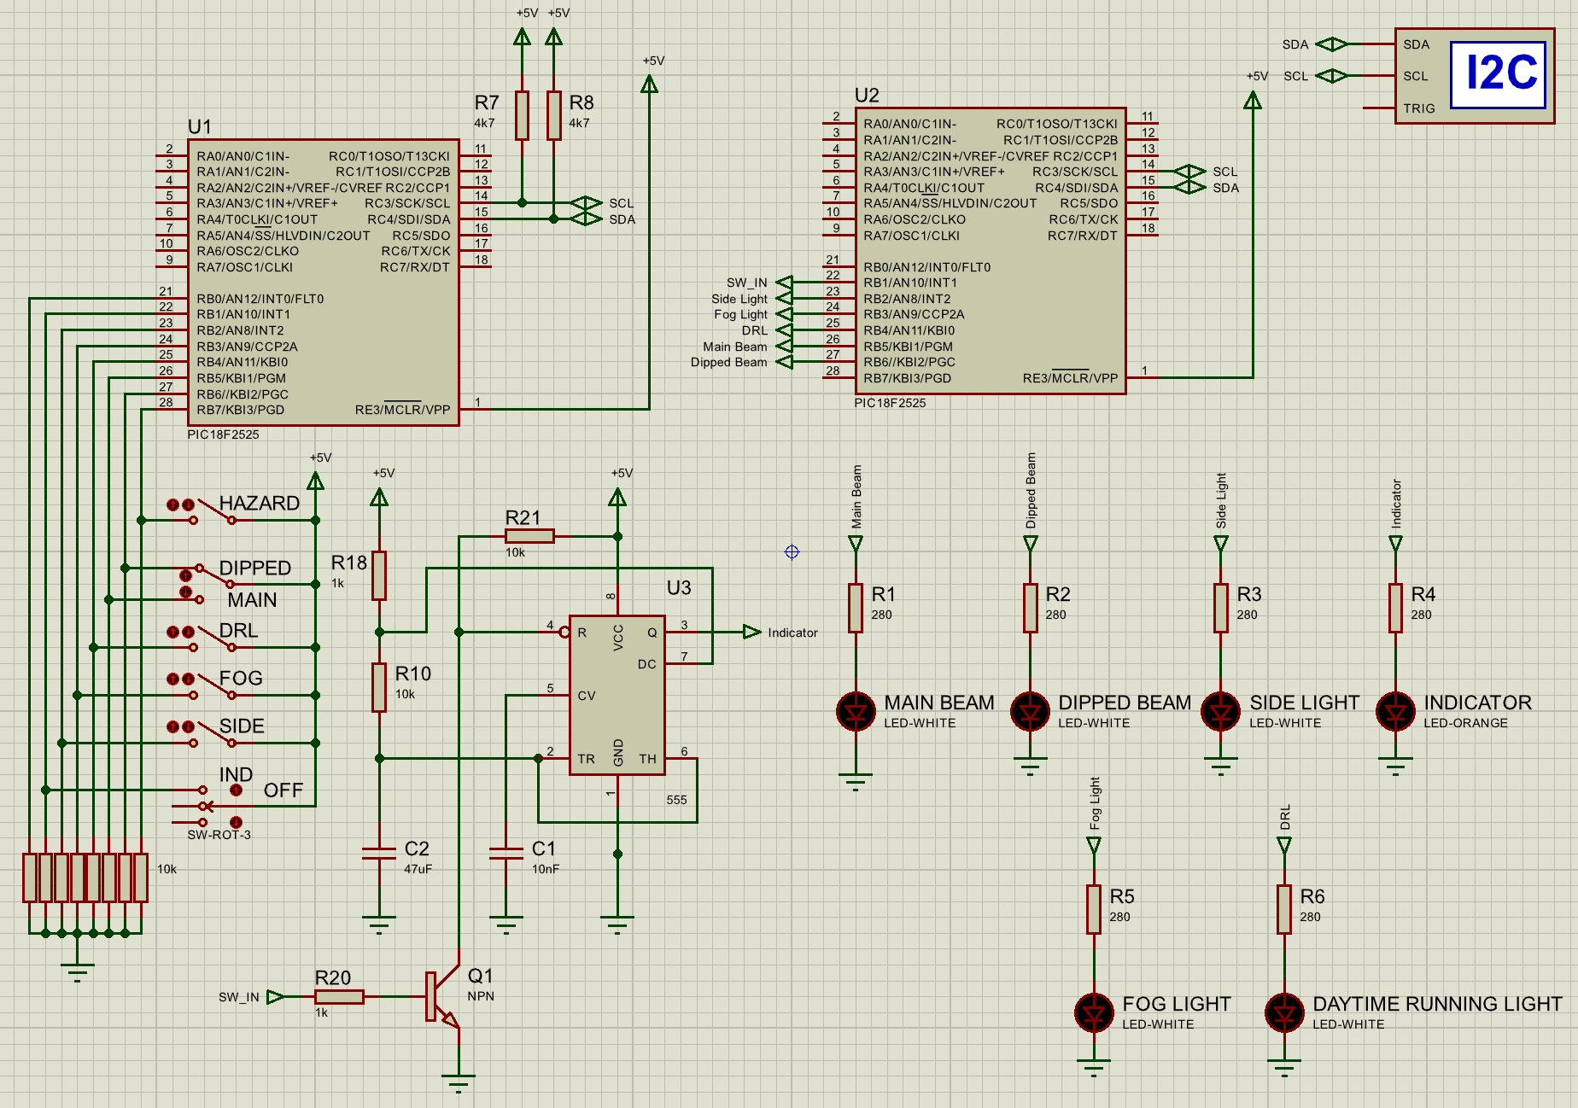
The overall circuit design, seen in figure 2 below, can be broken down into 2 main sections: the Master and the Slave, both containing the required circuits to replicate how a cars headlight system works.
Figure 2 – Overall Proteus Car Headlight circuit

Master
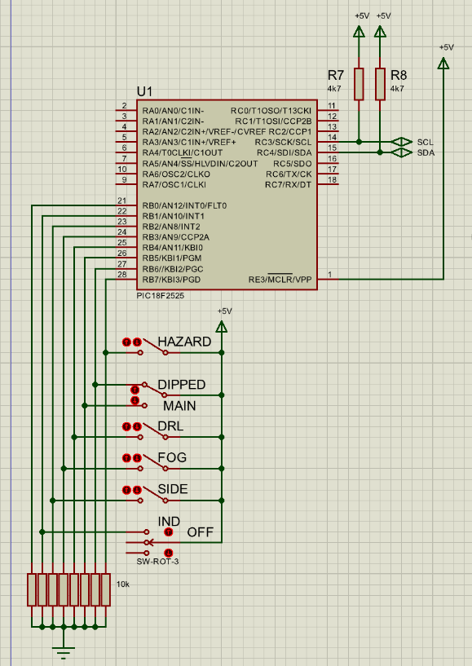
The master half of this distributed intelligence system contains pull-up resistors on the I2C lines. There are switches on Port B, with pull-down resistors to hold the pins low when open.
Figure 3 – Master Circuit Overview
[19]The Master talks to the Slave device through I2C, which is a type of serial communication, typically used for short distance, low-speed data transmissions. The protocol also allows for multiple slave device to talk to multiple master devices on the same bus. This means that only two signal lines are required: Serial Clock (SCL) and Serial Data (SDA).
[19] [20]I2C requires a pull-up resistor on both the signal lines as it needs the ability to output a high level. Without the pull-ups, the output would be open drain, which typically cannot output a high level. These resistors are pulled high to the operating logic voltage (usually 3.3V – 5V). They should be greater than 1kΩ to prevent high power consumption and high current being sunk into the port. Recommended values typically used are 2.2k or 4.7kΩ.
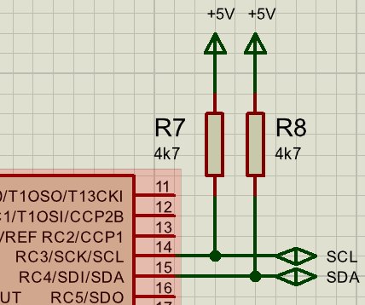
Figure 4 – Pull-up resistors on I2C data lines
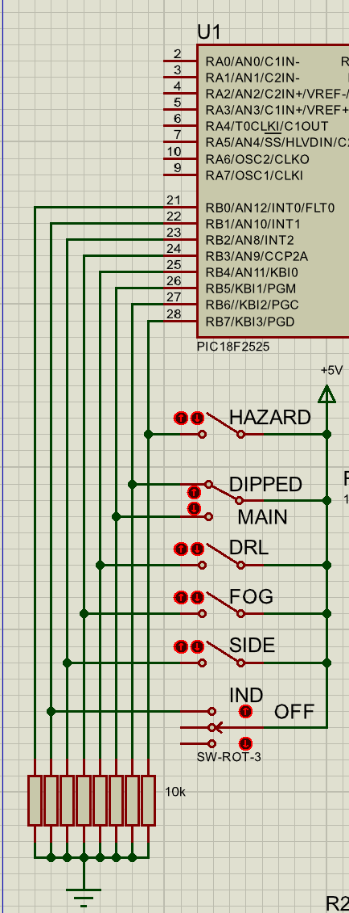
The master has the input switches for each of the lights connected to Port B, switching the pin high when closed. A 3 way switch has been used for the indicator to replicate an indicator stalk, where the middle position is off, and either side of the switch is the left or right indicator. The circuit is only half a car’s front headlight system, therefore only one indicator is connected. There is a 2-way switch to change between main beam and full beam, meaning they can’t be on at the same time, as it is on a car.
Figure 5 – Button inputs on Port B
[21]The input pins of Port B are pulled low when the switches are open as cars typically have majority of their structure connected to ground, meaning it is more likely to short to ground. Having it setup this way increases the safety of the system.

Slave
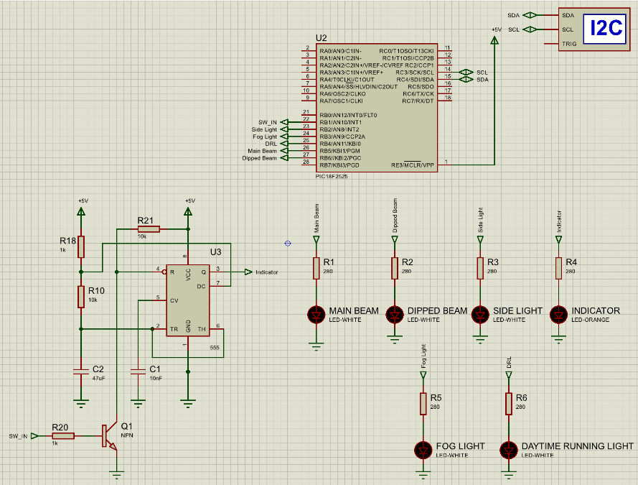
[22]The Slave microcontroller has the I2C connected into its SDA and SCL data lines to receive the data in from the master. The headlight LEDs are connected to Port B, with the pinout corresponding to the correct switch. Each LED has a 280Ω current limiting resistor to power the LED at the correct voltage and prevent it drawing too much current.
Figure 6 – Slave circuit Overview
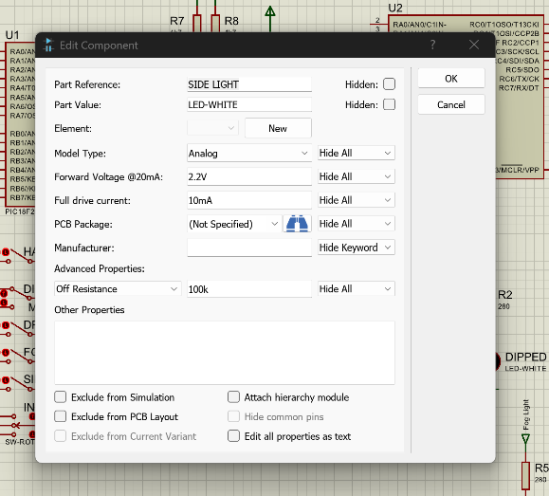
[22]The LED in proteus has a forward voltage of 2.2V and full drive current of 10mA. To calculate the resistor values, the formula is $R= \frac{V}{I}$, where V is the voltage to be dropped over the resistor (in Volts) and I is the current the LED is to run at (in Amps). With the logic voltage of 5V, the voltage to drop over the resistor is 5V – 2.2V = 2.8V. Putting this into the formula:
$R= \frac{2.8}{0.01}$ = 280Ω
Figure 7 – Specification of Proteus LED
[23]For the Indicator, a 555 timer was used to simplify the code. The device is setup for Astable operation, where it triggers itself and acts as a multivibrator, causing the LED to blink. The output pin from the slave goes into the reset pin of the 555 through an NPN transistor. The circuit works by taking the 555 timers reset to ground, disabling the device when the indicator switch is open. When the switch is closed, the slave pin is set low, turning off the NPN transistor, meaning the 555 can be pulled high, activating the astable multivibrator.
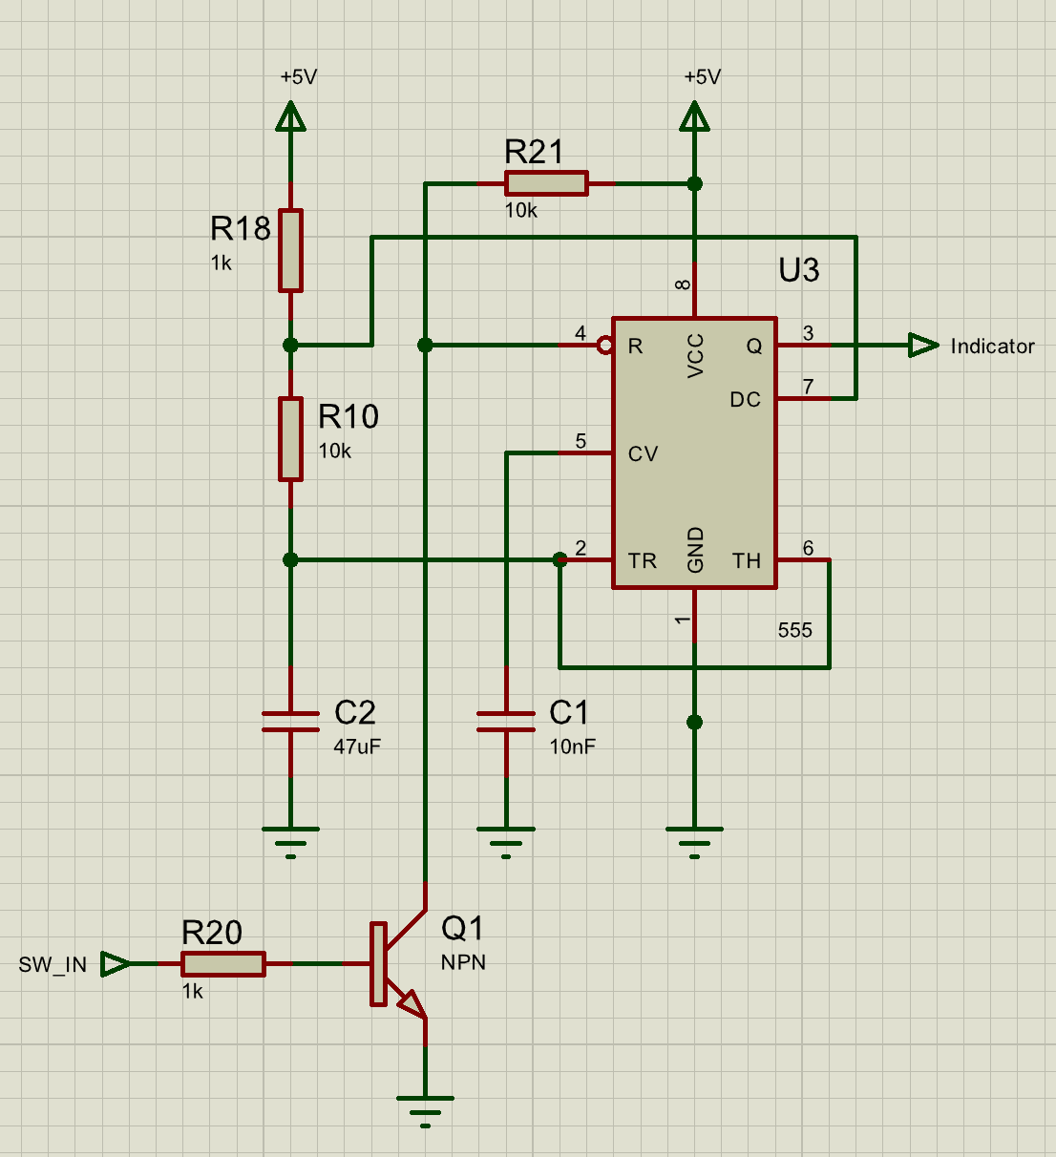
Figure 8 – 555 timer circuit for Indicator LED
[23]C2 (C), R10 ($R_{B}$) and R18 ($R_{A}$) set the charging and discharge timing of the 555. $t_{1}$ is the charge time when the output is high and $t_{2}$ is the discharge time when the output is low. These are given in the 555’s datasheet to be
$$t_{1}=0.693 \left(R_{A}+R_{B}\right) C$$
$$t_{2}=0.693 \left(R_{B}\right)C$$
[24]“The Road Vehicles Lighting Regulations 1989”, 12a say that indicators must flash at a rate between 60 – 120 blinks per minutes, or 1-2 blinks per second. Putting the values chosen for C, $R_{A}$ and $R_{B}$ (as seen in figure ) give a charge time of $t_{1}=0.358s$ and a discharge time of $t_{2}=0.326s$, for a total time of $0.684s$. Dividing a minute (60 seconds) by the total time for charging and discharging gives the blinks per minute: $\frac{60}{0.684}=87.7 Blinks per minute$, which is within the allowed rates.

Programme Development
For reading the switches, the I2C communication process and outputting of the correct data to Port B, the system needed a structured flow of logic to be properly programmed. The flowcharts below in figures 9 and 10 represent the necessary logic that was needed to be implemented into the Master and Slave microcontrollers.
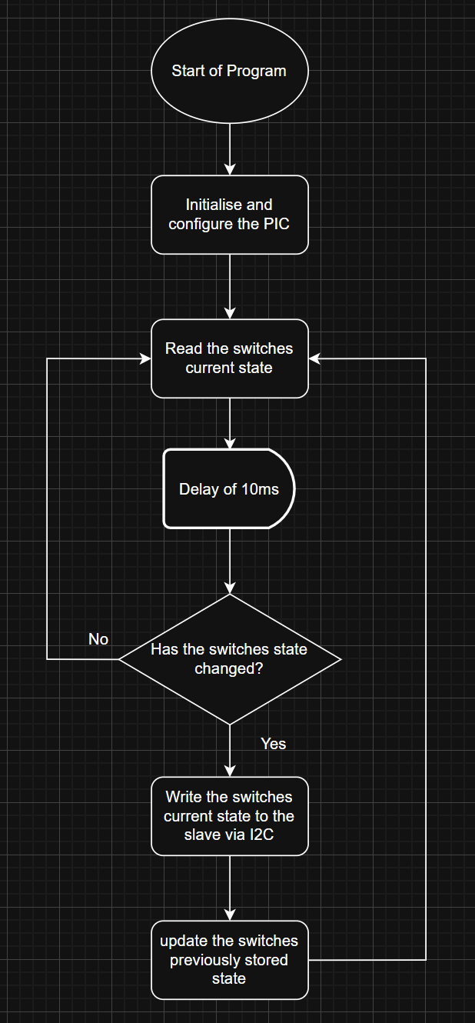
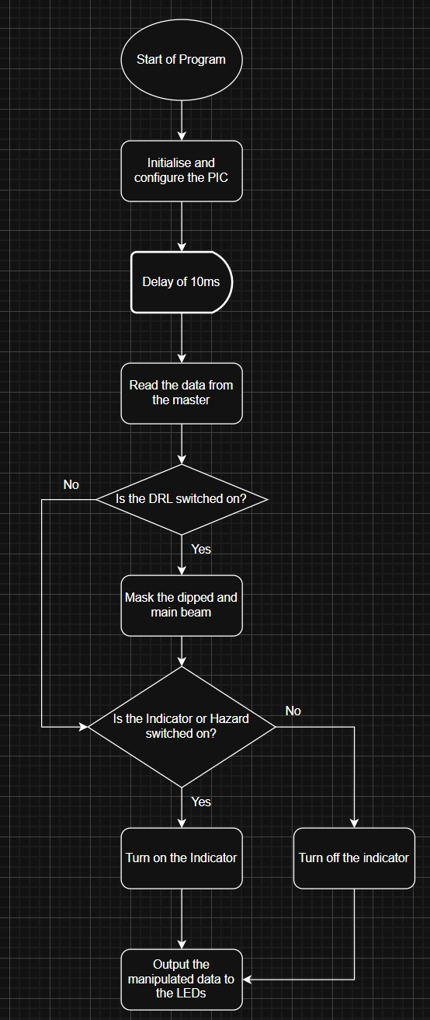
Figure 9 – Master Flowchart Figure 10 – Slave Flowchart
The Programme for the Master, seen in Appendix 1, first reads the current state of the switches on Port B, then checks if the current state has changed from the previous switch state reading. If the state of one of the switches has changed, the I2C transmission will begin. The first byte is the Slaves address, followed by the information byte containing the current state of the switches.
[25]Once the slave has received these two bytes by reading the I2C line, it does checks using bit masking to see if the Daytime running light (DRL), hazard or indicator switch is pressed. If the DRL switch is closed, it will clear the bits for the dipped and main beam, replicating that DRLs and nighttime lights (dipped and main beam) cannot used at the same time.
If the indicator or hazard switches are closed, it will set the Pin B1 bit to 0, turning off the NPN transistor and starting the indicator blink, otherwise setting it to 1. This then outputs the complete modified byte to Port B of the Slave. The code for this operation is within appendix 2.

Analysis
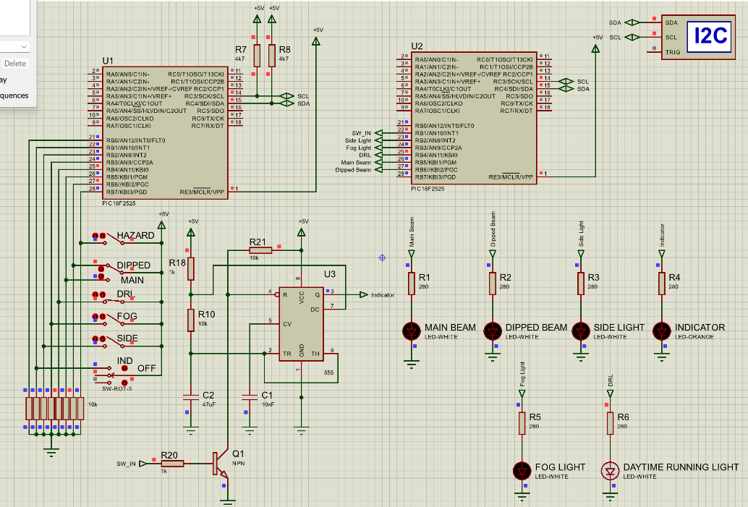
To confirm that the circuit works, below are the checks for each switch to ensure that they function as intended. Starting with the DRL, it can be seen below (figure 11) that the DRL light is on, the dipped and main beam lights are off, meanwhile other lights still work (figure 12).
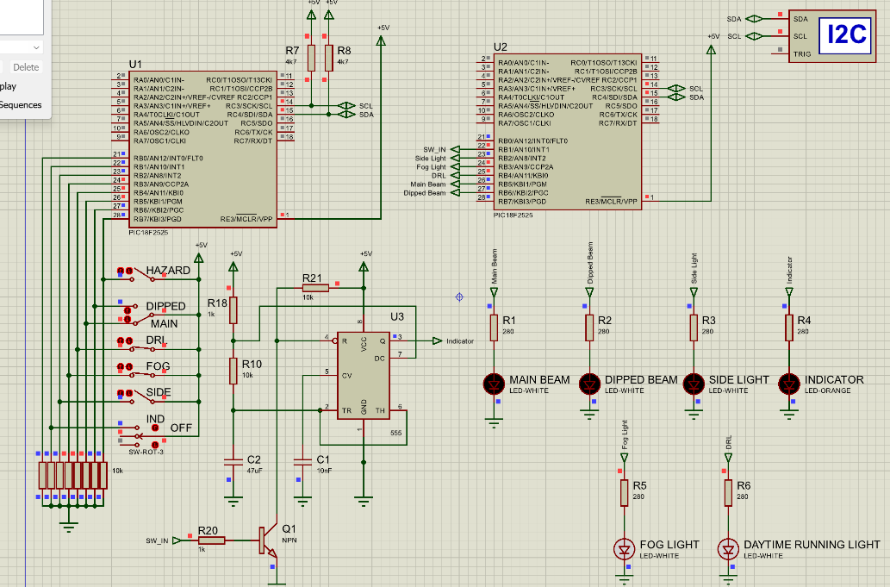
Figure 11 – DRL switch closed, Dipped beam off
Figure 12 – DRL switch closed, Main beam off and Fog light still works
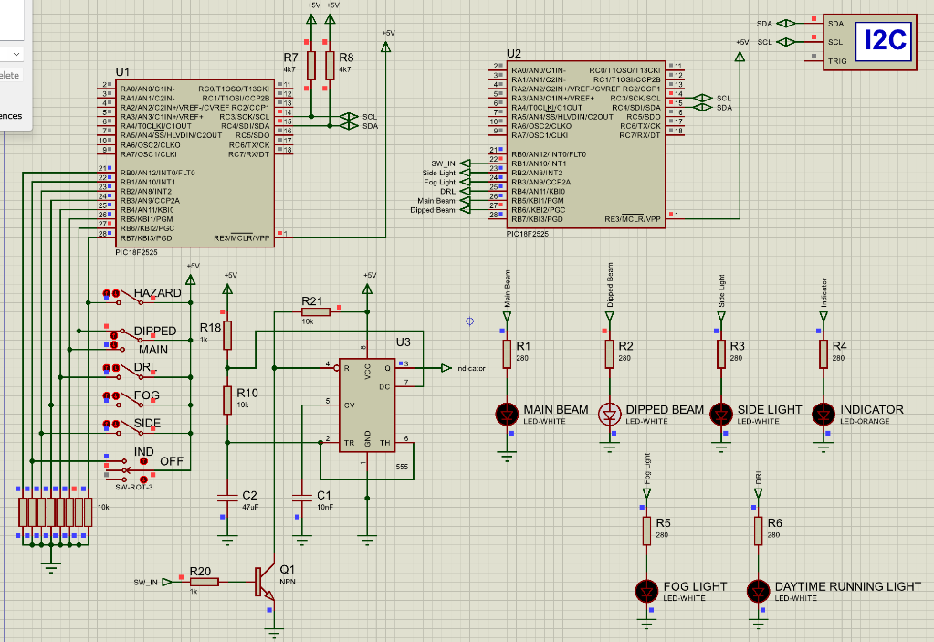
The next switch is for the dipped beam light. This required the DRL to be turned off, which can be seen in Figure 13.
Figure 13 – DRL turned off, Dipped beam now works
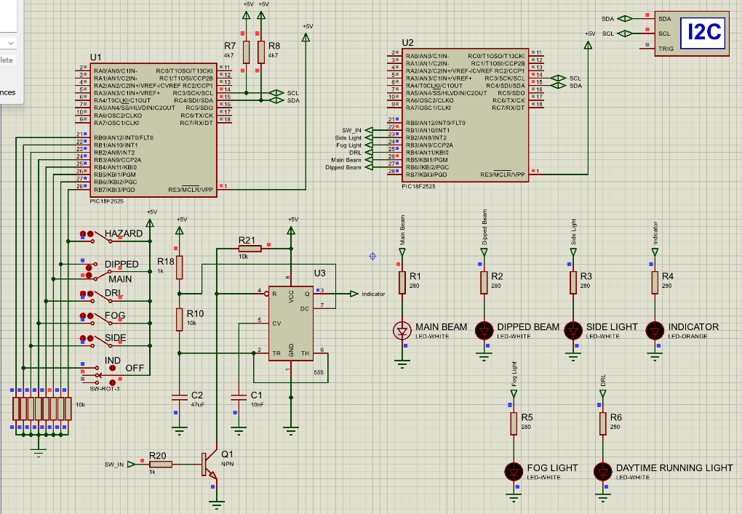
With the switch changed to Main, the main beam light now comes on.
Figure 14 – DRL turned off, Main beam now works
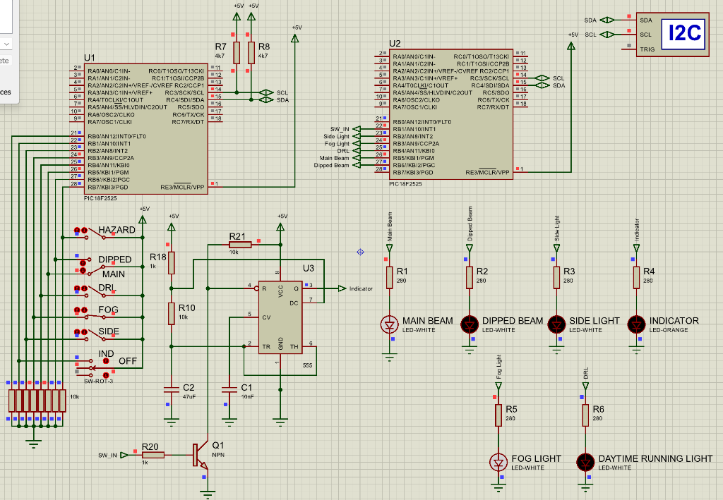
The Following figures are the tests that show the Fog light, side light and indicator works (when either the hazard or indicator switch is pressed). Either the DRL, Dipped beam or Main beam remain on as they would on a car.
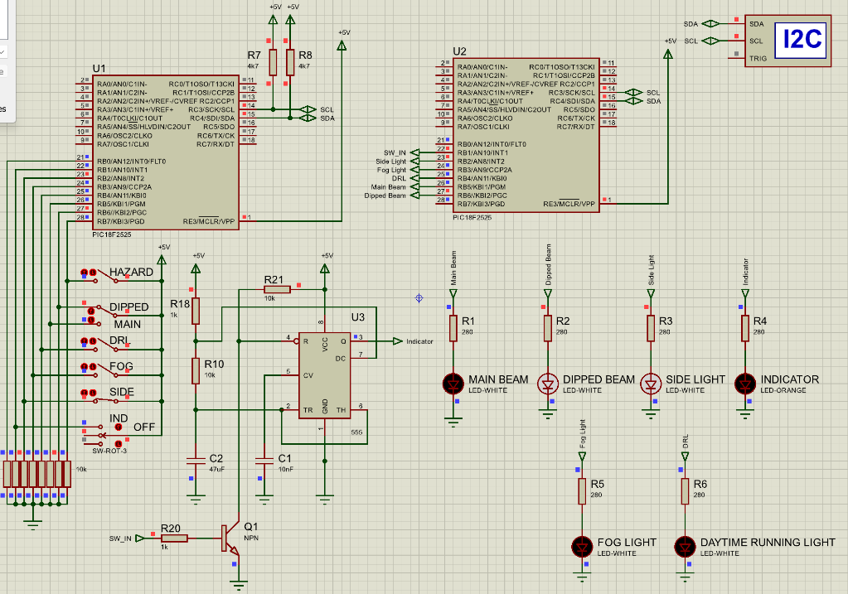
Figure 15 – Fog light working, Main beam on
Figure 16 – Side light working, Dipped beam on

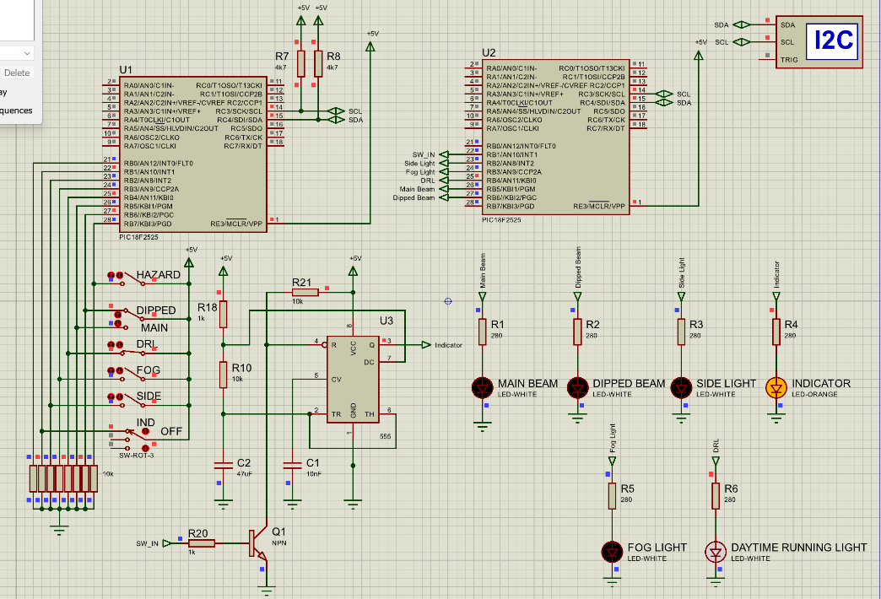
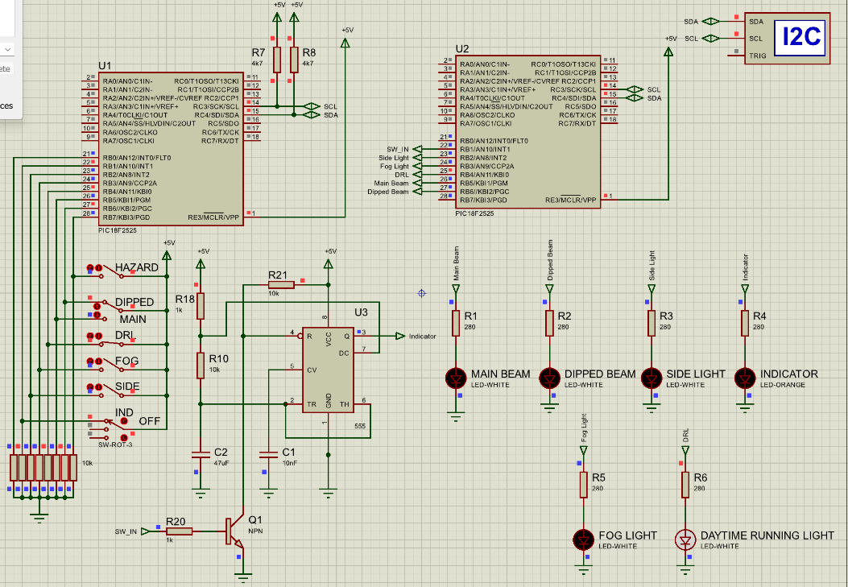
Figure 17 – Indicator switch on, Indicator light at off state, DRL on
Figure 18 – Indicator switch on, Indicator light at on state, DRL on

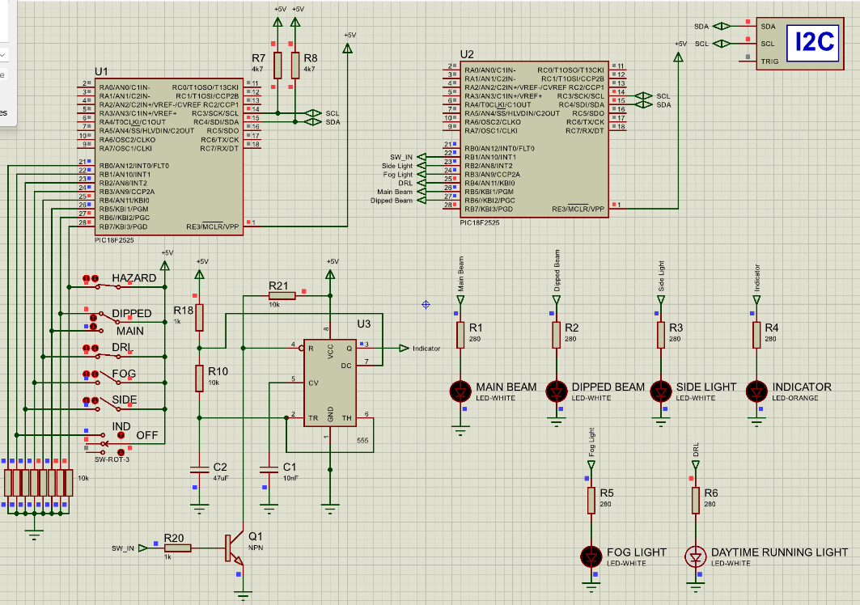
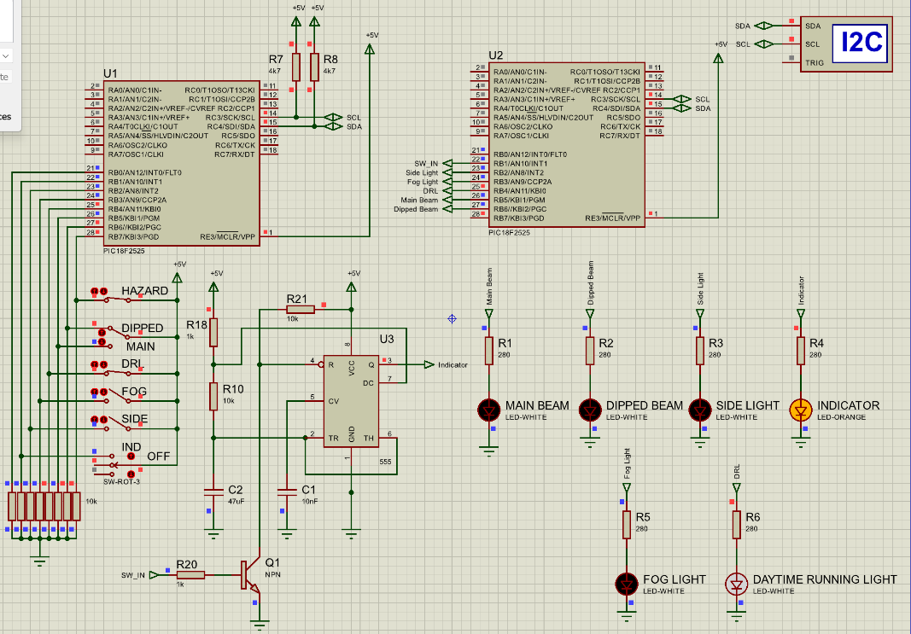
Figure 19 – Hazard on, Indicator off, Indicator light blink on stage
Figure 20 – Hazard on, Indicator off, Indicator light blink off stage

Future work
The Proteus simulation concept for the front right side of a cars headlight system works well, and future work on this could involve completing the other side of the car, where the hazard switch would need to trigger both indicators, and the 3 way switch would need the opposite side connected for indicating left. This would require a second slave or the LEDs connected to another PORT on the slave PIC.
Another future iteration could include digitalising the indicator timing, reducing component cost. However, this would bring added complexity to the programme since integrating a timing delay without effecting the slaves ability to receive new data over I2C can be difficult to get working reliably.

Conclusion
This report has covered what Quality management systems are and some of the standards for QMS. It explored the importance of them to businesses and how, while it can be expensive to do, in the long term saves money by reducing waste. It then looked into different transmission types; Point-to-Point, Point-to-Multipoint and Multi-Master, discussing how each of them works and some examples of how they are used in systems. Finally, it covered a distributed intelligence system made up of two PIC18 microcontrollers to replicate how one side of a cars front headlight system works through I2C, with future work possibilities discussed.

Bibliography

[1] | The International Organisation for Standards (ISO), “Quality management systems: An introduction,” [Online]. Available: https://www.iso.org/quality-management/what-is-qms. [Accessed 5 November 2025].
[2] | R. Chaves, “What is a Quality Management System (QMS)?,” British Assessment Bureau, 5 September 2025. [Online]. Available: https://www.british-assessment.co.uk/insights/what-is-a-quality-management-system/. [Accessed 5 November 2025].
[3] | V. Nanda, Quality Management System Handbook for Product Development Companies, Boca Raton: CRC Press, 2005.
[4] | American Society for Quality, “Quality Management System,” American Society for Quality, [Online]. Available: https://asq.org/quality-resources/quality-management-system. [Accessed 6 November 2025].
[5] | Z. Y. Viriansky and S. O. Shaposhnikov, “Quality Assurance of Quality Management Systems,” in Quality Management, Transport and Information Security, Information Technologies, International, 2019.
[6] | P. E. G. K. Kafetzopoulos DP, “The impact of quality management systems on the performance of manufacturing firms,” International Journal of Quality & Reliability Management, vol. 32, no. 4, pp. 381-399, 2015.
[7] | M. J. G. A. Kumar P, “Impact of quality management systems on firm performance,” International Journal of Quality & Reliability Management, vol. 35, no. 5, pp. 1034-1059, 2018.
[8] | E. D. P. A. D. Aggelogiannopoulos, “Implementation of a quality management system (QMS) according to the ISO 9000 family in a Greek small-sized winery, A case study,” Food Control, vol. 18, no. 9, pp. 1077-1085, 2007.
[9] | S. Santra and P. P. Acharjya, “A Study And Analysis on Computer Network Topology For,” International Journal of Emerging Technology and Advanced Engineering, vol. III, no. 1, pp. 522-525, 2013.
[10] | meter, “What is point-to-point networking? All you need to know,” meter, 3 October 2024. [Online]. Available: https://www.meter.com/resources/what-is-point-to-point. [Accessed 25 November 2025].
[11] | navlaniwesr, “Point-to-Point Communication in Distributed Systems,” geeksforgeeks, 23 July 2025. [Online]. Available: https://www.geeksforgeeks.org/system-design/point-to-point-communication-in-distributed-systems/. [Accessed 25 November 2025].
[12] | H. R. Anderson, “Fixed, Portable and Mobile Terminals,” in Fixed Broadband Wireless System Design, Chichester, John Wiley & Sons Ltd, 2003, pp. 18-19.
[13] | A. Chen, “What is Point-to-Multipoint Communication,” Sanny Telecom, 18 May 2024. [Online]. Available: https://www.sannytelecom.com/what-is-point-to-multipoint-communication/. [Accessed 25 November 2025].
[14] | ComputerNetworkingNotes, “Network Topologies Explained with Examples,” ComputerNetworkingNotes, 11 July 2025. [Online]. Available: https://www.computernetworkingnotes.com/networking-tutorials/network-topologies-explained-with-examples.html. [Accessed 25 November 2025].
[15] | meter, “What is Point-to-Multipoint (PtMP) communication?,” meter, 26 March 2025. [Online]. Available: https://www.meter.com/resources/point-to-multipoint. [Accessed 25 November 2025].
[16] | Microchip, “26.4 Multi-Master Bus Systems, Arbitration, and Synchronization,” Microchip, [Online]. Available: https://onlinedocs.microchip.com/oxy/GUID-0EC909F9-8FB7-46B2-BF4B-05290662B5C3-en-US-12.1.1/GUID-76E847C6-8B91-40D9-86F6-A917307D5BEE.html. [Accessed 27 November 2025].
[17] | Altera, “5.10.6.7.2. Multi-Master System,” 7 July 2025. [Online]. Available: https://www.intel.com/content/www/us/en/docs/programmable/814346/25-1/multi-master-system.html. [Accessed 27 November 2025].
[18] | M. Shahbazi, S. F Atashzar, A. Talebi and R. Patel, “Novel Cooperative Teleoperation Framework:Multi-Master/Single-Slave System,” IEEE/ASME TRANSACTIONS ON MECHATRONICS, vol. 20, no. 4, pp. 1668-1679, 2015.
[19] | SYSPCB, “Why does I2C need a pull-up resistor?,” SYSPCB, 3 April 2025. [Online]. Available: https://www.syspcb.com/pcb-blog/knowledge/why-does-i2c-need-a-pull-up-resistor.html. [Accessed 30 November 2025].
[20] | C. Nelson, “Working with I2C Devices,” Adafruit, 9 March 2022. [Online]. Available: https://learn.adafruit.com/working-with-i2c-devices/pull-up-resistors. [Accessed 30 November 2025].
[21] | C. Valens, “How to Choose Between High-side and Low-side Switching,” Elektormagazine, 13 August 2019. [Online]. Available: https://www.elektormagazine.com/articles/high-side-low-side-switching. [Accessed 30 November 2025].
[22] | Electronics Tutorials, “LED Resistor,” Electronics Tutorials, [Online]. Available: https://www.electronics-tutorials.ws/resistor/led-resistor.html. [Accessed 29 November 2025].
[23] | Texas Instruments, “ LM555 Time,” January 2015. [Online]. Available: https://www.ti.com/lit/ds/symlink/lm555.pdf. [Accessed 29 November 2025].
[24] | “The Road Vehicles Lighting Regulations 1989,” Legistlation - UK Government, 1989. [Online]. Available: https://www.legislation.gov.uk/uksi/1989/1796/schedule/7/made. [Accessed 29 November 2025].
[25] | UK Government, “Daytime running lights,” Department for Transport, Driver and Vehicle Standards Agency, 1 November 2010. [Online]. Available: https://www.gov.uk/government/publications/daytime-running-lights/daytime-running-lights. [Accessed 25 November 2025].

Appendices

Appendix A – Master Code
/* Main.c file generated by New Project wizard
*
* Created: Mon Nov 10 2025
* Processor: PIC18F2525
* Compiler: CCS for PIC
*/

#include <main.h>
#use i2c(MASTER, SDA=PIN_C4, SCL=PIN_C3, slow) // setup for i2c communication on master

unsigned int sw_last_input = 0; // holds the previous state of the switches on Port B
unsigned int sw_input = 0; // holds the current state of the switches on Port B
void main()
{
setup_adc_ports(NO_ANALOGS); // disables all analog inputs
set_tris_b(0xFF); // set Port B pins as inputs

while(TRUE) // main loop begins
{

sw_input = input_b(); // read the current state of switches on Port B
delay_ms(10); // delay of 10ms

if(sw_input != sw_last_input) // check if the state of the switches has changed
{
i2c_start(); // if the state has changed, send start condition to start i2c
i2c_write(0x20); // write to the slave address, set to 0x20
i2c_write(sw_input); // write the current switches state to the slave
i2c_stop(); // send a stop condition to finish the i2c transmission
sw_last_input=sw_input; // set the current state of the switches as the previous state, ready for next check
}

}

}

Appendix B – Slave Code
/* Main.c file generated by New Project wizard
*
* Created: Mon Nov 10 2025
* Processor: PIC18F2525
* Compiler: CCS for PIC
*/

#include <main.h>
#use i2c(SLAVE, ADDRESS=0x20, SDA=PIN_C4, SCL=PIN_C3) // setup for i2c communication on slave

int8 read_incoming = 0; // initializing an 8 bit variable to 0 for holding i2c data coming in

void main()
{
setup_adc_ports(NO_ANALOGS); // disables all analog inputs
set_tris_b(0x00); // set Port B pins as outputs

while(TRUE) // main loop begins
{

delay_ms(10); // delay of 10ms

read_incoming = i2c_read(); // read one byte from i2c data coming in
//read_incoming = ~read_incoming; // invert the i2c data since the switches are pulled high when off

if (read_incoming & (1 << 4)) // check to see if the DRL switch (B4) is closed (since DRLs and the night time lights dont run at the same time)
{
read_incoming &= ~((1 << 6) | (1 << 5)); // if the DRL switch is on, turn off B5 and B6
}

if ((read_incoming & (1 << 7)) || (read_incoming & (1 << 1))) // check to see if the the hazard or indicator switch is closed (on B1 and B7)
{
read_incoming &= ~(1 << 1); // if the hazard or indicator switch is closed, turn on the indicator light
}
else
{
read_incoming |= (1 << 1); // else if not, turn off the indicator light bit (B1)
}

output_b(read_incoming); // write the modified byte to port B of the slave

}

}

