Leaflet - Optimising Diabetes Management in the NHS
Student Name
Student I’D
Professor Name
Course Name
November; 13 2025

Introduction

Background
T2DM is a long-term health issue that has increased rapidly across the globe and a major challenge to the public health in the UK. It occurs when the body fails to respond to insulin properly or fails to produce sufficient amounts of insulin resulting in high blood sugar levels in the long term. The illness may cause severe issues such as heart diseases, kidney failure and blindness. According to Diabetes UK, now more than 4.3 million individuals in the UK are diagnosed and approximately 850,000 individuals are not yet diagnosed with diabetes. In England, the NHS directly incurs approximately 10 bn annually on the care of diabetes which represents 1/10th of the total expenditure by the NHS (Cleveland Clinic, 2021).

Purpose of the Booklet
- Examines the prevalence of diabetes type 2 in the UK, its causes, and its impacts.
- Identifies the current treatments and the response of the country.
- Examines plans around the world and United Kingdom, including the House of Care and Chronic Care Models.
- Discussion of primary NHS policies, such as the NHS Long Term Plan and NICE policies.
- Attempts to provide nurses and doctors with proven information.
- Makes individuals consider the way they work and treat patients.
- Continues to improve and get better at preventing and managing diabetes (Sorensen et al., 2020).

Structure of the Booklet
- Begins by explaining what causes Type 2 Diabetes, how many people acquire it, and what it entails to them.
- Examines how it is treated and demonstrates its care in the NHS.
- Checks the impact of laws and ideas upon the care of diabetes.
- Discussion of what people treasure in their health, the caring perspective of the person and moral concerns.
- Concludes with practical suggestions on how to improve diabetes care.
- Promotes learning, equitable access to care, and novel means of controlling diabetes in the UK (Nazar et al., 2015).

Understanding Type 2 Diabetes

Definition and Pathophysiology
Definition: A long term metabolic disorder, type 2 diabetes is a condition in which the body cannot utilize insulin effectively leading to elevated levels of sugar in the blood. Mostly Type 2 Diabetes is associated with lifestyle choices like improper diet, physical inactivity and overweight; unlike Type 1 Diabetes which is autoimmune. With time, there is a decrease in the amount of insulin that the pancreas secretes, thus, making it difficult to control blood sugar.
Pathophysiology: The mechanism of the onset of type 2 diabetes is that the muscle, liver and fat cells fail to respond to insulin in the right way. The pancreas then produces increased insulin in an attempt to assist but with time the insulin producing cells become weaker. Blood sugar rises when the insulin level drops and the level of resistance becomes further aggravated. Lengthened elevated blood sugar damages blood vessels and may lead to eye illness, kidney issues, nerve injury and increased vulnerability to cardiovascular and blood vessel issues (Młynarska et al., 2025).

Prevalence and Epidemiology
Globally, Type 2 Diabetes has reached epidemic proportions, affecting more than 537 million adults according to the World Health Organization (2023). This figure is projected to exceed 640 million by 2030 due to ageing populations, urbanisation, and rising obesity rates. In the United Kingdom, the prevalence of diabetes has more than doubled in the past two decades. Approximately 4.3 million people have been diagnosed, with an additional 850,000 estimated to be living undiagnosed. Type 2 Diabetes accounts for nearly 90% of all cases. The condition is most prevalent among individuals aged 45 and above but is increasingly observed in younger adults and adolescents due to lifestyle changes.
According to Diabetes UK (2024), the NHS spends nearly £10 billion annually on diabetes management, equivalent to almost 10% of its total healthcare expenditure. Higher prevalence is observed in deprived regions and among Black, South Asian, and African-Caribbean communities, reflecting the strong link between diabetes, socioeconomic inequality, and ethnicity (Goyal, Jialal and Singhal, 2023).

Global and UK Burden
Diabetes type 2 is deteriorating all over the world and in the nation, it is straining the hospitals and the economy. The UK has almost doubled the number of patients admitted to hospitals with problems associated with diabetes over the past decade. Diabetes may lead to severe issues such as failure of the heart, kidney damage, blindness and amputation of legs. Such issues complicate the lives of people and are also more expensive and strain employees at the NHS (GBD 2021 Diabetes Collaborators, 2023).

Causes and Risk Factors

Lifestyle and Behavioural Factors
- Lifestyle choices are the most alterable and largest causes of Type 2 Diabetes.
- Consuming excessive amounts of refined carbs and processed foods as well as sugary beverages lead to gain of weight and reduced efficiency of insulin.
- Physical inactivity decreases the capacity of muscles to absorb glucose which increases the level of blood sugar and the general metabolism.
- Additional weight to the body particularly belly fat results in inflammation that disrupts the insulin mechanism.
- Obesity in the central area is intimately related to insulin resistance and pre-diabetes.
The NHS Diabetes Prevention Programme reveals the idea that a good strategy to modify diet, exercise more, and lose weight could prevent or postpone type 2 diabetes in people at risk by as much as 58%. This demonstrates that maintaining positive habits and receiving constant assistance of professionals are critical in minimizing these risks that are subject to change (Chakraborty, 2025).

Genetic and Demographic Factors
There is a significant influence of genetic factors on whether a person can develop type 2 diabetes or not. Studies reveal that when the individual has a close family member with diabetes then the risk of the individual increases by 30 to 40 percent. Individuals of South Asian, African-Caribbean, and Hispanic origins are two or four times more likely to contract it than individuals of White European origin. Age also plays a factor; the older they are the less the body is sensitive to insulin due to the change of body composition and activity (Ali, 2013).

Socioeconomic and Environmental Factors
Individuals living in poverty, living in poor houses, and unable to afford good and cheap food have far more chances of acquiring diabetes. Residents of low-income neighbourhoods cannot easily access medical services, screenings, and educational resources on how to be healthy. Such poor conditions, being ignorant of health to a great extent, complicate and intensify diabetes to them. This is because correcting these social issues would be the solution to prevent and control diabetes equally among all (Hill-Briggs, 2020).
Category | Key Points
Lifestyle Factors | Unhealthy diet, physical inactivity, obesity, sugary drinks.
Behavioural Factors | Sedentary habits, poor sleep, smoking, high-calorie intake.
Genetic Factors | Family history of diabetes, inherited insulin resistance.
Demographic Factors | Higher risk in older adults, South Asian, African-Caribbean groups.
Socioeconomic Factors | Poverty, limited healthcare access, unhealthy food environments.
Environmental Factors | Urbanisation, reduced physical activity, limited green spaces.

Impacts of Type 2 Diabetes

Physical Impact
Type 2 diabetes (T2DM) brings a number of health issues that slowly damage multiple body systems. In the long run, high blood sugar leads to small blood vessel issues, including eye damage, kidney and nerve damage, and big blood vessel issues, including heart disease, leg problems and strokes. Damage of nerves by diabetes damages the sensation and automatic body functions resulting in sore feet, infections and the risk of a leg or arm having to be amputated. Continuous kidney damage may evolve into persistent kidney illness and diabetes is the primary cause of kidney breakdown in UK. Heart disease takes the lives of approximately half of the diabetic population and it removes life span by up to six to ten years (Galicia-Garcia et al., 2020).
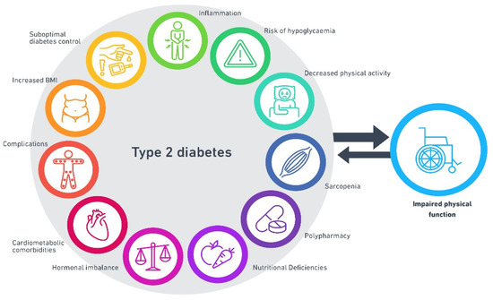
Figure 1:Physical Impact of Type 2 Diabetes(Ahmad et al., 2022)

Psychological Impact
Being a type 2 diabetes patient can be extremely psychologically stressful. Most individuals are anxious or depressed because they have to check their blood sugar every minute, eat on strict diets and worry about their health conditions. Research indicates a prevalence of major depression in 40 percent of type 2 diabetes patients. It is able to demotivate them and reduce their likelihood of adhering to their treatment. Guilt or frustration with the change in blood sugar may lead to diabetes burnout, which is a type of emotional exhaustion that complicates self-care. Mental health is also damaged by brain fatigue and sleeping problems. The incorporation of mental health screening and counseling in diabetes clinics, i.e., through sending to the psychologists, support group, or therapy, can make them stronger, learn to cope and feel more confident (Jena, Kalra and Yeravdekar, 2018).
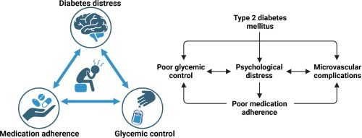
Figure 2: Psychological Impact of Type 2 Diabetes(Akshatha and Nayak, 2024)

Social and Family Impact
In addition to the individual, type 2 diabetes has implications on family and the community. Caregiving and assisting with medication, meals and appointments usually result in emotional and financial strain on the family members. New eating habits and changes can disorient the family, and emotion of shame over weight and illness will result in isolation. Purchasing of healthy food and medical supplies aggravate inequality in low-income homes. Individually tailored culture-sensitive, family-teaching programs involving community support networks have demonstrated usefulness in reducing caregiver stress, enhancing adherence, and encouraging shared responsibility of the long-term health management (Williams and Buttfield, 2016).
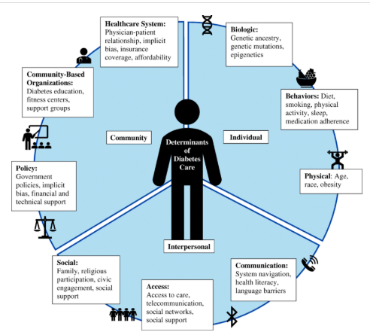
Figure 3: Social and Family Impact of Type 2 Diabetes (ResearchGate, 2024)

Treatment and Management in the NHS

Clinical Treatment Pathways
The management of Type 2 Diabetes Mellitus (T2DM) in the United Kingdom adheres to the NICE NG28 (2022) guideline that promotes a patient-centred and step-by-step management. The initial management is based on lifestyle modification: healthy diet, physical activity, weight reduction, cessation of smoking, frequent blood sugar monitoring and blood pressure. When the lifestyle modifications fail to achieve the blood sugar targets, medication is initiated. The first drug that is used is Metformin since it is effective and safe regarding heart conditions. In case of necessity of more medication, the possible variants are SGLT2, DPP-4, and thiazolidinedione, which may be selected according to the additional health issues, the risk of low blood sugar, and the preferences of the patient. GLP -1 receptor agonists integrate into treatment of obese or heart disease patients as they are used to manage blood sugar and lower weight (NICE, 2019).

Multidisciplinary Care
The NHS has a team-based approach, which involves family doctors, diabetes nurses, hormone doctors, nutrition experts, foot doctors, eye doctors, and mental health employees, to provide holistic and patient-centered diabetes care. Collaboration will maintain continuity between primary and hospital and community services. Educational programmes or courses such as DESMOND (Diabetes Education and Self-management ongoing and newly diagnosed) and DAFNE (Dose Adjustment for Normal Eating) have demonstrated that the patients learn better, maintain the blood sugar levels within the normal range, and feel more confident. The NHS Diabetes Prevention Programme (NDPP) also provides the same assistance to individuals who are at high risk where coaching to change behaviour, lose weight and live healthier is provided. Early problem detection Special foot and eye checks prevent ulcers and vision loss, and community nurses monitor patients in the home to prevent patients visiting the hospital without warning (Bain, Cummings and McKay, 2019).

Limitations and Gaps in Care
- Although there has been improvement, there is still no consistency in treating diabetes in all regions of the UK.
- Poor and minority people tend to wait longer and have fewer opportunities to visit specialists.
- Staffing shortage and insufficiency of mental health reduces the quality of care.
- Low level of education which does not translate to the various cultures makes it more difficult to involve people.
- Personalized learning, community outreach and increased use of digital tools can be used to address these gaps (United Nations, 2020).

Theoretical Models and Frameworks

The House of Care Framework (UK Model)
The primary means by which the NHS deals with long-term illnesses such as Type 2 diabetes is through the House of Care Framework. NHS England approved it and was developed by the Year of Care Partnerships. It is a framework that is founded on four pillars linked, all engaged and informed patients, collaborating doctors and nurses, team-supporting health services and team-linking planners. These four pillars combined ensure that patients and their health workers make care plans jointly to make sure that they align with their needs, beliefs or goals. It also makes people become in control of their health, and it promotes the process of early communication in the primary care. This is equal to the NHS Long Term Plan (2019 2209) that centers on prevention of troubles and providing patients with control over their care. Practically, in the yearly diabetes reviews, doctors and patients make decisions and utilize personal care plan. Even though it is effective, not every Integrated Care Board has been applying it regularly. Essentially, the understaffing, lack of equal access to digital technology, and insufficient training on shared care are all problematic. The House of Care framework has been demonstrated to lead to happier patients, retention of patients after treatment, better health outcomes, and increased collaboration in the health workers in primary and community care when fully implemented (Department of Health, 2001).
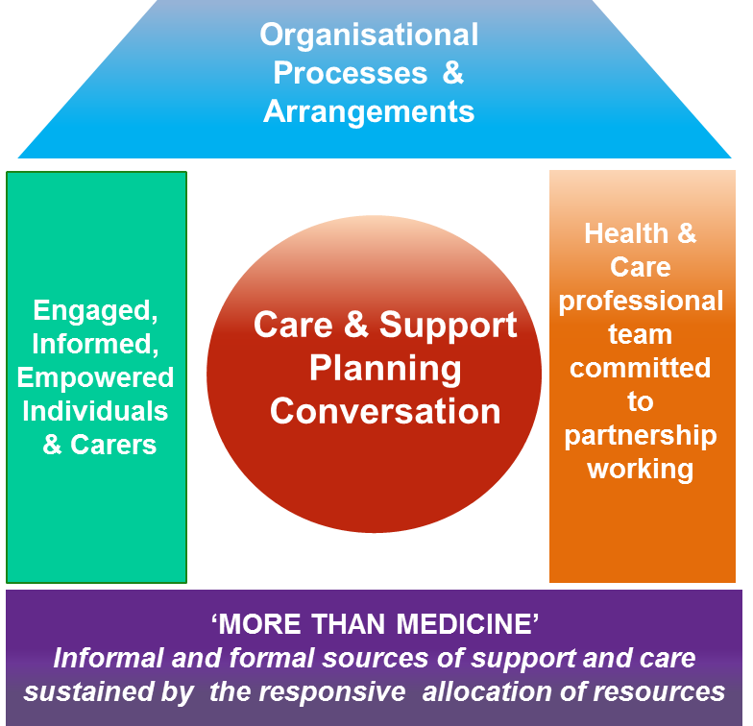
Figure 4:The House of Care Framework (Scotland’s House of Care, 2015)

Chronic Care Model (International)
Chronic Care Model (CCM), initially outlined by Wagner and others in 1998, is a global model of management of such long-term diseases as Type 2 Diabetes. The model consists of six main components, which are; helping patients take care of themselves, designing health system functioning, supporting good decisions, using clinical information, organising health services, and linking community resources. All these sections combined change care to not merely responding to issues but to prevent them proactively, and they engage patients long-term. The CCM informs them in the care of diabetes how to combine existing medical decisions and patient empowerment and collaboration with community organizations. As an example, frequent checkups, electronic files and instructional initiatives are used to maintain care consistency and make decisions based on data. In many countries it has been found that the CCM use enhances blood-sugar management, reduces hospitalization, and improves the quality of life. The model is also adaptable and thus every nation can make it fit in the health system of the country, and hence it can be utilized to compare it with how the NHS manages long-term conditions (Essential Health, 2024).
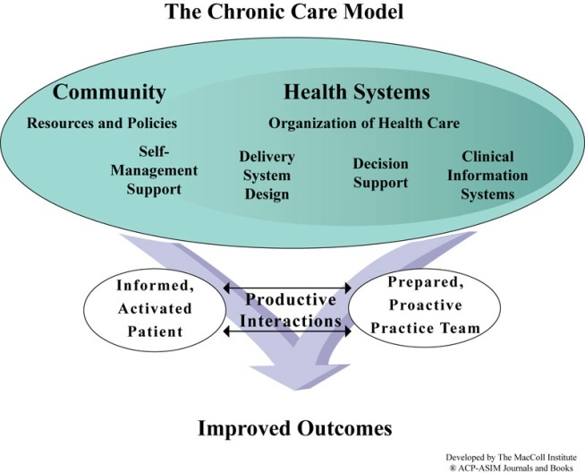
Figure 5: Chronic Care Model (International) (Wordpress.com, 2025)

Comparison and Critical Evaluation
- Both models are in favor of active, teamwork and patient-centred care of long term illnesses.
- The Chronic Care Model (CCM) is applicable across the globe and assists in the enhancement of whole health systems.
- The House of Care is NHS-oriented and dedicated to work with patients and service organisation.
- Use of both models together will ensure that diabetes care is more robust as global best practices are aligned to local NHS requirements and regulations (Khanna et al., 2022).
Feature | House of Care Framework (UK) | Chronic Care Model (International)
Origin | Developed for the NHS | Developed by Wagner et al. (1998)
Focus | Person-centred care, shared decision-making, commissioning | System redesign, proactive chronic care, community support
Main Components | Engaged patients, proactive professionals, organisational systems, supportive commissioning | Self-management support, delivery system design, decision support, clinical information systems
Strengths | Tailored to UK health structure; supports personalised care | Globally applicable; strong evidence of improved outcomes
Limitations | Inconsistent adoption across NHS regions | Requires strong system integration and resources
Best Use | Improving NHS-long-term condition management | Enhancing chronic care across diverse health systems
Combined Value | Provides local relevance | Provides global best practice

Policy and Political Context

National Policies
The policy of prevention and management of Type 2 Diabetes in the United Kingdom is highly encouraged by the national policy. Chronic-disease reforms by the NHS Long Term Plan (20192029) focus on diabetes. It emphasizes prevention of diabetes through lifestyle change and early detection and the use of digital health tools such that individuals can manage themselves. The plan also expanded the NHS Diabetes Prevention Programme to cover more adults at high risk by educating them on behaviour change and help with losing weight. The NICE guideline NG17 and NG28 provide clinicians with an evidence-based approach to diagnosing, treating, and following up patients, thus making sure that patients receive the same care throughout the country. The other initiatives such as Public Health England, Obesity Strategy (2020) and all-party parliamentary group on Diabetes (2023) consider the more extended health aspects. They demand the use of less sugar, more physical exercise, and equitable access to services (Vaughan and Edwards, 2020).

Local Health Strategies
Integrated Care Systems (ICSs) and Integrated Care Boards (ICBs) at the local level transform national policy into the local ways of working suitable to the community. ManyICSs established diabetes programmes and communal digital programmes such as Healthy Living for People with Type 2 Diabetes with free online lessons and coaching. Local councils collaborate with charities and other organizations to enhance health knowledge as well as to provide culturally appropriate assistance. Nevertheless, it has been observed that not all individuals participate and remain in such programs, particularly those belonging to ethnic minorities and poorer regions, which demonstrates that they still struggle to provide equal and continuous attention to all (Porte and Sampaio, 2012).
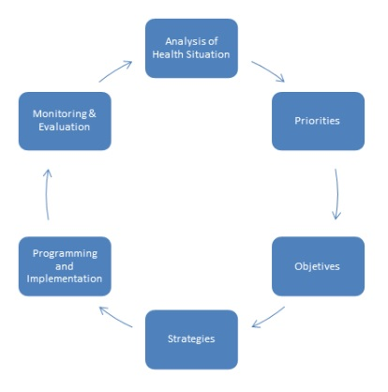
Figure 6: Local Health Strategies (Brito, 2018)

Policy Gaps
- There is lack of sufficient research on the long-term effectiveness of diabetes programmes and hence it is difficult to plan.
- There is a lack of investments in specialist staff training, and this issue causes deficits in diabetes nurses, dietitians and mental support appropriations.
- The lack of education resources that suit various cultures means that the interaction between various communities is compromised.
- Collaboration among the NHS, local authorities and community organisations is poor, thereby hindering development.
- Financing is not balanced and uniform in all regions and therefore, national diabetes targets are hard to execute (Egede et al., 2022).

Person-Centred Care and Self-Management

Empowerment and Self-Efficacy
Diabetes is a disease that needs individuals to take care of themselves. The concepts underlying behavior change programs that assist people to change behavior are the Health Belief Model and Self- Efficacy Theory. Research indicates that when patients feel that they are able to handle their diabetes, they adhere to the treatment and experience less trouble. Confidence and having the capacity to manage diabetes are enhanced by formal learning, conversing with a coach and online coaching tools (Gómez-Velasco et al., 2019).

Technology and Digital Health
People can manage their own care through the use of technology, such as mobile health apps, continuous glucose monitors (CGM), and telehealth visits. These devices provide immediate responses and allow physicians to monitor they when outside the clinic. The NHS web page, called Healthy Living, has simplified the process of connecting with people, but there are still some older adults and the poor who cannot afford to utilize digital tools (Muller, 2023).

Culturally Sensitive and Family-Centred Approaches
Adherence is enhanced with the involvement of the family, and culturally relevant education, particularly among the ethnic minorities. Interventions that recognize language, diet, and cultural beliefs make people more active and effective (Attridge et al., 2014).
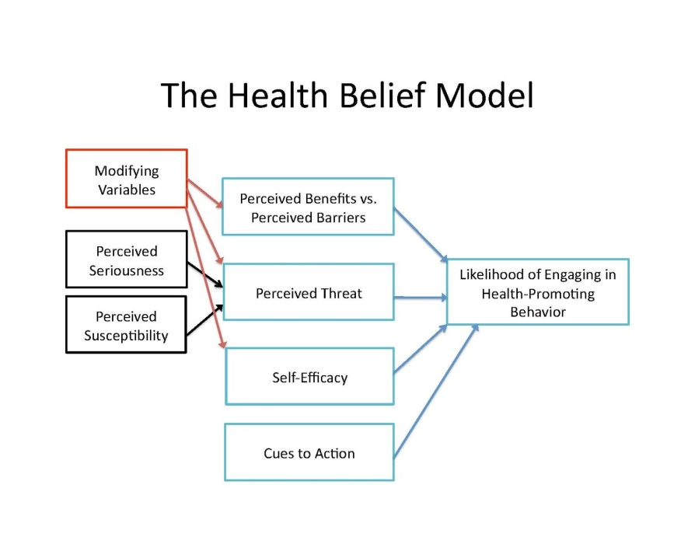
Figure 7: The Health Belief Model (Urich, 2020)

End-of-Life and Ethical Considerations
Care could be aimed at alleviating symptoms and enhancing the quality of life when the problems with diabetes become severe. The decisions made must respect dignity, express consent and discuss discontinuation or change of treatment. Collaborating with diabetes and palliative teams, holistic care is provided to the patient with respect to his body, feelings, and spirit (Quinn, Hudson and Dunning, 2006).

Recommendations for Improvement

Service Delivery Improvements
- Expressly, make education programs (more precisely, DESMOND) accessible to every newly diagnosed patient.
- Extend the equal access to all regions by the national regulation.
- Digital primary care Usage of monitoring tools in primary care to provide immediate feedback.
- Workforce should be expanded by training nurses to be advanced practitioners.

Addressing Health Inequalities
- Put more emphasis on culture-fitting interventions.
- Ensure that education and technology is equally accessible to people with low income and minority people.
- Collaborate with service users in order to create materials together, and thus keep them engaged.

Research and Innovation
- Invest time and resources to develop digital tools in years.
- Pilot AI-based early diagnosis instruments in NHS services.
- Enhance collaboration among various professionals in order to develop superior care plans.

Conclusion and Summary
Diabetes type 2 is a severe chronic illness that touches upon a significant number of individuals in UK. To cope with it successfully implies organizing medical treatment, educating individuals on the situation, and providing them with the necessary equipments and self-esteem. Collaboration with plans that are centered on the individuals is important. It is a strong foundation that they have in the House of Care and Chronic Care approaches to enhance what they are doing. To be successful in the future, they need to offer equal opportunities when accessing services, utilize new digital resources, and embrace all cultures (Diabetes UK, 2023).

Reference List
Ali, O. (2013). Genetics of Type 2 Diabetes. World Journal of Diabetes, [online] 4(4), p.114. doi:https://doi.org/10.4239/wjd.v4.i4.114.
Attridge, M., Creamer, J., Ramsden, M., Cannings-John, R. and Hawthorne, K. (2014). Culturally appropriate health education for people in ethnic minority groups with type 2 diabetes mellitus. Cochrane Database of Systematic Reviews, 9(9). doi:https://doi.org/10.1002/14651858.cd006424.pub3.
Bain, S., Cummings, M.H. and McKay, G.A. (2019). Multidisciplinary Approach to Management and Care of Patients with Type 2 Diabetes Mellitus. EMJ Diabetes, [online] 7(1), pp.73–81. doi:https://doi.org/10.33590/emjdiabet/10314374.
Chakraborty, A. (2025). Systematic Review: Risk Factors for Developing Type 2 Diabetes Mellitus. European Journal of Cardiovascular Medicine, [online] 15(1), pp.382–390. doi:https://doi.org/10.5083/ejcm/25-01-62.
Cleveland Clinic (2021). Insulin resistance: What it is, causes, symptoms & treatment. [online] Cleveland Clinic. Available at: https://my.clevelandclinic.org/health/diseases/22206-insulin-resistance.
Department of Health (2001). National Service Framework for Diabetes: Standards Modern Standards and Service Models Contents. [online] Available at: https://assets.publishing.service.gov.uk/media/5a7ad8cb40f0b66a2fc03365/National_Service_Framework_for_Diabetes.pdf.
Diabetes UK (2023). How Many People in the UK Have diabetes? [online] Diabetes UK. Available at: https://www.diabetes.org.uk/about-us/about-the-charity/our-strategy/statistics.
Egede, L.E., Ozieh, M.N., Campbell, J.A., Williams, J.S. and Walker, R.J. (2022). Cross-Sector Collaborations Between Health Care Systems and Community Partners That Target Health Equity/Disparities in Diabetes Care. Diabetes Spectrum, 35(3), pp.313–319. doi:https://doi.org/10.2337/dsi22-0001.
Essential Health (2024). Why Healthcare Should Shift from Reactive to Proactive - Essential Health. [online] Essential Health. Available at: https://essentialhealth.health/why-healthcare-should-shift-from-reactive-to-proactive/.
Galicia-Garcia, U., Benito-Vicente, A., Jebari, S., Larrea-Sebal, A., Siddiqi, H., Uribe, K.B., Ostolaza, H. and Martin, C. (2020). Pathophysiology of type 2 diabetes mellitus. International Journal of Molecular Sciences, [online] 21(17), pp.1–34. Available at: https://pmc.ncbi.nlm.nih.gov/articles/PMC7503727/.
GBD 2021 Diabetes Collaborators (2023). Global, regional, and national burden of diabetes from 1990 to 2021, with projections of prevalence to 2050: a systematic analysis for the Global Burden of Disease Study 2021. The Lancet, [online] 402(10397). doi:https://doi.org/10.1016/s0140-6736(23)01301-6.
Gómez-Velasco, D.V., Almeda-Valdes, P., Martagón, A.J., Galán-Ramírez, G.A. and Aguilar Salinas, C.A. (2019). Empowerment of patients with type 2 diabetes: current perspectives. Diabetes, Metabolic Syndrome and Obesity: Targets and Therapy, [online] Volume 12(12), pp.1311–1321. Available at: https://www.dovepress.com/empowerment-of-patients-with-type-2-diabetes-current-perspectives-peer-reviewed-fulltext-article-DMSO.
Goyal, R., Jialal, I. and Singhal, M. (2023). Type 2 diabetes. [online] National Center for Biotechnology Information. Available at: https://www.ncbi.nlm.nih.gov/books/NBK513253/.
Hill-Briggs, F. (2020). Social determinants of health and diabetes: A scientific review. Diabetes Care, [online] 44(1), pp.258–279. doi:https://doi.org/10.2337/dci20-0053.
Jena, B., Kalra, S. and Yeravdekar, R. (2018). Emotional and Psychological Needs of People with Diabetes. Indian Journal of Endocrinology and Metabolism, [online] 22(5), pp.696–704. Available at: https://pmc.ncbi.nlm.nih.gov/articles/PMC6166557/.
Khanna, A., Fix, G.M., Anderson, E., Bolton, R.E., Bokhour, B.G., Foster, M., Smith, J.G. and Vimalananda, V.G. (2022). Towards a framework for patient-centred care coordination: a scoping review protocol. BMJ Open, [online] 12(12), p.e066808. doi:https://doi.org/10.1136/bmjopen-2022-066808.
Młynarska, E., Czarnik, W., Dzieża, N., Jędraszak, W., Majchrowicz, G., Prusinowski, F., Stabrawa, M., Rysz, J. and Franczyk, B. (2025). Type 2 Diabetes Mellitus: New Pathogenetic Mechanisms, Treatment and the Most Important Complications. International Journal of Molecular Sciences, [online] 26(3), p.1094. doi:https://doi.org/10.3390/ijms26031094.
Muller, E. (2023). 7 Common Remote Patient Monitoring Devices. [online] www.healthrecoverysolutions.com. Available at: https://www.healthrecoverysolutions.com/blog/7-common-remote-patient-monitoring-devices.
National Institute for Health and Care Excellence (NICE) (2015) Type 1 Diabetes in Adults: Diagnosis and Management (NG17). London: NICE. Available at: https://www.nice.org.uk/guidance/ng17
National Institute for Health and Care Excellence (NICE) (2022) Type 2 Diabetes in Adults: Management (NG28). London: NICE. Available at: https://www.nice.org.uk/guidance/ng28
Nazar, C.M.J., Bojerenu, M.M., Safdar, M. and Jibran Marwat (2015). Effectiveness of diabetes education and awareness of diabetes mellitus in combating diabetes in the United Kigdom; a literature review. Journal of Nephropharmacology, [online] 5(2), p.110. Available at: https://pmc.ncbi.nlm.nih.gov/articles/PMC5297564/.
NHS England (2019) The NHS Long Term Plan (2019–2029). London: NHS England. Available at: https://www.longtermplan.nhs.uk/
NICE (2019). Type 2 diabetes in adults: management. [online] PubMed. London: National Institute for Health and Care Excellence (UK). Available at: https://www.ncbi.nlm.nih.gov/books/NBK553486/.
Porte, M. and Sampaio, E. (2012). Inconsistencies in Sustainability Reports-The Case Suzano. Research Journal of Finance and Accounting, [online] 5(15). Available at: https://www.researchgate.net/publication/321278301_Inconsistencies_in_Sustainability_Reports-The_Case_Suzano [Accessed 10 Nov. 2025].
Quinn, K., Hudson, P. and Dunning, T. (2006). Diabetes Management in Patients Receiving Palliative Care. Journal of Pain and Symptom Management, 32(3), pp.275–286. doi:https://doi.org/10.1016/j.jpainsymman.2006.03.011.
Sorensen, M., Groven, K.S., Gjelsvik, B., Almendingen, K. and Garnweidner-Holme, L. (2020). The roles of healthcare professionals in diabetes care: a qualitative study in Norwegian general practice. Scandinavian Journal of Primary Health Care, 38(1), pp.12–23. doi:https://doi.org/10.1080/02813432.2020.1714145.
The Lancet Diabetes & Endocrinology (2023) ‘Global, regional, and national burden of diabetes from 1990 to 2021’, The Lancet Diabetes & Endocrinology, XX(X), pp. XXX–XXX. Available at: https://www.thelancet.com/journals/lancet/article/PIIS0140-6736(23)01301-6/fulltext
UK Government (2020) Tackling Obesity: Empowering Adults and Children to Live Healthier Lives. London: HM Government. Available at: https://www.gov.uk/government/publications/tackling-obesity-empowering-adults-and-children-to-live-healthier-lives
United Nations (2020). Inequality – Bridging the Divide. [online] United Nations. Available at: https://www.un.org/en/un75/inequality-bridging-divide.
Vaughan, L. and Edwards, N. (2020). The problems of smaller, rural and remote hospitals: Separating facts from fiction. Future Healthcare Journal, 7(1), pp.38–45. doi:https://doi.org/10.7861/fhj.2019-0066.
Wagner, E.H., Austin, B.T. & Von Korff, M. (1996) ‘Organizing care for patients with chronic illness’, The Milbank Quarterly, 74(4), pp. 511-544. doi:10.2307/3350391. Available at: https://doi.org/10.2307/3350391
Williams, C.R. and Buttfield, B. (2016). Beyond Individualised Approaches to Diabetes Type 2. Sociology Compass, 10(6), pp.491–505. doi:https://doi.org/10.1111/soc4.12369.
World Health Organization (WHO) (2023) Diabetes Fact Sheet / Global Report on Diabetes. Geneva: WHO. Available at: https://www.who.int/news-room/fact-sheets/detail/diabetes
Image References
Ahmad, E., Sargeant, J.A., Yates, T., Webb, D.R. and Davies, M.J. (2022). Type 2 diabetes and impaired physical function: A growing problem. Diabetology, [online] 3(1), pp.30–45. doi:https://doi.org/10.3390/diabetology3010003.
Akshatha, S. and Nayak, U.B. (2024). The psychological distress associated with type 2 diabetes mellitus represents an unmet need for drug discovery. Medicine in Drug Discovery, [online] 23, p.100196. doi:https://doi.org/10.1016/j.medidd.2024.100196.
Brito, D. (2018). Local Health Plans: Value and Structure. [online] EuroNet MRPH. Available at: https://euronetmrph.org/local-health-plans-value-and-structure/.
ResearchGate. (2024). Determinants of diabetes care. This figure represents some of the... [online] Available at: https://www.researchgate.net/figure/Determinants-of-diabetes-care-This-figure-represents-some-of-the-individual_fig1_343531741.
Scotland’s House of Care. (2015). Unlocking the House of Care. [online] Available at: https://houseofcare.wordpress.com/2015/03/05/unlocking-the-house-of-care/.
Urich, A. (2020). The Health Belief Model. [online] PennState. Available at: https://psu.pb.unizin.org/kines082/chapter/the-health-belief-model/.
Wordpress.com. (2025). Available at: https://houseofcare.wordpress.com/wp-content/uploads/2015/03/ccm.jpg [Accessed 10 Nov. 2025].

