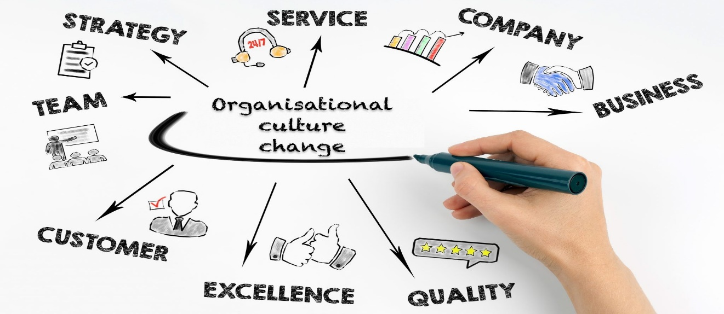

Workplace Culture and its impact on Organizational Efficiency
BMSK 5005
Student: Titu Miah 17088002
Lecturer: Rebeca Kavanagh
Contents
Introduction 1
Workplace culture 1
Structure of Warwick Spice Restaurant: 3
PESTLE analysis of a restaurant 3
Porter’s Five Forces Analysis 6
SWOT Analysis: 9
Recommendations: 9
Kotter’s Eight Step Plan: 11
Conclusion 11
Appendices 13
SWOT Analysis Figure 1: 13
Kotter’s Eight Step Plan Figure 2: 14
Bibliography 14

Introduction
This is a report about workplace culture at Warwick Spice Indian Restaurant organization. Organizational environment is the outside area of the company. These can be external factors or influences that can affect the internal and external functions or activities of an organization. I will be assessing the impact of the environmental factors on the culture in a restaurant in Warwickshire. To do this a PESTLE and SWOT analysis will be used to determine the impact of the environmental factors. The report will include porters five forces analysis, Mckinseys 7s framework model, a restaurant organizational culture and structure which will show who is responsible or accountable to whom.

Workplace culture
The culture of an organization is made up of shared ideology, beliefs, principles, values, how employees should behave with each other as well as with other individuals outside the organization, interactions is also important in keeping good communications between individual employees in the organization, how work responsibilities can be carried out and how decisions can be made. Culture is a critical component needed to help in recruiting, attracting and keeping talented individuals in the organization. For example, you often hear someone asking a friend in the line of “How is the company culture like in your workplace?”. The response might be something like “friendly people. Flexible hours. Get to finish early on Fridays”.
A healthy culture in the workplace will encourage employees to have good relationship between each other, to stay motivated and loyal towards the organization. Most organizations will have a set of guidelines for all employees to follow and work accordingly. All organizations have their own individual work cultures which makes it different from each other, it gives them their own individual identity and helps in creating
a branding image of the organization. The work culture unites people from different background which helps in creating unity amongst workers. The Warwick Spice restaurant uses the management theory of Peters and Waterman’s. They have adapted the theory by using the strategy of listening, understanding the customers and front of house staff. Also, to inspire and motivate staff there is a need for managers and all staff to share common set values and act with integrity for the process to work (McGrath, J. 2013). The workplace needs to have interactions between everyone in the organization.

Structure of Warwick Spice Restaurant:

PESTLE analysis of a restaurant
Pestle analysis is used by organizations to determine and find opportunities and threats in the external environment. When you have all the correct information of everything externally that is going around outside of your restaurant that can affect your business, the owner then has a clear picture as to what is happening then they are in a better position to take decisions according to the situation. Pestle is the abbreviation of political, economic, social, technological, environmental and legal factors.
For example, as a restaurant proprietor, you will have internal factors which is controllable, such as employees, wages, recipes, fixture and fittings inside the restaurant, but external environmental factors are uncontrollable which are things like customers, legislation (law), health and safety guidelines, inland revenue tax, technology, consumers tastes and reviews. These external environment factors which are not in your control can affect the future of the business in the long term. In order to avoid this, it’s necessary to analyze what is around you in order to have a better chance of survival in a competitive world.

Political Factors:
Political factors are determined by governments that are in power, which can be like tax reforms, licensing for alcohol laws (Startups.co.uk, 2020), food and health safety guidelines (GOV.UK, 2020). Then you can determine if these factors have affected your business then you will need to take the necessary decisions in order to minimize the impact of these regulations and guidelines. This may affect things like purchasing, cooking, packaging, delivery, salaries, working hours of employees and finance. Health and food regulations are changing for consumers dietary and allergy reasons by the government. UK government will have to take necessary steps in order to make changes of the law, legislation, regulations as a result of Brexit. Post Brexit immigration plan has seen the government announce that it is going to bring in a point-based immigration system after the EU and UK free movement ends. Labor laws. Tax rates. Employment laws such as minimum pay and working hours (Legislation.gov.uk, 2020).
Economic Factors:
Brexit will also determine price and tax for any imported foods and ingredients from Europe as well. If inflation rate increases this would have a knock-on effect on the restaurant, which will result in an increase on menu prices that will then be passed on to the customers. Customers will also be affected by inflation which may leave them with less disposable income, they may stop coming to the restaurant but instead have cheaper alternatives such as KFC, McDonalds or local fish and chips shop. Also, the restaurant is located near Warwick castle, which is very popular destination for tourists, they help in contributing to sales, profits, jobs and income for all surrounding businesses such as hotels, shops, local transportations and retail trades as well. Low skilled or unskilled workers will have an impact in businesses such as restaurants, agriculture, care homes, coffee shops, hotels, constructions, factories and this will have a certain effect on the economy because there isn’t enough staff trained in the United Kingdom to do these jobs. Cost of living may rise.
Social Factors:
There are various social factors which may positively or negatively have an effect in a restaurant. At present a lot people are getting health conscious which means they may prefer organic foods, no butter or ghee and may be vegans instead of oily, spicy or junk foods. Another example is people who work late or have busy lifestyle, they may have no time for proper food because of their busy routines and will rely on fast foods. It may be difficult to keep all customers happy but it’s the consumers social lifestyle that may determine how the restaurant reacts to the supply and demand of their customers. Population demographics, e.g. mature population.
Technology Factors:
Technology is rapidly moving forward at pace and this can have an impact on the restaurant business. Nowadays the technology has advanced so much that you can have CCTV cameras installed inside and outside of the restaurant, which you can access through your mobile app to see what is happening. There are business management systems such as purple I, quick books online, which if used properly will save time, money, increase profitability and it’s a faster streamline administrative process. Some businesses have their own Facebook account in which they can upload any events, photos or give an online offer to customers who are following them online. It’s a new way to serve and engage your customers by having an online media presence and collect feedback from all users.
Environmental Factors:
It is very important for all businesses to consider internal and external environment. A restaurant should help in keeping their external surrounding area clean. For example, having a food waste management which can be done having different bins for different waste such as foods, cardboard and paper, used vegetable oil waste and plastic waste. This will help the refuse collectors to take the waste to the correct recycling center. You can donate out of date food to charity which is helping others. Climate change is also a big issue for restaurants. All businesses are contributing to the environmental problems (atmospheric) and to avoid these problems you must follow government guidelines and regulations in protecting the world we all live in. Pollution is also needed to be considered.
Legal Factors:
Legal is government departments and local councils can influence the restaurant in a positive or negative way. The health authorities do visit all restaurants to make sure all regulations are adhered to accordingly. Welfare of employees is the responsibility of the employer. The Employment Act 1996 protects the rights of employees (Legislation.gov.uk, 2020). The Equality Act 2010 protects people from any discrimination (Legislation.gov.uk, 2020). Also, there is a legal requirement to be able to cater for disable people. A new law and regulation will be in place for migrant workers (Uniyal, 2020) (low skilled or non-skilled) who will need to apply and be able to pass the point system to work in UK.

Porter’s Five Forces Analysis:
Porter’s five forces framework can be used by any business to analyze competition. The restaurant industry remains competitive because of adapting to modernization, technology advancement and other various ways such as healthy/organic foods which attract customers (Michaux, S., Cadiat, A. and Probert, C.2015). Restaurants that have survived and remained successful over the years have acquired knowledge and their brand identity. Such restaurants have maintained knowledge of the activity of their competitors and understand the factors that make them unique and different from all others.
Therefore, it is vital for the catering industry to take advantage and understand the application of porter’s five forces. There is a need in considering interconnections among various services in the restaurant industry, competition will create differences in incomes among the businesses and the market condition can dictate or have influence of making profitability amongst the different restaurants. Competitive advantage can be attained by using different resources. If these competitive strategies are implemented, it can enhance profitability if sustained over a period. According to porter, every industry and business is faced by the same five competitive forces which are bargaining power of buyers, bargaining power of suppliers, threat of substitute products and competitive rivals.
Bargaining Power of Buyers:
The power of bargaining by customers is pushing restaurants profit margins down, they have access to online technology which gives them knowledge of the market and if they are not happy because of the price of food they may seek to go elsewhere. Customers in the restaurant industry are very hard and demanding to please. In some instances, a customer may order online and then expect the restaurant to deliver the order for free. Some restaurants do offer free delivery to a certain mile radius, but you will still get some customers who live outside the free radius but still try to get a free delivery. This service is costing the restaurant because they must employ a driver and pay him to do this job, but they are unable to put that charge onto the customer’s bill fearing the loss of trade. The restaurant industry is also affected by the buyer’s choice and switching behavior (Adhikari and Rao, 2012). Buyers can affect a restaurant in some ways are the items that are being offered, the quality of the items, quantity of items offered, changes in prices e.g. Brexit food prices may go up etc. The prices may need adjusting depending on how the market is after Brexit but if the prices are high then it will limit the number of customers that are coming to the restaurant. Based on this analysis, such services have empowered the bargaining power to the customers in the restaurant industry. The bargaining power of the customer has become a threat to the restaurant industry.
Bargaining Power of Suppliers:
The bargaining power of supplier’s affect the operation of the restaurants in relation to employees, supply of products and services. Depending on how many suppliers are available in the region will determine who has the bargaining power. If there is insufficient supplier then the power advantage lies with the supplier but if there is a lot of suppliers, then the power advantage goes to the restaurants. Also, the size of the restaurant and the amount of order can also be a determining factor when it comes to bargaining power of suppliers because they must take into consideration if offering a good price deal to keep that business as a customer or if it’s not worth it. There are restaurants that don’t hold bargaining power against suppliers due to being in a difficult region, Saffron Indian restaurant in Inverness, Scotland, where there is no availability of spice suppliers or substitutes nearby, or it could be a holiday resort place e.g. lakeside but for these restaurant it would be that they are vulnerable to the bargaining power of suppliers as the may charge extra for food prices as well as the cost of transport. If suppliers have a higher negotiation position due to small limited order but if the order is a bulk one, then their negotiation position is a lot weaker. The restaurant industry is dependent on various suppliers such as farm produce, bakery, beverages, wine, beers, spice (east end foods), dairy products, organic produce, meat and poultry. If ever there is a lack of substitutes in the market or scarcity of vegetable produce will give suppliers, the advantage to bargain. The bargaining power of supplier does carry a threat to the profitability of the restaurant industry.
Threat of Substitute Products
The biggest challenge facing the restaurants is finding a substitute product. Grocery and supermarkets are a good substitute for the restaurant, but just as other suppliers’ grocery stores are is looking for ways in which to capture more market share. There is also another threat from customers who can make a choice of switching from one restaurant to another quite easily. The ease of switching of customers between restaurants as they please are very low costing and this in turn makes it a high threat of substitute products in the restaurant industry.
Competitive Rivals:
The restaurant industry is a very competitive market. The rivalry increases because of changing in customer behaviors, new or different products, increasing of more competitors in the area, rising cost and the increasing costs of risk management in the industry. For example, you will have Chinese, Italian, Mexican, Turkish, among other restaurants in Warwick. Also, there is the presence of fast food businesses who are also competing in this market.
These restaurants are all trying to get the customers to come to dine at their establishment. They will have various levels of menu options, services, cleanliness, food and hygiene star ratings, trip advisor reviews and a have a good ambiance.
At the present time where technology is at the forefront of all industries the restaurant industry is taking advantage of the social media presence online. Most restaurants are using online platform to reach new potential customers. The marketing costs are being reduced by having an online presence. Therefore, customers can check or compare prices of any restaurants online in their locality and be able to choose whichever one that suits their taste, menu prices and the type of cuisine. Keeping a competitive edge for restaurants would mean for them to be able to provide quality supplies, have excellent services and products(foods) for their customers.

SWOT Analysis:
Swot analysis is an important tool for restaurants to conduct, it will help in understanding the strength and weaknesses, the opportunities and threat that the business may be facing. The swot analysis allows the owner to be able to evaluate their position in their industry, see if there is any opportunity in their market they serve, and then identify a strategy on moving forward.
Strength and weaknesses are within the control of the owner, opportunities and threat you don’t have control over, but they can have an impact on the restaurant. The SWOT analysis has been done for Warwick Spice and it is shown in appendices figure 1.

Recommendations:
Mckinsey 7s Model:
The mckinsey’s 7’s framework can be used for reviewing marketing capabilities of an organization from different viewpoints (Ravanfar, M. 2015). The model is used to review the effectiveness of a business in marketing operations, determine how to support a new strategy direction and asses if changes are needed to support digital transformation of an organization (Mindtools.com. 2020).

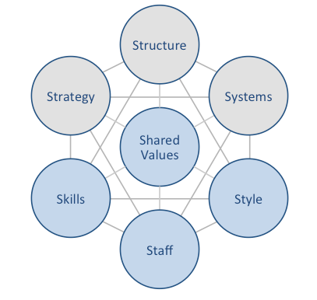
Hard Elements
Strategy. The strategy of Warwick spice restaurant is to be the best in the region. The restaurant has been establishing an excellent service to local consumers. The profit margin is advantageous.
Structure. Warwick Spice is owner-based structure but there are responsibilities given to other management staff. Decision making is done by managers and owner.
Systems. Finance is done through accountant. Right staff are placed in the roles needed to achieve its goals.
Soft Elements:
Staff. The staff needed would be managers, waiters, barman, chefs, cook, and kitchen porters. These staffs are recruited and interviewed through advertisements. Bonuses and holidays are provided which help moral of staffs.
Skills. The skilled staffs train up new staff from their own previous experiences.
Style. Indian and Bangladeshi foods availability and English. The style is classy and old.
Shared Values. There are different people of different culture working alongside each other. Everybody respects the diversity and background of all individuals to work in harmony.

Kotter’s Eight Step Plan:
Kotter’s eight step plan is for implementing changes to succeed in an organization (Kotter, 2008). The first three steps create a sense of urgency, create a guiding coalition and create a vision for change. These three steps are about creating the various climate for change. Steps 4 up to 6 are communicate the vision, remove obstacles, create short term wins, which is engaging and enabling the change to the whole organization in order to implement the new vision. Steps 7 and 8 is consolidate improvements and anchor changes. This means that its necessary to do regular evaluation of progress, also the organization needs to be looking at improving and if success is achieved that means the change was established. There is a diagram in appendices figure2.

Conclusion
The Warwick spice restaurant would benefit by doing a PESTLE and SWOT (appendices figure 1) analysis. The restaurant market is turbulent and continually changing. To succeed in this competitive environment, restaurants must now monitor trends, anticipate threats and opportunities, perform internal (swot) and external (PESTLE)analysis of strengths and weaknesses of the businesses capabilities and resources, and formulate effective strategies to gain competitive advantages against other businesses. The report findings can help improve the business, firstly there is a need to implement in training local staff for the future after Brexit. With the uncertainty of being able to employ migrant staff because of new immigration legislation. Social factors also can be improved by perhaps including organic and vegan food in the menu to invest into this new consumer market. There is a demand for online orders, can try using UBER eats or JUST eat to see if that has any impact on sales and revenues because these 2 businesses have already got themselves a platform in the hospitality industry. Also, investing in a management system such as purple I. can be advantageous because using this equipment will eliminate carbon copy order pads, it will be fast and efficient, can have messages sent from kitchen to front of house e.g. out of stock of certain dish, this faster feedback enables waiters to inform and avoid taking orders for that dish, storage of information about your sales, stock list of food supply and other transactions etc. Controlling waste recycle management for the environment. The porters five forces analysis of data collected for Warwick spice restaurant shows that the business is experiencing various competitive forces and would need to employ strategic responses to respond to competition. The customers have high bargaining powers, so in order to retain these customers you must have the ability to offer the products they want, the ability to adapt either when customers’ needs change or when conditions change, or even both. Supplier power can be controlled by having contacts with other supplies e.g. at Birmingham food market. Competitive rivalry can be competed by having reasonable prices, quality of food and services, value and promotions and analyzing competitors around the area.

Appendices

SWOT Analysis Figure 1:

Kotter’s Eight Step Plan Figure 2:

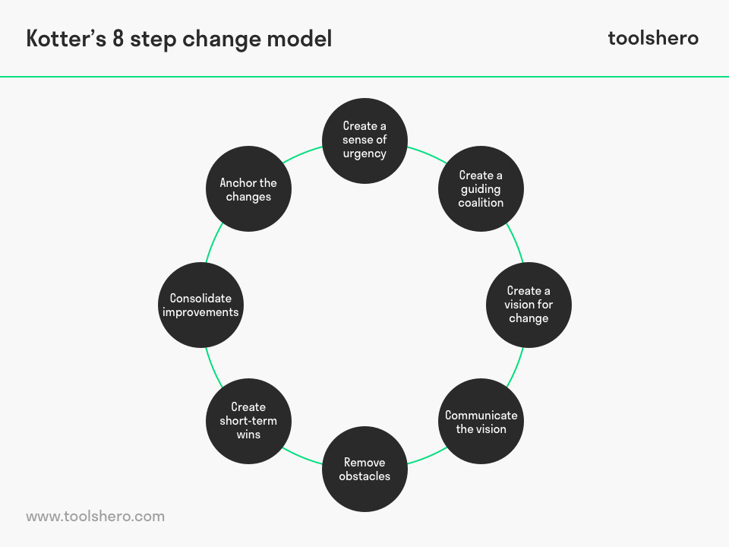

Bibliography
Austin-Broos, D. (1987). Creating culture. Sydney u.a.: Allen & Unwin.
Adhikari, A. and Rao, A. (2012). Individual Preference and Bargaining Behavior in Families’ Buying Decisions of Restaurant Service. Cornell Hospitality Quarterly, 54(3), pp.248-261.
Contributor, P. (2020). PESTLE Analysis of India in five Steps. [online] PESTLE Analysis. Available at: https://pestleanalysis.com/pestle-analysis-india/ [Accessed 6 Mar. 2020].
Fullen, S. (2005). Opening a Restaurant or Other Food Business Starter Kit. Ocala: Atlantic Publishing Group.
GOV.UK. (2020c). Food safety - your responsibilities. [online] Available at: https://www.gov.uk/food-safety-your-responsibilities [Accessed 29 Feb. 2020].
Harvard Business Review. (2020). The Five Competitive Forces That Shape Strategy. [online] Available at: https://hbr.org/2008/01/the-five-competitive-forces-that-shape-strategy [Accessed 21 Jan. 2020].
Hse.gov.uk. (2020d). Health and Safety at Work etc. Act 1974 – legislation explained. [online] Available at: https://www.hse.gov.uk/legislation/hswa.htm [Accessed 29 Feb. 2020].
https://www.tripadvisor.co.uk/Restaurant_Review-g186543-d7139084-Reviews-Saffron_Indian_Restaurant-Inverness_Scottish_Highlands_Scotland.html?m=19905
Johnson, G. (2000). Strategy through a Cultural Lens. Management Learning, 31(4), pp.403-426.
Kotter, J. (2008). A sense of urgency. Boston, Mass.: Harvard Business Press.
Kotler, P., Armstrong, G., Saunders, J. and Wong, V. (2001). Principles of Marketing, 2nd edition20011Principles of Marketing, 2nd edition. Hemel Hempstead: Prentice‐Hall 1998. 1042 pp., ISBN: 0132 622548 £32.99. Corporate Communications: An International Journal, 6(3), pp.164-165.
Review, H., Kotter, J., Kim, W. and Mauborgne, R. (2011). HBR's 10 Must Reads on Change Management (including featured article ""Leading Change, "" by John P. Kotter). Boston: Harvard Business Review Press.
Legislation.gov.uk. (2020a). Employment Rights Act 1996. [online] Available at: http://www.legislation.gov.uk/ukpga/1996/18/contents [Accessed 29 Feb. 2020].
Legislation.gov.uk. (2020b). Equality Act 2010. [online] Available at: http://www.legislation.gov.uk/ukpga/2010/15/contents [Accessed 29 Feb. 2020].
McGrath, J. (2013). Little Book of Big Management Theories. Harlow, England: Pearson.
Michaux, S., Cadiat, A. and Probert, C. (2015). Porter's five forces. [Place of publication not identified]: 50Minutes.
Mindtools.com. (2020). The McKinsey 7-S Framework: - Making Every Part of Your Organization Work in Harmony. [online] Available at: https://www.mindtools.com/pages/article/newSTR_91.htm [Accessed 18 Feb. 2020].
Organizational Behaviour Paperback – 9 Aug 2016
by Prof David Buchanan (Author), Dr Andrzej Huczynski (Author)
Porter, M. and Porter, M. (2008). Competitive Strategy. Riverside: Free Press.
Ravanfar, M. (2015). Analyzing Organizational Structure based on 7s model of McKinsey. International Journal of Academic Research in Business and Social Sciences, 5(5).
Startups.co.uk. (2020c). Restaurant license and regulation laws. [online] Available at: https://startups.co.uk/restaurant-regulations/ [Accessed 29 Feb. 2020].
Uniyal, V. (2020). UK: New policy restricts entry of non-English speaking and unskilled foreign workers. [online] Le·gal In·sur·rec·tion. Available at: https://legalinsurrection.com/2020/02/uk-govt-wants-migrants-to-speak-english-hold-high-end-skills/ [Accessed 29 Feb. 2020].

