Dr. Alex Bell
University of Wales: Trinity Saint David
Business inquiry and research
Matthew Kilgariff 1705241 Business
Table of Contents
Introduction 3
Data Collection 3
Analysis Approach 4
Procedure 4
Analytical Procedure. 5
Data Presentation and Findings 6
Cross tabulation of results. 12
Limitations of the data. 13
Conclusion 14

Introduction
This report aims to examine the consumer buying habits of clothing. Studies show that the textiles industry is a significant contributor to the environmental issues being the second largest polluter of water globally, after farming (Perry, P. (2018) and a source of global repression of workers. Recycling clothes is possible but unfortunately the industry is more disposable than ever. The quantitative research in this report will give insights in to consumers’ attitudes towards buying, disposing and recycling clothing. This topic associates well with ‘the globally responsive Wales’ section of the Future Generations Act (Future Generations Commissioner. (2019).
The study area was chosen because of personal experience in the second-hand clothing industry and the impact that changes in attitudes towards clothing has on consumerism and the planet. Factors may be the increasing use of synthetic materials that contribute to global warming or with connections to child labour in third world economies.

Data Collection
Data was collected in a quantitative survey method to explain the chosen phenomenon (Muijs, Daniel. (2010). The data collection method was an online questionnaire. The survey method was chosen because of low cost and ease of accessibility. Non-probability convenience sampling was used ensuring the sample was large and diverse enough in opinions to secure a valid range of results (Ray, A. (2012).

Analysis Approach
Quantitative data is information that is in or can be converted into numbers so it can be analysed in a mathematical calculation and used to create statistics (Williams, C. (2007). Types of quantitative data include counter, sensory calculation and quantification of qualitative information.
Cross tabulation is a method of analysing relationships between multiple variables. This method works best on categorical data which is data that can be divided into mutually exclusive groups i.e. cannot be in more than one category at once. Cross tabulation method can minimise errors in analysis by grouping the variables in to clear groups. Correlations in the data are then analysed and emerging themes are noted.

Procedure
A survey data collection method was used in a cross-sectional observational study. This is where the natural environment of the participants is not manipulated. This was chosen over a longitudinal study method because it is time efficient and multiple variables can be studied at one given time (Cross-Sectional Study Vs Longitudinal Study. (2019).
An online questionnaire was the data collection method because of its ease of distribution. Survey Monkey, an online survey development software, was used to create the questionnaire (SurveyMonkey. (2019). This software is cloud based so it can be assessed and edited from any location.
The questions were developed with the aim of gaining information on the clothing habits of participants in connection to sustainability, the use of second hand recycled clothing and personal buying habits. The questionnaire comprised of a combination of closed ended questions, nominal questions such as gender selection and ordinal questions such as likelihood to purchase second hand clothing. Interval and ratio measurement scales were used (Trochim, W., Donnelly, J., & Arora, K. (2015). The first three questions provided information on the demographics of the participants which linked themes to groups in the analysis. There was a range of response methods including multiple choice, level of measurement, contingency and dichotomous (Trochim, W. (2006).
The survey was distributed to a wide range of participants online. This method means that distance and time was not an issue as the survey takers could fill out the questionnaire in a time and place that suited them. Ten participants took part in the online survey

Analytical Procedure.
The IBM Statistical Package for Social Sciences (SPSS) and Survey Monkey analysis for graphs was used to process the data and identify trends from within the data. An ID was assigned to all participants so there was no breach of confidentiality. A coding frame was created where labels were given corresponding to multiple choice answers. Variables were entered and made to be either nominal, scale or ordinal.
The survey results were imported into SPSS. Some variables were entered in numeric form to aid analytics and to match the labels assigned. The data was cleaned making ensuring there were no errors in the findings.

Data Presentation and Findings

Q1. What gender do you identify by?
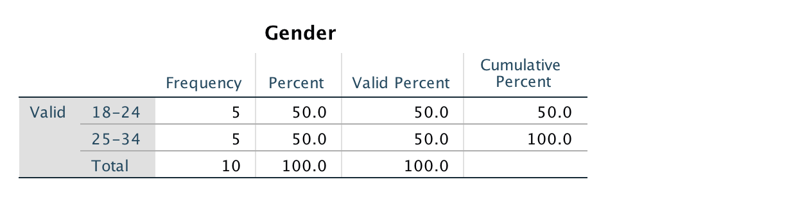
The data from the question shows and even men to women ratio. This makes for a fair representation of the general population.
Q2. What age group are you?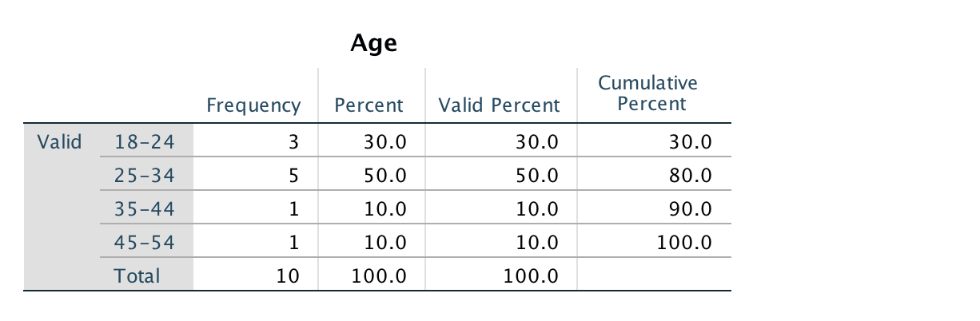
This table shows the age distribution of participants. The majority are 25-34 years of age but there is representation in every age range sampled.
Q3. What do you do as a profession?
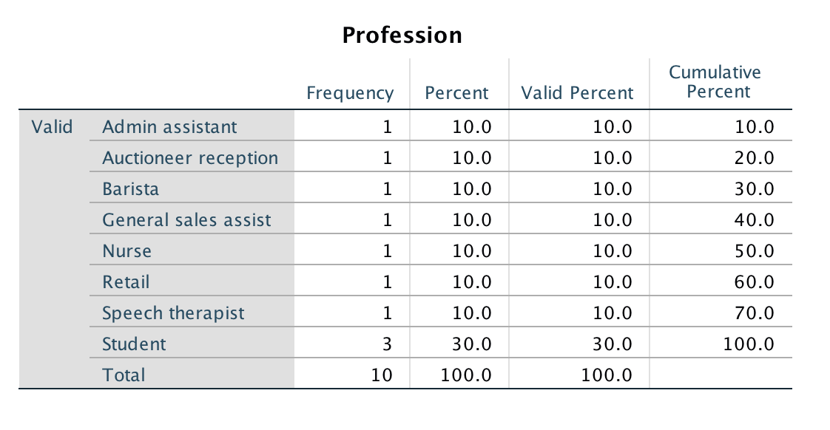
The majority of the participants were students. This was because of the convenience sample used but there is a range of occupations reflecting the general population.
Q4. Where would you normally shop?
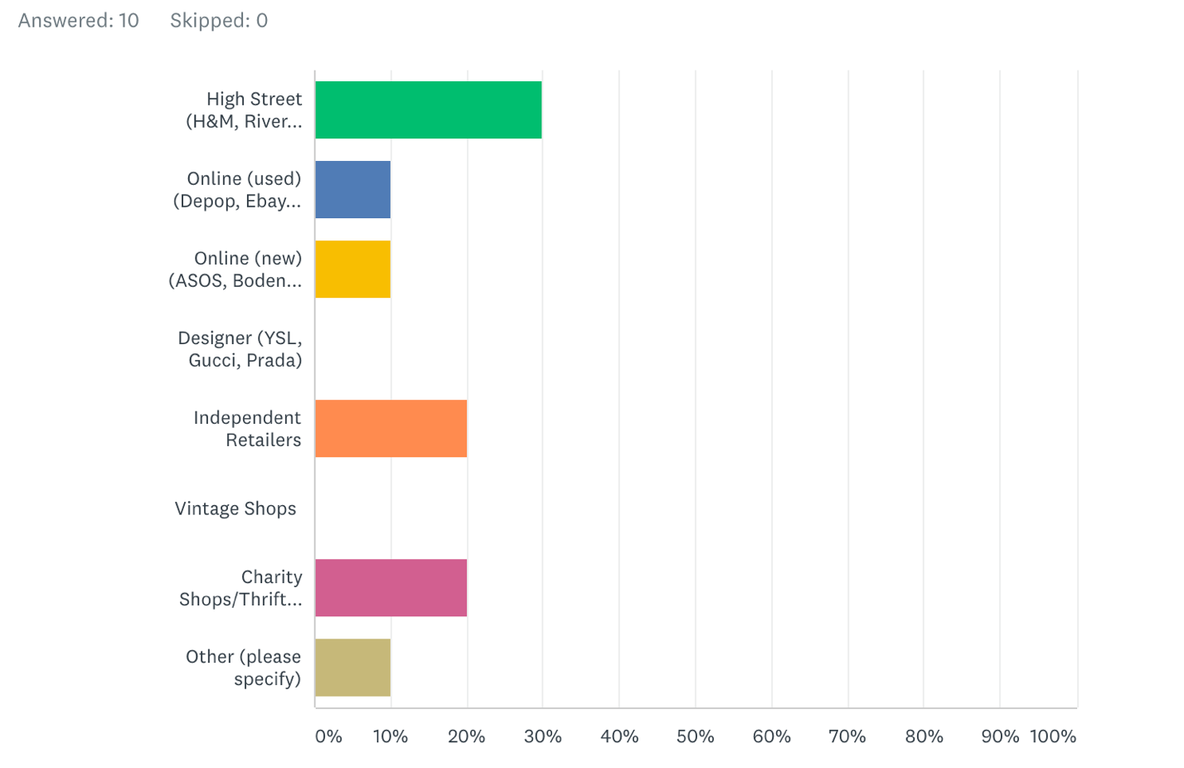
The High Street was the most popular purchase destination with thirty percent selecting this as their main place to buy clothing. Independent retailers were the next most popular and charity shops. This may reflect the fact that the participants were mainly young and students. Online shopping scored the least which was surprising because there is a media perception that this is a growing trend with a detrimental effect on the High Street.

Q5. How often do you buy new clothing?
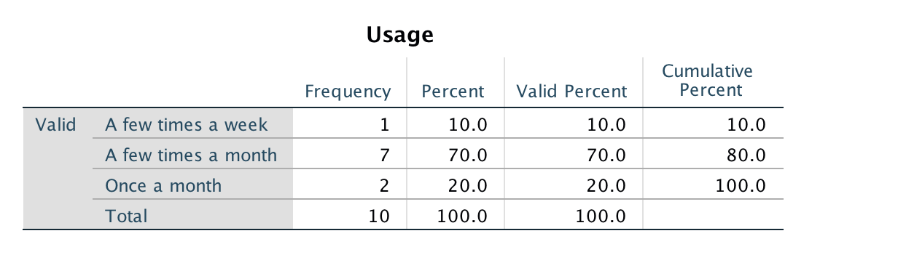
Seventy percent of participants bought clothing a few times a month. This gives data on the volume of clothing that participants purchase monthly and over a year there will This matches with findings that suggest that British citizens now own four times as much clothing than in the 1980s (Bain, M. (2015).

Q6. How likely are you to buy second hand?
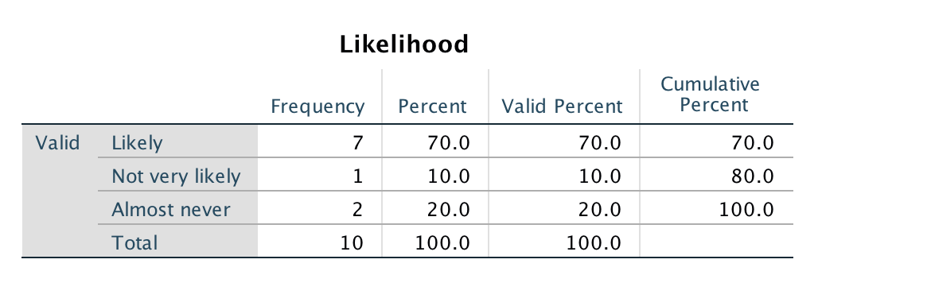
The above results show that most consumers are willing to buy second hand clothing but twenty percent said they would almost never do so. It can be concluded from the data that consumers are not opposed to buying used garments. This can be a good way of improving the lifecycle of clothing and reducing the environmental impact of the clothing industry.

Q7. What would put you off buying second hand clothes?
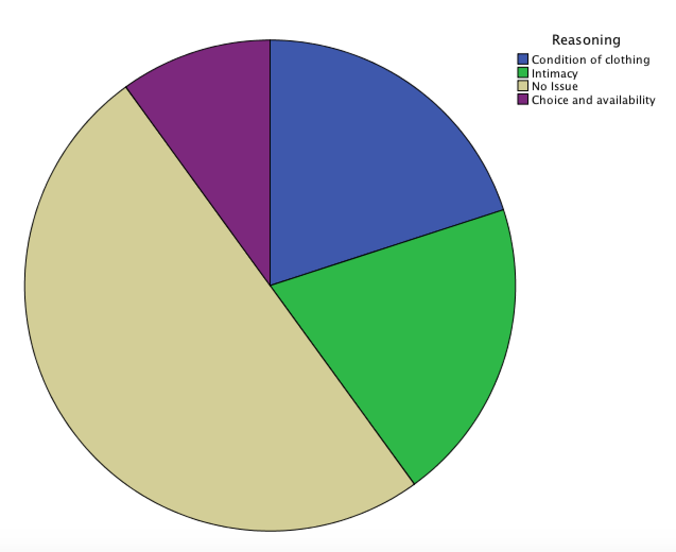
The results were collected in a short answer format which was then converted from qualitative to quantitative by grouping similar responses into four main categories which were assigned corresponding numbers. Although most of the sample had no problem with buying second hand clothing, the condition, availability and not wanting to wear garments that have been worn by someone else were barriers to some consumers.

Q8. How long do items of clothing last you?
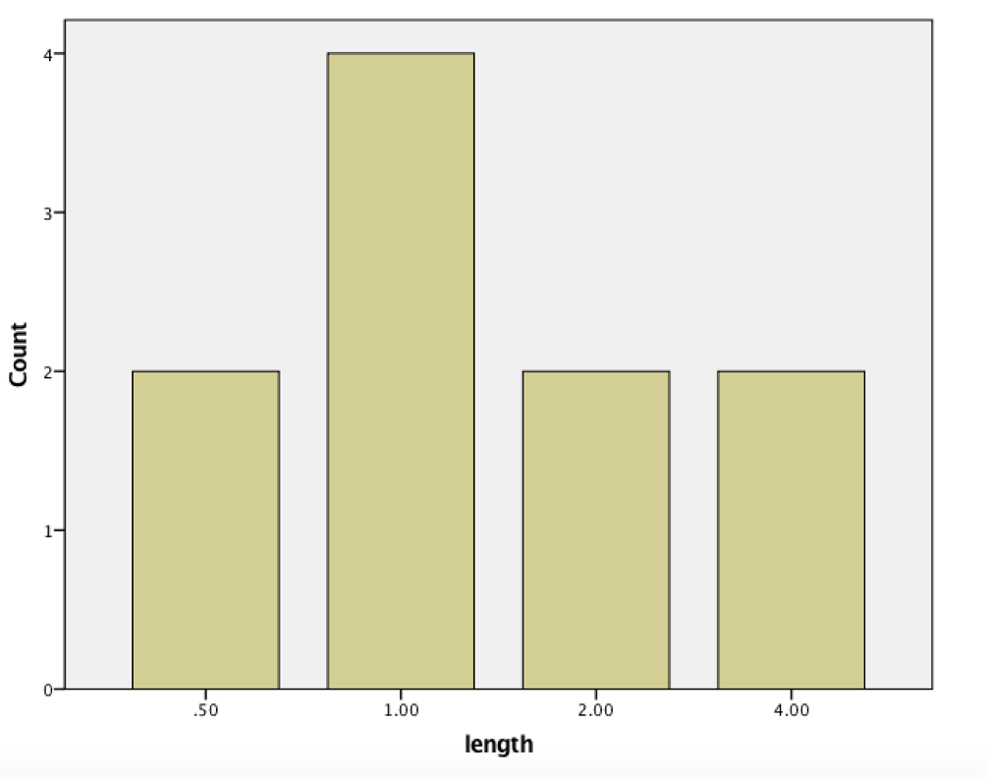
The results for the length of time items of clothing lasted were converted into a scale where 1.0 meant one year and 0.5 represented 6 months. It can be concluded that the average lifetime of a garment is one year.

Q9. How do you dispose of unwanted clothing?
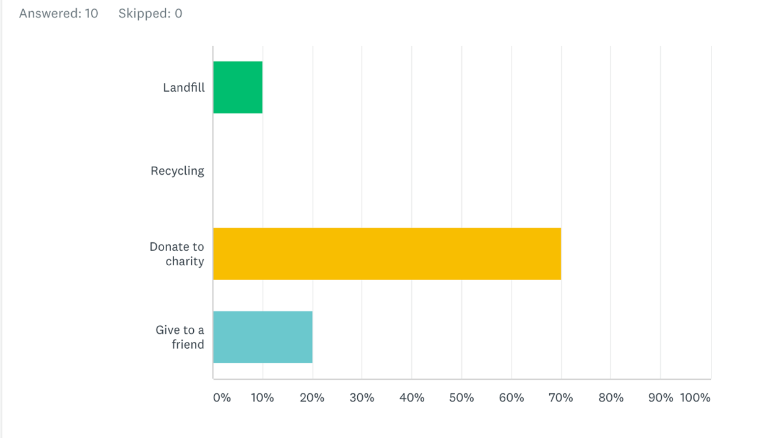
The graph shows the patterns in disposal of unwanted clothing. The majority is donated to charity so this is a good indicator of changes in disposal habits towards a more environmental friendly and circular lifespan of clothing.

Q10. Would you pay more for ethically sourced clothing?
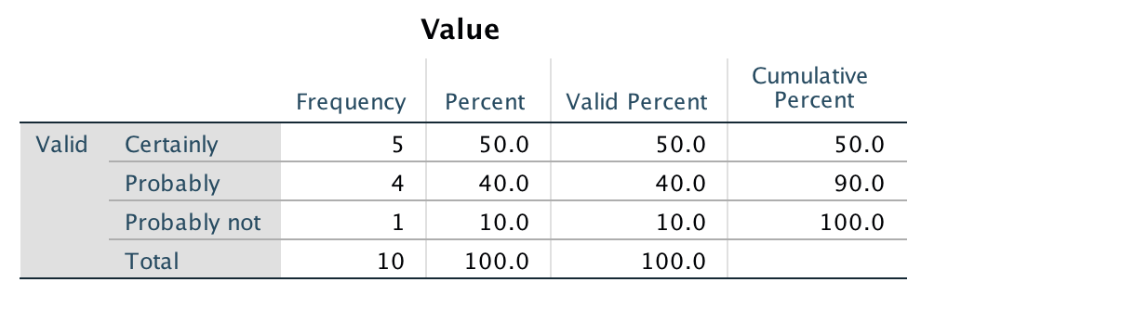
The majority of the sample group responded positively to paying more for ethically sourced clothing. However, the question only gives information on an intention rather than the actual buying behaviour.

Cross tabulation of results.
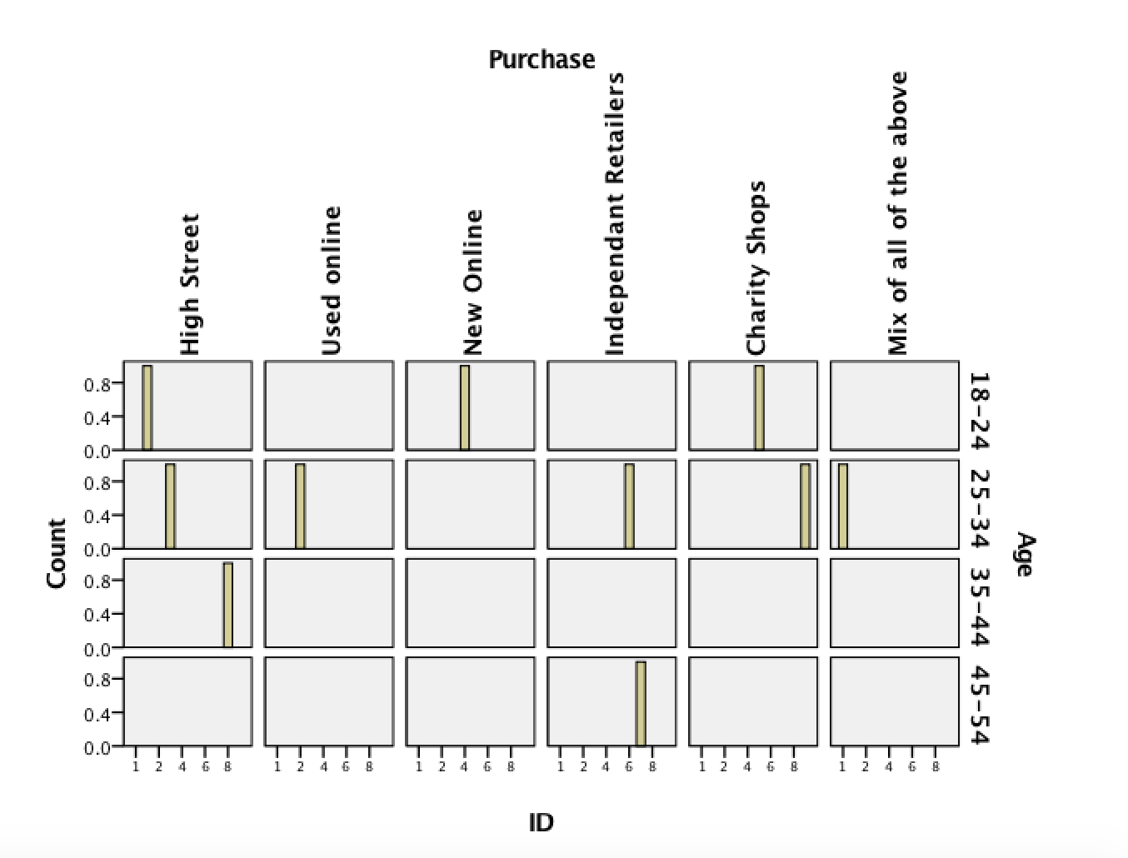
The graph above shows age and purchasing place. High street shops are popular throughout a wide range of age groups. Online methods appeal more to the younger generations. This may be because these generations have grown up using technology.

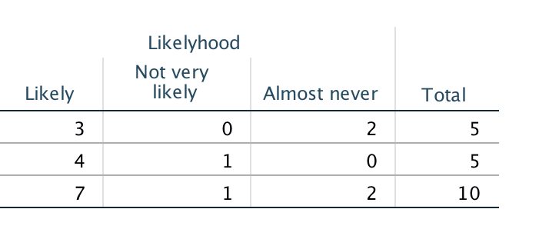

Male
Female

The above table shows a cross tabulation between gender and likelihood to purchase second hand clothing. Males are less likely to purchase second hand items than females. This is possibly because there is less variety of male garments in second hand shops.

Limitations of the data.
The small sample size is a limiting factor as it means that caution needs to be taken before generalising the results to a wider population. The convenience sampling method had similar limitations because of the restricted range of participants. A more random probability sampling method would have led to a more varied set of findings. An ‘other’ multiple choice option could have been added to the gender question to represent any participants who did not identify as either male or female.
Future research would need a larger sample group, more robust sampling techniques and longitudinal follow up to examine buying habits over time. It would be interesting to look at the amount of money spent in each sector and whether people are willing to pay more for ethical fashion. The methods of recycling garments are currently not diverse and there may be new ways of recycling in the future.

Conclusion
To conclude, there is now a growing awareness of the effects of a disposable fashion system. The clothing industry however has an interest in turning over cheap and disposable garments to increase profits. Changing fashions, cheaper production of clothing, social influences and media all contribute to the newly found perception that clothing is meant to be thrown away. The consequences are detrimental to the planet and unstainable. Possible future solutions include changing consumers buying habits, extended life cycles of clothing and recycling fabrics more effectively. The current practice is wasteful and imaginative solutions to meeting consumer, business and global needs must be found to ensure sustainability and protect the environment.

REFRENCES
Babbie, E. (2010). The Practice of Social Research. 12th ed. Belmont: Wadsworth Cengage.

Bain, M. (2015). Consumer culture has found its perfect match in our mobile-first, fast-fashion lifestyles. Quartz. https://qz.com/359040/the-internet-and-cheap-clothes-have-made-us-sport-shoppers/

Cross-Sectional Study Vs Longitudinal Study. (2019). https://www.questionpro.com/blog/cross-sectional-study-vs-longitudinal-study/

Ernst, A. (2003). Comparison of Qualitative and Quantitative Research. Munich: GRIN Verlag GmbH.

Future Generations Commissioner. (2019). A Globally Responsible Wales Archives. https://futuregenerations.wales/aotp/global-resonsibility/

Harrell, M., & Bradley, M. (2009. Data collection methods. Santa Monica, CA: RAND.

Muijs, Daniel. (2010). Doing Quantitative Research in Education with SPSS. 2nd edition. London: SAGE Publications.

Perry, P. (2018). The environmental costs of fast fashion. The Independent.
https://www.independent.co.uk/life-style/fashion/environment-costs-fast-fashion-pollution-waste-sustainability-a8139386.html

Ray, A. (2012). The Methodoloy of Sampling and Purposive Sampling. Munich: GRIN Verlag.

SurveyMonkey. (2019). It's All About Powering the Curious. https://www.surveymonkey.com/mp/aboutus/

Trochim, W. (2006). Social Research Methods - Knowledge Base - Types Of Questions. Retrieved from http://www.socialresearchmethods.net/kb/questype.php

Trochim, W., Donnelly, J., & Arora, K. (2015). Research methods. Ontario: Nelson Education.

Williams, C. (2007). Research Methods. Journal of Business & Economics Research (JBER), 5(3). https://doi.org/10.19030/jber.v5i3.2532

